Powershell based Database Assessment
Last Modified 2/2025
Nick Patti

Contents
About 1
Limitations 1
Customer server 1
DBA computer 2
Potential Features 2
Recent Features 2
Instructions 3
SETUP 3
Running the Assessment Scripts 4
Compiling the Data 7

About
This process will automate the data collection portion of a database assessment. At a high level, you would copy the files down to a server in the customer environment, run the powershell script, and then copy the output to your laptop. On your laptop, you run another powershell script to compile the output into a nicely formatted excel file.
The purpose of using the powershell script is to streamline the data collection. The entire process generally takes about 15 minutes to run per server to generate the output and another 5 minutes per server to compile it. This means no more copy/paste for 100+ scripts and then adjusting formatting, column widths, etc.

Limitations

Customer server
- Local Admin permissions
- Windows Server 2008 R2 or newer
- Powershell version 3.0 or newer. You can check this via $PSversionTable
- SQL SMO (typically included with SSMS installations)

DBA computer
- Must have office/Excel installed
- Powershell version 3.0 or newer (5+ is recommended). You can check this via $PSversionTable

Potential Features
If there are any specific features you would like added, please reach out

Recent Features
- Supports SQL 2000 to SQL 2022. SQL 2000 and 2005 will not have as many scripts as newer versions, but some data will be collected.
- Added option to use SQL Authentication
- Added option to run as another windows user
- Added invoke-sqlcmd2 which offers more flexibility with connections.
- Set the default timeout to 180/900 seconds for normal/slow queries to prevent any runaway queries.
- Updated a couple scripts to work with case-sensitive collations.
- Updated the Recent Backup script to include backup location.
- Updated the Error Log script to now include only the errors (ignoring several informational messages) to make it easier to digest/review.
- Added ability to run RDS / Mini / Performance / Config / Custom assessments alongside the full assessment.
- Added ability to run SECURITY assessments and CYBER HYGIENE assessments for security standpoint (to support security teams).
- Added progress bars to better display progress.
- Made variables/input more user friendly by prompting for settings with defaults already defined
- Changed the logic on when to call invoke-sqlcmd vs invoke-sqlcmd2
- General bug fixes/code cleanup/ SQL Script tweaks
- General rewrite of functions to cleanup code and streamline.
- Added option to pass -TrustServerCertificate for encrypted connections

Instructions

Setup
- Copy the entire folder down to your laptop in a location you want to save all your assessments and compilations. You are free to move the compiled spreadsheets out to customer specific folders after it is compiled, but we will need a standard location for excel to process these files.
- Copy the .zip file down to a local server in the customer environment. Extract the file; I normally place it so the structure is C:\DataStrike\Powershell\Assessment, but it can be placed elsewhere or on other drives. The script uses relative positioning so it will work regardless of what drive it is placed on.
- Navigate to the servers.txt file, and populate it with a list of servers you want it to run against. As long as you can register the instance using Windows Authentication from the server that hosts the scripts, then it should be able to collect the data. You can do a single instance, or multiple instances. The list should look like below:
serverA
ServerB
ServerC\instanceName1
ServerC\instanceName2
serverD

- Launch powershell as administrator and set the execution policy:
  - Set-ExecutionPolicy RemoteSigned –scope currentuser

- Sometimes you may need to unblock the files. You can do this with this command:
  - Get-ChildItem -Path "C:\DataStrike\Powershell\Assessment " -Recurse | Unblock-File
- If you get errors the the sqlserver modules cannot be loaded, you may have to install those. The script should provide the commands when it throws an error, but if you need to do an offline install of sqlserver module, refer to this doc
  - https://learn.microsoft.com/en-us/powershell/sql-server/download-sql-server-ps-module?view=sqlserver-ps
  - Save-Module -Name sqlps -Path 'C:\Datastrike\sqlps' -Force

Running the Assessment Scripts
- Open the Run script (Powershell_Assessment_Run_v9.ps1) – you can open it in Powershell ISE or by running the file.
- Setting input options:
  - The first prompt will ask how you would like to connect to the server(s). It will prompt for a Trusted connection (passing your current windows creds to SQL), using an Other Windows Account (you will be prompted for a set of domain credentials) or using SQL Login (you will be prompted for SQL credentials). The default option is the Trusted Connection.
    - 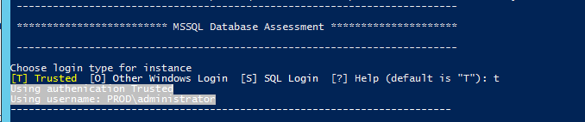
    - 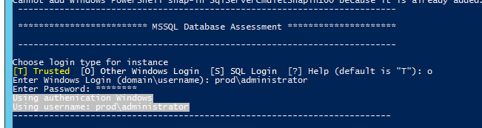
    - 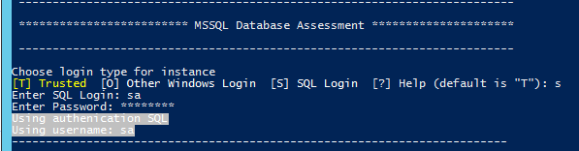
  - Next, it will prompt you to see if you need to trust the server certificate. This option is to resolve errors with "provider: SSL Provider, error: 0 – The certificate chain was issued by an authority that is not trusted." This is only available in v22 of invoke-sqlcmd. I suggest leaving this to Untrusted (U) unless you run into the above error. Run this command to check your version of invoke-sqlcmd:
    - (Get-Command Invoke-SqlCmd).Module
  - To upgrade invoke-sqlcmd run this command:
    - Install-Module -Force SqlServer
    - 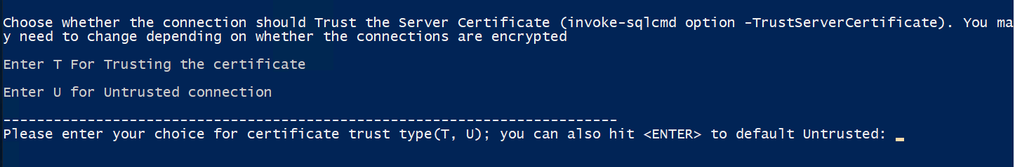
  - After determining the authentication type, it will show the servers it plans to run against; at this time, reference the list and if you need to change the server list, update servers.txt. After you hit <ENTER> it will reload the list of servers.
    - 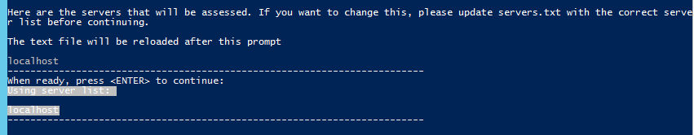
  - The next prompt sets the variable for where you want the CSV files located; the default location (based on where you placed the scripts) is provided as the default. Hit <ENTER> to accept, or enter a new location. It will validate the path you provided; if the path cannot be found you will need to stop the script and restart the process.
    - 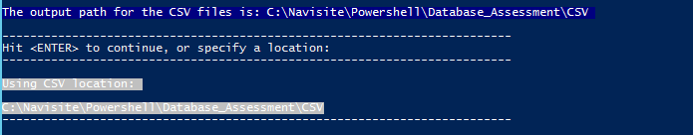
  - The next prompt is the extended query timeout setting. By default, most queries (90%) will run in under a minute each. There are around 10 queries that are known to take longer, and will rely on the setting defined here. The default is 900 seconds (10 minutes). You can set this to any integer, or set to 0 for an unlimited timeout. Hit <ENTER> to accept or enter a new value.
    - 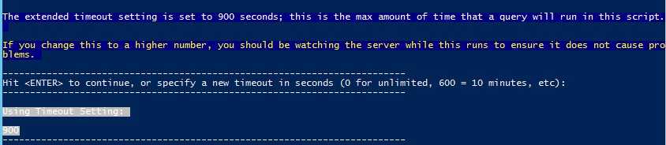
  - The final option prompts for which type of assessment you would like. The default option is a FULL assessment but you can also choose Performance, Mini, or Configuration.
    - 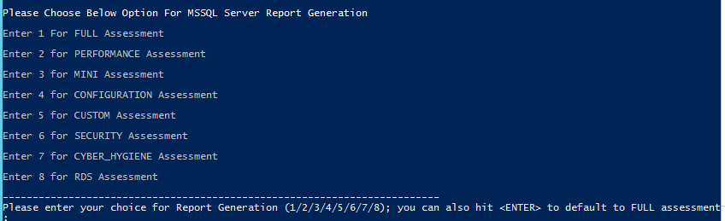
    - If you wish to choose a CUSTOM assessment, you will need to update the config file with the list of scripts you want included. This can be done by updating the file CUSTOM.txt in the Configs folder; enter the three digit code for each script you want ran. You can use the MINI.txt file as an reference.
    - The Security and Cyber Hygiene Assessments are security focused and are used for specific needs but provide some useful information if you are looking at a security based assessment.
    - The RDS assessment is a new assessment tailored around RDS instances and avoids scripts that would normally fail due to permissions.
  - After setting all options, the assessment will start.
- Watch for errors, note any issues with scripts running, and review the output logs.
  - If you had any failures, you can execute the “RerunFailedAssessmentScripts.ps1” script, which will loop through all CSV Assessment folders and rerun any failed scripts with an unlimited timeout. This can be helpful for any queries that timed out or were deadlocked; if a script fails due to a different reason (e.g. SQL Agent script on Express edition), it won’t fix the script, it will just try it again.
  - If needed, you can rerun scripts manually and paste into the spreadsheet after you compile it.

- Copy the CSV folder back to your laptop, placing in your directory for the assessments.

Compiling the Data
- Open the Compile script on your laptop (Powershell_Assessment_Compile_v9.ps1) – you can open it in Powershell ISE or by running the file.
- If this is your first time running this, you may need to unblock the compile scripts. You can do this by running this command against the directory that contains the compile script.
  - dir -r | unblock-file
- Setting Compilation options
  - The first prompt when you run the scripts will show you the servers it intends to compile; review this list and copy up the CSV folders from the customer environment if you haven’t already. Pressing <ENTER> will reload the list of files to process
    - 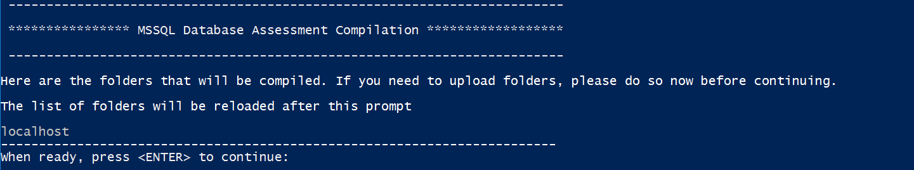
  - The second prompt will ask you for a naming convention. The default is DataStrike_SQL_Assessment followed by the assessment type (FULL/MINI/PERF), followed by the servername (serverA, serverB, etc), and then followed by a date time stamp. Press <ENTER> to accept or provide a new naming convention
    - 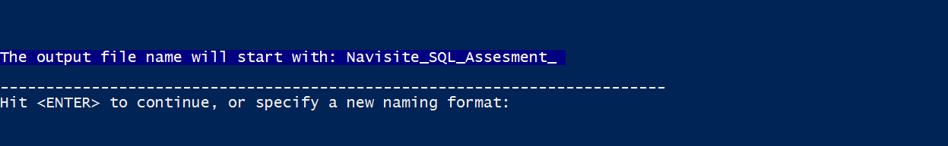
  - The last prompt will ask whether you want the sheets formatted as tables. The first example below shows WITH table formatting, and the second example is WITHOUT table formatting. The default is to use table formatting, so hit <ENTER> to accept or type “N” without quotes to refuse table formatting.
    - 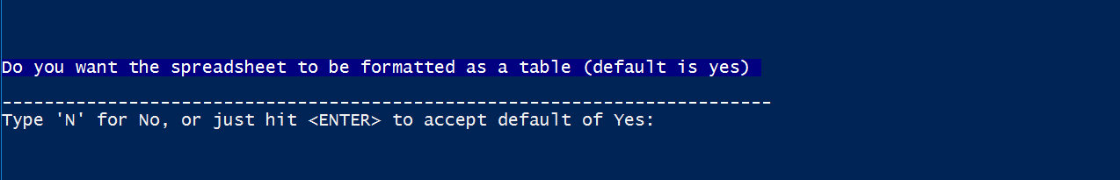

  - All other variables are determined by the script itself, including the assessment type, the template, the logo location, etc.
- Once you have started the compilation, wait for it to complete. Be sure you don’t try to copy/paste anything while it runs, as it relies on your clipboard to compile the spreadsheet. This process usually takes about 5 minutes per server.
- Review the spreadsheet and verify the file for accuracy and completion.

