- Explain regression.
- Help me understand SQL.
- Create a dataset.

1a. Explain regression to someone who comes from a background in education. Keep the explanation short to 5-7 sentences.
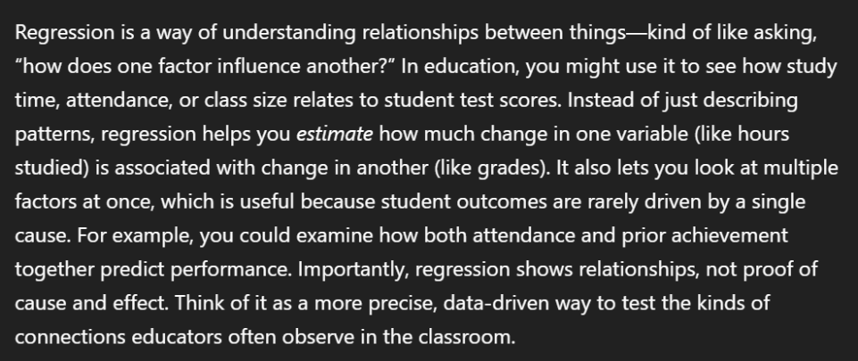

2a. Help me understand SQL in a way that is digestible and easy to understand. Keep the explanation short to 5 sentences.
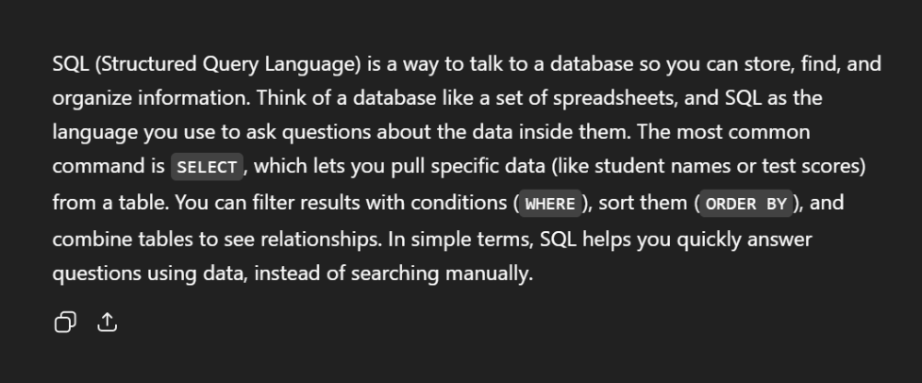

3a. Create a simple dataset that compares album sales compared to the ages of teenage listeners in the early 2000s.
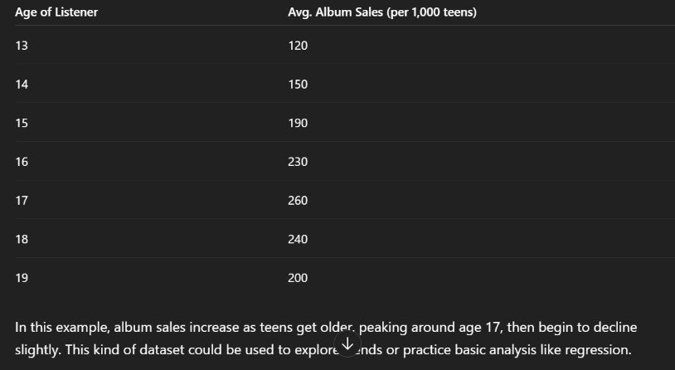

My revised prompts are stronger because they included clearer instructions and details which yielded better results. For example, when I asked the AI, ChatGPT to explain regression in a way that someone with an education background can understand, the results were explained in a way that was clear for me. As someone with a background in education chat compared the definition of regression to a students study time and test scores.

