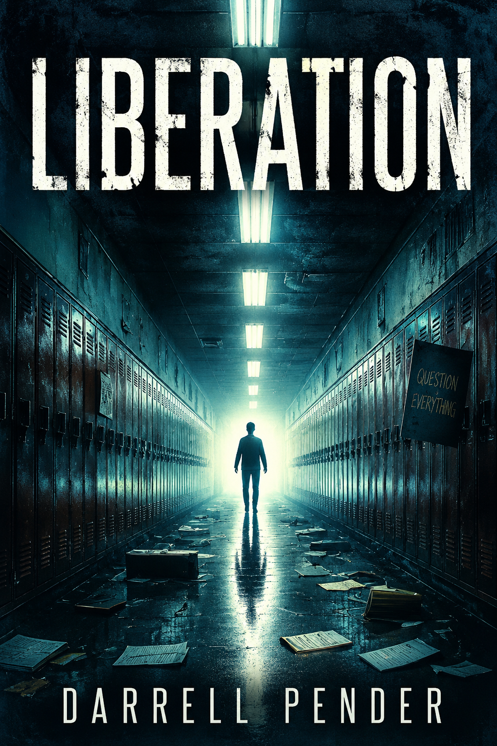

Darrell Barrow
Barrow Publications
© 2004, All Rights Reserved

Table of Contents
Haze 4

Haze
I woke up in the school cafeteria, feeling dazed. Wait, something seems off. I've been away from school for many years, and the school has been closed for quite some time. The school reminded me of my elementary school or what my mind imagined while recovering from whatever had caused me to sleep.

I pushed myself upright, my head spinning. The fluorescent lights buzzed overhead, flickering in sync with the pulse in my temples. The cafeteria looked empty, but the air felt thick as if charged with something just out of reach. I could hear a faint hum, distant yet persistent, like a radio picking up static. I tried to gather my bearings, looking around at the unchanged tables and chairs. The scent of waxy linoleum and leftover lunch trays filled the air, and a sense of déjà vu washed over me. But this wasn’t just nostalgia. This was something deeper.

Something was off.

I stood up, my legs wobbly, and moved toward the nearest door. My hand froze on the handle. The school had been closed for years—why was I here? Why now? I opened the door, expecting to see the familiar empty hallway outside. But what I saw made my stomach drop.

It was the hallway, exactly as I remembered it from childhood. The lockers were lined up, and the bulletin board still displayed the same faded poster of a science fair that had been there when I was ten. But I shouldn’t have been able to see this. This place should have been abandoned, left to gather dust. Yet, it felt like I was transported back, though I couldn’t tell if it was the past or something else entirely.

I stepped into the hallway, my heart pounding. No one was around, but I could sense something—like the presence of people, memories carved into the walls. I didn’t just feel it; I could almost hear faint whispers or echoes in the distance, like a conversation lingering in the air.

It’s not just the school, I murmured to myself. It’s me.

A sharp thought pierced my mind—an unsettling realization. Had I been transported back in time?

I clutched my head, trying to shake off the vertigo. I must have hit my head harder than I thought. Maybe I was dreaming. But the feeling of time being out of sync—that nagging sensation of being in two places at once—was hard to ignore.

"No," I muttered, trying to steady myself. "Focus."

I needed to understand what was going on. There had to be a reason I was back here and feeling things I couldn’t explain.

I stumbled down the hall, looking for anything that could help me understand this. As I passed the lockers, I saw a familiar face, my best friend, Duey. He turned his back and was talking to someone I didn’t recognize.

But when I called his name, he didn’t turn around.

I stopped in my tracks, the hairs on my neck standing up. Deuy was always the kind to joke around and mess with me. He would have turned, but... he didn’t.

That was when I realized I was all alone.

The kid in front of me wasn’t Duey. It felt like I was seeing someone else’s memory or version of my school.

Was I revisiting my childhood memories? Or was this a new reality altogether?

I looked again—Tim, or whatever version of him, continued talking, his voice muffled and distant, as if it were coming through a wall. But something else caught my eye—something far more unsettling.

A note was pinned to the corkboard on the wall just ahead of me.

“Do you remember?”

I didn’t recognize the handwriting; it wasn’t from anyone I knew. Yet, the words echoed in my mind like a distant bell tolling.

“Do you remember?"
The Mystery Grows Deeper

I approached the note and pulled it off the corkboard, my fingers trembling as I unfolded it.

The note was straightforward, written in jagged, uneven letters:

“You need to repair what was broken.

Suddenly, I felt a jolt, like an electric shock coursed through my body. The cafeteria doors behind me slammed shut, and I turned to see that the entire room had changed.

It wasn’t just the environment; it felt like the past and present had collided, tangled together in a knot. The fluorescent lights overhead flickered erratically, and the faded mural on the wall—a depiction of school spirit—looked somewhat... off. The colors seemed to bleed into each other, warped by time. I glanced down at my hands, only to see them shaking uncontrollably.

The sensation was overwhelming—both real and unreal at once.

The note. The message. It told me I had a job to do.

I felt a sudden pull—a call—to move deeper into the school, toward something I couldn’t yet see, but sensed it drawing me in. Standing in the hallway, I realized I wasn’t alone anymore—not in the way I had thought. Others weren’t quite there yet who had been. Their faces flickered in and out of existence, like memories trying to take root. A low and haunting voice whispered behind me.

"You aren’t the first to arrive here, and you won’t be the last."

I spun around, but there was nothing there.

Was I losing my mind?

No. Something bigger was happening here. Something beyond my comprehension. I could feel it—deep in my bones.

Unraveling the Mystery

I needed answers to understand what was happening. My mind raced, thoughts collided, and then, as if on cue, a door at the far end of the hallway creaked open.

Inside, a figure stood in the shadows.

“You’re here.” The voice sounded both familiar and strange. “We’ve been waiting for you.”

I couldn’t move. The sound of the voice froze me in place. This figure, whoever they were, appeared to know me. And I had a sinking feeling that they understood why I was here as well.

The air thickened again, and the building's hum grew louder.

"This is bigger than you," the figure said, stepping out of the shadows. "Time isn’t just about the past. It’s about what you’ve already lost and what you need to do to fix it."

I couldn’t understand their words—my head was spinning. Still, the urgency felt real. There was something I needed to do: a moment I had to fix, a mistake I had to rewrite.

If I didn’t act, the world as I knew it could fall apart, slipping beyond my reach forever.

Combined Premise:
Darrell's consciousness is mysteriously sent back into his younger body, but he’s not just reliving the past—he’s stuck in a fractured timeline, experiencing two parallel versions of his life. The twist? This time displacement isn’t just a random event; he’s been chosen by a cosmic force to fix a dangerous anomaly in the timeline that could affect not only his future but also the fate of the world. As he navigates this tangled reality, Darrell must solve a time-bending mystery, discovering who or what is manipulating time and why, all while facing deep questions about his identity, choices, and destiny.

Detailed Plot Breakdown:
Act 1: The Catalyst
- Darrell’s Awakening: Darrell wakes up in his childhood school, confused and disoriented. He realizes his consciousness has been sent back in time, but he’s not just reliving his youth—something is deeply wrong with the fabric of time itself.
  - The school feels familiar, but time seems warped. He sees glimpses of his adult life, but in distorted, fragmented ways. There are moments where people from his future appear in his past, and Darrell starts receiving cryptic messages or visions from an unknown source.
  - He begins to realize that two versions of himself are playing out in parallel: in one timeline, he’s living the life he’s already experienced, making all the same safe, conventional choices; in the other, he’s making risky, unconventional decisions that lead to a very different future.
  - The cosmic force guiding him is mysterious—perhaps an unknown entity or a higher power (even something tied to the school itself, like an ancient force). This force seems to be manipulating the timelines, and Darrell is the key to fixing whatever is broken.
Act 2: Investigation and Conflict
- The Mystery Unfolds: As Darrell navigates his dual timelines, he uncovers that something—or someone—is tampering with time. He begins noticing glitches: events repeating in strange ways, memories bleeding through, and people acting out of character.
  - The Cosmic Mission: He learns that he’s been chosen to solve a cosmic puzzle: to fix the timeline and restore balance. The higher power guiding him (the one sending him back) might have its own agenda, pushing Darrell toward certain decisions without fully revealing the consequences of his actions.
  - Two Realities: Darrell struggles with his choices as he moves between these parallel timelines. Each timeline represents a different version of himself. The “safe” version plays out as expected—comfortable, stable, but unfulfilled. The “risky” version leads him to adventure, growth, and self-discovery, but comes with greater personal stakes and hardships.
  - The Stakes: Darrell realizes that if he doesn’t fix the broken timeline, both realities could collapse, causing irreparable damage not just to his life, but to those he loves. The anomaly seems to be growing, and he must uncover what triggered it before it spreads beyond repair.
Act 3: The Confrontation
- Uncovering the Source: Darrell’s investigation delves into the school’s mysteries. He learns that the school is tied to the timeline disruption—perhaps it’s a nexus point where past, present, and future intersect, and something supernatural about the place is causing the anomalies.
  - He encounters figures from both timelines who reveal pieces of the mystery, but not all are trustworthy. Some are part of the cosmic force guiding him, while others may be trying to manipulate him for their gain.
  - He must confront his past, reliving pivotal moments and decisions leading to the current fractured timeline. The key to fixing the timeline lies in a specific choice he must make—one that could either restore balance or shatter everything.
Act 4: The Resolution
- The Final Choice: Darrell faces a moment of decision in which he must choose between two versions of himself: the safe, predictable life he already knows or the risky, uncertain path that represents his true self. The timeline anomaly forces him to decide which version of reality should become the true timeline.
  - He might have to sacrifice something personal to fix the timeline, whether it’s a relationship, a dream, or even part of his identity. But in doing so, he might find that choosing one path creates a new possibility, a hybrid of both realities where he can forge his own future.
  - In the end, Darrell discovers that the cosmic intervention wasn’t just about fixing time—it was about him discovering his true self, and the higher power’s intention was to push him to take control of his fate, rather than follow a predestined path.

Thematic Focus and Exploration:
- Fate vs. Free Will: The story explores whether we are trapped by fate or if we can shape our own destinies. Darrell's journey will force him to confront the idea of choice—can he break free from the patterns of his past, or is he fated to live out a predetermined path?
- Identity: Darrell will struggle with understanding who he really is. The parallel timelines provide a rich opportunity to explore who he could have become if he had made different choices and, ultimately, what version of himself he wants to embrace.
- Sacrifice and Personal Growth: To restore the timeline, Darrell must confront parts of himself that he has repressed or ignored. His decision at the climax will involve personal sacrifice, but it will also lead to a deeper understanding of who he truly is and what he wants for his future.
- Cosmic or External Forces: The cosmic intervention adds an element of mystery and urgency. What is the larger force behind this time manipulation? Is it benevolent, or does it have its own motives? And how does Darrell’s journey ultimately shape the forces that control fate?

Possible Structure and Pacing:
- Opening: Start with Darrell waking up at school, confused but intrigued. Introduce the initial sense of displacement and strangeness—things feel off, and he begins noticing glitches in time.
- Middle: The parallel timelines and cosmic intervention are introduced gradually. Darrell moves between the two realities, uncovering clues about the timeline anomaly and his role in fixing it. Conflict ramps up as he starts to uncover more about the cosmic force and what’s at stake.
- Climax: Darrell must make the crucial choice—his decision will define not just his future, but the timelines' fate. This is where the mystery of the force behind the time disruption comes into full focus.
- Resolution: Wrap up with Darrell either restoring balance, embracing a new version of his life, or forging a third path that combines elements from both timelines. The cosmic force’s motives are revealed, and Darrell’s journey culminates in a deeper understanding of himself and his destiny.

Next Steps:
- Character Development: Focus on Darrell’s internal conflict—his sense of identity, the decisions he regrets, and what he learns about himself through this journey. The cosmic or higher power should feel like both a guide and a challenge to his free will.
- World-Building: Flesh out the mystery behind the school—is it just a random location, or is it tied to something bigger? What does the cosmic force want from Darrell? Is it manipulating him for a specific purpose, or does it have a more benevolent aim?
- Plot Refinement: Decide on the core event that caused the time anomaly. Is it a mistake from Darrell’s past? A future tragedy that must be prevented? Or is it something that happens at the school itself?

