Text S1: Pseudo-code for particle MCMC

We divide the pseudo-code below into two parts: algorithm 1 implements the MCMC component of the particle MCMC method, calling on algorithm 2, which implements the particle filter component of the particle MCMC method.

Algorithm 1: the MCMC component of particle MCMC

In the following algorithm, is the vector containing all model parameters, are the latent variables and are the observed data. m indexes the MCMC iterations from 1 to M.

Step 1: Initialize MCMC

- Set m = 0.
- Set 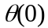 arbitrarily
- Run particle filter (Algorithm 2) to sample 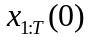 from and obtain the marginal likelihood estimate 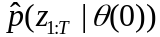.

Step 2: Run MCMC

For m = 1 to M

- Sample from a proposal density 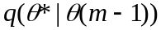.
- Run Algorithm 2 to sample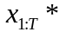 from 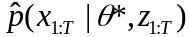 and obtain the marginal likelihood estimate 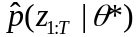.
- With probability

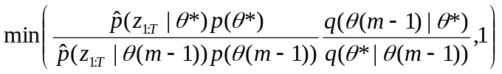,

set 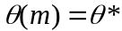, 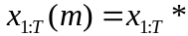 and 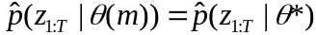;
else set 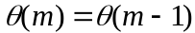, 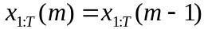 and .

End for

Algorithm 2: the particle filter component of particle MCMC

In the following algorithm, is the vector containing all model parameters, are the latent variables and are the observed data. t = 1 to T are the observation times. = 1 to N are the particle indices. For example, represents the state of particle j at time t. The notation is used to track the ancestry of particles backward in time, such that represents the parent index of particle j at time t.

Step 1: Initialize particle filter at time t = 1

- Set 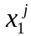 to initial values for all particles.
- Assign unnormalized particle weights

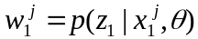.

- Normalize the particle weights

.

Step 2: Run particle filter

For t =2 to T

- Resample particles by sampling parent particle indices k according to their weights, such that

.

(b) Set for all particles.
(c) Propagate particles by simulating from the process model

to the next observation time t.
(d) Set 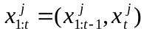 for all particles.
(e) Assign incremental, unnormalized particle weights

.

(f) Normalize particle weights

.

End for

Step 3: Estimate marginal likelihood

,
where

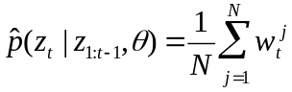.

Step 4: Sample from 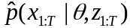 by tracing the lineage of one particle trajectory backwards through time

- Sample a particle index l_{T} such that

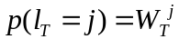.

For t = T back to 2

(b) set 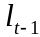 equal to its parent index 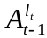.

End for

(c) Set 

