Hello I want to Purchase Wallor Full set wallet Which is Navy blue.

Is it possible to Engrave a name on it with the same font and small size on front side or back side of the wallet wherever it seems good .

I am including the name and picture of the font style and how it looks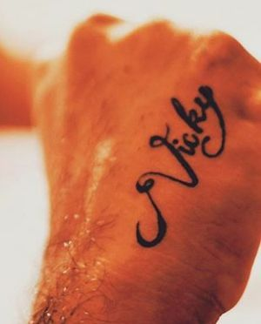

So would you able to do this same font style and letters size in my navy blue full set wallet?

I just need a prototype of wallet with this engraving before you start the production.

As the information if we don’t purchase by this month ending you are going to charge for data plan from next month, so if you provide me the exact details of my requirement whether its possible or not ,I can do the purchase of pre order for navy blue full set.

Thank you