Day 4 Stage 1 Review

Question:



Answer:

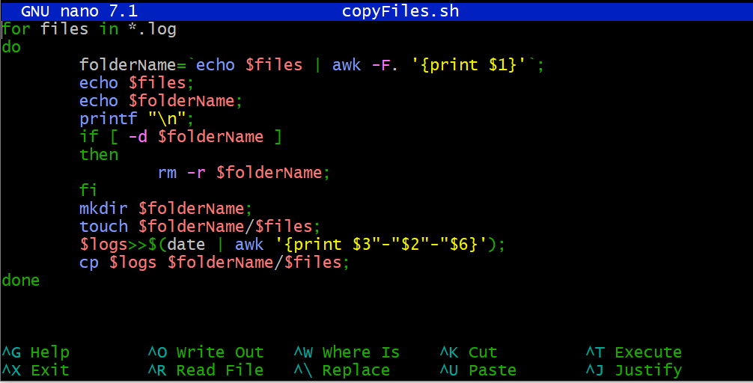

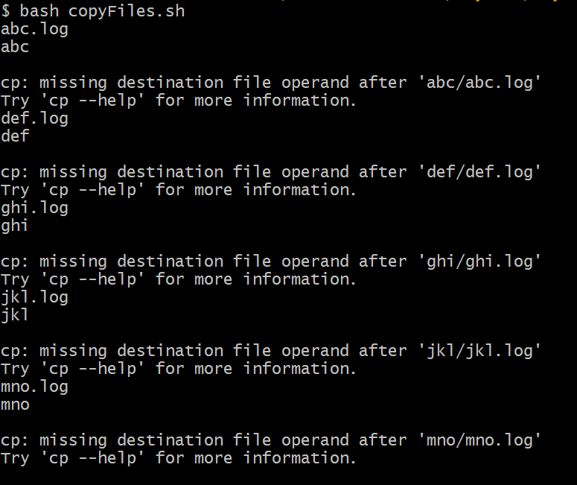

Solution by -

Dhondip Basumatary

Batch – 640

13/01/2023