**1.2.2 Scientific reasoning and importance of the experiment**

Throughout the animal kingdom, we observe collective animal behaviour in which animals form swarms, flocks, or schools in order to improve their chances of survival. Collective behaviour can distract and confuse predators or increase the group's awareness of potential dangers, or improve the success rate when foraging for food. In many cases, the advantages of collective behaviour are ultimately attributed to improved cognitive performance at the level of the group through integration of low-level cognition by individuals. As such, it is possible to understand the mechanisms of collective behaviour by modelling individual interactions and determining the resultant emergent properties. For decades, scientific studies of collective behaviour have aimed to understand how animals exploit emergent behaviours to achieve ecological or evolutionary successes.

Collective behaviour of animals can be more generally considered an example of decentralized information processing. Without a central control structure, decentralized processes are robust against fluctuations in information flow and disruptions in the processing network itself. For decades, decentralized processing has been a prominent strategy for applications of engineering and robotics. More recently, decentralized processing has been proposed in neural network models of multi-modal sensory integration. In this model, neurons form filter modules with reciprocal connections between modules that robustly integrate information in the brain. The performance of animal collectives far exceeds our current decentralized technologies, especially in rapidly changing and noisy environments. Understanding decentralized information processing by collective animal systems may therefore provide previously unseen insight that is relevant to other scientific realms, including computational and neurological sciences.

This study aims to demonstrate and characterize the information processing capabilities of collective animal groups. We will demonstrate collective information processing by comparing the capacity of animals groups to perform complex tasks used in neurological studies. We will characterize collective information processing by assessing the individual responses that comprise emergent behaviours, and exploiting these responses to enhance the processing capabilities of animal groups. We will accomplish these goals by observing the behaviour of freshwater fish in a laboratory setting. Our studies will focus on one species of fish, the sunbleak (*Leucaspius delineatus),* with partial use of a second species, the three-spined stickleback (*Gasterosteus aculeatus*) for species comparison studies. We will present groups of animals with visual stimuli and quantify their behaviour using state-of-the-art individual-based tracking techniques. The following sub-projects will be carried out:

1.) Binary decision-making by fish collectives.

1.1) Sensitivity of fish collectives to weak stimuli within noisy systems

1.2) Effect of group size on sensitivity to weak stimuli within noisy systems.

1.3) Cross-species comparison of binary decision-making within noisy systems

2.) Characterization of individual fish responses to visual stimuli.

2.1) Identification of visual stimuli that elicit robust responses in sunbleaks

2.2) Comparison of visual responses in sunbleaks and sticklebacks.

3.) Collective resolution of induced complex conflicts.

**1.2.3. Scientific explanation for the use of experimental animals**

We will investigate the processing power of animal collectives. The experiments are necessary in order to characterize the unique ways in which animals optimize the use of decentralized information processing. The results are based on the responses of animals, which are not fully understood. We will use fish as a model system due to the relative ease with which they can be housed and observed safely, ethically, and without suffering. The sunbleak has been previously proposed as a model system for the collective behaviour of fish. Sunbleak eggs can be easily captured from a nearby lake before hatching, minimizing stress and ensuring optimal nutrition and disease avoidance. Three-spined sticklebacks are a model system for studying collective behaviour of fish, and will allow us to relate our conclusions to a broader scientific context.

**1.3.1 List of relevant literature and internet search results**

Selected literature:

Berdahl, A., Torney, C.J., Ioannou, C.C., Faria, J. & Couzin, I.D. (2013) Emergent sensing of complex environments by mobile animal groups, Science 339(6119) 574-576.

Durrant-Whyte H, Henderson TC (2008) Multisensor data fusion. In: Springer Handbook of Robotics (Siciliano B, Khatib O, eds), pp 585–610. New York: Springer

Ioannou, C.C. (2016) Swarm intelligence in fish? The difficulty in demonstrating distributed and self-organised collective intelligence in (some) animal groups, *Behav. Process*. http://dx.doi.org/10.1016/j.beproc.2016.10.005

Shadlen, M.N., and Newsome, W.T. (1996). Motion perception: seeing and deciding. *Proc. Natl. Acad. Sci.* USA 93, 628–633.

Zhang, W., Chen, A., Rasch, M.J., Wu, S. (2016) Decentalized Multisensory Information Integration in Neural Systems, *J. Neurosci.* 36(2):532-547.

Internet search results:

Databases: Google Scholar

Date of search: 10.03.2017

Keywords: natural computation, swarm intelligence, fish

**1.3.2 Scientific novelty**

Several previous studies have explored the mechanisms by which collective behaviours emerge in animal groups (Ioannou, 2016). However, all collective behaviour studies of which we are aware have aimed to understand natural behaviours; no studies, to our knowledge, have sought to determine the extent to which animal groups can process information. By demonstrating complex problem solving in animal groups, we aim to introduce animal behaviour as a relevant system in the study of decentralized information processing through comparison with a well-established choice paradigm in neuroscience. By characterizing individual responses to visual stimuli, we may identify low-level cognitive functions that enhance group-level processing that have not been identified in engineering and neuroscience. By creating group configurations with properties rarely seen in nature, we aim to observe decentralized resolution of complex information conflicts from a perspective that provides many advantages over conventional information processing paradigms. Finally, the strategies that we will develop in the study for influencing the motion of fish will enable us to direct fish schools into positions optimal for our studies. These strategies will greatly increase the frequency with which experimental group configurations can be reached, thereby reducing the duration and replicates necessary for future animal research studies.

**1.4.1 Explanation for chosen species, age, and sex**

We will use sunbleaks and three-spined sticklebacks as example species in our study. Sunbleaks are a robust small fish that are widespread in lakes and ponds throughout temperate continental Europe. They exhibit very robust schooling behaviour, and have previously been suggested by experts to be a model system for studying swarm behaviour in fish (REF). We will collect captive sunbleaks, housed in mesocosms at the University of Konstanz Limnological Institute. We will use two age classes of sunbleaks, “juvenile” and “adults”, in order to normalize animal density (relative to body length) and animal count in small and large arenas (1,2m and 3,0m, respectively). “Juveniles” will be defined as animals less than one year post-hatching. “Adults” will be defined as animals older than one year post-hatching. For each proposed experiment, will determine whether to use juveniles or adults during pilot experiments. We will not control or record the sex of animals in this study.

The three-spined stickleback is a robust fish species that is found throughout the Northern Hemisphere, and are found in large numbers in nearby Lake Constance. They are larger than sunbleaks and form schools with lower density and swimming speed, therefore providing a second example species for comparison. We will use adult fish of both sexes for this study.

**1.4.2 Number of animals**

**a). Total number of animals for the planned experiments:**  13101 (12900 sunbleak + 201 stickleback)

**b) Table of experimental groups and experimental plan:**

We are going to conduct a series of behavioral experiments under laboratory conditions in newly-established fish facilities of the University of Konstanz. For the purposes of the project we will make use of robust test setups, reliable protocols, modern and individual-based tracking techniques that we have developed over the past few years. First, we will start with a series of pilot experiments to investigate the properties of visual stimuli (colour, object density, speed) that will influence collective behaviour and establish an appropriate range of variation under which to conduct this study. We plan a total of 10 short (30 minutes) pilot experiments with 1-100 fish, with replacement as outlined below. Based on these preliminary experiments we will conduct three stages of experimentation as introduced in section 1.2.2.

Due to the subject of this study (collective behaviour), we will use thousands of fish. Large numbers of fish are absolutely necessary for this study, as previous studies have demonstrated that the collective cognition capacity of fish schools increases in large numbers (Berdahl *et al*, 2013), and we aim to test hypotheses that even larger numbers of individuals will further increase the cognitive power of schools. In acknowledgement of the necessarily large numbers of animals per experiment, and in accordance with the mandate to limit the number of experimental animals as much as possible, we will re-use animals in multiple tests with minimum 1 day rest periods between experiments. Tables 1 and 2 below outline the number of fish to be used in each part of this study, and the total number of fish (part 1.4.2.A), reflects the replacement and re-use of animals in several experiments. The group sizes used in experiments are well within the natural range of group sizes observed in nature for both study species. Large group sizes are defined as ranges, because precise counting of large numbers of fish would impose additional handling, causing unnecessary stress on the fish.

Table 0: Summary of experimental group sizes for sunbleaks.

|  |  |  |
| --- | --- | --- |
| Experiment | Group size | Number of Replicates |
| Pilot | 100 (+/- 10%) | 10 |
| Binary decisions | 1  2  4  8  16  32 (+/- 3%)  64 (+/- 5%)  128 (+/- 5%)  256 (+/- 5%)  512 (+/- 5%)  1024 (+/- 5%)  2048 (+/- 5%)  4096 (+/- 5%) | 50  50  50  50  50  25  25  25  10  10  10  6  3 |
| Individual responses to visual stimuli | 1 | 25 per stimulus |
| Conflict resolution | *Up to 2048 (+/- 5%) | *Up to 6 per stimulus |
| * optimal group size will be determined in the group size study of binary decision-making. | | |

Table 0: Summary of experimental group sizes for sticklebacks.

|  |  |  |
| --- | --- | --- |
| Experiment | Group size | Number of Replicates |
| Pilot | 10 | 10 |
| Binary decisions | 1  2  4  8  16  32 (+/- 3%)  64 (+/- 5%) | 25  25  25  25  10  6  3 |
| Individual responses to visual stimuli | 1 | 25 per stimulus |
| Conflict resolution | 64 | 10 per stimulus |
| * optimal group size will be determined in the group size study of binary decision-making. | | |

In order to achieve a statistical significance, each experiment is carried out with several groups of fish. This is also an indispensable prerequisite to avoid influencing the data by stochastic variations in group dynamics and to quantify stereotyped behavioral responses, as we would like to observe. Furthermore, a combination of advanced recording systems and high-resolution tracking methods will minimize potential measurement errors and thus keep the number of fish groups examined as low as possible.

**1.6.2 Detailed description of experiments**

No biological samples are taken from the animals, nor are any interventions performed or substances administered. The experiments are completely behavioral responses to visual stimuli and are captured in videos, which can be analyzed after data collection.

Capture:

Juvenile sunbleaks will be captured as eggs from the mesocosms at the University of Konstanz Limnological Institute in springtime. The eggs will be brought into our climate-controlled laboratory. They will be allowed to hatch and develop in laboratory tanks. After one year of development, they will be considered “adults” for experimentation. Adults may also be taken directly from the mesocosm.

The sticklebacks come directly from Lake Constance and its tributaries and are caught by landing net, sinks and minnow traps. Fish collection is agreed with the respective fishers or the tenants as well as the fishmonger Mathias Bopp. Minnow trapping is a widely used way to catch sticklebacks, and affords them enough space to swim. This can also be well stocked with food. It will take at most half a day to bring the minnow traps and check them. This fishing method is classified as low by the stress level of the fish as opposed to other techniques such as angling. Once caught, the sticklebacks will be housed in large aquariums and allowed to acclimatize to laboratory conditions for at least 2 weeks before the start of the experiments.

Animal housing and experimental transfer procedures:

Fish will be housed with natural-looking plastic vegetation, ventilation and filtration in a temperature controlled (16C +/- 2C) and light-regulated (L:D; 11:13h) laboratory. They will be fed daily with commercial fish feed. Fish will be housed in 120 L tanks.

Animals will be transported to experimental arenas by gently netting them and transferring them to a bucket of tank water. Buckets will be carried to the experimental arena, where the temperatures of arena and bucket water will be measured. If the temperature difference is less than 1C, fish will be transferred from the bucket by gently tipping from a height of no more than 2cm. The same procedure will be used to return the fish to the housing tanks. Visual stimuli (moving dots projected from above that simulate flow) may be used to direct the animals to one side of the arena to ensure a rapid and low-stress recapture.

For large group sizes, fish may be housed in the experimental arena continuously for up to 3 days (Fig 1.) Transferring large groups out of the arena can be mildly stressful during recapture. Therefore, whenever experiments are planned on successive days, large groups (for which individuals must be re-used) will be housed in the arena between experimental sessions. During arena housing, water filters and aerators will be added to the arena and food will be provided. Light blue light from projectors and synchronized dark:light schedule will provide a similar environment to the housing tank. Temperature will be maintained at 16C +/- 2C.

Fig. 1: Experimental workflow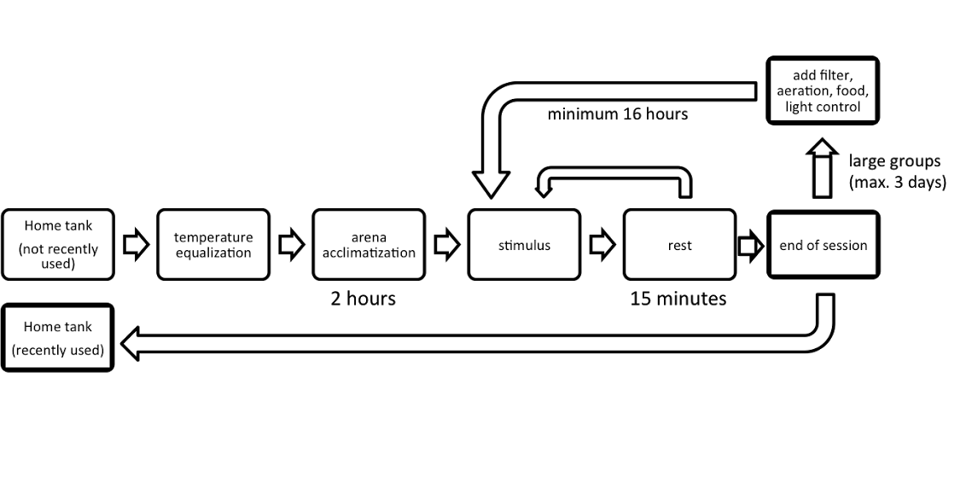

General experimental procedures

The following describes experimental conditions that are common to all proposed experiments of this study.

Fish will be placed in aquatic arenas with a water depth of 6-15cm, and temperature will be maintained at housing temperature. Fish will be allowed at least two hours to acclimatize to the arena and recover from transfer. An experimental session will begin with a visual stimulus. During a single experimental session, several stimuli will be tested, with 15-minute rest periods between stimuli. Experimental sessions will not exceed 8 hours, and will be limited to 1 session per 24 hour period.

Visual patterns will be displayed on the floor of the arena from projectors (beamers) mounted above. Patterns will typically consist of moving dots or shadows, and will be described in more detail for each experiment. Between stimuli and during housing daylight, pale blue light will be projected. Transitions to, from, and between stimuli will be made by slowly fading to avoid startling the animals.

The experiments will be captured on video from cameras mounted above the arena. In order to observe the behaviour of the animals unobstructed by the visual stimulus, the videos will be captured using infrared video technology. The arena will be illuminated with infrared light (>800nm) and visible light will be blocked from the camera. Infrared light is commonly used to illuminate animal experiments. Moderate intensity infrared light does aversely effect behaviour.

Binary decision task

The binary decision making task will be designed to be analogous to prominent decision making studies in neuroscience. The task will be a modified version of Variable Coherence Random Dot Motion (VCRDM; Shadlen & Newsome, 1996). In VCRDM, small dots appear on a screen and drift to the left or right, and the task requires an animal to decide in which direction the dots are moving. The difficulty of the decision can be adjusted by changing the coherence of the stimulus (proportion of dots moving in either direction). As our foremost experimental strategy, we will present dots that rotate, rather than translating left or right. Analogous to VCRDM, the rotating dots will vary in coherence of the direction of rotation (clockwise or counter-clockwise). We will refer to this assay as “Variable Coherence Random Dot Rotation” or VCRDR. During a stimulus bout, animals will be presented with VCRDR stimuli with several coherence values. In addition to VCRDR stimuli, other visual patterns may also be presented to fish. The duration of stimulus bouts may vary between 2 and 10 minutes.

Characterization of individual responses

The purpose of this experiment is to characterize individuals' responses to local stimuli in the absence of social cues. In order to present consistent stimuli across trials, it is necessary to control the position and orientation of stimuli relative to the focal fish. Using live video tracking software (Walter & Couzin, unpublished results), positional information from the fish will be used to set parameters for visual stimuli. Single animals will be observed in 1,2m arenas and moving dots or shadows will be presented to the fish with precise control of orientation, position, and speed. Through repetition and replication, we aim to determine the stereotyped responses to visual stimuli.

Stimulus-induced configurations

We will use visual stimuli to establish group configurations that are valuable for testing hypotheses related to collective information processing, but that may only rarely occur in unstimulated environments. The induced configurations will address contexts of convergent, divergent, and incongruous interactions (Fig 2).

Fig. 2: Visual stimuli to promote rare group configurations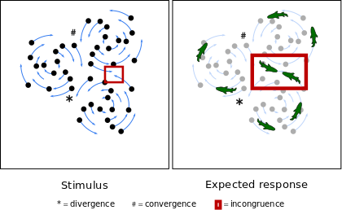

Left: schematic representation of stimulus. Three distinct points of rotation generate a region of divergence, convergence, and incongruence. Right: Expected response. As fish follow the flow of the stimulus, the group will resolve points of divergence, convergence, and incongruence.

1.7.2.2 We will not kill animals after experiments. We will return them to the mesocosm, where they will be subject to natural predation from birds, etc.