|  |
| --- |
|  |
| SRU232  (BLE 4.1 & ANT with Long Range)  Datasheet |
| Version 01.01.08 |

**Revision History**

|  |  |  |  |
| --- | --- | --- | --- |
| **Version #** | **Remark** | **Date** | **Done By** |
| 01.01.01 | Initial Release | May 08,2015 | Hiren |
| 01.01.02 | Add details about Mechanical data | May 08,2015 | Kinjal |
| 01.01.03 | Add Chapter 2 and Chapter 6, Update with latest template | May 13,2015 | Kinjal |
| 01.01.04 | Language verification | May 13,2015 | Shyamal |
| 01.01.05 | Formatting, Add table and Figure# and details | May 18,2015 | Kinjal |
| 01.01.06 | Some minor correction | May 19, 2015 | Ashok Hirpara |
| 01.01.07 | Modify Layout guideline | June 15,2015 | Jatin Bhatt |
| 01.01.08 | Update information as per review comments by Nick | June 26,2015 | Jatin Bhatt |
|  |  |  |  |

**Table of Contents**

1. Description 5

2. Features 6

3. Applications 7

4. Ordering Information 8

5. Module Accessories 9

6. Block Diagram 10

7. Support 11

8. Develop BLE powered product 12

9. Power on Reset and Brownout detector 13

10. Pin out detail and description 14

11. Electrical characteristics 18

11.1 Absolute Maximum Settings (1) 18

11.2 Recommended Operating Condition 19

11.3 DC Characteristics 20

11.4 Current Consumption 20

11.5 Current consumption with waveform while advertisement mode 20

11.6 Peak Current consumption vs tx power graph 20

11.7 Current consumption using DC converter (TPS62730) 20

12. RF Characteristics 21

12.1 RF specification summary 21

12.2 Radiation pattern - X Axis 21

12.3 Radiation pattern - Y Axis 21

12.4 Radiation pattern - Z Axis 21

12.5 Line of sight (L.O.S.) Range Testing 21

12.6 Impact of module height above Ground on range 21

13. Mechanical Dimension 22

14. Recommended land pattern 23

15. Design Guide Line 24

15.1 Reference Board and guidelines 24

15.2 Recommended Capacitor bank 25

16. Module placed on the recommended PCB land pattern 26

17. Soldering Recommendations 28

18. Certifications 29

18.1 Module FCC and IC Compliance Statement 29

18.2 OEM / Host Labeling / Statement Information 30

19.3 IC (Industry Canada) Labeling 32

19. Bluetooth SIG Approval 33

20. Device Marking 33

21. Contact Detail 33

# Description

* SRU232 is a single mode Bluetooth Low Energy (Bluetooth Smart) module with ANT network support.
* It has +10 dBm Tx Power and -93 dBm for RF Rx (BLE) and -90 dBm for RF Rx (ANT) sensitivity, which has best in-class Radio Frequency performance and provides long-range connectivity up to 250 meters, Line of Sight.
* The SRU232 has integrated physical radio 2.4GHz, Software Stack of BLE 4.1, GATT based profiles and ANT stack for mess network support.
* It contains ARM® Cortex M0 ® processor with 256KB flash memory and 32KB RAM, therefore no external microcontroller is required for size, price and power constrained devices. User can use 128KB memory for custom application development using SR-API. Delphian Customer support division will help you to build your custom application.
* Delphian Systems provide AT Commands and SR API base firmware support for use SecuRemote® platform with BLE and ANT base mesh network for rapid product development.

# Features

* Industry’s leading wireless range from integrated chip or external antenna
* Built in nRF51422 single-chip 2.4GHz Bluetooth Low Energy system on a chip
* Communicates over Bluetooth 4.1 and ANT simultaneously for mess network based IOT product
* Bluetooth Compliant Transmit Power: +10 dBm (Class 1.5)
* Maximum Transmit Power: +10dBm
* Maximum range: >250 meters Line of Sight
* RF Receive Sensitivity (BLE): -93 dBm
* RF Receive Sensitivity (ANT): -90 dBm
* Miniature Size: 20mm x 25mm x 1.5mm
* Operating Voltage: 2.0V to 3.6V
* Operating temperature: -40 ⁰C to +85 ⁰C
* Current Modular Certification: FCC (USA) and IC (Canada) – no need to certify your own radio
* Future Certifications: CE (Europe)
* Integrated ARM® Cortex® M0 32-bit Microcontroller
* Memory: 256KB Flash, 32KB RAM
* 8 Configurable ADC Channels
* 16 bit and 32 bit timers
* SPI Master/Slave, I2C, UART and PWM
* Low power comparator
* Temperature Sensor
* CPU Independent Programmable Peripheral Interconnect (PPI)
* Quadrature Decoder (QDEC)
* AES hardware encryption
* Real Time Counter
* RoHS compliant

# Applications

* + - * Long range BLE devices
* Internet of Things devices
  + - * High security remote controls
      * Home and Building Automation
      * iBeacon
      * Industrial Control Application
      * Medical (Ex. Heart Rate Monitor, Blood Pressure Sensor, Blood Glucose Meter)
      * Thermometer
      * Flood Alarm
      * Heating Control
      * Automatic Key Control
      * Industrial Sensors
      * Electronics Toys
      * Entertainment Devices
      * Mobile Accessories
      * BLE + ANT based mess network supported devices
      * Compatible with ANT protocol

# Ordering Information

|  |  |
| --- | --- |
| **Product Code** | **Description** |
| **SRU232-V3** | **SRU232 module with chip & u.FL antenna Connector** |

Table# 1 Ordering Information

# Module Accessories

|  |  |
| --- | --- |
|  | Description |
|  | 2.4 GHz Dipole Antenna with Reverse Polarity SMA Connector  Gain = +1 dB |
|  | U.FL to Reverse Polarity SMA Bulkhead Cable |

Table# 2 Module Accessories

# Block Diagram

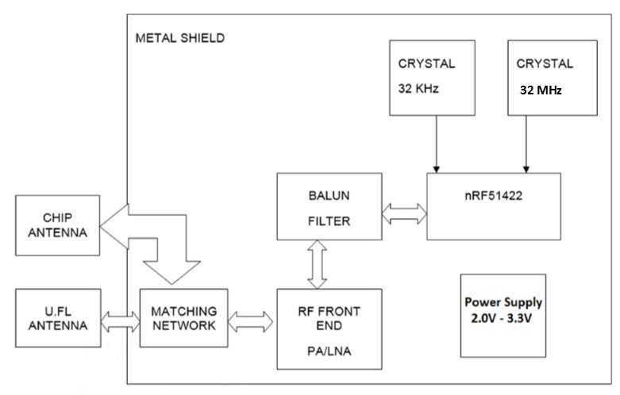

Figure# 1 Block diagram of SRU232

# Support

* The SRU232 module series uses nRF51422 from Nordic Semiconductor. Delphian has used native Bluetooth Low Energy stack from Nordic Semiconductor. Delphian will provide support to OEM on following areas:
  1. AT command and API based firmware development
  2. Custom firmware development
  3. SecuRemote Server interface support
  4. BLE based Smart phone application development for iOS and Android
  5. Hardware design support for product development using SRU232
  6. Mass production support

User can download datasheet, application note, sample Application and Firmware from <http://www.delphiansystems.com>

Delphian Support:

Information will add by Delphian USA.

# Develop BLE powered product

SRU232 has two approach to develop BLE powered product.

1. With help of AT Command
2. With help of SR-API
   1. **AT Command base product development**

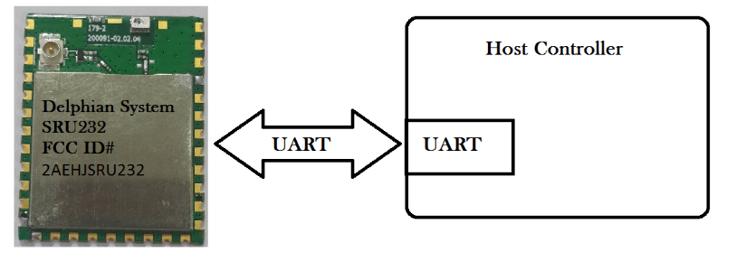

Figure# 2 Interface diagram between SRU232 and Host controller

* Delphian will provide complete AT Command set for BLE and ANT base application development.
* Please refer SRU232-ATCommand.pdf for more details.
* User needs to possess very limited knowledge on BLE and ANT for AT Command base product development
  1. **SR-API base product development**
* SRU232 has Cortex-M0 ARM processor with 256KB Flash and 32 KB RAM so user can develop custom application without using another Host controller.
* Delphian has provided SR-API for custom application development.
* Please refer SRU232-API.pdf for more details.
* User needs to possess good knowledge on BLE, ANT and Keil IDE.
* SRU232 module supports the Serial Wire Debug (SWD) interface (SWDCLK and SWDIO/RESET) for programming and debugging of the module.

# Power on Reset and Brownout detector

* SRU232 includes a power-on reset (POR), providing correct initialization during device Power ON.
* It also includes a brownout detector (BOD) operating on the regulated 1.8-V digital power supply only. The BOD protects the memory contents during supply voltage variations, which cause the regulated 1.8-V power to drop below the minimum level required by digital logic, flash memory, and SRAM.
* When power is initially applied, the POR and BOD hold the device in the reset state until the supply voltage rises above the power-on-reset and brownout voltages.

# Pin out detail and description

**Schematic Symbol:**

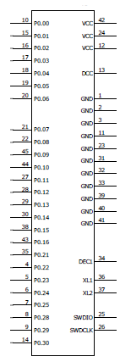

Figure# 3 Schematic Symbol

**Package Outline:**

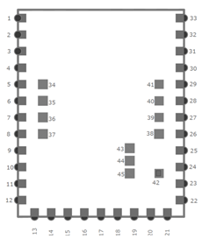

Figure# 4 Package Outline

**Pin Description:**

|  |  |  |  |
| --- | --- | --- | --- |
| **Serial #** | **Pin Name** | **Pin Type** | **Description** |
| 1 | GND | Ground | Ground Pin must be connected to solid GND plane |
| 2 | GND | Ground | Ground Pin must be connected to solid GND plane |
| 3 | GND | Ground | General Purpose Digital Input/output |
| 4 | P0.22 | Digital I/O | General Purpose Digital Input/output |
| 5 | P0.23 | Digital I/O | General Purpose Digital Input/output |
| 6 | P0.24 | Digital I/O | General Purpose Digital Input/output |
| 7 | P0.25 | Digital I/O | General Purpose Digital Input/output |
| 8 | P0.28 | Digital I/O | General Purpose Digital Input/output |
| 9 | P0.29 | Digital I/O | General Purpose Digital Input/output |
| 10 | P0.00  AREF0 | Digital I/O  Analog input | General Purpose Digital Input/output  ADC/LPCOMP reference input 0 |
| 11 | GND | Ground | Ground Pin must be connected to solid GND plane |
| 12 | VCC | Power | Power Supply |
| 13 | DCC | Power | DC/DC output voltage to external LC filter |
| 14 | P0.30 | Digital I/O | General Purpose Digital Input/output |
| 15 | P0.01  AIN2 | Digital I/O  Analog input | Digital Input/output and Analog Input  ADC/LPCOMP input 2 |
| 16 | P0.02  AIN3 | Digital I/O  Analog input | General Purpose Digital Input/output  ADC/LPCOMP input 3 |
| 17 | P0.03  AIN4 | Digital I/O  Analog input | General Purpose Digital Input/output  ADC/LPCOMP input 4 |
| 18 | P0.04  AIN5 | Digital I/O  Analog input | General Purpose Digital Input/output  ADC/LPCOMP input 5 |
| 19 | P0.05  AIN6 | Digital I/O  Analog input | General Purpose Digital Input/output  ADC/LPCOMP input 6 |
| 20 | P0.06  AIN7  AREF1 | Digital I/O  Analog input  Analog input | General Purpose Digital Input/output  ADC/LPCOMP input 7  ADC/LPCOMP reference input 1 |
| 21 | P0.07 | Digital I/O | General Purpose Digital Input/output |
| 22 | P0.08 | Digital I/O | General Purpose Digital Input/output |
| 23 | GND | Ground | Ground Pin must be connected to solid GND plane |
| 24 | VCC | Power | Power Supply |
| 25 | SWDIO  reset | Digital I/O | System reset (active low). Also hardware debug and flash programming I/O |
| 26 | SWDCLK | Digital Input | Hardware debug and flash programming I/O |
| 27 | P0.11 | Digital I/O | General purpose I/O pin. |
| 28 | P0.12 | Digital I/O | General Purpose Digital Input/ Output |
| 29 | P0.13 | Digital I/O | General Purpose Digital Input/ Output |
| 30 | P0.14 | Digital I/O | General Purpose Digital Input/ Output |
| 31 | GND | Ground | Ground Pin must be connected to solid GND plane |
| 32 | GND | Ground | Ground Pin must be connected to solid GND plane |
| 33 | GND | Ground | Ground Pin must be connected to solid GND plane |
| 34 | 1-Dec | Power | Power supply decoupling |
| 35 | P0.21 | Digital I/O | General Purpose Digital Input/ Output |
| 36 | XL1 | Analog Input | Connection for 32.768 kHz crystal or external 32.768 kHz  clock reference |
| 37 | XL2 | Analog Output | Connection for 32.768 kHz crystal |
| 38 | P0.15 | Digital I/O | General Purpose Digital Input/ Output |
| 39 | GND | Ground | Ground Pin must be connected to solid GND plane |
| 40 | GND | Ground | Ground Pin must be connected to solid GND plane |
| 41 | GND | Ground | Ground Pin must be connected to solid GND plane |
| 42 | VCC | Power | Power Supply |
| 43 | P0.16 | Digital I/O | General Purpose Digital Input/ Output |
| 44 | P0.10 | Digital I/O | General Purpose Digital Input/ Output |
| 45 | P0.09 | Digital I/O | General Purpose Digital Input/ Output |

Table#4 Pinout detail and description

# Electrical characteristics

## Absolute Maximum Settings (1)

Over operating free-air temperature range (unless otherwise noted).

|  |  |  |  |  |
| --- | --- | --- | --- | --- |
|  | | **Min** | **Max** | **Unit** |
| Supply Voltage |  | 1.8 | 3.6 | V |
| Voltage on any digital pin |  | -0.3 | Vdd+0.3 <= 3.6 | V |
| Input RF level |  |  | 10 | dBm |
| Storage Temp Range |  | -40 | +125 | ⁰C |
| Operating Temp Range |  | -25 | +75 | ⁰C |

Table# 5 Absolute Maximum Settings

1. Stress beyond those listed under Absolute Maximum Ratings may cause permanent damage to the device. These are stress ratings only and functional operation of the device at these or any other condition beyond those indicated under Recommended Operating Conditions is not implied. Exposure to absolute-maximum-rated conditions for extended periods may affect device reliability.
2. CAUTION: ESD sensitive device. Precautions should used when handling the device in order to prevent permanent damage.

## 

## Recommended Operating Condition

|  |  |
| --- | --- |
| **Items** | **Specification** |
| Supply Voltage (Vdd) | 2.0-3.6V |
| Vdd ripple | 100mV max |
| Max. Voltage on any pin | Vdd + 0.3V (Not 5V Tolerant) |
| Ambient Temperature range | -25⁰C to 85⁰C |

Table# 6 recommended operating condition

## DC Characteristics

ADD Later

## Current Consumption

Measurement done at TA = 25 ⁰C, VDD = 3V.

|  |  |
| --- | --- |
| **Items** | **Specification** |
| System Off – No RAM retention | 0.6uA |
| System Off – 8KB RAM retention | 1.2uA |
| System Off – 16KB RAM retention | 1.8uA |
| Low MCU Activity | 2.6uA |
| Rx (Peak Current) | 13mA |
| Tx 0 dBm | 10.5mA |
| Tx 10dBm | 50mA |
| Tx 20 dBm (Full power)* | 100mA |

*Where allowed by regulatory authorities.

Table# 7 Current consumption

## 11.5 Current consumption with waveform while advertisement mode

**-** Add later

## 11.6 Peak Current consumption vs tx power graph

**-** Add later

## 11.7 Current consumption using DC converter (TPS62730)

**-** Add later

# RF Characteristics

## RF specification summary

|  |  |
| --- | --- |
| **Items** | **Specification** |
| Frequency | 2402-2480 MHz in 2MHz steps |
| Data rate and Modulation | 1 Mbps, GFSK |
| Number of Channel | 40: 37 data /3 advertising |
| Receiver Sensitivity (BLE) | -93 dBm |
| Receiver Sensitivity (ANT) | -90 dBm |
| Output power | -12 dBm to 10 dBm |
| Rx/Tx Turnaround | 150 uSec |

Table# 8 RF Specification

## 12.2 Radiation pattern - X Axis

- Add later

## 12.3 Radiation pattern - Y Axis

- Add later

## 12.4 Radiation pattern - Z Axis

**-** Add later

## 12.5 Line of sight (L.O.S.) Range Testing

- Add later

## 12.6 Impact of module height above Ground on range

- Add later

# Mechanical Dimension



Figure# 5Mechanical Dimension

Note: All Dimensions are in mm.

|  |  |  |  |
| --- | --- | --- | --- |
| **No.** | **Item** | **Dimension** | **Tolerance** |
| 1. | Length | 25.00 mm | +/- 0.20 |
| 2. | Width | 20.00 mm | +/- 0.20 |
| 3. | Height | 2.3 mm | +/- 0.20 |

Table# 9 Mechanical Dimension

# Recommended land pattern

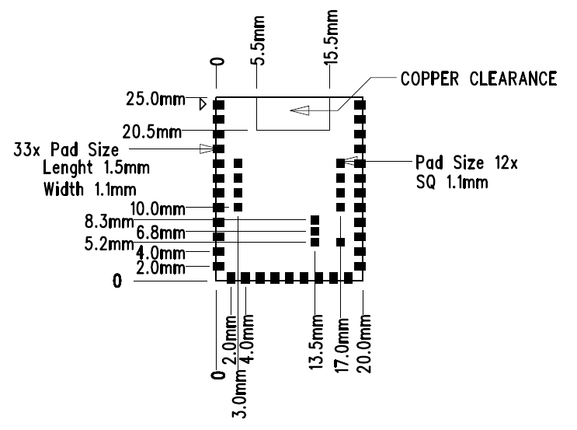

Figure# 6 Recommended land pattern

Note: All Dimensions are in mm.

# Design Guide Line

## Reference Board and guidelines

* Digital I/O, Power supply and Clock signals should shielded by GND plane and stitched via as per figure# 4.
* Preferable location of SRU232 is edge/corner of PCB.
* All ground pins must be connected directly to ground solid plane.
* Place ground via as close as possible to ground pins.
* For Optimal Radio performance, the SRU232 module’s antenna end should protrude at least 30 mm beyond any metal enclosure.

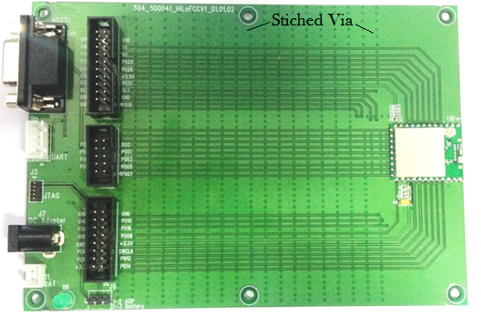

Figure# 7 Reference Host board for SRU232

* Layout above is utilized for FCC and IC testing. Specific restrictions for use of the module are defined in the Guideline bullets above.

## Recommended Capacitor bank

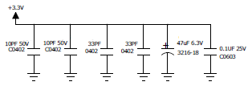

Figure# 8 Recommended Capacitor bank

* Ceramic and Tantalum Capacitor bank is recommended on VCC pins.
* Value of Capacitors are depends upon noise, PCB layout and surrounding components.
* It is recommended to derive correct value of capacitors after installation of SRU232 in actual host board.

# Module placed on the recommended PCB land pattern

* For optimal performance of the antenna, place the module at the edge of the PCB as shown in the Figure #6.
* Do not place any metal (traces, components, battery etc.) within the clearance area of the antenna. Connect all the GND pins directly to a solid GND plane.
* Place the GND via as close to the GND pins as possible. Use good layout practices to avoid any excessive noise coupling to signal lines or supply voltage lines.
* Do not place plastic or any other dielectric material in contact with the antenna.

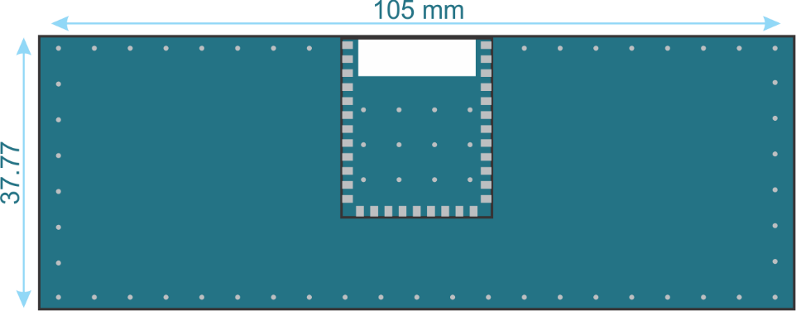

Figure# 9 Recommended layout of SRU232

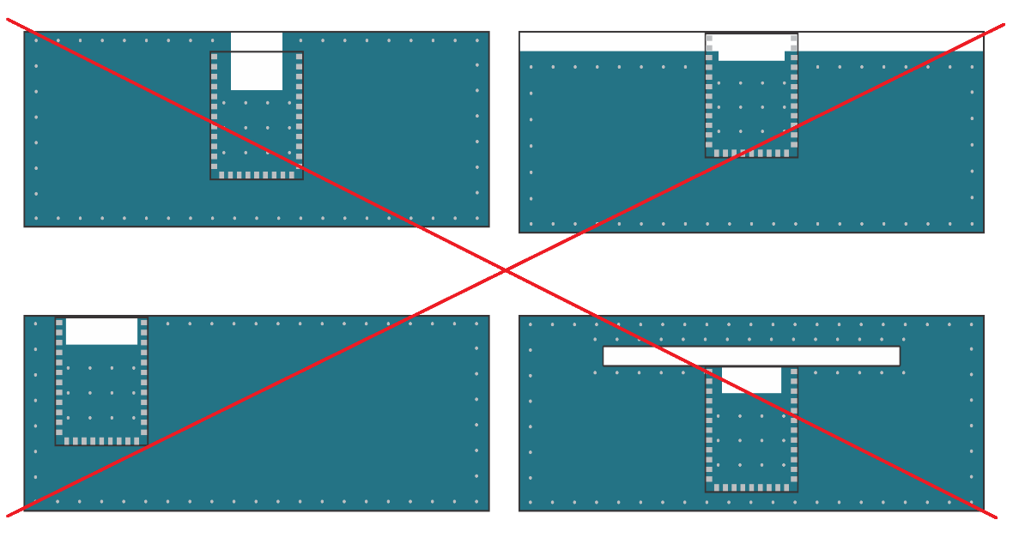

Figure# 10 Poor layout of SRU232



Figure# 11Range vs. Amount of GND

Note: Above graph taken from Bluegiga. We have to perform same test using our module.

# Soldering Recommendations

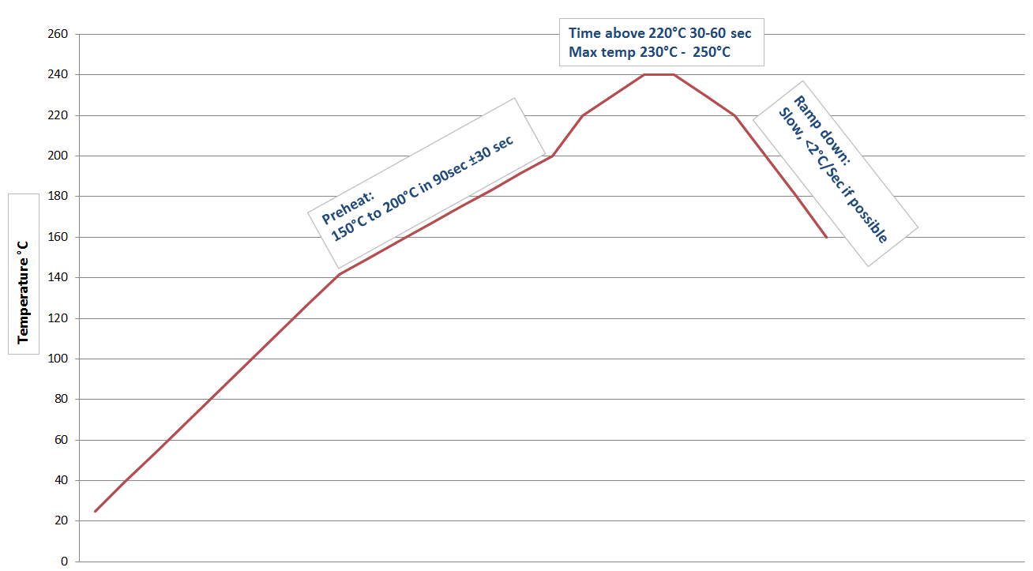

Figure# 12 Soldering Recommendations

# Certifications

## 18.1 Module FCC and IC Compliance Statement

FCC ID: 2AEHJSRU232

This device complies with Part 15 of the FCC Rules.

Operation is subject to the following two conditions:

1) This device may not cause harmful interference and

2) This device must accept any interference received,

Including interference that may cause undesired operation.

++++++++++++++++++++++++++++++++++++++++++++++++++++++++++++++++++++++++++

* This equipment has been tested and found to comply with the limits for a class B digital device, pursuant to part 15 of the FCC rules.
* These limits are designed to provide reasonable protection against harmful interference in a residential installation.
* This equipment generates, uses a can Radiate radio frequency energy and if not installed and used in accordance with the instructions, may cause harmful interference to radio communications.
* However, there is no guarantee that Interference will not occur in a particular installation. If this equipment does cause harmful interference to radio or television reception, which can be determined by turning the equipment off and on, the user is encouraged to try to correct the interference by one or more of the Following measures:
* Reorient or relocate the receiving antenna.
* Increase the separation between the equipment and the receiver.
* Connect the equipment into an outlet on a circuit different from that to which the receiver is connected.
* Consult the dealer or an experienced radio/TV technician for help.
* In order to maintain compliance with FCC regulations.
* Operation with non-approved equipment is likely to result in interference to radio and TV reception.
* The user is cautioned that changes and modifications made to this module without the approval of manufacturer could void the user’s authority to operate this equipment.

## 18.2 OEM / Host Labeling / Statement Information

* In order to comply with the use rules of Model SRU232, The OEM / Host is required to label the product according and provide the following statements:
* FCC Label #1: 2 part statement label. This label must be applied to the Host /OEM product. (Exception being products that are defined in Alternate statement below)
* Material: polyester white base with clear overcoat with permanent printing and acrylic adhesive. Size and printing as shown. Paper labels are not permitted, on the product.
* This label to be placed on product visible to end user on Host / OEM device/product.
* Alternate application: Printing permanently in the instructions is allowed whereas the Host / OEM product is smaller than the palm of a hand. Printing font must be 8 pt. or larger.

(FCC TWO PART STATEMENT)

¾”

Contains FCC ID: 2AEHJSRU232

This device complies with Part 15 of the FCC Rules.

Operation is subject to the following two conditions:

1) This device may not cause harmful interference and

2) This device must accept any interference received,

Including interference that may cause undesired operation.

* 1. “
* FCC Labels 2: To the FCC two part statement above, the following statement should be placed in the host device/product user’s manual.
* The words “Do Not Print” indicate the title of the section and / or instructions they do not need to be printed in the host device/product manual.

_________________________________________________________________

Do Not Print >>>>>>>> (FCC COMPLIANCE STATEMENT) <<<<< Do Not Print

* This equipment has been tested and found to comply with the limits for a class B digital device, Pursuant to part 15 of the FCC rules.
* These limits are designed to provide reasonable protection against harmful interference in a residential installation.
* This equipment generates, uses a can Radiate radio frequency energy and if not installed and used in accordance with the instructions, may cause harmful interference to radio communications.
* However, there is no guarantee that Interference will not occur in a particular installation.
* If this equipment does cause harmful interference to radio or television reception, which can be determined by turning the equipment off and on, the user is encouraged to try to correct the interference by one or more of the Following measures:
* Reorient or relocate the receiving antenna.
* Increase the separation between the equipment and the receiver.
* Connect the equipment into an outlet on a circuit different from that to which the receiver is connected.
* Consult the dealer or an experienced radio/TV technician for help.
* In order to maintain compliance with FCC regulations, shielded cables must be used with this equipment.
* Operation with non-approved equipment or unshielded cables is likely to result in interference to radio and TV reception.
* The user is cautioned that changes and modifications made to the equipment without the approval of manufacturer could void the user’s authority to operate this equipment.

## IC (Industry Canada) Labeling

* + **Product label:** Products built using the SRD521 module must have the following label affixed to it.
  + It must be placed in a location readily readable by the end user.
  + The label material is to be white polyester with black permanent ink and permanent adhesive. Minimum size of label and print are shown below.

Model: SRU232

Contains IC: 20053-SRU232

½” or 13mm

1.5 “or 38 mm

* + Industry Canada Information: The following statement is to be placed in the end product user manual.
  + This device complies with Industry Canada license-exempt RSS standard(s). Operation is subject to the following two conditions: (1) this device may not cause interference, and (2) this device must accept any interference, including interference that may cause undesired operation of the device.
  + Le présent appareil est conforme aux CNR d'Industrie Canada applicables aux appareils radio exempts de licence. L'exploitation est autorisée aux deux conditions suivantes: (1) l'appareil ne doit pas produire de brouillage, et (2) l'utilisateur de l'appareil doit accepter tout brouillage radioélectrique subi, même si le brouillage est susceptible d'en compromettre le fonctionnement.

# Bluetooth SIG Approval

Add later

# Device Marking

Add later

# Contact Detail

Email: [support@delphiansystems.com](mailto:support@delphiansystems.com)

Web address: [www.delphiansystems.com](http://www.delphiansystems.com/)

Remark: Add support phone number