

Abstract

Confidential Block diagram 4/8/2015 Copyrighted  
Information and devices shown in this guide have patents and patents pending.

SRU233 MODULE

01.01.02 Block diagram

Gary Myers, Ashok Hirpara

gary.myers@delphiansystems.com ashok.hirpara@delphiansystems.com

**This document contains Confidential Information regarding block charts for:**

* **US FCC ID: 2AEHJSRU233**
* **Canada IC: 20053-SRU233**

**This document is supplementing:**

1. **User Guide**
2. **Operational Guide (confidential)**
3. **Schematics (confidential)**

**The Information contained here within is considered confidential subject to terms and conditions of confidentiality statement.**

Table of Contents

1. Scope 3

2. Block diagram of SRU233 module 4

3. Internal block diagram of nRF51422 5

4. Pin out Detail of SRU233 module 6

5. Revision History 8

# Scope

The purpose of this document is to detail the data flow with pin out details and the basic block information for the Model SRU233:

* In US FCC: 2AEHJSRU233 module.
* In Canada IC: 20053-SRU233 module.

# Block diagram of SRU233 module

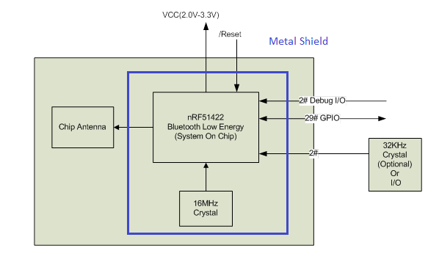

Figure Block diagram of SRU233 module

**Description of Block Diagram:**

**A] nRF51422**

The nRF51422 is an ultra-low power 2.4 GHz wireless System on Chip (SoC) integrating the nRF51 series 2.4 GHz transceiver, a 32 bit ARMR Cortex™-M0 CPU, flash memory, and analog and digital peripherals.

nRF51422 supports ANT, Bluetooth low energy, and a range of proprietary 2.4 GHz protocols, such as Gazell from Nordic Semiconductor.

**B] 16MHz Crystal**

The system high frequency clock (HFCLK) is derived from 16MHz quartz crystal. It is Ultra miniature size low profile SMD crystal. This crystal is shielded by metal shield so that it will not export any high frequency from the module. HFCLK is required for Radio, UART, and Timer.

Specification of 16MHz Crystal

|  |  |
| --- | --- |
| **Part** | **16 MHz Crystal** |
| Frequency Stability | +/‐30ppm |
| Frequency Tolerance | +/‐20ppm |
| Load Capacitance | 10pF |
| Motional Resistance(ESR) | 80 Ohm |

**C] SLOW CLOCK (32 KHZ) SOURCE REQUIREMENTS**

Two 32-kHz oscillators are available in the device as clock sources for the 32-kHz clock:

• 32-kHz XOSC – External Crystal Oscillator

• 32-kHz RCOSC – Internal RC Oscillator

By default, after a reset, the 32-kHz RCOSC is enabled and selected as the 32-kHz clock source. The RCOSC consumes less power, but is less accurate compared to the 32-kHz XOSC. The chosen 32-kHz clock source drives the Sleep Timer, generates the tick for the Watchdog Timer, and is used as a strobe in Timer 2 to calculate the Sleep Timer sleep time. The crystal is required for accurate sleep timing, so it is only needed to for the module be BLE certified when using low power modes.

User can connect external 32 KHz crystal on Pin# 20 and 21 of SRU233 for accurate clock, if required.

This clock is not used for radio frequency generation.

Specification of External 32 KHz Crystal

|  |  |
| --- | --- |
| **Part** | **32 KHz Crystal** |
| Frequency Stability | +/‐30ppm |
| Frequency Tolerance | +/‐20ppm |
| Load Capacitance | 10pF |
| Motional Resistance(ESR) | 70 kOhm |

**D] Debug I/O**

SWDCLK and SWDIO are required for programming and Debugging of module.

**E] GPIO**

The general purpose I/O is organized as one port with up to 32 I/Os (dependent on package) enabling

access and control of up to 32 pins through one port. Each GPIO can be accessed individually with the

following user configurable features:

* Input/output direction
* Output drive strength
* Internal pull-up and pull-down resistors
* Wake-up from high or low level triggers on all pins
* Trigger interrupt on all pins
* All pins can be individually configured to carry serial interface or quadrature demodulator Signals
* 29# of Digital Input/output are available.

**F] Antenna**

Ceramic Chip Antenna is used.

# Internal block diagram of nRF51422

- The module utilizes a Nordic Semiconductor nRF51422 microcontroller.

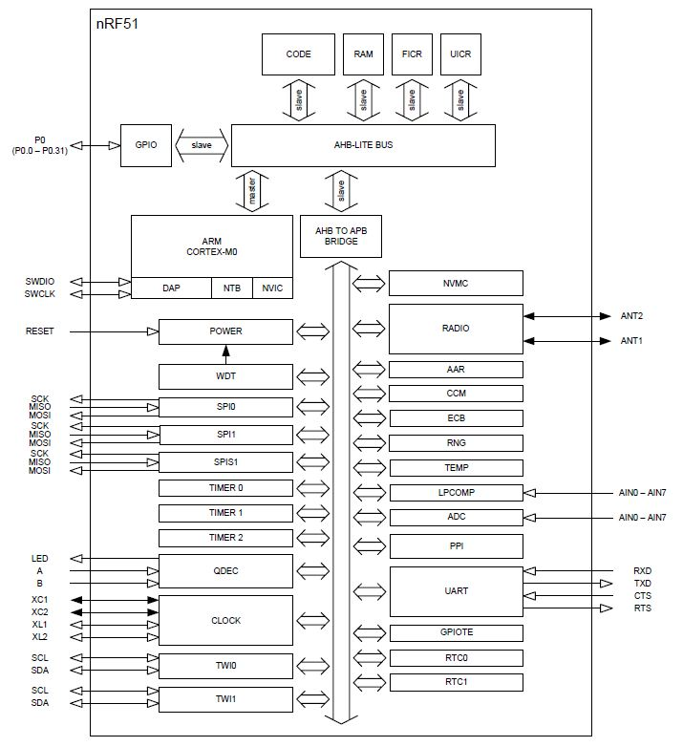

Figure Internal Block diagram of nRF51422

# Pin out Detail of SRU233 module

|  |  |  |  |
| --- | --- | --- | --- |
| **Sr. number** | **Pin Name** | **Pin Type** | **Description** |
| 1 | P0.01  AIN2 | Digital I/O  Analog input | Digital Input/output and Analog Input  ADC/LPCOMP input 2 |
| 2 | P0.00  AREF0 | Digital I/O  Analog input | General Purpose Digital Input/output  ADC/LPCOMP reference input 0 |
| 3 | P0.30 | Digital I/O | General Purpose Digital Input/output |
| 4 | P0.03  AIN4 | Digital I/O  Analog input | General Purpose Digital Input/output  ADC/LPCOMP input 4 |
| 5 | P0.05  AIN6 | Digital I/O  Analog input | General Purpose Digital Input/output  ADC/LPCOMP input 6 |
| 6 | P0.07 | Digital I/O | General Purpose Digital Input/output |
| 7 | P0.08 | Digital I/O | General Purpose Digital Input/output |
| 8 | P0.11 | Digital I/O | General purpose I/O pin. |
| 9 | P0.13 | Digital I/O | General Purpose Digital Input/ Output |
| 10 | P0.16 | Digital I/O | General Purpose Digital Input/ Output |
| 11 | SWDIO  reset | Digital I/O | System reset (active low). Also hardware debug and flash programming I/O |
| 12 | SWDCLK | Digital Input | Hardware debug and flash programming I/O |
| 13 | GND | Ground | Ground Pin must be connected to solid GND plane |
| 14 | GND | Ground | Ground Pin must be connected to solid GND plane |
| 15 | GND | Ground | Ground Pin must be connected to solid GND plane |
| 16 | GND | Ground | Ground Pin must be connected to solid GND plane |
| 17 | AVDD | Power | Analog power supply (Radio) |
| 18 | AVDD | Power | Analog power supply (Radio) |
| 19 | GND | Ground | Ground Pin must be connected to solid GND plane |
| 20 | XL2_32Khz/P0.26 | Analog Output | Connection for 32.768 kHz crystal |
| 21 | XL1_32Khz/P0.27 | Analog Input | Connection for 32.768 kHz crystal or external 32.768 kHz clock reference |
| 22 | P0.28 | Digital I/O | General Purpose Digital Input/output |
| 23 | P0.29 | Digital I/O | General Purpose Digital Input/output |
| 24 | VCC_NRF | Power | Power Supply |
| 25 | VCC_NRF | Power | Power Supply |
| 26 | P0.02  AIN3 | Digital I/O  Analog input | General Purpose Digital Input/output  ADC/LPCOMP input 3 |
| 27 | P0.04  AIN5 | Digital I/O  Analog input | General Purpose Digital Input/output  ADC/LPCOMP input 5 |
| 28 | P0.06  AIN7  AREF1 | Digital I/O  Analog input  Analog input | General Purpose Digital Input/output  ADC/LPCOMP input 7  ADC/LPCOMP reference input 1 |
| 29 | P0.10 | Digital I/O | General Purpose Digital Input/ Output |
| 30 | P0.09 | Digital I/O | General Purpose Digital Input/ Output |
| 31 | P0.12 | Digital I/O | General Purpose Digital Input/ Output |
| 32 | P0.14 | Digital I/O | General Purpose Digital Input/ Output |
| 33 | P0.15 | Digital I/O | General Purpose Digital Input/ Output |
| 34 | P0.17 | Digital I/O | General Purpose Digital Input/ Output |
| 35 | P0.18 | Digital I/O | General Purpose Digital Input/ Output |
| 36 | P0.22 | Digital I/O | General Purpose Digital Input/output |
| 37 | P0.21 | Digital I/O | General Purpose Digital Input/ Output |
| 38 | P0.23 | Digital I/O | General Purpose Digital Input/output |
| 39 | P0.25 | Digital I/O | General Purpose Digital Input/output |
| 40 | P0.24 | Digital I/O | General Purpose Digital Input/output |
| 41 | P0.20 | Digital I/O | General Purpose Digital Input/output |
| 42 | P0.19 | Digital I/O | General Purpose Digital Input/ Output |
| 43 | GND | Ground | Ground Pin must be connected to solid gnd plane |

Table Pin out detail table

# Revision History

|  |  |  |  |
| --- | --- | --- | --- |
| **Revision** | **Date** | **Author** | **Modification/Remarks** |
| 01.01.01 | Aug 04, 2015 | Kinjal | Initial release for module SRU233 |
| 01.01.02 | Aug 14, 2015 | Mitesh | Update FCC ID detail |