

Gary Myers, Ashok Hirpara

gary.myers@delphiansytems.com ashok.hirpara@delphiansytems.com

Abstract

Confidential Schematics, Gerber files and Bill of Materials [BoM] 8/1/2015 Copyrighted,   
 Products described in this Guide have US patents and patents pending.

SRU233 Module

01.01.01 Schematics, BOM and Gerber

**This document contains Confidential Information regarding Schematics, BOM and Gerber files for:**

**In US FCC ID: 2AEHJSRU233module**

**In Canada IC: 20053-SRU233module**

**This document is supplementing:**

1. **Block Diagram Flow Guide (confidential)**
2. **User’s Manual**
3. **Operational Guide (confidential)**

**The Information contained here within is considered confidential subject to terms and conditions of confidentiality statement.**

Contents

1. Scope 3

2. Application for the module: 3

3. Description for the module 4

4. Bill of Material [BoM] 4

4a. BoM excel sheet 5

4b. Do Not Populate [DNP] 5

4c. Revision history for BoM 5

5. Schematic 6

6. Gerber Files 7

7 Revision History 8

# Scope

The purpose of this document is to detail the specific specialized information regarding Schematics, Bill of Material, and Gerber files for the Model SRU233 module:

* In US FCC: 2AEHJSRU233module.
* In Canada IC: 20053-SRU233module.

# Application for the module:

Below is the example for Embedded Wireless applications.

Note: All applications must adhere to the minimum 20 cm separation details as defined by the RF exposure statement enclosed in the User Guide document.

* Industrial Controls
* Automotive
* Medical Cabinetry
* Access Points
* Scanners
* Wireless Sensors
* Monitoring and Control
* Security systems
* Garage Door Operators

# Description for the module

SRU233 is short range, for implementing Bluetooth functionality into various electronic devices.

Communication between the module and host controller is carried out via UART and I2C.

This module contains Nordic Semiconductor’s nRF51422. The nRF51422 is a power optimized true system-on-chip (SoC) solution for Bluetooth low energy applications. It enables robust network nodes to be built with low total bill of material.

The SRU233 module is a power-optimized true system-on-chip (SoC) solution for Bluetooth Low Energy, ANT or proprietary 2.4-GHz applications. The processor combines the excellent performance of a leading RF transceiver with an industry-standard a 32 bit ARM® CortexTM-M0 CPU, with 256K Flash, 16K/32K RAM, and many other powerful supporting features and peripherals.

This module features metal shielding which is provided for high EMI/EMC immunity.

This module can be programmed by two-wire UART Interface.

# Bill of Material [BoM]

4a. Excel image file has the all the components for population

4b. Parts options Do Not Populate [DNP]

4c. Revision history of BoM excel spreadsheet

## 4a. BoM excel sheet

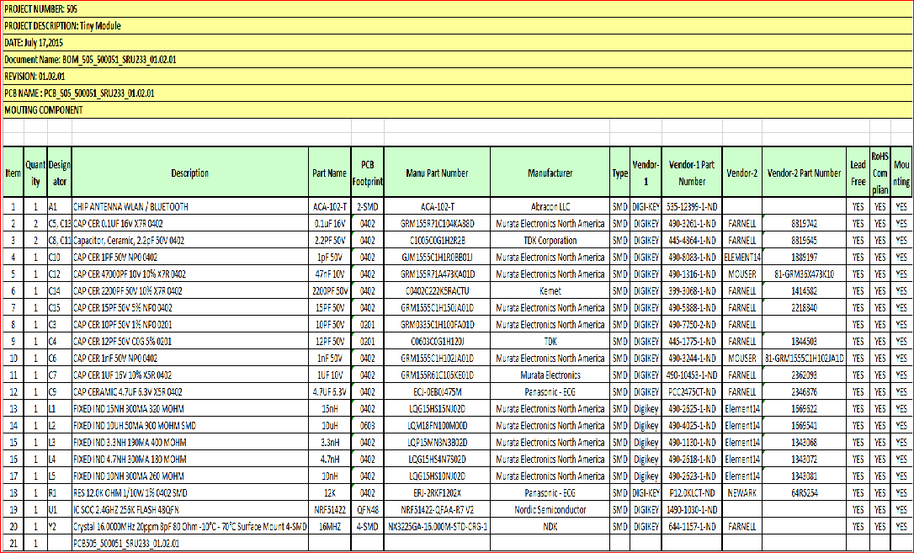

Table BOM505_500051_SRU233_01.02.01

## 4b. Do Not Populate [DNP]

## 4c. Revision history for BoM

|  |  |  |  |
| --- | --- | --- | --- |
| Revision History | | | |
|
|
| Serial Number | Revision Number | Description | Date |
| 1 | 01.01.01 | Initial Release | May 10, 2015 |
| 2 | 01.02.01 | 1. Y1, C1, & C2 is removed 2. Resistor R1 is added 3. Capacitor C3 & C11 value is change as per Avnet guide | Jul 17, 2015 |
|  |  |  |  |
|  |  |  |  |

Table Revision History

# 5. Schematic

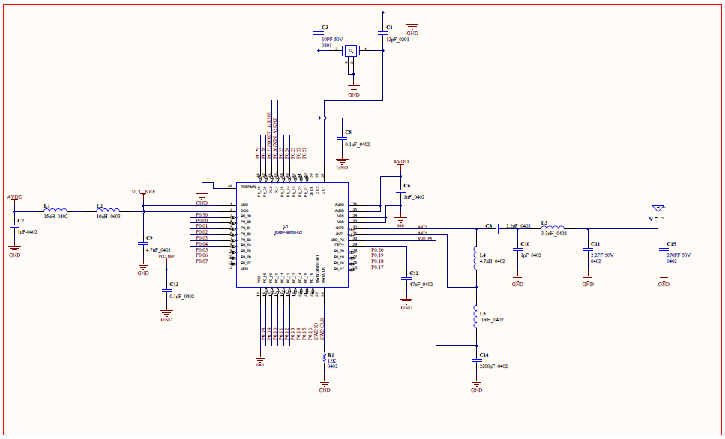

Figure Schematics

# 6. Gerber Files

|  |  |  |
| --- | --- | --- |
| **Serial #** | **Type** | **Gerber** |
| 1. | SRU233_01.01.01_L2 |  |
| 2. | SRU233_01.01.01.L3 |  |
| 3. | SRU233_01.01.01_L4 |  |
| 4. | SRU233_01.01.01_SPB |  |
| 5. | SRU233_01.01.01_SMB |  |
| 6. | SRU233_01.02.01_L1 |  |
| 7. | SRU233_01.01.01_SPT |  |
| 8. | SRU233_01.01.01_SMT |  |

Table Gerber Files

# 7 Revision History

|  |  |  |  |
| --- | --- | --- | --- |
| **Revision** | **Date** | **Author** | **Modification/Remarks** |
| 01.01.01 | 04/08/2015 | Kinjal | Initial release for module SRU233 |
|  |  |  |  |
|  |  |  |  |
|  |  |  |  |
|  |  |  |  |
|  |  |  |  |
|  |  |  |  |
|  |  |  |  |