Gary Myers, Ashok Hirpara

gary.myers@delphiansystems.com

ashok.hirpara@delphiansystems.com

Abstract

Non-Confidential User’s Guide 4/7/2015 Copyrighted,   
 Products described in this Guide have US patents and patents pending.

SRU233 Module

01.01.02 Users Guide



Table of Contents

1. Scope 3

2. Block Diagram of module 4

2.1 nRF51422 (Processor) 4

2.2 Crystal 16MHz 5

2.3 Crystal 32KHz 5

2.4 Impedance Matching Network 5

2.5 Chip Antenna (ACA-102-T) 5

2.7 Power Supply 7

2.8 Metal Shield: 7

3. Ground Planes 8

4. Frequency Hopping 8

5. Pin Detail 9

6. Electric specification 11

7. Mechanical Specification 13

8. Recommended module PCB Footprint 14

9. PCB Layout Guideline 16

10. Recommended Capacitor bank 17

11. Physical view of module 18

12. Soldering Temperature Profile 19

13. Module FCC and IC Compliance Statement 20

14. OEM / Host Labeling / Statement Information 21

15. IC (Industry Canada) Labeling 23

16. Ordering Information 24

17. RoHS Declaration 25

18. Datasheet status 26

19. Revision History 27

# Scope

This product specification describes Delphian System’s Bluetooth Low Energy module, series number SRU233. It includes integration information and guidelines to allow a basic understanding of the module functions, application and includes required documentation that is required to allow the integrator to properly label the OEM device.

**Caution!** Any changes or modifications to this module not approved by Delphian System LLC could void the authority to operate this module.

It contains documentation for proper labeling as required in *USA* by FCC part 15 and in *CANADA* by Industry Canada (IC) RSS-Gen Sec.5.2 and includes Industry Canada Information. This includes documents / labeling that must be applied to the end use host device by the OEM as outlined.

Use of this certified transmitter module (section15.212) could allow the end use host device manufacturer to reduce the testing associated with their product. Additional testing may be required to comply with all other applicable FCC and IC regulations.

# Block Diagram of module

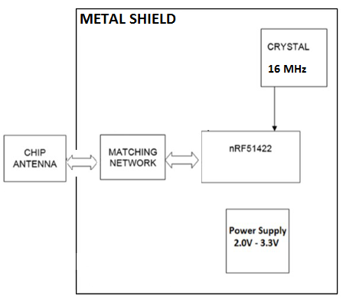

Figure Block Diagram of SRU233

SRU233 contains following components/section:

## 2.1 nRF51422 (Processor)

The SRU233 module is a power-optimized true system-on-chip (SoC) solution for Bluetooth Low Energy, ANT or proprietary 2.4-GHz applications. The processor combines the excellent performance of a leading RF transceiver with an industry-standard a 32 bit ARM® CortexTM-M0 CPU, with 256K Flash, 16KB/32KB RAM and many other powerful supporting features and peripherals.

## 2.2 Crystal 16MHz

16MHz crystal is source of Main Clock freq. of system. It is Ultra Miniature size low profile SMD crystal. This crystal is shielded by metal shield so that it will not export any high frequency from the module. During RF transceiver, this clock is enabled.

Specification: (confidential)

|  |  |
| --- | --- |
| Part | **16 MHz Crystal** |
| Frequency Stability | +/-30ppm |
| Frequency Tolerance | +/-20ppm |
| Load Capacitance | 10pF |
| Motional Resistance(ESR) | 80 Ohm |

## 2.3 SLOW CLOCK (32 KHZ) SOURCE REQUIREMENTS

Two 32-kHz oscillators are available in the device as clock sources for the 32-kHz clock:

• 32-kHz XOSC – External Crystal Oscillator

• 32-kHz RCOSC – Internal RC Oscillator

By default, after a reset, the 32-kHz RCOSC is enabled and selected as the 32-kHz clock source. The RCOSC consumes less power, but is less accurate compared to the 32-kHz XOSC. The chosen 32-kHz clock source drives the Sleep Timer, generates the tick for the Watchdog Timer, and is used as a strobe in Timer 2 to calculate the Sleep Timer sleep time. The crystal is required for accurate sleep timing, so it is only needed to for the module be BLE certified when using low power modes.

User can connect external 32 KHz crystal on Pin# 20 and 21 of SRU233 for accurate clock, if required. This clock is not used for Radio frequency generation

This clock is not used for radio frequency generation.

Specification of External 32 KHz Crystal

|  |  |
| --- | --- |
| **Part** | **32 KHz Crystal** |
| Frequency Stability | +/‐30ppm |
| Frequency Tolerance | +/‐20ppm |
| Load Capacitance | 10pF |
| Motional Resistance(ESR) | 70 kOhm |

## 2.4 Impedance Matching Network

Capacitor and Inductor are used for impedance matching between the Antenna and the RF front end.

## 2.5 Chip Antenna (ACA-102-T)

* Chip Antenna constructed from solid dielectric ceramic material
* Suitable for RoHS compliant reflow
* Gain 3D 0.60 (Peak), -3.48 (Average) [dBi]
* VSWR 1.0 ~ 2.6 : 1
* Non Ground Mounting type
* Linear Polarization
* Matched to 50 Ohm

## 2.6 Power Supply

* Pin# 24 and 25 are VCC pins and it supply range is between 2.0V-3.6V and Pin#13, 14, 15, 16, 19and Pin #43 are GND pins of Module.
* Vcc is given to supply power through pin #24 and 25 via LC Filter which is reduced high frequency noise and give stable and noise free power.
* Ferrite bead and Ceramic capacitors are used in the LC filter. This filter is connected between the power supply pin and the power supply feed point of module. This filter will block high freq. noise in power supply and provide stability against EMI noise.
* The power range of 2.0V to 3.6V will not affect any DB output of the module.

## 2.7 Metal Shield:

Nickel Silver shield is used for shielding of processor and crystals. Shield is directly connected to GND plane which will restrict emission of any high freq. that may be generated from the module. Its specification is below:

Specification:

|  |  |
| --- | --- |
| Maximum Overall Dimension | 11.9 mm X 13.85 mm +\ - 0.2 mm |
| Maximum Overall Height | 1.5 mm +\- 0.2 mm |
| Material Thickness | 0.20 mm |
| Material | Nickel silver C77000 ½ hard |

# Ground Planes

Radio requires an RF ground plane on any board made to work with this module. The ground plane should cover the majority of the remaining (as much as permitted by other components) of the Printed Circuit Board (PCB) area. This can be located on any layer of the PCB. Extend the RF ground plane parallel to module pins 13 and 14 the entire length of the board. Connect all ground pins and do not notch the ground plane around the module. Bottom of module is grounded so be cognizant of vias or conductive traces located under the module that are not soldered masked to prevent shorting. Keep metallic components, connectors, copper traces, internal layers, and ground planes away from the antenna area in 3D space.

# Frequency Hopping

This module uses frequency hopping for data communication with other BLE devices. A pseudo list of no less than 37 available data channels are used and send data packets utilizing these channels. For advertising, it uses 3 fixed channels and hence it advertises fixed packet (47 bytes in length) on all three advertising channels. It uses frequency band between 2.402 GHz ~ 2.480 GHz.

# Pin Detail

|  |  |  |  |
| --- | --- | --- | --- |
| **Sr. number** | **Pin Name** | **Pin Type** | **Description** |
| 1 | P0.01  AIN2 | Digital I/O  Analog input | Digital Input/output and Analog Input  ADC/LPCOMP input 2 |
| 2 | P0.00  AREF0 | Digital I/O  Analog input | General Purpose Digital Input/output  ADC/LPCOMP reference input 0 |
| 3 | P0.30 | Digital I/O | General Purpose Digital Input/output |
| 4 | P0.03  AIN4 | Digital I/O  Analog input | General Purpose Digital Input/output  ADC/LPCOMP input 4 |
| 5 | P0.05  AIN6 | Digital I/O  Analog input | General Purpose Digital Input/output  ADC/LPCOMP input 6 |
| 6 | P0.07 | Digital I/O | General Purpose Digital Input/output |
| 7 | P0.08 | Digital I/O | General Purpose Digital Input/output |
| 8 | P0.11 | Digital I/O | General purpose I/O pin. |
| 9 | P0.13 | Digital I/O | General Purpose Digital Input/ Output |
| 10 | P0.16 | Digital I/O | General Purpose Digital Input/ Output |
| 11 | SWDIO  reset | Digital I/O | System reset (active low). Also hardware debug and flash programming I/O |
| 12 | SWDCLK | Digital Input | Hardware debug and flash programming I/O |
| 13 | GND | Ground | Ground Pin must be connected to solid GND plane |
| 14 | GND | Ground | Ground Pin must be connected to solid GND plane |
| 15 | GND | Ground | Ground Pin must be connected to solid GND plane |
| 16 | GND | Ground | Ground Pin must be connected to solid GND plane |
| 17 | AVDD | Power | Analog power supply (Radio) |
| 18 | AVDD | Power | Analog power supply (Radio) |
| 19 | GND | Ground | Ground Pin must be connected to solid GND plane |
| 20 | XL2_32Khz/P0.26 | Analog Output | Connection for 32.768 kHz crystal |
| 21 | XL1_32Khz/P0.27 | Analog Input | Connection for 32.768 kHz crystal or external 32.768 kHz clock reference |
| 22 | P0.28 | Digital I/O | General Purpose Digital Input/output |
| 23 | P0.29 | Digital I/O | General Purpose Digital Input/output |
| 24 | VCC_NRF | Power | Power Supply |
| 25 | VCC_NRF | Power | Power Supply |
| 26 | P0.02  AIN3 | Digital I/O  Analog input | General Purpose Digital Input/output  ADC/LPCOMP input 3 |
| 27 | P0.04  AIN5 | Digital I/O  Analog input | General Purpose Digital Input/output  ADC/LPCOMP input 5 |
| 28 | P0.06  AIN7  AREF1 | Digital I/O  Analog input  Analog input | General Purpose Digital Input/output  ADC/LPCOMP input 7  ADC/LPCOMP reference input 1 |
| 29 | P0.10 | Digital I/O | General Purpose Digital Input/ Output |
| 30 | P0.09 | Digital I/O | General Purpose Digital Input/ Output |
| 31 | P0.12 | Digital I/O | General Purpose Digital Input/ Output |
| 32 | P0.14 | Digital I/O | General Purpose Digital Input/ Output |
| 33 | P0.15 | Digital I/O | General Purpose Digital Input/ Output |
| 34 | P0.17 | Digital I/O | General Purpose Digital Input/ Output |
| 35 | P0.18 | Digital I/O | General Purpose Digital Input/ Output |
| 36 | P0.22 | Digital I/O | General Purpose Digital Input/output |
| 37 | P0.21 | Digital I/O | General Purpose Digital Input/ Output |
| 38 | P0.23 | Digital I/O | General Purpose Digital Input/output |
| 39 | P0.25 | Digital I/O | General Purpose Digital Input/output |
| 40 | P0.24 | Digital I/O | General Purpose Digital Input/output |
| 41 | P0.20 | Digital I/O | General Purpose Digital Input/output |
| 42 | P0.19 | Digital I/O | General Purpose Digital Input/ Output |
| 43 | GND | Ground | Ground Pin must be connected to solid gnd plane |

# Electric specification

**Absolute Maximum Ratings(1):**

Over operating free-air temperature range (unless otherwise noted)

|  |  |  |  |  |
| --- | --- | --- | --- | --- |
|  | | **Min** | **Max** | **Unit** |
| Supply Voltage | All supply pin(s) must have same voltage | -0.3 | 3.6 | V |
| Voltage on any digital pin |  | -0.3 | Vdd +0.3 <= 3.6 | V |
| Input RF level |  |  | 4 | dBm |
| Storage Temp Range |  | -40 | +125 | ⁰C |
| Operating Temp Range |  | -25 | +75 | ⁰C |

(1) Stresses beyond those listed under Absolute Maximum Ratings may cause permanent damage to the device. These are stress ratings only and functional operation of the device at these or any other condition beyond those indicated under Recommended Operating Conditions is not implied. Exposure to absolute-maximum-rated conditions for extended periods may affect device reliability.

CAUTION: ESD sensitive device. Precautions should be used when handling the device in order to prevent permanent damage.

**Operating Condition Summary Specification:**

|  |  |
| --- | --- |
| **Items** | **Specification** |
| Supply Voltage (Vdd) | 2.0-3.6V |
| Vdd ripple | 100mV max |
| Max. Voltage on any pin | Vdd + 0.3V (Not 5V Tolerant) |
| Ambient Temperature range | -25⁰C to 85⁰C |

**Current Consumption Summary Specification:**

Measurement done at TA = 25 ⁰C, VDD = 3V

|  |  |
| --- | --- |
| **Items** | **Specification** |
| System Off – No RAM retention | 0.6 uA |
| System Off – 8KB RAM retention | 1.2 uA |
| System Off – 16KB RAM retention | 1.8 uA |
| Low MCU Activity | 2.6 uA |
| Rx (Peak Current) | 13 mA |
| Tx 0 dBm | 10.5 mA |

**RF Specification Summary:**

|  |  |
| --- | --- |
| **Items** | **Specification** |
| Frequency | 2402-2480 MHz in 2MHz steps |
| Data rate and Modulation | 1 Mbps, GFSK |
| Number of Channel | 40: 37 data /3 advertising |
| Receiver Sensitivity | -93 dBm |
| Output power | -30 dBm to +4 dBm |
| Rx/Tx Turnaround | 150 uSec |

# Mechanical Specification

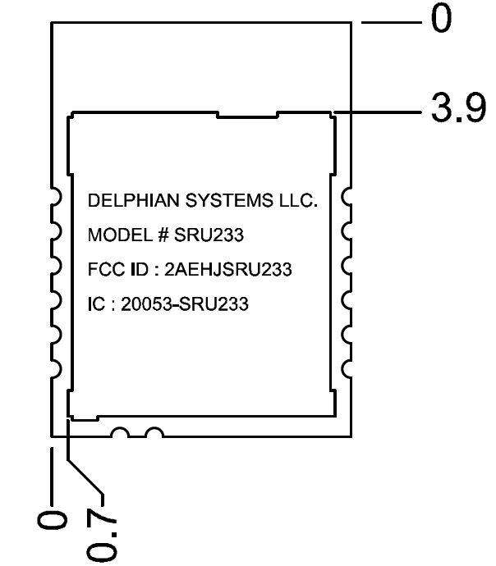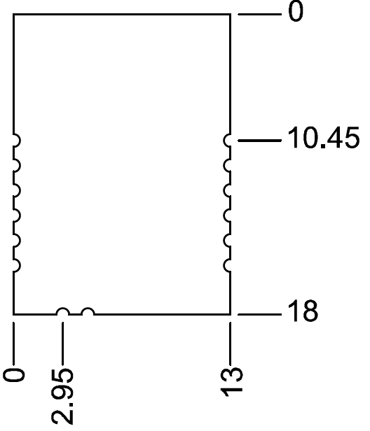

Figure 3: Mechanical specification

Note: All Dimensions are in mm.

|  |  |  |  |
| --- | --- | --- | --- |
| **No.** | **Item** | **Dimension** | **Tolerance** |
| 1. | Length | 18.00 mm | +/- 0.20 |
| 2. | Width | 13.00 mm | +/- 0.20 |
| 3. | Height | 2.3 mm | +/- 0.20 |

# Recommended module PCB Footprint

Note: All Dimensions are in mm.

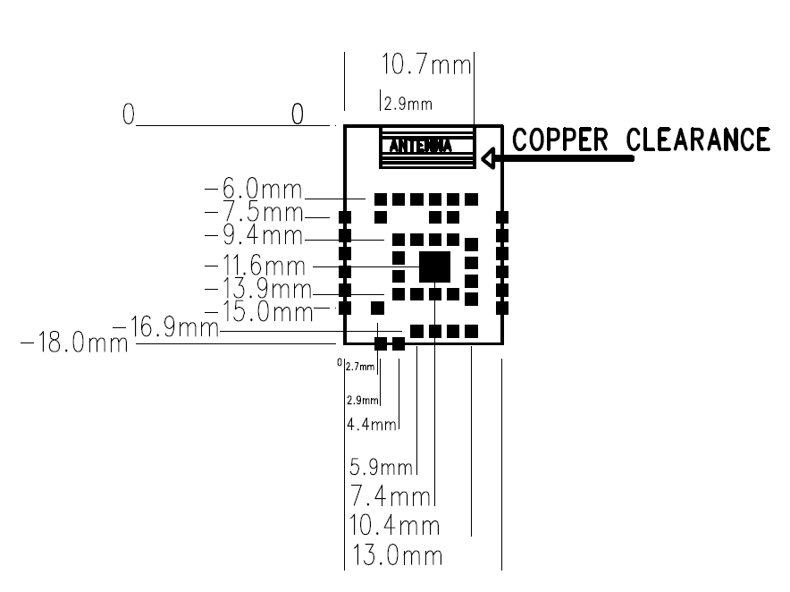

Figure 4: SRU233 module recommended PCB footprint

PCB Layout Guideline

* Digital I/O, Power supply and Clock signals should be shielded by GND plane and stitched via.
* Preferable location of SRU233 is edge/corner of PCB.
* All ground pins must be connected directly to ground solid plane.
* Place ground vias as close as possible to ground pins.
* For Optimal Radio performance, the SRU233 module’s antenna end should protrude at least 30 mm beyond any metal enclosure.

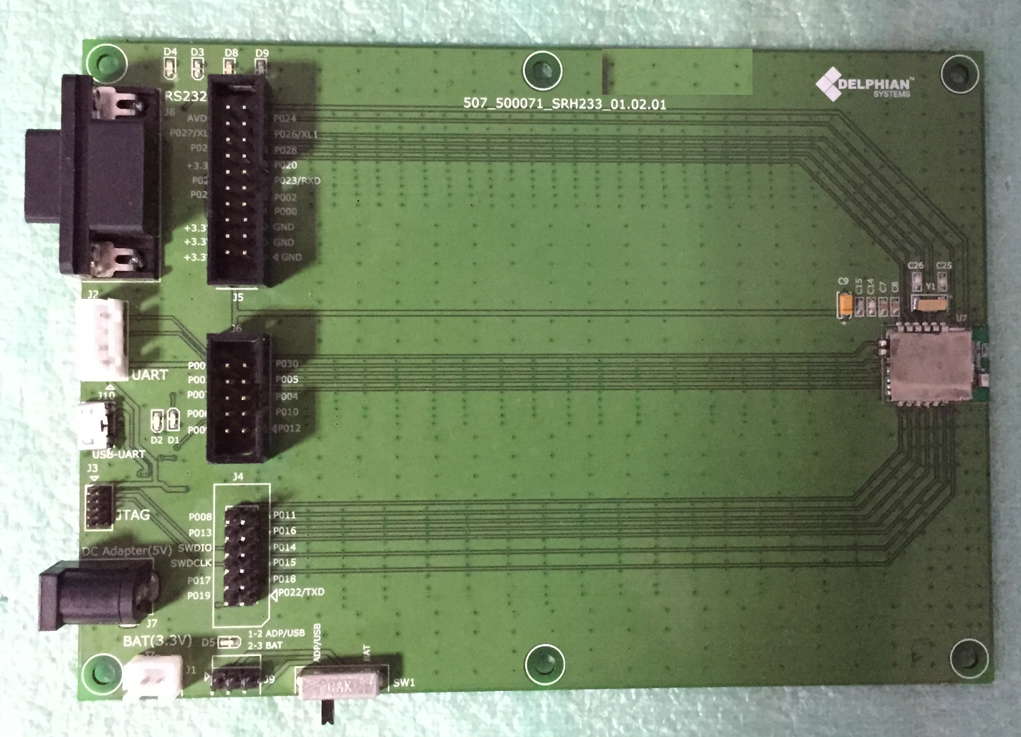

**SRU233**

Figure 5: Reference Host board for SRU233

Layout above is utilized for FCC and IC testing. Specific restrictions for use of the module is defined in the Guideline bullets above.

# Recommended Capacitor bank

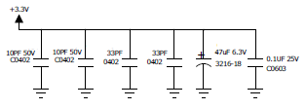

Figure 6: Recommended Capacitor bank

* Ceramic and Tantalum Capacitor bank is recommended on VCC pins.
* Actual value(s) of capacitors are dependent upon Noise, PCB layout and surrounding components.
* It is recommended to derive correct value of capacitors after installation of SRU233 in actual device host board.

# Physical view of module

**Manufacturer, Model #, FCC ID and IC: information as shown:**

**Information to be laser etched on Nickel shield**

13mm

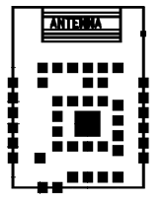

18 mm

Figure 7: Physical view of model

# Soldering Temperature Profile

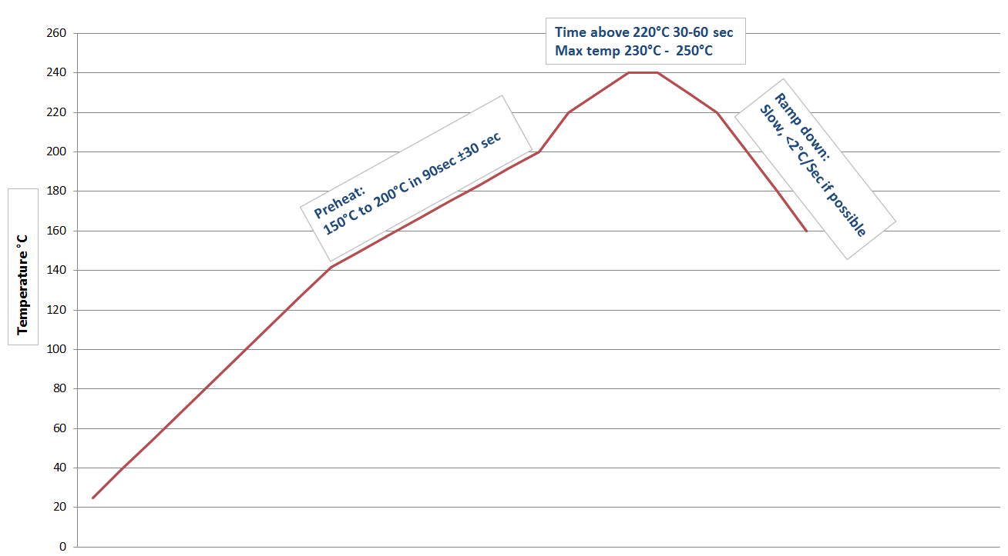

Figure 8: Recommended Soldering Profile

# Module FCC and IC Compliance Statement

FCC ID: 2AEHJSRU233

This device complies with Part 15 of the FCC Rules.

Operation is subject to the following two conditions:

1) This device may not cause harmful interference and

2) this device must accept any interference received,

including interference that may cause undesired operation.

++++++++++++++++++++++++++++++++++++++++++++++++++++++++++++++++++++++++++++++++++++

This equipment has been tested and found to comply with the limits for a class B digital device,

pursuant to part 15 of the FCC rules. These limits are designed to provide reasonable protection

against harmful interference in a residential installation. This equipment generates, uses a can

Radiate radio frequency energy and if not installed and used in accordance with the instructions,

may cause harmful interference to radio communications. However, there is no guarantee that

Interference will not occur in a particular installation. If this equipment does cause harmful

interference to radio or television reception, which can be determined by turning the equipment

off and on, the user is encouraged to try to correct the interference by one or more of the

Following measures:

* Reorient or relocate the receiving antenna.
* Increase the separation between the equipment and the receiver.
* Connect the equipment into an outlet on a circuit different from that to which the receiver is connected.
* Consult the dealer or an experienced radio/TV technician for help.

In order to maintain compliance with FCC regulations. Operation with non-approved equipment is likely to result in interference to radio and TV reception. The user is cautioned that changes and modifications made to this module without the approval of manufacturer could void the user’s authority to operate this equipment.

# OEM / Host Labeling / Statement Information

In order to comply to the use rules of Model SRU233, The OEM / Host is required to label the product according and provide the following statements:

FCC Label #1: 2 part statement label. This label must be applied to the Host /OEM device/ product. (Exception being products that are defined in Alternate statement below)

Material: polyester white base with clear overcoat with permanent printing and acrylic adhesive. Size and printing as shown. Paper labels are not permitted on the product.

This label to be placed on product visible to end user on Host / OEM device/product.

Alternate application: Printing permanently in the instructions is allowed whereas the Host / OEM product is smaller than the palm of a hand. Printing font must be 8 pt. or larger.

(FCC TWO PART STATEMENT)

Contains FCC ID: 2AEHJSRU233

This device complies with Part 15 of the FCC Rules.

Operation is subject to the following two conditions:

1) This device may not cause harmful interference and

2) this device must accept any interference received,

including interference that may cause undesired operation.

¾”

* 1. “

FCC Labels 2: To the FCC two part statement above, the following statement should be placed in the host device/product user’s manual.

_________________________________________________________________________________

This equipment has been tested and found to comply with the limits for a class B digital device,

pursuant to part 15 of the FCC rules. These limits are designed to provide reasonable protection

against harmful interference in a residential installation. This equipment generates, uses a can

Radiate radio frequency energy and if not installed and used in accordance with the instructions,

may cause harmful interference to radio communications. However, there is no guarantee that

Interference will not occur in a particular installation. If this equipment does cause harmful

interference to radio or television reception, which can be determined by turning the equipment

off and on, the user is encouraged to try to correct the interference by one or more of the

Following measures:

* Reorient or relocate the receiving antenna.
* Increase the separation between the equipment and the receiver.
* Connect the equipment into an outlet on a circuit different from that to which the receiver is connected.
* Consult the dealer or an experienced radio/TV technician for help.

In order to maintain compliance with FCC regulations, shielded cables must be used with this equipment. Operation with non-approved equipment or unshielded cables is likely to result in interference to radio and TV reception. The user is cautioned that changes and modifications made to the equipment without the approval of manufacturer could void the user’s authority to operate this equipment.

# IC (Industry Canada) Labeling

**Product label:** Products built using the SRD521 module must have the following label affixed to it. It must be placed in a location readily readable by the end user. The label material is to be white polyester with black permanent ink and permanent adhesive. Minimum size of label and print are shown below.

Model: SRU233

Contains IC: 20053-SRU233

½” or 13mm

1.5 “or 38 mm

**Industry Canada Information:** The following statement is to be placed in the end product user manual.

*This device complies with Industry Canada license-exempt RSS standard(s). Operation is subject to the following two conditions: (1) this device may not cause interference, and (2) this device must accept any interference, including interference that may cause undesired operation of the device.*

*Le présent appareil est conforme aux CNR d'Industrie Canada applicables aux appareils radio*

*exempts de licence. L'exploitation est autorisée aux deux conditions suivantes: (1) l'appareil ne*

*doit pas produire de brouillage, et (2) l'utilisateur de l'appareil doit accepter tout brouillage*

*radioélectrique subi, même si le brouillage est susceptible d'en compromettre le fonctionnement.*

# Ordering Information

PART Number: SRU233.

Contact: Delphian Systems LLC.

Web address: [www.delphiansystems.com](http://www.delphiansystems.com/)

Part is not available for online ordering.

Data sheet is available in electronic form or as printed document upon request.

# RoHS Declaration

Declaration of environmental compatibility for supplied products:

We hereby declare to our best present knowledge based on declaration of our suppliers that this product does not contain the following substances which are banned by Directive 2002/95/EC (RoHS) or if present, a maximum concentration of 0.1% by weight in homogeneous materials for:

* Lead and lead compounds
* Mercury and mercury compounds
* Chromium (VI)
* PBB (polybrominated biphenyl) category
* PBDE (polybrominated biphenyl ether) category

And a maximum concentration of 0.01% by weight in homogeneous materials for:

* Cadmium and cadmium compounds

# Datasheet status

* This data sheet contains the final specification as of the date shown in the header above.
* Delphian Systems reserves the right to make changes at any time without notice in order to improve design and supply the best possible product.
* Supplementary data sheets (white papers) are available upon request.
* Information supplied here is the most recent at the time of publication.
* Consult the most recently issued data sheet before initiating or completing a design.
* Contact Delphian Systems to secure the latest version of this data sheet: [www.delphiansystems.com](http://www.delphiansystems.com/)
* Delphian Systems assumes no responsibility for improper use of this product. Do not attempt to “overclock” or apply voltages other than what is shown in this document.
* All rights reserved. Design of these products shown here have U.S and foreign patents pending.
* The antenna(s) specified in this document was designed and tested to comply to FCC part 15. Any changes are not permitted.

# Revision History

|  |  |  |  |
| --- | --- | --- | --- |
| **Revision** | **Date** | **Author** | **Modification/Remarks** |
| 01.01.01 | Aug 11, 2015 | Mitesh | Initial Release of User Guide |
| 01.01.02 | Aug 14,2015 | Mitesh | Update mechanical details |
|  |  |  |  |
|  |  |  |  |
|  |  |  |  |
|  |  |  |  |