The Book Plot tool is a functional component of the Cadcorp Print Workshop Add-in for Cadcorp Map Editor.

Book plots are map compilations for a defined spatial area. Multi-page PDF documents or collections of image files can be generated with the book plot tool.

Book plots can only be generated from grid overlays which are created with the Book Plot tool itself. The two modes of the tool are to generate grid overlays and to create book plots from grid overlays.

The Book Plot dialog can be opened from the Print Workshop application group.

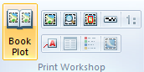

**Creating grid overlays**

The default option will be to create a new book plot grid overlay for the extent of the current map window.

If a grid overlay is found the default mode will be to create a book plot from an existing grid. The mode can be changed back to creating a new grid by ticking the Create New Grid checkbox.



The grid title is the name of the new grid and will be applied as title in the print template.

Changing the template, scale, or overlap will reflect in the number of rows and columns which are required to cover the map extent.

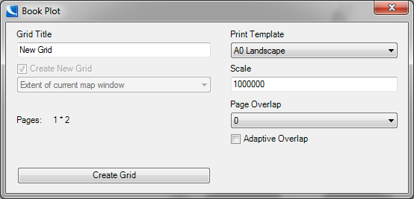

Without page overlap, the resulting grid will always bleed over the extent of the map.

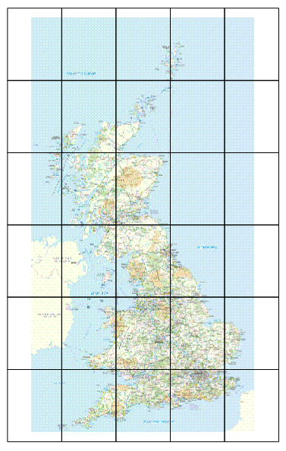

Adding page overlap may reduce the bleed over the extent.

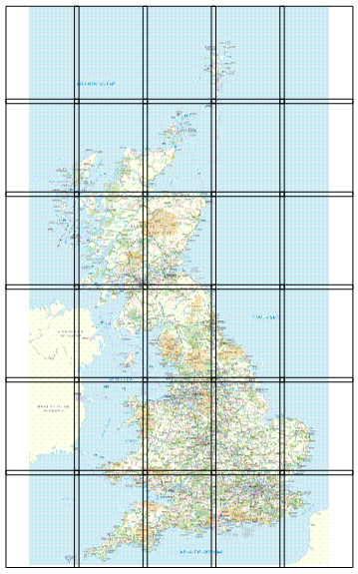

Increasing the page overlap further may cause an additional row or column (as well as increased bleed) to be added to the grid in order to cover the map extent.

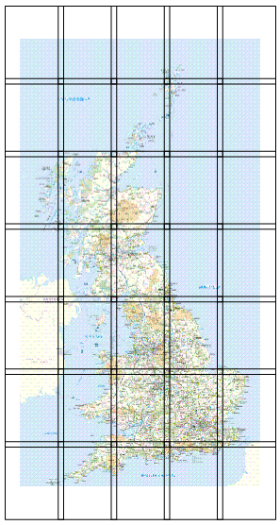

Using adaptive overlap will calculate the exact overlap which is required for the frames to cover the extent of the map window.

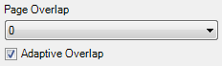

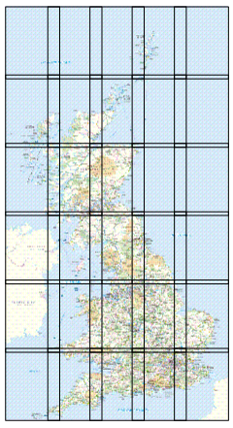

The book plot tool will ask whether an existing grid overlay should be overwritten.

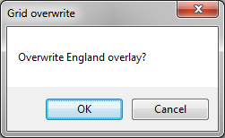

**Book Plots for selected items**

It is possible to create grids which cover only the extent of selected items. This will be the default option if the Book Plot dialog is opened with currently selected items.

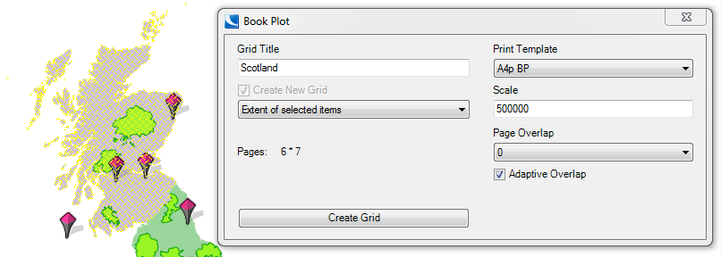

The resulting grid will only include frames which intersect the geometry of any of the selected items.

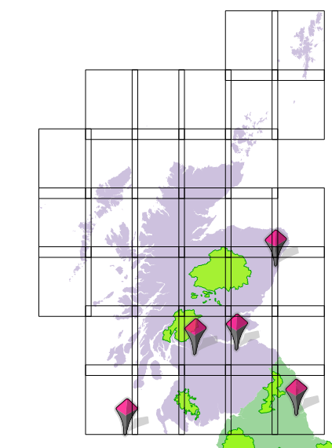

**Page Per Item**

Each selected item may be mapped by a single page. It is possible to order the pages in the output by the alphabetic name of a schema column. A schema column can also be assigned as title for the print template page.

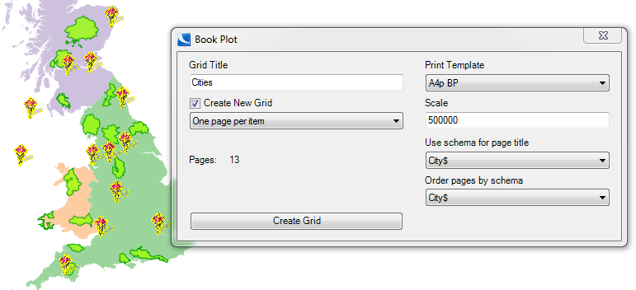

The size of the map frame on the print template and the scale define the size of the grid frame.

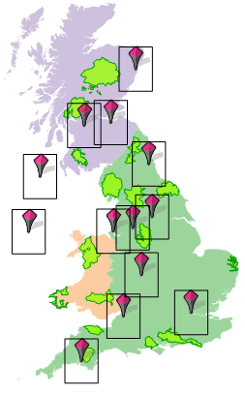

It is possible to modify the size of the frame by setting the _scale# system property on the input items.

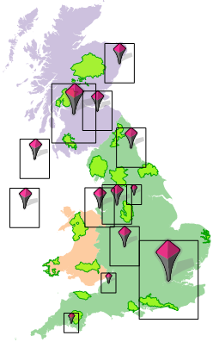

It is also possible to select point, line, and polygon features for ‘one page per item’ book plots. The frame size will be increased beyond the defined scale in order to ensure that the extent of each item is covered by the map frame.

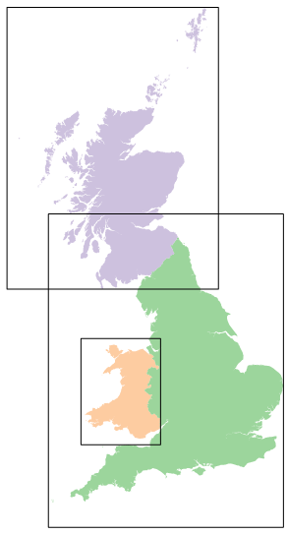

It is possible to select points, lines, and areas together. All items must have the same schema in order for the sorting to work.

**Creating Book Plots**

The book plot dialog checks for existing book plot grids during initialisation. Different grid overlays can be selected from a drop down control.

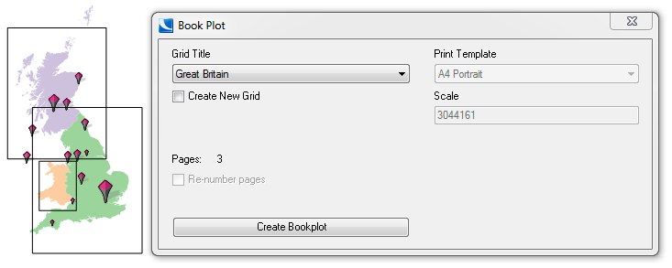

A new grid can be created by ticking the ‘Create New Grid’ checkbox.

The Book Plot add-in will ask for the name and format of the export.

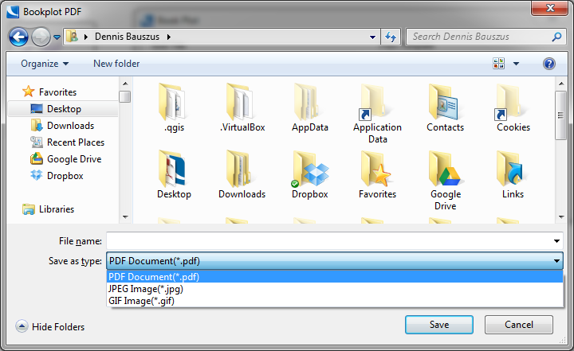

Supported formats are PDF, JPG, and GIF.

Only the PDF format supports multipage documents.

JPG and GIF pages are created as individual numbered images in a named folder.

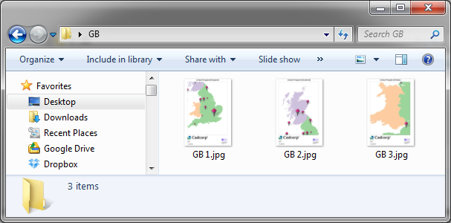

**Export and Import of grid overlays**

The book plot add-in recognises grid frames on internal overlays and on BDS datasets.

Caution should be taken when grid overlays are moved to a different map projection.

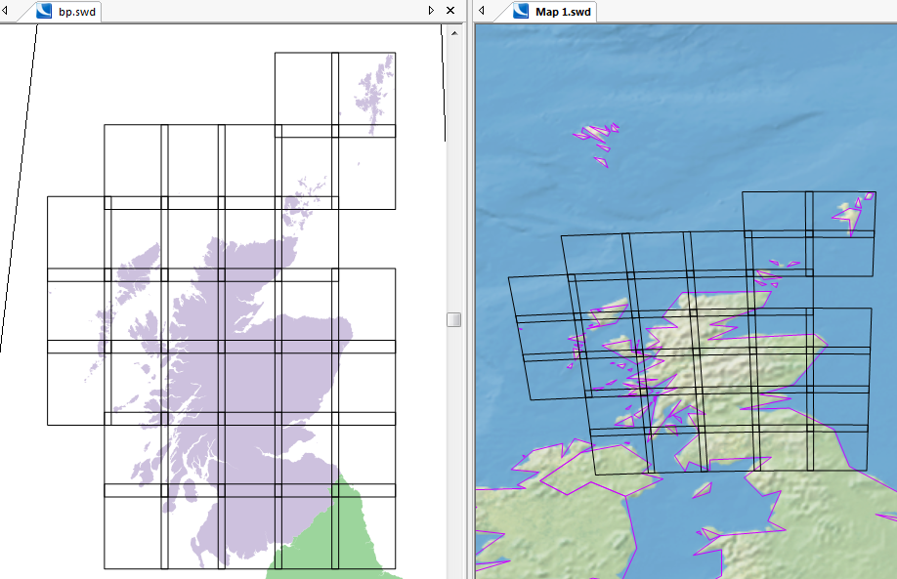

**CRS support**

The book plot add-in supports cartographic and spherical coordinate reference systems.

**Print Templates**

The add-in supports a range of map furniture specific to book plots.

These are continuation pages, page number, page count, and an index.

Furniture items will be automatically populated if found in the template, or removed if the type of book plot does not support this kind of furniture (e.g. continuation page numbers in one page per item series).

A default template A4 book plot template is provided in a separate NOL in the add-in install directory.

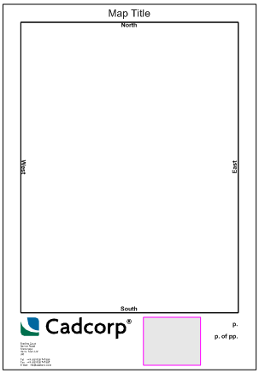

The book plot add-in recognise furniture items by their prompt (Prompt$) property. The prompts are:

**Title** - Title

**p North** - North continuation page

**p South** - South continuation page

**p East** - East continuation page

**p West** - West continuation page

**SheetN** - Page number

**SheetN_of_NN** - Page count and total number of pages

**Index** – The index overview

**Scale** – The scale of the map frame

**Index**

Index pages are linked in PDF documents. The index will be fitted into the existing index frame with the prompt (Index). The brush and pen of the index frame will be applied to indicate the current page.



**Page numbering**

The book plot add-in will calculate page numbers for continuous blocks when a grid is created.

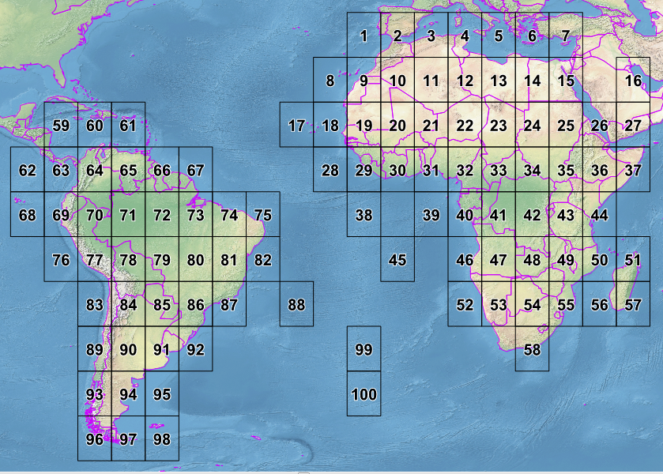

It is possible to re-calculate the page numbers before a book plot.

