The Print Workshop GISlink add-in for Cadcorp SIS 7.1 desktop products is intended to extend the user capabilities to place print templates and add print furniture such as scale bars, inset maps, and schema tables.

**Printing in the Cadcorp SIS Desktop**

In order to print a map from the SIS Desktop it is recommended to use Print Templates. Print Templates are Named Object Library (NOL) items with a Map Frame. Print Templates should user Paper Space as Coordinate Reference (CRS). The Map Frame is the map object of a Print Template. Prior to sending a Print Template to a Printer the Map Frame must be populated with a map.

A Print Template can be populated by using either the **Print Template**, or **Quick Print Template** dialog wizards from the Cadcorp SIS File Menu.

In addition to the Print Wizards, the Print Template File Menu has methods to **Store** a newly created Print Template or **Recall** existing Print Templates for editing.

The Cadcorp SIS desktop allows the creation of custom print templates which can be placed

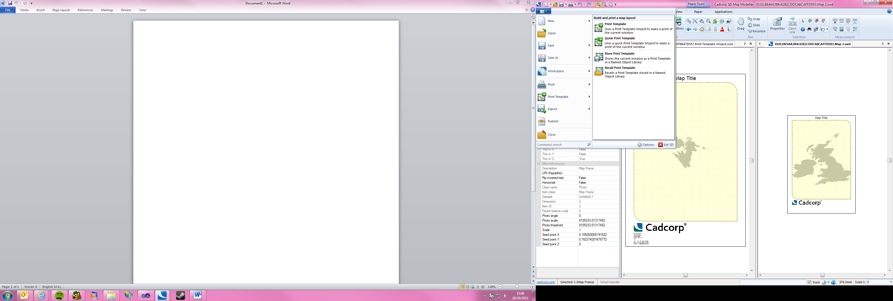

Map Frame items can be created from the Cadcorp SIS Create Tab.

**Paper Functions**

If a Map Frame item is in the current selection the Cadcorp SIS Paper Tab is available in the SIS Ribbon Interface.

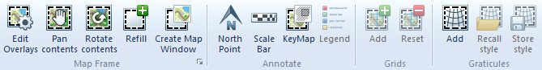

The Paper Tab contains groups to edit the Map Frame item, Annotate a Print Template, and to create Grids or Graticules. The individual Paper functions from the Cadcorp SIS desktop are outlined in Cadcorp SIS Help.

In addition to the Paper Tab, most of the Map Frame functions are available from the context menu of a selected Map Frame item.

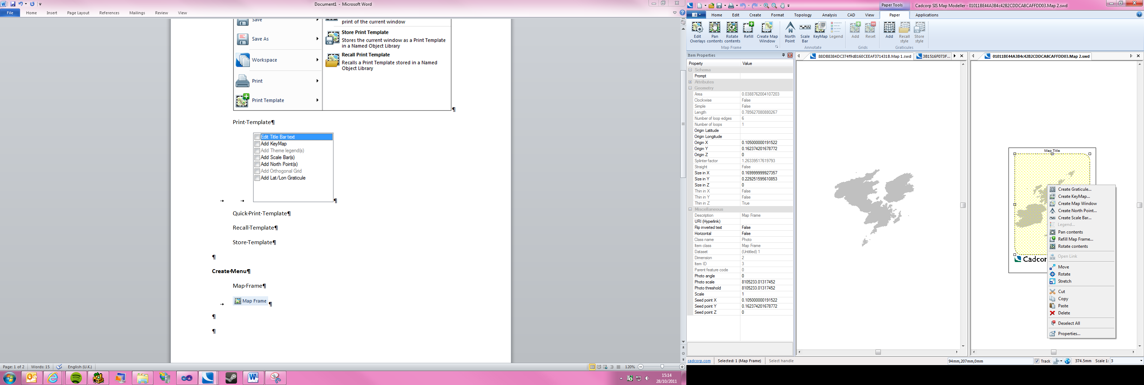

**Print Workshop**

The Print Workshop application group can be accessed from the Cadcorp SIS Applications Tab. In this add-in group are Paper functions which extend the core functionality of the Cadcorp SIS desktop product.

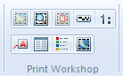

The individual function in the Print Workshop group are:

* Place Template
* Inset Map
* Key Frame
* Scale bar
* Scale text
* Label
* Schema Table
* Overlay Legend
* Watermark

**Place Template**



The **Place Template** function opens a dialog containing a list and preview of all available Print Templates. These are the Print Templates from the Cadcorp SIS Standard Library and all Print Templates from additionally loaded NOLs.

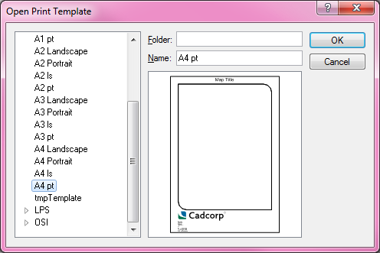

A Print Template can be selected and will be placed on the current Map Window. Hereby the Print Workshop will determine whether to keep the scale of the map window or the extent.

If the Map Window is set to a round scale (e.g. 1250, 20000, 25, 500, 750) the Map Frame will be composed on the exact scale. This means that the Map Frame on large Print Templates (e.g. DIN A2 paper format) will show a larger extent than the screen Map Window.



If no particular viewing scale is set for the Map Window, the Print Workshop **Place Template** function will compose the Map Frame with the viewing extent of the Map Window.

Note: It is not possible to Place a Print Template on a Map Window which already contains a Print Template (Map Frame).

**Inset Map**



The Print Workshop **Inset Map** tool has multiple functions. The main function of this tool is to create Inset Maps on a composed Print Template.

If the tool is run without any item selected, the user can draw a new **Inset Map** rectangle. Thereafter a second rectangle can be drawn on top of a composed Map Frame item to define the extent of an **Inset Map**. This method is suited to create an Inset which is a magnification of a smaller region in the main Map Frame.

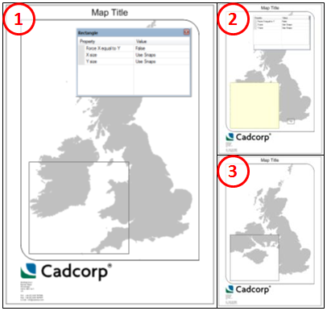

Alternatively the tool can be used to create a new Map Frame from a second Map Window. An **Inset Map** frame has to be drawn first, and thereafter a second Map Window can be selected by either clicking anywhere inside the Map Window or on the Map Window Tab if the Map Window itself is not visible. The Print Workshop Inset function will populate the new Map Frame with the extent of the second Map Window.

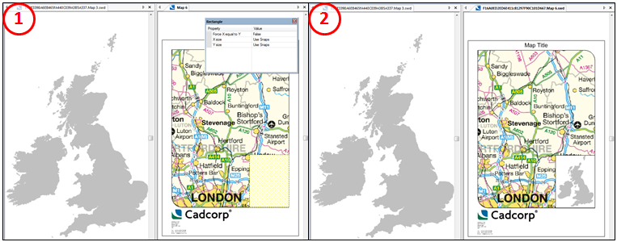

Instead of drawing a new **Inset Map** frame, any Area item can be used in the Print Workshop Inset function. If an Area item is already selected when the **Inset Map** function is run the first and only step is to select either an Inset area on an existing Map Frame (rectangle) or a second Map Window. The Inset function will then generate an **Inset Map** from the existing Area item (which will be removed).

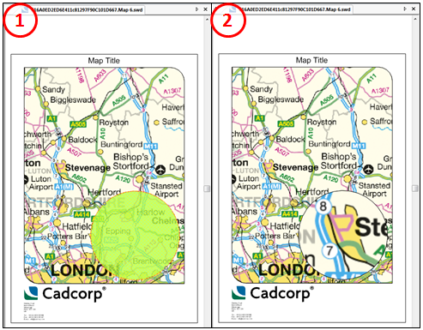

If a Map Frame is selected when the Print Workshop Inset function is run, then first and only step is to, either select a second Map Window and change the source of the Map Frame, or redefine the map extent of an **Inset Map**.

The map extent of an **Inset Map** Frame can be redefined by selecting an **Inset Map** frame and running the Print Workshop **Inset Map** function. A rectangle can be drawn in the relation to the existing Map Frame to zoom in, out, or move the extent of the **Inset Map** frame.

**Inset Maps** are Map Frames in their own right and can be edited with Cadcorp SIS Desktop and Print Workshop functions.

During the construction of **Inset Map** frames or **Inset Map** areas it is possible to cancel the process (ESC), or undo the first point of a rectangle construction (←). Cadcorp SIS Snap-aides (e.g. v for vertex) are available to assist with the construction in the Print Workshop Inset function.

The Inset Map frame function will respect the rotation of Map Windows.

**Key Frame**



The Print Workshop **Key Frame** function is a quick alternative to using Key Map items which can be created in the Cadcorp SIS desktop. The application of Key Map items is discussed in the Cadcorp SIS Help.

A **Key Frame** is an additional layer of a Map Frame which shows the location and extent of a second Map Frame.

In order to run the Print Workshop **Key Frame** function, two Map Frames must be selected. The **Key Frame** function will then draw the smaller map extent as a new **Key Frame** overlay within the larger (extent) Map Frame.

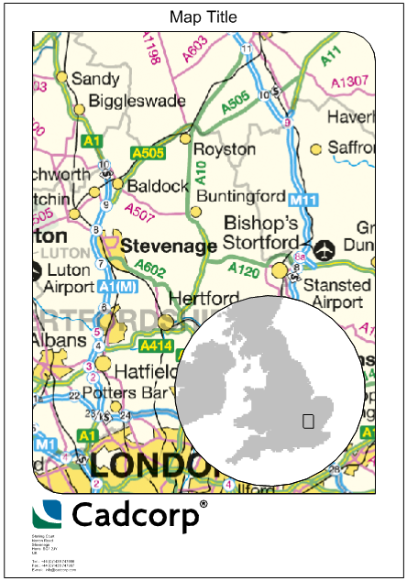

The **Key Frame** function will respect the rotation of Map Windows.

Since **Key Frames** are drawn within a Map Frame they will be moved and scaled with the Map Frame of which they are a part of but will not respect any changes to the source of extent of the Map Frame which they reference. It is advised to create **Key Frames** after the size and location of all Map Frame extents in a map composition have been defined.

**Scale Bar**



The Cadcorp SIS desktop has a function to add pre-made **scale bars** to Print Templates. The Print Workshop **Scale Bar** function allows to generate a new **scale bar** with a default styling to a cartographic Map Frame.

The Print Workshop **Scale Bar** function will determine the viewing scale of a Map Frame and size the **scale bar** according to user defined input.

After opening the **Scale Bar** function a first user defined hook point input will define the location of the **scale bar**. The second point input will define the size and orientation of the **scale bar**.

The orientation of the scale bar is defined by the vector from input location 1 to 2.

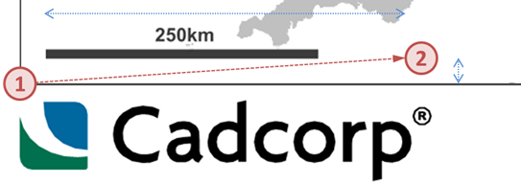

The longer axis of the vector will define the maximum length of the scale bar. The shorter axis will define the distance of the scale bar from the hook point (1).

It is recommended to use the V snap code to snap the hook point to a corner of a map frame. A scale bar can be drawn outside a map frame but must snap the map frame to query the viewing scale property.

It is possible to centre a **scale bar** in a Map Frame by snapping the hook point to the Centre of a Map Frame border (snap-code c). The second input location should be set away from the hook point to define the long vector axis and length of the scale bar. Putting the second point at a slight angle sets a distance for the **scale bar** from the Map Frame border.

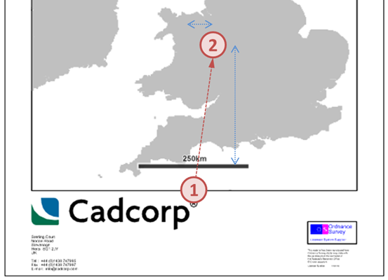

A **scale bar** can also be drawn in a Map Window. In this case the size of the **scale bar** is dependent on the viewing scale of the Map Window.

During the construction of **Scale Bars** it is possible to cancel the process (ESC), or undo the first point of a **Scale Bar** construction (←). Cadcorp SIS Snap-aides (e.g. v for vertex) are available to assist with the construction of **Scale Bars**.

**Scale Text**



The Print Workshop **Scale Text** function is available when a Map Frame item is selected. The function draws a dynamic text item which will represent the current viewing scale of a Map Frame item.

The Return key opens a Font dialog prior to dropping the **scale text** item on a Print Template.

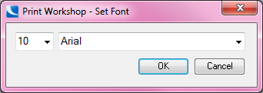

**Label**



The Print Workshop **Label** function reads label texts from a labels.txt file which must be in the applications directory \Addins\Print Workshop\.

**Labels** can only be drawn in a Map Window with a Print Template (Map Frame).

The label text can be changed in the Print Workshop **Labels** dialog. A drop down switches between the texts in the labels.txt document. The document can be opened in Notepad from the Print Workshop **Labels** dialog.

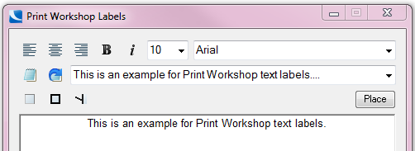

It is also possible to copy and paste new text snippets in the text window of the dialog. Font and style changes are represented in the dialog text box.

Three options buttons set whether an opaque background, a black frame, or label lines are drawn.

If label lines are switched on a second input position must be given after dropping the label. A line will then be drawn from the outside of the **label** to this second input location.

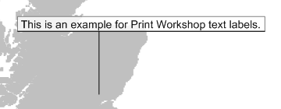

**Schema Table**



The Print Workshop **Schema Table** function adds a table item to a Print Template. A Map Frame must be selected in order to open the Print Workshop Schema Table dialog.

The data grid view in the Print Workshop **Schema Table** dialog is populated from an overlay drop down which contains all Map Frame overlays. The column width is adjusted in regard to all values in an individual column.

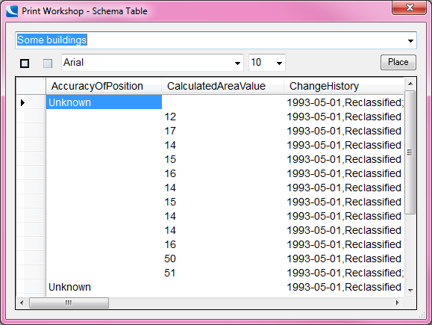

The Schema **Table** dialog can be used to set font style and size of a table. Options button set whether an opaque background and item frame should be drawn on the Print Template table.

The context menu on the data grid view header fields can be used to toggle whether a schema column should be included in the **table**.



An outline of the new **table** item will give an indication of the size of a **table** before the item is dropped as new Group item on the Print Template.

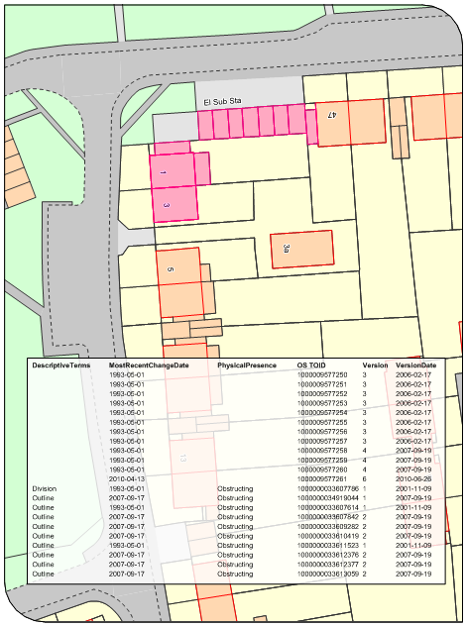

**Overlay Legend**



The Print Workshop **Overlay Legend** function will create a legend for overlay styles in a selected Map Frame. The **Overlay Legend** function will check all overlays within a Map Frame for Pen, Brush, and Symbol Override settings.

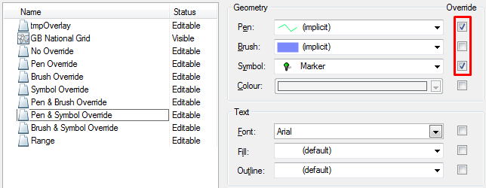

The Return key opens a Font dialog prior to dropping the **Overlay Legend** item on a Print Template.



The styles for overlays which have at least one override option set true are compiled in the **Overlay Legend**.

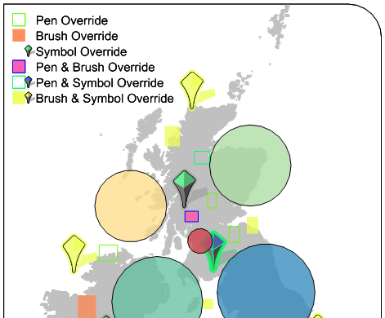

**Watermark**



A Map Frame must be selected in order to open the Print Workshop **Watermark** dialog. The Print Workshop can use *.BMP;*.GIS;*.PNG images to create a **Watermark** on a Map Frame.

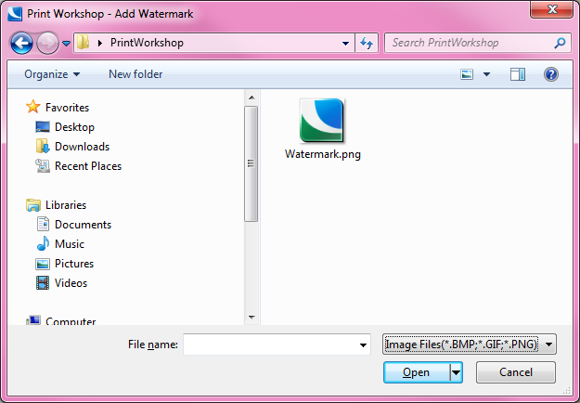

The **Watermark** will be drawn central with 30% space to border of the Map Frame. The Print Workshop **Watermark** function will set a 200 point Alpha transparency on the **Watermark** item.

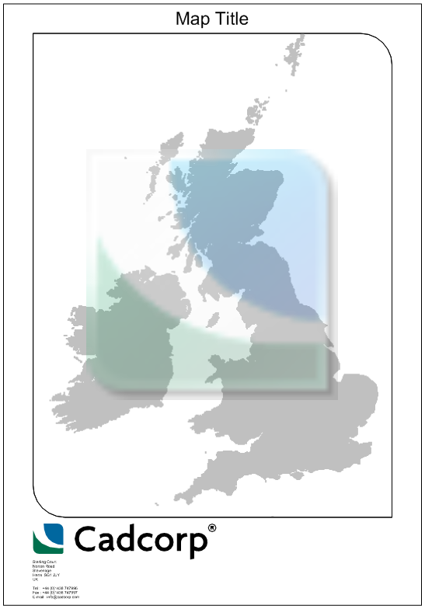

**Temporary NOL items**

In order to run most function the Print Workshop needs to create temporary items (Filter and Print Templates) in the current library. By default this is the (temporary) library which will be emptied when SIS is closed.

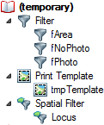

**Print Templates**

Part of the Print Workshop add-in is a NOL in \Addins\Print Workshop\ which includes sample templates for all DIN landscape and portrait paper formats. This resource may be used to create custom Print Templates. More information on the creation and editing of Print Templates can be found in the Cadcorp SIS Help.

