Values Game Documentation
By Dan B

Overview

The objective of the values game is to determine top 5 values of the player (eg happiness, honesty) from the list of 50 values. To narrow down those values the game will be consisting of 3 levels.
NOTE: The coding aspect of the project may contain a significant amount of redundant variables or room for optimization, not to mention the amount of spaghetti. Thus enter at your own disclosure.

Level 1: On the first level the player will be presented all 50 values and will be assigning number to them. The the numbers will be recorded and passed on to the next level.

Level 2: On the second level the values will be picked from the saved list and will be sorted by the value assigned by the user. The top values with the greatest score will be then compared with one another. The comparison will feature 2 values at a time in which the value that gets picked will be given a point. Once all the combinations of the values have been asked the list containing all the partaking values along with there score will be send to the third level.

Level 3: The data containing list will load and pick top 8 values and repeat same questioning as in stage 2. At the end top 5 values with greatest amounts of points will be shown to user as there top values.

Project architecture

Note: During the development, the scripts were build with modularization in mind. Thus most of them are being reused in different levels with minor adjustments.

Level 1

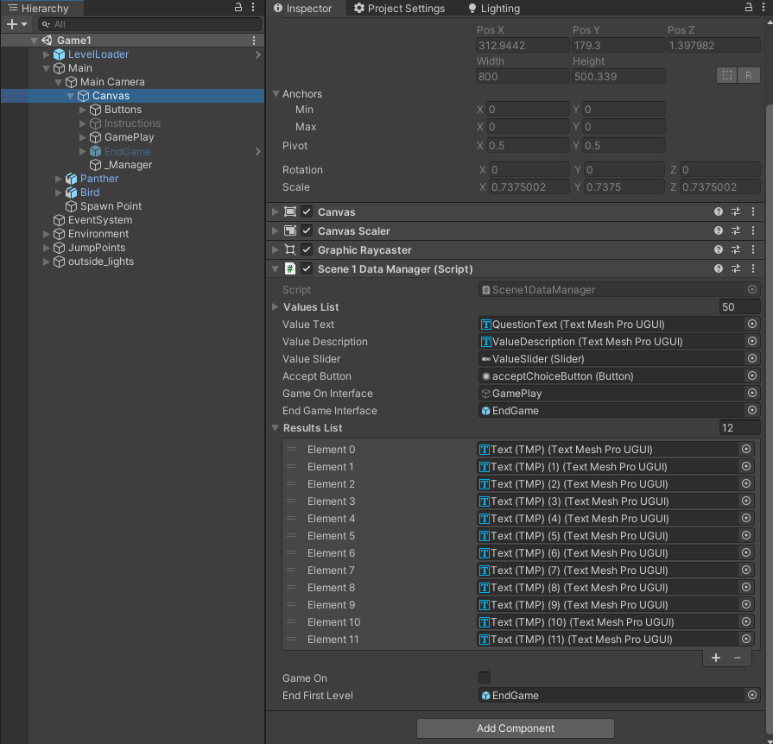

The level 1 components can be broken down in 2 parts, that is all the data management happening in the background while animations and tabs showing in the foreground.

The Scene1DataManager is the script that is in charge of managing questions along with saving them for the next level in the xml file format. The script is also in communication with the MovementManager script.

The script also manages the user interface, that is it is activating the questions panel, results panel and tips panel at the start (note the tips management code aspect panel activation is made not in the most clean and efficient way, thus will need to be redone or replaced).
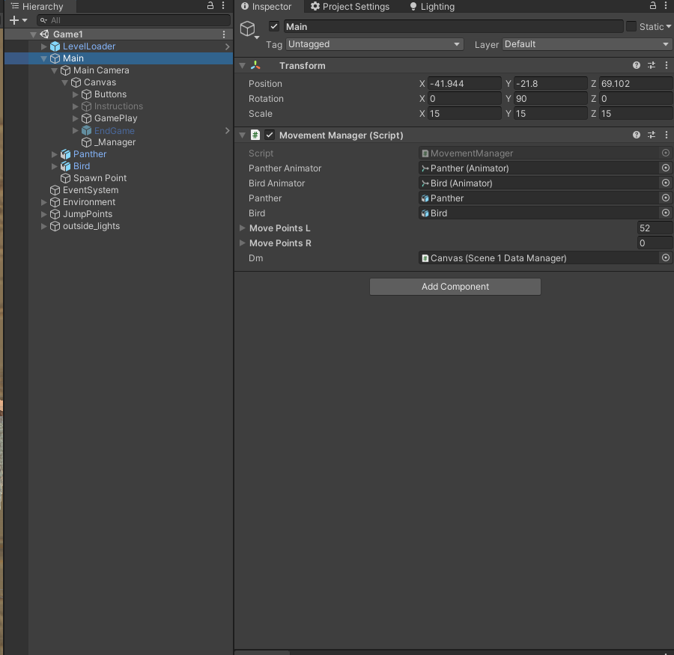
The MovementManager script is in control of animations and notifying the DataManager script that the player character have reached the next point in the game.

The script references the waypoints the player character will be reaching. And can have the animation, location, speed and type of movement (translation/teleport) adjusted in the list of way points.

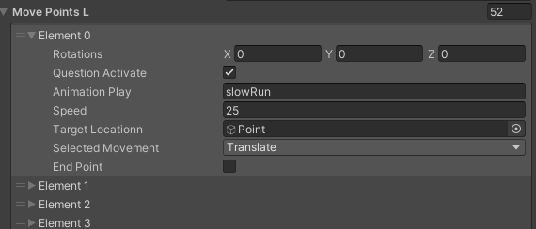
Once the player object have reached the point and the QuestionActivate variable is set active, the animationManager will access DataManager script and activate a GameOn method in it. That method will set the question interface on that will be featuring the next value question.

Interface Button

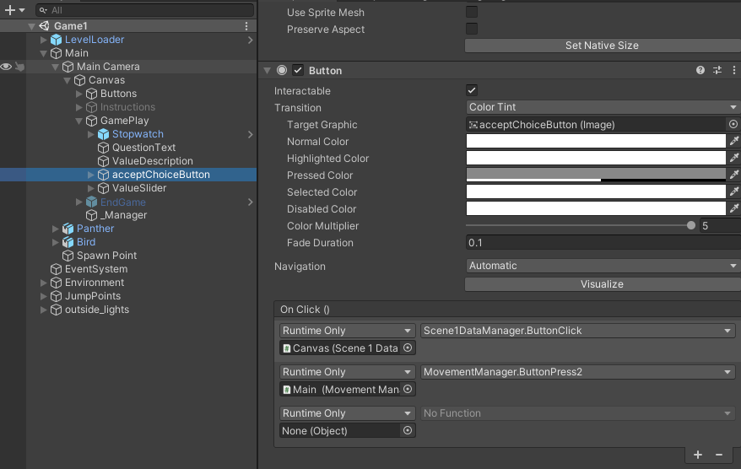

The interface button during the game play has 2 method attached. The top is to set data and move to the next question in the data manager and turn off interface, while the bottom is to trigger animations. Once animation reaches its destination the interface will reactivate and repeat the process until game completion.

Level 2/3

NOTE: Level 2 and 3 data manger is a script derived from the first, thus they share many similarities, same can be said about animation manager in that level. Thus only the aspects that have been changed will be noted in this documentation.

Data Manager

The most notable difference in the level 2 data manager is that it uses values pairs objects to make user compare which of the 2 values it prefers. The data manger accesses the savefiles and collects data of saved values. The top values are then collected from it based on there respective score.

Then with the use of those top values a list of questions objects is generated, then each question is randomly picked from that list. Once that question is answered, the chosen value in it is then added to the list of picked values. Then each value is counted in that answer list and based on its frequency in that list (the more value is picked the more frequent it is in the list and more score it gets). Once all the questions in the question list have been answered, the game ends and interface with the results is populated with the most chosen values and displayed to the user.

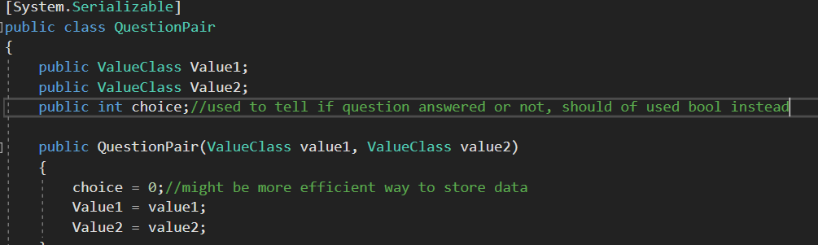
Animation

Same animation system is used as in level 1, with only notable difference is that each of the choice buttons triggered different direction of player movement (left button goes left, right button player goes right)

SaveFile Container (data storage)

All the data will be stored inside of file in xml format. It will independently hold data from each level in the form of lists recording each value and its score.

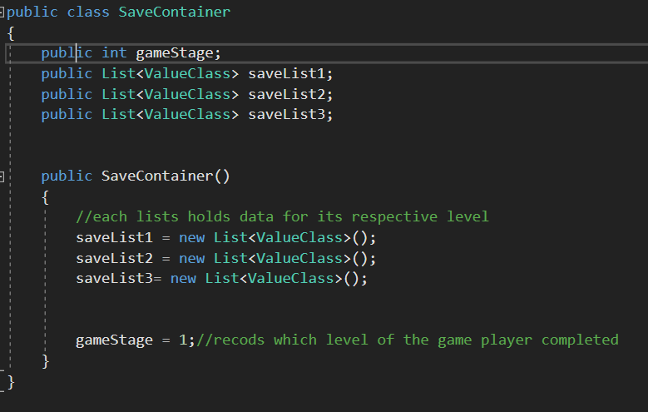

Known bugs and unimplemented/not working parts:

Data not stored in json format, needs to be changed as the game will be runing in browser

Timer display is now working properly in all levels, needs to be reworked

The scene change after each animation is completed in levels 2/3 is not implmented

The animations for level 2/3 now set up properly, thus needs to be reworked (no script change will be necessary)

