

Shreeji Car Accessories

**A PROJECT REPORT**

SUBMITTED IN PARTIAL FULFILLMENT OF THE REQUIREMENT FOR THE AWARD OF THE DEGREE OF

**B.TECH. (COMPUTER ENGINEERING) TO**

**RK UNIVERSITY, RAJKOT**

**SUBMITTED BY**

Name of Student Enrollment No.

Darshit Busa 19SOECE13003

**UNDER THE GUIDANCE OF**

**Internal Guide External Guide**

Prof. Sheetal Pandya

Professor

RK University Rajkot

April 2022



**SCHOOL OF ENGINEERING, RK UNIVERSITY, RAJKOT**

# DECLARATION

I hereby certify that I am the sole author of this project work and that neither any part of this project work nor the whole of the project work has been submitted for a degree to any other University or Institution. I certify that, to the best of my knowledge, my project work does not infringe upon anyone’s copyright nor violate any proprietary rights and that any ideas, techniques, quotations, or any other material from the work of other people included in my project document, published or otherwise, are fully acknowledged in accordance with the standard referencing practices. I declare that this is a true copy of my project work, including any final revisions, as approved by my project review committee.

**Signature of Student**

Darshit Busa (19SOECE13003), Date:

Place: Rajkot



# CERTIFICATE

This is to certify that the work which is being presented in the Project Report entitled **“ Shreeji Car Accessories ”,** in partial fulfillment of the requirement for the award of the degree of **B.Tech. (Computer Engineering)** and submitted to the School of Engineering, RK University, is an authentic record of my/ourown work carried out during a period from **December 2021 to April 2022.**

The matter presented in this Project Report has not been submitted by me/us for the award of any otherdegree elsewhere.

Darshit Busa (19SOECE13003)

**Signature of Student**

This is to certify that the above statement made by the student is correct to the best of my knowledge.

|  |  |  |
| --- | --- | --- |
| **Internal Guide**  Sheetal Pandya | **External Guide**  Varsha Oberoi | **Head of Department**  Prof. Ashwin Raiyani |
| Professor, | Software Engineer, | CE / IT / BCA / MCA |
| RK University, | RadixWeb, | School of Engineering, |
| Rajkot | Ahmedabad | RK University, Rajkot |

April 2022

**SCHOOL OF ENGINEERING, RK UNIVERSITY, RAJKOT**

# ACKNOWLEDGEMENT

The internship opportunity I had with **Radix Software Services Pvt Ltd** was a great chance for learning and professional development. Therefore, I consider myself as a very lucky individual as I was provided with an opportunity to be a part of it. I am also grateful for having a chance to meet so many wonderful people and professionals who led me though this internship period. specially thanks to external guide **Mrs. Varsha Oberoi** and internal guide **Prof. Sheetal Pandya** for constant encouragement and helping me to this project.

# ABSTRACT

Shreeji Car Accessories is an inquiry and information-sharing project. The project is a web-based application. This web application is developed for information and inquiry about car accessories.

This web application is beneficial for the client to upgrade the business. This web application provides a user-friendly interface So that users can interact easily with the web application.

# INDEX

DECLARATION ii

ACKNOWLEDGEMENT iv

ABSTRACT v

Company Profile 1

Chapter 1 Introduction of PHP 2

* 1. *Introduction of PHP 2*
  2. *PHP Version 2*
  3. *Hardware Requirements 3*
  4. *Software Requirements 3*

Chapter 2 Frameworks 4

* 1. *Laravel (PHP Framework) 4*
     1. Features of Laravel 4
  2. *Bootstrap (CSS Framework) 5*
     1. Features of Bootstrap 5

Chapter 3 Project Introduction 6

* 1. *Introduction 6*
  2. *Project-Profile 6*

Chapter 4 System Requirements Study 7

* 1. *User Characteristics 7*
  2. *Hardware and Software Requirements 7*

Chapter 5 System Analysis 8

* 1. *Functions of System 8*

Fig. 5.1.3.1 Use Case Diagram for Admin 9

Fig. 5.1.3.2 Use Case Diagram for Users 10

* 1. *Data Modeling 11*
     1. Data Dictionary 11
     2. E-R Diagram 16

Fig. 5.2.2.3.1 Entity Relationship Diagram 17

* + 1. Object Interaction (Sequence Diagram) 18

Fig. 5.2.3.3.1 Object Interaction Diagram 19

* + 1. System Activity 20

Fig. 5.2.4.3.1 Object Interaction Diagram 21

Chapter 6 System Analysis 22

*6.1 Feasibility Study 22*

Chapter 7 ADVANTAGES AND FUTURE ENHANCEMENT PLAN 23

* 1. *Advantages 23*
  2. *Future Plan 23*

Chapter 8 Screenshots 24

*8**.1 Screenshots 24*

Fig. 8.1.1 Main (Landing) View (Computer View) 24

Fig. 8.1.2 Main View - Special Deals (Computer View) 24

Fig. 8.1.3 Main View – Popular Items (Computer View) 25

Fig. 8.1.4 Main View – Store Information and Review (Computer View) 25

Fig. 8.1.5 Products List View (Computer View) 26

Fig. 8.1.6 Single Product View (Computer View) 26

Fig. 8.1.7 Contact us View (Computer View) 27

Fig. 8.1.8 Login For Admin (Computer View) 27

Fig. 8.1.9 Admin Dashboard View (Computer View) 28

Fig. 8.1.10 Main View (Mobile View) 29

Fig. 8.1.11 Products List & Single Product View (Mobile View) 30

Fig. 8.1.12 Admin Login and Dashboard View (Mobile View) 31

Fig. 8.1.13 Admin Banner Maintain View (Desktop View) 32

Fig. 8.1.14 Admin Banner Maintain View (Mobile) 32

Fig. 8.1.15 Multiple Image Support (Desktop View) 33

Fig. 8.1.16 Category Module (Desktop View) 33

Fig. 8.1.17 Special Deals Maintain (Desktop View) 34

Fig. 8.1.18 Special Deal Maintain (Mobile View) 34

Fig. 8.1.19 Admin sidebar (Mobile View) 35

Fig. 8.1.20 Admin Product Edit View (Desktop View) 35

Chapter 9 Conclusion 36

*9.1 Conclusion 36*

Chapter 10 References 37

*10.1 Website 37*

# Company Profile

## About Company

* Radixweb is one of the huge Ahmedabad based IT Solutions companies.
* Radixweb is one of the most sought-after Software Development partners because of our extensive domain expertise.
* Besides being thought leaders, our focus is to be updated with industry trends and develop cutting-edge software solutions.
* Founded in 2000.
* 600+ Active Employees.

## Power of Knowledge

* We base our projects on an extensive understanding of the client’s business ecosystem and niche. Market research is one of our USPs and we do in-depth study of a project’s sector dynamics and macroeconomic environments. Our investments in terms of knowledge development and capacity building make us thought leaders of the force.

## Code of Conduct

* Transparency and integrity are two virtues deeply ingrained in our business ethics. We value our partners’ reputation like our own and treat their business environments with respect. We temper our projects with high social responsibility and strongly believe in the power of collaboration. We aim to leave behind highly ethical footprints with our work.

## Continuous Innovation

* We believe in accepting and integrating change in our work processes at every step of the business. Our aim is to offer best-in-class, curated solutions to our clients and we constantly update our own processes and resources. Partnering with us is way more than just developing software solutions – it is fostering mutual growth and capabilities.

# Chapter 1 Introduction of PHP

## Introduction of PHP

* + - PHP is a server-side scripting language designed primarily for web development but also used as a general-purpose programming language.
    - PHP stands for Personal Home Page, but it now stands for the recursive acronym PHP: Hypertext Preprocessor
    - PHP scripts are always executed on the server
    - All the PHP based applications can run on various types of platforms like UNIX, Windows and Linux.

## PHP Version

* **PHP 1** :-

PHP was created by Rasmus Lerdorf in 1994. It was initially developed for HTTP usage logging and server-side form generation in UNIX.

* **PHP 2** :-

Transformed the language into a Server-side embedded scripting language. Added database support, file uploads, variables, arrays, recursive functions, conditionals, iteration, regular expressions, etc.

* **PHP 3** :-

Added support for ODBC data sources, multiple platform support, email protocols (SNMP, IMAP), and new parser written by Zeev Suraski and Andi Gutmans.

* **PHP 4** :-

Became an independent component of the web server for added efficiency. The parser was renamed the Zend Engine. Many security features were added.

* **PHP 5** :-

Adds Zend Engine II with object oriented programming, robust XML support using the libxml2 library, SOAP extension for interoperability with Web Services, sqlite has been bundled with PHP.

* **PHP 6** :-

PHP has received criticism due to lacking native Unicode support at the core language level, instead only supporting byte strings. In 2005, a project headed by Andrei Zmievski was initiated to bring native Unicode support throughout PHP.

* **PHP 7** :-

During 2014 and 2015, a new major PHP version was developed, which was numbered PHP 7. The numbering of this version involved some debate. While the PHP 6 Unicode experiment had never been released

## Hardware Requirements

This Requirements are for latest version of PHP only

1. 1.6 GHz or faster processor
2. 1 GB of RAM (1.5 GB if running on a virtual machine)
3. 50 MB of available hard disk space
4. 5400 RPM hard drive

## Software Requirements

1. For windows user WAMP or XAMPP server.
2. For linux user LAMP or XAMPP server.

# Chapter 2 Frameworks

## Laravel (PHP Framework)

* + - Taylor Otwell developed Laravel in July 2011, and it was released more than five years after the release of the Codeigniter framework.
    - Laravel follows the model-view-controller (MVC) architectural pattern.
    - Laravel is one of the most popular PHP frameworks after Codeigniter.
    - Laravel is a PHP based web framework for building high-end web applications using its significant and graceful syntaxes.
    - It comes with a robust collection of tools and provides application architecture.
    - This framework is an open-source framework. It facilitates developers by saving huge time and helps reduce thinking and planning to develop the entire website from scratch.

### Features of Laravel

* + - * Routing controllers.
      * Configuration management.
      * Testability.
      * Authentication and authorization of users.
      * Modularity.
      * ORM (Object Relational Mapper) features.
      * Provides a template engine.
      * Building schemas.
      * E-mailing facilities.

## Bootstrap (CSS Framework)

* + - Developed by Jacob Thornton and Mark Otto at Twitter as a framework to promote consistency across internal tools, Bootstrap is an open-source framework containing CSS and JavaScript-based templates for interface components.
    - Bootstrap is known for popularizing the focus on responsive design among web developers.
    - With Bootstrap, developers don’t have to build separate projects around adjusting a site for smaller screen sizes. They just need to incorporate the necessary Bootstrap classes, and the design adjusts itself.

### Features of Bootstrap

* + - * Responsive Utility Classes
      * Easily Customizable
      * Development speed
      * Simplicity
      * Easier to use and develop
      * Simple integration
      * Grid
      * Packaged JavaScript components
      * Pre-styled components

# Chapter 3 Project Introduction

## Introduction

Shreeji Car Accessories is an inquiry and information-sharing project. The project is a web-based application. This web application is developed for sharing information or inquire about car accessories. Here we describe project related information in tabular form.

## Project-Profile

|  |  |  |
| --- | --- | --- |
| Sr. No | Title | Description |
| 1. | Project Title | Shreeji Car Accessories |
| 2. | Institute | RK University |
| 3. | Front End | PHP, HTML, CSS, JS |
| 4. | Database | MySQL |
| 5. | Framework | Laravel, Bootstrap |
| 6. | Develop For | Sharing information or inquire about car accessories |
| 8. | Internal Guide | Prof. Sheetal Pandya |
| 9. | Submitted To | RK University |
| 10. | Developed By | Darshit Busa |

# Chapter 4 System Requirements Study

## User Characteristics

There are 2 types of users can interact with the system:

* + - Admin User
    - Normal User

### Role of Admin User:

* + Role of admin user is to maintain the information stored in the database. Like
  + Manage the Categories module
  + Manage the Products module
  + Manage the Slider module
  + Manage the Offer module

### Role of Normal User:

* + Normal user can search for the required product
  + Normal user can check the information of product
  + Can contact for the specific product

## Hardware and Software Requirements

### Hardware Requirements

* + 1.6 GHz or faster processor
  + 1 GB of RAM (1.5 GB if running on a virtual machine)
  + 50 MB of available hard disk space
  + 5400 RPM hard drive

### Software Requirements

* + For windows user WAMP or XAMPP server.
  + For linux user LAMP or XAMPP server.
  + Composer for package installation.

# Chapter 5 System Analysis

## Functions of System

* + 1. Overview

Use case diagram is dynamic in nature, there should be some internal or external factors for making the interaction. These internal and external agents are known as actors. Use case diagrams consists of actors, use cases and their relationships. The diagram is used to model the system/subsystem of an application.

## Notations

|  |  |
| --- | --- |
| Use case |  |
| Actor |  |
| Dependency |  |
| Relationship |  |

* + 1. Diagram

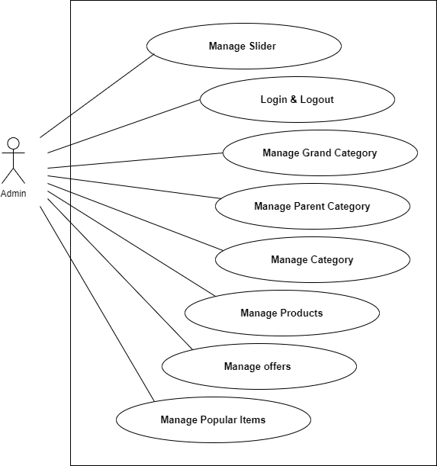

Fig. 5.1.3.1 Use Case Diagram for Admin

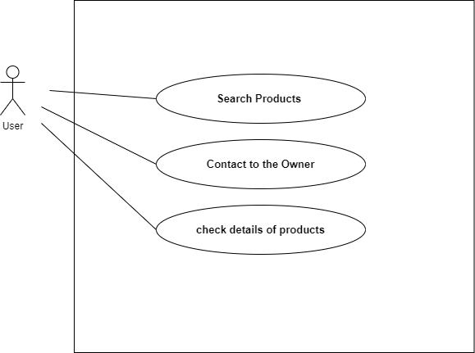

Fig. 5.1.3.2 Use Case Diagram for Users

## Data Modeling

* + 1. Data Dictionary
       1. Overview

A data dictionary contains metadata i.e data about the database. The data dictionary is very important as it contains information such as what is in the database, who is allowed to access it, where is the database physically stored etc. The users of the database normally don't interact with the data dictionary, it is only handled by the database administrators.

## Data Dictionary

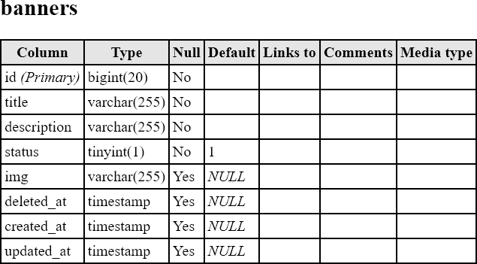

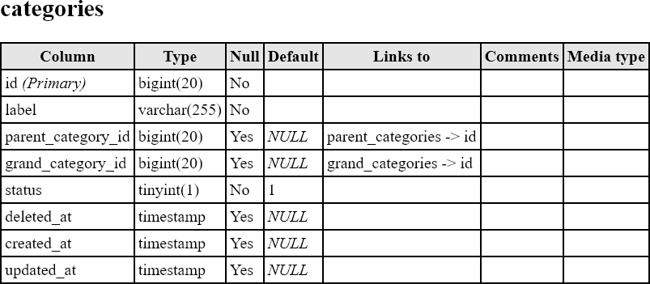

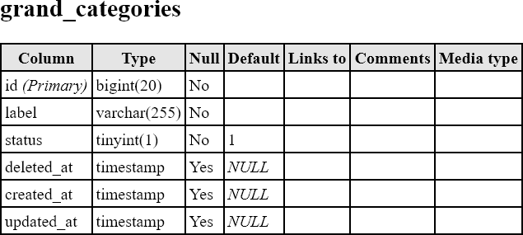

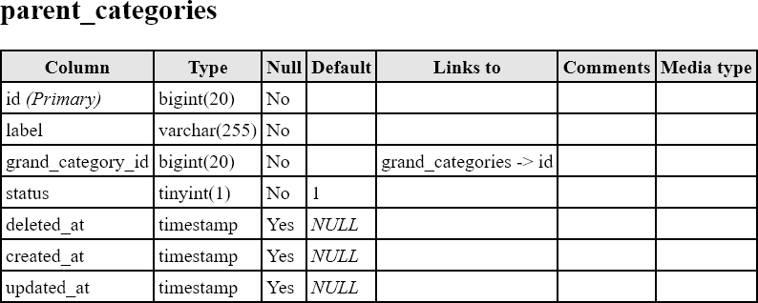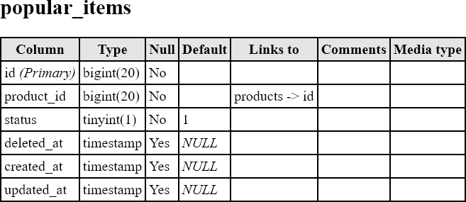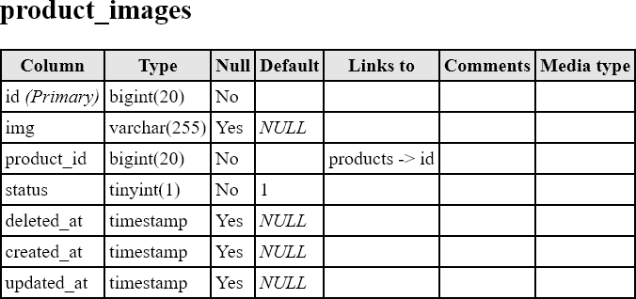

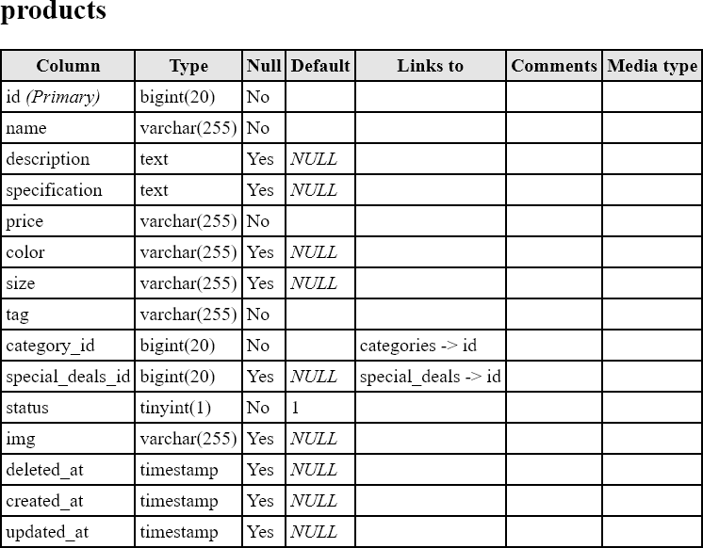

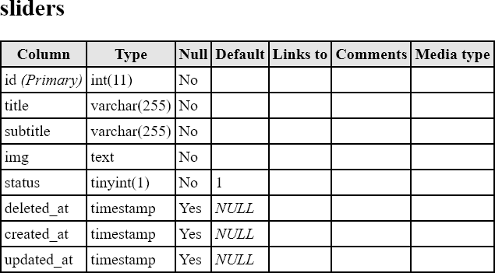

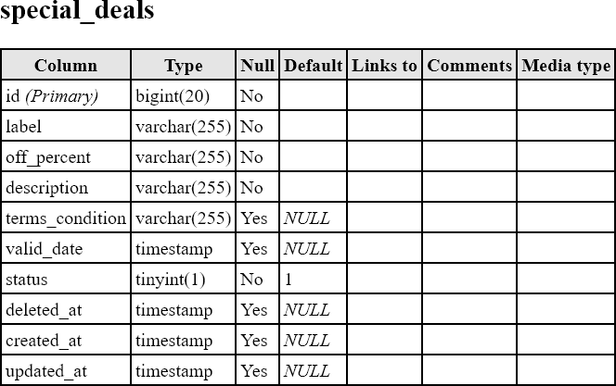

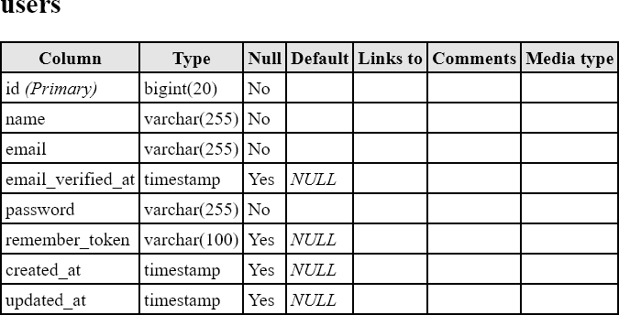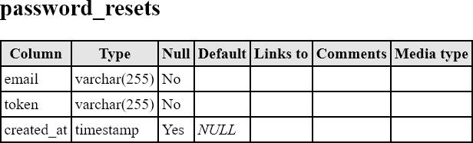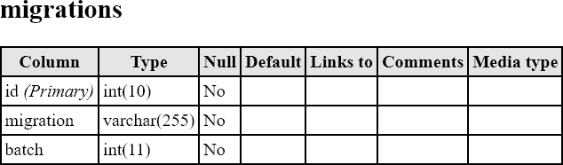

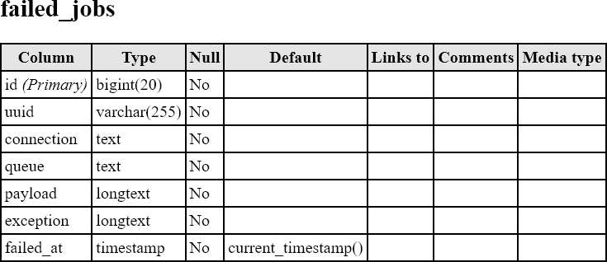

* + 1. E-R Diagram
       1. Overview

An entity relationship diagram is a graphical representation of an information. That show relationship between entities or Attributes.

## Notation

|  |  |
| --- | --- |
| Entity |  |
| Attribute |  |
| Relation |  |
| Key Attribute |  |
| Derived Attribute |  |
| Multi value Attribute |  |

* + - 1. Diagram

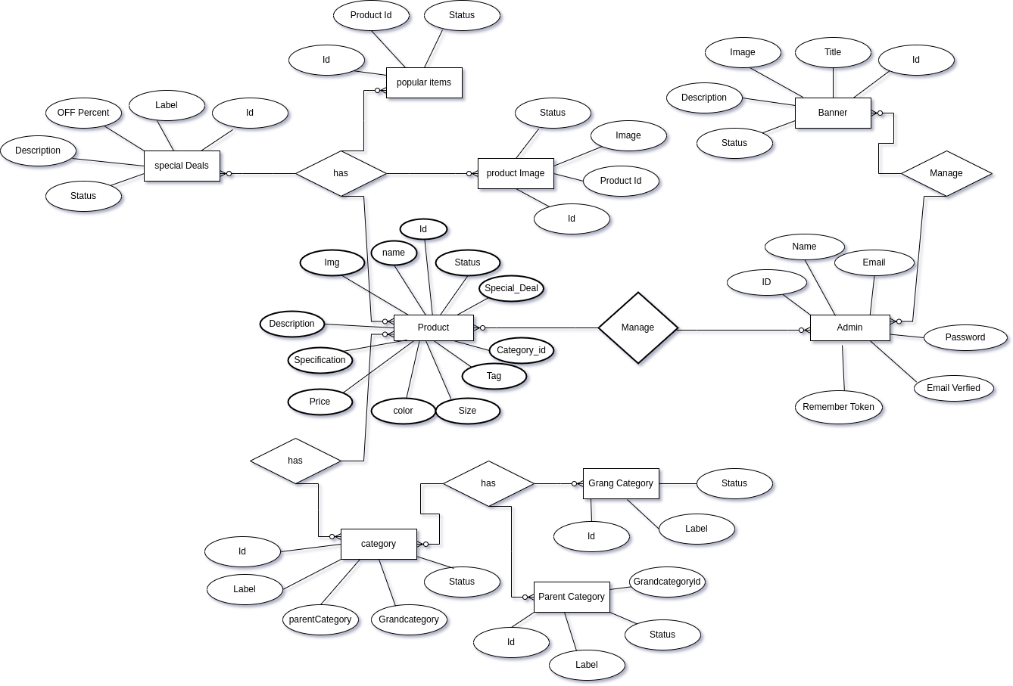

Fig. 5.2.2.3.1 Entity Relationship Diagram

## Object Interaction (Sequence Diagram)

* + - 1. Overview

A sequence diagram is structured in such a way that it represents a timeline which begins at the top and descends gradually to mark the sequence of interaction. Each object has a column and the message exchange between them are represented by arrows.

## Notation

|  |  |
| --- | --- |
| Object |  |
| Actor |  |
| Timeline |  |
| Synchronous Message |  |
| Activation |  |
| Reflexive Message |  |

* + - 1. Diagram

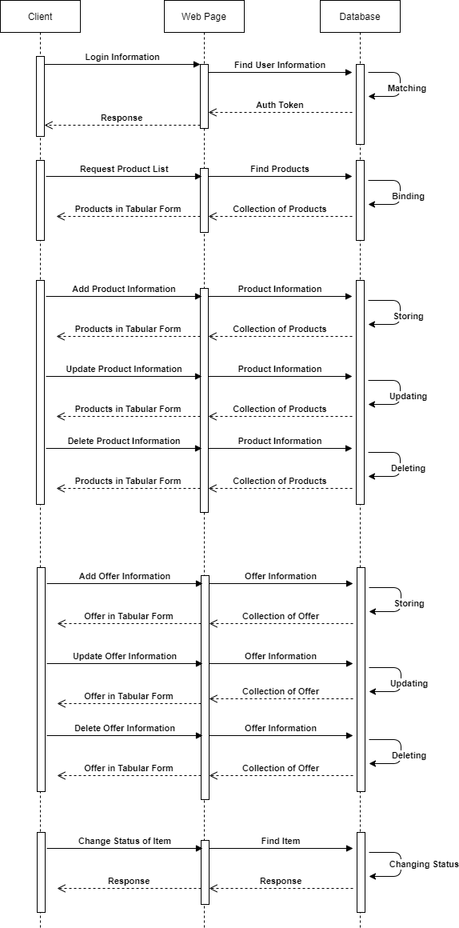

Fig. 5.2.3.3.1 Object Interaction Diagram

## System Activity

* + - 1. Overview

Activity diagram is basically a flowchart to represent the flow from one activity to another activity. The activity can be described as an operation of the system. The control flow is drawn from one operation to another. This flow can be sequential, branched, or concurrent. Activity diagrams deal with all type of flow control by using different elements such as fork, join, etc.

## Notation

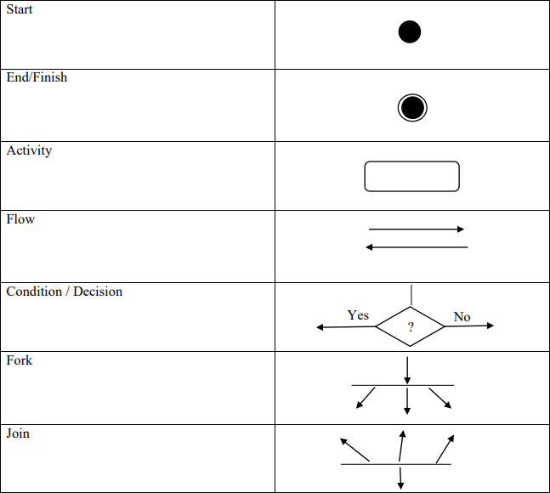

* + - 1. Diagram

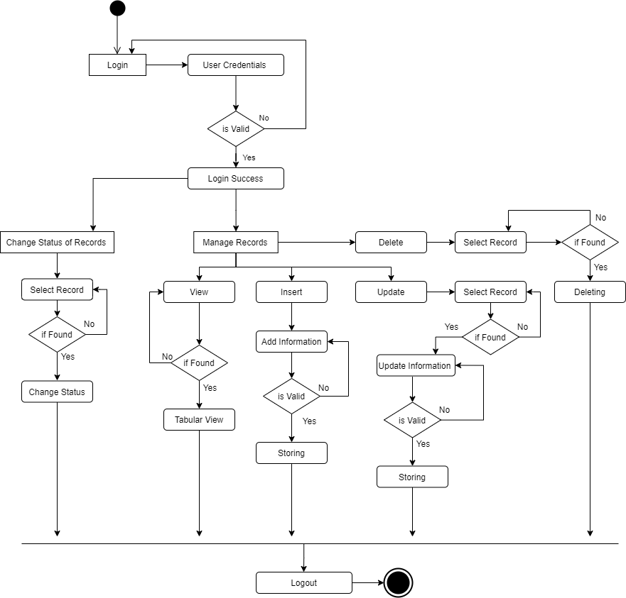

Fig. 5.2.4.3.1 Object Interaction Diagram

# Chapter 6 System Analysis

## 6.1 Feasibility Study

An importance outcome of the preliminary investigation is the determination that the system is feasible or not. The main aim of the feasibility activity is to determine whether it would be financially or technically to develop a project.

### Technical feasibility:

* + The technical issues usually raised during the feasibility stage of the investigation include the technology, the developer’s awareness about the technology, accuracy, reliability and expansion of the system.
  + The following factors were considered for technical feasibility while developing this application.
  + Here we preferred NodeJS with MongoDB behind for customizing the software, Moreover, owing to the user friendliness of online marketing.

### Operational feasibility:

* + Operational feasibility measures how well the solution will work in the organization and how will end-user & management feel about system?
  + Proposed system will allow the users to query and get the appropriate and adequate information.
  + The organization was very enthusiastic and optimistic with the development of the proposed system because prior to the development of the system, there was no provision for Spatial Querying.
  + So, there was a lot of support from the organization for developing this project. Software should work properly according to owner of company.

### Schedule feasibility:

* + Software must be completed within half year.

### Economic feasibility:

* + It does not require any other equipment and extra expenses in software, so it is economical.

# Chapter 7 ADVANTAGES AND FUTURE ENHANCEMENT PLAN

## Advantages

* + - Easy to use User Interface.
    - Help client to grow his business with modern world.
    - Do not need any installation for client system.

## Future Plan

* + - We can implement Payment Gateways in this application.
    - We can improve the User interface for more smooth working of web application.
    - Online Ordering for Accessories.

# Chapter 8 Screenshots

## 8.1 Screenshots

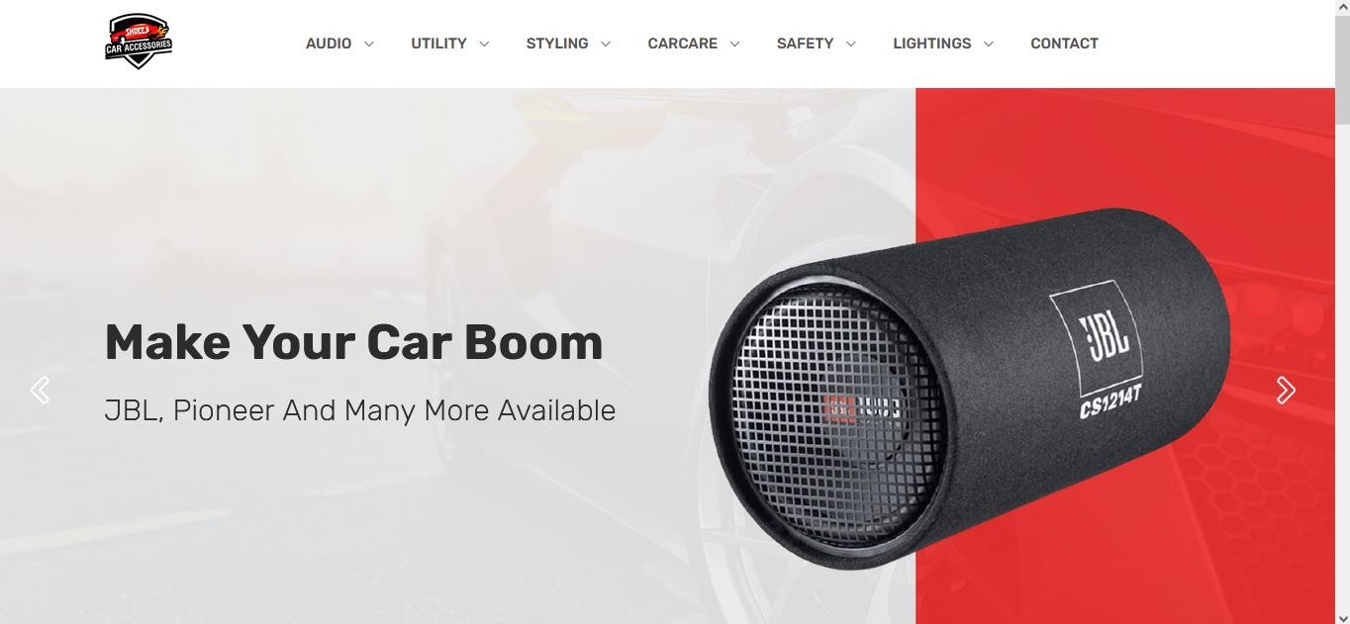

Fig. 8.1.1 Main (Landing) View (Computer View)

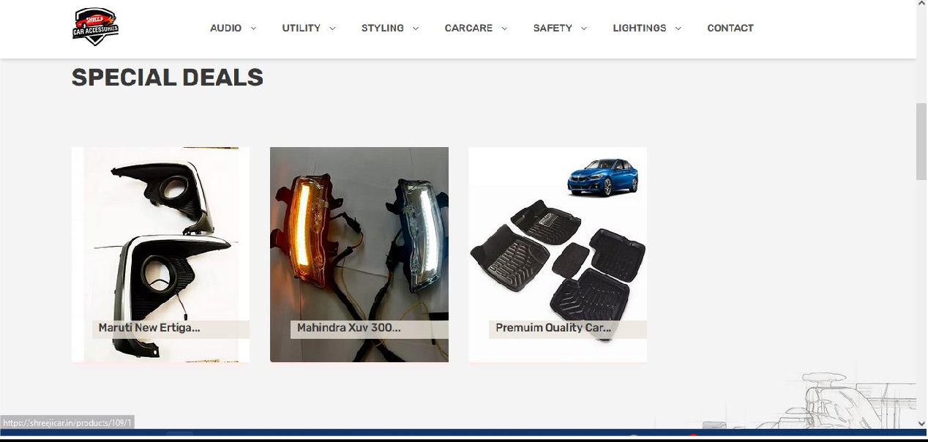

Fig. 8.1.2 Main View - Special Deals (Computer View)

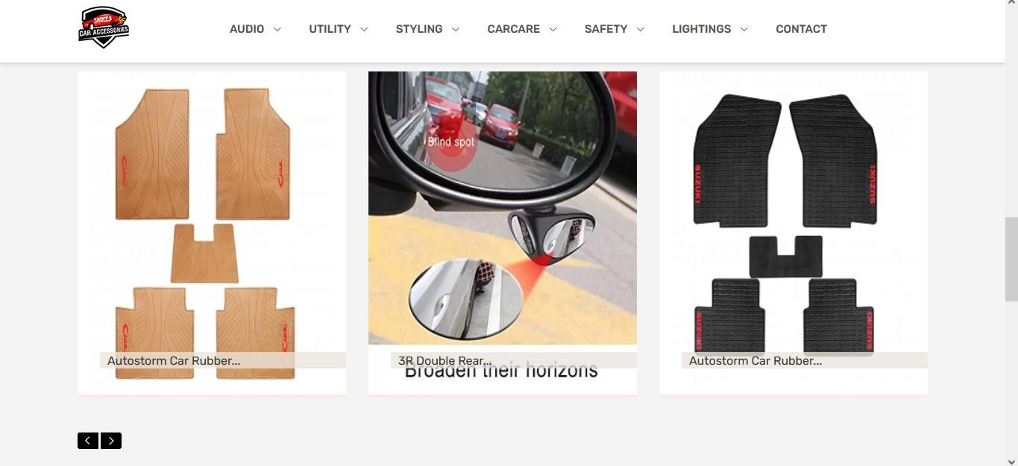

Fig. 8.1.3 Main View – Popular Items (Computer View)

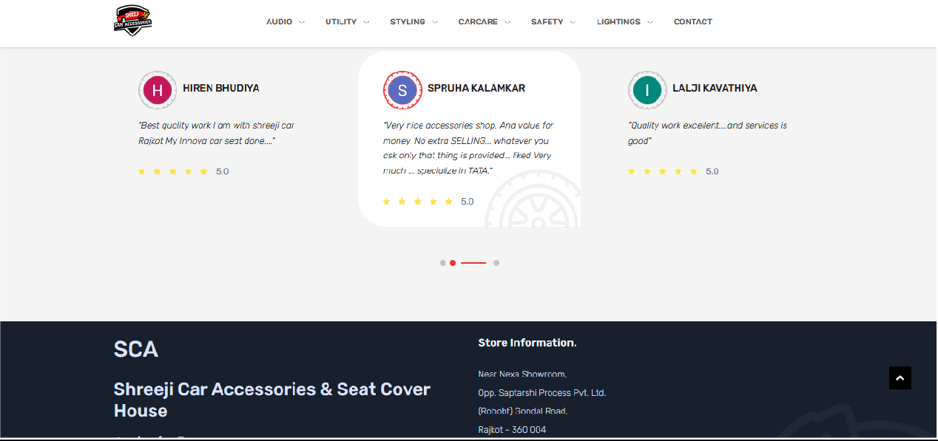

Fig. 8.1.4 Main View – Store Information and Review (Computer View)

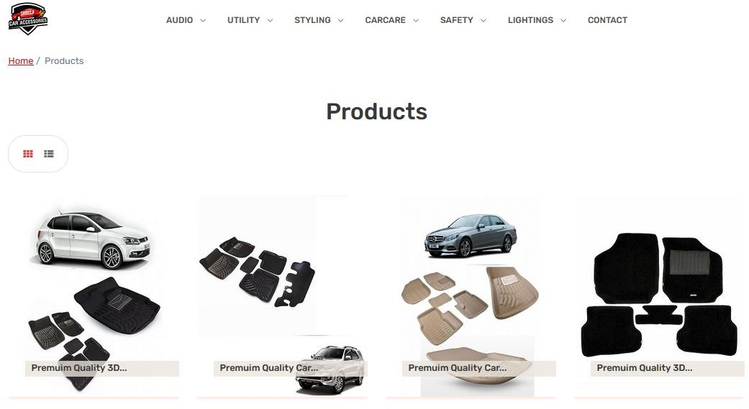

Fig. 8.1.5 Products List View (Computer View)

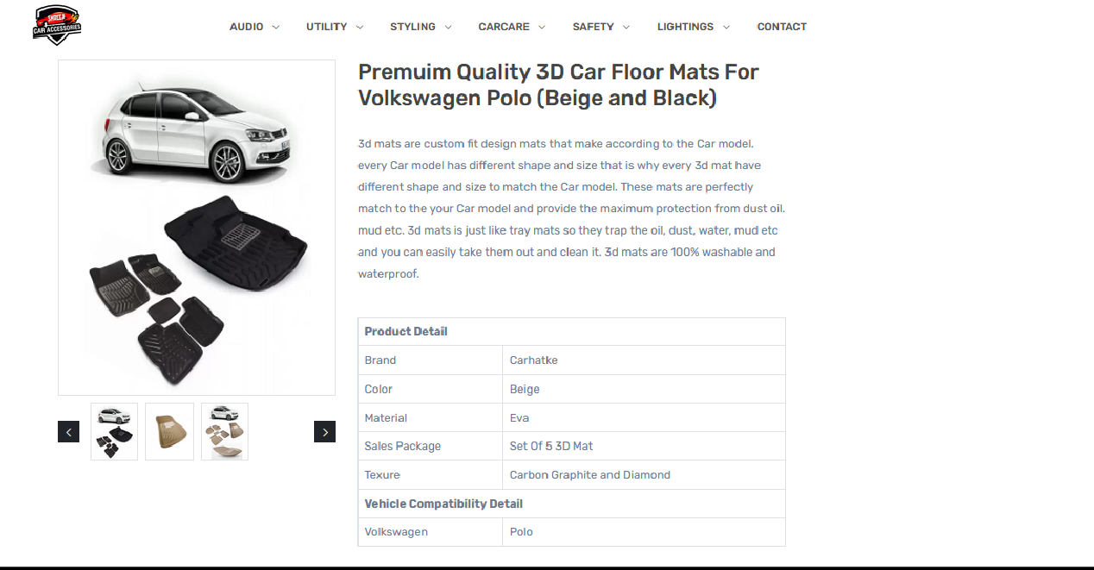

Fig. 8.1.6 Single Product View (Computer View)

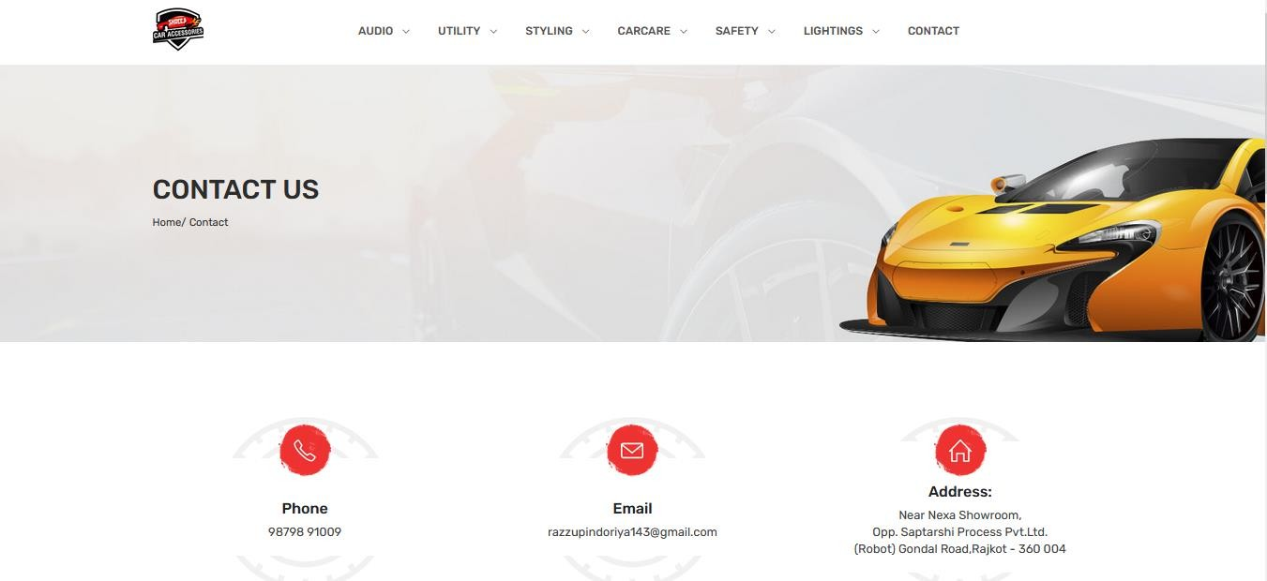

Fig. 8.1.7 Contact us View (Computer View)

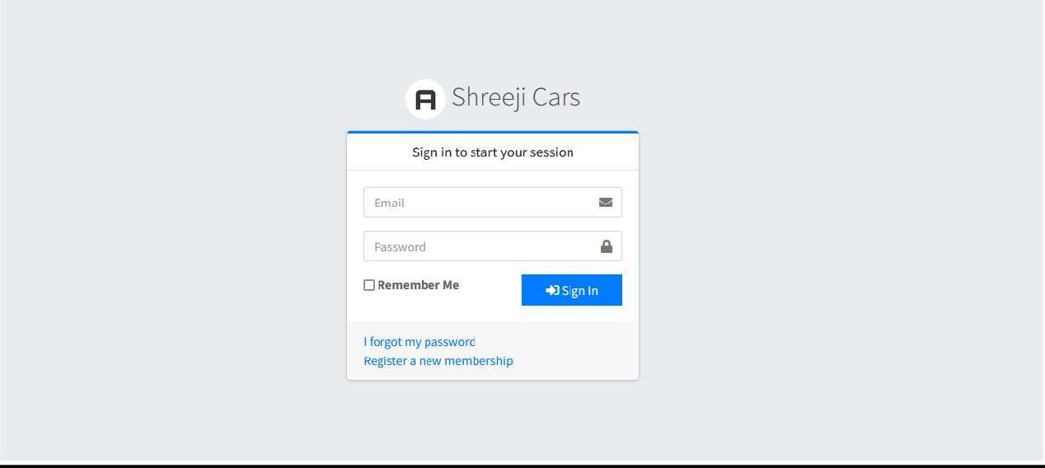

Fig. 8.1.8 Login For Admin (Computer View)

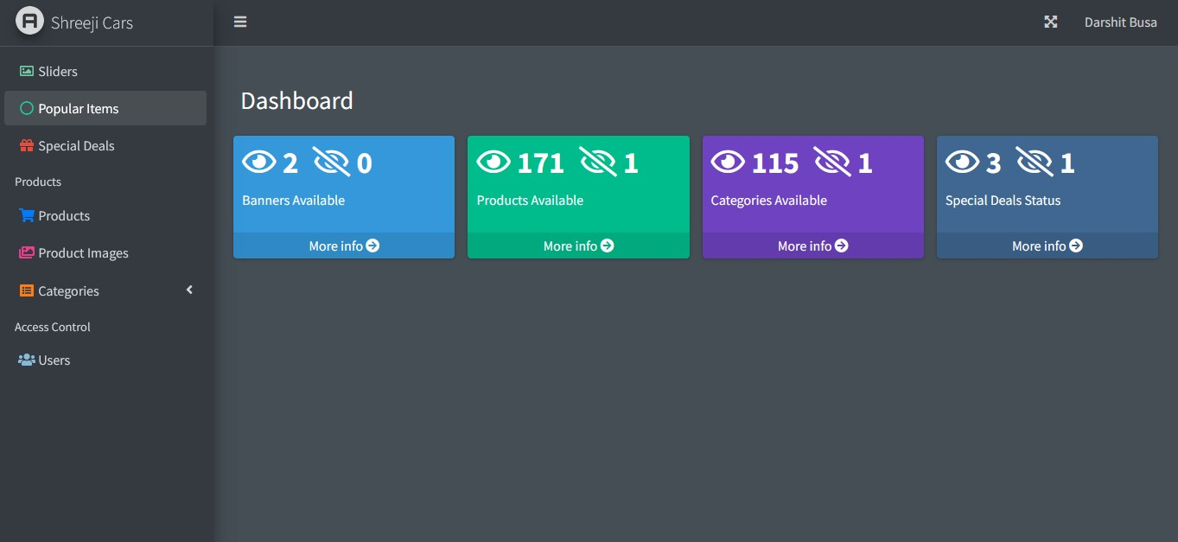

Fig. 8.1.9 Admin Dashboard View (Computer View)

 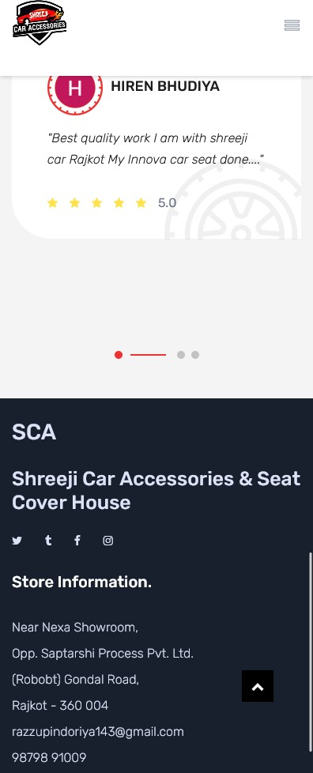

Fig. 8.1.10 Main View (Mobile View)

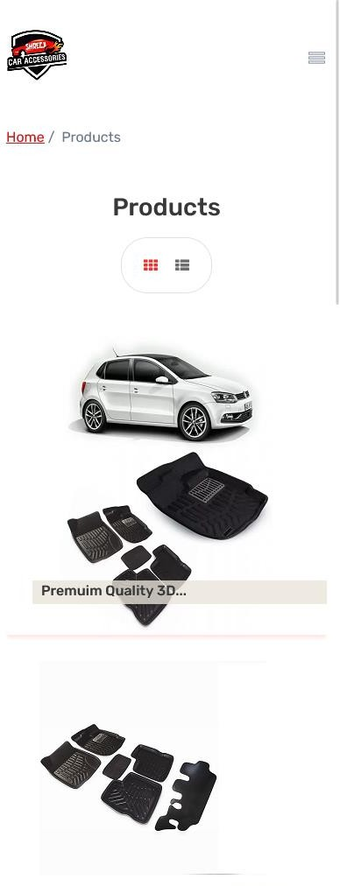 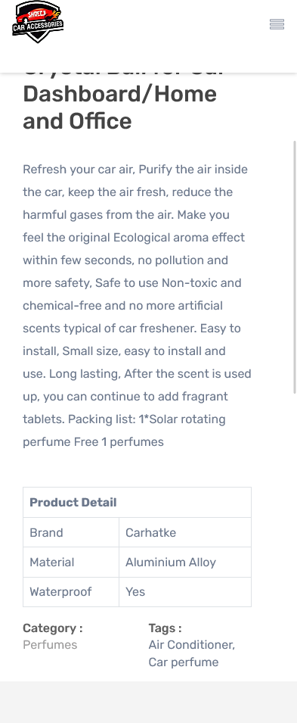

Fig. 8.1.11 Products List & Single Product View (Mobile View)

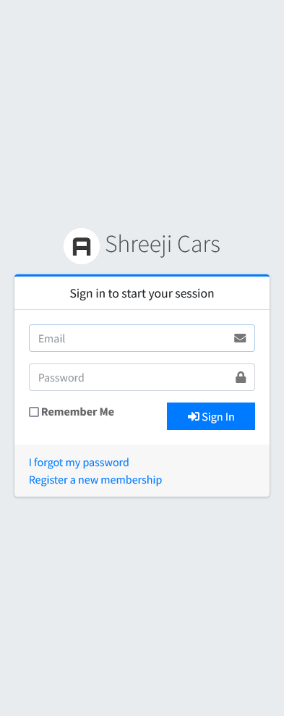 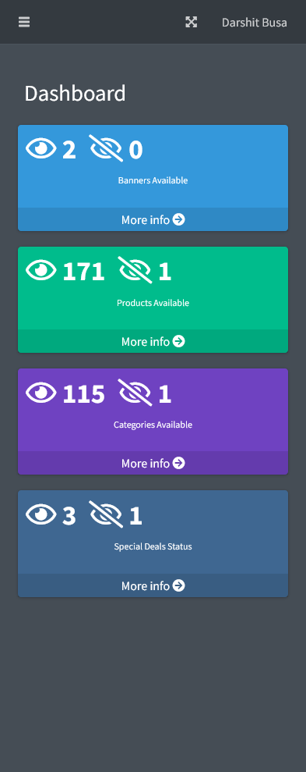

Fig. 8.1.12 Admin Login and Dashboard View (Mobile View)

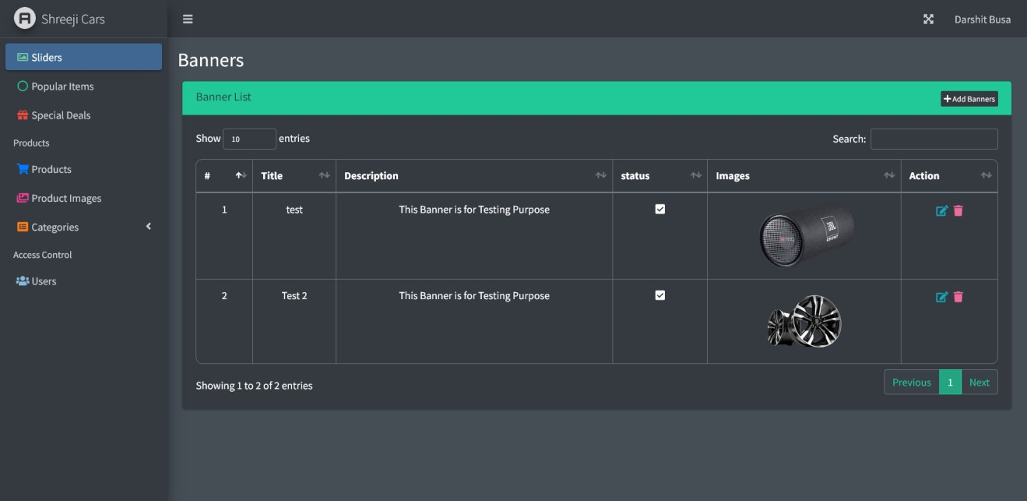

Fig. 8.1.13 Admin Banner Maintain View (Desktop View)

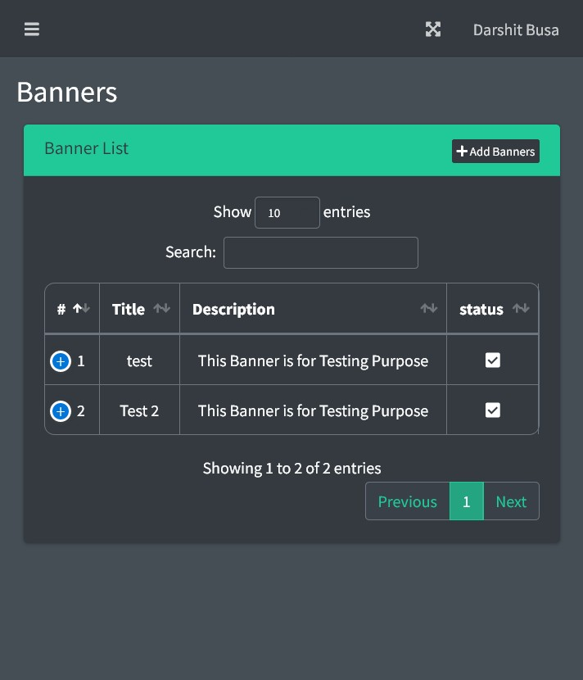

Fig. 8.1.14 Admin Banner Maintain View (Mobile)

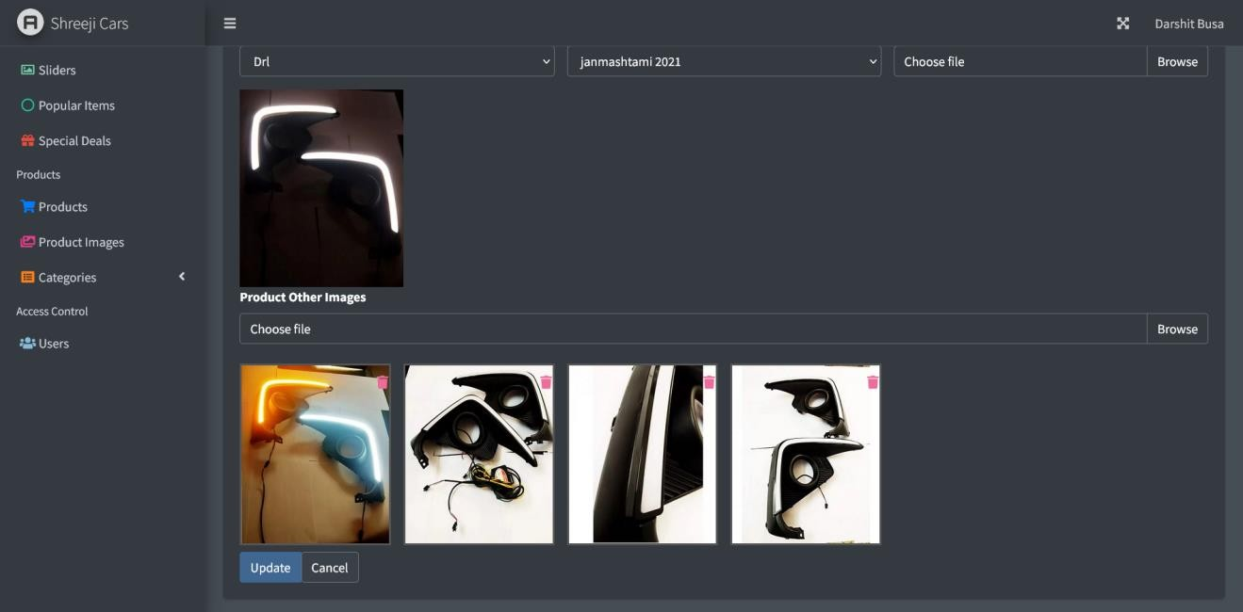

Fig. 8.1.15 Multiple Image Support (Desktop View)

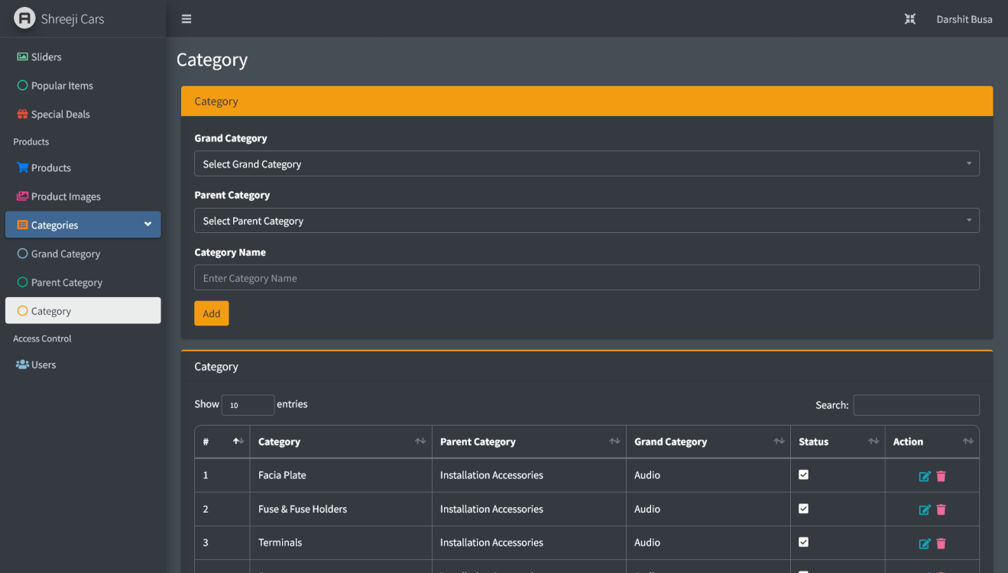

Fig. 8.1.16 Category Module (Desktop View)

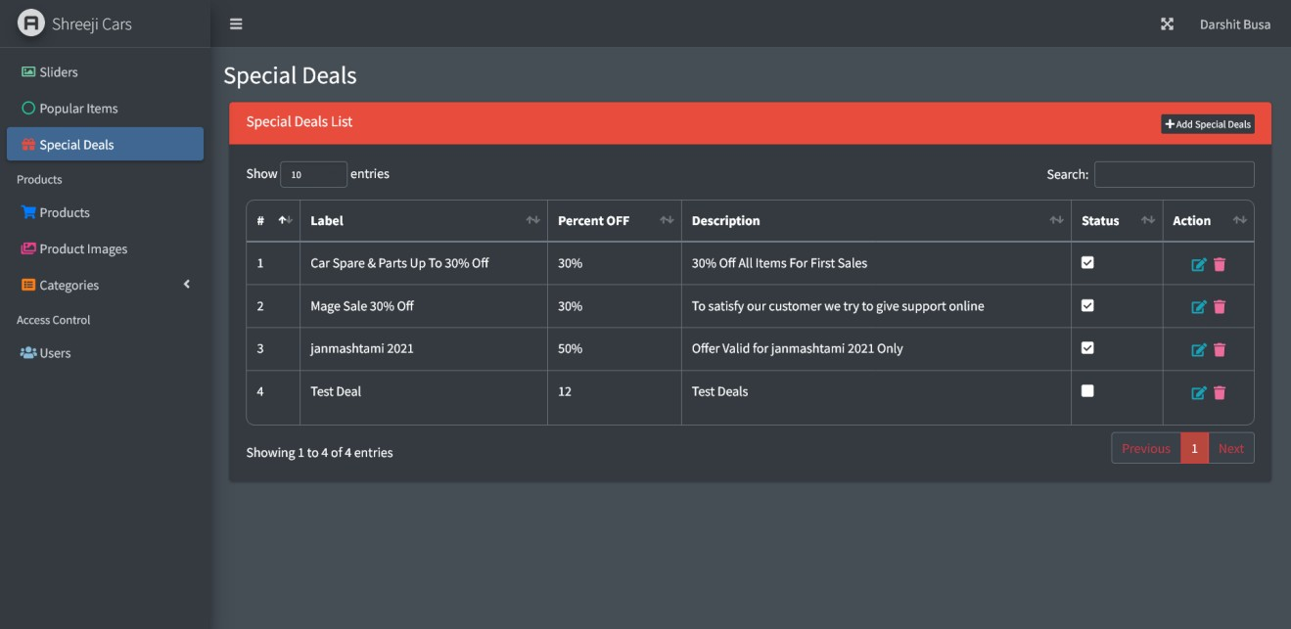

Fig. 8.1.17 Special Deals Maintain (Desktop View)

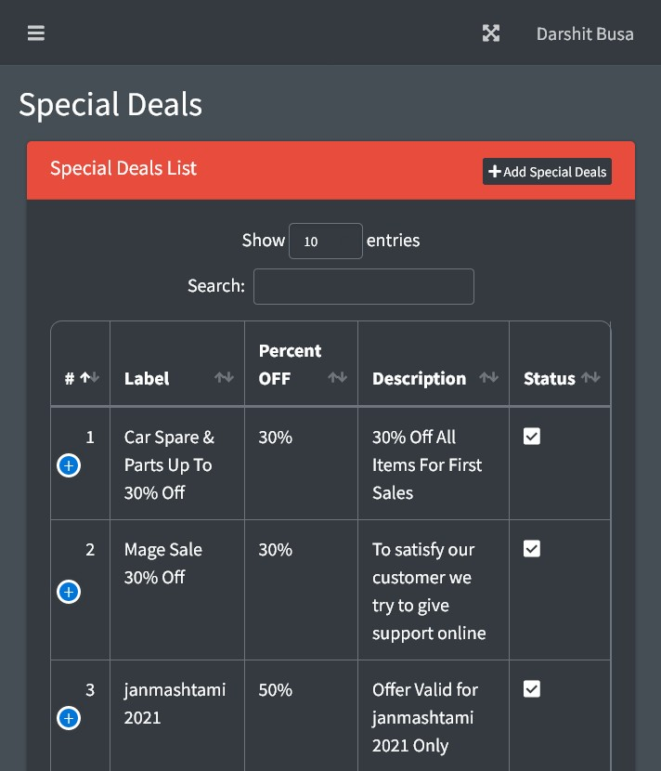

Fig. 8.1.18 Special Deal Maintain (Mobile View)

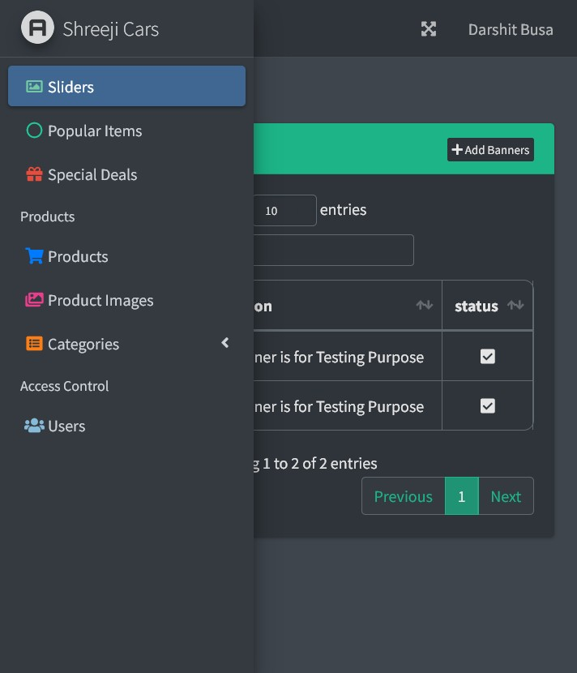

Fig. 8.1.19 Admin sidebar (Mobile View)

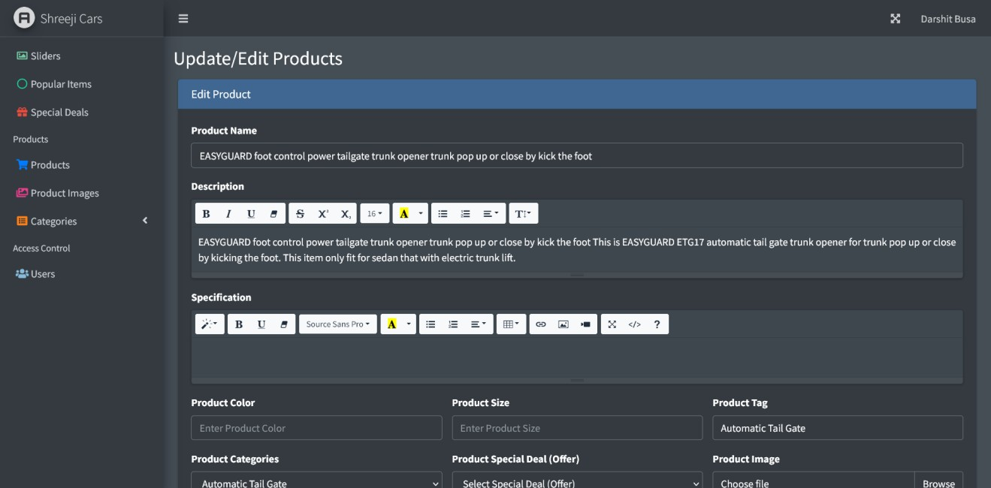

Fig. 8.1.20 Admin Product Edit View (Desktop View)

## 9.1 Conclusion

# Chapter 9 Conclusion

This web application is beneficial for the client to upgrade the business. This web application provides a user-friendly interface So that users can interact easily with the web application.

## Website

# Chapter 10 References

* + - <https://adminlte.io/>
    - <https://laravel.com/>
    - <https://github.com/jeroennoten/Laravel-AdminLTE/wiki/>
    - <https://stackoverflow.com/>
    - <https://getbootstrap.com/docs/5.0/getting-started/introduction/>