SILREC User Guide

SILvicultural RECording System (SILREC) records harvest and other disturbance activities in State Forest, monitors change in stand status, and tracks follow-up silvicultural treatments to ensure objectives are achieved. It provides feedback to silvicultural staff on operations, offers a unified data capture system for integration with other platforms, and generates a range of output reports and GIS maps to support decision-making.

SILREC was developed in 1993, with three major versions released. Version 1 and 2 were operated in a dual MicroStation/Access environment, while Version 3 runs on a Postgresql/PostGIS and Django framework.

1. The Workflow
Draft | Processing  Shapefile | With  Operator | With  Reviewer | Review  Completed
Operator can upload &  process shapefile | Process Shapefile  Revert  Processed Shapefile  Keep  Processed Shapefile | Operator completes  data entry  (cohorts, treatments) | Reviewer reviews and  approves/rejects | Final status -  proposal closed
 | Operator / Silrec Admin  can send to  With Operator | Operator can send  to With Reviewer | Reviewer can move to  Review Completed  Reviewer can send back  to With Operator | Only Silrec Admin  can reopen to  With Reviewer
Operator can return
to Draft

Transitions Between Statuses
From → To | Transition | Permitted Roles
Draft → Processing  Shapefile | Upload & process shapefile | Operator
Processing  Shapefile → With  Operator | Processing complete → With Operator | Operator,  Silrec Admin
With  Operator → With  Reviewer | Send to Reviewer | Operator,  Silrec Admin
With  Operator → Draft | Return to Draft | Operator,  Silrec Admin
With  Reviewer → Review  Completed | Approve → Review Completed | Reviewer,  Silrec Admin
With  Reviewer → With  Operator | Send back to Operator | Reviewer,  Silrec Admin
Review  Completed → With Reviewer | Reopen | Silrec Admin
Role Definitions
Role | Description
User | View-only access. Can see proposals but cannot change status.
Operator | Can upload shapefiles, enter data, send to reviewer. Core data entry role.
Reviewer | Can review, approve, or return proposals to operator.
Silrec Admin | Full access. Can act as any role and override status transitions.

Note: A user can belong to multiple groups. For example, an Operator who also reviews can be assigned both Operator and Reviewer groups.

1.1 Processing Status Workflow
Every proposal (application) moves through a lifecycle managed by its `processing_status` field. The status determines what actions are available and who can perform them.
Draft
│ (upload & process shapefile)
▼
Processing Shapefile
│ (processing completes)
▼
With Operator
│ (operator completes data entry)
▼
With Reviewer
│ (reviewer approves/rejects)
▼
Review Completed

Key statuses and what they mean:
Status | Meaning
`Draft` | Proposal created, shapefile not yet uploaded
`Processing Shapefile` | Shapefile is being processed (locked to other proposals)
`With Operator` | Operator can enter cohort & treatment data
`With Reviewer` | Reviewer checks the data
`Review Completed` | Reviewer has signed off
`Amendment Required` | Changes requested, sent back to operator
`Declined` / `Discarded` | Proposal rejected or abandoned
How to transition: Use the workflow buttons at the bottom of the proposal detail page. Each button appears only when the permitted user role and current status match.

Example Workflow Buttons

1.2 Role Workflow
SILREC defines four user groups with increasing permissions:
Group | Capabilities
**User** | View-only access to proposals, treatments, map, reports, search
**Operator** | Create/edit proposals, upload/process shapefiles, enter cohort and treatment data, send proposals to reviewer
**Reviewer** | Review proposal data, send back to operator, approve/review-complete
**Silrec Admin** | Full access — can bypass transitions, manage users, configure system settings
Visual indicator: The navigation menu and action buttons adjust automatically based on your role. If a button is missing or grayed out, your current role does not permit that action for the proposal's current status.

1.3 User Group Configuration
How to add users to groups:
1. Log in to the Django Admin site at `/admin/` (Silrec Admin access required).
2. Go to Authentication and Authorization > Users.
3. Select the user you want to configure.
4. Under Groups, select one or more of: `User`, `Operator`, `Reviewer`, `Silrec Admin`.
5. Save the user.
**Note:** A user can belong to multiple groups. For example, an Operator who also reviews can be assigned both `Operator` and `Reviewer`.
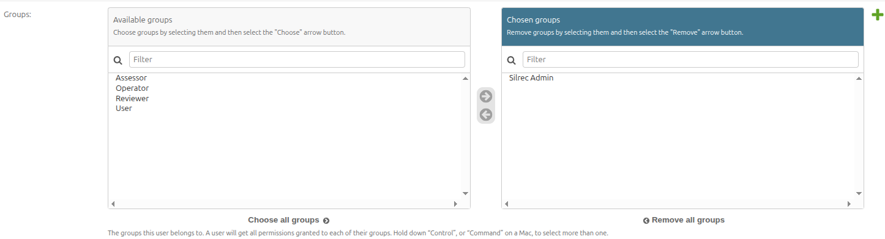
Admin User Groups

2. New Application

2.1 Upload Shapefile
1. From the Proposals dashboard, click the proposal's Lodgement Number to open it.
2. Find the Shapefile section.
3. Click Upload Shapefile and select your `.zip` file containing the shapefile components (`.shp`, `.dbf`, `.prj`, `.shx`).
4. A single `.zip` or individual component files are accepted.
5. After upload, the shapefile attributes will be displayed for validation.
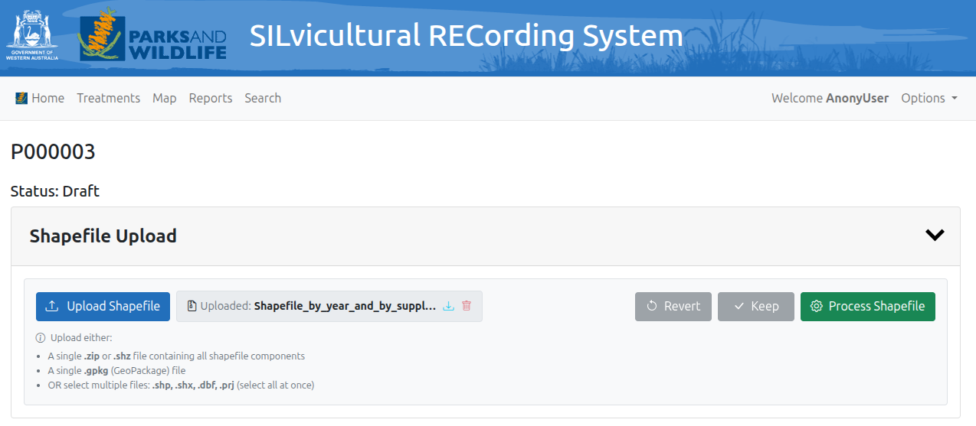
Shapefile Upload

2.2 Shapefile Attribute Validation Framework
When a shapefile is uploaded, the system validates its attributes against the Shapefile Attribute Config for the proposal's application type:
- Mandatory fields — must be present in the shapefile; missing fields are flagged.
- Data types — each attribute is checked against its expected type (text, number, etc.).
- Reserved fields — certain field names are reserved for system use.
To configure attribute validation rules (Silrec Admin only):
1. Go to `/admin/`.
2. Navigate to Proposals > Shapefile attribute configs.
3. Filter by Application type to see rules for a specific proposal type.
4. Each record defines:
- `field_name` — the expected shapefile column name
- `display_name` — a user-friendly label
- `is_mandatory` — whether this field is required
- `data_type` — expected data type (string, integer, float, date)
- `target_db_field` — optional mapping to a database field (format: `app_base.app_label.model_name.field_name`)
Clone an existing config row: Select one row, choose the "Clone selected record" action, provide a new field name, and the system copies all settings.
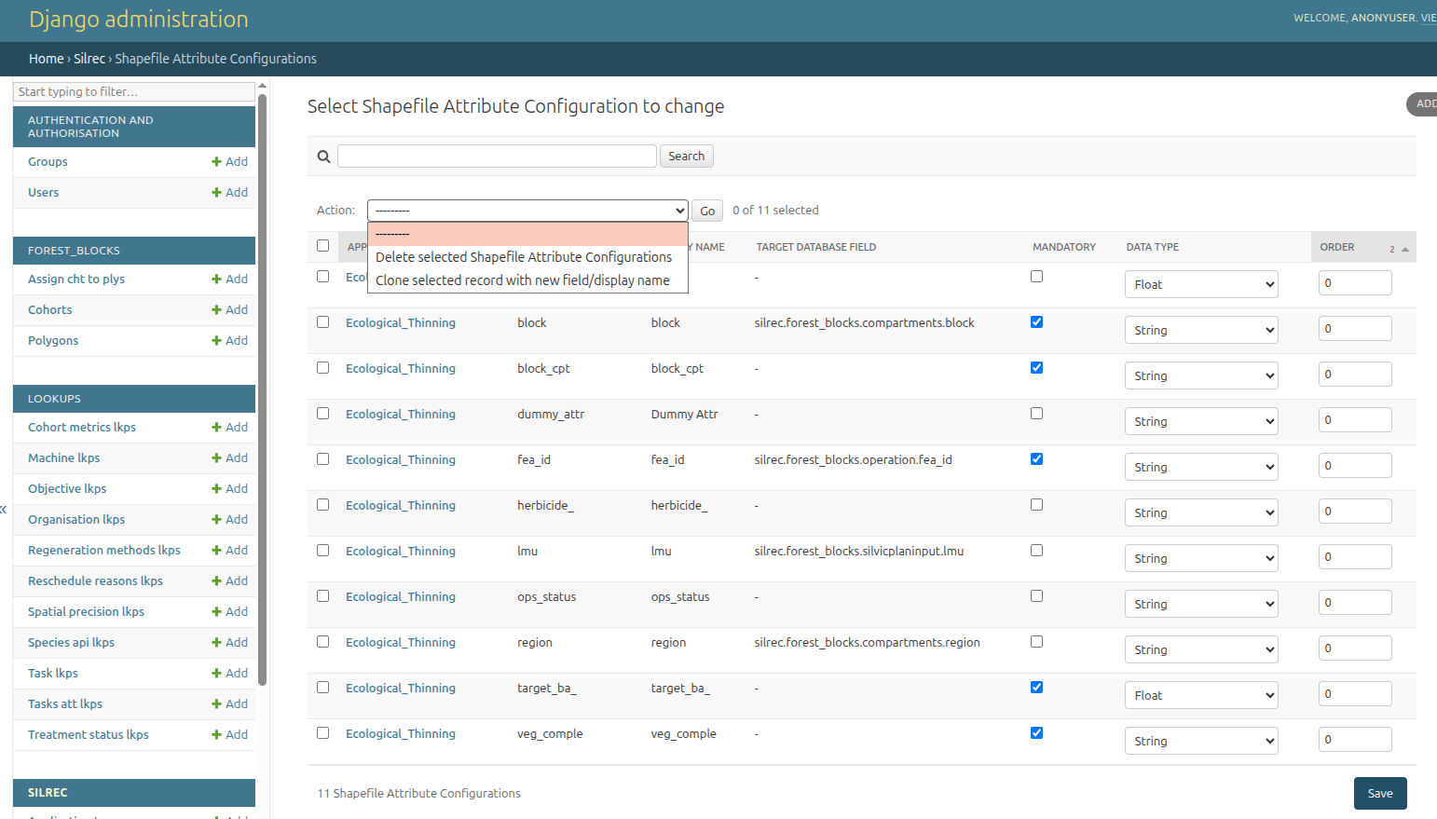
Admin Shapefile Attribute Configuration

2.3 Process Shapefile
Once the shapefile passes attribute validation:
1. Click Process Shapefile.
2. The system runs the ShapefileSliversMerger — it:
- Projects the geometry to the working CRS
- Detects and dissolves sliver polygons (area/length ratio below threshold)
- Detects and resolves polygon overlaps
- Writes the processed data into the `polygon` table
- Creates `cohort` and `assign_cht_to_ply` records
3. Processing is tracked via Processing Runs and Savepoint Records, showing each iteration and the changes made.
4. While processing is running, the proposal is locked — no other proposal can be processed simultaneously (shows a lock icon on other proposals).
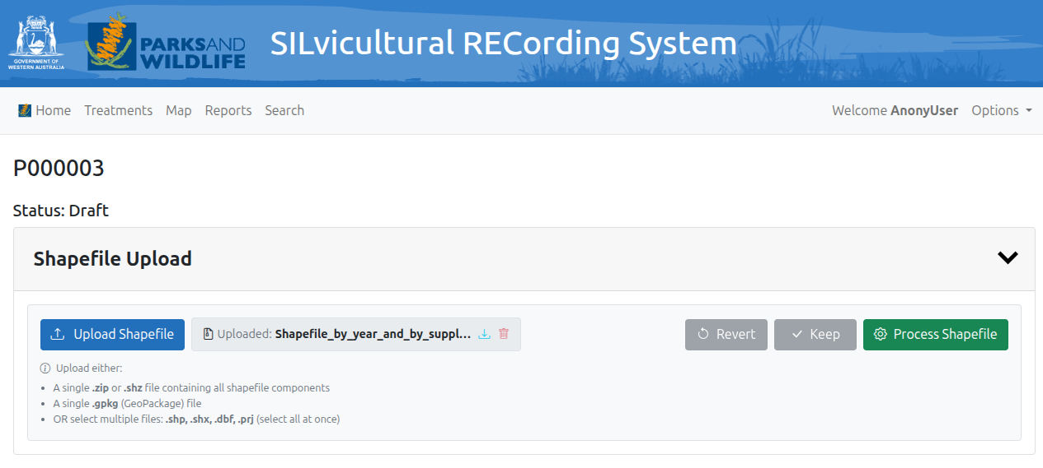
Process Shapefile Button

2.4 Keep / Revert

After shapefile processing completes:
- Keep — confirms the processed data is correct and transitions the proposal to With Operator status.
- Revert — undoes all changes made during processing, restoring the 3 core tables (`polygon`, `cohort`, `assign_cht_to_ply`) to their pre-processing state.
The revert mechanism uses either:
- Savepoint (default): The system creates baseline backups of the 3 core tables before processing. Revert truncates and re-inserts from those backups.
- pg_dump: A database dump is taken before processing; revert uses `pg_restore --clean`.
Both mechanisms also create a `pg_dump` file as a secondary backup.
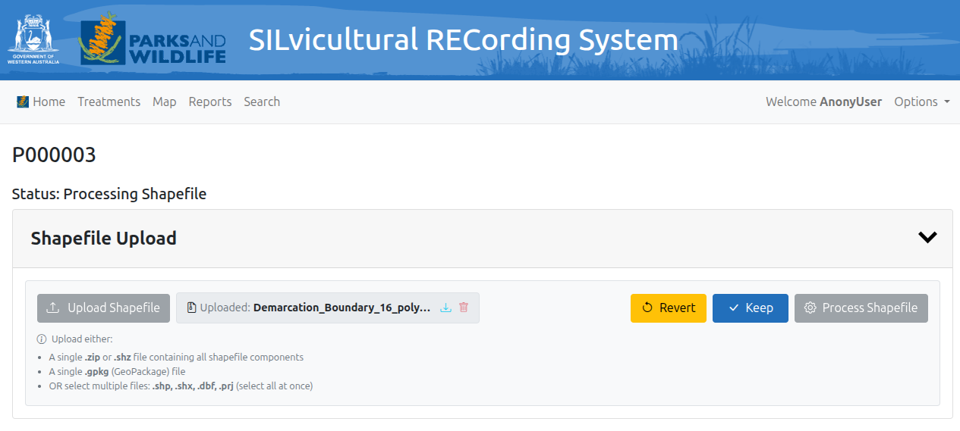
Keep Revert Button

2.5 Datatable Dashboard
The main Proposals dashboard displays all proposals in a DataTable with:
- Filters — collapse/expand filter panel above the table:
- Type (application type dropdown)
- Status (processing status dropdown)
- Lodged From / Lodged To (date pickers)
- Sorting — click any column header to sort
- Search — the DataTable search box searches across all visible columns
- Locked proposals — proposals currently processing appear first in the list with a lock icon
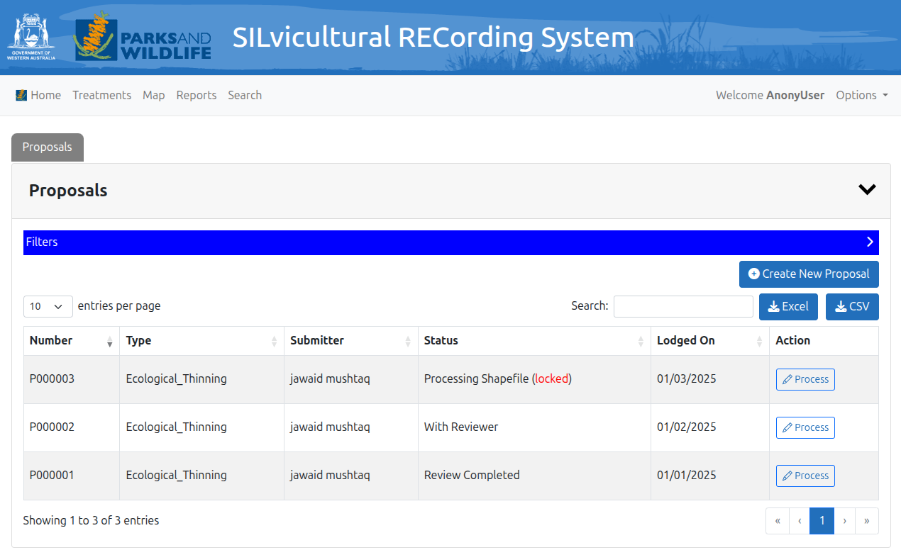
Proposals Dashboard

2.5.1 Navigating Each Record
Click any proposal's Lodgement Number to open its detail page. The detail page shows:
- Proposal header with lodgement number and current status
- Status transition comment alerts (if status was recently reverted)
- An Application Form for different data sections
- A fixed bottom navbar with workflow action buttons
[Screenshot: proposal-detail.png]

2.5.2 Adding/Updating Data in Forms (Cohorts, Treatments, etc.)
Within a proposal detail page:
- Cohorts — each polygon can have one or more cohorts (species groups). Navigate via the polygon/cohort data table or the linked detail routes.
- Treatments — each cohort can have one or more treatments (silvicultural activities). Each treatment has:
- Task, classification, status
- Planned year/month, completed date
- Machine, operator details
- Area, cost information
- Prescriptions — silvicultural prescriptions linked to treatments
- Silviculturist Comments — free-text notes on treatments
- Survey Assessment Documents — uploaded documents (shapefiles, PDFs, images) linked to treatments
To edit: click the edit icon or the record link, fill in the form, and save. Forms use Select2, date pickers, and validation rules.
[Screenshot: cohort-form.png]
[Screenshot: treatment-form.png]

2.5.3 Admin Form Validation Framework
The Form Validation Rules (configured at `/admin/` under Silrec > Form validation rules) define which fields are required or optional per model, per status. For each rule:
- `model_name` — e.g., `forest_blocks.Treatment`
- `field_name` — the model field
- `field_label` — display label
- `is_required` — ticked if the field must be filled
- `status_values` — JSON list of proposal statuses where this rule applies
- `order` — display order
Admins can clone an existing rule to create a new one with the same settings but a different field name or target model. The clone page shows all available fields for that model that are not already configured.
[Screenshot: admin-form-validation-rules.png]
[Screenshot: clone-form-validation-rule.png]

3. Treatments Menu Item
The Treatments page (navigate via the top menu) provides a standalone treatments datatable, independent of any specific proposal.

3.1 Filtering and Searching Records
The Treatments table offers:
- Collapsible filter panel with:
- Task Classification (parent filter) — selecting a classification filters the Task dropdown
- Task (child filter) — searchable dropdown that updates based on classification
- Status — filter by treatment status
- Plan Year / Plan Month — filter by planned date
- Complete Date Range — filter by completion date
- Machine — filter by machine used
- Operator — filter by assigned operator
- DataTable features: sort by column, global search box, pagination
- Refresh button to reload data
[Screenshot: treatments-datatable.png]

3.2 Adding/Updating Data
Click a treatment record to open the Treatment Detail page (`/internal/treatment/{id}/`). Here you can:
- Edit treatment fields (task, status, dates, area, cost, etc.)
- Add Treatment Extras (additional line items for a treatment)
- Add Prescriptions (silvicultural instructions)
- Add Silviculturist Comments
- Upload Survey Assessment Documents
Each sub-form has its own save button. The form validation framework (see 2e.iii) applies here too — fields marked as required for the current status must be filled before the record can transition.
[Screenshot: treatment-detail.png]
[Screenshot: treatment-extras-form.png]

3.3 Admin Form Validation Framework
Identical to section 2e.iii — the same `FormValidationRule` model governs field requirements for treatment forms. Rules with `model_name` starting with `forest_blocks.Treatment`, `forest_blocks.TreatmentXtra`, etc. apply here.

4. Map Menu Item
The Map page (`/internal/map`) provides a spatial view of all polygons with filtering and search capabilities.

4.1 Filtering and Searching Records
The map includes:
- Search by text — find polygons by compartment, block, district, FEA ID, objective code
- Filter panel with:
- Compartment
- Block
- District
- Objective classification
- Treatment status
- Created date range
- Post-2024 filter — automatically filters to records matching the configured plan period (`OP_PLAN_PERIOD`)
- Map navigation — pan, zoom, click features
- Click a feature to open a popup showing:
- Block, compartment number
- FEA ID
- Area (ha)
- Objective code
- Link to polygon detail page
[Screenshot: map-view.png]
[Screenshot: map-feature-popup.png]

4.2 Adding/Updating Data
Clicking a feature on the map opens the feature popup. From there, click through to the Polygon Detail page where you can:
- View polygon attributes
- Navigate to linked Cohorts (via the polygon/cohort data table)
- From cohorts, navigate to Treatments
- Add/edit data via the same forms described in sections 2e.ii and 3b
**Note:** The map supports merge and cut polygon tools (toggled by `SHOW_MERGE_POLYGON_TOOL` and `SHOW_CUT_POLYGON_TOOL` settings). When enabled, you can merge two adjacent polygons or split a polygon using a cutting line.
[Screenshot: merge-polygon-tool.png]
[Screenshot: cut-polygon-tool.png]

5. Reports Menu Item
The Reports page (`/internal/reports`) provides a configurable report generator.

5.1 Selecting Reports and Output Formats
1. Step 1: Select Report — choose a report type from the dropdown. Each report has a description explaining what it shows.
2. Step 2: Set Parameters — depending on the report, you may see:
- Single Select dropdowns
- Multi-Select (Select2 tag mode) — select multiple values
- Year Enhanced — enter a single year, comma-separated years (e.g., `2024,2023`), or a range (e.g., `2020-2024`)
- Text / Number input fields
- Date picker
- Month select
- Range (two values for BETWEEN operator)
- Custom WHERE clause — advanced users can add field/operator/value filters
3. Step 3: Select Export Format:
- Excel (.xlsx)
- CSV (.csv)
- PDF (.pdf)
- Shapefile (.shp) — downloads a zipped shapefile
4. Click Generate Report to download, or Preview Data to see results in a modal first.
[Screenshot: report-step1-select.png]
[Screenshot: report-step2-parameters.png]
[Screenshot: report-step3-format.png]
[Screenshot: report-preview-modal.png]

5.2 Configurable Word Templates for PDF Reports
PDF reports use Word templates (`.docx`). Each report can have one or more Report Templates:
- Templates are uploaded and versioned in the admin interface
- One template per report is marked as current (the active version)
- When generating a PDF, the system renders the current template with report data

5.3 Configuration via Admin
Admin configuration is at `/admin/` under Proposals > Sql reports.
[Screenshot: admin-sql-reports.png]
[Screenshot: admin-sql-report-edit.png]

5.3.1 Clone from Existing Report
1. Go to the SQL Reports list in admin.
2. Select one report.
3. Choose the Clone selected report action.
4. Enter a new name (and optional description).
5. The clone copies the SQL query, WHERE clauses, export formats, columns, and allowed groups. Templates are also copied with their current version flag.

5,3.2 Filter Configuration
Each report's WHERE clauses are defined as JSON in the admin form. Example:
[
{
"field": "year",
"operator": "YEAR",
"parameter_name": "year",
"label": "Select Year",
"field_type": "select",
"options_query": "SELECT DISTINCT EXTRACT(YEAR FROM date_column) FROM table ORDER BY 1 DESC",
"default_value": "2024",
"required": true
},
{
"field": "supply",
"operator": "=",
"parameter_name": "supply",
"label": "Select Supply",
"field_type": "multiselect",
"options_query": "SELECT DISTINCT supply FROM compartments ORDER BY supply",
"required": true
}
]
Field types available:
- `select` — single dropdown
- `multiselect` — multi-value (uses IN operator)
- `text` / `number` / `date` — simple inputs
- `year` / `year_enhanced` — year input (enhanced supports ranges)
- `month` — month selector
- `range` — two number inputs for BETWEEN

5.3.3 Preview Data / SQL
Before generating a full report:
1. Click Preview Data on the report generator page.
2. A modal opens showing:
- The generated SQL query (collapsible section)
- The first rows of data
3. This lets you verify that your parameters produce the expected results.

5.4 Generated Reports

5.4.1 Immediate Download
After clicking Generate Report:
- The report is generated asynchronously
- Once ready, it downloads directly to your browser
- The filename includes the report name and a timestamp

5.4.2 Options → Generated Reports
Previously generated reports are available for download:
1. Go to Options > Generated Reports (or navigate to `/mgt-commands/generated-reports/`).
2. A list shows all generated report files with timestamps.
3. Click a filename to download it.
4. Reports are kept for a configurable number of days (default: 20, set by `REPORT_RETENTION_DAYS` environment variable).
5. Silrec Admin users can delete individual report files if needed.
The cleanup is automatic via `python manage.py cleanup_generated_reports --keep-days 20`.
[Screenshot: generated-reports-list.png]

6. Search Menu Item
The Search page (`/internal/search`) provides three search modes accessed via tabs:

Text Search
1. Search Text — enter any text string (minimum 2 characters).
2. Records to Search — select a model type to search within (e.g., polygons, cohorts, treatments, proposals). Each option shows how many search fields it covers.
3. Match Type — choose how the text is matched:
- Contains (default) — text appears anywhere in the field
- Exact Match — must match exactly
- Starts With / Ends With
4. Date From / Date To — optional date range filter.
5. Click Search to display results in a table.
6. Results show matching records with links to their detail pages.
[Screenshot: search-text.png]
[Screenshot: search-text-results.png]
Configured via admin at `/admin/` under Proposals > Text search model configs:
- Each config entry defines which model to search, which fields to search, and how results are displayed.
- Search field display names can be customised via Text search field displays.

User Search
Search for users by name, email, or username — useful for finding operator/reviewer assignments.
[Screenshot: search-user.png]

Reference Number Search
Quick lookup by lodgement number or reference number.
[Screenshot: search-reference.png]

7. System Maintenance
The System Maintenance page (`/mgt-commands/`) is accessible to superusers and Silrec Admin users.
[Screenshot: system-maintenance.png]

Management Dashboard
The page displays:
- DB Dumps section — lists database backup files (`pg_dump` outputs) with download and delete options.
- Generated Reports section — lists generated report files for re-download.
- Cleanup commands — run via management commands on a schedule or manually.
[Screenshot: db-dumps-list.png]

Maintenance tasks:
Task | Command | Schedule
Database backup | `python manage.py db_dump` | Cron (configured via `CRON_RUN_AT_TIMES`)
Clean old reports | `python manage.py cleanup_generated_reports --keep-days 20` | Cron
Manual revert (pg_dump) | `python manage.py manual_pgrestore_revert --proposal-id=X` | As needed
Restore shapefile dump | `python manage.py restore_shapefile_dump --proposal-id=X` | As needed

Configuration options (set in `.env`):
- `DB_DUMPS_DIR` — where database dumps are stored (default: `file_exports/db_dumps`)
- `REPORT_EXPORT_DIR` — where generated reports are stored (default: `file_exports/generated_reports`)
- `REPORT_RETENTION_DAYS` — how long to keep generated reports (default: 20)
- `SHAPEFILE_EXPORT_KEEP` — number of shapefile exports to retain (default: 10)

Quick Reference: Navigation Paths
Page | URL | Description
Home / Proposals | `/` or `/internal/` | Proposals datatable + Map tab
Proposal Detail | `/internal/proposal/{id}/` | View/edit a proposal
Treatments | `/internal/treatments/` | Standalone treatments datatable
Treatment Detail | `/internal/treatment/{id}/` | View/edit a treatment
Map | `/internal/map/` | Spatial view of polygons
Reports | `/internal/reports/` | Report generator
Search | `/internal/search/` | Text, user, and reference search
System Maintenance | `/mgt-commands/` | DB dumps and generated reports
Django Admin | `/admin/` | Full system configuration
Generated Reports | `/mgt-commands/generated-reports/` | Re-download past reports
DB Dumps | `/mgt-commands/db-dumps/` | Download database backups

Screenshot Checklist
Place your screenshots in the `docs/screenshots/` directory. Below is every screenshot reference in this guide, grouped by section.

1. Workflow
# | File | Description
1 | `workflow-buttons.png` | Workflow buttons at bottom of proposal detail page
2 | `admin-user-groups.png` | Django Admin user edit page with group checkboxes

2. New Application
# | File | Description
3 | `shapefile-upload.png` | Shapefile upload section on proposal detail page
4 | `admin-shapefile-attribute-config.png` | Shapefile Attribute Config admin list
5 | `clone-shapefile-attribute.png` | Clone shapefile attribute form
6 | `process-shapefile-button.png` | Process Shapefile button
7 | `keep-revert-buttons.png` | Keep / Revert buttons after processing
8 | `proposals-datatable.png` | Proposals datatable with filters
9 | `proposal-detail.png` | Proposal detail page header and status
10 | `cohort-form.png` | Cohort edit form
11 | `treatment-form.png` | Treatment edit form
12 | `admin-form-validation-rules.png` | Form Validation Rules admin list
13 | `clone-form-validation-rule.png` | Clone form validation rule form

3. Treatments
# | File | Description
14 | `treatments-datatable.png` | Treatments datatable with filters
15 | `treatment-detail.png` | Treatment detail page
16 | `treatment-extras-form.png` | Treatment extras form

4. Map
# | File | Description
17 | `map-view.png` | Map view with polygon layer
18 | `map-feature-popup.png` | Feature popup on map
19 | `merge-polygon-tool.png` | Merge polygon tool
20 | `cut-polygon-tool.png` | Cut polygon tool

5. Reports
# | File | Description
21 | `report-step1-select.png` | Report generator — Step 1: Select Report
22 | `report-step2-parameters.png` | Report generator — Step 2: Set Parameters
23 | `report-step3-format.png` | Report generator — Step 3: Export Format
24 | `report-preview-modal.png` | Preview Data modal with SQL
25 | `admin-sql-reports.png` | SQL Reports admin list
26 | `admin-sql-report-edit.png` | SQL Report admin edit form
27 | `generated-reports-list.png` | Generated Reports list page

6. Search
# | File | Description
28 | `search-text.png` | Text Search page
29 | `search-text-results.png` | Text Search results
30 | `search-user.png` | User Search page
31 | `search-reference.png` | Reference Number Search

7. System Maintenance
# | File | Description
32 | `system-maintenance.png` | System Maintenance page
33 | `db-dumps-list.png` | DB Dumps list

