SILREC User Guide
(Demo)

Contents
- Create New Proposal
- Treatments - Geometries/Polygons
- Map View - Geometries/Polygons
- Report Generator
- Search
- Admin – Configuration Settings

1. Create New Proposal

1.1) Go to URL https://silrec-uat.dbca.wa.gov.au --> This will take the user to the main landing page (menu item 'Home'), showing main Dashboard of all Proposals in the system.

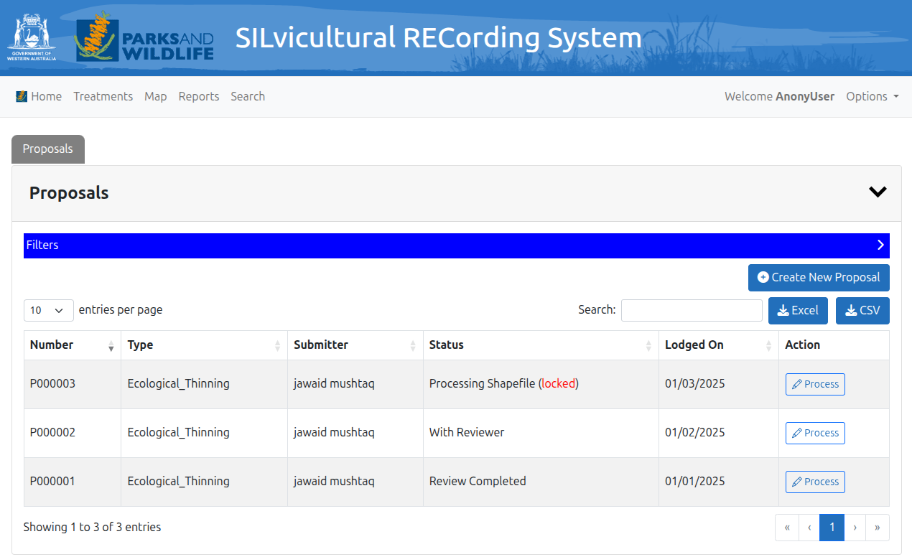

1.2) click 'Create New Proposal' (or open an existing one from the Dashboard)
a. Initial 'Processing Status == Draft'

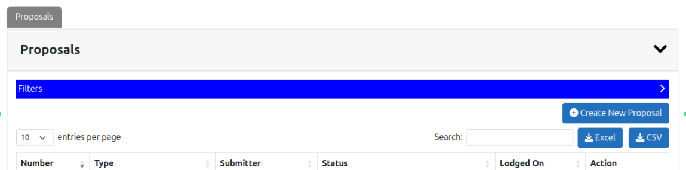

1.3) click 'Upload Shapefile'
a. Either .zip, .gpkg or all '.shp, .shx, .dbf, .prj'

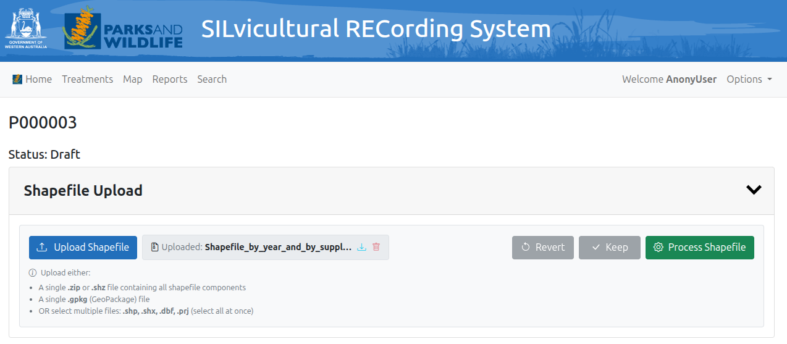

1.4) click 'Process Shapefile' (Assuming successful Shapefile Upload)

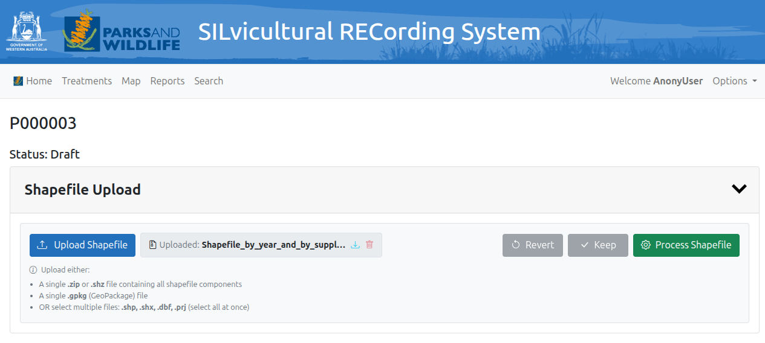

1.5) (Assuming ‘Process Shapefile’ succeeded) the Revert/Keep buttons become enabled.
- Revert - If you are unhappy with the results of the ‘Process Shapefile’ action i.e. the resulting new cookie-cut geometries click ‘Revert’. This will ‘undo’ the ‘Process Shapefile’ action.
- Keep - If you are happy with the results of the ‘Process Shapefile’ action i.e. the resulting new cookie-cut geometries, click ‘Keep’. The Keep action will permanently save the new cookie-cut geometries to the Silrec database. NOTE: This action cannot be reverted/rolled-back.

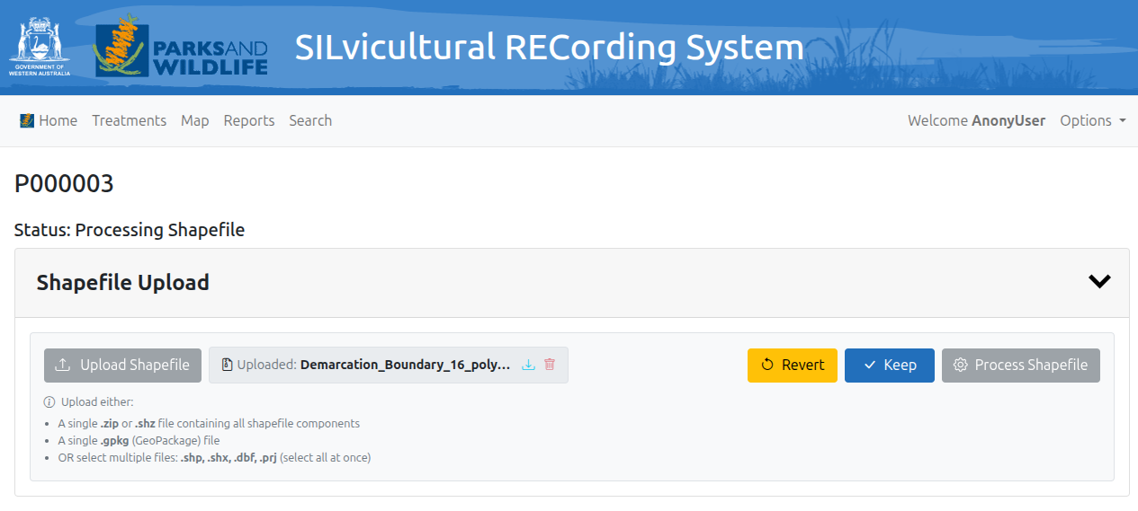

1.6) If ‘Keep’ action button is clicked, the new geometry topology is saved irreversibly to the Silrec database. These new geometries created can be studied from the Map component section and also from the Dashboard table:

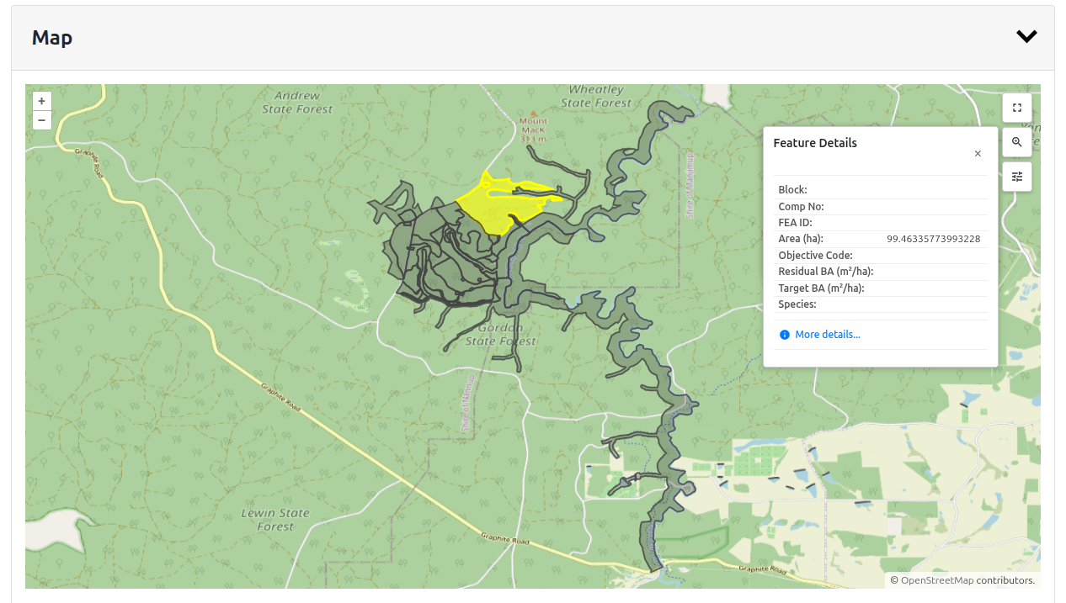

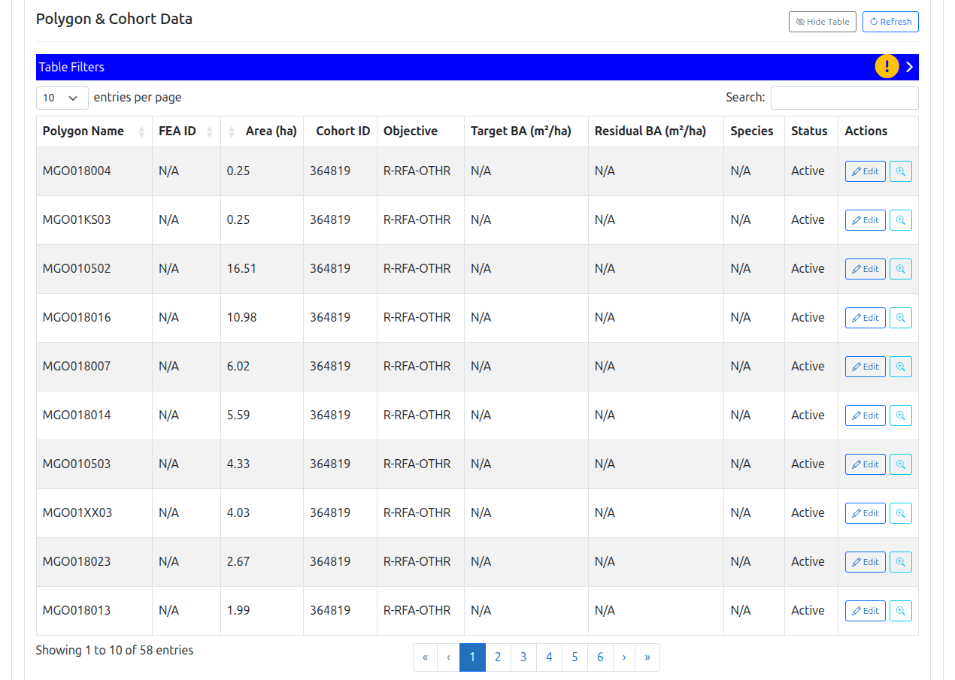

1.7) The Operator role user can click on the Dashboard table ‘Edit’ action to edit data related to that given geometry/polygon, and repeat for each row/polygon in the table:

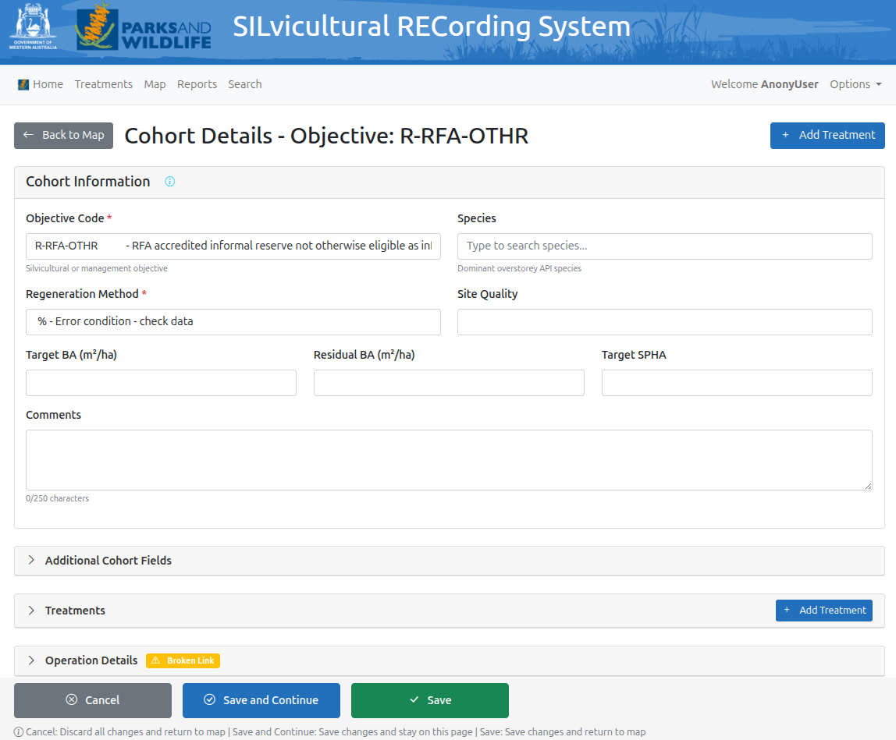

2. Treatments - Geometries/Polygons

The Treatments menu item allow the user to search geometries/polygons and their associated records for viewing, reviewing or editing (for Operator role). The filter section allows the user to select specific details that they want to search and the resulting records are displayed in the Dashboard table section

The user can the view or edit the records by clicking the appropriate action button in the table ‘Actions’ column:

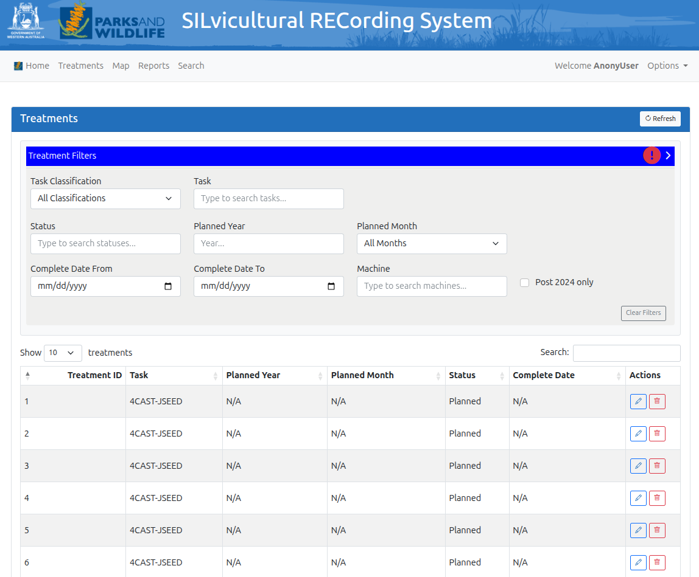

3. Map View - Geometries/Polygons

The Map menu item allows the user to search geometries/polygons and their associated records for viewing, reviewing or editing (for Operator role), together with a visual representation of the filtered dataset returned in the Map component section. The filter section allows the user to select specific details that they want to search and the resulting records are displayed in the Map component and the Dashboard table section.

The user can the view or edit the records by clicking the appropriate action button in the table ‘Actions’ column:

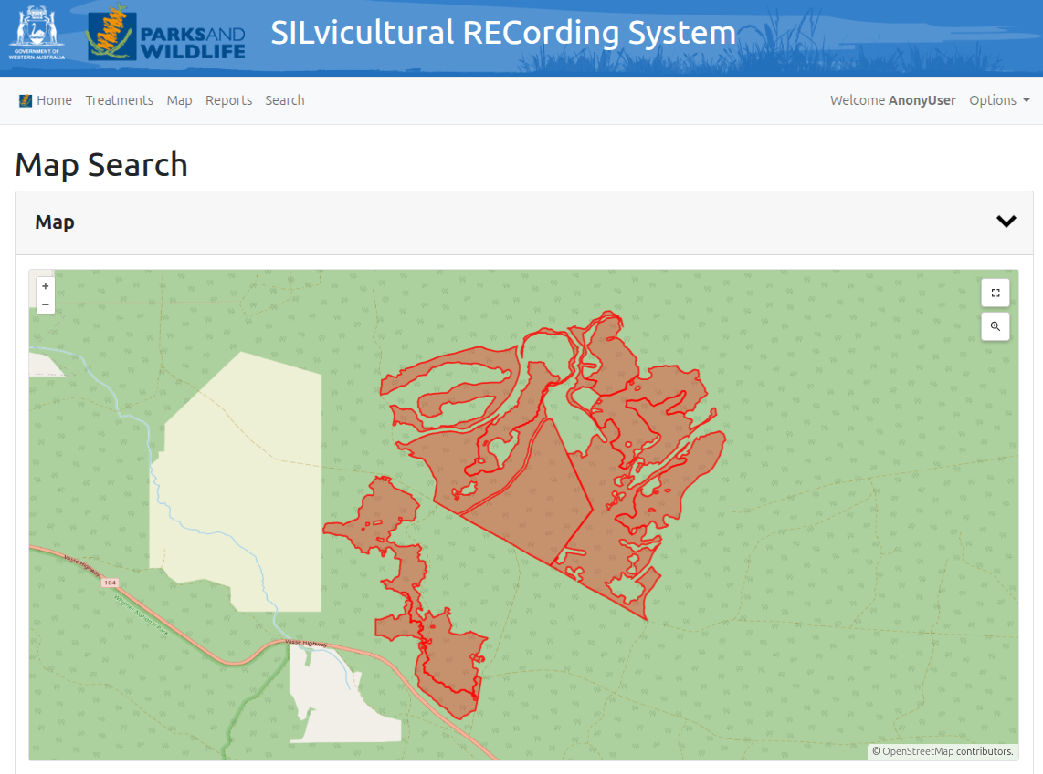

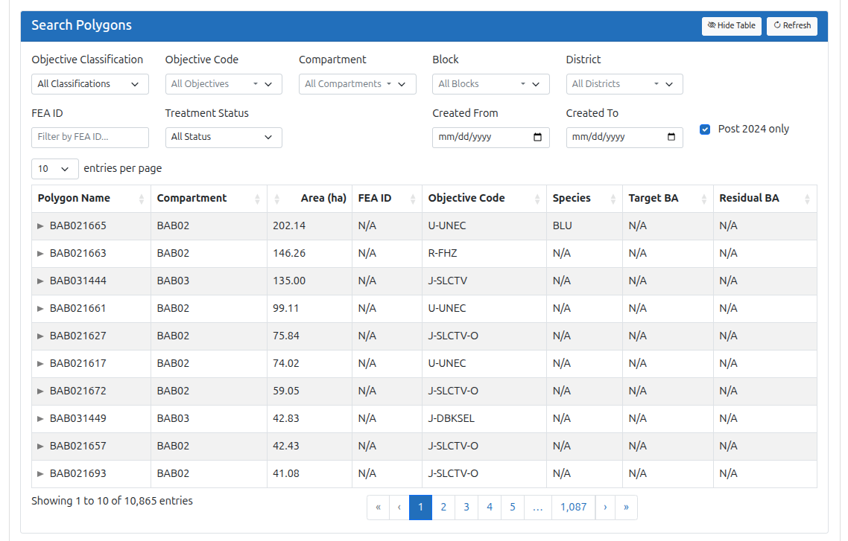

4. Report Generator

The Report menu item allows the user to create and download Excel, CSV, PDF reports and Shapefile exports (for Operator and Reviewer roles). The filter section allows the user to filter the reports output as required.

a. Each report type may have different filter options (depending on the report config.).
b. Export format will also have different format available (depending on the report config.)

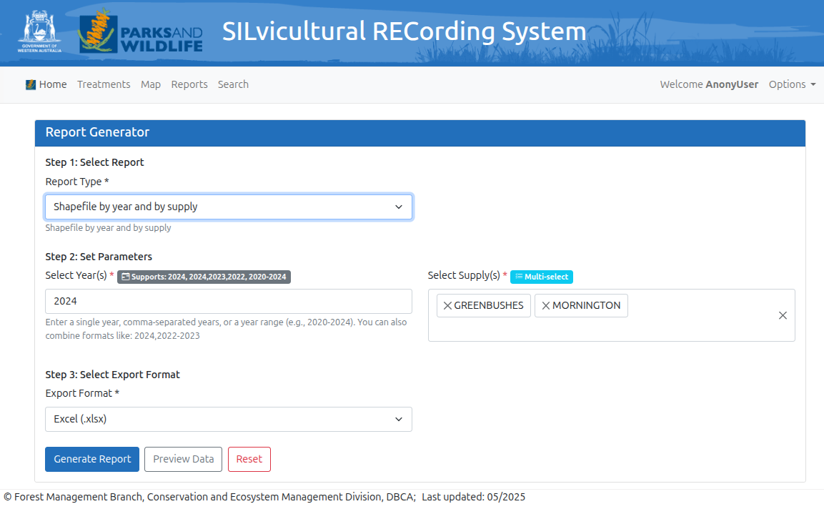
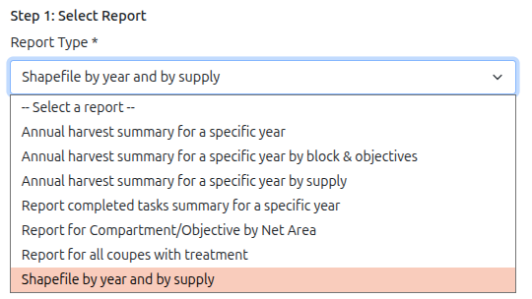

4.1) The Reports generated will be downloaded to the user Downloads folder.

4.2) The Reports generated will also be available for a given number of days (depending on the configured retention policy) from the ‘Options’ → ‘Generated Reports’ menu item

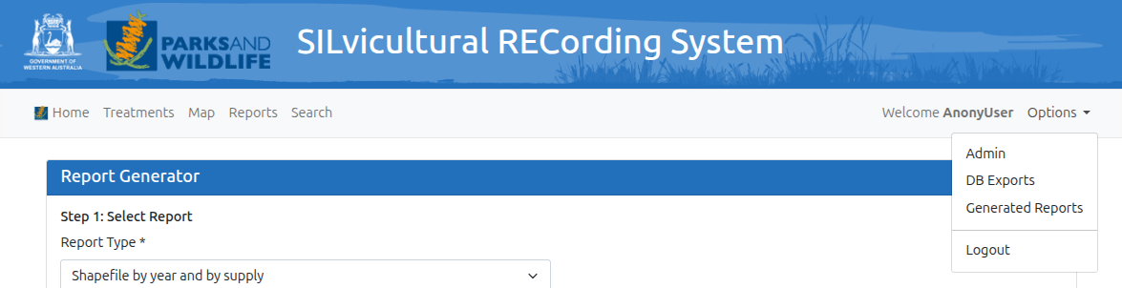

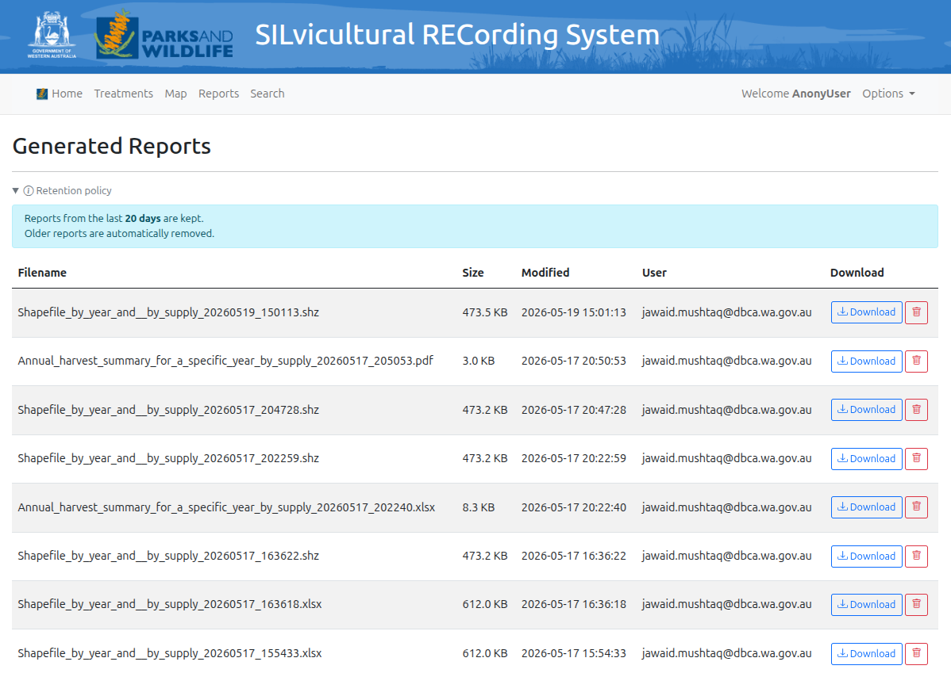

5. Search

The Search menu item allows the user to search the SILREC database tables for specific text string(s). The user can then View or Edit the records found (if role allows)

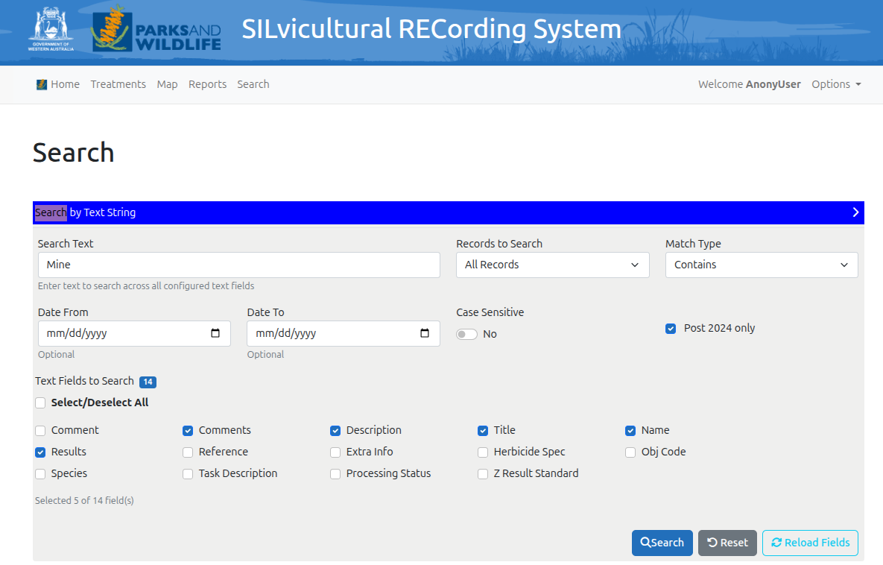

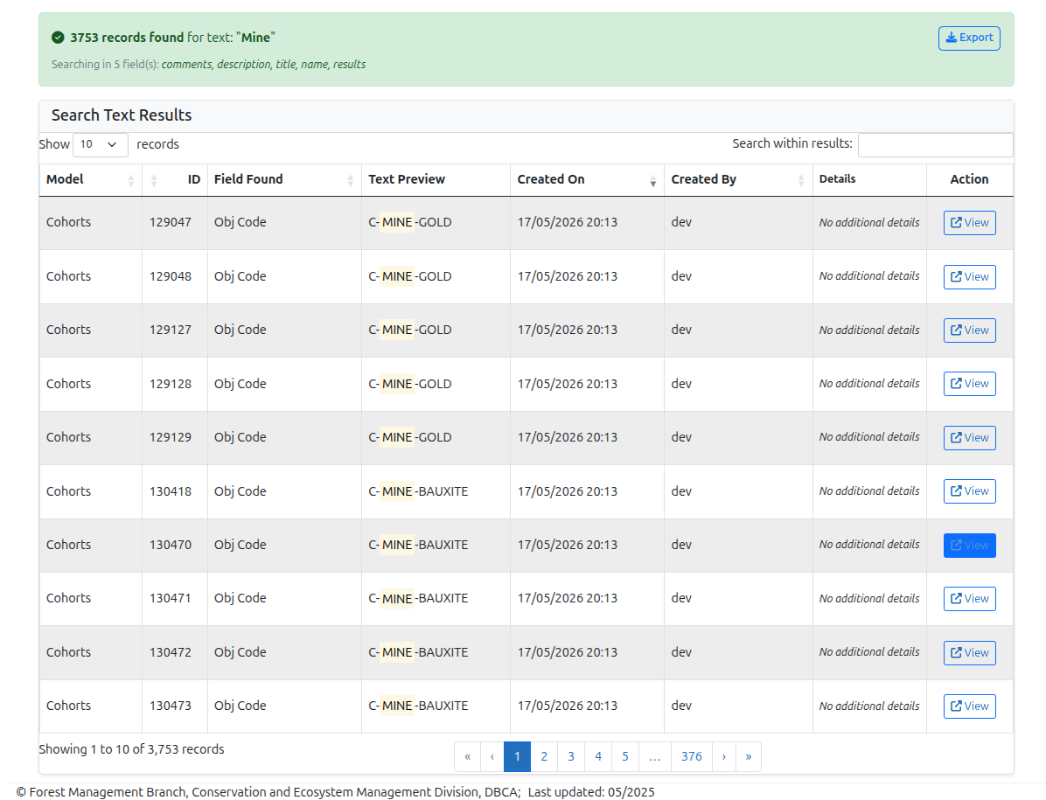

6. Admin

SILREC Admin section allows a user with role ‘Silrec Admin’ to configure various functional components of the SILREC application.

6.1) User Group Configuration

How to add users to groups:
a. Log in to the Django Admin page, ‘Options’ → ‘Admin’ (‘Silrec Admin’ user access required).
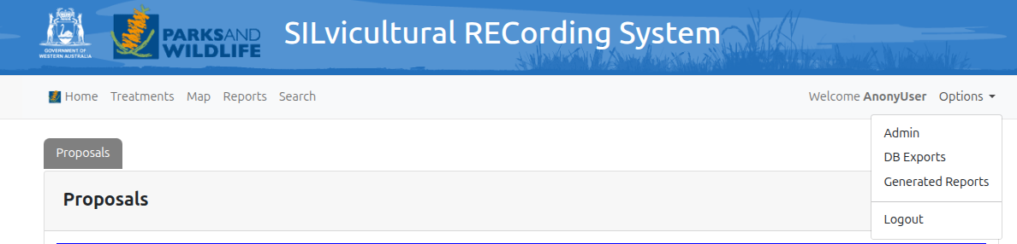

b. Go to Authentication and Authorization > Users.
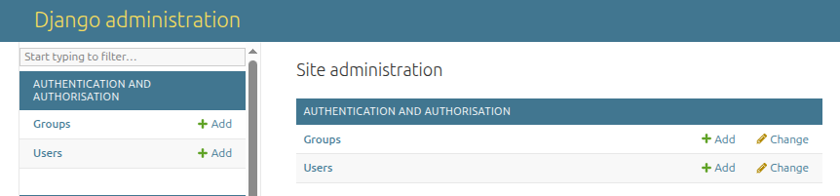

c. Select the user you want to configure.
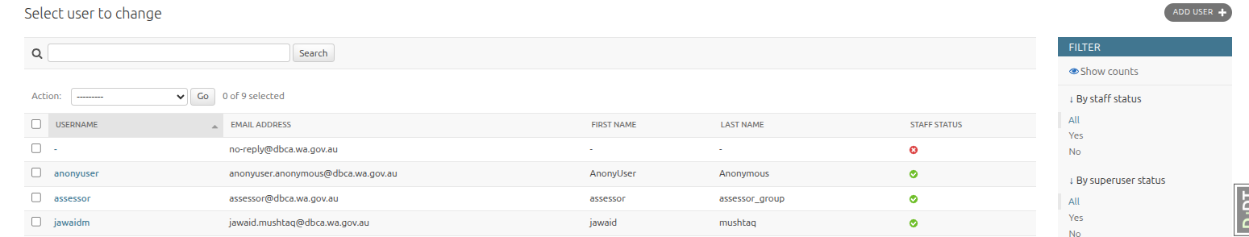

d. Under Groups, select one of: `User`, `Operator`, `Reviewer`, `Silrec Admin`.
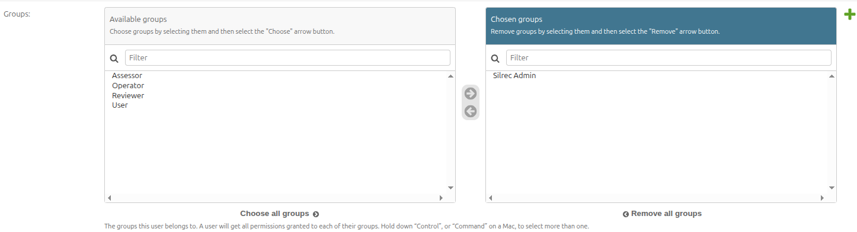

e. Save the user.
**Note:** A user can belong to multiple groups. For example, an Operator who also reviews can be assigned both `Operator` and `Reviewer`.

