 

**INSTITUTE FOR ADVANCED COMPUTING AND SOFTWARE DEVELOPMENT**

AKURDI, PUNE - 411044

**Documentation On**

**“Bank Nifty Price Prediction”**

**PG-DBDA AUG 2024**

Submitted By:

**Group No: 21**

**Aman Bhawsar (248506)**

**Vivek More (248555)**

**Mrs. Priyanka Bhor Mr. Rohit Puranik**

**Project Guide Centre Coordinator**

**DECLARATION**

I, the undersigned hereby declare that the project report titled "Bank Nifty Price Prediction" written and submitted by me to Institute For Advanced Computing And Software Development, Akurdi Pune, in the fulfilment of requirement for the award of degree of Post Graduate Diploma In Big Data Analytics (PG DBDA) under the guidance of Dr Shantanu S Pathak and Mrs. Priyanka Bhor is my original work .I have not copied any code or content from any source without proper attribution, and I have not allowed anyone else to copy my work.

The project was completed using Python and ML and libraries. The project was developed as part of my academic coursework. I also confirm that the project is original, and it has not been submitted previously for any other academic or professional purpose.

Place: Signature:

Date: Name: Aman Bhawsar / Vivek More

**ACKNOWLEDGEMENT**

I would like to express my sincere gratitude to Mrs. Priyanka Bhor , Project Guide , for providing me with the guidance and support to complete this academic project . Their valuable insights , expertise and encouragement have been instrumental in the success of this project .

I would also like to thank my fellow classmates for their support and cooperation during the project . Their feedback and suggestions were helpful in improving the quality of the project.

I would like to extend my gratitude to Mr. Rohit Puranik , Centre Coordinator , for providing me with the necessary resources and facilities to complete this project . Their support has been crucial in the timely completion of this project.

Finally , I would like to thank my family and friends for their constant encouragement and support throughout the project . Their belief in me has been a constant source of motivation and inspiration.

Thank you all for your support and guidance in completing this academic project.

Aman Bhawsar (248506)

Vivek More (248555)

**Abstract**

This report presents an in-depth study on Bank Nifty price prediction using Machine Learning (ML) and Deep Learning techniques. The financial market is highly volatile and complex, making accurate predictions a challenging task. This project aims to analyze historical Bank Nifty index data and develop predictive models using ARIMA, LSTM, and LightGBM to forecast future price movements.

The study leverages time-series forecasting techniques to identify patterns in past price data and improve decision-making for traders and investors. LSTM (Long Short-Term Memory) is used for capturing sequential dependencies, ARIMA (AutoRegressive Integrated

Moving Average) for linear time-series modeling, and LightGBM (Light Gradient Boosting Machine) for efficient and scalable predictions.

The results demonstrate the potential of ML-based models in improving financial forecasting accuracy. However, market fluctuations, external economic factors, and sudden events can impact predictions. Future enhancements may include real-time data integration, sentiment analysis, and advanced feature engineering to improve model robustness. This project contributes to the growing field of AI-driven stock market analysis, helping investors make informed trading decisions.

# Table Of Contents

1. INTRODUCTION 1
   1. Problem Statement 2
   2. Scope 2
   3. Aim & Objectives …..2
2. TOOLS AND TECHNIQUE 3
   1. Python 4
   2. Machine Learning 4
   3. Pandas 5
   4. Deep Learning(LSTM) 6
3. WORKFLOW 7
   1. Model Workflow 8
   2. Project Workflow 12
4. PROJECT REQUIREMENTS 17
   1. Hardware Requirement 18
   2. Software Requirement 19
5. FUTURE SCOPE 20
6. CONCLUSION 22
7. REFERENCES 24

**CHAPTER 1**

**INTRODUCTION**

# Introduction

# Problem Statement

## Bank Nifty Price Prediction

Stock market prediction has always been a challenging task due to its highly volatile and complex nature. The **Bank Nifty Index**, which represents the performance of banking sector stocks in India, is influenced by multiple factors, including market trends, economic indicators, and global financial events. Traditional forecasting methods often struggle to capture these dynamic patterns, leading to inaccurate predictions.

This project aims to **develop a Machine Learning (ML) and Deep Learning-based predictive model** to forecast **Bank Nifty prices** using historical market data. By leveraging techniques such as **ARIMA, LSTM, and LightGBM**, the objective is to identify trends, minimize prediction errors, and enhance decision-making for traders and investors. The model will analyze past price movements, generate future price estimates, and provide valuable insights to support data-driven investment strategies in the stock market.

# Scope

This project explores Machine Learning techniques for predicting Bank Nifty prices,

aiding traders and investors in decision-making. It covers data preprocessing,

model evaluation, and performance analysis. The study highlights ML’s potential

in financial forecasting while acknowledging external market influences on accuracy.

* 1. **Aim & Objective**

The aim of this project is to develop and analyze Machine Learning models for predicting Bank Nifty price movements, helping traders and investors make informed decisions. The objectives include collecting and preprocessing historical Bank Nifty data, exploring

various ML algorithms like Linear Regression, Random Forest, and LSTM, and implementing feature engineering techniques to improve prediction accuracy. The study evaluates model performance using metrics such as Mean Squared Error (MSE) and R-squared (R²) while comparing different approaches to identify the most effective one. Additionally, the project examines the influence of external factors on predictions and highlights the potential of ML-based forecasting in financial decision-making. By

leveraging data-driven insights, this research aims to enhance market analysis and support more strategic trading practices.

**CHAPTER 2**

**TOOLS AND TECHNIQUES**

# Tools & Techniques

# Python

Python is a high-level, interpreted, general-purpose programming language. Its design philosophy emphasizes code readability with the use of significant indentation. Python is dynamically typed and garbage-collected. It supports multiple programming paradigms. It is often described as a "batteries included" language due to its comprehensive standard library.

Guido van Rossum began working on Python in the late 1980s as a successor to the ABC programming language and first released it in 1991 as Python

0.9.0. Python 2.0 was released in 2000 and introduced new features such as list comprehensions, cycle-detecting garbage collection, reference counting, and Unicode support. Python 3.0, released in 2008, was a major revision that is not completely backward-compatible with earlier versions. Python 2 was discontinued with version 2.7.18 in 2020.

# Machine Learning

Machine Learning (ML) is a branch of artificial intelligence that enables computers

to learn from data and make predictions without being explicitly programmed.

It plays a significant role in financial markets by analyzing historical data,

identifying patterns, and improving forecasting accuracy. Unlike traditional

methods, ML algorithms can adapt to dynamic market conditions, making

them valuable for price prediction and decision-making.

For Bank Nifty price prediction, supervised learning techniques such as

Regression models help establish relationships between historical prices and

future trends. Additionally, deep learning models like Long Short-Term

Memory (LSTM), a specialized form of recurrent neural network (RNN),

are highly effective in processing time-series data, capturing long-term

dependencies, and enhancing predictive performance.

By integrating ML techniques, this project aims to provide traders and investors

with a data-driven approach for analyzing market trends, reducing risks,

and optimizing trading strategies. ML-based forecasting offers a systematic

and efficient way to predict stock market fluctuations, ultimately improving

financial decision-making in volatile markets.

* 1. **Pandas**

Pandas is a powerful open-source Python library used for data manipulation and analysis.

It provides data structures such as **Series** (one-dimensional) and **DataFrame**

(two-dimensional), which allow efficient handling of structured data. In financial analysis, Pandas is widely used for processing large datasets, performing data cleaning, transformation, and statistical analysis.

For Bank Nifty price prediction, Pandas helps in loading historical stock market

data, handling missing values, computing technical indicators, and preparing data

for Machine Learning models. Its built-in functions allow efficient operations like filtering, grouping, and time-series analysis, making it an essential tool for financial forecasting.

By leveraging Pandas, this project ensures accurate data preprocessing, which is crucial for training reliable ML models. Its flexibility and efficiency enhance the overall workflow, improving the accuracy and effectiveness of stock price

predictions.

# Deep Learning-Long Short-Term Memory (LSTM)

Long Short-Term Memory (LSTM) is a specialized type of recurrent neural

network (RNN) designed to handle sequential and time-series data. Unlike

traditional RNNs, LSTM overcomes the issue of short-term memory by using

gated mechanisms—forget gate, input gate, and output gate—to retain relevant

past information while discarding unnecessary data. This makes LSTM highly effective for financial market predictions, where historical trends play a crucial

role in forecasting future prices.

For Bank Nifty price prediction, LSTM is used to analyze historical stock prices, identify long-term dependencies, and generate accurate forecasts. By leveraging its ability to capture temporal patterns, LSTM helps in reducing noise and improving predictive accuracy compared to traditional ML models.

This project utilizes LSTM to enhance financial forecasting, providing traders and investors with a more data-driven approach to market analysis and decision-making.

# 

**CHAPTER 3**

**WORKFLOW**

# 3. Model Workflow-

1. **Data Collection**

The first step involves gathering historical Bank Nifty price data from reliable

sources such as **National Stock Exchange (NSE) or Yahoo Finance**. The dataset

typically includes:

* **Date/Time** – Timestamp for each record
* **Open Price** – Price at the beginning of the trading session
* **High Price** – Highest price during the session
* **Low Price** – Lowest price during the session
* **Close Price** – Final price at market close
* **Volume** – Number of shares traded during the period
* **Other Technical Indicators** (if available)

1. **Data Preprocessing**

Before training the model, the raw dataset must be cleaned and structured to ensure accuracy. This step includes:

* **Handling Missing Values** – Replacing missing data using interpolation or forward-filling techniques.
* **Removing Outliers** – Identifying and eliminating extreme values that could distort predictions.
* **Normalizing Data** – Scaling numerical features to a uniform range (e.g., Min-Max scaling or Standardization) to improve model performance.
* **Converting Dates** – Transforming date and time information into useful numerical features (e.g., day of the week, month).

Preprocessing ensures that the dataset is clean, structured, and ready for analysis.

1. **Feature Engineering**

Feature engineering involves extracting and creating new features that improve the predictive power of ML models. Some commonly used features include:

* **Moving Averages** – Simple Moving Average (SMA) and Exponential Moving Average (EMA) to smooth price fluctuations.
* **Relative Strength Index (RSI)** – A momentum indicator that identifies overbought and oversold conditions.
* **Bollinger Bands** – Measures market volatility.
* **MACD (Moving Average Convergence Divergence)** – Identifies trend direction and strength.
* **Lag Features** – Previous price data points used to predict future trends.

1. **Data Splitting**

The dataset is divided into:

* **Training Set (70-80%)** – Used to train ML models.
* **Testing Set (20-30%)** – Used to evaluate model performance on unseen data.

Splitting ensures that the model learns from past trends while being tested on new, unseen data for reliable predictions.

1. **Model Selection and Training**

Various ML models are implemented and compared to determine the most effective approach for Bank Nifty price prediction. These models include:

* **Linear Regression** – A basic statistical approach to model price trends.
* **Random Forest** – An ensemble learning method that enhances prediction accuracy by using multiple decision trees.
* **LSTM (Long Short-Term Memory)** – A deep learning model specifically designed for time-series data, capturing long-term dependencies in price trends.

Each model is trained on the historical data to recognize patterns and trends.

1. **Model Evaluation**

The performance of each model is assessed using key evaluation metrics:

* **Mean Squared Error (MSE)** – Measures the average squared difference between actual and predicted prices.
* **Root Mean Squared Error (RMSE)** – The square root of MSE, providing error magnitude.
* **R-squared (R²)** – Indicates how well the model explains price variations.

By comparing these metrics, the most suitable model for Bank Nifty price prediction is selected.

**7. Hyperparameter Tuning**

To optimize model performance, hyperparameters are fine-tuned using techniques such as:

* **Grid Search** – Systematically searching for the best combination of parameters.
* **Random Search** – Randomly selecting hyperparameters to find an optimal combination.
* **Optimization Algorithms** – Adam, RMSprop, or Stochastic Gradient Descent (SGD) for deep learning models.

Tuning ensures improved model accuracy and stability.

**8. Prediction and Analysis**

The trained model is then used to predict future Bank Nifty prices based on historical trends and technical indicators. The results are analyzed to determine:

* **Short-term and long-term price trends**
* **Market volatility and risk factors**
* **Potential trading signals for investors**

Predictions help traders and investors make informed financial decisions.

**9. Result Interpretation and Visualization**

The predicted stock prices are visualized using graphs and charts for better analysis, including:

* **Line Charts** – Comparing actual vs. predicted prices over time.
* **Error Plots** – Displaying prediction errors.
* **Correlation Heatmaps** – Identifying relationships between features.

These visualizations help in understanding market trends and evaluating model accuracy.

**10. Conclusion and Future Scope**

The project concludes with:

* **Summary of key findings** – Effectiveness of different models and best-performing approach.
* **Limitations** – External factors like economic events, news, and global influences affecting predictions.
* **Future Scope** – Potential improvements such as sentiment analysis, reinforcement learning, and hybrid ML models to enhance accuracy.

# 3.1 Project Workflow

# 

**Data Collection :-**

Gather historical **Bank Nifty** data from sources like **NSE, Yahoo Finance**, including **OHLC, Volume, and technical indicators**.

**Data Pre-processing :-**

Handle **missing values, outliers**, and normalize data to ensure consistency and improve model performance.

**Feature Engineering :-**

Create additional features like **moving averages, RSI, Bollinger Bands**, and **lag variables** to enhance prediction accuracy.

**Data Splitting:-**

Divide data into training (70-80%) and testing (20-30%) sets while maintaining the time-series structure.

**Model Selection & Training :-**

Train models like **LSTM, Random Forest, and XGBoost** to learn historical price patterns.

**Model Evaluation :-**

Assess model performance using **RMSE, MAE, and R²** Score to ensure accuracy and reliability.

**Hyperparameter Tuning :-**

Optimize parameters (learning rate, layers, dropout) using Grid Search or Bayesian Optimization for better results.

**Prediction & Analysis :-**

Use the trained model to forecast **Bank Nifty** prices and analyze trends for insights.

**Result Interpretation & Visualization :-**

Compare actual vs. predicted prices using charts and error analysis to evaluate

performance.

**Conclusion & Future Scope :-**

Summarize findings and suggest improvements like **alternative data sources, reinforcement learning, or sentiment analysis**.

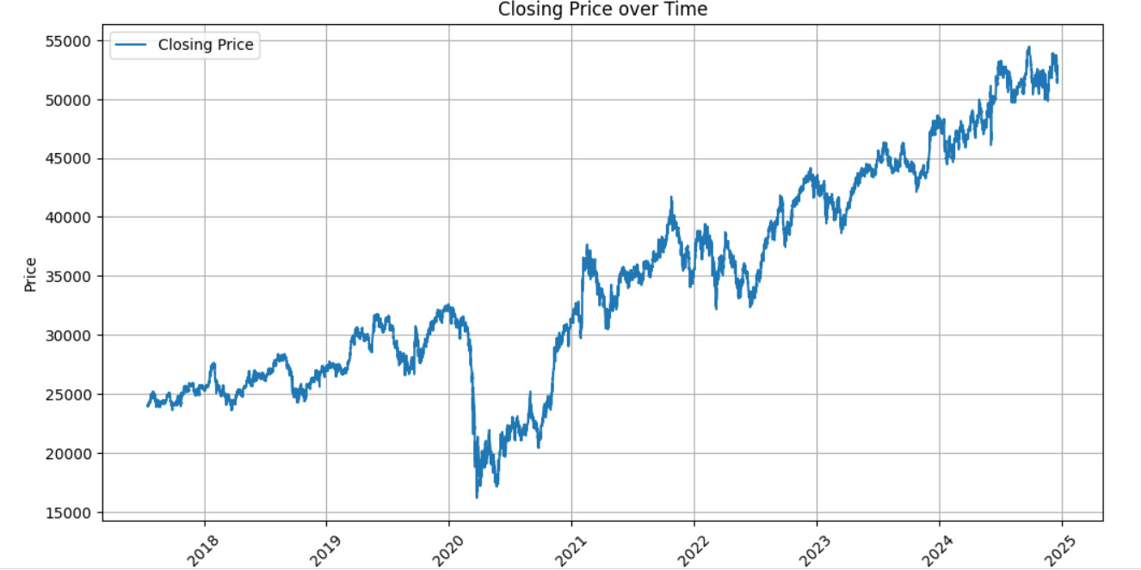

**Fig 1**

**(Closing Price Over Time)**

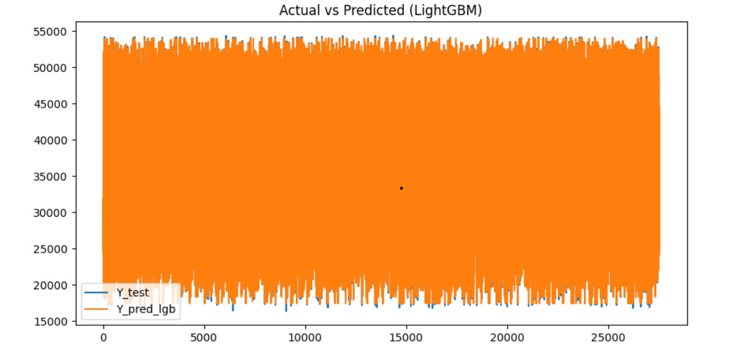

**Fig 2**

**(Light Gradient Boost)**

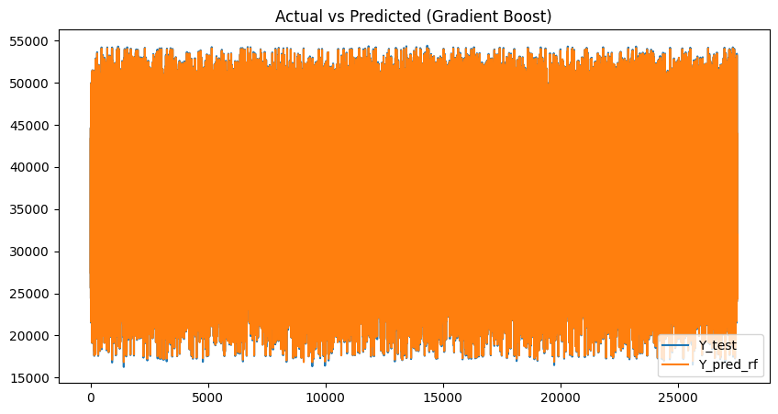

**Fig 3**

**(Gradient Boost)**

**COMPARING GBM AND LIGHTGBM-**

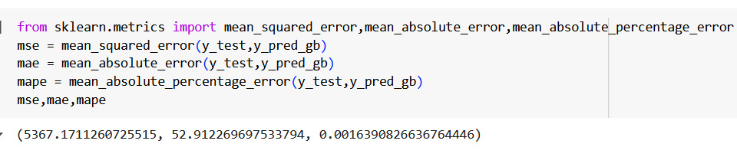

**Fig 4**

**(GBM)**

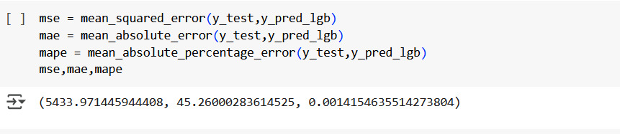

**Fig 5**

**(LIGHT GBM)**

**CHAPTER 4**

**PROJECT REQUIREMENTS**

* 1. **PROJECT REQUIREMENTS -**

**Hardware Requirements:**

🔹 **Processor**: Intel i5/i7 or AMD Ryzen 5/7 (or higher)  
🔹 **RAM**: Minimum 8GB (Recommended: 16GB for large datasets)  
🔹 **Storage**: Minimum 50GB free space (SSD recommended)  
🔹 **GPU**: Optional, but useful for training deep learning models (NVIDIA GPU recommended for LSTM)

**Software Requirements:**

🔹 **Operating System**: Windows 10/11, macOS, or Linux  
🔹 **Python Version**: 3.7 or higher  
🔹 **Jupyter Notebook / Google Colab**: For development and experimentation  
🔹 **Git & GitHub**: For version control and code collaboration

**Libraries & Dependencies:**

Install these Python libraries using pip install or in a requirements.txt file:  
🔹 **Pandas** – Data manipulation and analysis (pip install pandas)  
🔹 **NumPy** – Numerical computations (pip install numpy)  
🔹 **Matplotlib & Seaborn** – Data visualization (pip install matplotlib seaborn)  
🔹 **Scikit-learn** – ML models and preprocessing (pip install scikit-learn)  
🔹 **Statsmodels** – Time series forecasting (pip install statsmodels)  
🔹 **TensorFlow/Keras** – Deep learning models like LSTM (pip install tensorflow keras)  
🔹 **LightGBM** – Gradient boosting model (pip install lightgbm)

**Dataset Requirements:**

🔹 **Historical Bank Nifty data** (Closing prices, Open, High, Low, Volume)  
🔹 **Source**: NSE India, Yahoo Finance, or Kaggle  
🔹 **Data Format**: CSV or JSON  
🔹 **Time Range**: At least 2-5 years of data for better predictions

**Model Requirements:**

🔹 **LSTM (Long Short-Term Memory)** – For sequential time-series forecasting  
🔹 **ARIMA (AutoRegressive Integrated Moving Average)** – For traditional statistical modeling  
🔹 **LightGBM (Light Gradient Boosting Machine)** – For fast and efficient predictions

**Evaluation Metrics:**

🔹 **MAE (Mean Absolute Error)**  
🔹 **MSE (Mean Squared Error)**  
🔹 **RMSE (Root Mean Squared Error)**  
🔹 **MAPE (Mean Absolute Percentage Error)**

**Deployment -**

🔹 **Streamlit** – For interactive visualization (pip install streamlit)

**CHAPTER 5**

**FUTURE SCOPE**

**5. FUTURE SCOPE –**

The **Bank Nifty Price Prediction** project has significant potential for future enhancements and broader applications. Some key areas for future scope include:

🔹 **Integration of Real-Time Data** – Enhancing model accuracy by incorporating **live market data streams** and continuously updating predictions.

🔹 **Sentiment Analysis** – Using **news articles, social media, and financial reports** to factor in market sentiment and predict trends more effectively.

🔹 **Hybrid Models** – Combining multiple ML and deep learning techniques (**LSTM, ARIMA, LightGBM**) to improve prediction accuracy and reliability.

🔹 **Feature Engineering Improvements** – Incorporating additional indicators like **Bollinger Bands,**

**RSI, MACD**, and external economic factors for better forecasting.

🔹 **Explainable AI (XAI) for Transparency** – Implementing **SHAP values** or other interpretability techniques to make models more explainable for traders and investors.

🔹 **Cloud-Based Deployment** – Deploying models on **AWS, Google Cloud, or Azure** for large-scale real-time predictions and accessibility.

🔹 **Algorithmic Trading Applications** – Developing **automated trading bots** that execute trades based on predictive models, reducing human intervention.

🔹 **Multi-Asset Predictions** – Expanding beyond **Bank Nifty** to predict **stocks, commodities, forex, and cryptocurrencies** for diversified investment strategies.

With these improvements, **AI-driven stock market predictions** will become more precise, making financial decision-making more data-driven and efficient.

**CHAPTER 6**

**CONCLUSION**

**7. CONCLUSION -**

This project successfully explores the application of **Machine Learning (ML) and Deep Learning** techniques for predicting **Bank Nifty prices**. By

leveraging models like **LSTM, ARIMA, and LightGBM**, we analyzed historical market data to forecast future price movements. The results demonstrate that ML-based approaches can enhance decision-making for

traders and investors by identifying market trends and patterns.

However, financial markets are influenced by numerous external factors, such as economic policies, global events, and market sentiment, which can impact prediction accuracy. Despite these challenges, integrating real-time data, sentiment analysis, and advanced feature engineering can further improve model performance.

This study highlights the potential of **AI-driven stock market forecasting** in assisting traders with data-driven investment strategies. Future enhancements and hybrid models can make predictions more reliable, contributing to the advancement of **financial analytics and algorithmic trading**.

**CHAPTER 7**

**REFERENCES**

# 7. REFERENCES-

1. **NSE India – Official website of the National Stock Exchange**

https://www.nseindia.com

1. **Python Libraries & Documentation**

**Pandas (For Data Manipulation)**

https://pandas.pydata.org

**NumPy (For Numerical Computation)**

https://numpy.org

**Scikit-Learn (For Machine Learning Models)**

https://scikit-learn.org

**TensorFlow/Keras (For Deep Learning – LSTM)**

https://www.tensorflow.org

**LightGBM (For Boosting Model)**

https://lightgbm.readthedocs.io

**Matplotlib (For Data Visualization)**

https://matplotlib.org

1. **Simple Guides & Tutorials**

**Stock Market Prediction using ML**

https://towardsdatascience.com

1. **Research & Articles for Beginners**

**Basic Understanding of LSTM for Stock Price Prediction** https://colah.github.io/posts/2015-08-Understanding-LSTMs/