**Specific Aims**

Soft tissue tumors, those arising from connective tissues like muscle, tendons, fat, lymph and blood vessels, and nerves, may be benign, locally aggressive, or malignant. For aggressive and malignant tumors, standard-of-care options of surgery and radiation treat the entire tumor plus margins. Even with advances in chemotherapy, recurrence remains a substantial problem, and morbidity associated with surgery or chemoradiation treatment or re-treatment can have a severe and lasting impact on quality of life. While magnetic resonance-guided focused ultrasound (MRgFUS) is a promising therapeutic technology with the potential to join or even displace traditional soft tissue tumor therapies, challenges associated with fatty tissues, which are often present within or surrounding tumors, can inhibit time-efficient, efficacious treatments.

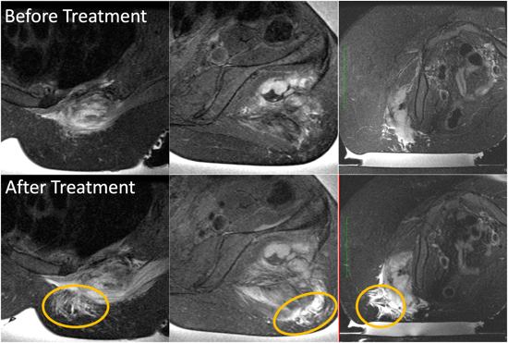For example, interventional radiologists performing MRgFUS therapies of desmoid tumors have noted that the T2-weighted MR signal of subcutaneous fat in the ultrasound near field increases in intensity during the treatment (see figure at right). After this change occurs, focal temperatures within the tumor decrease and getting sufficient energy to the target tissue for ablation becomes difficult. Treatment times are extended, power requirements for effective ablation rise, and treatment uncertainty increases along with the likelihood of normal tissue damage in the near field. Since MR temperature measurement within fat is difficult and not utilized clinically, it is unclear what drives this phenomenon.

The main objective of this proposed research is to characterize the temperature dependence of and to identify correlations between subcutaneous fat properties. Achievement of this objective will inform alternative treatment strategies or compensatory approaches that enable complete ablation of the tumor and margin for all soft tissue tumors, particularly sarcomas. A long-term goal is to establish a simulation-based treatment planning platform accounting for fat property variation that can be used to predict temperatures and thermal dose prior to sonications, preemptively alter the treatment execution to avoid collateral tissue damage from excessive normal tissue heating, and optimize sonication parameters for improved safety and efficacy.

**Hypothesis 1**: Increased temperature in subcutaneous fat (superficial to targeted tumors) alters local tissue properties reducing sonication efficiency at the deeper target tissue.

**Specific Aim 1** comprises the experimental assessment of fat tissue properties. (1) Ex vivo porcine and human subcutaneous fat samples will be characterized with MRI to determine temperature-dependent T1 and T2 relaxation times over the range of 20 – 80 C. (2) Acoustic (speed of sound, attenuation coefficient), thermal (thermal conductivity, thermal diffusivity, specific heat capacity), and mechanical (shear modulus) properties of the fat samples will be measured with established methods over the same temperature range. (3) Statistical analysis will be performed to correlate temperature-dependent acoustic, thermal, and mechanical properties with MR T1 and T2 properties.

**Hypothesis 2**: Implementing temperature-dependent properties in treatment modeling will provide more accurate predictions of the temperature rise location, magnitude, and distribution in MRgFUS treatments than using literature-derived constant properties.

**Specific Aim 2** includes a computational demonstration of fat properties’ impact and implementation for treatment planning. (1) MR imaging data from desmoid MRgFUS treatments will retrospectively be segmented into tissue types including skin, fat, muscle, tumor, and bone. (2) Subsequent acoustic and thermal modeling of the treatment will be performed with both constant and temperature-dependent fat properties. (3) Accuracy of the computational model’s focal location, distribution, and intensity will be statistically evaluated by comparison to MR temperature data acquired during the treatment. (4) A prospective pipeline for clinical implementation of computational modeling tools, including phase aberration correction, that compensate for temperature-dependent fat property changes will be developed.

Successful completion of these aims has the potential to substantially impact clinical practices for soft tissue tumor MRgFUS treatments and other thermal therapies. Temperature-dependent tissue properties in the literature are scarce, and many of the ex vivo measurements prescribed in this study cannot be assessed in the clinical setting. Computational models are underutilized in the clinic due in part to a lack of model validation. By accurately characterizing temperature-dependent properties and validating computational models for treatment planning, we will provide novel tools that can inform clinicians in ways that will increase safety, reduce treatment times, and improve MRgFUS treatment efficacy.

Our research team has extensive experience in MRI, tissue property characterization, and bioheat transfer modeling. Brigham Young University has the facilities and equipment needed to perform this important work and collaborators at Stanford University and the University of Utah provide additional expertise and access to clinical data. This work has great potential to advance our understanding of the physics driving unexplained clinical phenomena, improve simulation capabilities for model-based treatment planning, and improve treatment outcomes in the growing field of MRgFUS thermal therapies.