**Specific Aims**

Approximately <percentage or number> people suffer from soft tissue tumors within their connective tissues per year. These tumors cause pain, impair mobility, and, if malignant, metastasize to vital organs. While surgery and radiation can treat the entire tumor plus margins, recurrence and morbidities, including <examples>, remain in <number/percentage> patients. Magnetic resonance-guided focused ultrasound (MRgFUS), a promising therapeutic alternative, may reduce morbidities related to surgery, chemotherapy and radiation because it non-invasively and precisely destroys a soft tissue tumor with non-ionizing radiation. However, at present, the high percentage of patients whose tumors are infiltrated or surrounded by fat do not receive the full benefit of MRgFUS. Current treatment methods make inaccurate assumptions about the response of fatty tissues to MRgFUS, resulting in under treatment, ablation of sensitive structures, and prolonged treatment times. This study proposes to reduce morbidity and increase MRgFUS efficiency in patients suffering from soft tissue tumors by developing novel technologies that accurately model how fat responds to FUS irradiation.

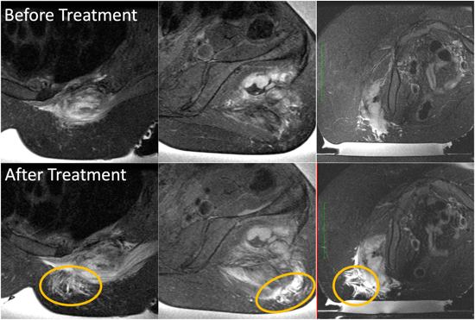For example, interventional radiologists performing MRgFUS therapies of desmoid tumors have noted that the T2-weighted MR signal of subcutaneous fat in the ultrasound near field increases in intensity during the treatment (Fig 1). After this change occurs, focal temperatures within the tumor decrease though the FUS power remains constant, leading to extended treatment times, higher risk of skin burns and damage to healthy tissues surrounding the tumor, and greater uncertainty regarding successful tumor treatment. This phenomenon is suspected to be temperature-driven, however, given the lack of temperature feedback or accurate modeling in fat tissues, it is currently impossible to predict.

The objective of this proposed research is to reduce treatment times, healthy tissue damage, and likelihood of tumor recurrence by creating clinically useful models for the temperature-dependent response of subcutaneous fat during MRgFUS. Achievement of this objective will inform alternative treatment strategies or compensatory approaches that enable complete ablation of the tumor and margin for all soft tissue tumors, particularly sarcomas. The significance of this work is that it will enable a future simulation-based treatment planning platform that can incorporate temperature-dependent fat properties and patient-specific information to predict the thermal dose of a given treatment, preemptively alter the treatment execution to avoid collateral tissue damage , and optimize sonication parameters for improved safety and efficacy. To achieve these aims, the study will examine the following hypotheses and aims.

**Hypothesis 1**: Increased temperature in subcutaneous fat (superficial to targeted tumors) alters local tissue properties reducing sonication efficiency at the deeper target tissue.

**Specific Aim 1**. We will assess fat tissue properties for MRgFUS-relevant temperatures: (1) We will characterize the change of T1 and T2 MR relaxation times in ex vivo porcine and human subcutaneous fat samples over the range of 20 – 80 °C. (2) We will measure acoustic (speed of sound, attenuation coefficient), thermal (thermal conductivity, thermal diffusivity, specific heat capacity), and mechanical (shear modulus) properties of the fat samples over the same temperature range. (3) We will analyze correlation bewteen and investigate causal effects of temperature-dependent acoustic, thermal, and mechanical properties on MR T1 and T2 properties.

**Hypothesis 2**: Accounting for temperature-dependent properties in treatment modeling will provide more accurate predictions of the temperature rise location, magnitude, and distribution in MRgFUS treatments than using literature-derived constant properties.

**Specific Aim 2**. We will perform simulations to demonstrate the impact of fat properties and how they might be used in MRgFUS treatment planning. (1) We will retrospectively segment MR imaging data from desmoid MRgFUS treatments into tissue types including skin, fat, muscle, tumor, and bone. (2) We will subsequently model the acoustic and thermal responses of the treatment with both constant and temperature-dependent fat properties. (3) We will statistically evaluate the accuracy of the computational model’s focal location, distribution, and intensity by comparison to MR temperature data acquired during the treatment. (4) Finally, we will develop a prospective pipeline for clinical implementation of computational modeling tools, including phase aberration correction, that compensate for temperature-dependent fat property changes.

Successful completion of these two aims has the potential to substantially impact clinical practices for soft tissue tumor MRgFUS treatments and other thermal therapies. Temperature-dependent tissue properties in the literature are scarce, and many of the ex vivo measurements prescribed in this study cannot be assessed in the clinical setting. Computational models are underutilized in the clinic due in part to a lack of model validation. By accurately characterizing temperature-dependent properties and validating computational models for treatment planning, we will provide novel tools that can inform clinicians in ways that will increase safety, reduce treatment times, and improve MRgFUS treatment efficacy.

Our research team has extensive experience in MRI, tissue property characterization, bioheat transfer modeling, and statistical analysis. Brigham Young University has the facilities and equipment needed to perform this important work and collaborators at Stanford University and the University of Utah provide additional expertise and access to clinical data. This work has great potential to advance our understanding of the physics driving unexplained clinical phenomena, improve simulation capabilities for model-based treatment planning, and improve treatment outcomes in the growing field of MRgFUS thermal therapies.