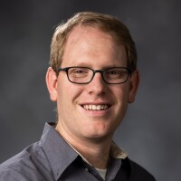

Steven Allen
Assistant Professor
Electrical and Computer Engineering

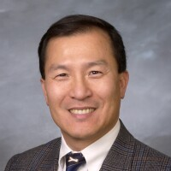

D. J. Lee
Professor
Electrical and Computer Engineering

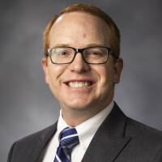

Christopher Dillon
Assistant Professor
Curriculum Vitae
Mechanical Engineering

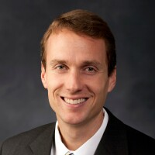

John D. Hedengren
Professor
Chemical Engineering



Douglas Cook
Assistant Professor
Mechanical Engineering

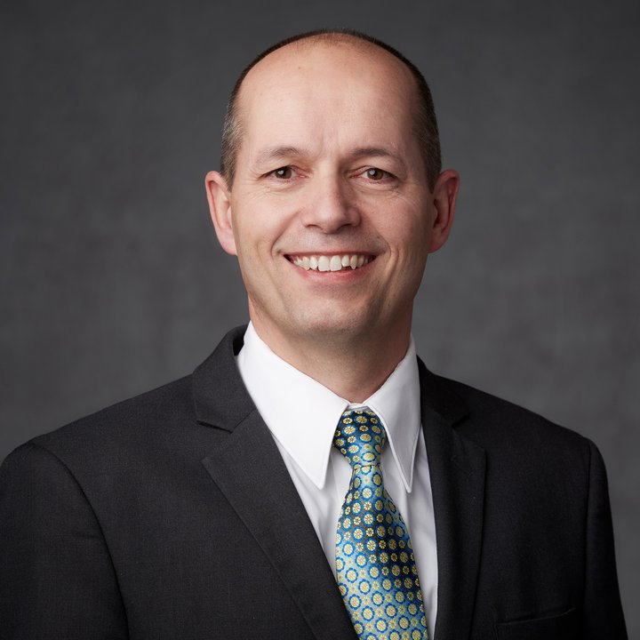

Christophe Giraud-Carrier
Professor
Computer Science

