David S. Smith

Week 1 - Exercise 1.2

DSC520 – Statistics for Data Science

Professor Chase Denton

June 11, 2023

**Task 3:** What is the level of measurement of the following variables:

1. The number of downloads of different brands’ songs on iTunes.

Classification: Discrete, Ratio

Reasoning: The entire song needs to be downloaded for the count to make sense.

There may be a brand with zero downloads.

1. The names of the brands that were downloaded.

Classification: Nominal

Reasoning: More than one brand exists but has no logical order.

1. The position in the iTunes download charts.

Classification: Ordinal

Reasoning: A logical order exists within the chart.

1. The money earned by the bands from the downloads.

Classification: Continuous, Ratio

Reasoning: Currency has a distinct value and can be broken down into smaller increments.

1. The weight of drugs bought by the bands with their royalties.

Classification: Continuous, Ratio

Reasoning: Has a distinct value that can be broken down into smaller increments.

1. The types of drugs bought by the bands with their royalties.

Classification: Categorical, Nominal

Reasoning: There are several different drugs, and their name has meaning.

1. The phone numbers that the bands obtained because of their fame.

Classification: Categorical, Nominal

Reasoning: The band received phone numbers from multiple people.

1. The gender of the people giving the bands their phone numbers.

Classification: Categorical, binary

Reasoning: Gender can be either male or female.

1. The instruments played by the band members.

Classification: Categorical, Nominal

Reasoning: The instrument names have meaning.

1. The time they had spent learning to play their instruments.

Classification: Continuous, Ratio

Reasoning: Time could be 0 or broken down into smaller increments.

**Task 4:** Measurement of error in the friend’s CD-counting device is: 6

Showing work:

863 – 857 = 6

**Task 5:**

Normal Distribution:

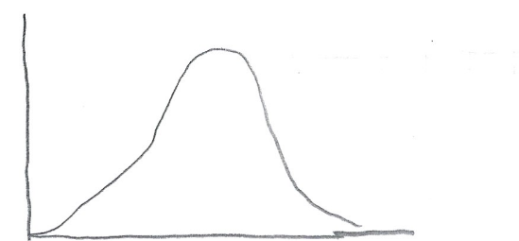

Positively Skewed Distribution”

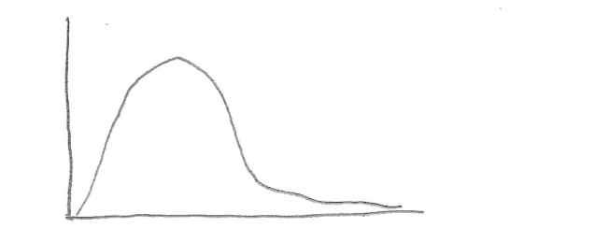

Negatively Skewed Distribution:

