ASSIGNMENT 4

David Smith

2023-07-16

# Markdown Basics

## Favorite Foods

1. Pigs in a blanket
2. Macaroni Salad
3. Fried Shrimp

## Images

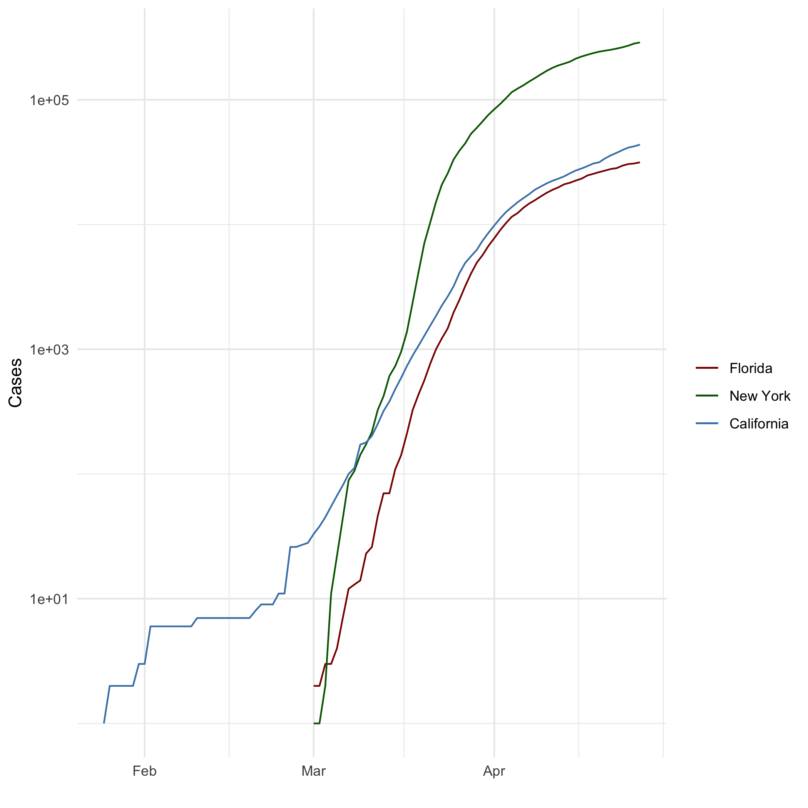

ALL Cases (Log Plot)

## Add a Quote

* A wife of noble character is her husband’s crown, but a disgraceful wife is like decay in his bones. Proverbs 12:4*

## Add an Equation

$$V_{sphere}=\frac{4}{3}πr^{3}$$

## Add a Footnote

[1]

## Add Citations

* (Lander 2014)
* (Field, Miles, and Field 2012)

# Inline Code

## NY Times COVID-19 Data

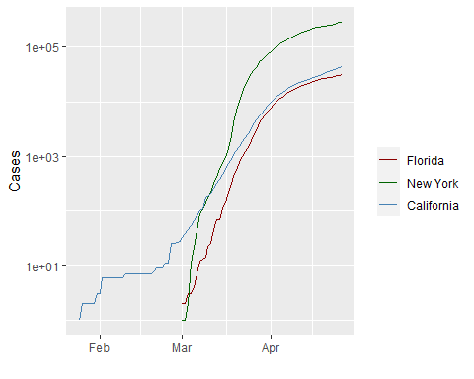

## R4DS Height vs Earnings

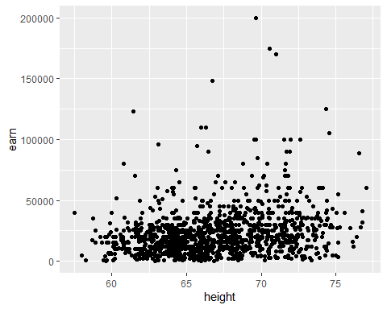

# Tables

## Knitr Table with Kable

| first_column | second_column | third_column | fourth_column | fifth_column |
| --- | --- | --- | --- | --- |
| Aragon | Men | Yes | No | 88 |
| Bilbo | Hobbit | No | Yes | 129 |
| Frodo | Hobbit | Yes | Yes | 51 |
| Sam | Hobbit | Yes | Yes | 36 |
| Sauron | Maia | No | Yes | 7052 |

One Ring to Rule Them All

| Name | Race | In Fellowship | Is Ring Bearer? | Age |
| --- | --- | --- | --- | --- |
| Aragon | Men | Yes | No | 88 |
| Bilbo | Hobbit | No | Yes | 129 |
| Frodo | Hobbit | Yes | Yes | 51 |
| Sam | Hobbit | Yes | Yes | 36 |
| Sauron | Maia | No | Yes | 7052 |

| first_column | second_column | third_column | fourth_column | fifth_column |
| --- | --- | --- | --- | --- |
| Aragon | Men | Yes | No | 88 |
| Bilbo | Hobbit | No | Yes | 129 |
| Frodo | Hobbit | Yes | Yes | 51 |
| Sam | Hobbit | Yes | Yes | 36 |
| Sauron | Maia | No | Yes | 7052 |

## Pandoc Table

#pander.table(characters_df, style = ‘grid’)

# References

@ref(<https://cran.r-project.org/web/packages/pander/vignettes/pandoc_table.html>)

Field, A., J. Miles, and Z. Field. 2012. *Discovering Statistics Using r*. SAGE Publications. <https://books.google.com/books?id=wd2K2zC3swIC>.

Lander, J. P. 2014. *R for Everyone: Advanced Analytics and Graphics*. Addison-Wesley Data and Analytics Series. Addison-Wesley. <https://books.google.com/books?id=3eBVAgAAQBAJ>.

1. Markdown is pretty helpful after the initial shock wears off.