DANIEL B. DIMITROV
daniel.boykov.dimitrov@gmail.com
https://github.com/dbdimitrov
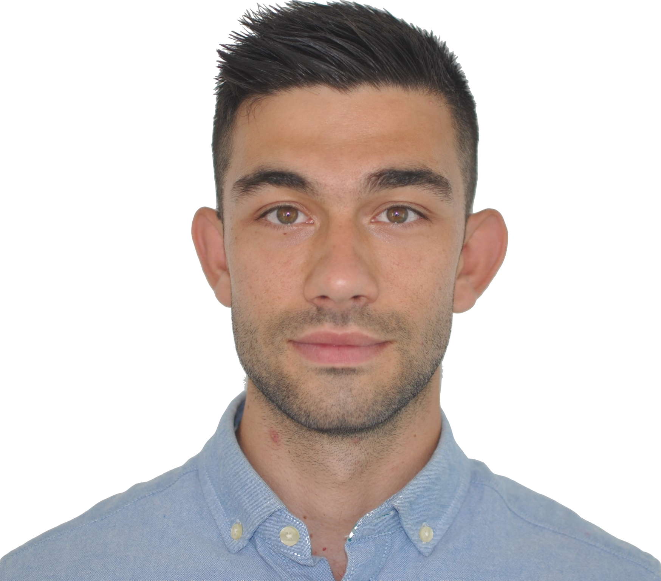
 https://tinyurl.com/scholarddimitrov
Address: Mühlenstraße 10, 68173,
Schwetzingen, Germany
DOB: 04.10.1994
POB: Varna, Bulgaria
Tel: +49 177 705 6912

 EXPERIENCE  Postdoctoral Researcher Stegle Lab, EMBL, Heidelberg  September 2024 - Present  • Developing probabilistic models to infer perturbed and niche-specific intercellular signalling in spatial omics data  Early Stage Researcher Saez Lab, UKHD, Heidelberg, DE  September 2020 - August 2024  • Developed methods to model cell-cell communication from single-cell and spatial (multi-)omics data  Visiting Predoc Zeller Group, EMBL, Heidelberg, DE  September 2022 – March 2023  • Analysed multi-modal host-microbiome spatial data  Visitor Glorieux Lab, Ghent University Hospital, BE  May 2022 – June 2022  • Integrated multi-omics samples from CKD patients  Junior Data Engineer Experian EAD, Sofia, BG  December 2019 – August 2020  • Improved and maintained an ETL (Extract, Transform, and Load) pipeline for terabytes of customer data  Postgraduate thesis project University of Glasgow, UK  May 2019 – December 2019  • Developed and published a user-friendly R-based application for Bulk and Single-cell RNA-Seq analyses  IMPRS-Funded Internship MPI-CBG, Dresden, DE  May 2018 – August 2018  • Refined the 3D models of IFT train particles using Cryo-EM and Subtomogram averaging   LANGUAGES  • English: fluent  • German: intermediate  • Bulgarian: native |  EDUCATION  PhD in Computational Biology, Heidelberg University  September 2020 – June 2024  • Experienced in mechanistic hypothesis generation from omics data using prior knowledge  MSc in Bioinformatics, University of Glasgow  September 2018 – December 2019  • Obtained practical experience in Functional omics  BSc (Hons) in Cell Biology, University of Stirling  September 2014 – June 2018  • Acquired knowledge in Molecular and Cellular biology   PROGRAMMING  • Experienced with Python and R  • Machine Learning stacks (PyTorch; PyG; scikit-learn)  • Well-versed with single-cell, spatial, and multi-omics analysis frameworks (scverse, BioConductor)  • Reproducibility principles (git, conda, docker)  • Programming Best Practices (Agile development, Continuous Integration, Unit testing, Copilot)  • Developer and maintainer of:  ◦ LIANA+ (https://github.com/saezlab/liana-py)  ◦ LIANA (https://github.com/saezlab/liana)  ACHIEVEMENTS  • Distinction from the University of Glasgow  • Scottish Funding Council Scholarship for my Postgraduate studies  • ‘Research-Based Learning Prize’ awarded for the best Biology dissertation’  • First-class Degree from the University of Stirling
REFERENCES
Dr. Julio Saez-Rodriguez  PhD Supervisor  Head of Research  EMBL-EBI  julio.saez@uni-heidelberg.de | Dr. Oliver Stegle  Postdoctoral Supervisor  Acting Head of AI  EMBL & DKFZ  oliver.stegle@embl.de

SELECTED PUBLICATIONS AND PREPRINTS (out of 16)
Dimitrov, D.#,*., Schrod, S.#,*, Rohbeck, M. and Stegle, O.*, 2025. Interpretation, Extrapolation, and Perturbation of single Cells. Under Review. Preprint Accessible Here.

Farr, E.B.#, Dimitrov, D.#, Turei, D., Schmidt, C., Lobentanzer, S., Dugourd, A. and Saez-Rodriguez, J., 2024. MetalinksDB: a flexible and contextualizable resource of metabolite-protein interactions. Briefings in Bioinformatics, pp.2023-12.

Dimitrov, D., Schäfer, P. S. L., Farr, E., Rodriguez Mier, P., Lobentanzer, S., Dugourd, A., ... & Saez-Rodriguez, J., 2024. LIANA+: an all-in-one cell-cell communication framework. Nature Cell Biology, 2023-08.
Baghdassarian, H.#, Dimitrov, D.#, Armingol, E.#, Saez-Rodriguez, J., & Lewis, N. E., 2023. Combining LIANA and Tensor-cell2cell to decipher cell-cell communication across multiple samples. Cell Reports Methods.
Dimitrov, D., Türei, D., Garrido-Rodriguez, M., Burmedi, P.L., Nagai, J.S., Boys, C., Ramirez Flores, R.O., Kim, H., Szalai, B., Costa, I.G. and Valdeolivas, A. & Saez-Rodriguez, J., 2022. Comparison of methods and resources for cell-cell communication inference from single-cell RNA-Seq data. Nature Communications, 13(1), pp.1-13.

Bülow, R.D. #, Dimitrov, D.#, Boor, P. and Saez-Rodriguez, J., 2021. How will artificial intelligence and bioinformatics change our understanding of IgA Nephropathy in the next decade?. In Seminars in Immunopathology (Vol. 43, No. 5, pp. 739-752).
# shared co-first
* corresponding

SELECTED EVENTS
Talk at GAF Sofia 2025 on “Modelling Cell-Cell Communication using Single-cell and Spatial Transcriptomics Data”

Talk at MOPITAS symposium 2024 on “Cell-cell communication in single-cell, spatial, and multi-omics data”

Short talk at VIB Spatial Omics 2024 on “LIANA+: an all-in-one framework for cell–cell communication inference”

Co-organised the Heidelberg scverse Hackathon April 2023

Organised and presented a Tutorial at ECCB 2022 on “Functional analysis of single-cell transcriptomics”

Short talk at ISMB/ECCB 2021 on "Comparison of Resources and Methods to infer Cell-Cell Communication”

