Computer Architecture

Let’s take a look at the Apple IIe personal computer, which was introduced in 1983.

The Outside The Inside
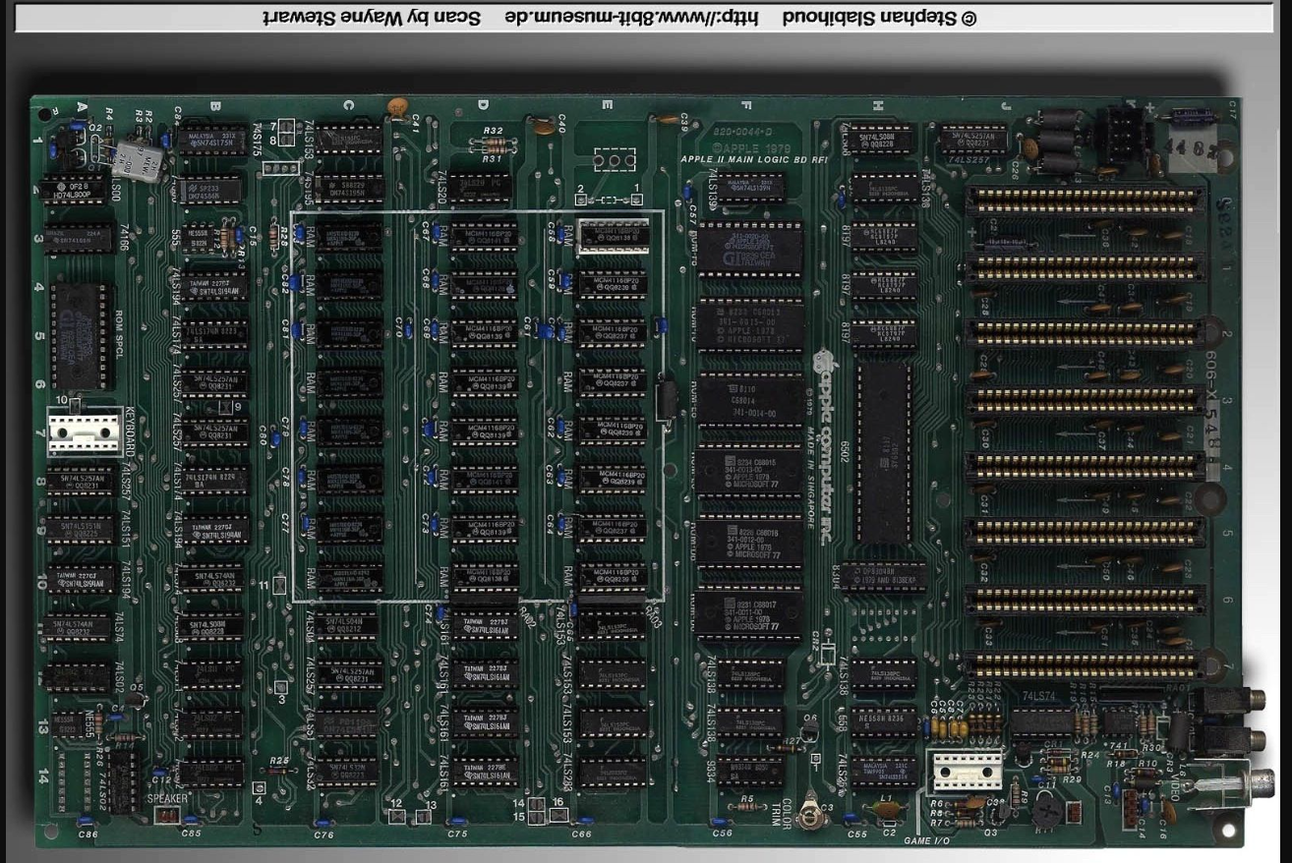
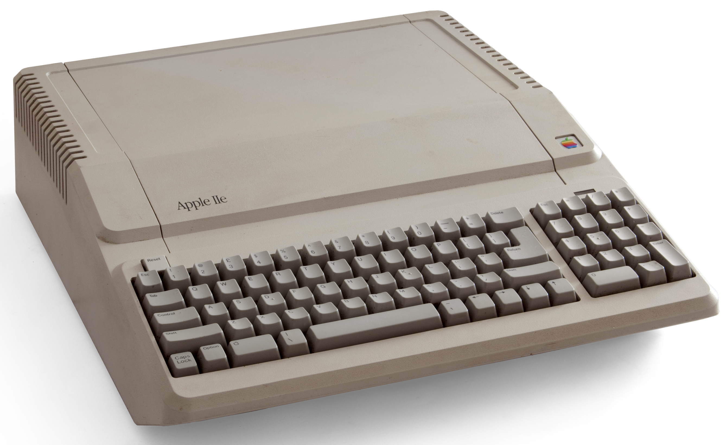

By Bilby - Own work, CC BY 3.0,
https://commons.wikimedia.org/w/index.php?curid=11119627

The 6502 Microprocessor Random Access Memory

