Write XML Clash Data to SQLite Database .exe v1.0.0

The “clashes_to_sql_v1.0.0.exe” will take the xml files exported from Navisworks using the Clash SQL Export plugin. Refer to the “Navisworks Clash Data Exporter to SQLite” document for more information.

The exe file should be located in the following location to work with the Navisworks plugin.

Installation Location - C:\Program Files\Autodesk\IPS Navis clashes to database

Running the Program

1. Double click the .exe file to run program. (Skip this step if you are running the exporter from Navisworks)

Image 1

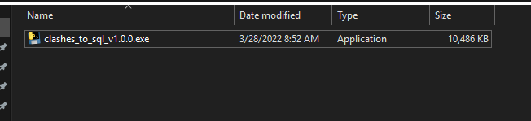

1. The first window will ask you to select the SQLite file you wish to add the clash data to. Select your project database file and click “Open”.

Image 2

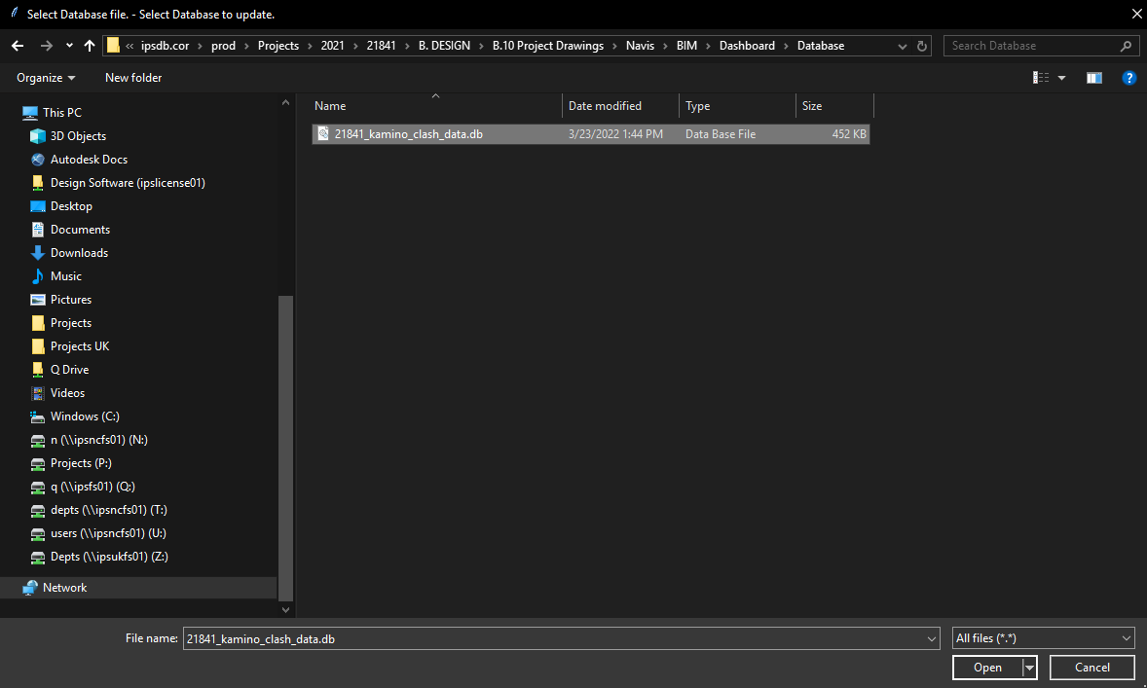

1. The second window will ask you to select the folder that contains the xml file. These are the xml files from Navisworks that contain the clash data. Select your folder and click the “Select Folder Button”.

Image 3

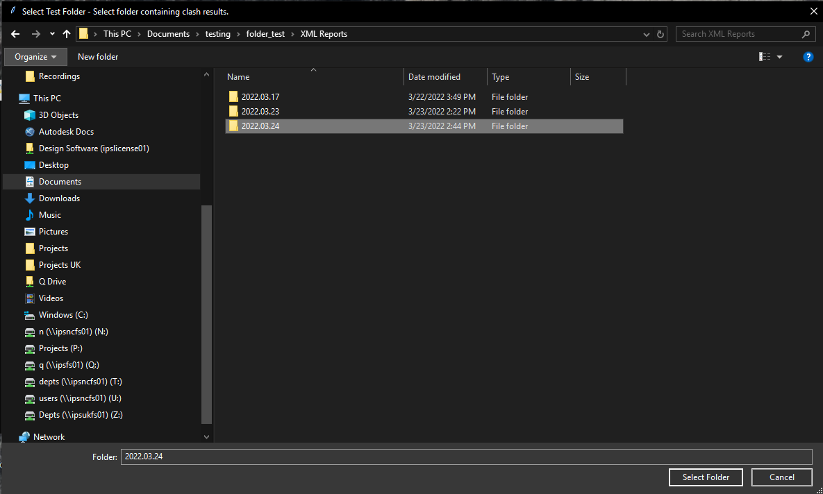

1. You will then be asked if the test data was exported today.

Image 4

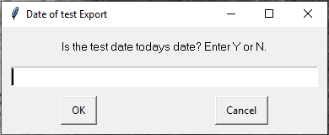

If your response is Y the current date will be used. (skip item 5)

If your response is N you will be prompted to enter the date the clash data was exported from Navisworks. (Continue to item 5)

1. Only applies if you answered N to item 4. Enter the date the tests data was exported in YYYY.MM.DD format.

Image 5

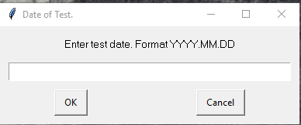

This date should be the same as the date that was appended to the end of each xml report. (See image 6)

Image 6

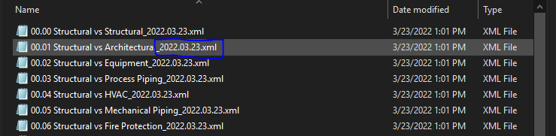

1. Confirm the date of the tests to use.

Image 7

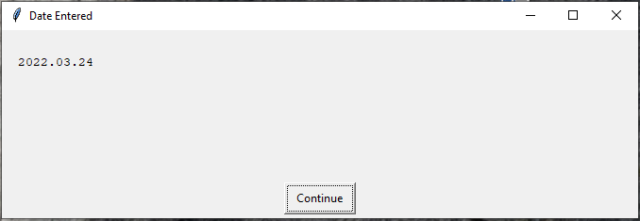

1. If any standard IPS clash test files were not present you will be shown a list of the test files not found. This is ok. If any of your tests in Navisworks have not been ran, no xml file is exported for those tests. Simply verify that the test not found are not needed.

Image 8

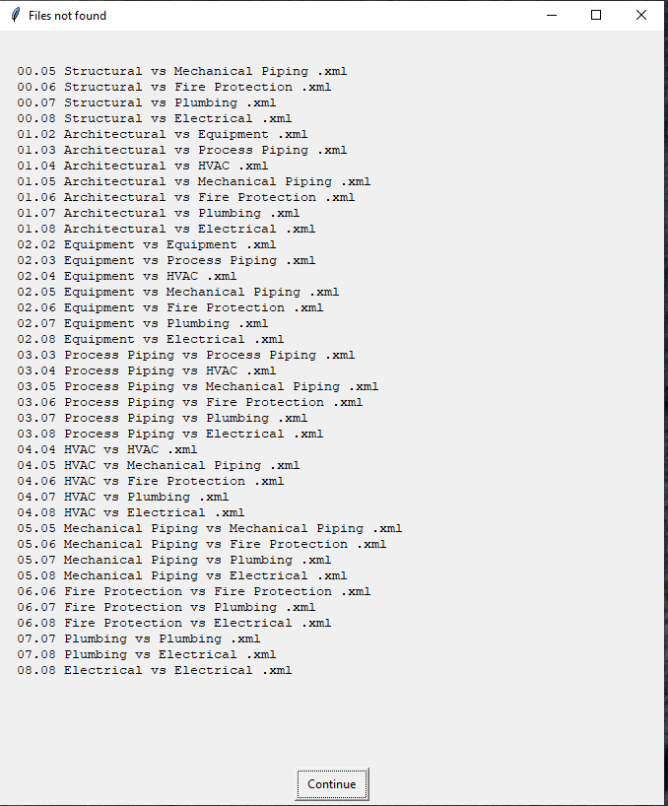

1. The next window will ask if the test table needs to be populated. The clash database contains two tables. One table is for the clash results and the other is for the clash tests information. The first-time data is imported into the database the test table will need to be populated. After that it does not need to be done again. Enter Y to fill in the clash test table. Enter N if the table has already been populated.

Image 9

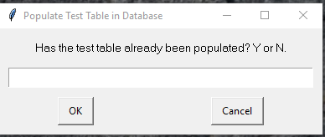

If you select N and the clash test data has been populated in the table already you will be presented with the following error.

Image 10

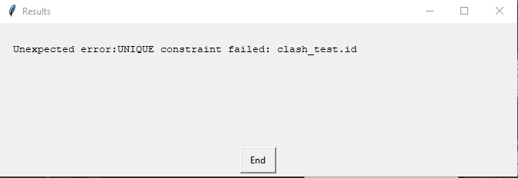

If this happen no data will be written to the database. You will need to re-run the program again to enter the clash data into the database.

1. If the tests were successfully populated you will receive the following message.

Image 11

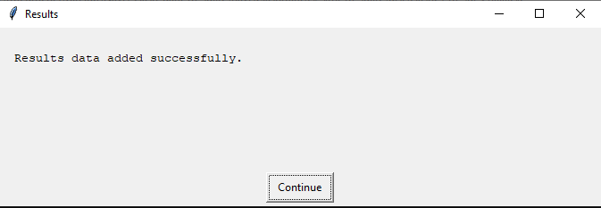

1. Be sure to verify that your clashes are present in the database by refreshing your Power BI dashboard.