ITC 6002
Exploring and Analyzing Data - Final Project
Exploratory Data Analysis and Forecasting of Apple Inc. (AAPL) Stock Price

Exploratory Data Analysis and Forecasting of Apple Inc. (AAPL) Stock Price

Team Members: Nikitas Valtadoros, David Frederick, and Dimitrios Bechrakis
Deree – The American College of Greece
ITC 6002: Exploring and Analyzing Data
Dr. Dimitris Milioris
December 16, 2025

Contents
Introduction 4
Dataset Choice 4
Possible Challenges 5
Part A: Data Preparation and Methodology 5
Data Acquisition and Cleaning Strategy 5
Outlier Analysis 6
Theoretical Framework 7
Performance Metrics 8
Part B: Year 1 Analysis 9
Context 9
Level Forecasting 10
Techniques 10
Optimization 10
Comparison 11
Trend and Seasonality 12
Graph breakdown 12
Year 1 Metrics Comparison 14
Part C: Year 2 Analysis 14
Context 14
Level Forecasting 15
Comparison 16
Trend and Seasonality 17
Graph breakdown 18
Year 2 Metrics Comparison 19
Part D: Comparative Analysis 20
Quantitative Comparison 20
Forecast Error Comparison 20
Part E: Forecast Adjustment with similar Data Sets 21
Methodology 21
Results & Analysis 22
Conclusion 24

Introduction
The financial market is widely recognized as complex adaptive systems where asset prices fluctuate unpredictably in response to a myriad of factors, ranging from macroeconomic indicators to company specific news. This inherent volatility makes the accurate forecasting of stock prices a significant challenge for analysts and data scientists alike. Because financial data is often non-stationary, meaning its statistical properties change over time, standard prediction models frequently struggle to differentiate between genuine market trends and random noise.
The primary objective of this project is to predict the daily closing price of Apple stock for the majority of the year using only the data from the first month as a training set. The goal is to evaluate the performance of various forecasting techniques. By analyzing data from two different years, this study aims to determine which methods can best handle the challenges of real-world financial data.

Dataset Choice
As mentioned beforehand, our dataset of choice is the daily stock price of Apple Inc. (AAPL). This choice was driven by the fact that financial data is inherently complex and is often characterized by high noise and intricate, recurring trading cycles rather than simple linear paths. By analyzing a high-volume, liquid asset like Apple, we can better test whether structural models can identify signal amidst this volatility. Finally, adjustment models like A/F ratios will be deployed to test the effectiveness of reference class forecasting.

Possible Challenges
Before diving deeper into the analysis, financial data inherits multiple challenges. Stock prices do not have stable statistical properties like mean and variance, they change over time, which results in poor predictions regarding future performance. Moreover, financial markets are extremely volatile. They often experience periods of relative calm which are then followed by burst of changes in their value.

Part A: Data Preparation and Methodology

Data Acquisition and Cleaning Strategy
The raw data was downloaded from Yahoo Finance and included the daily Open, High, Low, Close, and Volume for Apple (AAPL) stock for the years 2023 and 2024. We processed the data in Python using the following steps:
- We filtered out inconsistent rows, to specifically remove any days where the High price was lower than the Low price.
- We used forward fill to fix missing values and converted the index to datetime objects so the charts would plot correctly.
- Finally, we stripped the data down to just the Date and Close columns and split it into three separate groups:
  - AAPL 2023 as Year 1: Closing prices for the full year 2023 for year 1 analysis
  - AAPL 2024: Closing prices for the full year 2024 for year 2 analysis
  - AAPL 2024 Monthly: A separate dataset tracking the closing price on the first trading day of each month for part E analysis.

Outlier Analysis
We identified 7 outliers where the daily price shifted by more than 3 standard deviations from the adjacent day. While we list these instances to illustrate real market reactions to news, We chose to retain these outliers in the test set to ensure our model evaluation reflected true market conditions. Removing them would create an unrealistic testing environment that ignores the genuine risks of market shocks.

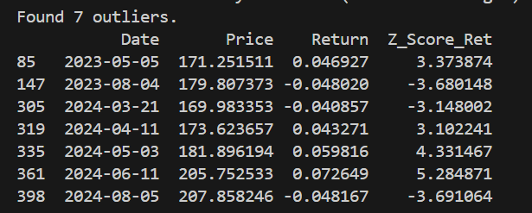
- May 5, 2023: Apple reported Q2 results, beating revenue and profit expectations. Furthermore, the board approved a massive share-repurchase program up to $90B resulting in a 5% rise of the stock
- August 4, 2023: In the end of Q3 Apple reported declined revenue following weaker than expected iPhone sales.
- March 21, 2024: : A significant drop driven by the U.S. Department of Justice’s antitrust lawsuit against Apple.
- April 11, 2024: News leaked on Apple releasing in-house processors with AI capabilities leading to an increase in share value.
- May 3, 2024: After their release of Q2 report which underlined that revenue was down, Apple announced the largest share-repurchase authorization in U.S history leading to a 6% rise in the stock price.
- June 11, 2024: A +7.3% surge corresponding to the "Apple Intelligence" announcement at WWDC.
- August 5, 2024: Warren Buffet’s Berkshire Hathaway had sold half of its stake in Apple after already trimming it more the previous quarter. This led to other investors selling stocks resulting in a drop of 4.8%.

Theoretical Framework
To evaluate Apple’s stock price, we organized our forecasting approach into three stages: establishing a baseline, modeling the structure, and applying an external reality check.
- Baseline Level Models: We started with simple "level" models to set a performance benchmark. These assume that despite daily volatility, prices fluctuate around a slowly changing average. We used the Naïve Approach (which assumes tomorrow’s price will equal today’s) and Moving Averages (MA) to smooth out daily noise. We also utilized Simple Exponential Smoothing (SES). Unlike a standard average, SES gives more weight to recent data, allowing the model to react faster to new trends while ignoring minor blips.

- Structural Decomposition Models: Since averages often miss long-term growth, we moved to structural models. We used Linear Trend Projection to map the stock's overall direction by fitting a regression line through the data. However, because stocks rarely move in straight lines, we combined this with an Additive Seasonal Adjustment . This method isolates the recurring 21-day trading cycle, allowing us to account for the monthly institutional patterns that drive price action.

- Reference Class Forecasting: Finally, we looked outside Apple's own data to correct for potential "tunnel vision." We used Reference Class Forecasting ("Outside View") by analyzing ten similar technology stocks. We calculated the average performance gap (A/F ratio) for this peer group and applied it to our Apple forecast. This tested whether aligning our forecast with the broader tech sector’s momentum would improve accuracy.

Performance Metrics
To compare the accuracy between models, we will utilize two primary error metrics recommended by Hyndman & Koehler (2006) for forecast evaluation.
  - Mean Absolute Deviation (MAD)
MAD measures the average magnitude of errors in a set of forecasts, without considering their direction. It provides a view of the error in the same units as the data.
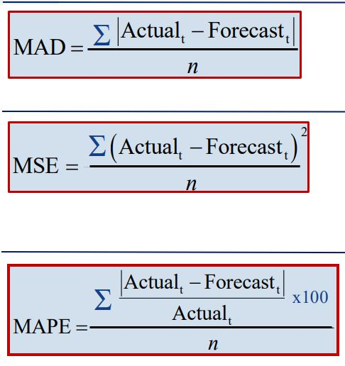

  - Mean Absolute Percentage Error (MAPE)
MAPE measures the average magnitude of error relative to the actual value, expressed as a percentage. This allows for comparison between datasets with different price levels.


Part B: Year 1 Analysis

Context
The first-year analysis (APPL 2023) dataset was split into 2 parts in order to simulate a realistic training and test scenario. 21 days (January) as training set and the rest of the year (February-December) as test set. By using such approach, we aim to test the ability of the model to project long-term behavior of the stock price using a limiting training window.

Level Forecasting

Techniques
The first method was the Naïve Approach. It assumes the demand in period (t+1) which equals demand in period t. Second method used was Moving Average (MA). It is a series of arithmetic means with the aim of smoothing. Third and last Level forecasting technique is that of Simple Exponential Smoothing (SES). In this technique we apply a weighted average, where said weights exponentially decline.

Optimization
For our first tests we applied three Level Forecasting techniques which don’t have any trend or seasonality. For optimizing the parameters, we minimized the Mean Absolute Deviation (MAD) on the training data. Starting with the moving average (MA) through our optimization we found that the best window size is n=2. Such choice would underline our need that the most recent prices are by far more important for predicting than older ones. For Simple Exponential Smoothing (SES) through our testing the optimal value for our smoothing constant was found to be a= 0.9. The choice of 0.9 as an alpha value indicates that the model places 90% of the weight on the most recent price which results in closely mimicking our first method, that of the Naïve forecast.

Comparison
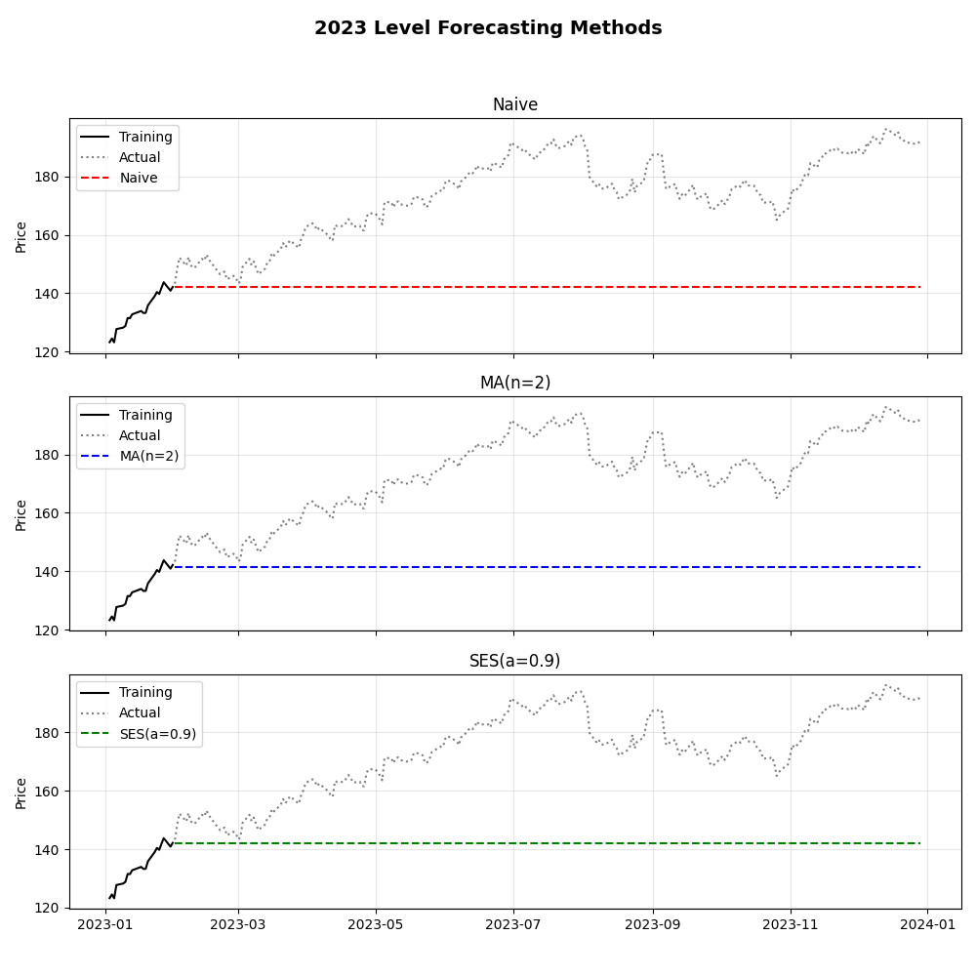
The doted gray line represents the actual price of the stock throughout the year. As we can see there was an upwards trend throughout the year rising from around $143 to $190. The Level forecasting techniques which we used resulted in a flatline, failing to capture this trend.
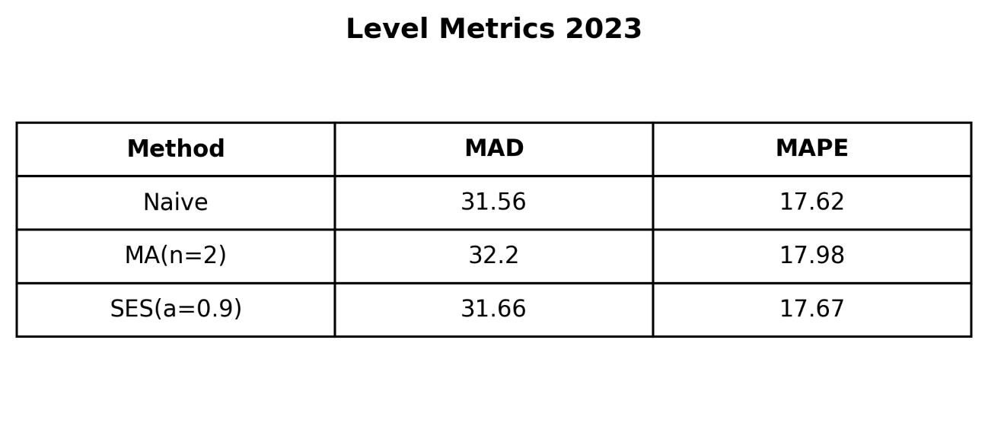
As for numbers, the metrical analysis suggested that the Naïve approach had the best performance with a Mean Absolute Error (MAD) of 31.56 and a MAPE of 17.62%. The reason behind these numbers is due to the stock trending upwards in January, and since the Naïve model relies solely on the last observed price (which happened to be the monthly high), whereas the Moving Average as the name suggests averages the lowest prices from earlier in the month as well.

Trend and Seasonality
We diagnosed a seasonality of p=21 days (1 trading month) over a smaller period like weekly or quarterly due to financial markets often exhibiting monthly rhythmic behaviors as a result of option expirations and institutional rebalancing. The model extracted a static wave pattern from the January residuals and superimposed it onto the trend.

Graph breakdown
The graph below illustrates the Trend and Seasonal components.
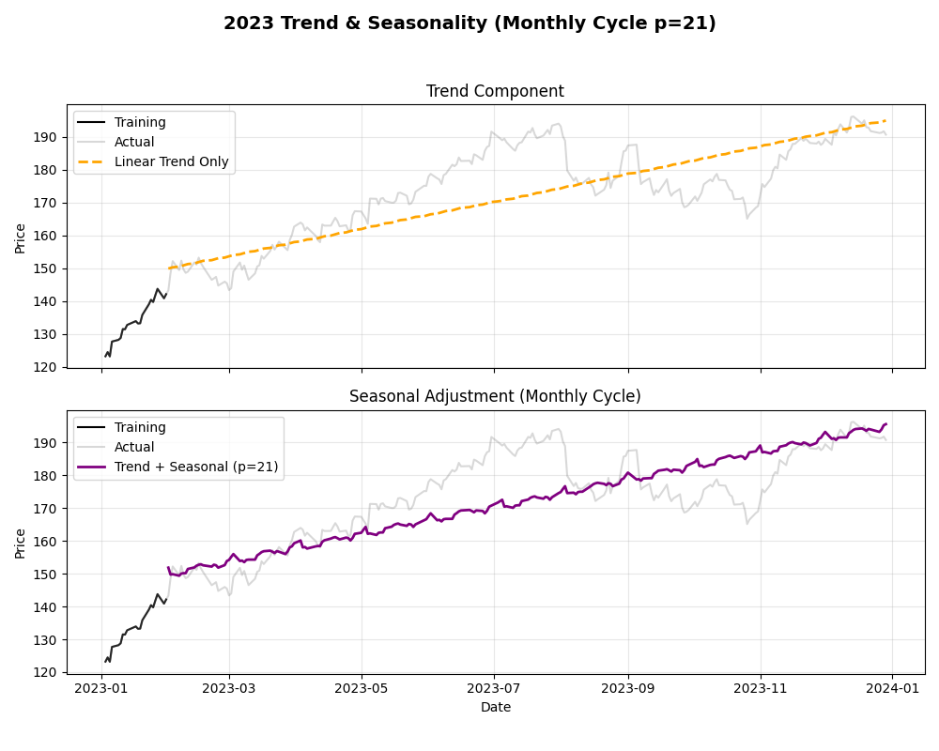
The orange line which represents the Linear Trend captures the upwards trend of the price but lacks accuracy as it overshoots the magnitude. This happens because it assumes the rapid rise that happens in January will continue indefinitely. The purple line represents the Seasonal Adjustment which adds the needed volatility pattern which often represents financial markets.

Year 1 Metrics Comparison
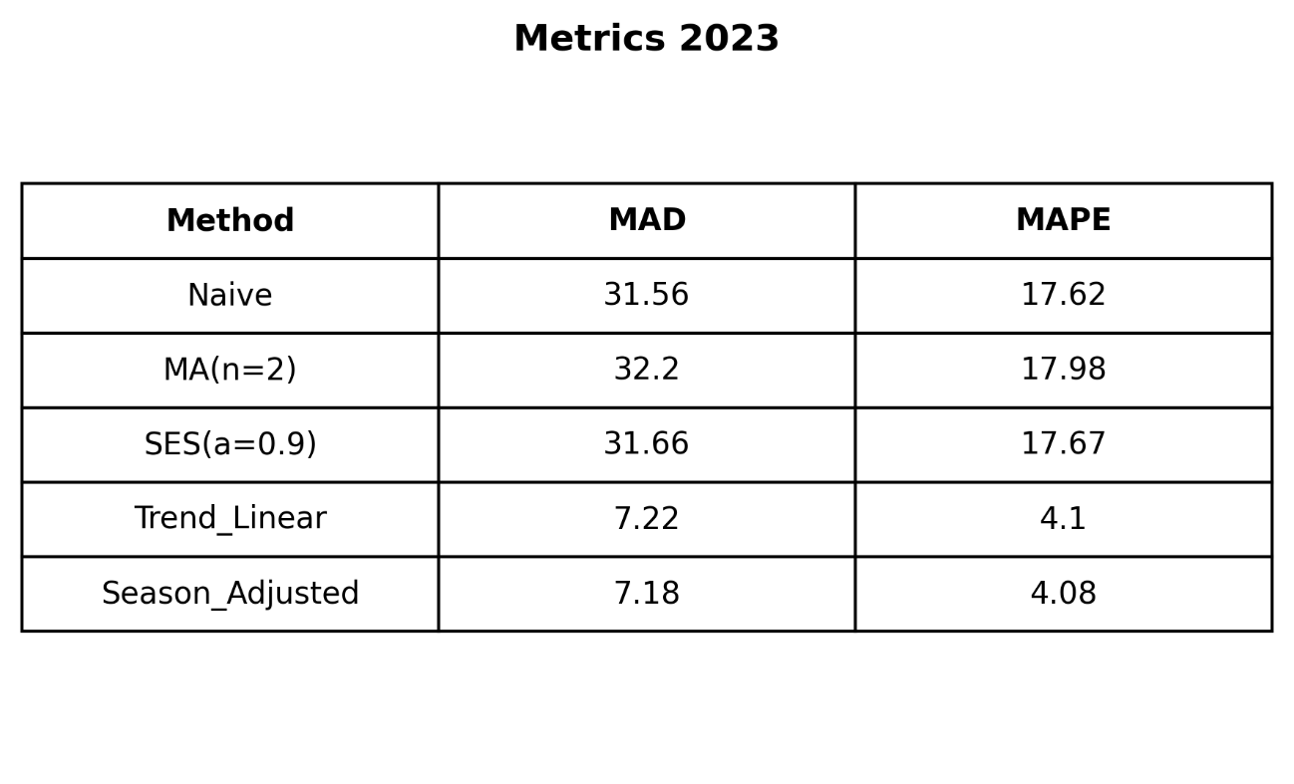
After adjusting the seasonality model, we reached the conclusion that it was the superior forecasting technique for the year 2023 by achieving MAD value of 7.18 and a MAPE of 4.08%. The reason behind this result lies in the fact that while the Linear Trend captured the upward trend and the bulk of the accuracy, reducing the error from 31.56 to 7.22, the Seasonal Adjustment (additive) provided further improvements to the MAD values by modeling the minor monthly oscillations around that trend.

Part C: Year 2 Analysis

Context
In this second-year analysis, the dataset was also split into 2 parts in order to simulate a realistic training scenario. 20 days (January) as training set and the rest of the year (February-December) as test set. By using such approach, we aim to test the ability of the model to project long-term behavior of the stock price using a limiting training window.

Level Forecasting
The optimization process of the year 1 was repeated for the second year as well. Which resulted in the same outcome of a Moving Average of n=2 and an alpha value of 0.9 for SES. The persistence of these values between the two years reinforces the fundamental statistical structure of financial markets. Meaning that even if the price changes the structure does not. Specifically, the high smoothing parameter (a=0.9) indicates that the model prioritizes rapid adaptation to recent price changes over historical smoothing.

Comparison
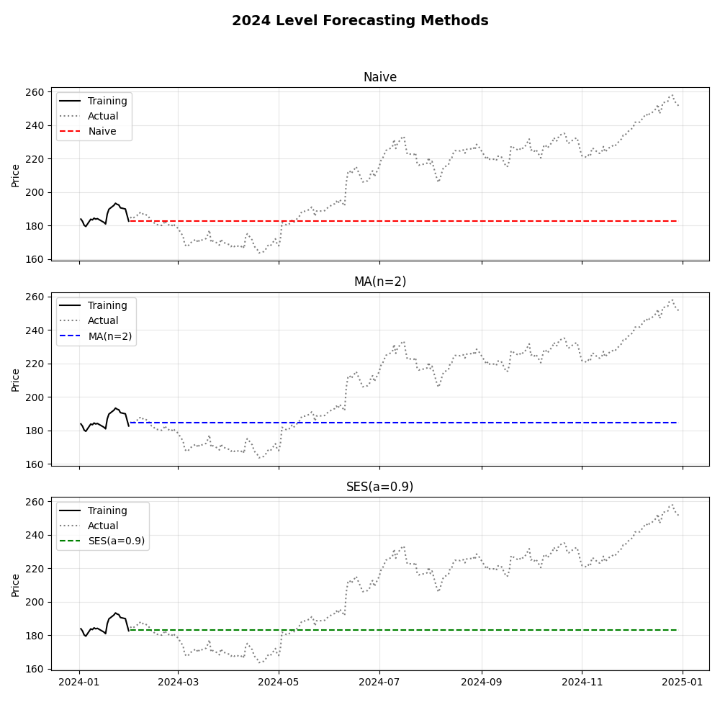
Unlike the previous year, year 2024 showcased a downward trend in the first month. The Naïve model picked its forecast to the last price of the month (the local bottom), whereas the Moving Average model averaged the slightly higher prices from the previous days of the given month. Another difference between this year and the previous year is that this time the MA model proved closer to the year-end reality since the market eventually rose after a low performing first month proving that the slightly higher baseline of the MA model was better in this time around.
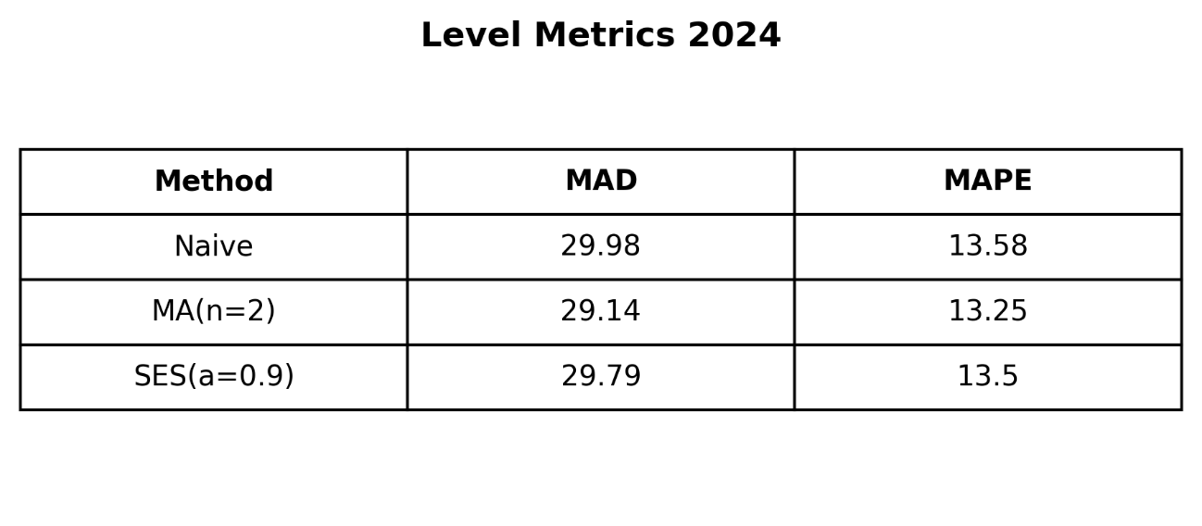
Quantitatively, this advantage is reflected in the metrical table above, where the Moving Average (n=2) achieved a lower Mean Absolute Deviation (MAD) of 29.14 and MAPE of 13.25, compared to the Naive and simple exponential smoothing models. This small improvement shows that in a “dip-and-recover” situation, using a smoothed lowest month-end price gives a steadier starting point than depending only on the latest data point.

Trend and Seasonality
The year would be described as bullish, meaning that the price was expected to rise after a low performance in the first month. To confirm this quantitatively, we applied a diagnostic linear regression on the full dataset. 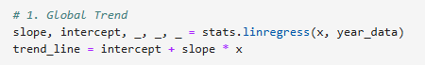

Graph breakdown
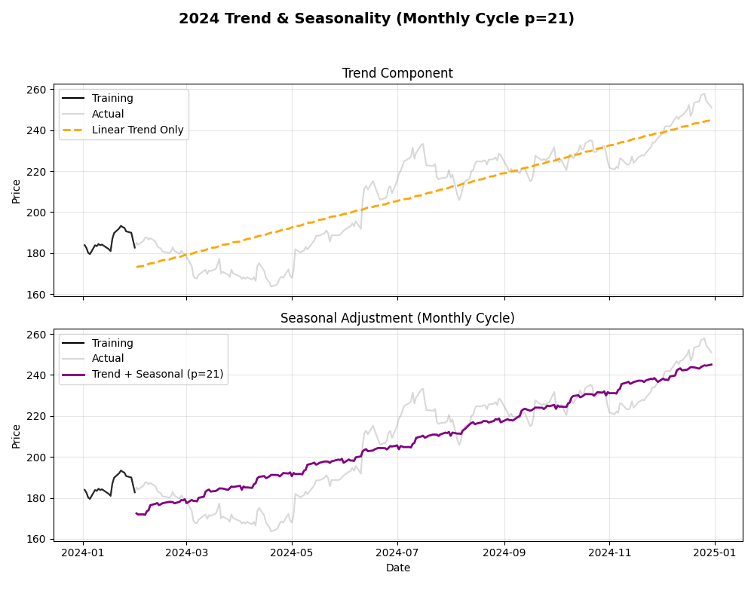

Year 2 Metrics Comparison
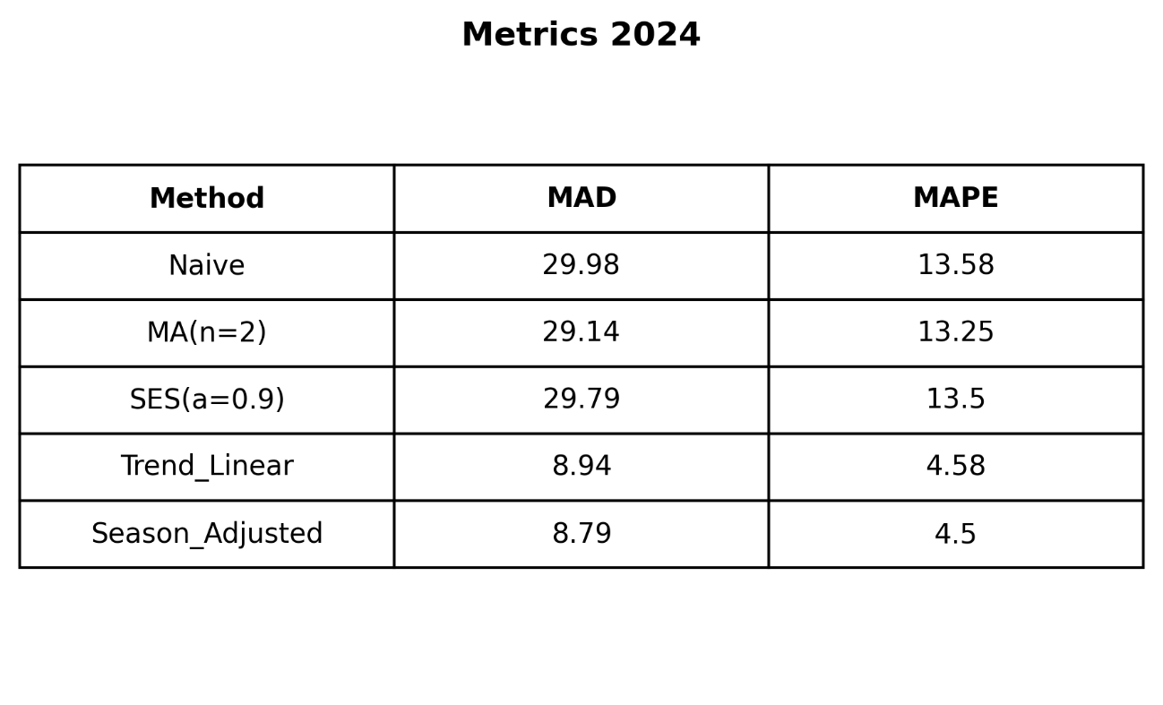
The metrical table above summarizes the performance metrics for all models applied in Year 2. As seen the seasonal Adjusted (additive) was also the superior forecasting technique for Year 2 by achieving MAD value of 8.79 and a MAPE of 4.50%. The reason behind this result lies in the fact that while the Linear Trend captured the upward trend and the bulk of the accuracy, reducing the MAD from 29.14 to 8.94, the Seasonal Adjustment provided slight improvements to the MAD values by modeling the minor monthly oscillations around that trend.

Part D: Comparative Analysis

Quantitative Comparison
Comparing the market behavior between Year 1 (2023) and Year 2 (2024) reveals a shift toward a more aggressive and unstable market environment.
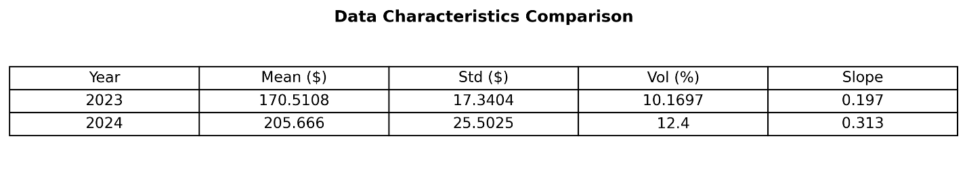
- Price & Volatility: 2024 was defined by significantly higher valuations, with the average price jumping from $170.51 to $205.67. However, this growth came at the cost of stability. The standard deviation which is a key measurement of risk rose from 17.34 to 25.50, and volatility increased to 12.4%.
- Trend Strength: Contrary to the "dip and recover" start, the overall trend for 2024 was actually steeper than the previous year. The slope metric increased from 0.197 in 2023 to 0.313 in 2024, indicating that once the rally began, the upward momentum was more intense than in 2023.

Forecast Error Comparison
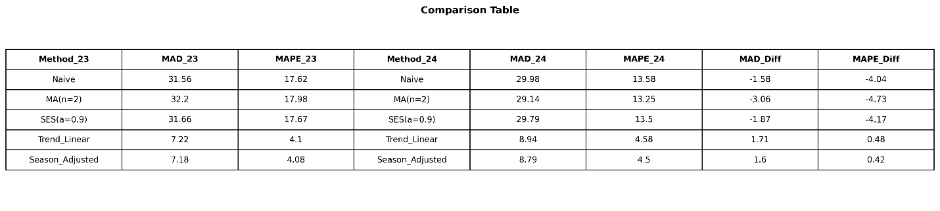
According to the above metrical comparison table:
- The Level Models (Naive, MA, SES): models actually performed better in the more volatile 2024. For instance, the Naïve model’s MAPE dropped from 17.62% (2023) to 13.58% (2024). This is likely because the "dip" in early 2024 kept prices closer to the January baseline for a longer period, whereas in 2023, the price immediately marched away from the starting line.
- Structural Models (Trend & Seasonality): Our best model (Seasonal Adjusted) remained highly consistent, with the MAD shifting from 7.18 to 8.79 and the MAPE from 4.08% to 4.50%. This proves that while level models fluctuate wildly based on market luck, a model that mathematically accounts for trend and seasonality provides a robust forecast regardless of the year's specific volatility.

Part E: Forecast Adjustment with similar Data Sets

Methodology
In this final stage, we applied the A/F (Actual/Forecast) ratio technique to determine if incorporating an 'Outside View' could refine our forecast. Using this technique, we aimed to mitigate the cognitive biases by benchmarking our forecast against a reference class of similar assets to APPL stock.
For this reference class, we analyzed the performance of ten major technology stocks in 2024: MSFT, GOOGL, AMZN, NVDA, META, TSLA, AMD, INTC, IBM, and ORCL. We used a monthly dataset for these stocks consisting of the closing price on the first trading day of each month.
Then we used these external benchmarks to adjust our 'Inside View,' which was based on the best performing model from Part C: the Seasonal Adjusted Model (Trend + Seasonality, p=21).

Results & Analysis
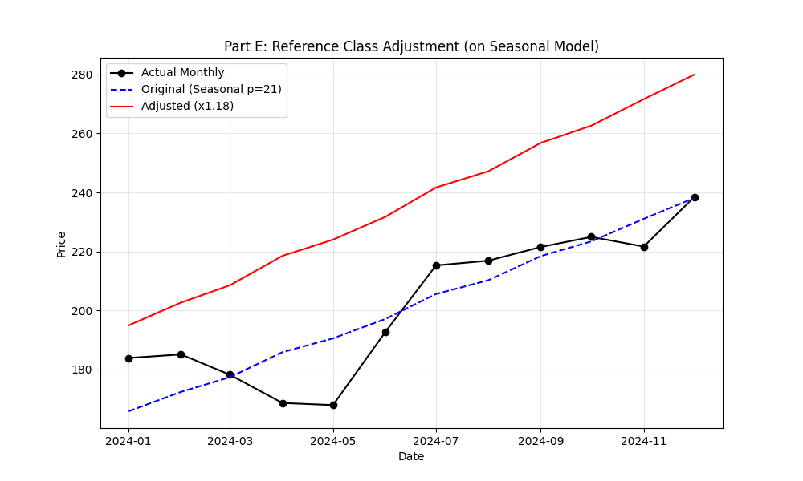
As shown in the graph above, our analysis on the ten other tech stocks resulted in an adjustment factor of 1.18. In the graph, the Red Line represents the forecast modified by this factor. This indicates that, on average, the reference class of stocks performed 18% better than expected in 2024. This suggests the broader tech sector experienced a strong rally that our Seasonal Adjusted Model (Trend + Seasonality, p=21) did not account for.
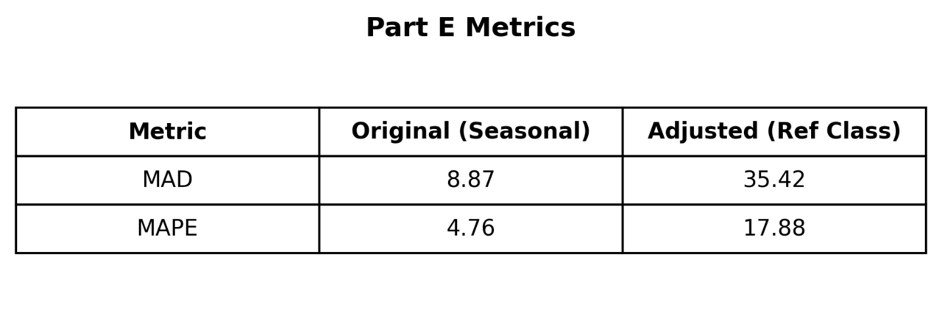
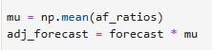

However, when we applied this 1.18 factor to our Apple forecast, the accuracy decreased significantly. As seen in the table, the MAD and MAPE increased from 8.87 and 4.76 in our original model to 35.42 and 17.88 in the adjusted model, respectively. Since lower metrics score indicates a better forecast, this confirms that the adjustment introduced a large amount of error. Furthermore, it demonstrates that while the rest of the tech stock surged, Apple followed its own specific pattern. Therefore, applying the general market trend was too optimistic for this specific case, and our Seasonal Adjusted model remained the superior model.

Conclusion
This project examined how different forecasting methods perform on highly volatile financial data, using Apple (AAPL) stock during 2023 and 2024. The analysis led to several critical insights concerning the forecasting of prices in stock/financial market. Primarily, the results that were produced by static level-based models such as Naive, MA, and SES have clear limitations when applied to stock prices. Because these methods rely on fixed baselines, they consistently failed to adapt to the upward momentum observed in both years. Although their performance marginally improved during the volatile "dip-and-recover" pattern of 2024, their average error rates remained too high to be considered viable for practical trading strategies.
In contrast, the decomposition of the time series into its constituent parts proved to be a far more effective approach. The Seasonal Adjusted Model, which mathematically accounted for both the linear trend and the recurring 21-day trading cycle, consistently outperformed all other methods. By isolating the underlying market structure from random noise, this model maintained a stable and low error rate across both the steady bullish market of 2023 and the high volatility environment of 2024. This consistency suggests that capturing the intrinsic structural dynamics of a stock is significantly more valuable than merely smoothing out recent price history.
Finally, the experiment with Reference Class Forecasting highlighted the risks of relying too heavily on external market benchmarks. While the broader technology sector experienced an aggregate rally of approximately 18% in 2024, incorporating this "Outside View" into the Apple forecast drastically increased the Mean Absolute Deviation from 8.87 to 35.42. This drop in accuracy indicates that Apple’s price action did not follow the same strong momentum as the rest of the sector during this period. Consequently, this study concludes that while external benchmarks can be useful, the "Inside View" derived from the asset’s own historical data remains the better predictor when a specific company does not share the broader market's strong growth.

