**Game Design Document**

**Game: Save Earth from Global Warming**

**Members:**

**Shobhit Dhamania - Gameplay Programmer**

[Durrell Bedassie](mailto:dab6084@g.rit.edu) **- Gameplay Programmer / Sound Design**

**Unity Version : 2020.3.14f1**

**Github:** <https://github.com/gdd-shobhit/SaveEarthFromGlobalWarming>

**Content:**

**1) Overview**

**2) Story**

**3) Timeline**

**4) Level Design**

**5) Assets**

**6) Gameplay**

**Elevator Pitch: As y'all know that global warming is causing so much harm to aquatic life, life at shore and even human life. There gotta be a way to prevent it or slow down.**

**This game is set in stone age, progressing towards modern age, trying to prevent earth from dying from global Warming. Build houses, factories, farms, docks and different buildings to progress towards your imaginative world but be careful, it comes with a price. Everything you build has a damage on your 'health bar' as a cost along with some resources which is the health of Earth. If you don't plant enough trees or destroy a lot of trees after installing a factory, if you don't install enough purifiers for water sources, if you don't think about enough O2 level when building a house which increases your population and if you don't think about your civilization in sustainable way, you will probably end up destroying your civilization and your planet.**

**I.** **Overview**

**Theme: Civilization Builder**

**Map is going to be a 2D world which you can rotate and see what’s on the other side of the world. The world will be divided into 3 sections: Urban, Sub-Urban and Farms/Villages for better organization.**

**Urban: You have to place buildings/huts/apartments so people can live in them. More houses mean more humans and hence more Human waste.**

**Sub-Urban: Factories for different stuff which will be automated to give out a certain amount of waste. Example Clothing factory gives 20 wastage per Hour, Food factory gives 10 per Hour etc.**

**Note: Factories are to be placed because it improves the civilization and that’s how a civilization becomes ‘developed’. But, they come with cost like more wastage per wave. So we need appropriate number of towers for the each Wave**

**Farms/Villages: This will be a place for our passive income/active income. Passive as in the farms produce food and sell so we get money. Amount of money would be dependent on the QUALITY of food. QUALITY of the food will depend on how CLEAN our environment is and therefore depends on the player’s health which is going to be a pollution gauge bar which fills up and depletes according to wastage going in the environment.**

**This is a really interesting feature because for example if there is more human waste than other thing and human waste KILLER(filtration plant) costs a lot and you don’t have that much money for preventing that to pollute then your gauge will just go up. So it is more about strategizing things and keeping check on things**

**The factories will also have power ups like installing some feature inside the factory which reduces the waste by 20% or something like that.**

**Mood Board:**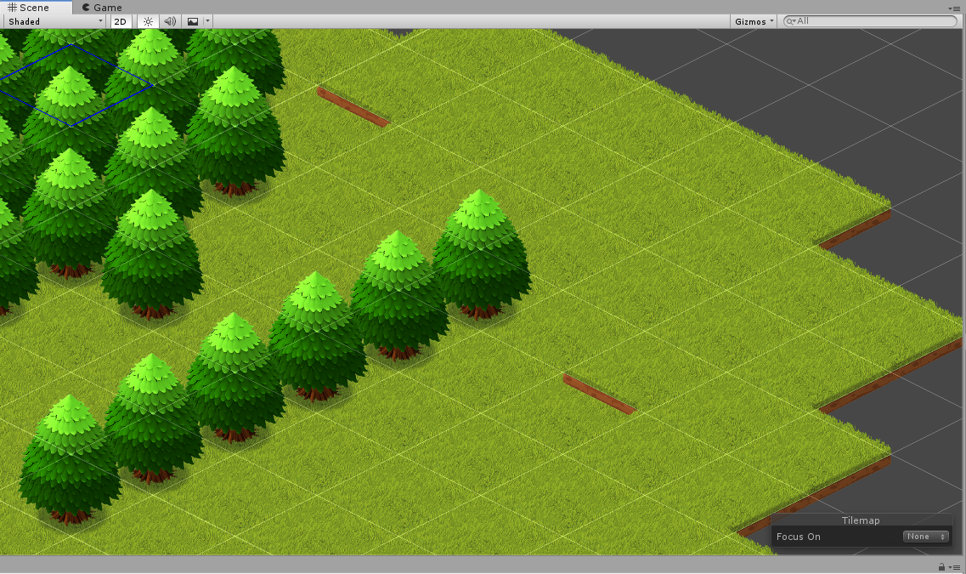

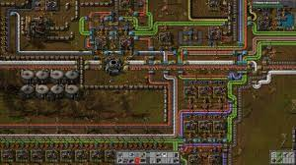

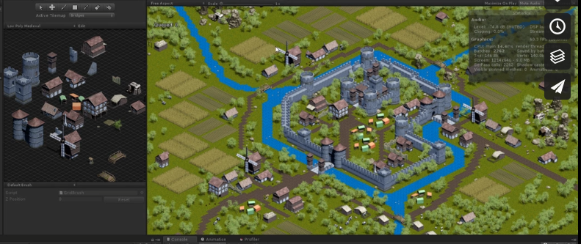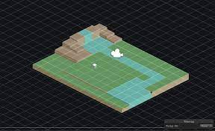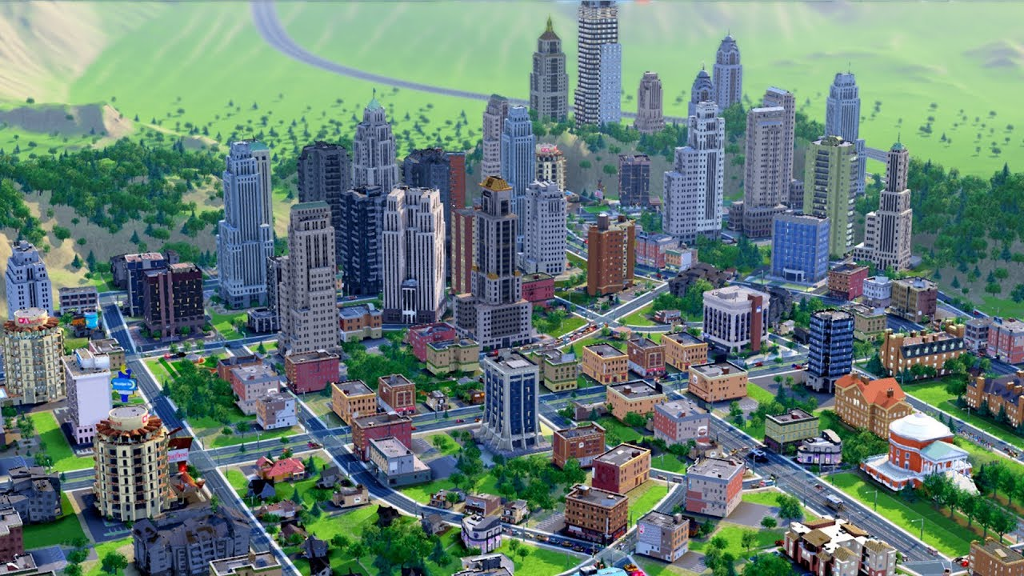

Week 3 (thursday):

1. Setup Isometric tiles in scene
   1. Possibly write a TileManager
      1. Use Dijkstra's to change tile type when health reduces
2. Cycle of day and night
3. Types of terrain(assets build out)
   1. Possibly a segway towards world building
   2. Trees and shit
4. Movement of camera
5. Setup the ‘Pollution’ backend
   1. Write economy of how much it costs to make things and stuff

**Stretch Goal:**

1. **Heat Map**