(Student C00306133) Daniel Belov
19/04/2026
Object Oriented Software Development
ATM System

Table of Contents
Summary 2
Description 2
Requirements 3
Functional Requirements 3
Authentication 3
Customer Management 3
Account Management 3
Card Management 3
Transaction Management 4
Non-Functional Requirements 4
Database tables 5
Account 5
Card 5
Customer 6
Transaction 6
ER diagram 7
Code snippets 8
DBConnection.java 8
TransactionsDAO.java 8
CardDAO.java 9
CustomerPanel.java 10
CustomerPanel.java 12
TransactionPanel.java 12
Test cases 13

Summary
The ATM system is a java application which allows users to perform banking operations such as withdrawals, deposits and transfers. It consists of a java swing GUI frontend connected to a MySQL database backend, following an object oriented design with model, DAO and GUI.

Description
The ATM system is an application that allows users to manage their bank accounts and perform financial transactions. Users can authenticate themselves by inserting their card number and PIN in order to gain access to their account. The system supports full customer management, allowing customers and their associated accounts and cards to be created, viewed, updated and deleted. Once authenticated, users can perform three types of transactions: withdrawals, deposits and transfers between accounts. The system automatically updates account balances after each transaction and provides error handling for scenarios such as insufficient funds, invalid PIN entry and incorrect input types. The system is designed to simulate a real world ATM experience using a java swing GUI connected to a MySQL database.

Requirements

Functional Requirements

Authentication
- The system shall allow users to log in using their card number and PIN
- The system shall reject invalid card numbers or PINs
- The system shall redirect users to the main page following successful login

Customer Management
- The system shall allow users to add new customers with all fields required
- The system shall validate that first name and last name contain letters only and are between 2 and 15 characters
- The system shall validate that address is between 10 and 70 characters
- The system shall validate that phone number is between 7 and 15 digits
- The system shall validate that email is between 5 and 30 characters and follows a valid email format
- The system shall allow users to view all customers in a table
- The system shall allow users to update existing customers details with the same validation rules
- The system shall allow users to delete customers with a confirmation

Account Management
- The system shall allow users to create checking or saving accounts
- The system shall require a balance value between 0 and 999,999
- The system shall validate that balance is a valid number
- The system shall prevent account creation if no customers exist
- The system shall allow users to view and update account details with the same validation rules
- The system shall allow users to delete accounts with a confirmation

Card Management
- The system shall allow users to add cards with all fields required
- The system shall validate that cad number contains between 13 and 19 digits
- The system shall validate that PIN is exactly 4 digits
- The system shall validate that CVC is exactly 3 digits
- The system shall allow users to select an expiration date using day, month, and year dropdowns
- The system shall prevent card creation if no accounts exist
- The system shall allow users to view, update, and delete cards with the same validation rules

Transaction Management
- The system shall allow users to perform withdrawals, deposits and transfers
- The system shall require an amount value between 0 and 99,999
- The system shall prevent withdrawals and transfers if funds are insufficient
- The system shall prevent transfers to the same account
- The system shall automatically record the date of each transaction
- The system shall allow users to view, update and delete transactions
- The system shall prevent transaction creation if no accounts exist

Non-Functional Requirements
- The system shall perform well and respond quickly to user actions
- The system shall not crash and shall display error messages to the user instead
- The system shall be easy to use with a clean and consistent interface
- The system shall validate all user inputs before processing to prevent invalid data entry
- The system shall use a secure login system requiring both a card number and PIN

Database tables

Account

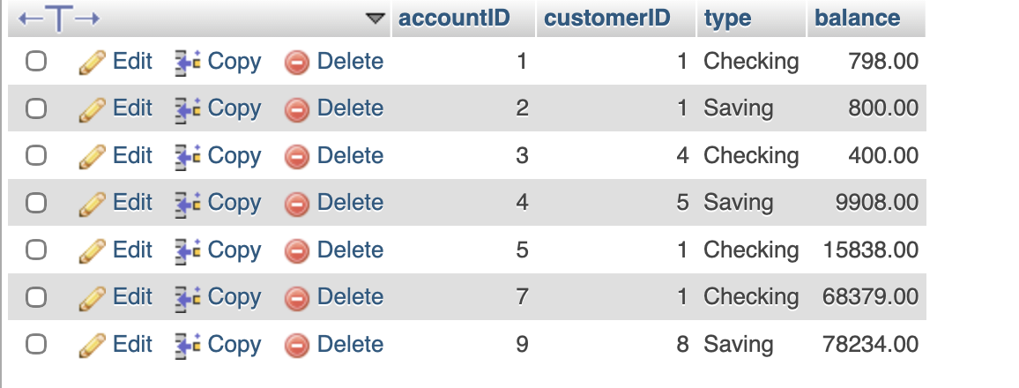

Card

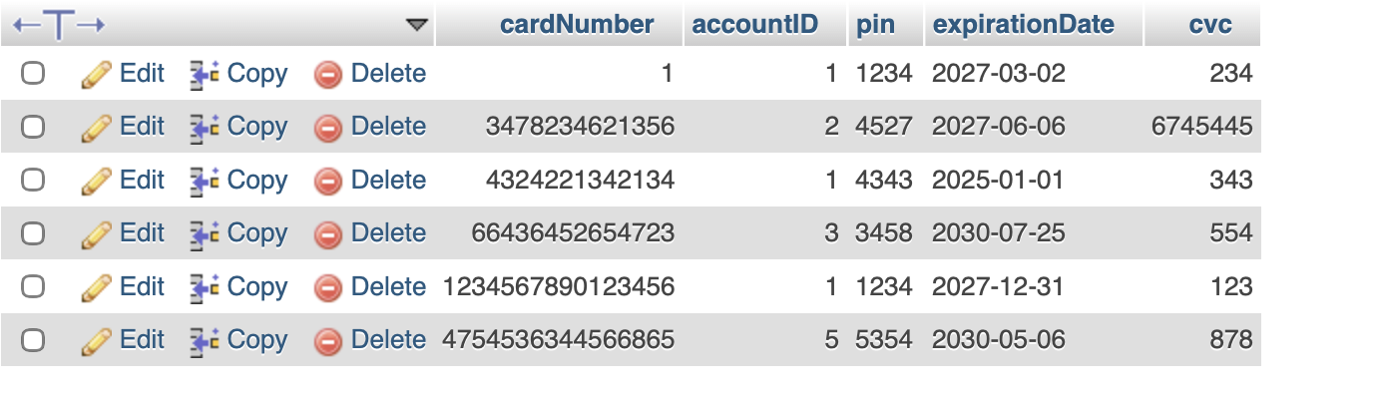

Customer

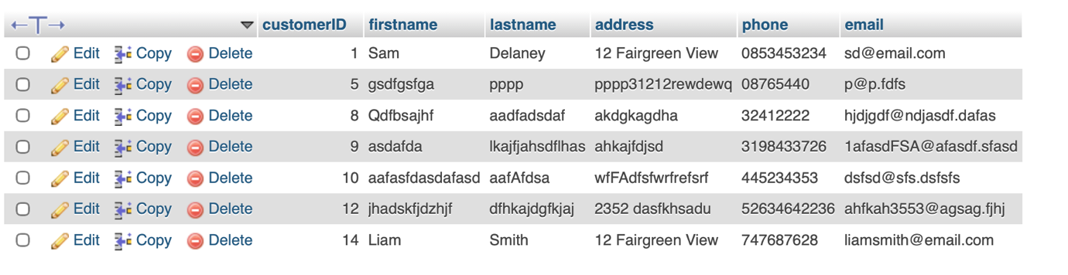

Transaction
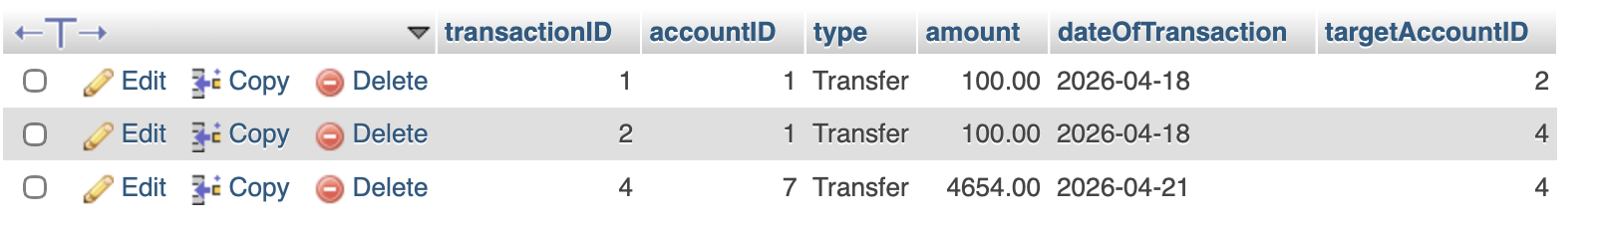

ER diagram
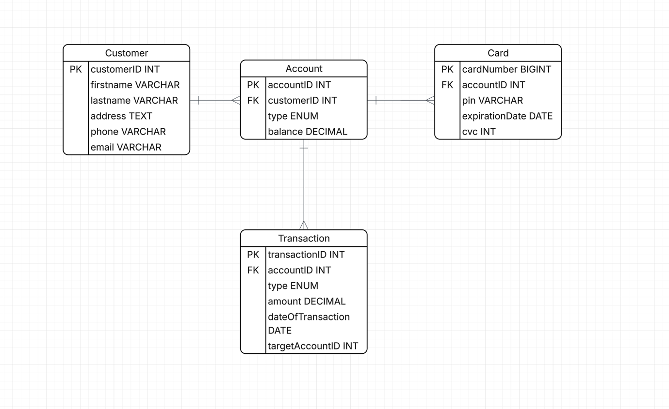

Code snippets

DBConnection.java
Database connection using MySQL
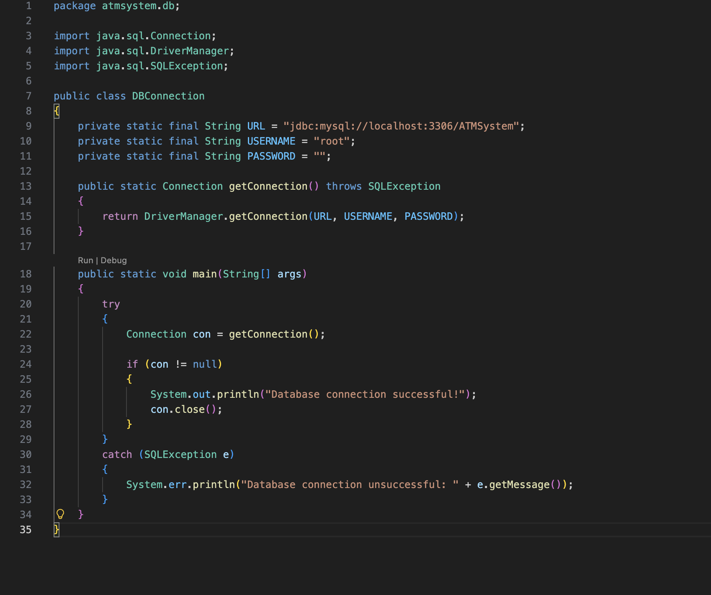

TransactionsDAO.java
Inner join query used across customer, account and transaction tables
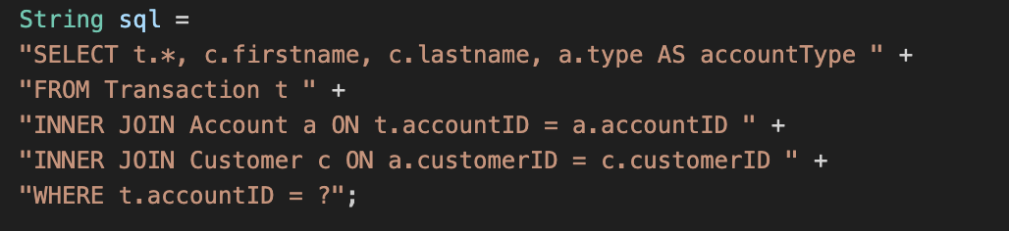

CardDAO.java
Login authentication used to validate card
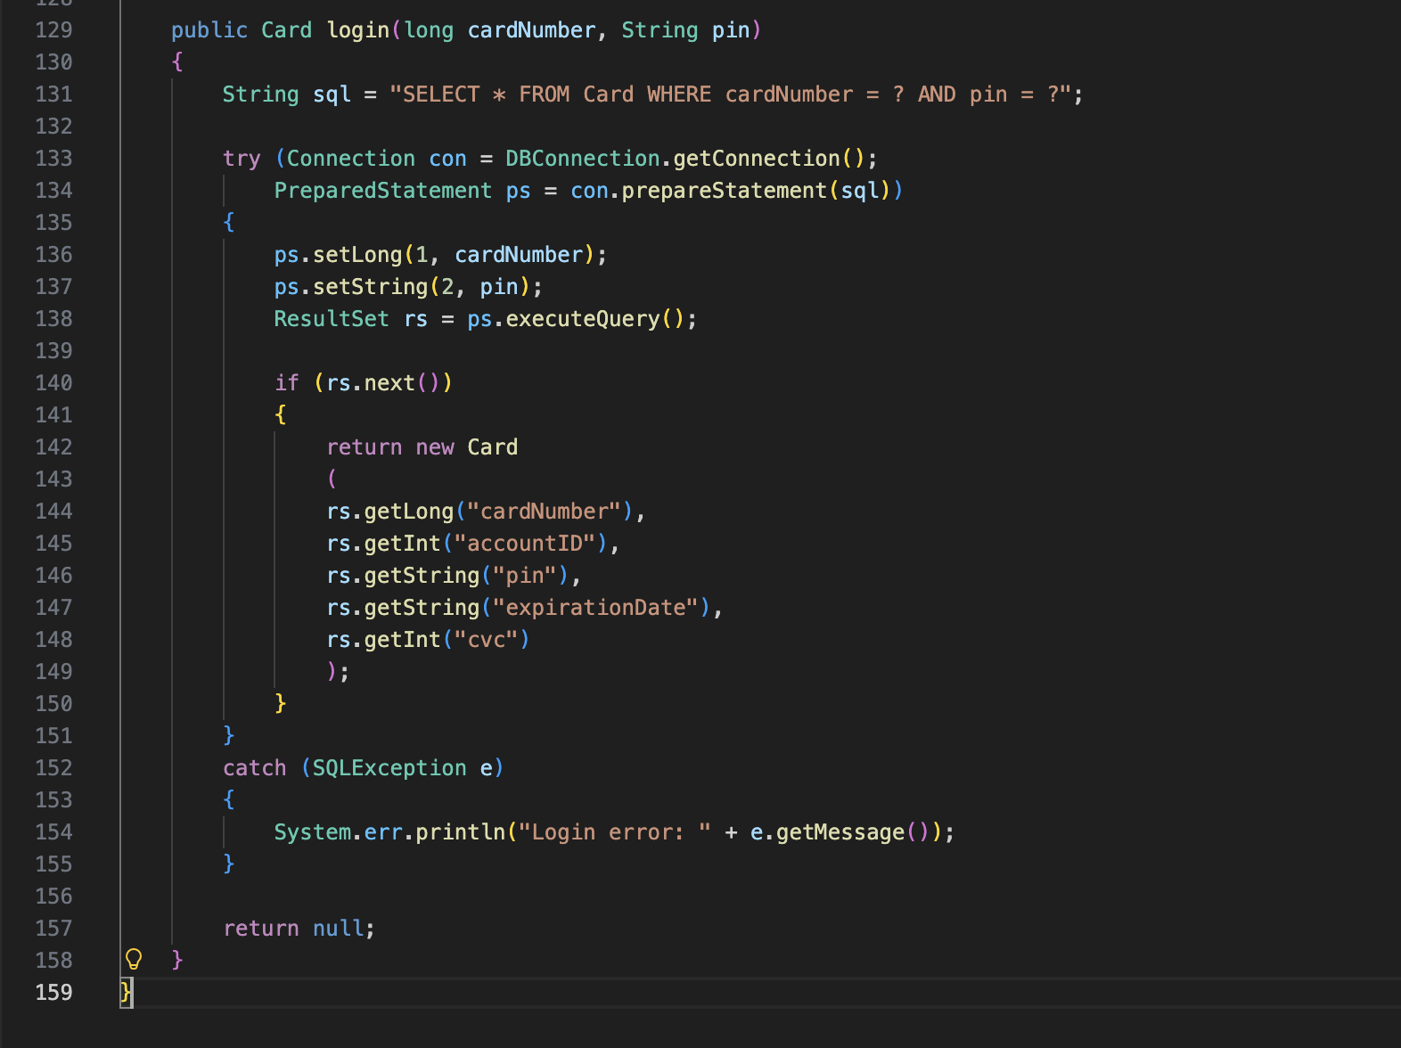

CustomerPanel.java
Error handling including regex for preventing invalid data from being entered
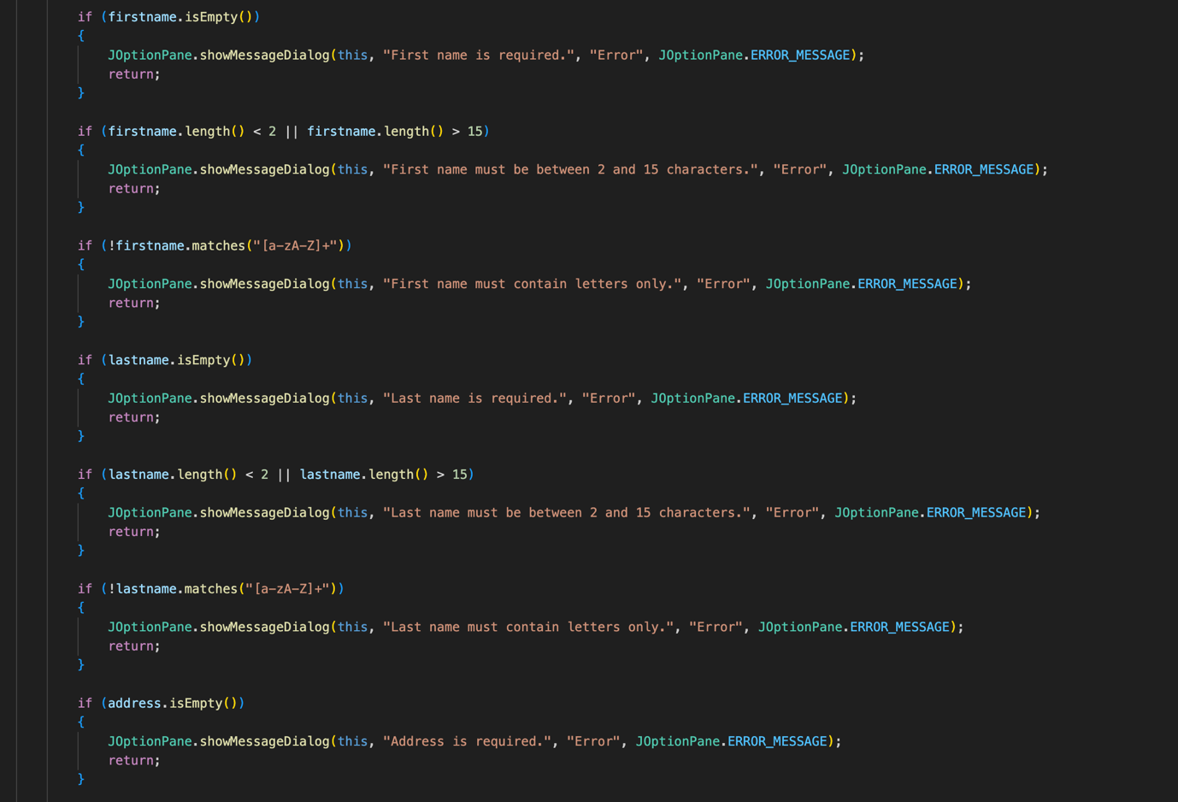

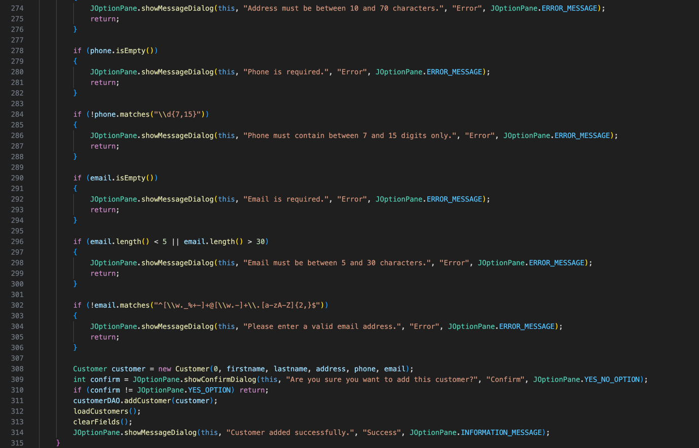

CustomerPanel.java
Overrides paintComponent and paintBorder functions to create custom rounded fields
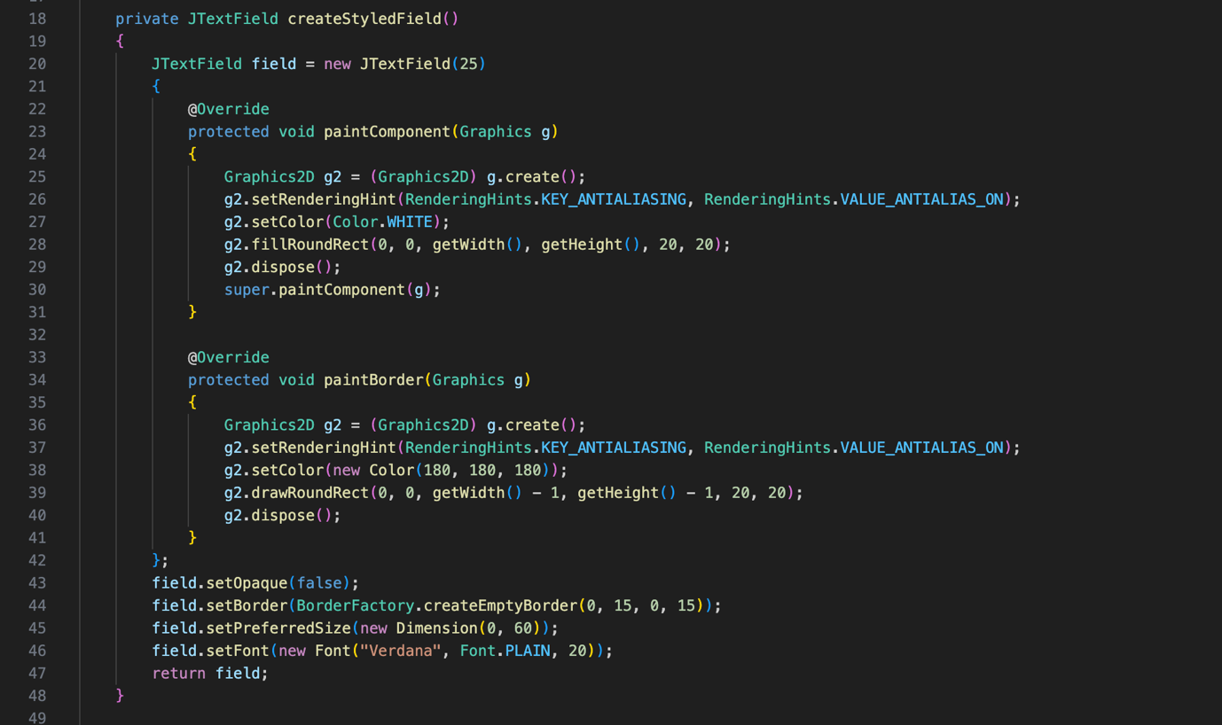

TransactionPanel.java
Handles balance updates and insufficient funds checks

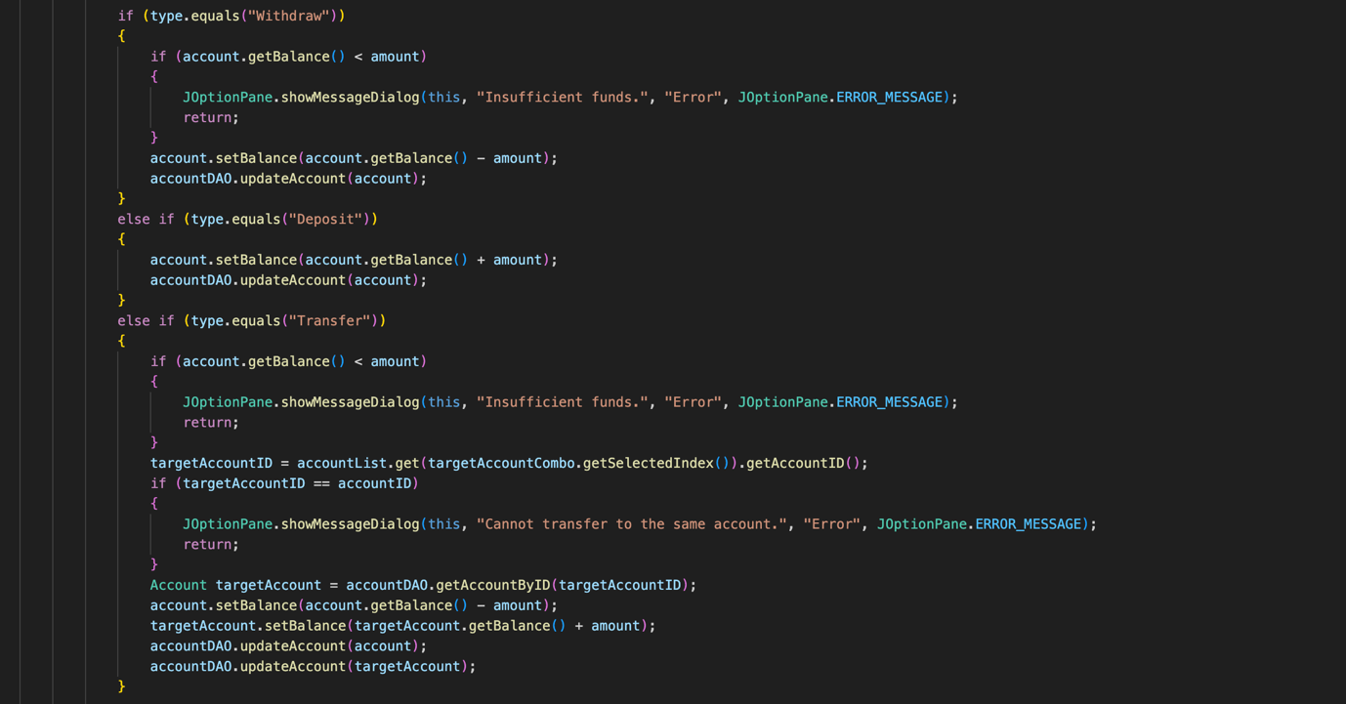

Test cases

Name | TC-01 Verify that card number and PIN code entry results in access to bank account
Requirement | FR-1 (User Authentication), bullet 1
Preconditions | User has a valid card and knows PIN number (base machine state BS-04)
Steps | - User inserts card number  - User inputs PIN  - Verify input matches PIN number
Expected results | - User can access their account  - Authentication window is dismissed  - Return to base state BS-04

Name | TC-02 Verify that user has access to customer screen
Requirement | FR-2 (Customer Screen), bullet 1
Preconditions | User is a valid customer (base machine state BS-04)
Steps | - User adds customer  - User updates customer  - User deletes customer
Expected results | - Customer has been modified  - Customer table is updated  - Return to base state BS-04

Name | TC-03 Verify that user has access to account
Requirement | FR-3 (Account Screen), bullet 1
Preconditions | User is eligible for a valid account (base machine state BS-04)
Steps | - User adds account  - User updates account  - User deletes account
Expected results | - Account has been modified  - Account table is updated  - Return to base state BS-04

Name | TC-04 Verify that valid card is obtained
Requirement | FR-4 (Card Screen), bullet 1
Preconditions | User has valid card (base machine state BS-04)
Steps | - User adds card  - User updates card  - User deletes card
Expected results | - Card has been modified  - Card table is updated  - Return to base state BS-04

Name | TC-05 Verify that transactions are eligible
Requirement | FR-5 (Transaction Screen), bullet 1
Preconditions | User has enough balance for transaction (base machine state BS-04)
Steps | - User adds transaction  - User updates transaction  - User deletes transaction
Expected results | - Transaction has been modified  - Transactions table is updated  - Return to base state BS-04

