

ECE 524L – Advanced FPGA Design

Fall 2024

Final Project

Specifications

11/17/2024

Daniel Beltran

**Unmet Project Requirements**

* 2 clock domains were used but did not work properly since CDC was not implemented.
* Only 2 PMODs are confirmed working on the board.
* Only the clock wizard was used from the IP catalog.
* PMOD testing was only done on the board since I was unsure of how to simulate I2C and SPI without a return from a slave device.
* Board feature not covered in class was also not implemented.

**Overall Design**

* ToF sensor uses I2C to perform distance measurements
* Polling time in between measurements is determined by keypad input
* Measurements are calculated then outputs to the LCD screen.
* Bitstream file is loaded to the board from micro SD card

**Working Modules:**

* PMOD CLS: LCD DISPLAY:

This module uses a state machine to control commands and ASCII values sent to the PMOD using SPI communication protocol. Each command needs to be sent one at a time. After the display is cleared and the cursor position have been sent ASCII characters are taken to print to the LCD. Uses a lookup table to hold commands and ASCII characters, where each character is read using a SEL value.

* + Takes a 100MHz clock domain.
  + Active high reset.
  + Active high START signal.
  + Active high CLEAR signal to clear the display.
  + Communicates using SPI master provided by Digilent at 100kHz.
  + SEL is used to pull commands and ASCII values from the lookup table.
* PMOD KYPD

This PMOD uses two modules, the keypad controller, and the keypad decoder. The keypad controller detects which key was pressed and outputs a 16-bit values which represents which key is pressed. The keypad decoder translates this value to an integer which can be more easily used in the ToF master.

* + Both modules take 100MHz clock domain.
  + Active low reset on keypad controller.
  + Active high reset on key decoder.

**Modules Not Working:**

* ToF PMOD:

Attempts to write the following data to the given registers on the ISL29501 to initialize the module. The ISL29501 has I2C address 0x57.

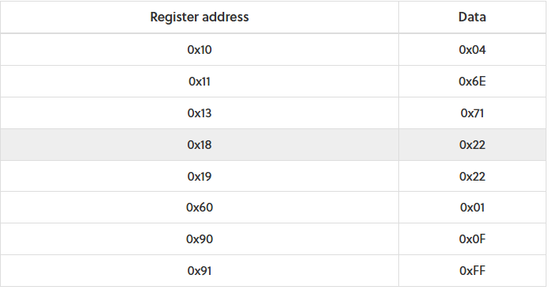

**Fig. 1 ToF PMOD Initialization Data**

In Fig. 2 the addresses and data stored in the EEPROM is stored by default. The EEPROM has I2C address 0x50. The module attempts to read the factory calibration data and then writes the data to the ISL29501 from register 0x24 to 0x30.

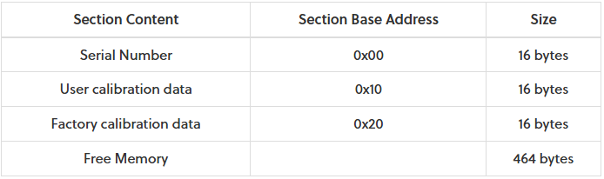

**Fig. 2 ToF EEPROM Addresses**

In Fig. 3 the firmware routine for the ToF sensor is shown. The module attempts to move through the routine and output the calculated value.

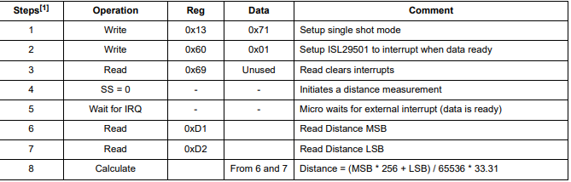

**Fig. 3 ToF Distance Measurement Routine**

* + Takes a 50MHz clock domain. (Parameterized to take any clock domain)
  + Active high reset.
  + Attempts to start the LCD PMOD output and clear the output using control lines.
  + Attempts to take keypad inputs and control delay in between measurements.
  + Uses I2C module provided by digikey and operates at 100kHz.