

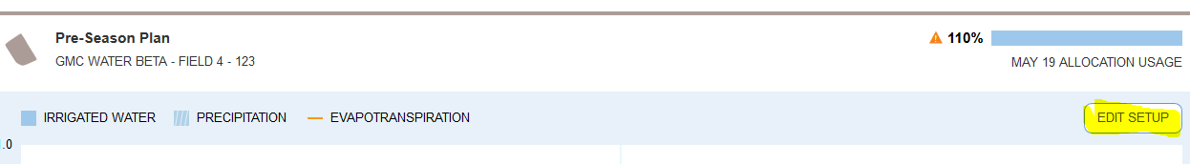

Questions:

Within out Test or Development environments are we able to confirm these requirements are functioning as expected:

* How do you tell when a field is in pre-season vs in- season? The spec'd states that Fields are "in-season" if they have a probe in the ground. Currently all fields (in the test/dev env) whether it is setup or not has at least 1 probe.

Pivot Pass Metrics Display

* Verify when the selected pivot pass is in the past, or is currently running, a marker appears to the right, stating it is not editable.
* Verify if the selected pivot pass is a future pass, this marker will become a button