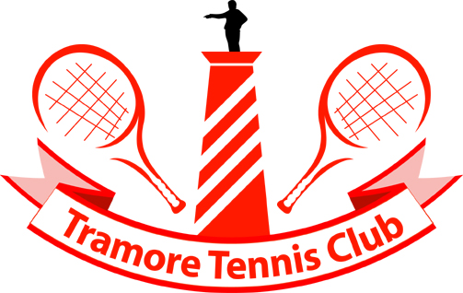  TRAMORE TENNIS CLUB  (ESTB. 1921)  Doneraile Drive, Tramore. Co Waterford  PHONE NO. 051 381426  E-MAIL tramoretennis@tramoretennis.com. | JUNIOR OPEN WEEK  SUNDAY 10TH JULY TO SATURDAY 16TH JULY 2011  KINDLY SPONSORED BY WALCO FOODS

NAME: ______________________________________________________

ADDRESS: _____________________________________________________________________________________

DATE OF BIRTH: _______________________: T.I. PIN NO ______________________________________________

HOME CLUB: __________________________________ CLUB E-MAIL ADDRESS;____________________________

CONTACT NUMBERS: HOME; _______________________ MOBILE _______________________________________

SIGNATURE OF PARENT ___________________________________________

EVENT | FEE | PARTNER | TICK EVENT
1. Boys U/8 (team event no capitation fee) | €10.00
2. Girls U/8 (team event no capitation fee) | €10.00
3. Boys U/9 (team event no capitation fee) | €10.00
4. Girls U/9 (team event no capitation fee) | €10.00
5. Boys U/10 singles (no capitation fee) | €10.00
6. Girls U/10 singles (no capitation fee ) | €10.00
7. Boys U/12 singles | €10.00
8. Girls U/12 singles | €10.00
9. Boys U/14 singles | €10.00
10. Girls U/14 singles | €10.00
11. Boys U/16 singles | €10.00
12. Girls U/16 singles | €10.00
13. Boys U/18 singles | €10.00
14. Girls U/18 singles | €10.00
15. Boys U/10 Doubles | €7.00
16. Girls U/10 Doubles | €7.00
17. Boys U/12 Doubles | €7.00
18. Girls U/12 Doubles | €7.00
19. Mixed U/12 Doubles | €7.00
20. Boys U/14 Doubles | €7.00
21. Girls U/14 Doubles | €7.00
22. Mixed U/14 Doubles | €7.00
23. Boys U/16 Doubles | €7.00
24. Girls U/16 Doubles | €7.00
25. Mixed U/16 Doubles | €7.00
TENNIS IRELAND CAPITATION FEE |  |  | €3.00
TOTAL DUE |  |  | €

CONDITIONS/RULES

- The tournament is sanctioned and will be governed by Tennis Ireland Rules and its code of conduct enforced
- The U/8’s and U/9’s will be run under the Rules and Regulations and code of conduct of Tennis Ireland and is part of the Tennis Ireland Tennis 10’s Circuit.
- U/8 Red size court playing with red tennis balls (born 2003/04).
- U/9 Orange size court playing with orange tennis balls (born 2002).
- U/8’s and U/9’s will take place on Sunday 10th July 2011
- Should there not be sufficient entry in an event teams may be mixed in U/8’s and U/9’s only.
- U/10’s singles and doubles will take place on Monday 11th July 2011 using full size court playing with green tennis balls (born 2001) with finals to be played on Saturday 16th July.
- Entrants must be under the stipulated age as at 31st December 2010. Any player wishing to play up an age group must enclose a copy of their Tennis Ireland Passport.
- Parents may be asked to supervise some matches - no parent will be asked to umpire their own child’s matches.
- In the event of any dispute the decision of the Referee or his/her deputies will be final.
- Photographs will be taken during the presentation of prizes, if you do not wish your child’s photo to be taken please inform the club prior to the event commencing.
- Entries by post or e-mail no later than 6pm on Monday 4th July 2011.
- Entry forms require TI Pin no. – this can be obtained from Tennis Ireland
- Players must be present 20 minutes before stated time. Players not present at appointed time may be scratched.
- Matches in events 7 to 25 inclusive are best of 3 sets. Tie break will operate at 6-all in each set.
- Draw will be available on line from Friday 8th July after 6pm. It is the players own responsibility to ascertain when they are playing.
- Competitors may enter only 3 events, of which no more than 2, are singles events – rules as per Tennis Ireland Passport will apply
- The Committee reserves the right to cancel any event in which less than 8 entries are received.
- Play commences at 10am each day.
- A plate event may be organised where numbers of entries is sufficient.
- Players are only allowed play one age group up in any or all 3 events in U12; U14 & U16. The exception to this rule is where events have to amalgamate up an age.
- Tramore Tennis Club and tournament committee shall not be responsible for any personal injury, loss or damage to personal belongs suffered by a competitor during the course of the tournament.
- Tennis Ireland's Complaint, Objection and Disciplinary Rules and Procedures apply to this event
- The Committee reserve the right to alter, amend and/or delete any of the above conditions

TRAMORE TENNIS CLUB,
PH0NE NO. 051 381426
E-MAIL tramoretennis@tramoretennis.com.

