Heritage Crystal Championships of Co Waterford

Tramore Tennis Club

Senior Open Week 2011

Sunday 31st July to Sunday 7th August 2011

Entries close Wednesday 20th July at 6 p.m.

Or earlier if fully subscribed
(limited to the first 200 paid entries)

FEE MUST ACCOMPANY ENTRY

Entries To: Tramore Senior Week,
Tramore Tennis Club, Tramore, Co Waterford

Ph. (051) 381426

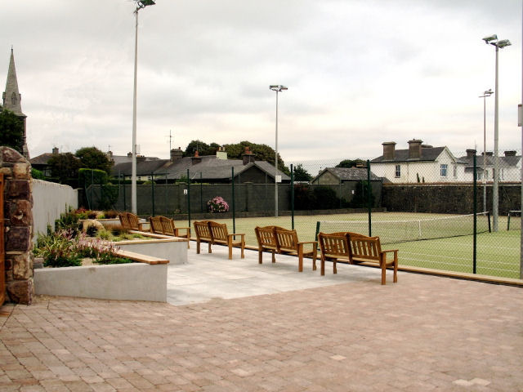

Tramore Tennis Club – Senior Week 2011
Restricted to the first 200 fully paid entries– entries close Wednesday 20th July 2011
Name (block capitals): |  | Address:
Contact Phone Number: |  | Address:
Club: |  | Address:
T.I. Grading: | (If you do not have a grading contact your Club Secretary):

N.B. Those entering 3 events must be available for the full 8 days of the tournament.
Only 1 non-availability request can be accepted for those entering 1 or 2 events.

Due to scheduling constraints, requests will not be considered unless on your Entry Form.
Non - Availability Requests:

Play will commence for all grades on Sunday 31st July
Semi Finals will be held on Saturday 6th August and Finals will be held on Sunday 7th August

All Events €10.
EVENT | Partners Name | A  Grades 1 - 3 | B  Grade 4 | C  Grade 5 -7 | Entry  Fee
Mens Singles | N/A |  |  |  | €
Ladies Singles | N/A |  |  |  | €
Mens Doubles |  |  |  |  | €
Ladies Doubles |  |  |  |  | €
Mixed Doubles |  |  |  |  | €
 |  |  |  | T.I. Capitation | €5.00
 |  |  |  | TOTAL | €
CONDITIONS OF ENTRY
- The tournament is sanctioned by Tennis Ireland and Tennis Ireland’s Complaint, Objection and Disciplinary Rules and Procedures apply to this event.
- All entries must be on an official entry form or photocopy of same. Fees due before first match.
- Play commences Sunday 31st July at 11 a.m. for ALL GRADES. Players limited to 3 events.
- Once play has commenced in a section, change of partner will not be permitted.
- Competitors who have not reported to the Tournament Office 15 minutes before their scheduled match time will be automatically scratched.
- Matches are best of 3 sets. Tie break will operate at 6 all in 1st and 2nd sets. Full 3rd set.
- The Committee reserves the right to withdraw any event in which there are less than 8 entries.
- Synthetic courts and Tretorn tennis balls will be used for this Tournament.
- The Committee reserves the right to upgrade or demote players to a different section.
- Draw will take place in the Clubhouse on 28th July 2011.
- Committee’s decision is final in all matters relating to the Tournament.
- Sunday’s time sheet will be available in the Clubhouse from 2p.m. Saturday 30th July. Players are responsible for checking their own match times.
- Club rules require that proper tennis attire must be worn on court. No black soled runners allowed.
- Juniors eligible to enter Grade A only and must be 16 years or over on 1st January 2011. This Tournament will take precedence over any other Tournaments running concurrently.
- Entries will be close at 6 p.m. on Wednesday 20th of July or earlier if fully subscribed i.e. first 200 paid entries.
- The Committee reserves the right to alter any of the above regulations if deemed necessary.

