Split Windows: A Simple Technique
for Presenting Retrieved Documents

Michael Arvold, Daniel Berleant*,
Jeff Brown, Ryan DeVries,
Kian-How Lim, and Jonathan Simonson
*Corresponding author:
Dept. of Electrical and Computer Engineering
2215 Coover Hall
Iowa State University
Ames, Iowa 50011 USA
(515) 294-3959
berleant@iastate.edu

ABSTRACT
####about 100 words, problem, then approach, then findings, then conclusions.

Keywords

Text display, screen design, information retrieval, search engines, interface, WISER, multidisplay

INTRODUCTION AND MOTIVATION
There is wide recognition of the need for further progress in Web search engine interfaces (e.g. Schneiderman et al. 1998). Current Web Search engines have a number of deficiencies. An important one is that documents retrieved on the basis of a user query are typically displayed in a generic way that does not help the user immediately see the connection between the retrieved document and the query that retrieved it. The simple technique of bolding or coloring occurrences of the search terms in the document are frequently found in results from site-specific search utilities, though not in the most commonly used general-purpose Web search engines. However for many such documents scrolling or Web browser-supported string searches are still often necessary to find the terms in the displayed documents, because the entire document will not fit in the display area. Thus while coloring or bolding can help reduce the cognitive overhead of determining the relevance of the document to the query, further reduction is desirable. In this paper we propose and demonstrate a method of displaying retrieved documents that provides the desired reduction in cognitive overhead.

The system we have constructed is called WISER (Figure 1). WISER presents a retrieved document in two subwindows, each containing part of the document. The upper subwindow shows the document up to but not including the first occurrence of the query term; the lower subwindow shows the document starting from the first occurrence of the search term. Figure 2 shows this strategy; Figure 3 shows an actual WISER result display. This seemingly simple strategy has significant advantages over the traditional single-window display strategy, as discussed in the next section, on evaluation. The subsequent section discusses how the system does what it does.

EVALUATION
The two subwindow display strategy has significant advantages compared to the display strategies users currently experience. They are listed next.
- When the query term does not appear in the text of the document (which could happen if the document has changed since it was indexed by the search engine, or if the search term is present in the HTML source but not the displayed text produced by interpreting the HTML source), the user can discover this more efficiently that is currently the case. Currently the entire document must be read or the browser’s string search utility must be employed. Both have significant cognitive overhead. In contrast, in the split window approach as we have implemented it, the document splitter will not find a place to split the document, and consequently the lower subwindow will be blank. Noticing this obviously requires significantly less cognitive overhead.
- When the query term does appear in the text of the document (the “normal” case), the user can focus on the part of the document that contains its first occurrence with no scrolling down, skimming, or use of the browser’s string search capability, unlike with

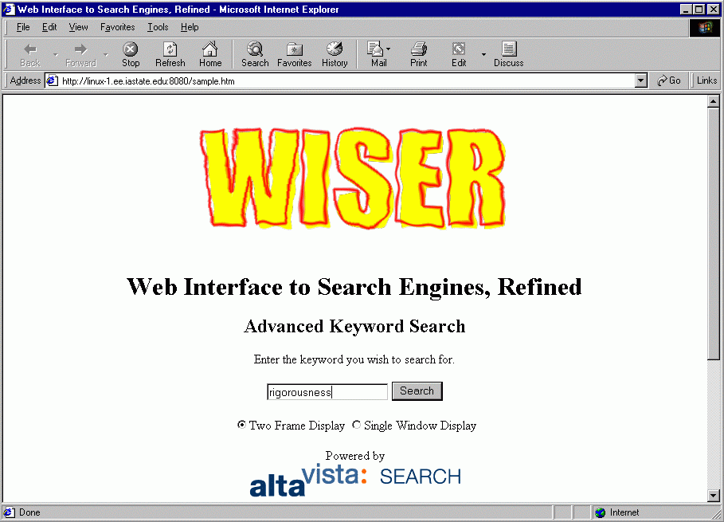
Figure 1. WISER start page.

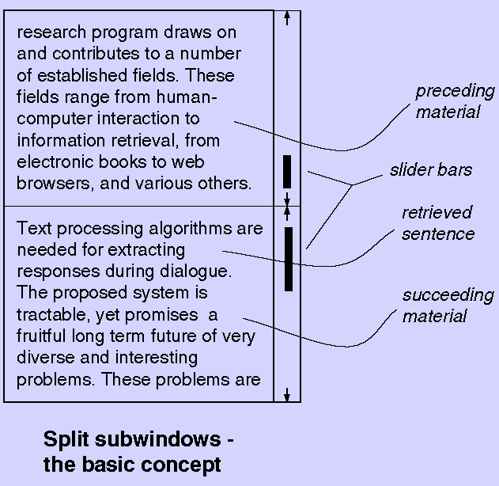
Figure 2. Splitting a text presentation window into subwindows at the point of occurrence of a key passage.

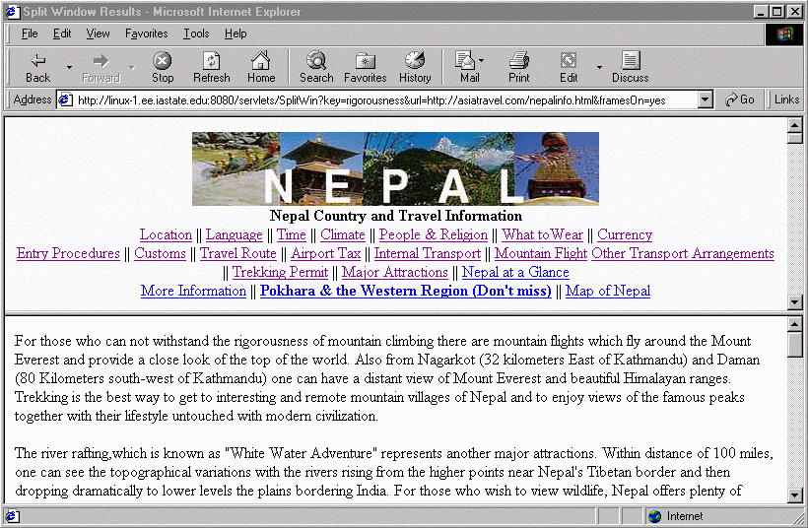
Figure 3. Display of a document in WISER; split is based on the first occurrence of the query term “rigorousness.” The document is divided into two portions, with the first portion appearing in the upper window and the last portion in the lower window. The upper window initially shows the beginning of the file to help communicated broad subject and context, but if scrolled all the way down will then show the passage immediately preceding the beginning of the lower window (as in Figure 6).

the current generation of search engine displays. This technique is a kind of dynamic querying (Shneiderman et al. 1998) and, like other dynamic query techniques, has the advantage of requiring lower cognitive overhead on the part of the user. On the other hand, if the user simply wants to peruse the entire document, it is all there. The top part of it is in the upper subwindow (starting from the beginning of the document, Figure 3), and upon scrolling down to the end of the upper subwindow the user can start reading the lower one, where the text immediately following the end of the upper subwindow is already displayed.
3) The split in the file at the point where the query term first appears provides a place that is both likely to be an especially relevant location as well as very easy to return to, since the user need only scroll the lower subwindow all the way up, or the upper window all the way down, to get there. In contrast, the traditional approach of displaying the file in one window with one vertical scroll bar means that once the user scrolls away from the initially displayed passage, returning there will tend to require some “hunting around,” especially for longer files. Thus the split window system reduces cognitive overhead of browsing by providing an anchor point in the middle of the file, which in turn helps prevent users from getting lost within the file.
The two subwindow strategy does have the disadvantage of requiring more computation than the simpler traditional one window display strategy. However the extra manipulation of the file required does not increase the order of magnitude of the computation required, so as computing and network speeds continue their exponential increases the computational hit involved will become progressively more insignificant.

HOW WISER WORKS
The system takes a user query which it passes to a Web search engine. When the user clicks on a URL in the list of URLs returned by the search engine, the document is displayed such that the first occurrence of the query term is at the beginning of the lower of two subwindows (Figure 3). Figure 2 shows the strategy. We examine the details in the context of a specific example next.
- The user starts by using a Web browser to access the URL for the WISER input screen (Figure 1).
- The user then types a query term in the presented type-in box, after which the system accesses a search engine (it currently uses Alta Vista) and passes the query to it.
- The search engine returns a list of URLs, but not to the user’s browser as normally occurs with search engine use. Rather, the list of URLs is returned to WISER which will modify it before passing it on to the user’s browser. See Figure 5.
- WISER goes through the HTML source of the returned list of URLs and finds the links to the URLs in the list. It modified these links by making them point to a servlet in WISER itself, passing to the servlet the identity of the original unmodified link. For example, the link http://asiatravel.com/nepalinfo.html is modified to be http://linux-1.ee.iastate.edu:8080/servlets/SplitWin?key=rigorousness&url=http://asiatravel.com/nepalinfo.html&framesOn=yes which calls the servlet SplitWin and passes to it the user’s query term (“rigorousness” in this case), the original URL, and a request to use two subwindows to display the document at asiatravel.com/nepalinfo.html (“framesOn=yes”). The HTML code from the search engine, thus modified, is passed on to the user’s browser (Figure 5).
- If the user clicks on item 2 (“COUNTRY AND TRAVEL INFORMATION OF NEPAL”), the browser will follow the modified link created in the previous step, causing WISER’s SplitWin servlet to run.
- WISER then downloads the original URL (http://asiatravel.com/nepalinfo.html). It processes the downloaded document by dividing it into two parts and storing them in two files, upper.html and lower.html. The point at which the file is divided is chosen so that upper.html ends just before the line containing the first occurrence of the query term, and lower.html starts with that line.
- Simple HTML source, containing a frameset command that creates upper and lower subwindows and places upper.html in the upper one and lower.html in the lower one, is generated and sent to the client. The HTML source is shown in Figure 4.
<html>
<head>
<title>Split Window Results</title>
</head>
<frameset rows="33%, 67%">
<frame src="/test/upper.html">
<frame src="/test/lower.html#rigorousness">
</frameset>
</html>
Figure 4. HTML source returned to the client when the user has clicked on an item in the list of URLs returned by the search engine via WISER.
- Standard Web browsers process the returned frameset by automatically requesting the files lower.html and upper.html, and displaying them inside the specified frames (Figure 3).

VARIATIONS AND ALTERNATIVES
A number of variations on the split window strategy and alternatives to it suggest themselves. We first discuss variations, followed by alternatives.

Split Windows – Variations
The general purpose of the split window strategy can be met by a number of variations. In contrast to having two subwindows with the upper subwindow displaying the file starting at its beginning, other possibilities are as follows.
- Split windows with upper subwindow initially set to display the text immediately preceding the point at which the file was split, as in Figure 6. This maximizes the presentation of the immediate context

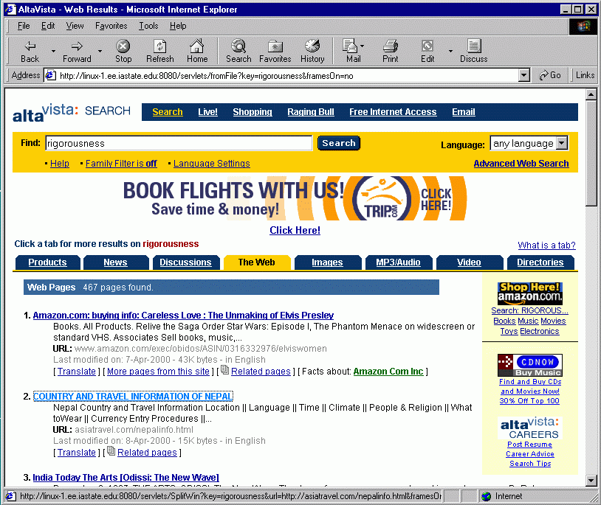

Above: full display ↑ . Below: just the essential parts of the display ↓.


Figure 5. WISER processes Alta Vista output before presenting it: note the URL name in the address box near the top, which is a proxy server rather than the actual Alta Vista site; also note the URL name of the highlighted link to “COUNTRY AND TRAVEL INFORMATION OF NEPAL,” appearing in the status line at the bottom, which is not at asiatravel.com but rather at the proxy server, linux-1.ee.iastate.edu.
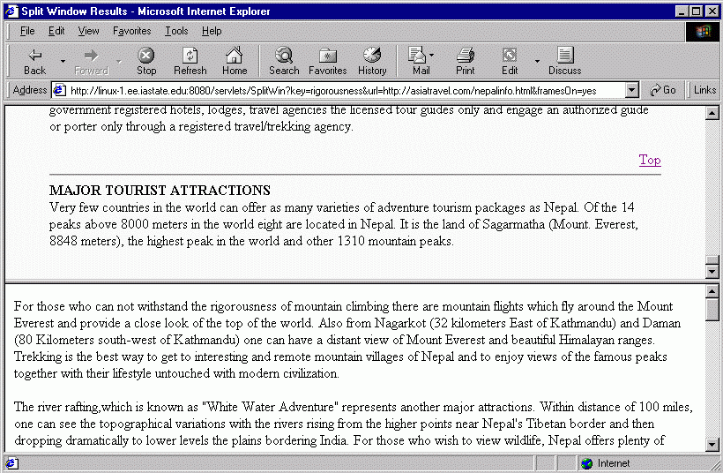Figure 6. Split windows with the top subwindow displaying that portion of the file before the split which immediately precedes the point of splitting.

of the first query term occurrence, at the expense of not requiring the user to scroll the upper subwindow upward to see the beginning of the file, which tends to be rich in such topic relevant information as the title and introductory passages. While it is not clear whether or not this would be an improvement, it is a trivial difference from an implementation standpoint, and could be implemented as a user configuration option. A user study would help in determining which is better and under what circumstances.
- Split windows with three subwindows, the middle containing just the immediate context of the first occurrence of the query term. The upper subwindow contains the portion of the file preceding the passage displayed in the middle subwindow, and the lower subwindow contains the portion of the file following the passage displayed in the middle subwindow. This would have the advantage of keeping a relevant passage from the document constantly in view in the middle subwindow regardless of the user’s exploration of the document using the other two subwindows. A user study would help in verifying (or refuting) the intuition that this strategy would be less valuable than the two subwindow approach.
- Split windows with three subwindows, the upper and middle dividing the portion of the file preceding the first occurrence of the query term between them. The upper subwindow would be initialized to display the beginning of the file with its rich topic-relevant information (title, etc.), the middle subwindow would be initialized to display the text immediately preceding the first occurrence of the query term, and the lower subwindow would be initialized as usual. This strategy allows initial display of the beginning of the file, the context immediately preceding the first occurrence of the query term, and the context immediately following it, all at the same time. A user study would help in determining if this is better. It is possible that the tradeoff between the advantages of displaying more useful parts of the file, and having smaller subwindows that can display less of the file at one time, would cause this three subwindow strategy to be either better or worse than a two subwindow strategy, or better in some circumstances and worse in others.

Split Windows – Alternatives
The point of split windows is to enhance the user interface to documents retrieved via queries on the Web. Because the present state of the practice in Web search engines has not addressed this important topic to the degree it should, improvement could be made without great difficulty. One approach is to present a retrieved document so that its initial display focuses on the location in it at which a search term appears, using a single window. WISER does this when invoked with the “Single Window Display” option (Figure 1), resulting in response displays like that of Figure 7. To do this, the proxy server adds an HTML <name=…> anchoring command at that point in the document, and then asks the client browser to display the document starting at that anchor.
Note that this has the disadvantage, compared to the split window strategy, that a user who scrolls up or down will later have to “hunt around” to return to the initially displayed location in the document.
Even with the split window approach we have described, a user who is interested in checking multiple occurrences of a query term rather than just the first occurrence will have the advantages of the approach available only for the first occurrence. Finding later occurrences will be much the same experience as it would be without a split window interface.
To address this, an extension to the WISER system might include a clickable list of the occurrences of the search terms in a small separate frame. Each list item could be named after some noteworthy characteristic of the document near that occurrence of the term. This could be the preceding and/or succeeding words, the ordinality of the search term (3rd occurrence, 4th, etc.), etc. Mouseovers might present more of the term’s context as a transient popup display.
This has the disadvantage, compared to the split window strategy, of taking up screen space with the new frame. It has the advantage, however, of providing easy access to any occurrence of a query term in the document. This approach could easily be hybridized with the split window strategy; they are not mutually exclusive.
To eliminate the screen space disadvantage of a frame containing clickable items, the document could be modified by the proxy server so that instances of query terms in it are not only given HTML anchors, but also made clickable. Clicking on one occurrence causes the display to jump to the next occurrence. This approach has the disadvantage, like any single-window approach, of not being able in general to show the beginning of the document and the passage containing the first occurrence of the query term at the same time. Like the small frame approach just described, this approach could be easily hybridized with the split window strategy.

RELATED WORK
Computer display of text was surveyed by Galitz (1985), Mills and Weldon (1987), and Gropper (1991). Subsequent surveys have emphasized multimedia display (Vanderdonckt and Gillo 1994), although computer display of text itself is still an important topic needing further progress (Nielson 1999). Recent work on display of text has emphasized visualizations that capture large numbers of documents and efficiently help users to locate

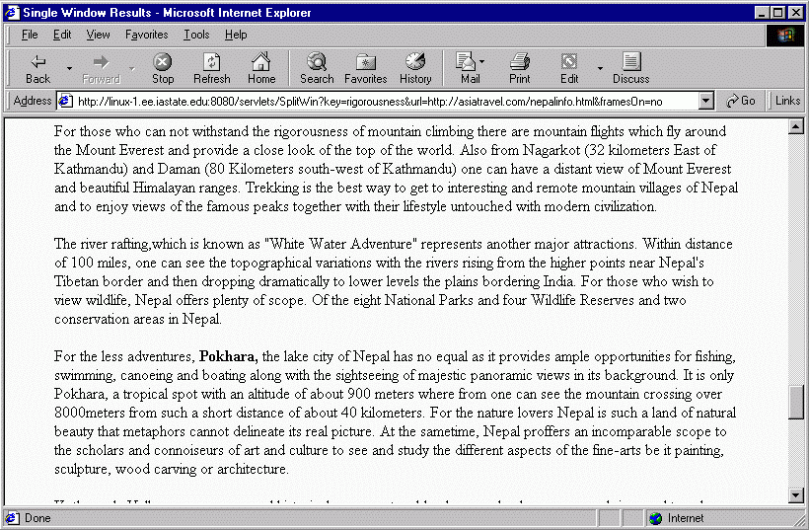Figure 7. Given the query “rigorousness” followed by a click to the same Nepal tourism URL shown in Figure 3, the single window response option displays the document with the scroll bar set so that the displayed view of the document begins at the line containing the first occurrence of the term “rigorousness.”

those documents of interest (Hetzler et al. 1998; Card et al. 1998), however both visualizations (Spoerri 1993; Hearst 1995) and integrations of text and visualizations (Robertson and Mackinlay 1993; Byrd 1999) have addressed presentation and navigation within documents. A purely text-based approach to finding relevant locations in a text file was taken by Burke et al. (1997) in the FAQ Finder system. This has an information retrieval flavor as a FAQ file, although often a single file is a collection of disjoint text units. Work on maximizing the user friendliness of small screen display areas has recently addressed the timely problem of PDA displays, because of the necessarily small size of these displays (e.g. Kamba et al. 1996). Yet the problem of small screen displays is more general, since even workstations can display only small documents in their entirety. Even when displays are cheap and thin enough to sell in rolls, by the square meter, and when verbal communication with computers becomes mature, there will be situations in which visual presentation is preferable and the amount of space available for it is limited (as on control panels for vehicles, portable computing devices, etc.).
Text display in the specific context of Web search engines has also been addressed in recent years. Google provides a line or two from URLs that it lists in response to a query that, unlike the lines from listed URLs presented by other major search engines, are extracted specifically to be relevant to the query. Shneiderman et al. 1998 break the interaction process between user and text search utilities into four phases, of which the present system addresses the “action” phase, in which a response to the user query is generated and presented. Marias and Bharat (1997) classify Web browsers and browser augmenting tools as “browserware.” Such tools can be implemented as custom browsers, which tends to reinvent the wheel to a significant degree; plug-ins, which must be downloaded and installed on the client machine before use; applets (and presumably JavaScripts), which are parts of individual URLs and have difficulty affecting browsing of other URLs; parasites (like their “vistabar” system, Alexa (Web site) is another example), which must be downloaded to the client machine and run in conjunction with the browser; and proxy servers (Brooks et al. 1995; Anonymizer web site), which do not have the disadvantages just listed for the other techniques. Thus our system was implemented as a proxy server to make it easy to both build and easy to use by anyone with a Web browser client without the need to download and install anything.

DISCUSSION AND CONCLUSION
Current Web search engine interfaces leave much to be desired. In addition to the often-cited problems with organization and length of the returned lists of URLs, the actual URL that a user accesses by clicking on a link in the returned list is presented by major search engines in a remarkably unfriendly way, with no clue as to why it appeared in the list or where in the returned document it was found that it satisfies the query. What is needed is a customized (Berleant and Berghel 1994) presentation of the document that provides a tailored overview, anchoring of the point of maximum user interest in the document, and a view and organization tailored to the user’s needs. User studies indicate that even uncustomized, generic presentations of documents on the Web would benefit greatly from overviews, organization, filtering, and “sense of location” (Kandogan and Shneiderman 1997). Furthermore, studies indicate that users prefer retrieval interfaces that support both querying and browsing (Hertzum and Frøkjær 1996).
Split windows supports these desirable characteristics. The overview is provided by the conjunction of the initial portion of the document in one subwindow with a view of the document based on where the query is first satisfied in another subwindow. The anchoring sense of location, and the filtering function, are provided by the point at which the document is split between subwindows, a point which the user can easily return to while browsing by either scrolling the upper subwindow all the way to its end, or scrolling the lower subwindow all the way to its beginning. The organization is provided by the two subwindows and their custom bisection of the document. These properties focus on easing the browsing of a document once it has been retrieved, so that browsing and querying complement each other rather than interfering as in Herzum and Frøkjær (1996).
As a technique for presenting documents in response to queries, split windows is simple way to address significant needs in an important application domain.

REFERENCES
- Alexa. Software available at http://alexa.com.
- http://anonymizer.com.
- Bodart, F. and J. Vanderdonckt. Visual layout techniques in multimedia applications, in Proceedings of CHI '94 (Boston MA, April 1994), ACM Press, 121-122.
- Brooks, C., M.S. Mazer, S. Meeks, and J. Miller. Application-specific proxy servers as HTTP stream transducers, in Proceedings of WWW4 (Boston MA, December 1995).
http://www.w3.org/Conferences/WWW4/Papers/56/.
- Byrd, D. A scrollbar-based visualization for document navigation, in Proceedings of DL ’99 (Berkeley CA, August 1999), 122-129.
- Card, S., J. Mackinlay, and B. Shneiderman (eds.). Readings in Information Visualization. Morgan Kaufmann, San Francisco CA, 1998.
http://www.pnl.gov/remote/projects/starlight/theory.html and http://www.pnl.gov/remote/projects/starlight/.
- Galitz, W.O. Handbook of Screen Format Design. QED Information Sciences, Inc., Wellesely MA, 1985.
- Gropper, G.L. Text Displays: Analysis and Systematic Design. Educational Technology Publications, Englewood Cliffs NJ, 1991.
- Hetzler, B., P. Whitney, L. Martucci, and J. Thomas. Multi-faceted insight through interoperable visual information analysis paradigms, in Proceedings of InfoVis ’98 (Research Triangle Park NC, October 1998), IEEE, 137-144.
http://multimedia.pnl.gov:2080/infoviz/insight.pdf.
- Hertzum, M. and E. Frøkjær. Browsing and querying in online documentation: A study of user interfaces and the interaction process. ACM Transactions on Computer-Human Interaction 3, 2 (June 1996) 136-161.
- Kamba, T., S. Elson, T. Harpold, T. Stamper and P. Sukaviriya. Using small screen space more efficiently, in Proceedings of CHI ’96 (Vancouver BC, April 1996), ACM Press, 383-390.
- Kandogan, E. and B. Shneiderman. Elastic Windows: A heirarchical multi-window World-Wide Web browser, in Proceedings of UIST ‘97 (Banff AB, October 1997), ACM Press, 169-177.
- Marais, H. and K. Bharat. Supporting cooperative and personal surfing with a desktop assistant, in Proceedings of UIST ‘97 (Banff AB, October 1997), ACM Press, 129-138.
- Mills, C.B. and L.J. Weldon. Reading text from computer screens. ACM Computing Surveys 19, 4 (December 1987), 329-357.
- Nielsen, J. User interface directions for the Web. Communications of the ACM 41, 1 (January 1999), 65-72.
- Robertson, G.G. and J.D. Mackinlay. The Document Lens, in Proceedings of UIST '93 (Atlanta GA, November 1993), ACM Press, 101-107.
- Shneiderman, B., D. Byrd, and W.B. Croft. Sorting out searching: A user-interface framework for text searches. Communications of the ACM 41, 4 (April 1998), 95-98.
- Spoerri, A. InfoCrystal: A visual tool for information retrieval & management, in Proceedings of CIKM '93 (Washington, D.C., November 1993), ACM Press, 11-20.
- Vanderdonckt, J. and X. Gillo. Visual techniques for traditional and multimedia layouts, in Proceedings of AVI ’94 (Bari Italy, June 1994), 95-104.

###make sure last lines of pages go to the right margin.
###reference using [8] throughout.

