Special Work Performance 2 - Response Models for Aggregated Data

Group 17 - Spencer Arney (583252), David Berscheid (580687), Marvin Gauer (580553), Cemre Uenal (585962),

### To do:

1. Create content in RMarkdown file and get a Word output file
2. Do all the formating in the end and in Word
   * not more than 5 pages
   * change font to Times Roman in 12pt with 1.15 line spacing
   * in tables and graphs you may use 10pt and 1.0 line spacing
   * 1 inch space on all sides (Done by RMarkdown)
   * report names, group number, student numbers, page number (Done by RMarkdown)

### Example Question: Draw a visualization of all bivariate relationships.

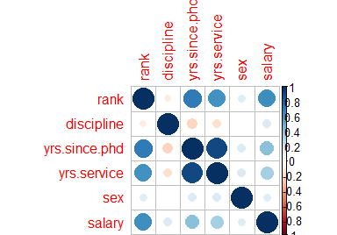

The visualization shows all bivariate relationships, more precisely respective correlations. The bigger the circle the more extreme the correlation. Results that are worth mentioning are...

### 2a:

**Describe the data from chain 33 and 65 in a meaningful way so that the uniformed reader understands the key features of the data. Do not report R-code and edit tables in such a way that they are easily and intuitively understandable. Document your data description strategy in some detail and be as precise and as explicitly as possible. (2 pages maximum).**

### SPW 2b:

**Use the data from chain 33 and 65 and compute aggregated data for each chain. Use this data to estimate the effect of price on demand and the multiplier effect of display and feature activity on sales at the brand, package and chain (store type)-level. To do this, regress log of units on log price and promotional instruments and potential seasonal and other variables. Do the analysis separately for each brand, package size and chain (store type) and document the estimation results in one table that contains all important estimation results and that allows an intuitive understanding of the key similarities and discrepancies of the estimation results across brands, package size and store type. Interpret the results carefully and also document your estimation strategy in some detail. Do not report R-codes and edit the estimation results you obtained with R. (3 pages maximum).**