Now that everything is installed and running, I will run through all the features in the app.
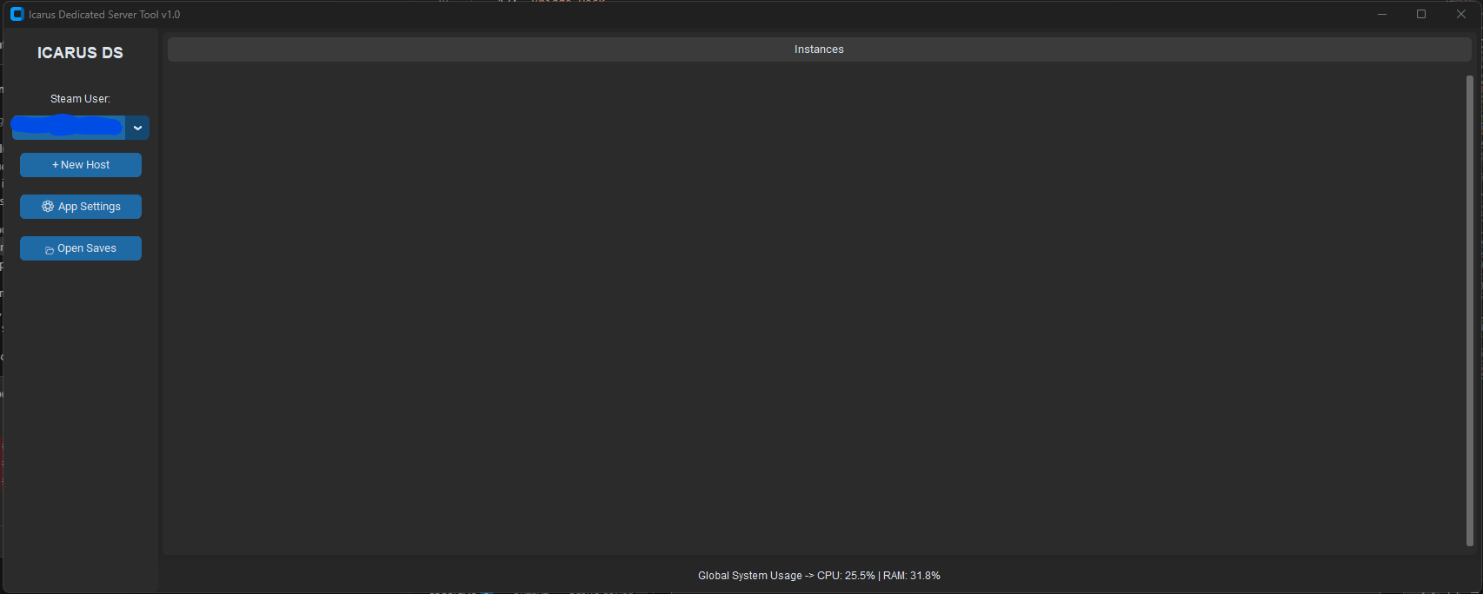
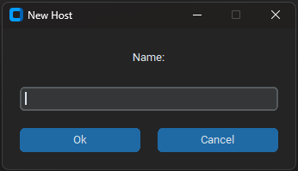
Once the watchdog has updated you will be presented with the main screen of the app. On the left your Steam ID will be displayed and if you have multiple users you can select between them.
Clicking + New Host will display a new window asking for the name of your new Host. This name will be displayed within Icarus to connect to.

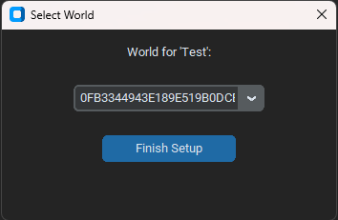
Clicking Ok will bring you to your save file selector window. You will see every local save file for the selected Steam ID here. Selecting the save file and clicking Finish Setup will then return you to the main screen with your Host.

The app settings button on the left controls app windows startup and light mode if you want it.
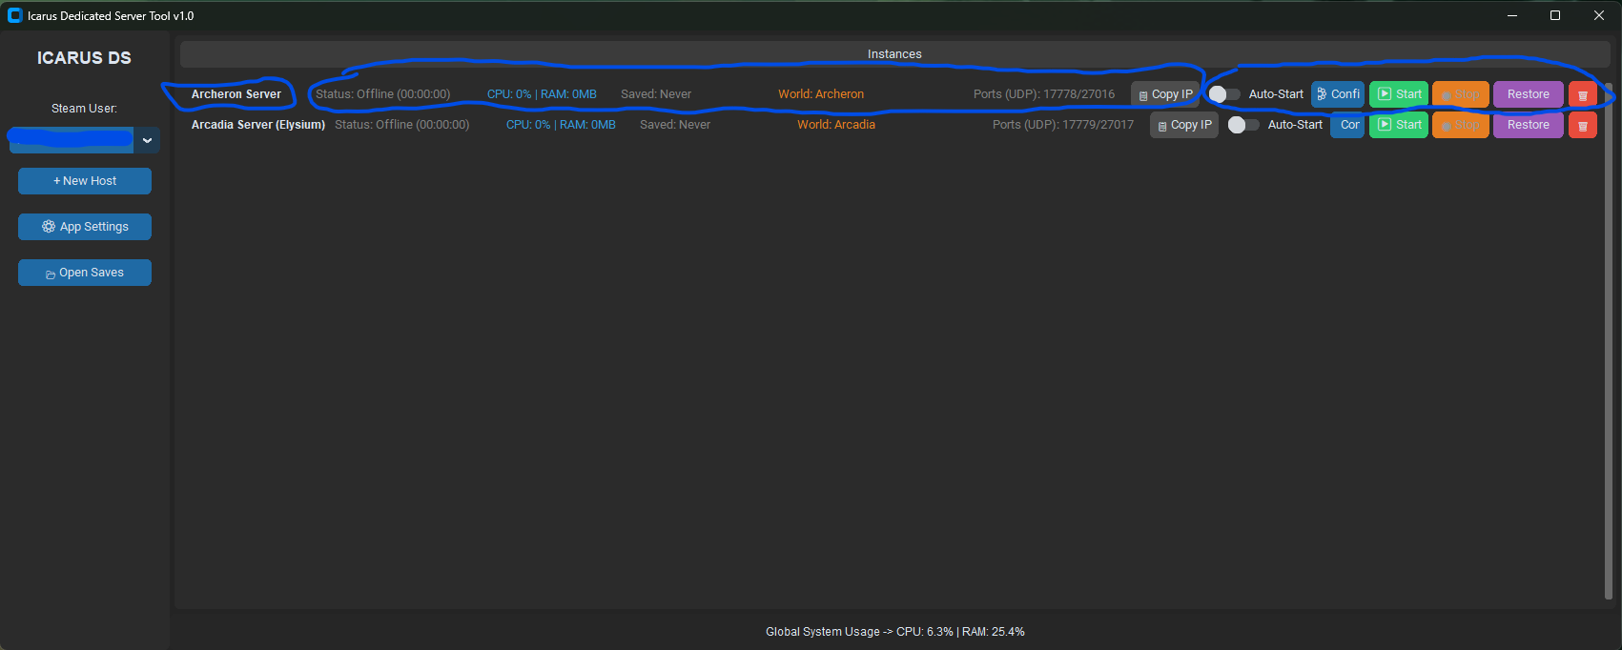
There are 3 components to a Host. Starting from the left is the Host name, then the entire middle is the status line and the buttons on the right are the user controls. The status line will show the current status of a server, server specific resource monitoring, last saved, save file name, the ports (UDP only), and quick DirectConnect Address copy.
The user control has a tonne of features all of which can only be changed when the server is offline. You cannot make any changes to a server while it is running or shutting down.
The auto Start slider is for app startup. When the app starts up it will automatically start any servers that have this slider enabled. The configuration button allows users to completely customize their servers to their liking (more later), the start and stop buttons control the launch and safe shutting down of a server, the restore button allows users to manage their backups and reload a restore point to launch the server from (more later), and the delete button. The delete button will delete the host within this app and the configuration files but it will not delete the backups.
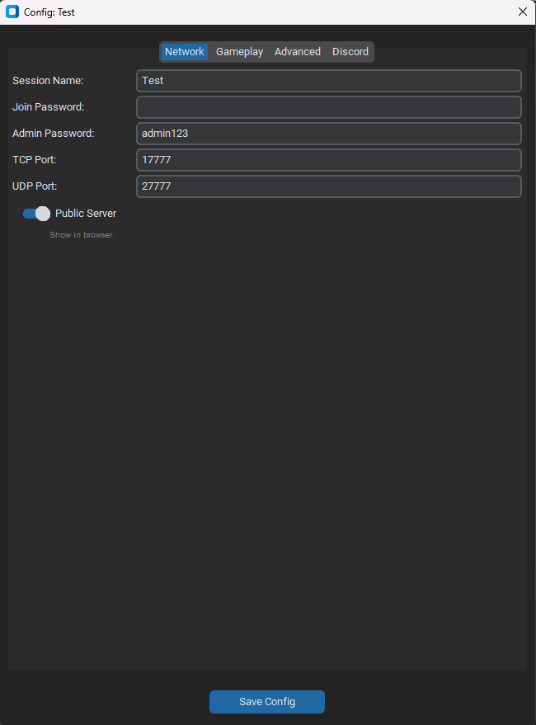
Configuration
There are 4 tabs within the Configure options starting with the Network tab which handles everything related to playing online. If you do not want to play online nothing needs to be done here other than dissabling public server if you don’t want it to be visible.
Icarus uses UDP ports in two sets, a Game Port and a Query Port. I have a rule in place that starts the Game Ports at 17778 and the Query Ports at 27016. You are able to select whatever ports you want, but in my research this has proven to be the best set to work with. You are able to changes these to whatever you would like but if you end up with connection issues please revert to default. The game port is the port to connect to via direct connect in game which is what will be copied from the copy IP button.

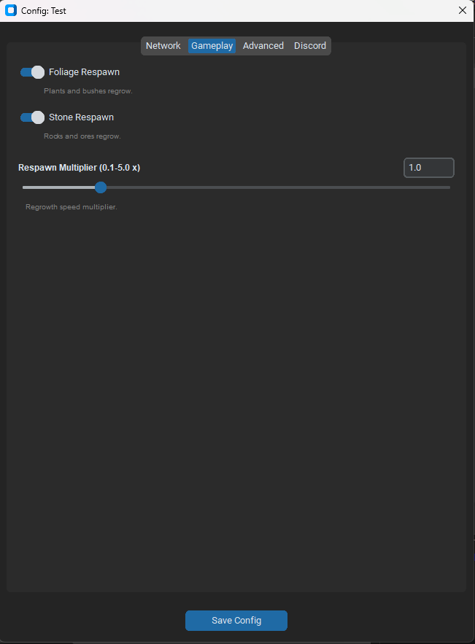
The gameplay tab has a couple options that adjust the foliage and stone respawn and the rates at which they respawn.

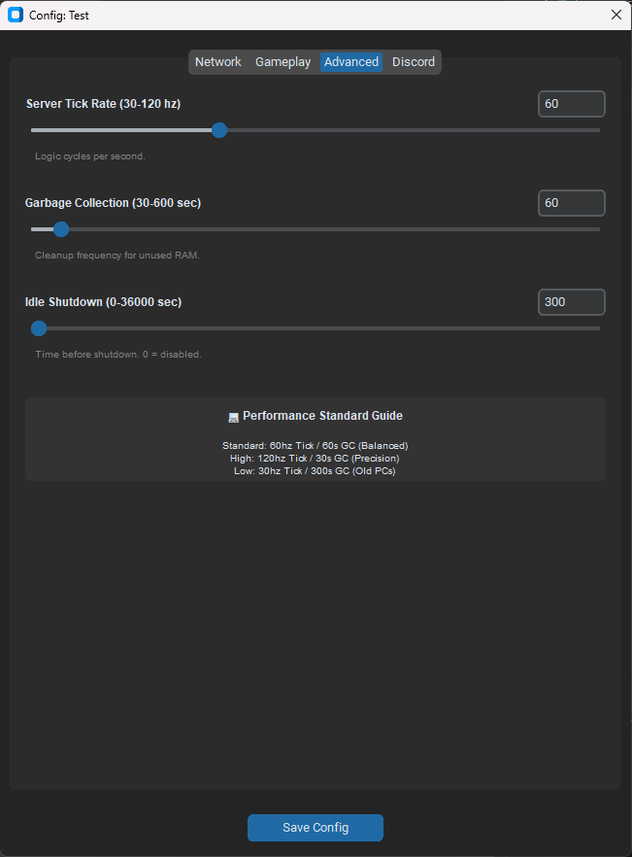
The advanced tab has what would have been the performance profiles from my older tool. This now gives the user direct control over their desired server performance.
The server tick rate adjusts the frequency at which the server refreshes. Garbage Collection is an Icarus feature that cleans and frees up RAM. Idle Shutdown timer is the time when empty before the server will return to the lobby (returning to lobby saves resources).

Lastly, there is a discord tab that simply adds a discord webhook so that you can automatically send to a discord channel that the server is live as well as the direct connect address for easy connecting.
Any settings changed must be applied with the Save Config button otherwise they will not be applied!
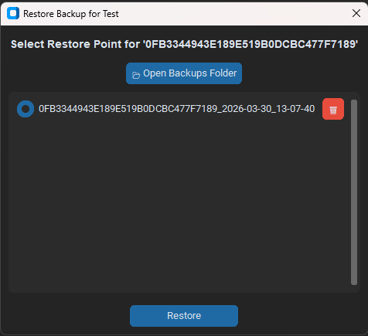
The Restore feature is something I am excited about because it allows user control over backups in the event a corrupt file occurs or, something I have found annoying, missions that become locked with what path you take or if you just felt like you made a mistake in world and want to correct it. This restore feature is hardcoded in so that a backup is created the moment a host is created as well as any time a server is stopped. When a restore point is selected you will be presented with a window asking if you are sure to load from the restore point. Your current local save will be temporarily overwritten, and you can confirm the changes upon server stop if you would like to overwrite the local save with the restore point, discard the temporary save file or rename the save file.
The server takes about ~1-2 minutes to startup. Once you see a line "-------- Server is now empty --------" in the PowerShell window then the server is ready to join.
The App will not be able to close (unless forced but not recommended) while a host is active and will prompt the user to stop any running hosts before closing. If a server window (the powershell window) is closed, the watchdog routine will engage and immediately restart the server.
How to join
Once the Dedicated Server is loaded you can click join within Icarus, navigate to the dedicated server option, click the LAN tab and you should see your server within. Once Port Forwarded others will need to join via DIRECT CONNECT with the IP address of the DS computer:Game Port. The Host status line contains a Copy IP button for easy sharing or pasting and the Discord Webhook provides automated sharing and notifications.
Multi-Hosting
I have protocols in place so that multiple hosts with the same ports cannot run at the same time. I have it this way so that multiple hosts can be created with the same ports, just that they cannot run at the same time. I want it this way because I personally have multiple worlds save files that I want to manage in this app but not necessarily run them all at the same time.
When an additional Host is created it will be offset +1 for the ports by default. These can be changed I just wanted it hardcoded in so that mistakes aren’t made immediately.
Enjoy the unlocked performance Prospector!

