First Project in Surround

Whether you are a researcher or an engineer who is using Machine Learning to derive insights, chances are you have been facing issues such as:

1. Lack of a standard pipeline architecture or a standard way of running scrips causing you to change your code again and again.
2. Using glue code to tie in multiple machine learning models together.

Enter Surround, an open-sourced framework developed by Applied Artificial Intelligence Institute (A2I2) to tackles some of the common issues around Machine Learning projects and save time between data exploration and a proof-of-concept application ready to be deployed.

# Getting Started

## Prerequisite:

1. Python 3+ (Tested on 3.6.5)
2. Docker
3. Surround supports MacOX, Linux and Windows

## Installing Python on Windows:

1. Surround requires Python 3+. To check the current version of python, open the command prompt and type in the following code.

*$ python*

You should something like this:

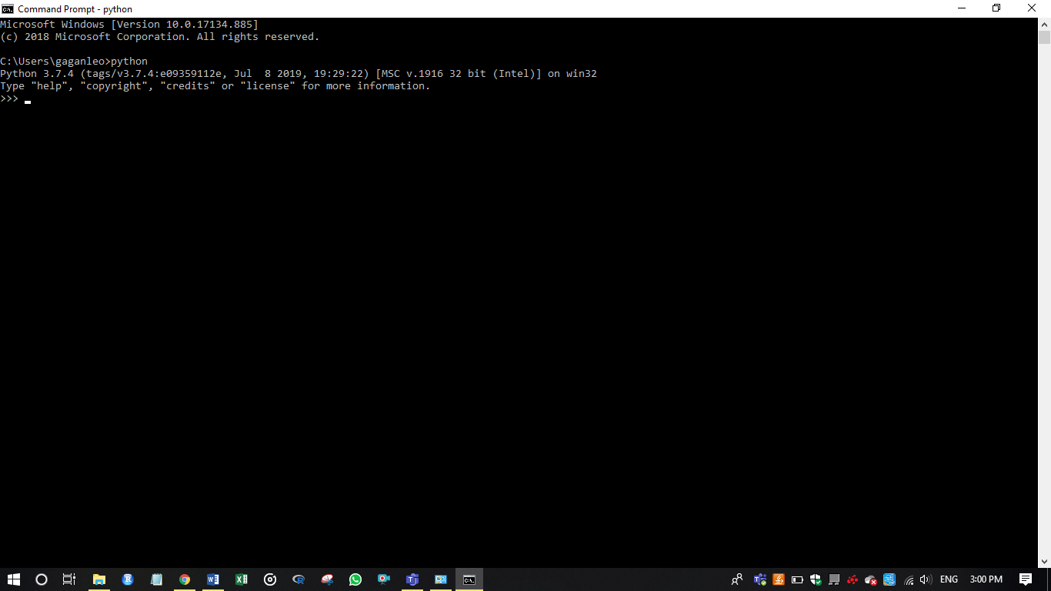

If the version of Python is 2.X.X, you need to uninstall python before proceeding with the below steps. You can find the uninstallation procedure here.

1. Download the latest version of Python from <https://www.python.org/downloads/>.
2. Double-click the downloaded file to start the installation process. In the window that appears, make sure to select Add Python 3.7 to the PATH at the bottom. Then click on Install Now.

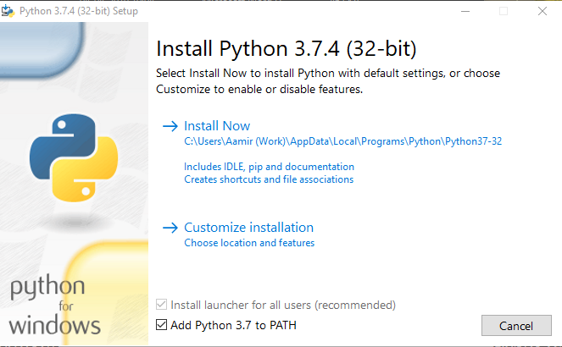

1. Verify the installation by closing and reopening the command propmt and typing in the below code

*$ python*

You should see similar output as step 1 with the latest version of python.

## Installing Python on Mac

1. Mac system often have python pre-installed in it. You can check the installed version of python by typing

*$ python –version*

If the installed version is below 3, do not attempt to uninstall it as it may cause your operating system to crash. Simply follow the below steps to install Python 3.

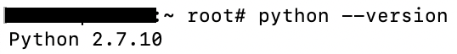

1. Install the Homebrew package manager by opening the Terminal and typing the below code:

*$ ruby -e "$(curl -fsSL* [*https://raw.githubusercontent.com/Homebrew/install/master/install*](https://raw.githubusercontent.com/Homebrew/install/master/install)*)"*

Hit Enter/Return when prompted.

1. Install Python 3 by typing

*$ brew install python*

1. Check the installed version of Python by typing

*$ python3*



## Installing Surround

1. Run the following command in Command Prompt (Windows) or Terminal (MacOX, Linux)

*$ pip3 install surround*

The Surround library will be installed. To verify, type

*$ surround*

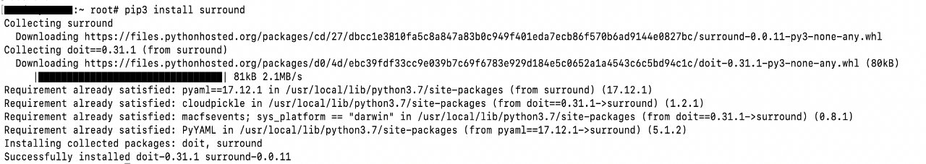

# Surround CLI

Surround comes with a host of command line tools to help you create projects and pipelines.

1. *init* – Used to create a new Surround project
2. *lint* - Used to run the Surround Linter which checks if Surround conventions are being used correctly.
3. *run* – used to run the intended task.

# Running the Hello-World script in Surround

Now that Surround is installed, lets check everything is as it is supposed to be by running a test script.

1. Download and extract the Surround repository from GitHub by click the below link,

<https://github.com/a2i2/surround>

Keep note of the path where you extract the repository.

1. Open the Command Prompt/Terminal and type in the below code:

Windows: *$ python YOUR_DIR/surround-master/examples/hello-world/main.py*

Mac: *$ python3 YOUR_DIR/surround-master/examples/hello-world/main.py*

Where YOUR_DIR is the folder in which you extracted the surround repository.

You should see the below output

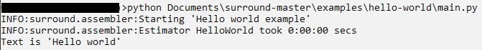

# Creating your first Project in Surround

Now that we have verified that everything in the system works, lets create out first project in Surround.

1. The below code will generate a new project

*$ surround init -p firstproject -d "Our First Surround Project"*

You will get a prompt asking if we require a web-container, type *n* for now. You should see an output similar to this:



1. Any new project in Surround comes with a sample pipeline that can be executed straight away using the command

*$ cd firstproject*

*$ python -m firstproject (Windows) or $ python3 -m firstproject (Mac)*

Your output should be same as below:

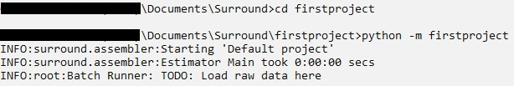

Congratulations! You have successfully created installed Python and Surround and generated your first project in Surround. We will look at generating pipelines in the subsequent blogs.