
CHAITANYA BHARATHI INSTITUTE OF TECHNOLOGY
(Autonomous)
Gandipet, Hyderabad - 500075, Telangana

FUNDAMENTALS OF DATA SCIENCE
CASE STUDY REPORT
Case Study 2: Clustering Analysis of East-West Airlines Customers
Case Study 5: Wine Quality Assessment Using Physicochemical Properties

Name | : | Deekonda Bhavesh
Roll No | : | 160124733170
Section | : | CSE-3
Year | : | III Year
Subject | : | Fundamentals of Data Science
Faculty Name | : | S. Durga Devi

CASE STUDY 2: CLUSTERING ANALYSIS OF EAST-WEST AIRLINES

1. Problem Statement
East-West Airlines wants to understand its customers better. The airline is mainly interested in how customers fly, how they earn and use frequent flyer miles, and how they use the airline credit cards. The task is to divide the customers into groups (segments) so that the airline can treat each group in a suitable way.
Since the data has no ready-made group labels, this is an unsupervised learning problem. Three clustering methods are applied and compared: K-Means, Hierarchical clustering and DBSCAN. The work covers data cleaning, exploratory analysis, parameter selection, visualization, interpretation of the clusters and evaluation with the silhouette score.

2. Dataset Description
The dataset has 3,999 customers and 12 columns. The ID column only identifies a customer, so it was not used for clustering. Table 1 explains the remaining columns.
Table 1: Description of the airline dataset columns
Column | Meaning
Balance | Miles available for award travel
Qual_miles | Miles that count towards Topflight status
cc1_miles | Miles earned with the frequent flyer credit card (category 1 to 5)
cc2_miles | Miles earned with the rewards credit card (category 1 to 5)
cc3_miles | Miles earned with the small business credit card (category 1 to 5)
Bonus_miles | Miles earned from non-flight bonus transactions in the last 12 months
Bonus_trans | Number of non-flight bonus transactions in the last 12 months
Flight_miles_12mo | Flight miles in the last 12 months
Flight_trans_12 | Number of flight transactions in the last 12 months
Days_since_enroll | Number of days since the customer enrolled in the programme
Award? | 1 if the customer has received an award, otherwise 0

3. Methodology

3.1 Data Preprocessing
- Missing values and duplicates: The data was checked for empty cells and repeated rows. None were found.
- Selecting features: The ID column was dropped. The Award? column was kept aside and used only to describe the clusters afterwards. The other ten columns were used for clustering.
- Outlier removal: A few customers had extremely large values, for example a balance of more than 1.7 million miles. For the five columns Balance, Bonus_miles, Bonus_trans, Flight_miles_12mo and Flight_trans_12, a z-score was calculated, and customers with a z-score above 5 in any of these columns were removed. This removed 85 customers (about 2.1 percent) and left 3,914 customers.
- Scaling: Clustering methods depend on distance, and the columns have very different ranges (balance is in lakhs while cc2_miles is between 1 and 3). So all ten features were standardized to have mean 0 and standard deviation 1.

3.2 Clustering Methods Used
- K-Means: Customers are assigned to the nearest of K centres, and the centres are updated until they settle. The best K was studied using the elbow curve and silhouette scores for K from 2 to 10.
- Hierarchical clustering: Customers are merged step by step into larger groups, and the process is shown as a dendrogram. Four linkage types (Ward, complete, average and single) were compared.
- DBSCAN: Groups are formed in dense regions, and customers in sparse regions are marked as noise. The values of epsilon (the neighbourhood radius) and minPts (the minimum points needed) were chosen with a k-distance plot and a small parameter search.

3.3 Evaluation and Visualization
The silhouette score was used to judge each result. It lies between -1 and 1, and a higher value means that customers sit well inside their own cluster and far from other clusters. To draw the clusters on a flat page, the ten features were reduced to two Principal Components using PCA. All work was done in Python using pandas, NumPy, matplotlib, SciPy and scikit-learn.

4. Statistical Findings

4.1 Effect of Outlier Removal
Figure 1 shows the box plots of the five columns before removing outliers. Many dots appear far above the boxes, which means a small number of customers have very large balances, bonus miles and flight activity. Such customers can pull the cluster centres towards them, so they were removed. Table 2 shows the columns after cleaning.
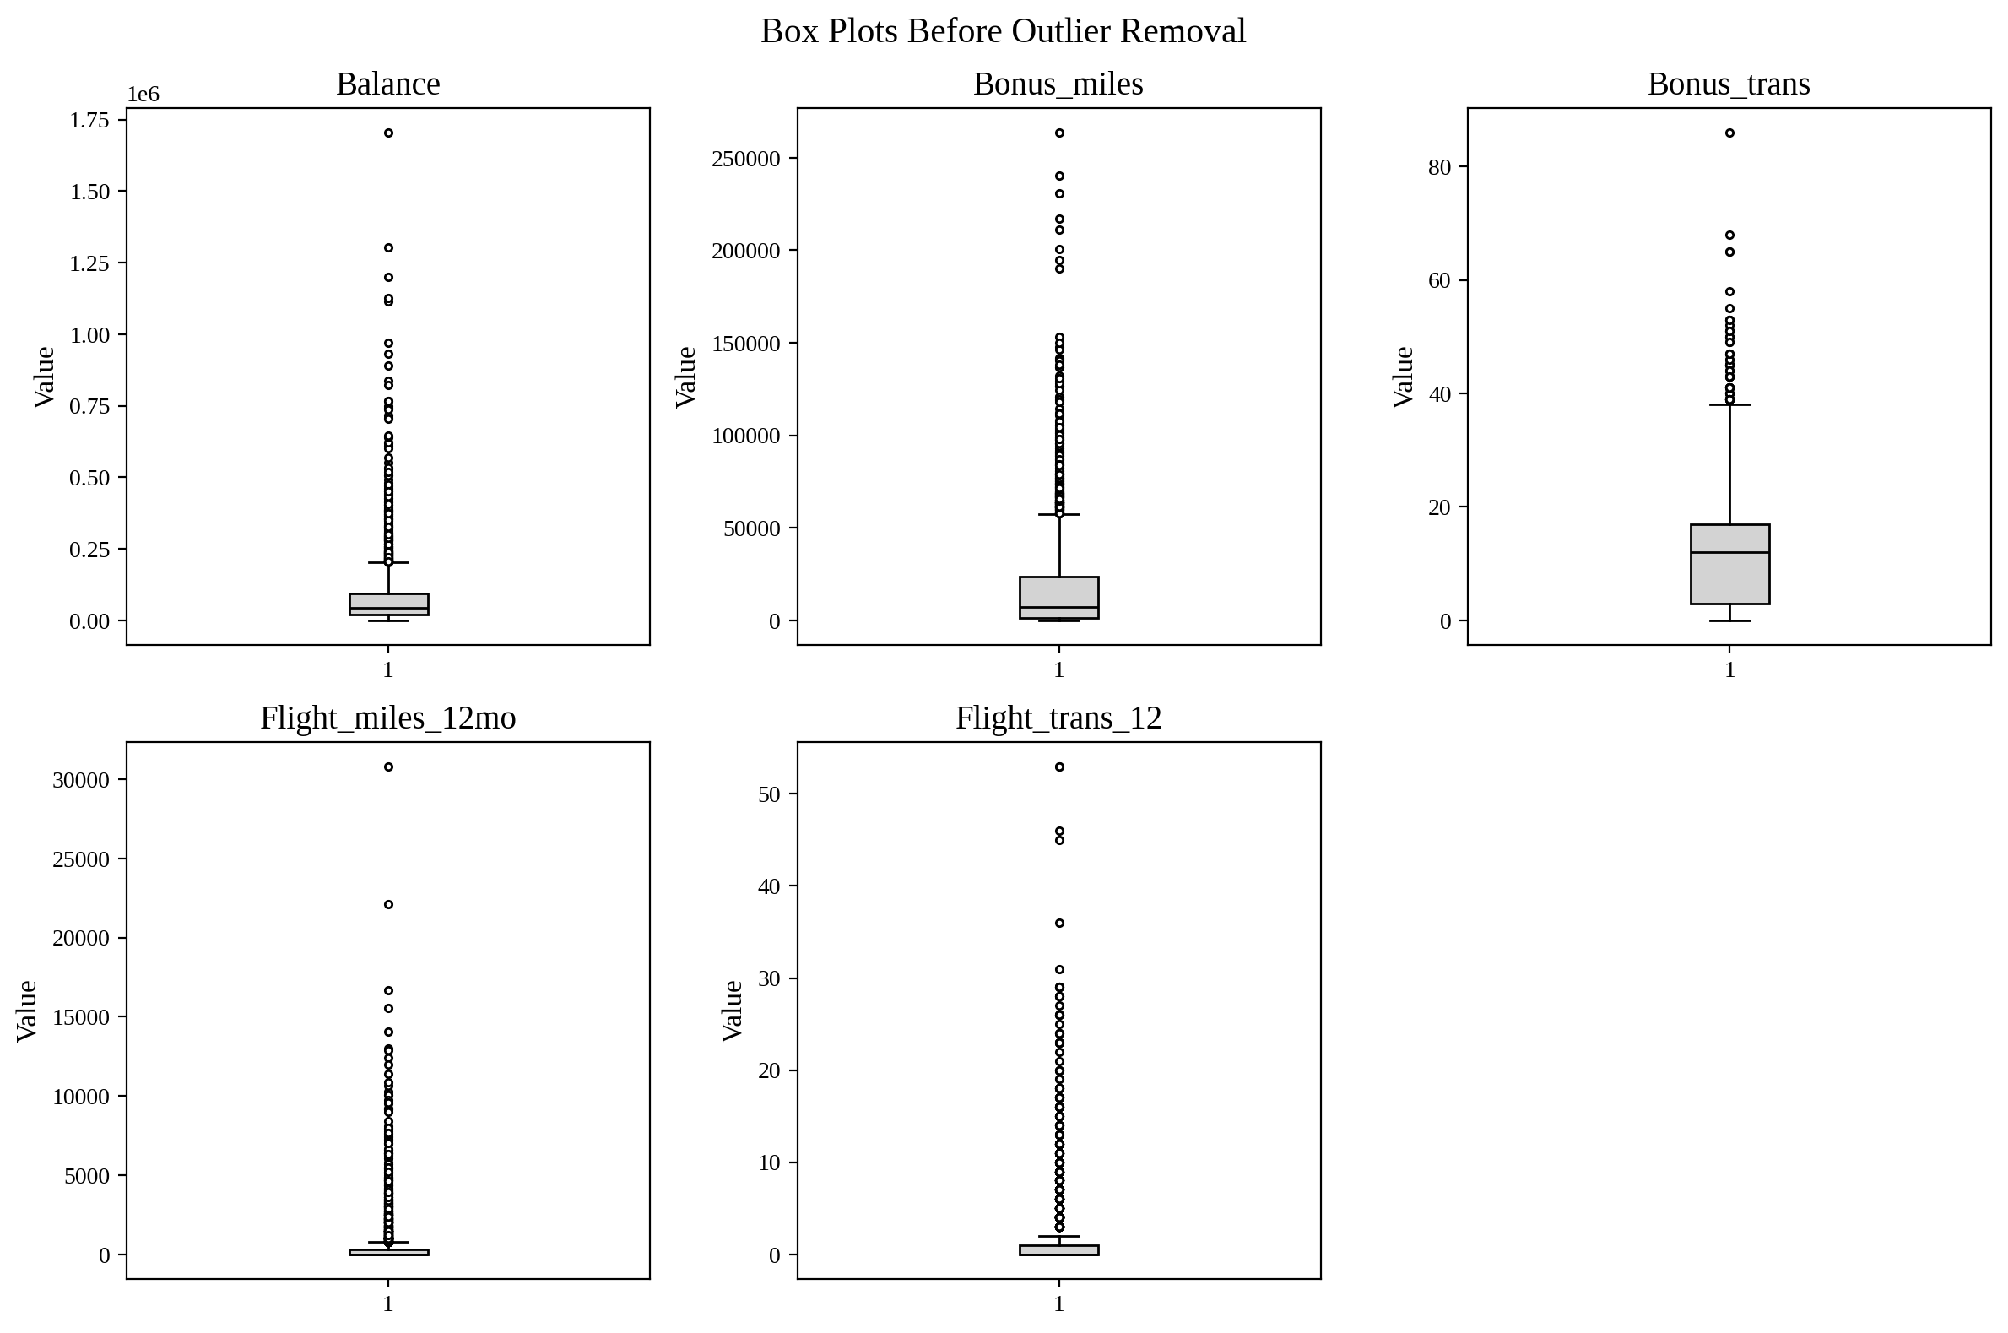
Figure 1: Box plots of key columns before outlier removal
Table 2: Summary of key columns after outlier removal (3,914 customers)
Column | Mean | Std Dev | Median | Max
Balance | 67,155 | 75,024 | 41,360 | 568,174
Bonus_miles | 16,108 | 21,262 | 6,778 | 136,704
Bonus_trans | 11.19 | 9.00 | 12 | 53
Flight_miles_12mo | 346.8 | 878.8 | 0 | 7,450
Flight_trans_12 | 1.05 | 2.52 | 0 | 20

The mean is much larger than the median for Balance, Bonus_miles and the flight columns. This shows that most customers have small values and a few have large ones.

4.2 Distribution of the Features
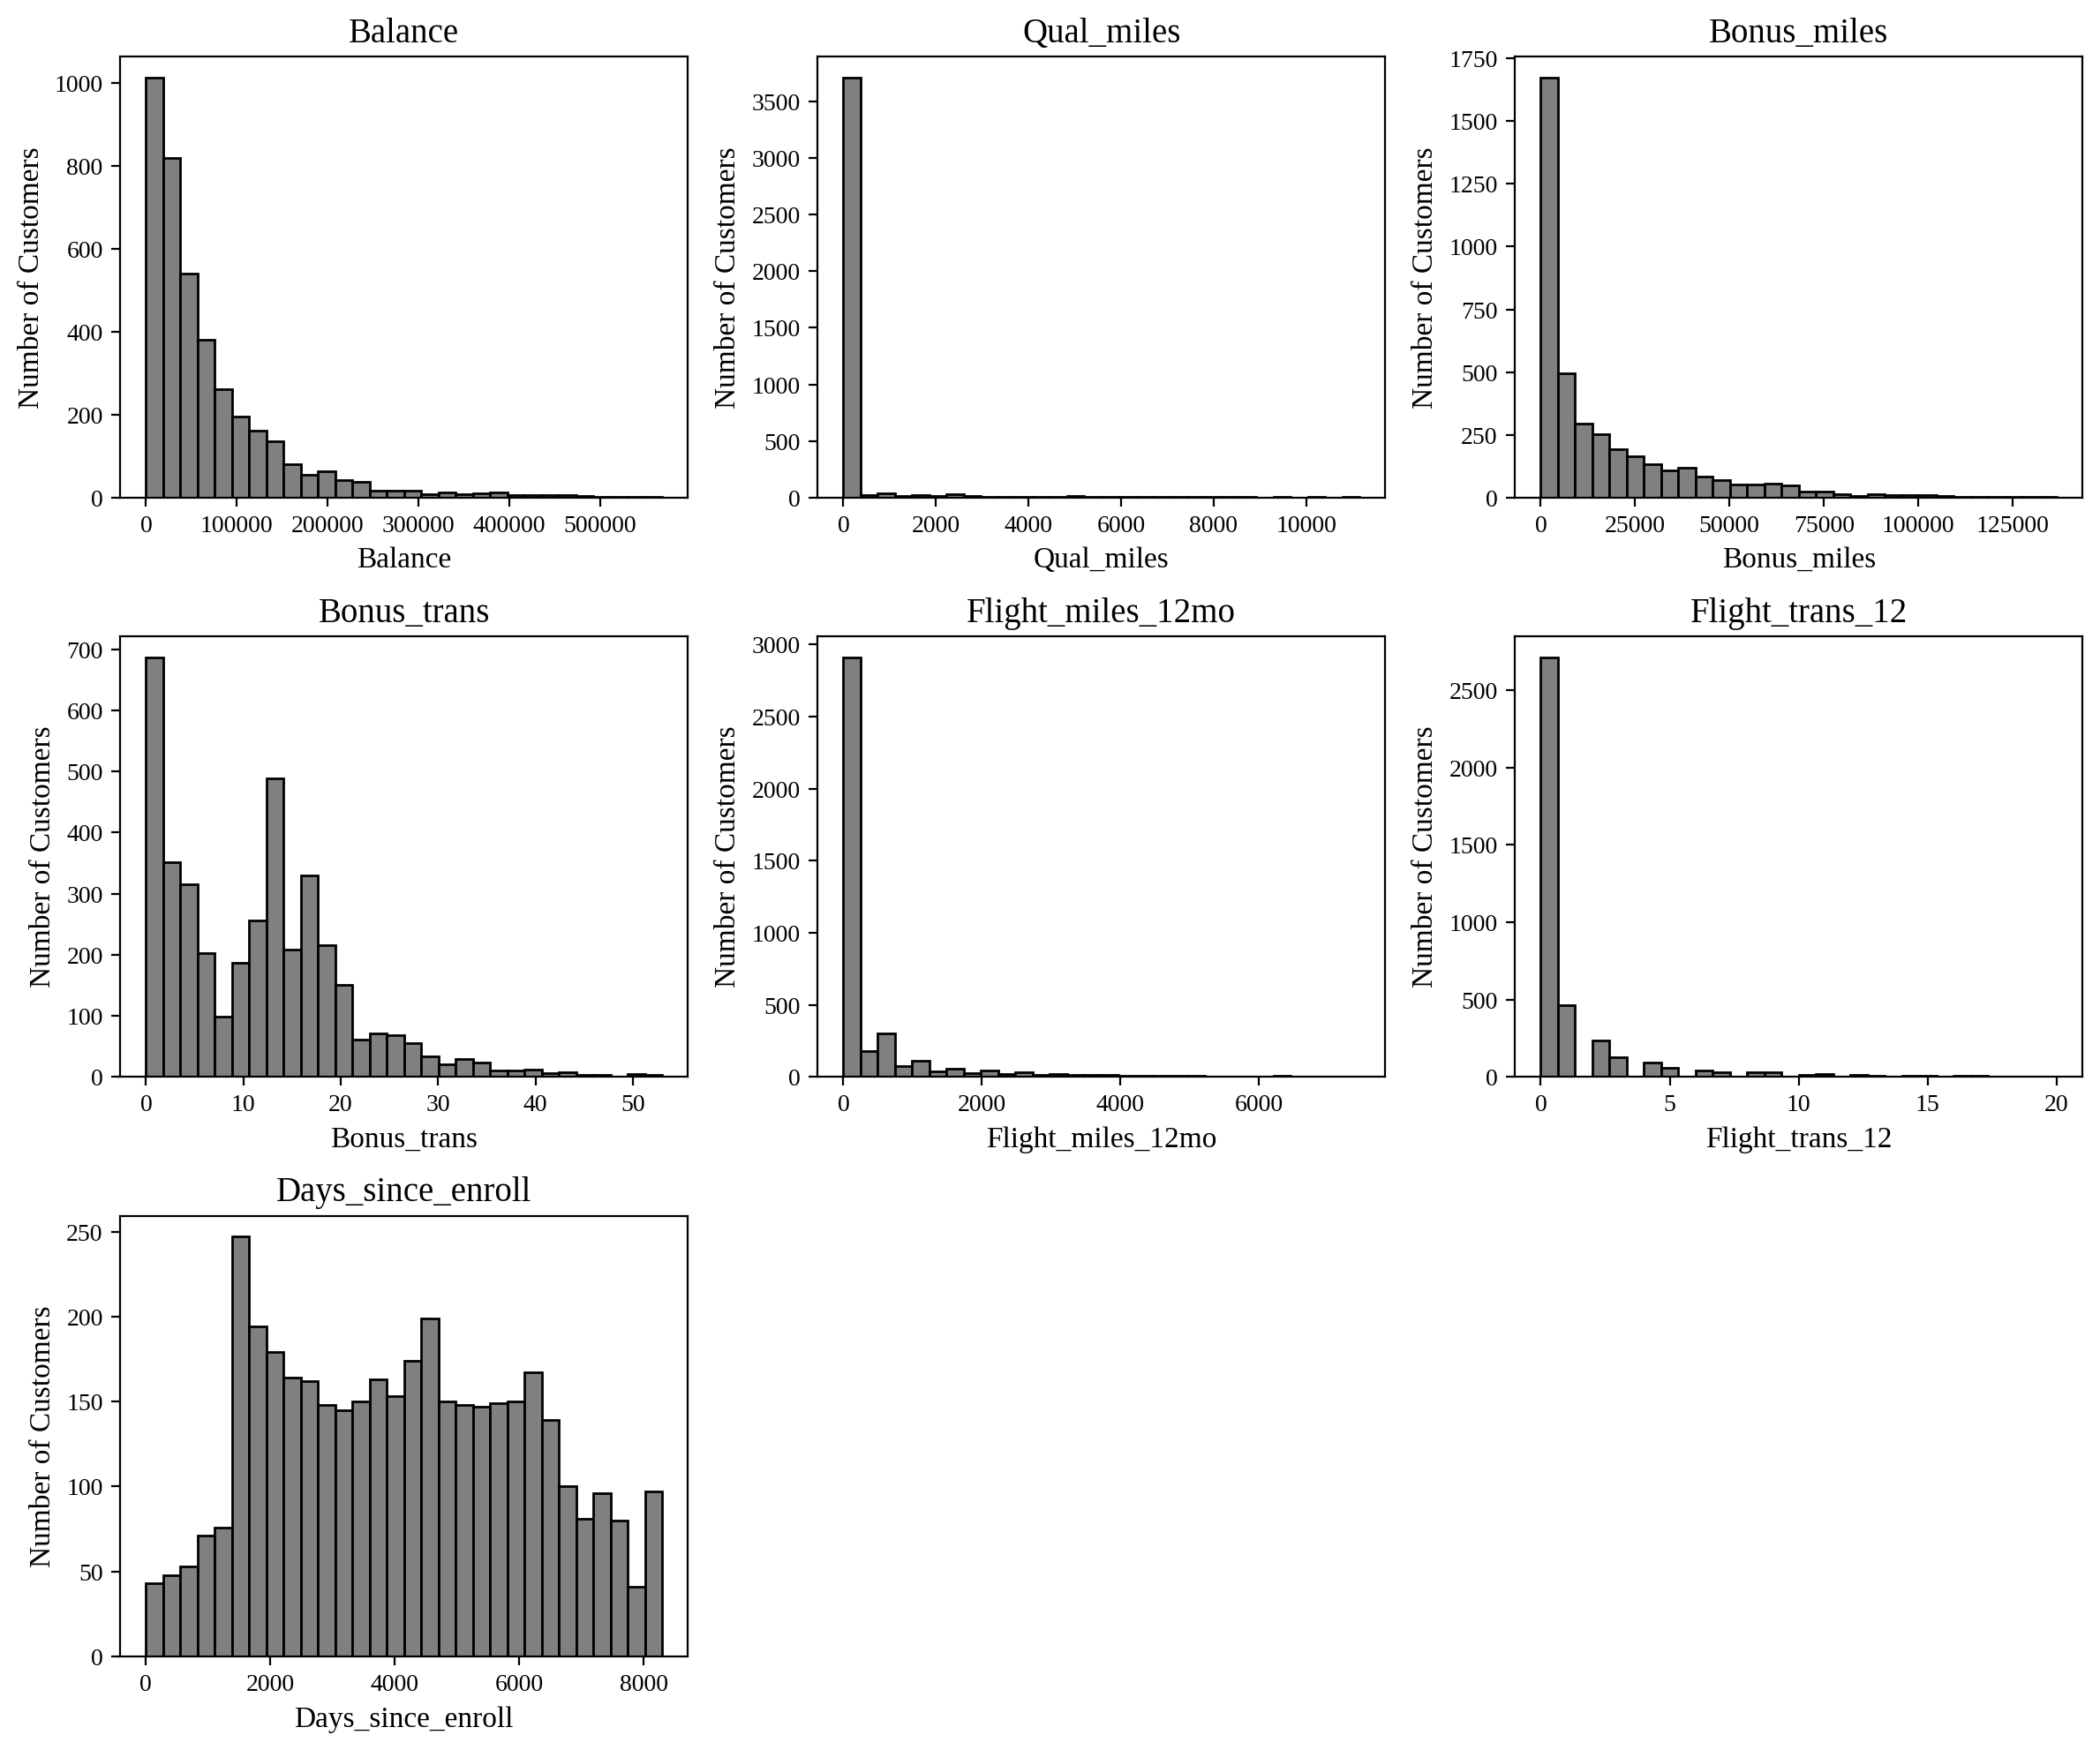
Figure 2: Histograms of the numeric features
Figure 2 shows that Balance, Qual_miles, Bonus_miles, Flight_miles_12mo and Flight_trans_12 are strongly right skewed. The skewness values are 2.44, 7.78, 1.95, 3.93 and 3.66 respectively. A very large number of customers have zero flight miles (69.4 percent) and zero qualifying miles (94.8 percent). This means that most customers earn their miles in ways other than flying. Bonus_trans is spread more evenly with two visible peaks, and Days_since_enroll is almost symmetric (skewness 0.12), so the customers joined at a fairly steady rate over the years.

4.3 Credit Card Mile Categories
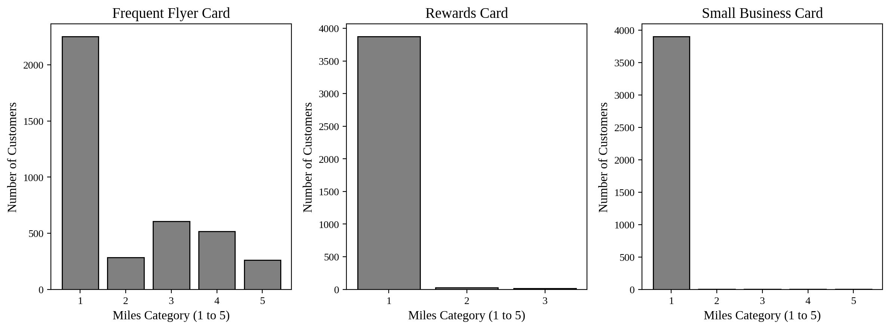
Figure 3: Number of customers in each miles category for the three credit cards
Figure 3 shows that the frequent flyer card (cc1) is the only card with real variety. About 57.5 percent of customers are in category 1, and the rest are spread over categories 2 to 5. For the rewards card and the small business card, 98.9 percent and 99.6 percent of customers are in category 1. These two columns therefore carry very little information to separate customers.

4.4 Award Status
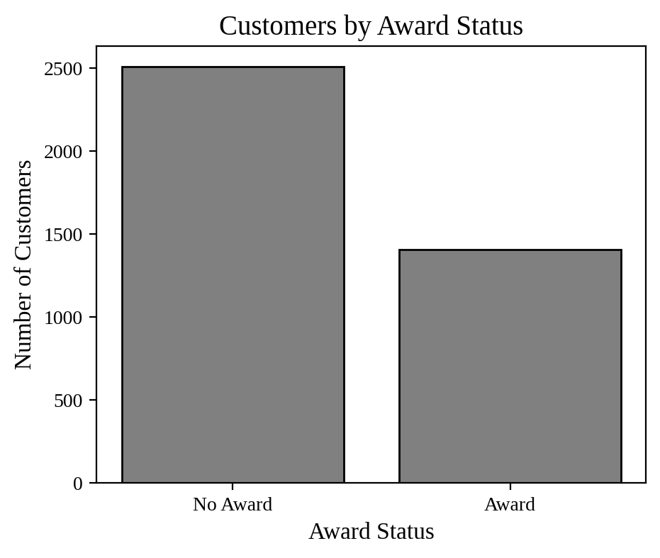
Figure 4: Number of customers by award status
Out of 3,914 customers, 1,406 (35.9 percent) have received an award and 2,508 (64.1 percent) have not. The two groups are not equal in size, but both are large enough to study.

4.5 Correlation Between Features
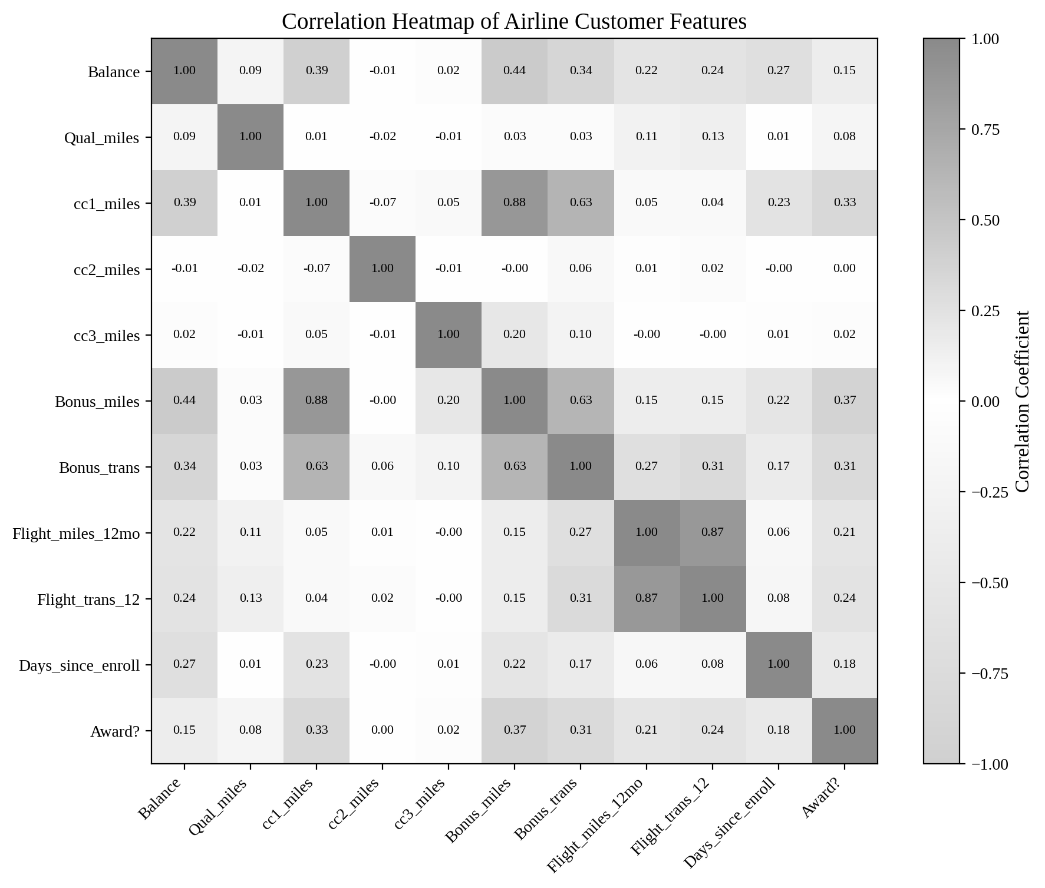
Figure 5: Correlation heatmap of the airline customer features
Figure 5 shows several strong relationships. Bonus_miles and cc1_miles are strongly related (0.88), and so are Flight_miles_12mo and Flight_trans_12 (0.87). Bonus_miles and Bonus_trans have a moderate relationship (0.63). Balance moves with Bonus_miles (0.44) and with Days_since_enroll (0.27), which is natural because customers who earn more and stay longer collect more miles. The Award? column is related most to Bonus_trans (0.31) and to Flight_trans_12 (0.24). These relationships suggest that the customers can be separated by their bonus activity and their flying activity.
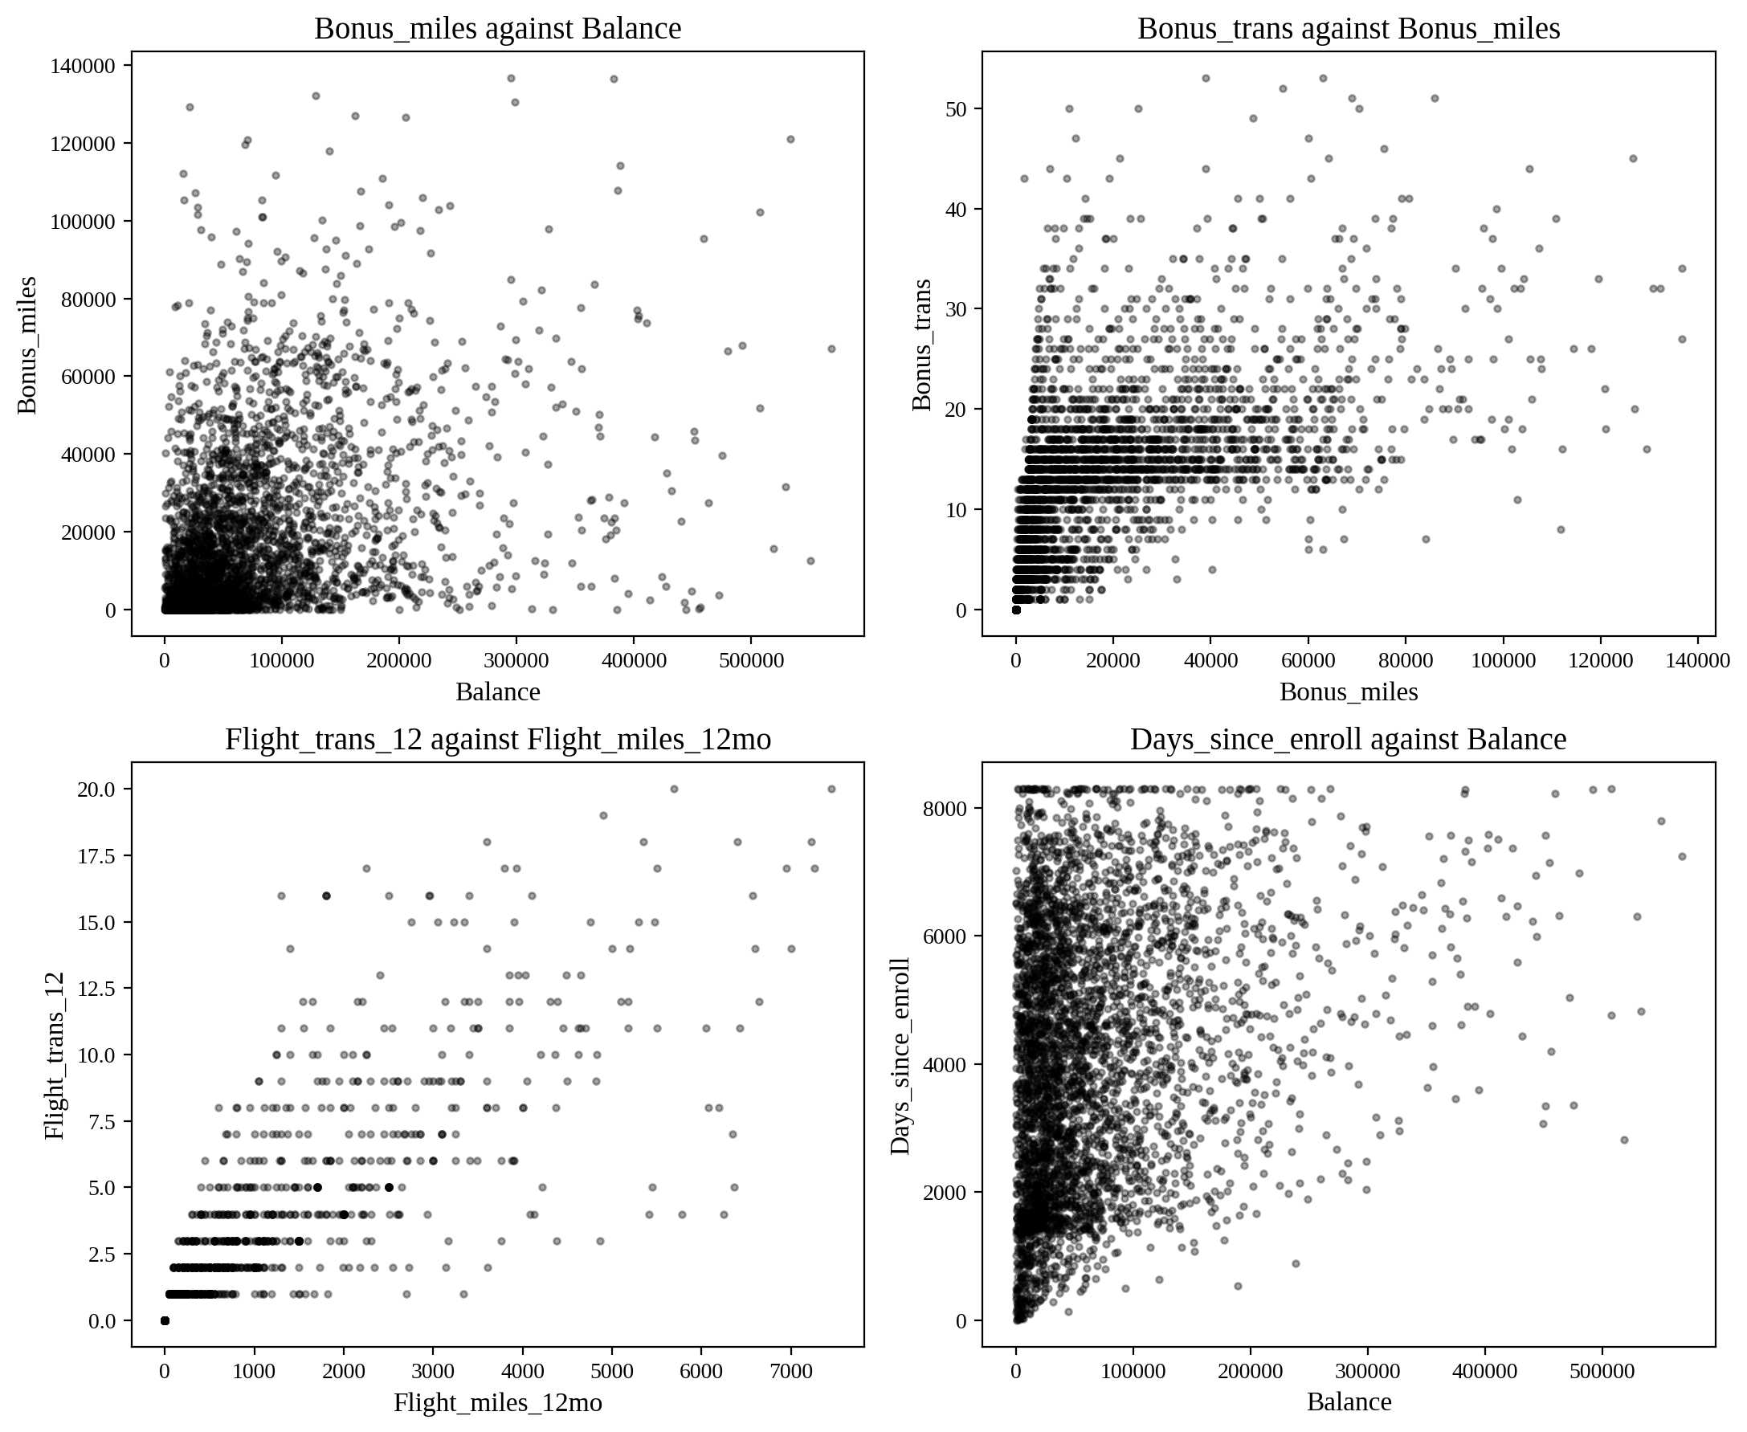
Figure 6: Scatter plots of four pairs of related features
Figure 6 supports the heatmap. Flight miles rise steadily with the number of flight transactions. Bonus miles rise with bonus transactions but with a wide spread. Most points are packed near the bottom-left corner, which is the group of low-activity customers, while a smaller number of points stretch outward. This pattern hints at at least two or three natural groups.

5. Model Evaluation

5.1 K-Means Clustering
K-Means was run for K from 2 to 10, and the inertia and silhouette score were recorded for each K. The results are shown in Figure 7 and Table 3.
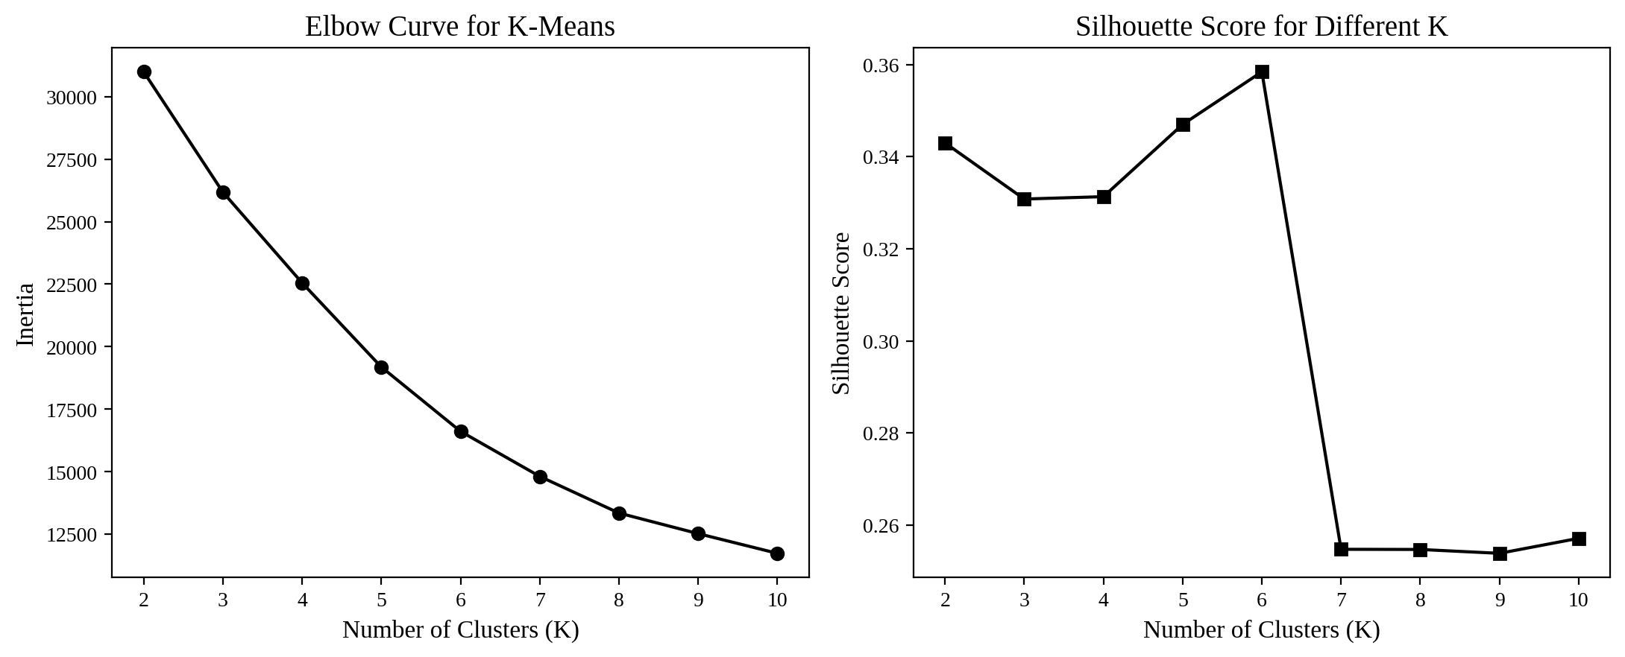
Figure 7: Elbow curve and silhouette scores for K-Means
Table 3: Inertia and silhouette score for different values of K
K | Inertia | Silhouette Score
2 | 30,986.9 | 0.343
3 | 26,177.7 | 0.331
4 | 22,552.4 | 0.331
5 | 19,189.1 | 0.347
6 | 16,617.9 | 0.358
7 | 14,817.6 | 0.255
8 | 13,352.8 | 0.255
9 | 12,530.0 | 0.254
10 | 11,742.7 | 0.257

The elbow curve bends gently around K = 3 and does not have one sharp elbow. The silhouette scores for K = 2 to 6 are all close to each other (0.33 to 0.36) and then fall sharply from K = 7. Because the scores are almost equal for small K, the choice was made on how useful the groups are. K = 3 gives three clear and well-sized customer groups. When K = 4 was tried, one of the clusters had only 13 customers, which is too small to be a useful segment. So K = 3 was selected. The final silhouette score is 0.331.

5.2 Hierarchical Clustering
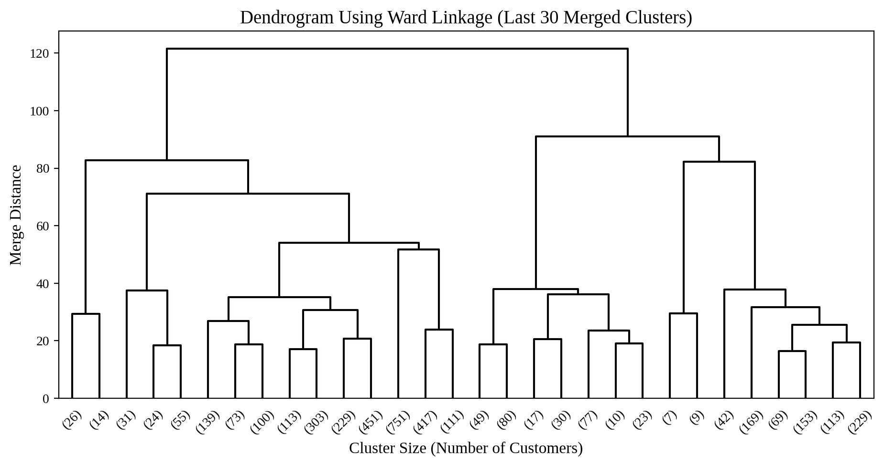
Figure 8: Dendrogram using Ward linkage (last 30 merged clusters)
The dendrogram in Figure 8 shows that the last merges happen at large distances (above 80), while most earlier merges happen below 40. Cutting the tree at a distance of about 90 gives three main branches, which agrees with the choice of K = 3 in K-Means. Table 4 compares the linkage methods.
Table 4: Comparison of linkage methods for hierarchical clustering
Linkage | Clusters | Silhouette | Largest Cluster Share
Ward | 3 | 0.334 | 72.5%
Ward | 4 | 0.352 | 71.5%
Ward | 5 | 0.339 | 71.5%
Complete | 3 | 0.566 | 98.3%
Complete | 4 | 0.577 | 97.3%
Complete | 5 | 0.579 | 97.1%
Average | 3 | 0.723 | 99.5%
Average | 4 | 0.656 | 98.4%
Average | 5 | 0.646 | 98.4%
Single | 3 | 0.567 | 98.9%
Single | 4 | 0.550 | 98.9%
Single | 5 | 0.558 | 98.6%

At first the complete, average and single linkage methods look better because their silhouette scores are higher (up to 0.723). But the last column explains why this is misleading. In these methods, one cluster holds 97 to 99 percent of all customers, and the other clusters are tiny groups of a few unusual customers. That is not a useful segmentation. Ward linkage gives balanced clusters, with the largest holding about 72 percent of customers, so Ward linkage with K = 3 was chosen. Its silhouette score is 0.334.

5.3 DBSCAN
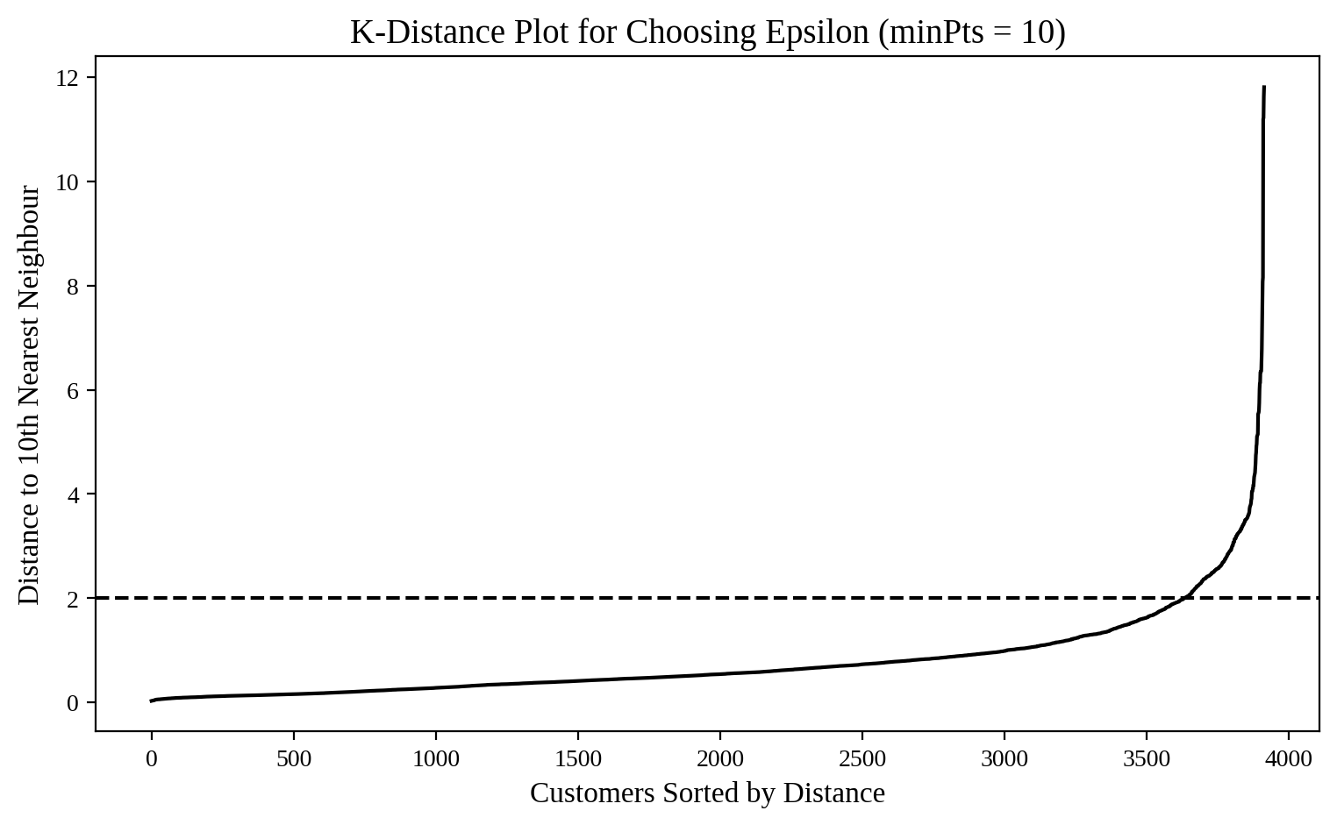
Figure 9: K-distance plot used to choose epsilon (minPts = 10)
Figure 9 plots the distance of every customer to its tenth nearest neighbour. The curve rises slowly and then turns upward sharply. The bend is close to a distance of 2, so epsilon = 2 was selected. Table 5 shows the parameter search.
Table 5: DBSCAN results for different epsilon and minPts values
Epsilon | minPts | Clusters | Noise Share | Silhouette
1.0 | 10 | 2 | 17.3% | 0.651
1.0 | 20 | 1 | 19.8% | Not defined
1.5 | 10 | 2 | 8.6% | 0.615
1.5 | 20 | 1 | 10.9% | Not defined
2.0 | 10 | 3 | 4.4% | 0.594
2.0 | 20 | 2 | 5.7% | 0.600
2.5 | 10 | 3 | 2.4% | 0.577
2.5 | 20 | 2 | 3.5% | 0.584
3.0 | 10 | 3 | 1.4% | 0.571
3.0 | 20 | 2 | 2.1% | 0.575

When epsilon is small, too many customers are called noise (up to 19.8 percent). When it is large, almost everything joins one cluster. Epsilon = 2 with minPts = 10 gives a fair balance: three clusters and only 4.4 percent noise (174 customers). The silhouette score is 0.594, calculated without the noise points. The clusters have 3,708, 22 and 10 customers.

5.4 Cluster Visualization
Figures 10, 11 and 12 show the clusters on the first two principal components. These two components together explain 48.0 percent of the total variation (30.4 percent and 17.6 percent), so the plots give a useful but not complete picture. Different shades and marker shapes are used for the clusters.
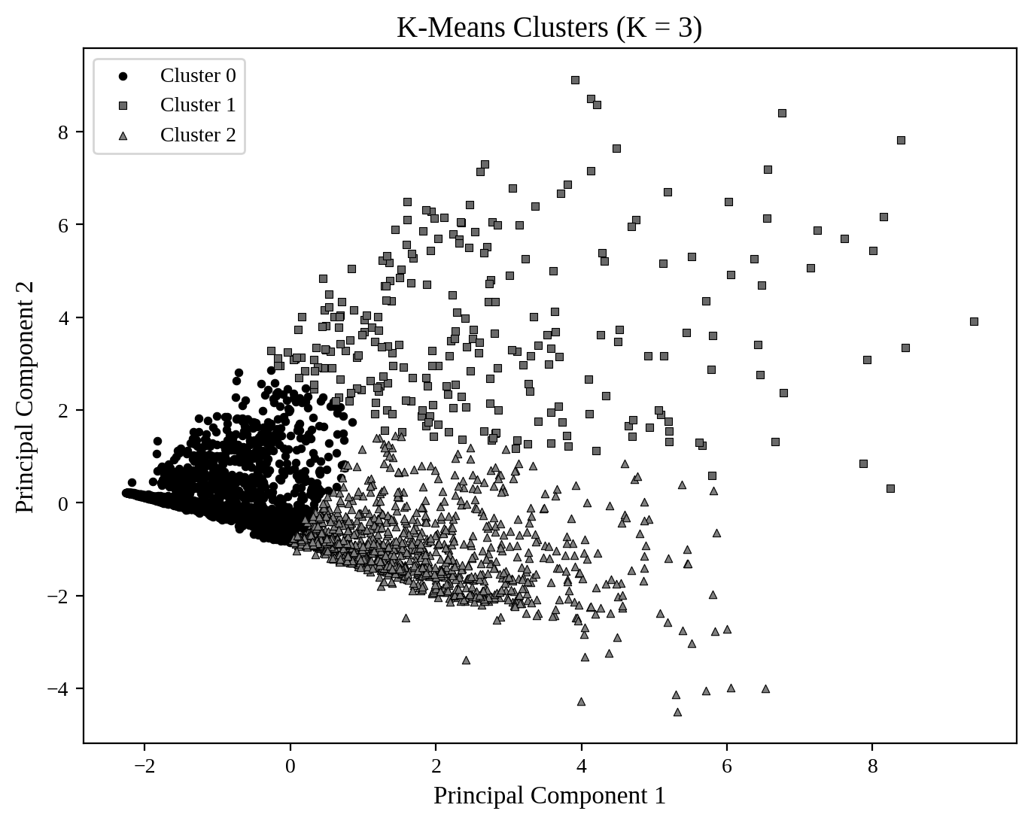
Figure 10: K-Means clusters shown on two principal components
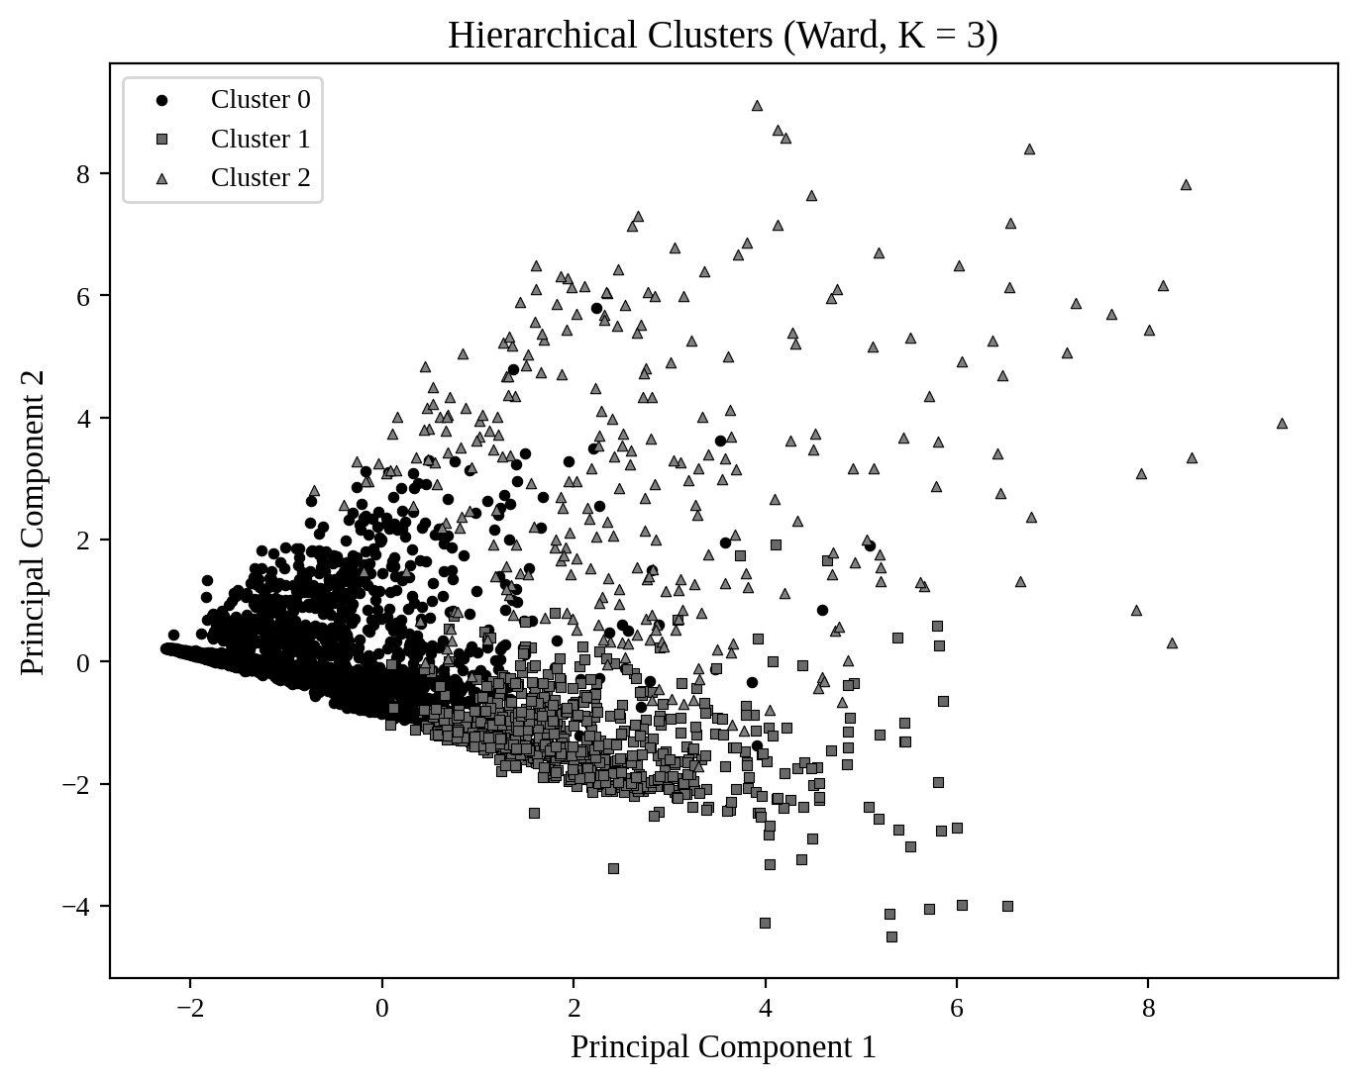
Figure 11: Hierarchical clusters (Ward linkage) shown on two principal components
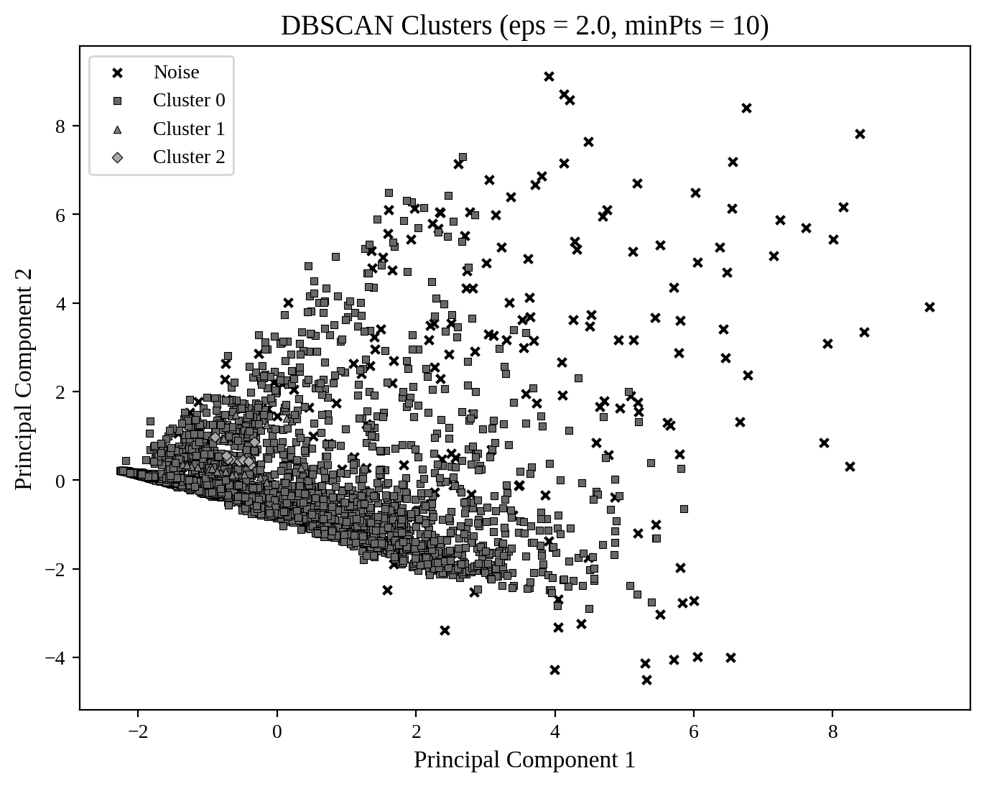
Figure 12: DBSCAN clusters and noise points shown on two principal components
In the K-Means plot (Figure 10), the large cluster of low-activity customers sits on the left, and the other two clusters spread towards the right and the top. The hierarchical plot (Figure 11) looks similar but draws the boundaries a little differently. The DBSCAN plot (Figure 12) is very different. Almost all points belong to one large cluster, and the crosses on the right and top are the noise points, which are the customers with very high values.

5.5 Comparison of the Three Methods
Table 6: Evaluation summary of the clustering methods
Method | Clusters | Silhouette Score | Noise Points
K-Means | 3 | 0.331 | 0
Hierarchical (Ward) | 3 | 0.334 | 0
DBSCAN | 3 | 0.594 | 174

K-Means and Hierarchical clustering have almost the same silhouette score (about 0.33), which shows a fair but not very strong separation. This is normal for customer data, where groups overlap. DBSCAN has the highest score, but it should be read carefully. The score was calculated after removing 174 noise customers, and 94.7 percent of the remaining customers are in a single cluster. So DBSCAN is better at finding unusual customers than at splitting the normal customers into useful segments.

6. Cluster Interpretation
To understand each cluster, the average value of every feature was calculated for each cluster. Table 7 shows the K-Means result, and Figure 13 shows the main differences.
Table 7: Average values of each K-Means cluster
Feature | Cluster 0 | Cluster 1 | Cluster 2
Customers | 2,404 | 256 | 1,254
Balance | 40,126 | 123,939 | 107,378
Qual_miles | 107 | 574 | 101
cc1_miles (category) | 1.18 | 2.05 | 3.68
Bonus_miles | 4,204 | 23,986 | 37,319
Bonus_trans | 6.5 | 20.0 | 18.4
Flight_miles_12mo | 129 | 3,063 | 210
Flight_trans_12 | 0.44 | 8.83 | 0.65
Days_since_enroll | 3,685 | 4,462 | 4,821
Award? (share) | 0.23 | 0.67 | 0.54

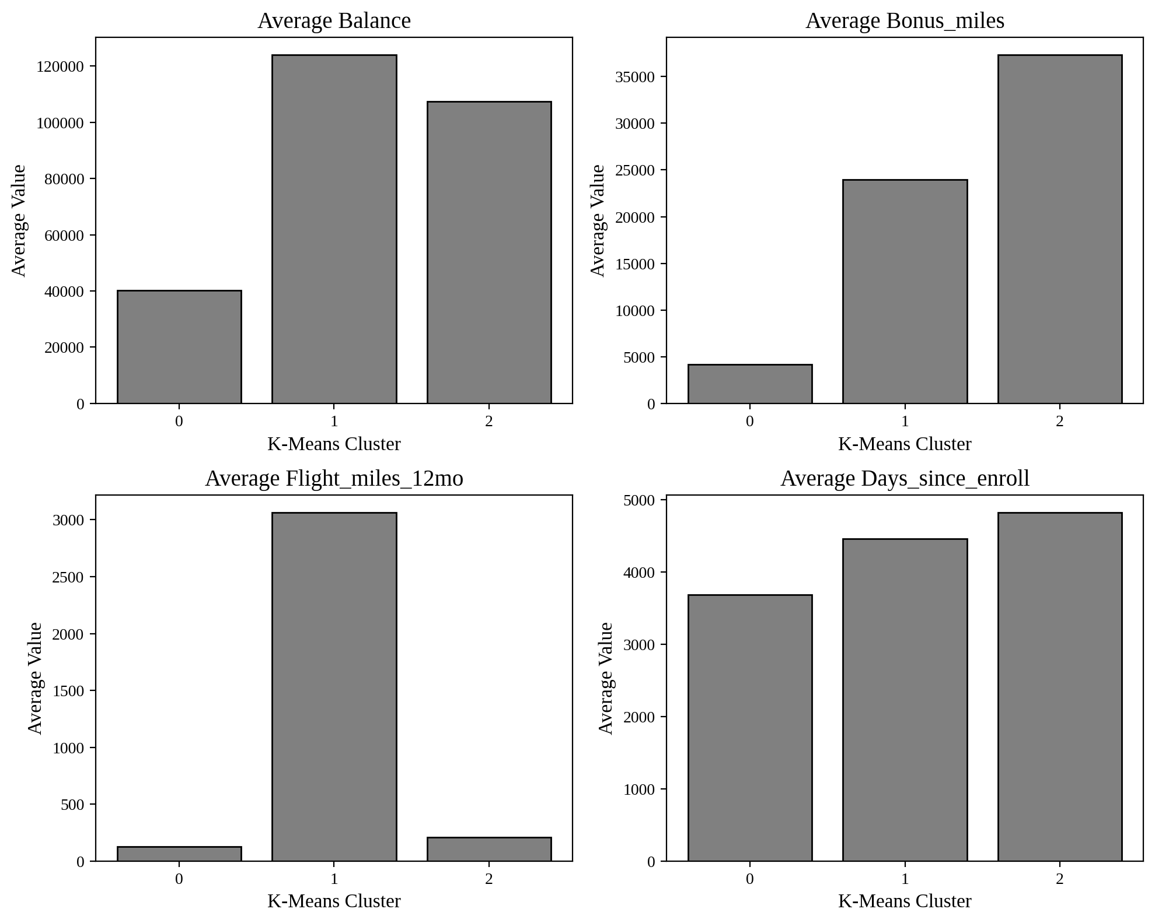
Figure 13: Average balance, bonus miles, flight miles and enrolment days of each K-Means cluster
Cluster 0: Low-activity customers (61.4 percent). These customers have the smallest balance (about 40,000 miles), earn very few bonus miles, almost never fly, and mostly use the basic card category. They also joined more recently (about 3,685 days). Only 23 percent have received an award. They are the largest group, and the airline can try to move them to more active use with simple offers.
Cluster 1: Frequent flyers (6.5 percent). This is the smallest group, but it flies far more than the others (about 3,063 flight miles and 8.8 flight transactions a year) and has the highest qualifying miles. They also have a high balance and the second highest award share (67 percent). These are the most valuable travellers and should get priority services such as lounge access and status benefits.
Cluster 2: Credit card and bonus earners (32.0 percent). These customers earn their miles mainly through credit cards and bonus transactions. They have the highest cc1 category (3.68), the highest bonus miles (about 37,000) and the longest membership (about 4,821 days), but they fly very little. The airline can target them with co-branded card offers and partner rewards to encourage them to also book flights.
The hierarchical result tells a similar story. Its three clusters have 2,837 customers (low-activity, average balance 45,306), 791 customers (long-standing card users with balance 128,433 and bonus miles 44,870) and 286 customers (frequent flyers with 2,781 flight miles and a 71 percent award share). The DBSCAN noise group of 174 customers has the highest averages in balance (161,368), qualifying miles (1,934) and flight miles (2,301). These are the heaviest users of the programme, and the airline may want to handle them individually.

7. Conclusion
The airline customers can be divided into three meaningful segments: low-activity customers, frequent flyers and credit card or bonus earners. K-Means and Hierarchical clustering with Ward linkage gave very similar results and similar silhouette scores of 0.331 and 0.334. DBSCAN gave a higher silhouette score of 0.594, but it placed almost every customer in one cluster and marked 4.4 percent of customers as noise, so it is more useful for spotting very high-value customers than for segmentation.
For business use, K-Means with three clusters is the most practical choice. It is simple, it gives well-sized groups and each group can be explained in plain words. The largest group (61.4 percent) is low-activity, the smallest group (6.5 percent) is the most valuable flyers, and the middle group (32.0 percent) earns miles mainly through cards. A limitation is that the silhouette score of about 0.33 shows that the groups overlap, and the two-dimensional plots capture only 48 percent of the variation in the data.

CASE STUDY 5: WINE QUALITY ASSESSMENT

1. Problem Statement
A wine company currently decides the quality of its wines only through sensory assessment, which means that experts taste the wine and give a score. Management wants to know whether laboratory measurements of the wine can explain the differences in quality and help in a more data-driven quality check.
The aim of this case study is to find which physicochemical characteristics are most strongly related to wine quality and to build a multiple linear regression model that predicts the quality score from the laboratory measurements. The case study has four tasks: statistical analysis, exploratory data analysis, predictive modelling and a business recommendation.

2. Dataset Description
The data is about the red and white variants of the Portuguese Vinho Verde wine. The red wine file has 1,599 samples and the white wine file has 4,898 samples. Both files were joined to form one dataset of 6,497 wines. There are no missing values. The quality score is the median of at least three expert ratings on a scale of 0 to 10. The 11 laboratory measurements are listed in Table 8.
Table 8: Physicochemical attributes in the wine dataset
Attribute | Mean | Std Dev | Min | Max
Fixed acidity | 7.215 | 1.296 | 3.800 | 15.900
Volatile acidity | 0.340 | 0.165 | 0.080 | 1.580
Citric acid | 0.319 | 0.145 | 0.000 | 1.660
Residual sugar | 5.443 | 4.758 | 0.600 | 65.800
Chlorides | 0.056 | 0.035 | 0.009 | 0.611
Free sulfur dioxide | 30.525 | 17.749 | 1.000 | 289.000
Total sulfur dioxide | 115.745 | 56.521 | 6.000 | 440.000
Density | 0.995 | 0.003 | 0.987 | 1.039
pH | 3.219 | 0.161 | 2.720 | 4.010
Sulphates | 0.531 | 0.149 | 0.220 | 2.000
Alcohol | 10.492 | 1.193 | 8.000 | 14.900
Quality (target) | 5.818 | 0.873 | 3 | 9

3. Methodology
- Data preparation: The two files were read and combined into one table. The data was checked for missing values (none) and repeated rows (1,177 repeated rows were found and kept, as the case study does not ask for their removal).
- Statistical analysis: The mean, median, mode, standard deviation and skewness were calculated for alcohol, volatile acidity and residual sugar. The coefficient of variation was used to compare variability, and the Pearson correlation was used to study alcohol and quality.
- Exploratory analysis: A histogram of quality, a box plot of alcohol for each quality score and a correlation heatmap were prepared.
- Modelling: A multiple linear regression model was trained on the 11 attributes. The data was split into 80 percent for training (5,197 wines) and 20 percent for testing (1,300 wines) with random_state = 42, so the same split can be repeated.
- Evaluation: MAE, MSE, RMSE and R-squared were calculated on the test set. Standardized coefficients were used to rank the predictors, and the Variance Inflation Factor (VIF) was used to check multicollinearity.

4. Statistical Findings

4.1 Task 1: Statistical Analysis
(a) Descriptive statistics. Table 9 gives the results for the three selected attributes.
Table 9: Descriptive statistics of alcohol, volatile acidity and residual sugar
Attribute | Mean | Median | Mode | Std Dev | Skewness
Alcohol | 10.492 | 10.30 | 9.50 | 1.193 | 0.566
Volatile acidity | 0.340 | 0.29 | 0.28 | 0.165 | 1.495
Residual sugar | 5.443 | 3.00 | 2.00 | 4.758 | 1.435

For all three attributes, the mean is larger than the median and the median is larger than or close to the mode, and the skewness is positive. This means each attribute is right skewed, with a tail of high values. Volatile acidity (1.495) and residual sugar (1.435) are strongly skewed, while alcohol (0.566) is only moderately skewed. In simple terms, most wines have low volatile acidity and low sugar, and a few wines have very high values.
(b) Relative variability. The standard deviation cannot be compared directly because the attributes have different units and sizes. The coefficient of variation (CV), which is the standard deviation divided by the mean, removes this problem. Table 10 shows the values.
Table 10: Coefficient of variation of the selected attributes
Attribute | Mean | Std Dev | CV (%)
Alcohol | 10.492 | 1.193 | 11.37
Volatile acidity | 0.340 | 0.165 | 48.47
Residual sugar | 5.443 | 4.758 | 87.41

Residual sugar has the greatest relative variability with a CV of 87.41 percent, followed by volatile acidity at 48.47 percent. Alcohol is the most consistent with a CV of only 11.37 percent. Wines differ a lot in sweetness, but they are much more similar in alcohol content.
(c) Alcohol and quality. The Pearson correlation coefficient between alcohol and quality is r = 0.4443, and the p-value is practically zero (about 1.5 x 10^-312). The direction is positive, so wines with more alcohol tend to get higher quality scores. The strength is moderate. Alcohol alone explains about 19.7 percent of the variation in quality (r squared = 0.197). The relationship is statistically very significant, but it is not strong enough to predict quality on its own.

4.2 Task 2: Exploratory Data Analysis
(a) Histogram of quality scores.
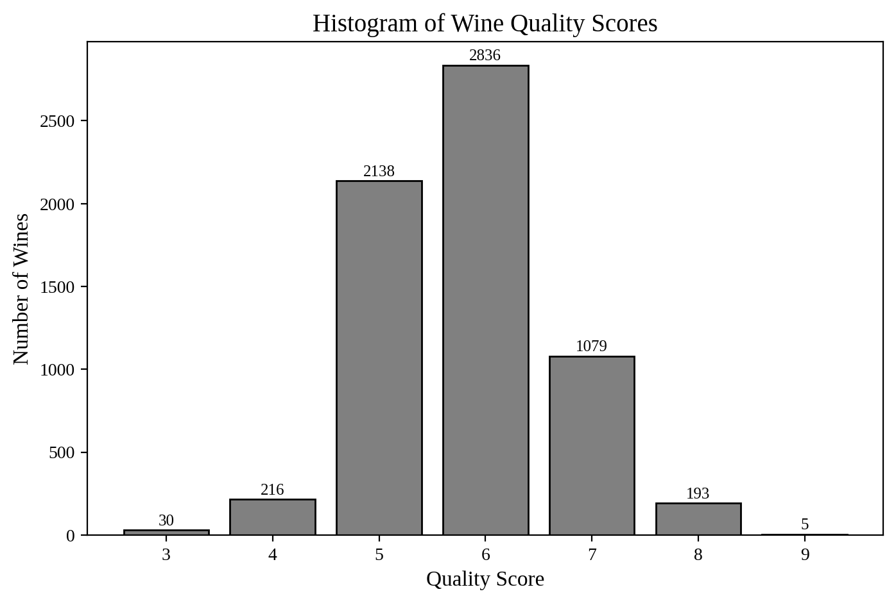
Figure 14: Histogram of wine quality scores
Figure 14 shows that the scores range from 3 to 9, but most wines are in the middle. Quality 6 is the most common (2,836 wines, 43.65 percent), followed by quality 5 (2,138 wines, 32.91 percent) and quality 7 (1,079 wines, 16.61 percent). Together, scores 5, 6 and 7 cover about 93 percent of all wines. Very poor wines (quality 3, only 30 wines) and excellent wines (quality 9, only 5 wines) are very rare. The shape is close to a bell curve with a small positive skewness of 0.19. The classes are clearly unbalanced, which makes it hard for a model to learn about the extreme scores.
(b) Box plot of alcohol by quality.
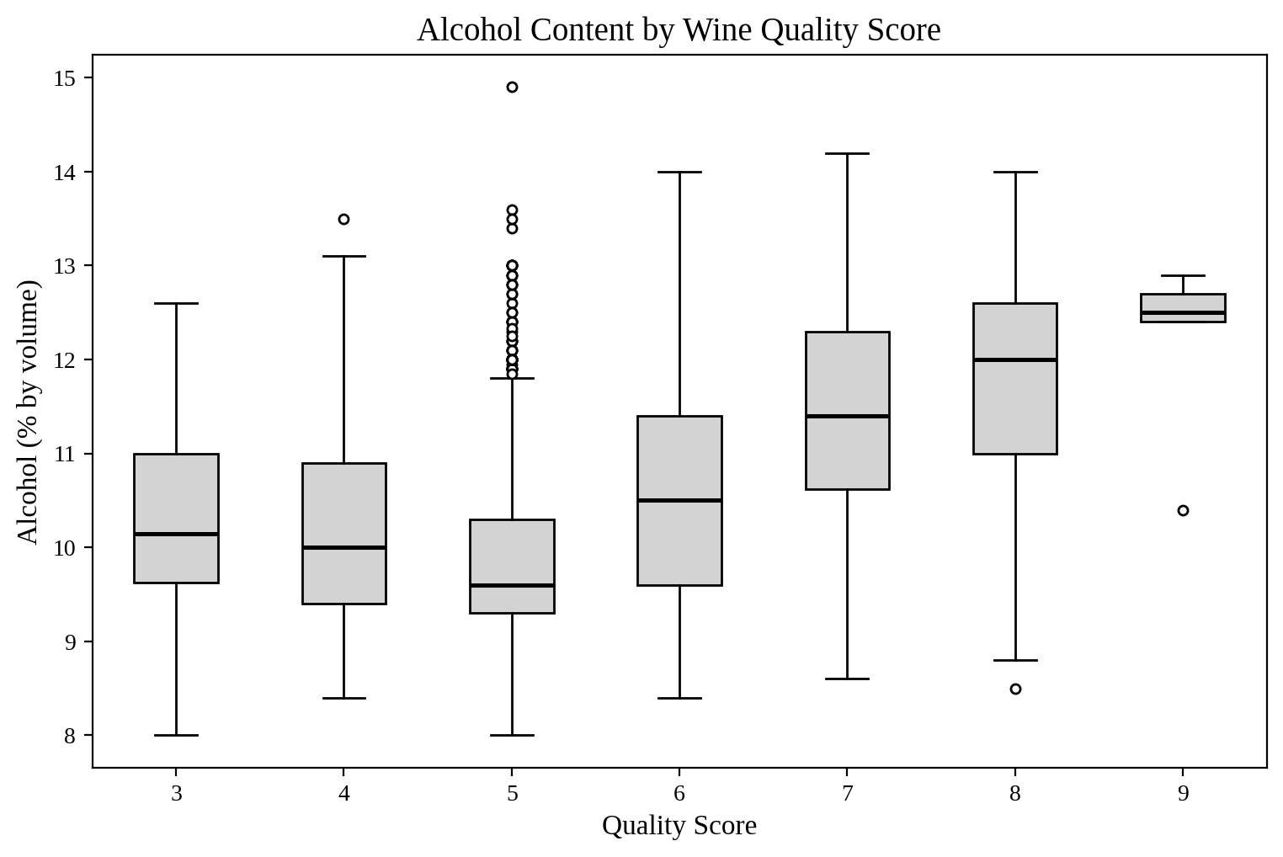
Figure 15: Box plot of alcohol content for each wine quality score
Table 11: Alcohol content for each quality score
Quality | Wines | Median Alcohol | Mean Alcohol
3 | 30 | 10.15 | 10.22
4 | 216 | 10.00 | 10.18
5 | 2,138 | 9.60 | 9.84
6 | 2,836 | 10.50 | 10.59
7 | 1,079 | 11.40 | 11.39
8 | 193 | 12.00 | 11.68
9 | 5 | 12.50 | 12.18

Figure 15 and Table 11 show a clear difference. From quality 5 onwards, the median alcohol rises steadily: 9.60 for quality 5, 10.50 for quality 6, 11.40 for quality 7, 12.00 for quality 8 and 12.50 for quality 9. Wines with quality 3 and 4 do not follow the pattern, as their median alcohol (about 10) is higher than that of quality 5. This is probably because there are few wines in these groups. Potential outliers were counted with the 1.5 x IQR rule. Quality 5 has the most, with 55 high-alcohol outliers shown as dots above its box. The other groups have at most one outlier each. These outliers are real measurements, not errors, so they were not removed.
(c) Correlation heatmap.
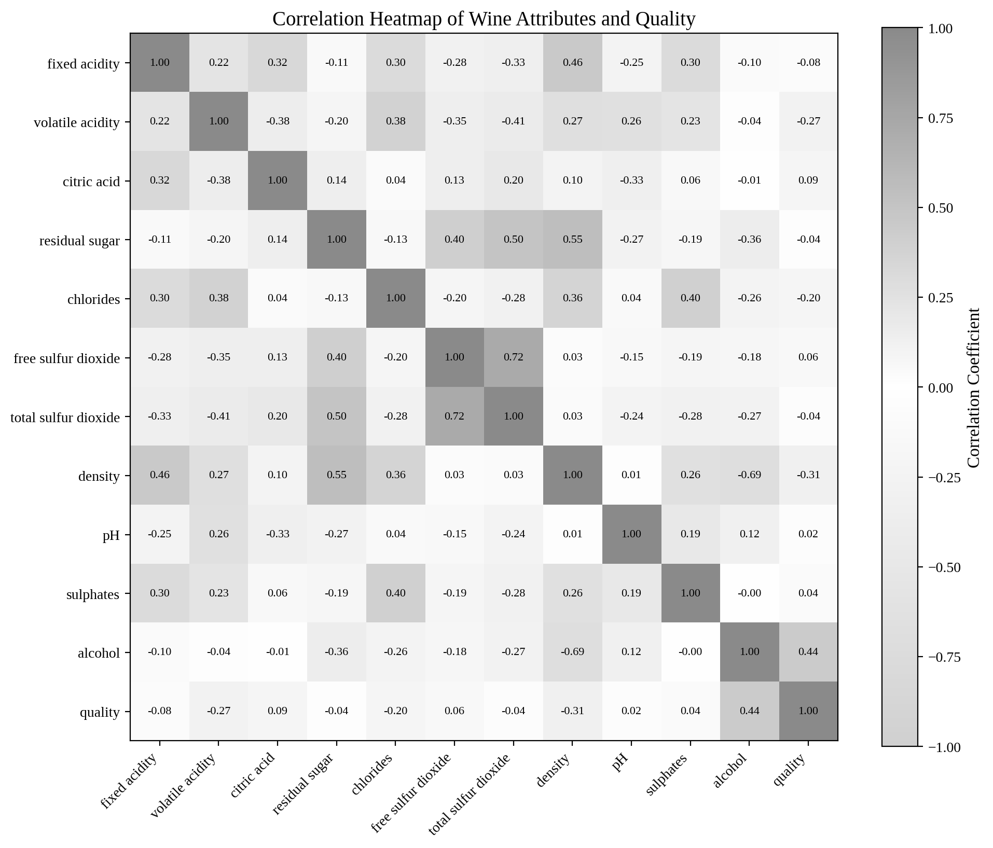
Figure 16: Correlation heatmap of the wine attributes and quality
Figure 16 shows how the attributes relate to each other and to quality. Along the quality row, alcohol has the strongest positive link, and density and volatile acidity have negative links. There are also strong links between the attributes themselves: density and alcohol (-0.69), free and total sulfur dioxide (0.72), density and residual sugar (0.55) and total sulfur dioxide and residual sugar (0.50). These are important for the regression part, because they point towards multicollinearity.
(d) Two attributes most associated with quality. Table 12 ranks the attributes by the absolute value of their correlation with quality.
Table 12: Correlation of each attribute with quality (ranked by absolute value)
Rank | Attribute | Correlation | Direction
1 | Alcohol | 0.4443 | Positive
2 | Density | -0.3059 | Negative
3 | Volatile acidity | -0.2657 | Negative
4 | Chlorides | -0.2007 | Negative
5 | Citric acid | 0.0855 | Positive
6 | Fixed acidity | -0.0767 | Negative
7 | Free sulfur dioxide | 0.0555 | Positive
8 | Total sulfur dioxide | -0.0414 | Negative
9 | Sulphates | 0.0385 | Positive
10 | Residual sugar | -0.0370 | Negative
11 | pH | 0.0195 | Positive

The two attributes most strongly associated with quality are alcohol (r = 0.4443, positive) and density (r = -0.3059, negative). Higher alcohol goes with higher quality, and higher density goes with lower quality. However, density and alcohol are themselves strongly and negatively related (-0.69), because alcohol is lighter than water, so wines with more alcohol are less dense. Much of the effect of density may therefore be the alcohol effect in another form. Volatile acidity (-0.2657) is a close third.

5. Model Evaluation

5.1 Task 3: Predictive Modelling
(a, b, c) Model and test set metrics. A multiple linear regression model with all 11 attributes was trained on 5,197 wines and tested on 1,300 wines. The test results are in Table 13.
Table 13: Performance of the regression model on the test set
Metric | Value | Meaning
MAE | 0.5659 | On average, the prediction is off by about 0.57 quality points
MSE | 0.5467 | Average of the squared errors
RMSE | 0.7394 | Typical error of about 0.74 quality points; large errors count more
R-squared | 0.2598 | The model explains about 26 percent of the variation in quality

The training R-squared is 0.2993, which is close to the test value of 0.2598, so the model is not overfitting. Its weakness is that it simply does not capture enough of the variation. To judge the errors, two more checks were made. About 53.9 percent of the test wines were predicted within 0.5 points of the actual score, and 84.2 percent were predicted within 1.0 point. As a baseline, a model that always predicts the average quality has an RMSE of 0.8596, so the regression model improves the error by only 14.0 percent.
(d) Influential predictors and multicollinearity. Raw coefficients cannot be compared because the attributes are measured on different scales. Standardized coefficients put them on the same scale, so Table 14 can be used to compare their influence.
Table 14: Standardized coefficients and VIF of the 11 predictors
Attribute | Raw Coefficient | Standardized Coefficient | VIF
Alcohol | 0.2707 | 0.3678 | 4.78
Residual sugar | 0.0459 | 0.2514 | 7.23
Volatile acidity | -1.3508 | -0.2499 | 1.95
Density | -58.9451 | -0.2023 | 15.91
Total sulfur dioxide | -0.0027 | -0.1706 | 2.94
Free sulfur dioxide | 0.0070 | 0.1398 | 2.14
Sulphates | 0.8084 | 0.1371 | 1.54
Fixed acidity | 0.0790 | 0.1161 | 4.90
pH | 0.4828 | 0.0879 | 2.54
Citric acid | -0.1438 | -0.0237 | 1.61
Chlorides | -0.3328 | -0.0132 | 1.63

By the size of the standardized coefficient, the two most influential predictors are alcohol (0.3678) and residual sugar (0.2514). Volatile acidity (-0.2499) is almost tied with residual sugar, so it is nearly as important.
Multicollinearity must be checked before trusting these effects. A VIF above 5 is a warning and above 10 is serious. Density has a VIF of 15.91, which is serious, and residual sugar has a VIF of 7.23, which is a warning. Alcohol (4.78) and fixed acidity (4.90) are just below the warning level. The reason is that density is strongly tied to alcohol (-0.69) and to residual sugar (0.55), so the model cannot separate their effects cleanly.
This changes how the result should be read. Residual sugar on its own has almost no correlation with quality (-0.037), yet its coefficient in the model is positive and large. This sign change is a typical effect of multicollinearity. Once density is in the model, residual sugar is acting as an adjustment for density and is not a true sign that sugar improves quality. In the same way, the large negative coefficient of density (-58.9) is unstable. The effect of alcohol is more reliable, since it agrees with its simple correlation and its box plot. Volatile acidity is also reliable because its VIF is low (1.95) and its sign agrees with its correlation.
(e) Predicted versus actual scores. Figure 17 compares the predicted and the actual scores for the test set.
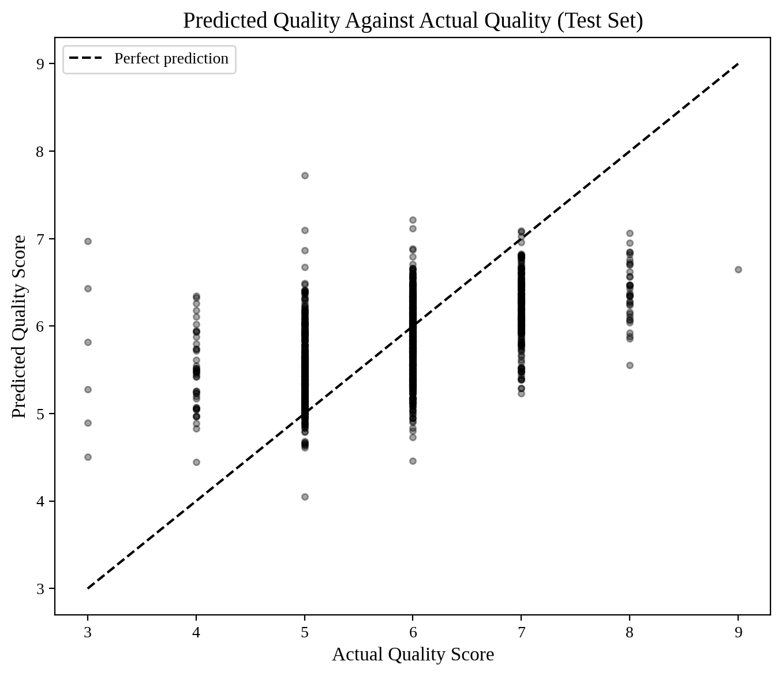
Figure 17: Predicted quality against actual quality on the test set
If the model were perfect, all points would lie on the dashed line. Instead, the points form a wide cloud. For every actual score, the predictions spread over a range of about two points. The model also pulls its predictions towards the middle. The average prediction for wines with a true score of 3 is 5.65, and for a true score of 9 it is 6.65. Poor wines are predicted too high and excellent wines are predicted too low, so the model cannot separate the extremes well. The ranking is still right in general, since the average prediction rises from 5.51 for quality 5 to 6.20 for quality 7 and 6.39 for quality 8.
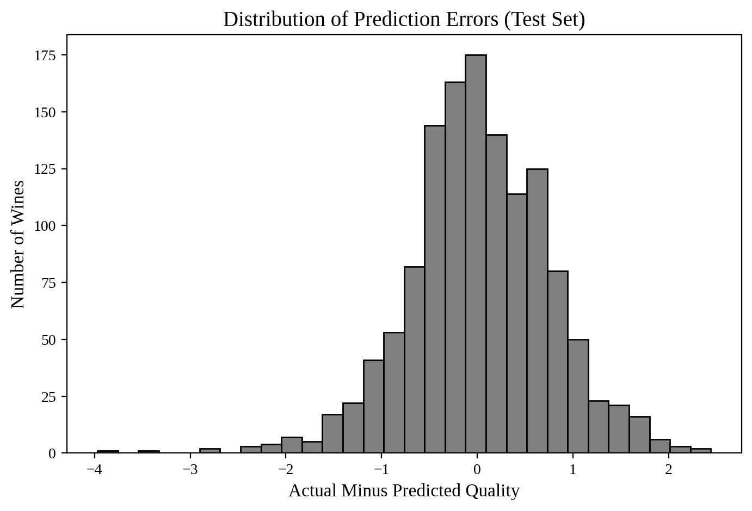
Figure 18: Distribution of prediction errors on the test set
Figure 18 shows that the errors are centred around zero (mean error 0.02), so the model is not biased up or down. But the spread is wide, and some errors are large: the biggest over-prediction is 3.97 points and the biggest under-prediction is 2.44 points. The main limitations of the model are the following.
- Linear form: It assumes a straight-line effect for every attribute, but wine quality may depend on interactions and curved effects.
- Few extreme wines: There are very few wines of quality 3, 4, 8 and 9, so the model learns little about them and predicts values near the average.
- Multicollinearity: Density, residual sugar and alcohol are tied together, which makes the individual coefficients unreliable.
- Subjective target: Quality comes from human taste scores, which carry personal opinion and cannot be explained fully by chemistry.

6. Business Decision-Making

6.1 Task 4: Recommendation to the Company
(a) Measurements to focus on during screening. The two measurements recommended are alcohol and volatile acidity. Alcohol has the strongest link with quality (r = 0.4443), a strong standardized coefficient (0.3678) and a clear rise in the box plots from quality 5 to quality 9. Volatile acidity has a clear negative link (r = -0.2657), a strong standardized coefficient (-0.2499) and a low VIF of 1.95, so its effect is dependable. In practical terms, wines with low alcohol or high volatile acidity should be flagged for closer checking. Density and residual sugar were not chosen, because their effects are tangled with alcohol and with each other.
(b) Can the model replace sensory evaluation? No, the model is not reliable enough to replace sensory evaluation. The test results give the reasons:
- R-squared is only 0.2598, so about 74 percent of the variation in quality is not explained by the 11 measurements.
- RMSE is 0.7394 and MAE is 0.5659. On a scale where most wines score between 5 and 7, an error of this size can move a wine into a different quality level.
- Only 53.9 percent of wines are predicted within 0.5 points, so nearly half of the predictions are further away.
- The RMSE is only 14 percent better than simply guessing the average score every time.
- The model fails for the most important wines. Poor wines are predicted as average, and excellent wines are also predicted as average.
The model is still useful as a support tool. It can be used for a first screening of wines in the laboratory, so that wines with unusual measurements are sent to the tasting panel, while the final decision on quality remains with the human experts.
(c) Limitations of the dataset and the approach. Two main limitations are listed below.
- Limitation of the dataset: The quality score is a median of expert opinions, which is subjective, and the scores are unbalanced, with 93 percent of the wines scored between 5 and 7. The data also comes from only one region (Vinho Verde from Portugal), has 1,177 repeated rows and does not include important factors such as grape type, brand or price. The red and white wines were also combined, although they can have different chemistry.
- Limitation of the approach: A single linear regression model was used, and it cannot capture curved or interacting effects. Several predictors are strongly correlated (density has a VIF of 15.91), so the individual coefficients are unstable. The quality score was also treated as a continuous number, although it is really an ordered category. Methods such as random forests or classification models, and separate models for red and white wines, could give better results.

7. Conclusion
The case study shows that the physicochemical measurements are related to wine quality, but only partly. Alcohol is the most important measurement and is positively linked to quality, while density, volatile acidity and chlorides are negatively linked. The multiple linear regression model reached an R-squared of 0.2598 and an RMSE of 0.7394 on the test set. This means it explains only about a quarter of the variation in quality. The company can use alcohol and volatile acidity as simple early warning checks in a laboratory screening process, but the model should support, and not replace, the sensory evaluation by expert tasters.

REFERENCES
1. P. Cortez, A. Cerdeira, F. Almeida, T. Matos and J. Reis. Modeling wine preferences by data mining from physicochemical properties. Decision Support Systems, Elsevier, 47(4):547-553, 2009.
2. East-West Airlines dataset. Based on real business data, with company names changed. Copyright 2016, Galit Shmueli and Peter Bruce.
3. F. Pedregosa et al. Scikit-learn: Machine learning in Python. Journal of Machine Learning Research, 12:2825-2830, 2011.

