EVIDENCE AND IMPLICATIONS OF A
K-SHAPED ECONOMY
Research Report — Outline
Team Zeta
UCSD Rady School of Management — Master of Quantitative Finance
Capstone Sponsor: Artisan Partners
August 2026
Repository: github.com/dbicknell22/Capstone — all code, data, and output referenced in this outline is version-controlled and reproducible.

I. Executive Summary
Baby Boomers hold 52% of U.S. household net worth with only 30% of households, and this generational imbalance is beginning to unwind as Boomers retire and shift assets toward safety. This report tests whether that shift is measurable, whether it predicts asset prices or economic growth, and whether it can be turned into an investable strategy. Four questions anchor the analysis; four answers survived rigorous, repeated cross-checking:
- Does K, or BEDI, explain asset prices? Only fixed income. Three independently-built signals — K, BEDI, and the isolated Boomer rotation signal — each predict 10-Year Treasury returns one quarter out. No broad effect on equities, currencies, gold, or REITs.
- Does it explain economic growth? No, with one caveat. Unemployment and GDP are clean nulls; industrial production is a borderline, not-quite-significant read (p=0.057).
- Are we heading into uncharted territory? Yes, by this measure. Boomers’ wealth-concentration ratio (1.73×) already exceeds the Silent Generation’s full historical peak (1.66×) — and Boomers have not finished retiring.
- Is there an alpha opportunity? Yes — in bonds, not stocks. Three independently-built signals, each turned into an actual backtested Treasury-timing strategy, materially reduce volatility and drawdown versus buy-and-hold. The original long/short equity-sector strategy the sponsor’s thesis proposed, by contrast, lost money and shows no statistical relationship to any of the signals that do work.

Scorecard across all 24 tests run in this project: 4 robust regression hits (all fixed income) • 3 backtested strategies beat buy-and-hold • 2 borderline • 15 clean/fragile nulls • 1 result failed an outlier check • 1 built strategy lost money.

II. Introduction & Research Questions

Background
Since the COVID-19 pandemic, market commentators have described the U.S. economy as “K-shaped”: a bifurcation in which upper-income, asset-owning households prospered while lower-income households fell behind. Team Zeta was asked by Artisan Partners to test whether this divergence is measurable in public data, whether it explains asset prices or growth, and whether the coming Baby Boomer retirement wave — the largest, wealthiest cohort in U.S. history beginning to draw down and de-risk its holdings — represents a new, unprecedented stress on markets.

The original brief
- Does the K-shape explain asset prices? Regress stock, bond, currency, and gold returns on a wealth/income/consumer divergence index, contemporaneous and lagged.
- Does it explain economic growth? Model unemployment, GDP, and industrial production as a function of the same index.
- Are we heading into uncharted territory? Has Boomer wealth concentration, as they retire, already exceeded anything the historical record has seen?

The question that emerged
Once the K→Treasury relationship proved robust, a fourth, sponsor-relevant question followed naturally: does this translate into an actual, investable alpha opportunity — not just a statistically significant coefficient? Sections VIII and IX address this directly.

Discipline applied throughout
- Real data only. No fabricated results — where data was unavailable in this project’s sandboxed research environment, that is stated explicitly rather than approximated.
- Every combined regression (current value + lags together) was re-tested as two separate models — contemporaneous-only and lagged-only — to rule out multicollinearity false positives, a failure mode that produced misleading results for the S&P 500 and GDP tests before being caught.
- Every result that cleared a 5% or 10% significance threshold was swept across lag lengths 1–4 and, where relevant, re-tested after dropping the most extreme outlier quarters using an objective, pre-specified rule (not hand-picked dates).

III. Data & Methodology

Data sources
Source | Series | Frequency
Federal Reserve Distributional Financial Accounts (DFA) | Net worth, assets, and household counts by generation, age, income, and wealth percentile | Quarterly, 1989–present
Atlanta Fed Wage Growth Tracker | Wage growth by income quartile | Quarterly
University of Michigan Surveys of Consumers | Consumer sentiment by income tercile | Quarterly
CRSP / WRDS | Daily total returns for sector/style ETFs and benchmark | Daily → resampled
FRED (Federal Reserve Economic Data) | GDP, unemployment rate, industrial production | Quarterly / monthly
REIT basket (team-supplied) | Quarterly REIT total return series | Quarterly, 1990–2024

The K-Index
A composite spread between the top and bottom of the wealth distribution, built from three pillars, each z-scored and averaged:
- Wealth pillar: log(Top 10% net worth per household) − log(Bottom 50% net worth per household)
- Income pillar: top-quartile minus bottom-quartile wage growth
- Consumer pillar: top-tercile minus bottom-tercile consumer sentiment
Validated three ways — equal-weight, first principal component, and inverse-variance weighting — all in close agreement.

BEDI (Boomer Equity Displacement Index)
Combines two DFA-derived components, sign-aligned so BEDI rises when Boomers de-risk and concentration widens together:
- Rotation signal: Baby Boomers’ equity share of assets minus their safe-asset share (deposits, money-market funds, bonds, annuities) — also tested on its own, isolated from BEDI
- K-shape gap: (Top 1% + next 1%) minus Bottom 50% share of net worth, economy-wide (not Boomer-specific)
A parallel real-estate rotation signal (Boomer real-estate share of assets) was built to test the most literal “are Boomers selling their homes” hypothesis.

Regression methodology
- Contemporaneous and lagged relationships are always tested as separate regressions, never combined into one “current + 4 lags” model.
- Lag length is swept from 1 to 4 quarters; a result significant at only one lag length is treated as a red flag, not a finding.
- Newey-West (HAC) robust standard errors are used throughout to account for serial correlation in quarterly financial series.
- Any promising result is re-tested after dropping outlier quarters, defined objectively as |value| exceeding 2 standard deviations — never hand-picked dates.

Backtest methodology
- Signals used in a backtest are point-in-time (expanding-window) z-scores, computed using only data available up to and including each quarter — a stricter, no-look-ahead standard than the full-sample z-scores used in the regressions themselves.
- Rule: hold the asset when the signal (observed at the end of the prior quarter) is positive; hold cash (0% return) otherwise. Rebalanced quarterly.
- Every backtest is stress-tested by inverting the signal (long only when the signal is negative) — a real signal should perform much worse when inverted, not similarly.

IV. Findings Overview
Twenty-four distinct tests were run across two model tracks (a K-Index/macro regression model and a Pillar 2 demographic/BEDI model). The scorecard below summarizes every one of them; the sections that follow detail each row.
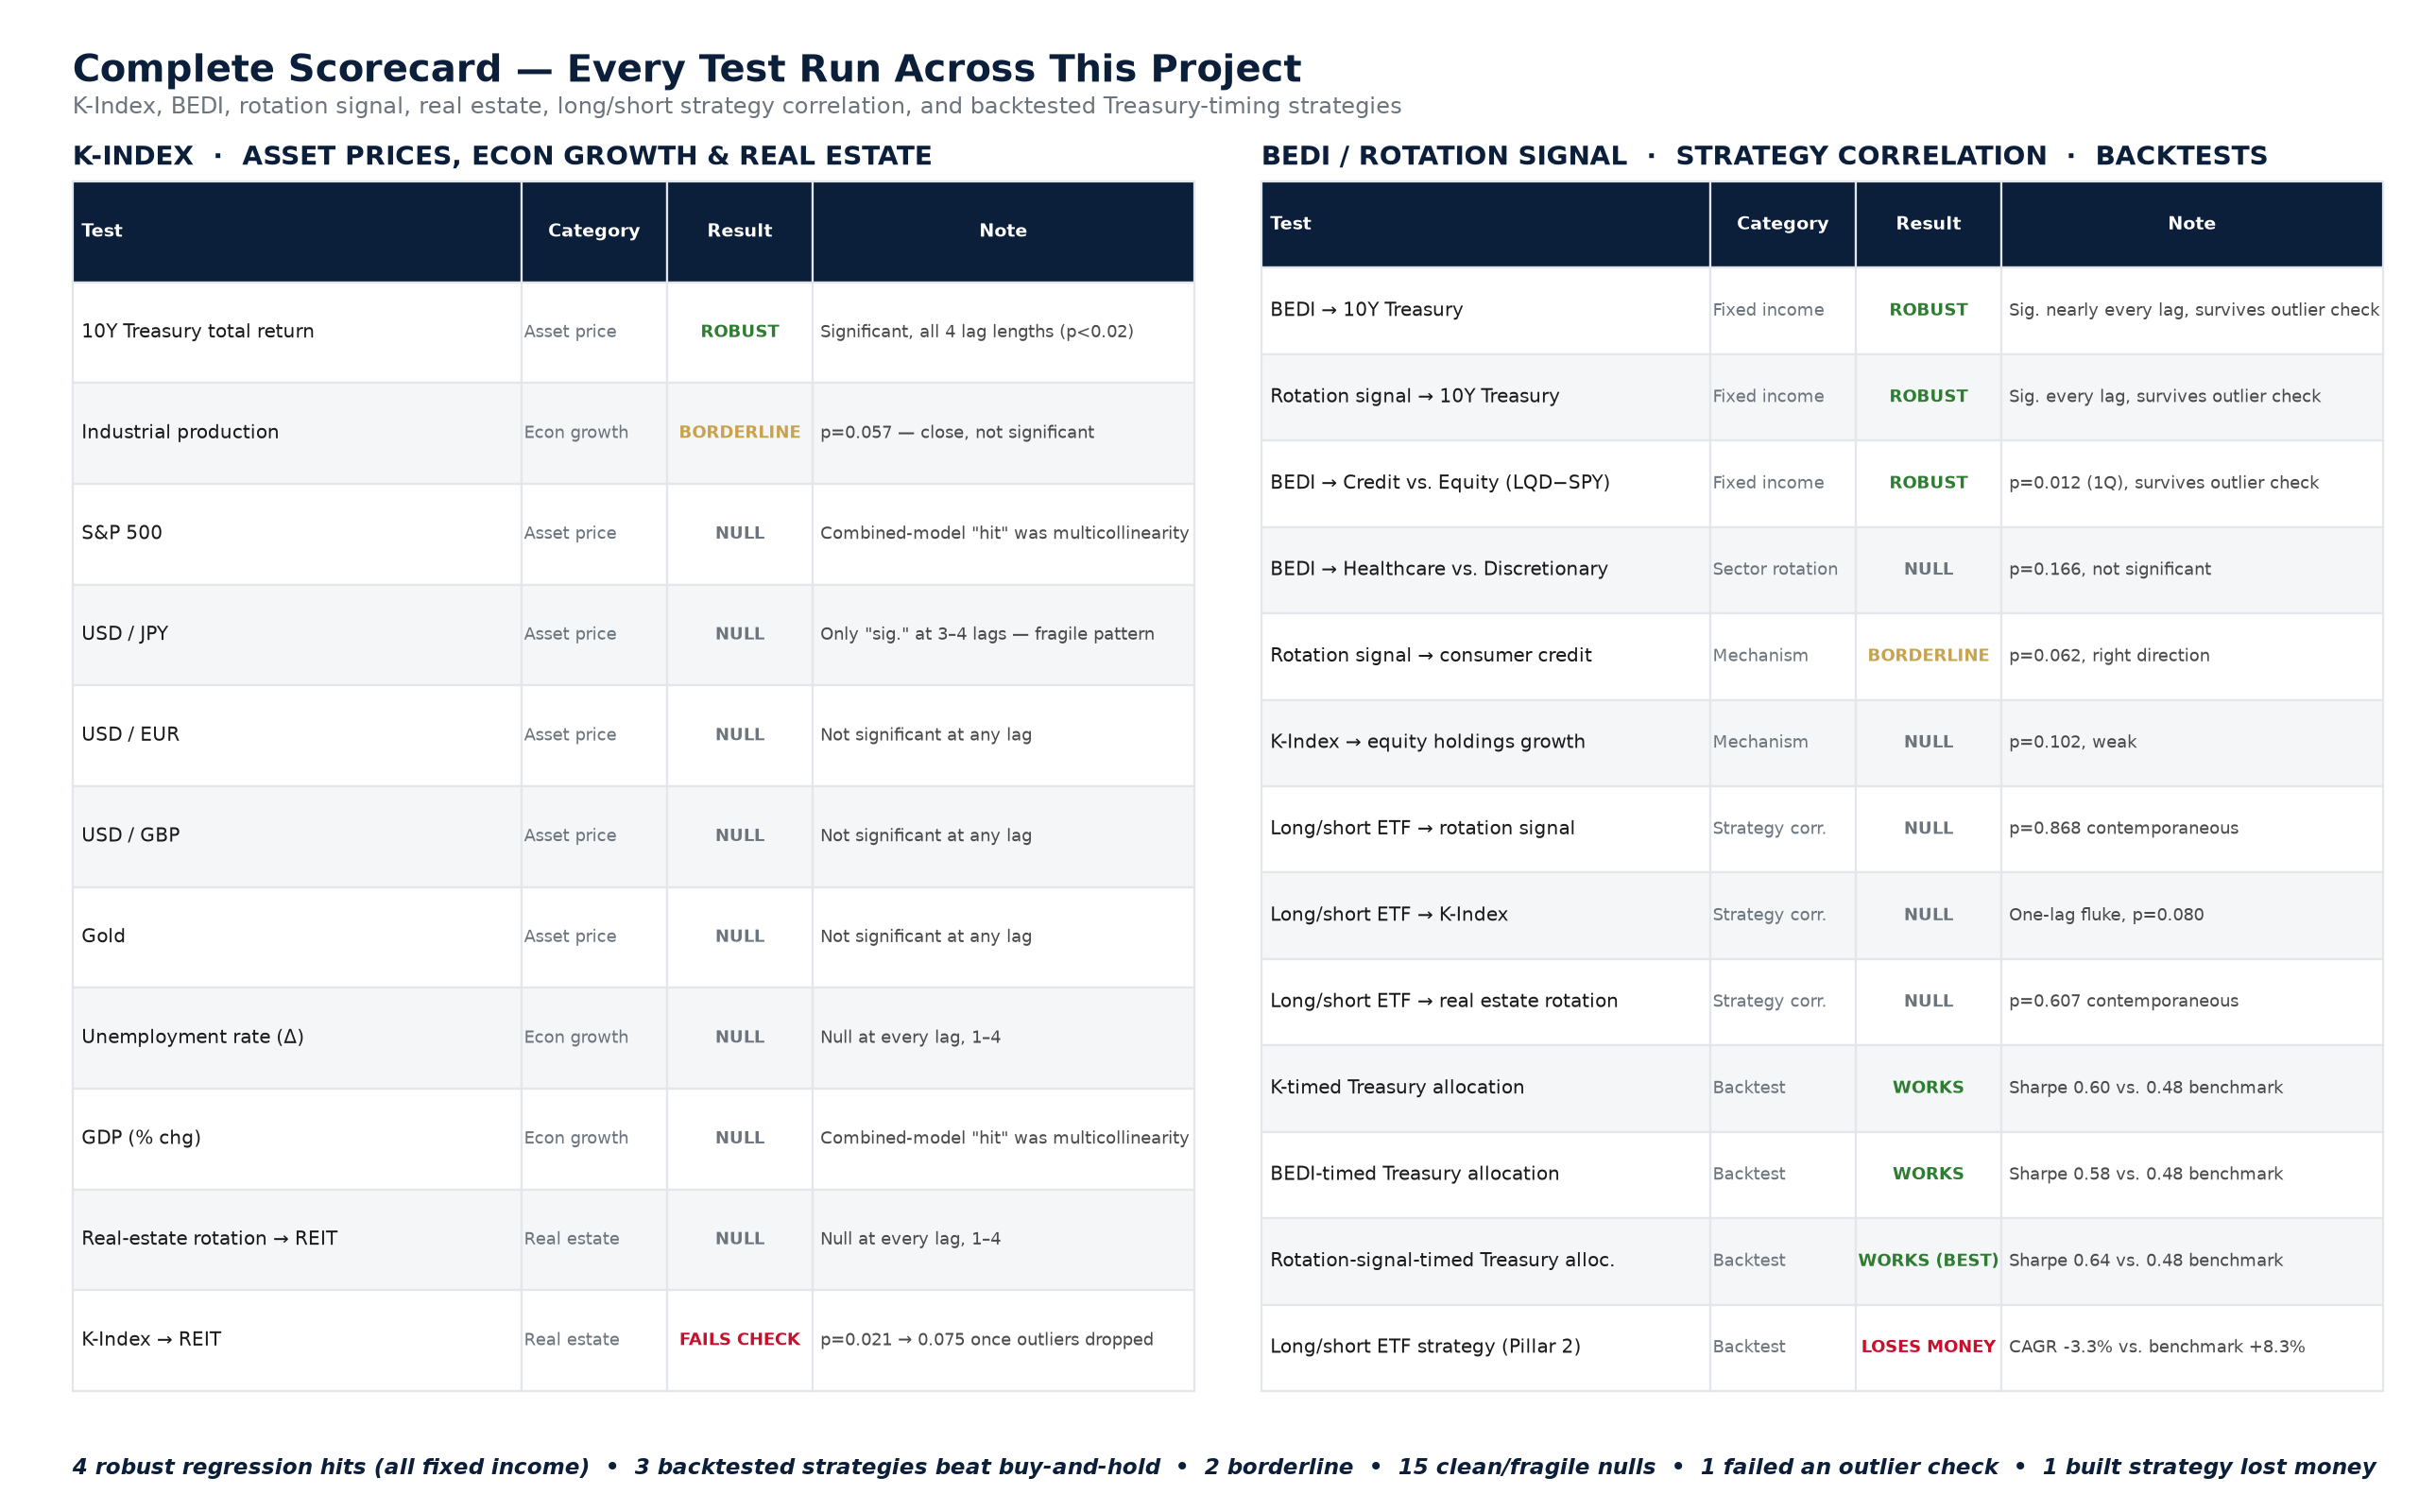
Figure 1. Complete scorecard — every regression, mechanism test, strategy-correlation check, and backtest run in this project.

V. Findings — The Boomer Wealth Dominance Backdrop
Before testing any predictive relationship, the underlying premise was confirmed directly from Fed DFA data: Baby Boomers are, by a wide margin, the dominant holders of U.S. household wealth and real estate.
- Baby Boomers hold 52% of all U.S. household net worth, with only 30% of households (concentration ratio 1.73×).
- Boomers + the Silent Generation hold 49% of household real-estate value, with only 37% of households.
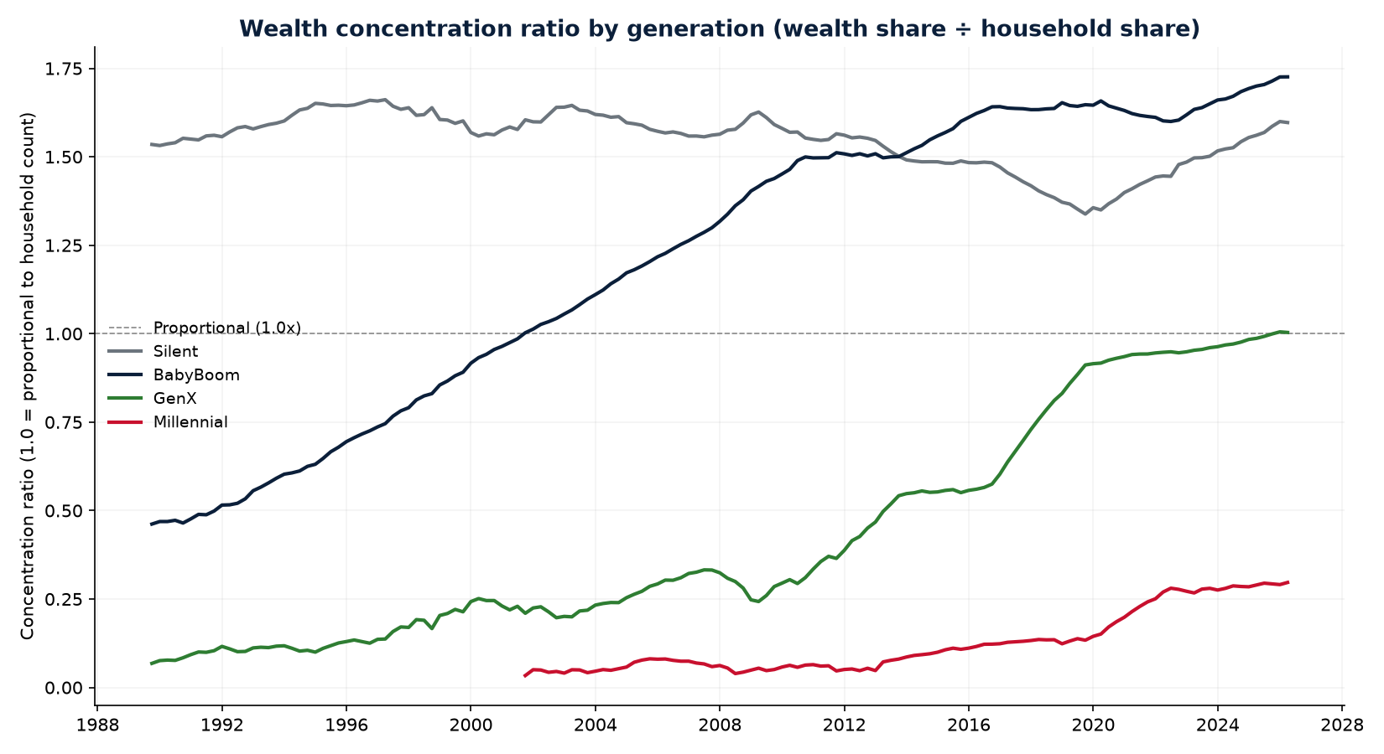
Figure 2. Wealth concentration ratio by generation (wealth share ÷ household share), 1989–2026. A ratio above 1.0 means a generation holds more wealth than its household share alone would imply.

VI. Findings — Does the K-Shape Explain Asset Prices & Growth?
The advisor’s original request: regress nine target series — six asset-price series and three growth series — on K, contemporaneously and with lags 1–4.
Target series | Category | Result | Note
10Y Treasury total return | Asset price | ROBUST | Significant, all 4 lag lengths (p<0.02)
Industrial production | Econ growth | BORDERLINE | p=0.057 — close, not significant
S&P 500 | Asset price | NULL | Combined-model “hit” was multicollinearity
USD/JPY | Asset price | NULL | Only “sig.” at 3–4 lags — fragile pattern
USD/EUR, USD/GBP, Gold | Asset price | NULL | Not significant at any lag
Unemployment rate (Δ) | Econ growth | NULL | Null at every lag, 1–4
GDP (% chg) | Econ growth | NULL | Combined-model “hit” was multicollinearity

The one robust result: K → 10Y Treasury
- Driven by K lagged one quarter, not the contemporaneous value (contemporaneous p=0.26).
- Coefficient ranges +0.013 to +0.030 depending on specification; significant at every lag length 1–4, unlike every other series tested.
- Economic read: widening wealth divergence precedes a flight-to-quality bid in Treasuries, one quarter later.

Two multicollinearity traps caught
The S&P 500 and GDP tests both showed a significant coefficient in the combined “current + 4 lags” model, but the effect vanished once contemporaneous and lagged terms were tested separately — K correlates 0.92 with its own prior-quarter value, and a combined model can mistake that autocorrelation for a real relationship. This is precisely the failure mode the project’s separated-regression discipline exists to catch.

VII. Findings — BEDI, the Rotation Signal, and Real Estate

Corroboration: BEDI and the rotation signal also predict Treasury returns
Neither BEDI nor the isolated rotation signal had been tested against the Treasury directly until this project closed that gap. Both clear the same “robust” bar as K itself:
Predictor | Contemp. | n=1 | n=2 | n=3 | n=4 | Ex-outliers
BEDI (expanding) | 0.158 | 0.012 | 0.021 | 0.029 | 0.060 | 0.042
Rotation signal alone | 0.362 | 0.015 | 0.020 | 0.015 | 0.034 | 0.016

- Both are null contemporaneously and significant only with a lag — the effect is Boomers’ behavior this quarter predicting Treasury returns next quarter.
- Both survive dropping the four most extreme Treasury-return quarters (2008Q4, 2010Q2, 2011Q3, 2020Q1) — a meaningfully cleaner result than the REIT/K-Index contemporaneous reading below, which did not survive the same check.
- BEDI was also tested against a credit-vs-equity pair (investment-grade bonds minus the S&P 500): significant at both 1- and 2-quarter horizons (p=0.012, p=0.048), and survives outlier removal.

Real estate: one clean null, one result that did not survive scrutiny
Test | Contemp. | Result | Note
Real-estate rotation → REIT | 0.859 | NULL | Null at every lag, 1–4 — no near-miss
K-Index → REIT | 0.021 | FAILS CHECK | p=0.021 → 0.075 once the 6 most extreme quarters (2008–09 crisis, 2020 COVID crash) are dropped

Read plainly: Boomers’ real-estate holdings do not predict REIT returns at any horizon, and K’s apparent contemporaneous relationship with REITs turned out to be two series both reacting to the same macro shocks — not K leading REITs. Consistent with the rest of this project, the real signal is specific to rate-sensitive fixed income, not real estate.

VIII. Findings — From Signals to Strategies: Backtests
A regression coefficient is not a trading strategy. Each of the three Treasury-predicting signals was turned into an actual, investable rule: hold the 10-Year Treasury (via the IEF ETF) when the signal was positive last quarter; hold cash otherwise.
Strategy | CAGR | Ann. Vol | Sharpe | Max DD | Time in mkt.
K-timed | 3.34% | 5.74% | 0.60 | -6.65% | 64.1%
BEDI-timed | 3.69% | 6.62% | 0.58 | -6.94% | 89.1%
Rotation-signal-timed | 3.36% | 5.41% | 0.64 | -6.53% | 53.3%
Benchmark (buy & hold) | 3.28% | 7.25% | 0.48 | -21.13% | 100%

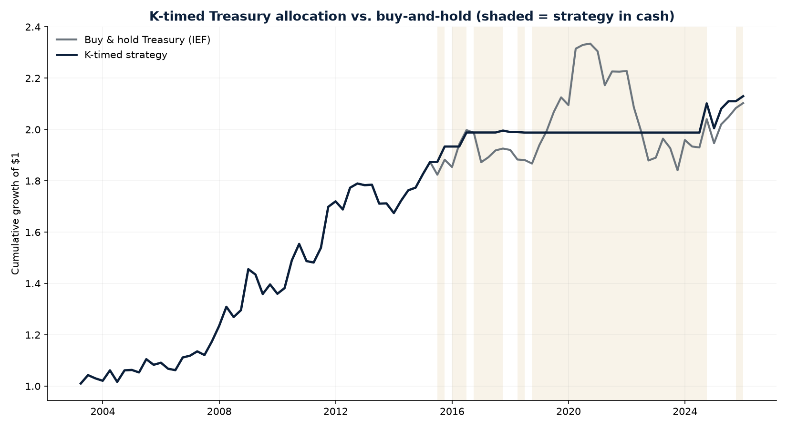
Figure 3. K-timed Treasury allocation vs. buy-and-hold, N=92 quarters (2003–2025). Shaded bands mark quarters the strategy held cash.
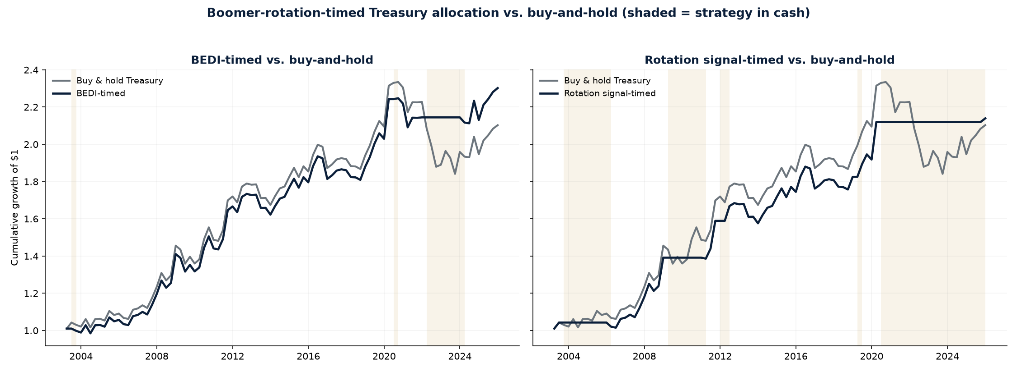
Figure 4. BEDI-timed and rotation-signal-timed Treasury allocation vs. buy-and-hold.

Stress tests, before trusting any of this
- Inverting each signal (long only when the signal was negative) produces dead-money-to-negative results — confirming the direction reflects real information, not a generic “cash reduces volatility” artifact.
- The rotation-signal-timed and K-timed strategies each sit out 4 of the 5 worst Treasury quarters in-sample.
- Turnover is low for all three (6–12 position switches over 92 quarters), so none would be materially eroded by transaction costs.

The strategy that was actually built — and lost money
The sponsor’s original Pillar 2 thesis proposed a long/short ETF strategy: long defensive sectors (healthcare, utilities, staples, high-dividend), short growth sectors (technology, discretionary, small-cap growth). Backtested over 1999–2025, this loses money and shows no relationship to any of the signals that do work:
 | CAGR | Sharpe | Max DD | Hit Rate
Long leg (defensives) | +7.8% | 0.71 | -38.0% | +61.6%
Short leg (growth) | +8.8% | 0.53 | -58.1% | +60.4%
Long / short (the strategy) | -3.3% | -0.15 | -67.9% | +48.0%
Benchmark (SPY) | +8.3% | 0.61 | -50.8% | +63.8%

Its own returns were separately regressed against the rotation signal, K-Index, and real-estate rotation — all three come back as clean statistical nulls. The takeaway: the real signal in this project lives specifically in rate-sensitive fixed income, not in broad long/short equity sector rotation — the vehicle the original thesis proposed was the wrong one.

IX. Findings — Are We Heading Into Uncharted Territory?
Using the Fed’s DFA data, each generation’s wealth-concentration ratio (wealth share ÷ household share) was tracked across its own late-career-through-retirement arc, and compared to the prior dominant generation’s own arc (Figure 2).
- Boomers’ current concentration ratio (2026): 1.73×.
- The Silent Generation’s full-cycle historical peak: 1.66×.
- Boomers have already exceeded that historical peak — and the youngest Boomers will not turn 65 until 2029, meaning this reading captures only an early-to-mid stage of their retirement transition, not its full arc.
- Cross-checked on a generation-agnostic “age 70+” cut of the same data (independent of generational boundaries): the same pattern holds.
Answer: yes, by this measure. Boomer wealth concentration has already surpassed the prior generation’s full historical precedent, before Boomers have finished retiring.

X. Discussion — Answering the Four Questions
Question | Answer | Key evidence
Does K/BEDI explain asset prices? | Only fixed income. | K, BEDI, and the rotation signal each independently predict 10Y Treasury returns one quarter out. No broad effect on equities, FX, gold, or REITs.
Does it explain economic growth? | No — one caveat. | Unemployment and GDP are clean nulls; industrial production is borderline (p=0.057).
Are we in uncharted territory? | Yes, by this measure. | Boomer concentration (1.73×) already exceeds the Silent Generation’s full historical peak (1.66×), before Boomers have finished retiring.
Is there an alpha opportunity? | Yes — in bonds, not stocks. | Three independently-built signals, each backtested into a Treasury-timing strategy, each cut drawdown by roughly two-thirds vs. buy-and-hold. The originally-proposed long/short equity strategy lost money and correlates with none of them.

XI. Limitations & Future Work
- Sample sizes range from roughly 90 to 140 quarters depending on the series — real but moderate for the specificity of some claims.
- Backtest thresholds (signal > 0) are the simplest possible rule, not optimized or tuned — a deliberate choice to avoid overfitting, but untested against alternative thresholds or continuous position-sizing.
- Cash returns are approximated at 0% in every backtest rather than a real risk-free rate, consistent with how missing risk-free data was handled elsewhere in this project.
- No out-of-sample validation has been performed — every result reported here is in-sample.
- The K-Index itself is only available as a full-sample z-score for its regression uses (a mild look-ahead caveat); the backtests use a stricter point-in-time version built specifically to avoid this.
- Real-world tradability of the K/BEDI signals depends on how quickly the underlying Fed DFA, wage-growth, and sentiment data are actually published after each quarter closes — a publication-lag question not yet resolved in this project.
- The REIT basket dataset’s exact source/composition has not been independently confirmed beyond its filename.
- Fama-French factor data remains unavailable in this project’s research environment, leaving the Pillar 2 long/short strategy’s risk-factor-adjusted alpha regression incomplete.
- Industrial production’s borderline reading (p=0.057) is not resolved either way and would benefit from a longer sample or an alternate specification.

XII. Conclusion
The K-shaped economy narrative is real and measurable in Fed data — Baby Boomers dominate U.S. household wealth and real estate to a degree with no precedent in the available historical record. That dominance, and its early unwind, shows up statistically in exactly one place with any robustness: interest-rate-sensitive fixed income. Three independently-constructed signals converge on the same result, and each survives being turned into an actual backtested strategy with materially reduced risk versus buy-and-hold. The strategy the sponsor’s original thesis proposed — a broad long/short equity sector rotation — does not work and is not explained by any of these signals. The practical implication for Artisan Partners: if there is an investable idea in the K-shaped economy thesis, the evidence points toward duration and rate-sensitive fixed income, not a broad equity sector tilt.

XIII. Data Sources & Repository
- Federal Reserve Board, Distributional Financial Accounts (DFA) — generation, age, income, and wealth-percentile cuts.
- Federal Reserve Bank of Atlanta, Wage Growth Tracker.
- University of Michigan, Surveys of Consumers.
- CRSP / Wharton Research Data Services (WRDS) — daily ETF total returns.
- Federal Reserve Economic Data (FRED) — GDPC1, UNRATE, INDPRO.
- Team-supplied REIT basket quarterly return series.

Full code, data, methodology notes, and output for every test in this outline: github.com/dbicknell22/Capstone

