**Simulation Overview**

To simulate organisms computing well-being we designed an agent-based simulation of foraging behavior in a dynamic environment. Foragers are autonomous intelligent agents competing and interacting according to individually determined goals. We assumed a certain homogeneity of goals for agents in the long-term (reproduction and socializing) but allowed agents to determine their own goals on short time scales. We designed foragers to have sensors, effectors, and the ability to compute their well-being to determine actions. We tracked forager age, energy, and well-being indicators. The simulation was stochastic in several ways: environmental dynamics, and parts of forager decision making, and deterministic in others: diffusion of ‘scents’ and well-being algorithms. We modeled a patchy environment similar to those used for other ecological experiments (Adams, Watson, Pearson, & Platt, 2012) with a difficulty component controlled by the temporal and spatial dynamics. Time steps in the experiment were modeled to correspond roughly to one day.

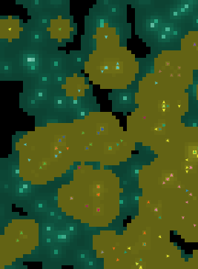Patchy environments have been used to model ecological questions with great success (Adams et al., 2012). In a patchy environment there is energy available for use by agents clumped into separated spatial locations (Fig. 1). To navigate an environment like this agents need access to sensors which enable them to access information about the environment. We chose to give foragers access to two “scent” variables, one emitted by other foragers and the other by the presence of energy sources (food, so to speak). The parameters used to control the emission and evaporation of scents were developed to encompass a realistic range. We chose to control the difficulty of the environment through the rate of food appearance and the number of patches growing food, rather than through the evaporation rates. The size of the environment (80x80 patches), patch death rate (5%), energy decrease per tick (0.5), and evaporation rate (10% diffusion, 1% evaporation) were all fixed throughout the experiments. Figure 1 shows an example of an easy environment. The difficulty of an environment can also be manipulated through the use of error values. An increase in the error value makes it more difficult for a forager to get an accurate assessment of the amount of scent on different patches. Because of the stochastic elements we chose to use two levels of randomness. The stochastic elements of the environment are set up to be manipulated independently of the foragers, allowing us to change forager parameters and review the results within comparable “environment runs”. We could then have *repetitions* of an experiment in the same environment run but with a new random seed, and new *environment runs* where we altered the environment seed.

Figure . Patchy Environment. Patches generating food and patch scent are shown in light blue and greens, respectively. Foragers appear as colored triangles. Forager scent is shown in dark yellow. The shading of the patch scent and forager scent colors indicates the relative quantity on a patch.

In a patch environment like the one described an agent needs a design with three parts to survive: *sensors*, which give the agent information about itself and the world, *effectors*, which allow the agent to interact with the world, and *cognition*, which lets the agent consider the state of the world and compute an appropriate response (Fig. 2). In addition to the sensors allowing foragers to access the environment they also need access to a short-term and long-term measure of their well-being. These were designed to approximate hedonic and eudaimonic life-valuation. Agents were designed to have five actions which they could perform on each tick: *collect*, *observe*, *socialize*, *reproduce*, and *wander*. Agents collect energy from the patch they are on, observe nearby patches to decide where to move next, and reproduce (asexually) by hatching a new agent and gifting it some initial energy. The only actions necessary for a population to survive in a patchy environment are collecting, observing, and reproducing. Socializing and wandering confer an advantage to agents under specific circumstances. For example, wandering allows foragers to cross regions with no food scent, in an environment with large spatial separation between food sources this could be a major advantage. Foragers translate form their sensors to actions through cognition. We modeled cognition as a two-step process, first computing well-being and second using well-being to determine a course of action. Hedonic well-being was modeled as a check to see whether a forager had either reproduced or eaten within a short time-window controlled by a hedonic set-point variable. Eudaimonic well-being was calculated as the weighted sum of energy, successful reproductions, and successful socialization, looking back over a longer time-window. To obtain a binary measure of eudaimonic well-being the summed value was compared to a eudaimonic set-point variable.

Figure . Agent Design. Agents were designed to have sensors, effectors, and to use cognition to determine their next actions. On a given time-step each forager could obtain information about the scents around them and their hedonic and eudaimonic states. These attributes were used to determine an action, and the outcome along with their decision were collected in memory.

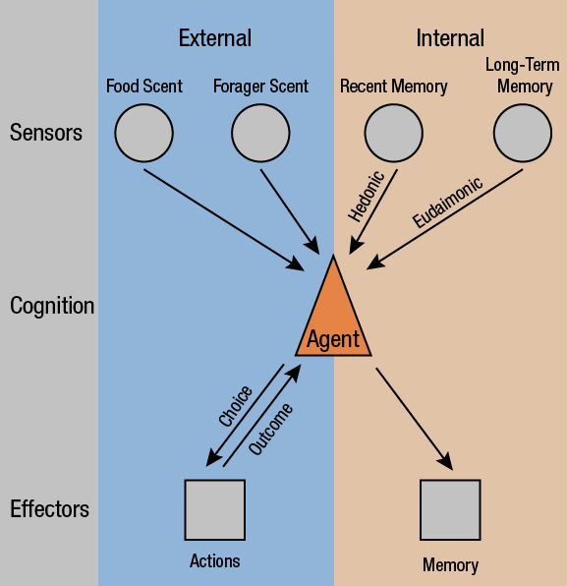

**Results**

Experiment 1: Influence of Well-Being on Survival in Difficult Environments

To understand how a foragers well-being indices can influence their survival in a dynamic environment we designed a three part experiment. We first investigated environmental difficulty, showing that varying seed values and number of patches has an effect on forager survival. We then took this information and looked at optimal hedonic and eudaimonic set points, as well as the optimal preference for using hedonic or eudaimonic well-being to determine decision making. Finally, we put optimized foragers in an easy environment and then temporarily made the environment impossible, collecting data on whether foragers were able to successfully survive the temporary difficulty. We found that foragers who had a preference for checking eudaimonic well-being were better able to survive temporary difficulty.

To determine environmental difficulty without making any assumptions about forager behavior we chose to fix the percentage of each action that foragers would perform at 20% each, uniformly distributed in time. This ensures that there will be no feed-forward interaction between the environment and forager behavior. We chose to model the seed values and patch numbers from 5 to 30 in increments of 5, including three repetitions and ten environmental runs (Fig. 3). Both number patches and seed value show an increasing trend over time. Seed values below 20 appear to be impossible to survive, while numbers of patches below 10 appear impossible to survive. Using these data we determine that the following seed value, patch number pairs would be easy, hard, and impossible: 25, 20; 20, 15; 15, 10.

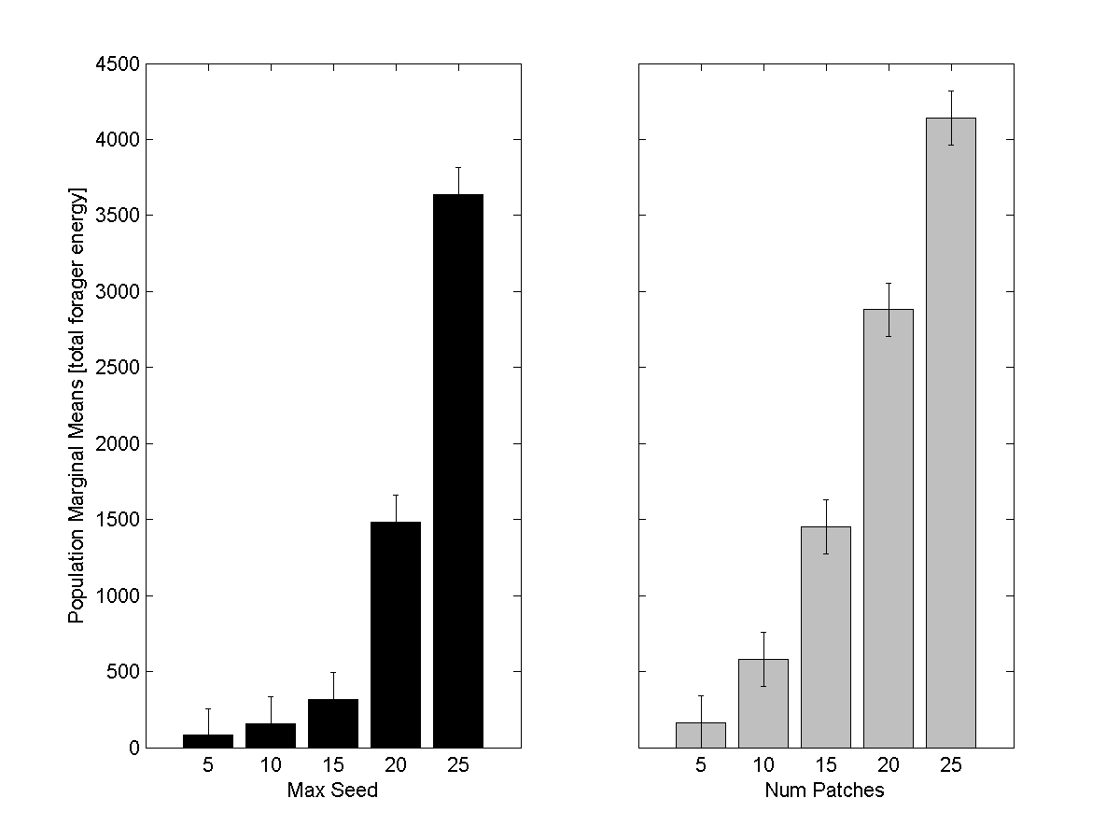

Using these values we then took an example easy environment (seed value = 25, # of patches = 20) and determine the optimal forager parameters for survival in that environment. Because forager parameters show interaction effects we modeled them all simultaneously (3-Factor design), using three repetitions and ten environmental runs. The main effects and interaction effects are reported in Figure 4. The main effects show several clear trends. Within the main effects increasing the eudaimonic set point increases total energy, while increasing the hedonic set point decreases total energy. Foragers who prefer to check their hedonic well-being to determine their next action show a higher fitness in easy environments. If we analyze forager decision making we can understand the optimal set points in a better context. Hedonic well-being, in this simulation, depends on reproducing and successfully eating. Eudaimonic well-being depends on a balance of having energy, socializing, and reproducing.

**Experiment 2: Analysis of Correlation and Time Constants for Well-Being Measures**

We designed the second experiment to look at how well-being measures varied over time in several ways. First, we compared well-being measures against the energy of foragers. We also looked at the within-measurement dynamics, including the percentage of time that foragers spent happy and unhappy, as well as the distance between peaks. We further collected histogram data showing the relative proportions of different periods of happiness and unhappiness in varied environments.

**Supplemental Information**

Pseudo code for Actions

**Collect**

**IF** Current patch has energy **THEN**

Take energy from this patch

**ELSE**

Call observe

**Observe**

Move UPHILL according to patch scent, within 180° forward

**Socialize**

**IF** Other foragers on this patch **THEN**

Reset social counter

**ELSE**

Move UPHILL according to forager scent

**Wander**

Pick one-of patches within 180° forward

Face and move-to patch

**Reproduce**

**IF** Random # < Success Rate **THEN**

Make a new forager at this point, move energy to new forager

Reset reproduce counter

Implementation Notes