Python Practical Programs Documentation

Program 1
Description:
This program reads the CSV file named “records.csv” and displays all student records in a neatly formatted way. It uses the csv module with DictReader to handle the header row and extract the required fields: student_name, roll_no, program, year, and group. The file must exist in the same directory as the program.
OUTPUT
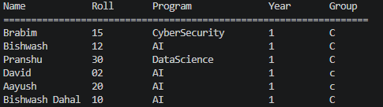

Program 2
Description:
This program takes student details from the user (via keyboard input) and appends a new row to the existing “records.csv” file. It uses csv_writer in append mode ('a'). The file must already exist with a header row.
OUTPUT
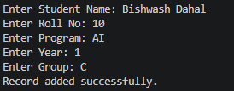

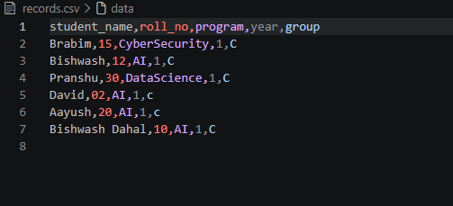

Program 3
Description:
This program repeatedly accepts two integers from the user, performs addition, subtraction, multiplication, and division, and saves the results to a new text file whose name includes the current date and time. The loop continues until the user chooses to exit. On exit, the entire file content is displayed in a neat format.
OUTPUT
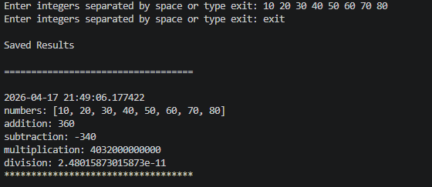

Program 4
Description:
This program asks the user for an input file name and an output file name, then copies the entire content of the input file to the output file.
OUTPUT
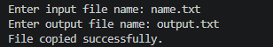
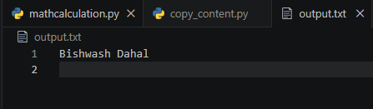

Program 5
Description:
This program defines a Learner class with the required attributes and demonstrates object creation by taking all attribute values from user input and displaying them.
OUTPUT
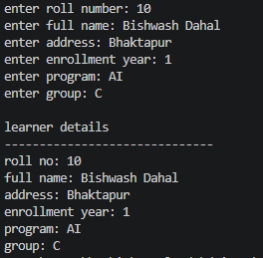

Program 6
Description:
Defines two classes: Dish (individual recipe) and Cookbook (collection manager). The Cookbook class maintains a list of Dish objects and provides methods to add and display all dishes.
OUTPUT
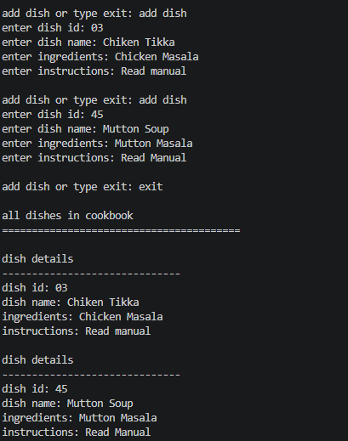

Program 7
Description:
Defines a Staff class. The program provides a menu-driven interface to add multiple staff members (data written to “staff.csv”) and view the complete list. Uses try/except for file handling
OUTPUT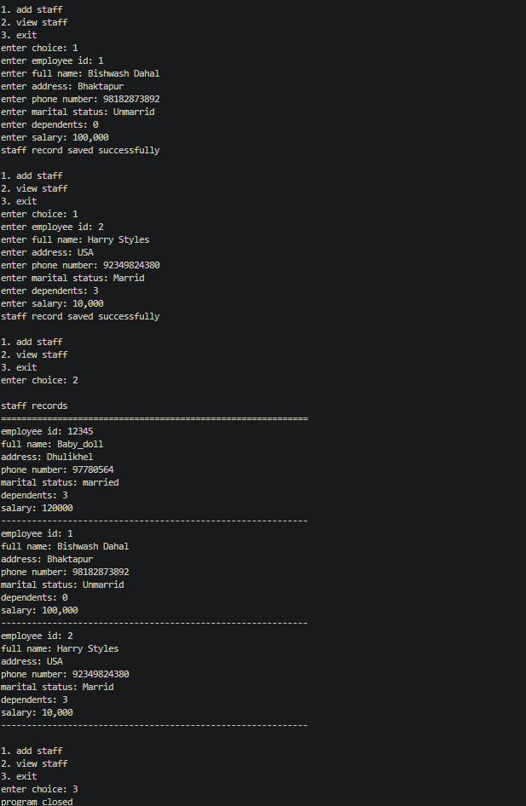
Program 8
Description:
A basic Library Management System using OOP (classes Book and Library). Supports searching, borrowing, and returning books. Book data persisted in “books.csv” with full exception handling.
OUTPUT
