Python Practical Programs Documentation

1. NumPy Array Operations
Description:
This program generates a NumPy array with values [10, 20, 30, 40, 50] and performs basic statistical operations such as sum, mean, maximum, and minimum.

Sample Output

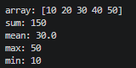

2. List Input, Sorting and Slicing
Description:
This program takes at least 12 numbers as input from the user, sorts them, and performs slicing operations for different index ranges.

Sample Output

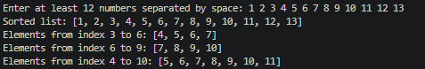

3. Random Array, Sorting and Reshaping
Description:
This program generates a random NumPy array, sorts it, and reshapes it into a matrix of valid dimensions.

Sample Output
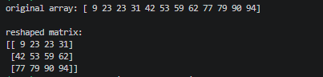

4. Matrix Operations
Description:
This program takes two matrices as input and performs addition, subtraction, and multiplication using NumPy. It validates dimension compatibility.

Sample Output
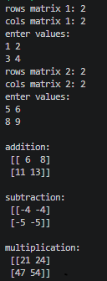

5. Data Visualization using Pandas and Matplotlib
Description:
This program reads 'health_data.csv' using Pandas and creates scatter plots for different variable relationships.

Plots Created
• Weight vs Height
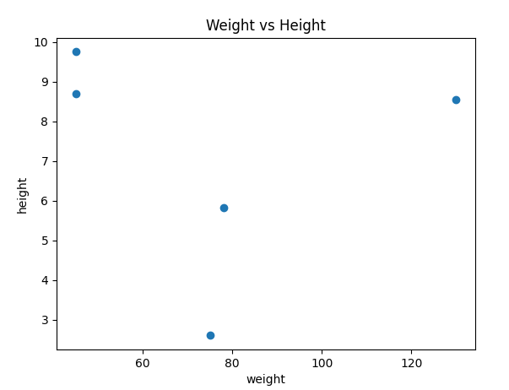
• Age vs Weight
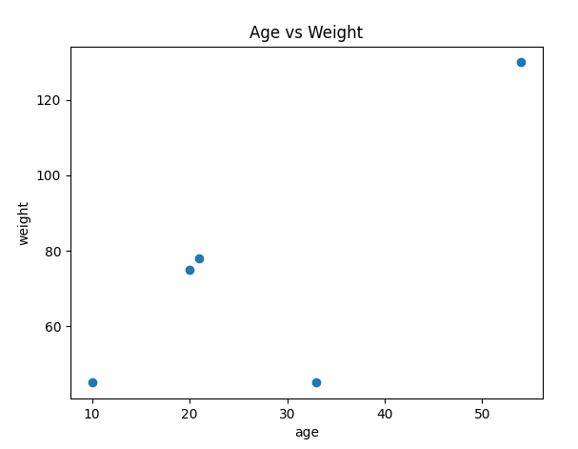

• Height vs Age
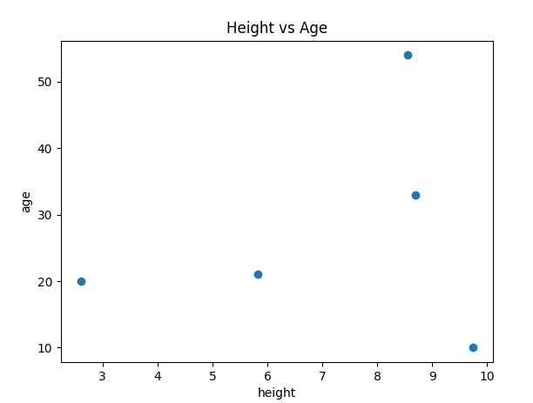
• Gender vs Height
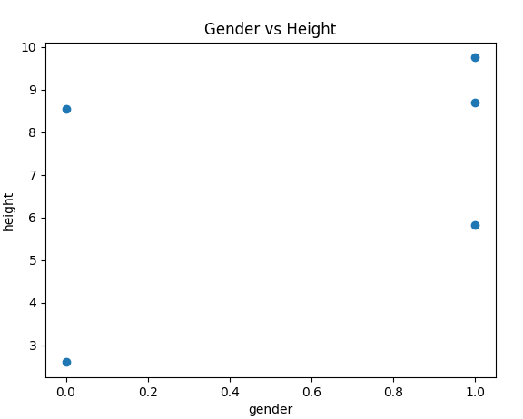

• Gender vs Weight
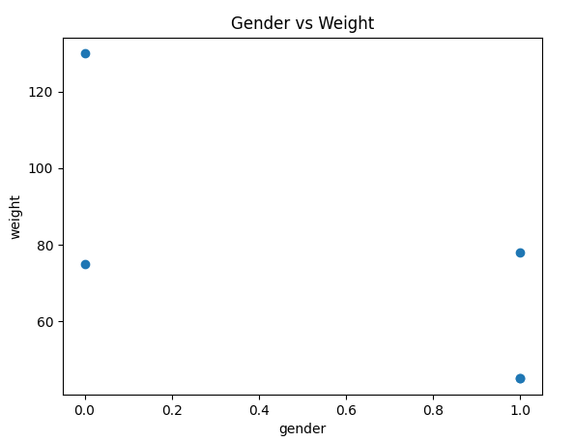

6. BMI and Health Status Calculation
Description:
This program reads 'health_data.csv', calculates BMI and assigns Health_Status based on BMI values.

Formula
BMI = Weight / Height

Health Status Conditions
BMI < 18.5 : Underweight
18.5 – 24.9 : Healthy range
25 – 29.9 : Overweight risk
30 – 34.9 : High risk
BMI ≥ 40 : Critical condition

Sample Output
