**BIODIESEL PRODUCTION FROM NEEM SEED OIL USING A BIO-BASED BIFUNCTIONAL CATALYST DERIVED FROM ORANGE PEEL AND SNAIL SHELL**

**BY**

**BISINA JAMES TAMARALAYEFA**

**MAT. NO: ENG1607610**

**BEING A PROJECT SUBMITTED TO THE DEPARTMENT OF CHEMICAL ENGINEERING, FACULTY OF ENGINEERING, UNIVERSITY OF BENIN, BENIN CITY,**

**IN PARTIAL FULFILLMENT OF THE REQUIREMENTS FOR THE AWARD OF BACHELOR DEGREE (B.ENG) IN CHEMICAL ENGINEERING**

**DECEMBER, 2022.**

# CERTIFICATION

This is to certify that this research project was carried out by BISINA JAMES TAMARALAYEFAof the Department of Chemical Engineering at the University of Benin, Benin City, Edo State, Nigeria.

----------------------------------- ----------------------

**ENGR. MR. C.E AKHABUE DATE**

**PROJECT SUPERVISOR**

------------------------------------ ----------------------

**ENGR. O.U. OSAZUWA DATE**

**PROJECT COORDINATOR**

-------------------------------------- ----------------------

**ENGR. DR. (MRS.) E.A. OYEDOH DATE**

**HEAD OF DEPARTMENT**

---------------------------------- ----------------------

**EXTERNAL EXAMINER DATE**

# DEDICATION

I dedicate my project to God Almighty and my family for their important contributions and support during the duration of my project work, as well as to everyone who has contributed to the success of this project.

**ACKNOWLEDGEMENT**

I would want to express my sincere appreciation to God Almighty for his direction and favor throughout my life. I am extremely grateful to my project supervisor and professor, Engr. Dr. C.E. AKHABUE, for his tremendous support, encouragement, and knowledge during the course of this research. In addition, .ENGR. DR. (MRS.) E.A. OYEDOH, Head of the Department of Chemical Engineering, has demonstrated exemplary leadership.

In addition, I would like to thank the lecturers and staff of the University of Benin's Department of Chemical Engineering for their contribution to the general learning process and character development throughout my time at the university, as well as for providing us with the proper background knowledge and teachings that allowed me to comprehend the project I was assigned to complete.

A particular thank you to my family; my parents, Mr. and Mrs. BISINA, for their financial, moral, and spiritual support throughout my time in school, and to my friends (Desmond, Bryan, and Ovie) for their never-ending encouragement.

# ABSTRACT

The preparation and uses of bio-based bi-functional catalyst for the production of biodiesel has become very important. In order to catalyze the synthesis of biodiesel from high free fatty acid (FFA) neem seed oil (NSO), this investigation created a bio-based catalyst from Snail Shell and Orange peel (SSOC). SEM, TGA/DTGA, BET-BJH, EDXRF, XRD, and FTIR were used to evaluate the SSOC's catalytic potential. Taguchi was used to fine-tune the one-pot manufacturing process. The effects of optimizing the methanol-to-oil molar ratio, catalyst loading, temperature, agitation speed, and reaction time on the biodiesel yield and FFA conversion of NSO were studied. A molar ratio of 12:1 methanol to oil, 2% by weight of catalyst, 55 degrees Celsius, agitation speed of 642.78 revolutions per minute, and a 60-minute reaction time were found to be optimal. Also, measurements of physiochemical properties were taken and found to be in accord with theoretical expectations.

TABLE OF CONTENTS

CERTIFICATION ii

DEDICATION iii

ACKNOWLEDGEMENT iv

ABSTRACT v

LIST OF TABLES ix

LIST OF FIGURES x

CHAPTER ONE 1

INTRODUCTION 1

1.1 BACKGROUND OF STUDY 1

1.2 STATEMENT OF THE PROBLEM 3

1.3 AIM AND OBJECTIVES 4

1.4 SCOPE OF STUDY 4

1.5 RELEVANCE OF STUDY 4

CHAPTER TWO 6

LITERATURE REVIEW 6

2.1 BIODIESEL 6

2.1.1. Properties of Biodiesel 6

2.1.1.1 Flash point 7

2.1.1.2 Viscosity 7

2.1.1.3 Iodine number 7

2.1.1.4 Cloud point and Pour point 8

2.1.1.5 Density 8

2.2. RAW MATERIALS IN BIODIESEL PRODUCTION 8

2.2.1 Non-edible Oil 9

2.2.2. Jatropha Seed 9

2.2.3. Edible Oil 10

2.3. NEEM SEED OIL 10

2.3.1. Physical and Chemical Properties of Neem seed oil 12

2.4 CATALYST FOR BIODIESEL PRODUCTION 13

2.4.1. Homogeneous Catalyst 13

2.4.2. Heterogeneous Catalyst 14

2.5 Methanol 15

2.6 BIODIESEL PRODUCTION PROCESS 16

2.6.1. Esterification 16

2.6.2. Transesterification 16

2.6.3. Glycerine 17

2.7. FACTORS AFFECTING BIODIESEL PRODUCTION 18

2.7.1. Effect of Water and Free Fatty Acid Contents 18

2.7.2. Catalyst Concentration 18

2.7.3. Effect of Molar Ratio of Alcohol 19

2.7.4. Reaction Temperature 19

2.7.5. Agitation speed 19

2.7.6. Reaction Time 20

2.8. BIODIESEL PRODUCTION TECHNIQUES 20

2.8.1. Direct Blending 20

2.8.2. Pyrolysis 20

2.9. CHEMISTRY OF BIODIESEL PRODUCTION. 21

2.10. DESIGN OF EXPERIMENT 21

2.10.1 Taguchi for Experimental Design 22

CHAPTER THREE 24

MATERIALS AND METHODS 24

3.1 MATERIALS 24

3.2. METHODS 26

3.2.1. Oil Characterization 26

3.2.1.1. Acid Value Test 26

3.2.1.2. Iodine Value 26

3.2.1.3. Saponification Value 27

3.2.1.4. Peroxide Value 27

3.2.1.5. Viscosity 28

3.2.1.6. Density 28

3.2.2. Catalyst Preparation 28

3.2.2.1. Preparation of Orange Peels 28

3.2.2.2. Preparation of Snail Shell 29

3.2.2.3. Preparation of Bi-Functional Catalyst 29

3.2.3. Experimental Design using Taguchi L16 Matrix 30

CHAPTER FOUR 32

RESULT AND DISCUSSION 32

4.1 PHYSIOCHEMICAL PROPERTIES OF NEEM SEED OIL 32

4.2 CHARACTERIZATION OF PREPARED CATALYST 34

4.2.1 Bio-based Bifunctional Catalyst Characterization 34

4.2.2 Surface Morphology of the SSOPC 34

4.2.3. Oxide composition of the SSOC 35

4.2.4. Crystal structure of the SSOPC 36

4.2.5. Functional groups present in the SSOPC 37

4.3. ANALYSIS OF VARIANCE OF THE ESTERIFICATION AND TRANSESTERIFICATION PROCESS 40

4.3.1. Statistical ANOVA of Esterification and Transesterification Process 40

4.3.2. Regression Model 41

4.3.3. Fit Statistics 43

4.4. EFFECT OF PROCESS PARAMETERS ON BIODIESEL YIELD AND ACID VALUE 44

4.4.1. Effect of Methanol-To-Oil Molar Ratio 45

4.4.2. Effect of Reaction Temperature on Biodiesel yield 46

4.4.3. Effect of Reaction Time on Biodiesel Yield 47

4.4.4. Effect of Methanol-To-Oil Molar Ratio on Acid Value 47

4.4.5. Effect of Reaction Temperature on Acid Value 49

4.4.6. Effect of Agitation Speed on Acid Value. 49

4.5. OPTIMISATION AND MODEL VALIDATION 50

CHAPTER FIVE 52

CONCLUSION AND RECOMMENDATIONS 52

5.1 CONCLUSION 52

5.2 RECOMMENDATIONS 52

REFERENCES 53

APPENDIX 63

# LIST OF TABLES

Table 2. 1: Fatty Acid Composition of Neem Oil 11

Table 2. 2: Physical and Chemical Properties of Neem Oil 12

Table 2. 3: Properties and Qualities of Biodiesel Produced from NSO 12

Table 3. 1: Materials and Reagents used during the cause of this experiment are shown below 24

Table 3. 2: Equipment, Apparatus and their uses 25

Table 4. 1: Physiochemical Properties of NSO 32

Table 4. 2: Physiochemical Properties of Neem Seed Oil Biodiesel 33

Table 4. 3: Percentage Oxides in the SSOPC 35

Table 4. 4: Taguchi Experimental Design Matrix and Values of Responses. 39

Table 4. 5: ANOVA for the Biodiesel Yield Model 40

Table 4. 6: ANOVA for the Acid Value Model. 41

Table 4. 7: Model fit Statistics for the One Pot Biodiesel Synthesis 44

# LIST OF FIGURES

Figure 2. 1: Neem seed 11

Figure 2. 2: Global Scheme for a Typical Continuous Homogeneous Catalysed Process 14

Figure 2. 3: The Transesterification Reactions of Vegetable Oil with Alcohol to Esters and Glycerol 17

Figure 2. 4: Transesterification of triglycerides (overall reaction) 21

Figure 4. 1**:** Surface Morphology of the SSOPC 34

Figure 4. 2**:** Crystal structure of the SSOPC 37

Figure 4. 3**:** The FTIR spectrum of SSOPC 38

Figure 4. 4**:** Predicted and Actual Value of Biodiesel Yield and Acid Value 43

Figure 4. 5**:** Effect of methanol-To-Oil Molar Ratio on Biodiesel Yield. 45

Figure 4. 6**:** Effect of Temperature on Biodiesel yield 46

Figure 4. 7**:** Effect of Reaction Time 47

Figure 4. 8**:** Effect of methanol/ oil ratio on Acid Value. 48

Figure 4. 9: Effect of Reaction Temperature on Acid Value. 49

Figure 4. 10: Effect of Agitation Speed on Acid Value**.** 50

Figure 4. 11: Model Validation 51

# CHAPTER ONE

# INTRODUCTION

# 1.1 BACKGROUND OF STUDY

Since greenhouse gases have had an adverse effect on the environment over the past few decades, the rising cost of oil and the accompanying uncertainty about its future availability has become a major concern. More people are thinking about using vegetable oils again as a fuel source because of this. For this reason, biofuel production is on the upswing as it is seen as the most viable replacement for fossil fuels. Fossil fuels are a popular choice for powering machinery and transportation due to their high heat transfer efficiency, ease of availability, and high efficiency of combustion; however, their reserves are quickly depleting. as reported by (Akhabue et al., 2018).

Biodiesel, widely regarded as a sustainable alternative to petroleum diesel, is produced by reacting fatty acid alkyl esters from vegetable or animal fats in the presence of a suitable catalyst.

In 2020 (Akhabue et al.) High production costs make it currently uncompetitive with petroleum-based diesel fuel. The high cost of feedstock is a major factor, accounting for over 70% of total production costs in commercial biodiesel production (Haas et al., 2012). So, it's possible that the price of biodiesel could be greatly reduced by switching to less expensive feedstock.

The recent increase in greenhouse gas emissions, rapidly rising petroleum prices, and access controls have raised serious environmental concerns. This has revitalized the debate over whether or not vegetable oils can replace fossil fuels. As a result, biofuel has been identified as a promising replacement for fossil fuels, and its production is on the rise. (2015) Researchers Tan YH and MO Abdullah

Biofuels are alternatives to fossil fuels that are produced using biological materials. We're talking about everything from bioethanol to biogas to biodiesel. They are considered environmentally safe for a number of reasons (low pollutant emissions, low emissions of greenhouse gases and particulate matter, simple biodegradability, etc.). But the essential ingredient is biodiesel (Betiku E. E., 2017).

Biodiesel is a diesel fuel alternative made from renewable resources such as vegetable oils and animal fats (Stamenkovi et al., 2012). Triglycerides, also called esters of fatty acids attached to a glycerol, are the primary components of both vegetable oils and animal fats. Several different fatty acids make up the triglycerides found in most vegetable oils and animal fats.

Due to the global competition between fuel and food, international organizations have restricted the use of plant oils (vegetable oils) to non-edible seed oil. However, while both edible seed oil and non-edible seed oils are a reliable source of biodiesel, the former has been predicted to lead to food crises for the expanding populations of the world. Because of this, vegetable oils have been proposed for a long time as viable diesel substitutes.

Each neem seed naturally contains about 30% oil, so this oil is extracted to be used in the production of biodiesel as neem seed oil (NSO). It's not safe for human consumption, but it's become widely used in the production of biofuel, soap, cosmetics, pesticides, and medicines (Djibril et at, 2015).

Catalyst is essential in the production of biodiesel as it reduces the activation energy and aids the reaction in reaching completion by providing the greatest alternative route in the reaction process. The catalyst, whether homogeneous or heterogeneous, must possess these characteristics. Heterogeneous catalysts have a promising future in the production of biodiesel due to their many benefits over their homogeneous counterparts. More than a decade ago, researchers began exploring the transesterification activity of different types of heterogeneous catalysts. according to (Endalew et al., 2011)

Several factors, such as reaction temperature, reaction time, methanol to oil ratio, and catalyst loading, affect the production of biodiesel. To achieve success, it is necessary to fine-tune these components. Taguchi's Design of Experiment (DOE) is used for this purpose in order to plan and enhance the manufacturing procedure.

Taguchi is a collection of statistical and mathematical techniques useful for modeling and analyzing problems with multiple confounding factors. Taguchi's work has found the most widespread application in the business world, where a number of variables influence a performance indicator known as the response in ways that are either not easily quantifiable or are otherwise impractical to model mathematically.

# 1.2 STATEMENT OF THE PROBLEM

Several problems are associated with conventional energy due to the dangers it poses to the environment and to human life in general. Pollution and ozone layer depletion from greenhouse gas emissions are two major effects that have motivated the search for a clean and sustainable alternative fuel source. The renewable and environmentally friendly biodiesel is a serious contender to replace it. Because of the difficulty and length of its two-step production process, an alternative, simpler method of production is required. However, this requires the creation of a dual-functional, low-cost heterogeneous catalyst capable of performing both biodiesel processes at once. In addition to being a cheap and effective method, making this heterogeneous catalyst from waste material also has environmental benefits.

# 1.3 AIM AND OBJECTIVES

The aim of this study is to produce biodiesel from Neem seed oil (NSO) by simultaneous transesterification and esterification using combine heterogeneous acid/base catalyst synthesized from bio-waste.

The following objectives have been used to achieve the aim of this study:

1. Collection and calcination of orange peels and snail shell.
2. Preparation and characterisation of the produced heterogeneous catalyst.
3. Optimization of the simultaneous transesterification and esterification using Taguchi design method.
4. Biodiesel production from NSO using the prepare bi-functional catalyst.
5. Production and characterization of the biodiesel gotten at the optimum conditions.

# 1.4 SCOPE OF STUDY

The scope of this research was limited to the confines of a laboratory. Consequently, it can only be used for the following:

1. Collecting Raw Materials and Making the Bifunctional Catalyst
2. Using the prepared catalyst, NSO is esterified and trans esterified simultaneously.
3. Analyzing the NSO's physical and chemical properties, including its saponification, peroxide, acid value, iodine value, moisture content, kinematic viscosity, and density.
4. Taguchi Methodology for the improvement of the manufacturing procedure.
5. The biodiesel production from NSO was calculated.

# 1.5 RELEVANCE OF STUDY

Biodiesel production costs are most affected by the system used and the cost of the feedstock. Making biodiesel from Neem seed oil (NSO) with the aid of a waste-based, bi-functional catalyst (orange peels and snail shells) not only provides a cost-effective and eco-friendly means of recycling these materials, but also brings the price of biodiesel down to a level where it can compete with diesel fuel made from petroleum. This research will provide the necessary experimental data for testing a bi-functional catalyst fabricated from waste orange peels and snail shells, which can be used to produce biodiesel from NSO by means of both transesterification and esterification.

# CHAPTER TWO

# LITERATURE REVIEW

# 2.1 BIODIESEL

Demand for petroleum-based goods has risen in recent years due to the dramatic increase in the number of cars on the road. As crude oil reserves are expected to run out in the coming decades, researchers have been trying to come up with creative replacements for diesel (Sathya and Manivannan, 2013). The increasing cost of fossil fuels and worries about the impact on the environment have brought biodiesel into the limelight. Vulnerability to the release of car-related toxic gases (Sathya and Manivannan, 2013)

The use of trans esterified vegetable oil as a diesel fuel is known as "biodiesel" (Demirbas, 2002). It is a renewable lipid-based diesel fuel composed of long-chain fatty acid mono alkyl esters rather than petroleum. Glycerin and fatty acid esters are typically formed during the reaction of vegetable oil or animal fat with methanol in the presence of a catalyst (biodiesel). The product has no sulfur or aromatics and its lifecycle carbon dioxide emissions are reduced by about 70% in comparison to conventional diesel fuel due to its renewable source. Diesel engines powered by biodiesel produce fewer carbon monoxide, unburned hydrocarbons, particulate matter, and air toxics than diesel engines powered by petroleum. Diesel engines can use this renewable fuel as an alternative.

## 2.1.1. Properties of Biodiesel

There are numerous ways to categorize the characteristics of biodiesel. The most crucial factors include those that affect how an engine operates (such as its ability to start easily, the fuel-air mixture's formation and burning, the production of exhaust gases, and heating value), as well as factors related to cold weather (such as cloud point, pour point, and cold filter plugging point), transport and depositing (such as oxidative and hydrolytic stability.

### 2.1.1.1 Flash point

A fuel's flash point is the temperature at which it will ignite when exposed to a flame or spark. The flash point is used to classify combustible and flammable materials according to safety regulations. A minimum flash point temperature must be attained to guarantee sufficient fuel safety. To ensure that the biodiesel component does not contain methanol and that any residual methanol from biodiesel production does not negatively affect combustion and other fuel components, a flash point criterion must be met before blending. Biodiesel is safer to work with because it has a lower ignition temperature than diesel made from petroleum. It has a higher flash point and burn time than diesel made from petroleum.

### 2.1.1.2 Viscosity

Liquids differ from gases and solids in their viscosity, which is a measure of their resistance to flow caused by internal friction. This is the primary advantage of biodiesel over its original oil formulation. Incomplete combustion and smoke deposits can be the result of injecting fuel with a high viscosity into the combustion chamber. Injector characteristics are governed by viscosity, so biodiesel needs to have a very low viscosity for use in diesel engines.

The higher the fuel's viscosity, the more likely it is to contribute to these issues. Therefore, one option to lessen the thickness of vegetable oil is to switch to biodiesel.

### 2.1.1.3 Iodine number

The iodine value (IV) or iodine number quantifies the total amount of unsaturation present in a given fatty material. Biodiesel oxidation stability testing is done with it. Unsaturated fats and oils, which are indicated by high iodine values, tend to polymerize and deposit on injector nozzles and piston rings. To prevent polymerization of glycerides during high-temperature processing, unsaturated fatty acids should be kept to a minimum. Thick sludge can form in an engine's crankcase if fuel leaks down the cylinder walls and collects there (Sanjay, 2013).

### 2.1.1.4 Cloud point and Pour point

Both of these aspects are critical in establishing biodiesel's overall quality. The cloud point is when the fuel first starts to crystallize. As the temperature drops, the crystals grow in size and number, eventually gelling the fuel and rendering it inert. The pour point is the lowest temperature at which the oil sample flows. Both characteristics are commonly used to define the cold-weather operability of fuel oils. Both the cloud and pour points are affected by the cold start of the motor. Reports indicate that biodiesel has relatively high cloud and pour points. If the biodiesel is frozen, the temperature at both points must be low enough for the motor to start (Sanjay, 2013; Alnuami et al., 2014).

### 2.1.1.5 Density

Due to the known relationship between the density of biodiesel and the residual esters and alcohol, the type of vegetable oil used has a major effect on this property (Encinar et al., 2010). Density, or the weight of a fluid relative to its volume, is an important fuel quality that affects an engine's output. The density is higher than that of diesel made from petroleum. This significant fuel attribute affects the fuel-to-air ratio and the fuel-injection mechanism, as well as the amount of fuel injected into the combustion chamber. This is because fuel injection pumps fuel by volume rather than by mass, and a denser fuel contains more mass in the same volume.

# 2.2. RAW MATERIALS IN BIODIESEL PRODUCTION

More than three hundred and fifty oil crops have been identified as possible sources for biodiesel production around the world. The abundance of different feedstock options is crucial to the biodiesel production process. As much as is practical, the feedstock should have large production scale and low production costs. The availability of feedstock for biodiesel production varies from country to country based on factors such as climate, geography, soil type, and farming practices. It is critical to select the least expensive feedstock in order to keep biodiesel production costs low.

In general, biodiesel feedstock can be divided into four main categories.

1. Edible vegetable oil which includes rapeseed, soybean, peanut, sunflower, palm and coconut oil.
2. Non-edible vegetable oil which includes jatropha, karanja, sea mango, algae and halophytes.
3. Waste or recycled oil.
4. Animal fats: tallow, yellow grease, chicken fat and by-products from fish oil.

## 2.2.1 Non-edible Oil

The widespread availability of non-edible oil resources, especially in marginal lands around the world, the absence of food competition, the decrease in deforestation rates, the enhancement of efficiency and environmental friendliness, the generation of useful byproducts, and the cost parity with edible oil sources are all contributing factors to their rising popularity. The second generation of biodiesel feedstock is primarily made from non-edible oils. Oils from plants like jatropha, neem, and rubber trees all fall into this category. However, reports suggest that the supply of second-generation feedstock may not be sufficient to meet the global energy demand. Animal and vegetable fat-based biodiesel, on the other hand, isn't the most efficient fuel in the winter.

Moreover, there is a great deal of variety.

## 2.2.2. Jatropha Seed

The use of animal and edible vegetable oils and fats for the production of biodiesel has recently become a major source of concern due to competition with food materials. Because of the dramatic increase in demand, using vegetable oils for fuel purposes, such as in biodiesel production, is no longer acceptable. Using these oils as fuel could also be more expensive. Non-edible plant oils, such as those found in jatropha and soap nut, will have a significant effect on the production of biodiesel. For financial and societal reasons, non-edible plant oils should replace edible oils as feedstocks for biodiesel production. Because of this, non-edible plant oils have a great deal of potential as a replacement feedstock for biodiesel (Stamenkovi, Veljkovi and Bankovi, 2012).

## 2.2.3. Edible Oil

The first generation of biodiesel feedstock consists of edible oil resources like soybeans, palm oil, sunflower, safflower, rapeseed, coconut, and peanut. They have a strong global presence, with well-established plantations in countries like Malaysia, the United States, and Germany. Nearly all biodiesel produced today comes from vegetable oils like rapeseed (84%), sunflower (13%), palm (1%), soybean (2%), and others (2%). However, their application raises numerous issues, including the food versus fuel crisis and major environmental problems, such as the severe destruction of vital soil resources, deforestation, and the usage of much of the accessible arable land. Further, the economic viability of the biodiesel industry will be impacted by the sharp increase in vegetable oil plant prices over the past decade. In addition, the widening gap between demand and supply of such oils means that using them to produce biodiesel is not sustainable over the long term in many countries. If the entire US soybean crop were diverted to biodiesel production, it would only be able to satisfy 6% of the country's diesel needs.

By using non-edible oils in biodiesel production, it may be possible to reduce demand for edible oil.

# 2.3. NEEM SEED OIL

Vegetable oil extracted from the seeds and fruits of the neem tree is called neem seed oil. It could be a variety of shades, including yellow, reddish-brown, dark brown, and greenish-brown. Those odors of peanuts and garlic are quite potent. The primary fatty acids found in the oil are palmitic acid (19.4%), stearic acid (21.2%), oleic acid (42.1%), linoleic acid (14.9%), and arachidic acid (1.4%). Numerous products—including insecticides, cosmetics, soap, engine lubricant, lamp oil, and remedies for both plant and human health—rely on it as a raw material. In order to obtain neem oil, the neem seed must undergo an extraction process. It is primarily cultivated in the northern region of Nigeria and is a perennial tropical plant. 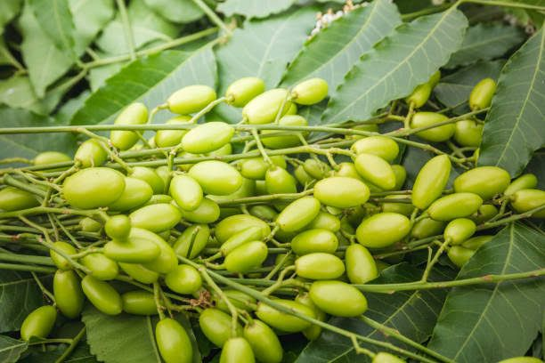 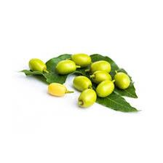 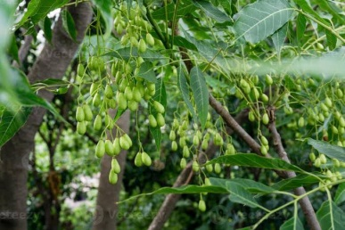

Figure 2. 1: Neem seed

Table 2. 1: Fatty Acid Composition of Neem Oil

|  |  |
| --- | --- |
| **Composition** | **%** |
| C16:Palmitic acid | 15.59±0.27 |
| C16:Palmitoleic acid | 0.12±0.00 |
| C18:Stearic acid | 18.71±0.46 |
| C18:Oleic acid | 41.91±0.69 |
| C18: Linoleic acid | 19.59±0.44 |
| C20:Arachidic acid | 1.33±0.01 |
| C18:Linoleinic acid | 0.44±0.01 |
| C20:Galdolelic acid | 0.08±0.00 |
| C22:Behenic acid | 0.86±0.38 |

## 2.3.1. Physical and Chemical Properties of Neem seed oil

Neem oil's appearance can change from a pale yellow to a deep brown. It's offensive to the senses in both smell and flavor. Two of the four significant saturated fatty acids in neem oil are palmitic acid, and the other two are stearic acid. The polyunsaturated fatty acids linoleic and oleic found in it are also beneficial.

Table 2. 2: Physical and Chemical Properties of Neem Oil

|  |  |  |
| --- | --- | --- |
| S/N | Properties | Characteristics |
| 1. | Colour | Pale yellow - dark brown |
| 2. | Odour | Strong Pungent |
|  | Specific gravity at 150C | 0.935-0.940 |
| 4. | Refractive index at 150C | 1.469-1.4771 |
| 5. | Acid value | 26mg KOH/g of oil |
| 6. | Saponification value | 198-202 |
| 7. | Iodine value | 74-98 |

Source: (Nandagopal and Subramanian 2010).

Oil extracted from neem seeds has been studied for its potential as a biodiesel feedstock. Neem oil has been studied extensively for its potential as a biodiesel feedstock. The table below details some of the features and qualities of NSO biodiesel**:**

Table 2. 3: Properties and Qualities of Biodiesel Produced from NSO

|  |  |
| --- | --- |
| Fuel Properties | Neem FAME Value |
| Density 15◦C (kg/m3) | 868 |
| Viscosity at 40◦C (cSt ) | 5.213 |
| Cetane number | 56 |
| Iodine number | 74 |
| Calorific value (MJ/kg) | 39.81 |
| Acid (neutralization) value (mg KOH/g)) | 0.649 |
| Pour point (◦C) | 1.4 |
| Flash point (◦C | 72 |
| Cloud point (◦C) | 1 |
| Cold filter plugging point (◦C) | 11 |
| Ash content % (w/w) | 15 |

Source: (Atabani et al. 2012).

# 2.4 CATALYST FOR BIODIESEL PRODUCTION

A catalyst is a substance that both speeds up and remains stable throughout a chemical reaction. Because it is not used up in the process, it can be recycled. The catalyst's job is to boost the transesterification reaction's yield and reaction rate. Transesterification of triglycerides may be accomplished with the help of enzyme catalysts, heterogeneous catalysts, or homogeneous catalysts.

## 2.4.1. Homogeneous Catalyst

Homogeneous catalysts perform their chemical reactions while suspended in the same liquid phase as the reactants. Basically, there are two kinds of homogeneous catalysts: acids (like H2SO4 or HCl) and alkalis (like NaOH or NH4OH) (KOH or NaOH). The biodiesel industry is dominated by homogeneous catalyst applications due to their ease of use and rapidity in oil conversion. Alkaline catalysts such as NaOH and KOH are frequently used because they are easily soluble in methanol and generate sodium methoxide and potassium methoxide, respectively, which speed up and complete the reaction. The advantage of this approach is that it allows for the production of methyl esters under benign conditions and in very high yields. However, base catalyzed transesterification relies on the use of high-quality feedstock. Triglycerides must be added to alcohol.

## 2.4.2. Heterogeneous Catalyst

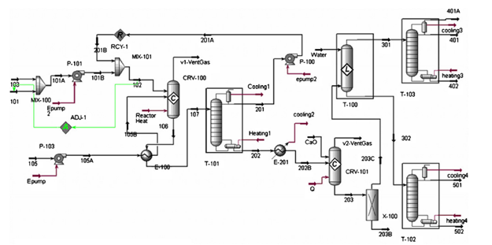The heterogeneous catalyst has a different phase than the reactants. Heterogeneous catalysts have greater activity, selectivity, and lifetimes because they are simpler to isolate from liquid products. They are also better for the environment and the wallet. These advantages have led to an increase in the application of heterogeneous catalyst. The efficiency of heterogeneous catalytic conversion is influenced by whether or not an active solid catalyst is used. In general, solid base catalysts are more efficient than solid acid catalysts, allowing for more rapid reaction times at lower temperatures. However, solid acid catalysts have several advantages over solid base catalysts. These include a reduced influence of water and free fatty acids on the reaction (FFA). For example, solid acid catalysts are useful for their ability to catalyze the esterification of free fatty acids, while solid base catalysts are useful for their ability to catalyze the transesterification of triglycerides.

Figure 2. 2: Global Scheme for a Typical Continuous Homogeneous Catalysed Process

# 2.5 Methanol

Methanol is highly favored due to its many physical and chemical advantages. It dissolves easily in NaOH and reacts rapidly with triglycerides. Furthermore, various alcohols and triglycerides can react (Musa 2016).

Biodiesel is synthesized using short-chain alcohols like methanol, ethanol, butanol, and amylic alcohol due to their higher conversion rates in the same amount of time. As a result of their accessibility, versatility, and low prices, methanol (CH3OH) and ethanol (C2H5OH) are the two alcohols that find the most widespread use. Because of its lower cost, ease of recovery of excess alcohol, and higher reaction rates, methanol is often preferred to ethanol in the production of biodiesel despite its high toxicity (Romano and Sorichetti 2011).

# 2.6 BIODIESEL PRODUCTION PROCESS

Biodiesel is made by combining vegetable oils or animal fats with alcohol and then going through a transesterification reaction. In terms of alcohol, a low molecular weight variety is preferable. In this chemical transformation, an ester (vegetable oil) is converted into a series of esters of the individual fatty acids that make up the oil or fat. Catalysts for the transesterification reaction can be either acids or bases. One disadvantage of alkaline catalysts is their extreme sensitivity to both water and free fatty acids in the oil.

## 2.6.1. Esterification

Esterification is often used as a remedy when a feedstock contains more than 1.0 wt% FFA. Creating biodiesel involves a two-stage process: pre-treatment of the feedstock with acid to lower its FFA concentration, and then transesterification with homogeneous base catalysts. Heat, an excess of methanol, and an acid catalyst (typically sulphuric acid) are used in a standard acid pre-treatment process to transform FFA into the corresponding FAME. The two-stage procedure is flexible enough to accommodate low-cost feedstocks with a high FFA content for biodiesel production (Moser, 2011).

## 2.6.2. Transesterification

Transesterification, also known as alcoholysis, is the process by which oil or fat is transformed into esters and glycerol. Transesterification reactions can only be carried out stoichiometrically when the molar ratio of alcohol to triglyceride is 3:1. For the best ester yield, this ratio needs to be higher than the stoichiometric one. Utilizing a catalyst is common practice to speed up a reaction and boost its yield. Since the reaction can be stopped and started again, excessive alcohol is used to swing the scales in favor of the products (Ma and Hanna, 1999).

As shown in Figure 2.5, transesterification involves a series of three independent reversible reactions that occur in rapid succession. At each stage, one ester molecule is produced for each glyceride molecule, with the final product being glycerol from monoglycerides (Ferrari, et al., 2010).

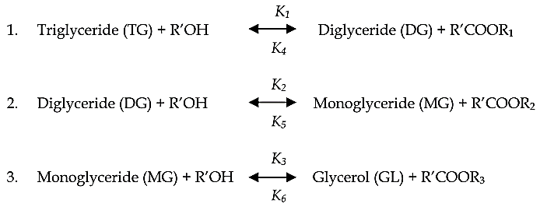

Figure 2. 3: The Transesterification Reactions of Vegetable Oil with Alcohol to Esters and Glycerol

The mechanism of the reaction is altered by the choice of catalyst. The alkali-catalyzed reaction mechanism is composed of three steps, the first of which involves an anion of alcohol attacking the carbonyl carbon atom of a triglyceride, leading to the formation of a tetrahedral intermediate. In the second stage, the intermediate presumably renews the anion of an alcohol. Ultimately, a diglyceride and a fatty acid ester are formed after the tetrahedral intermediate undergoes a third and final rearrangement. The alkoxide group formed when alkali is combined with alcohol catalyzes reactions, but alkali by itself does not. Any time that this reaction takes place (Akhabue et al, 2020).

## 2.6.3. Glycerine

Glycerine (or glycerol) is a clear, odorless, sticky liquid with a sweet flavor that is produced as a byproduct of biodiesel. The components are derived from both organic and synthetic sources. Triglycerides found in animal fats and vegetable oils are transesterified into glycerine to produce biodiesel. Propane-1,2,3-triol, glycyl alcohol, and glycerine are all names for glycerine. Transesterification, a critical process in the production of biodiesel, results in the formation of glycerine. At this point, crude glycerine, which is only 80% pure and contains impurities like water, soap, and methanol, is produced. This waste glycerine can be salvaged through a purification process.

# 2.7. FACTORS AFFECTING BIODIESEL PRODUCTION

## 2.7.1. Effect of Water and Free Fatty Acid Contents

There must be water and free fatty acids for the transesterification reaction to take place (FFAs). The production of biodiesel requires water-free and low-acid-value (1) raw materials for the base-catalyzed transesterification reaction. If the oil samples contain an excessive amount of FFA (greater than 1%), a more alkaline catalyst will be required in the reaction to neutralize the FFA. Soap production and foaming can increase viscosity, which means that the presence of water has a more negative impact than FFAs. Because they promote soap formation and consume the catalyst, free fatty acids and water almost always hinder transesterification. Methyl ester can be broken down by both water and FFA (Mathiyazhagan and Ganapathi, 2011).

## 2.7.2. Catalyst Concentration

The rate at which biodiesel is produced is affected not only by the type of catalyst used, but also by how much of it is used. The two most common catalysts used in the production of biodiesel are sodium hydroxide (NaOH) and potassium hydroxide (KOH) (KOH). An increase in catalyst concentration in oil samples results in a higher rate of triglyceride conversion to biodiesel (Ganapathi et al. 2012). However, a lack of catalyst leads to incomplete conversion of triglycerides into fatty acid esters. Accelerating the saponification reaction from triglycerides to soap rather than the ester causes a decrease in yield at higher catalyst concentrations. It was found, however, that a concentration of NaOH of around 1.5% resulted in the highest yield of product (biodiesel). In soapmaking, the viscosity rises when more catalyst is added (Agarwal et al. 2011).

## 2.7.3. Effect of Molar Ratio of Alcohol

Biodiesel yield, conversion efficiency, and production cost are all significantly impacted by the molar ratio of alcohol to oil (Musa 2016). In the transesterification reaction, one mole of triglycerides and one mole of alcohol are converted into three moles of fatty acid ester and one mole of glycerol. When consumed in large quantities, alcohol hastens the conversion of lipids into esters. Therefore, more biodiesel can be produced with a higher alcohol content. Furthermore, the ratio of alcohol content may vary depending on the catalyst used; for instance, transesterification of oils or fats necessitates an alkali catalyst and a 6:1 alcohol ratio. Responses to elevated levels of free fatty acids (FFA) are unresponsive (Encinar et al., 2010).

## 2.7.4. Reaction Temperature

The temperature at which a reaction is being performed has a major effect on its rate. By increasing the temperature of the reaction, the oil's viscosity may be reduced (Verma and Dwivedi, 2016). Saponification of triglycerides can be sped up by increasing the reaction temperature, but doing so results in a decrease in biodiesel production. Keeping the transesterification reaction below the alcohol's boiling point is the best way to prevent alcohol loss. The optimum reaction temperature may be anywhere from 50°C to 60°C, depending on the oils or fats used (Nwufo 2013).

## 2.7.5. Agitation speed

Accelerating the reaction by agitating the oil and catalyst combination is essential for producing the final product (mono alkyl ester or biodiesel) in a timely fashion. There is data suggesting that the most biodiesel can be produced at an agitation speed of 180 revolutions per minute. The yield of methyl esters decreases as the agitation speed rises above 180 rpm. This may be due to how the lipase is constructed. Over-agitation can cause mechanical damage to shear-sensitive biomolecules. As a result, higher stirring rates may contribute to a greater degree of lipase inactivation (Ebrahimi et al., 2012).

## 2.7.6. Reaction Time

A longer reaction time results in a greater degree of fatty acid ester conversion. The initial reaction time is prolonged because alcohol and oil are mixing and dispersing. When that happens, the chain reaction accelerates rapidly. While this was true, the maximum ester conversion still took less than 90 minutes to complete. Increasing the reaction time does not improve the yield product (biodiesel/mono alkyl ester). Since transesterification is reversible, longer reaction times lead to less biodiesel being produced in the end because esters are lost and soap is developed ( Daniyan et al., 2015).

# 2.8. BIODIESEL PRODUCTION TECHNIQUES

Biodiesel can be created through a number of processes, such as direct mixing, micro-emulsion, pyrolysis, and transesterification. Complexity in manufacturing comes from disentangling three long-chain fatty acid linkages from glycerol molecules.

## 2.8.1. Direct Blending

Starting in the 1980s, the feasibility of using vegetable oil as a fuel was hotly contested. In his research on the topic, Bartholomew (1981) recommended that petroleum, not vegetable oil or alcohol, be the "alternative" fuel, and that non-renewable resources be replaced with renewable energy. It was in South Africa, in response to the oil embargo, that pioneering work with sunflower oil was done (Ma and Hanna 1999). In 1980, Caterpillar Brazil began using pre-combustion chamber engines to maintain overall power without adjusting or modifying the engine. At the time, a blend of 20% vegetable oil and 80% diesel fuel was the best option.

## 2.8.2. Pyrolysis

Using heat or heat and a catalyst, pyrolysis transforms one substance into another (Borges and Daz 2012). The formation of small molecules is accomplished by heating chemical bonds in the absence of oxygen or air (Ma and Hanna 1999). Determining what exactly constitutes pyrolytic chemistry is difficult because of the vast number of possible reaction pathways and products that can result from the reactions that take place. In addition to oils and fats from plants and animals, pyrolysis can also be used on naturally occurring fatty acids and methyl esters of fatty acids. Researchers have been looking into the pyrolysis of fats for over a century, especially in areas with limited access to petroleum.

# 2.9. CHEMISTRY OF BIODIESEL PRODUCTION.

Biodiesel is made by transesterifying long-chain branched triglycerides into shorter-chain methyl esters with the help of a catalyst like an alkali, an acid, or an enzyme. From triglycerides, three moles of methyl esters and one mole of glycerol can be synthesized via a three-step process that involves the intermediate formation of diglycerides and monoglycerides. Here, a simplified diagram of the transesterification reaction of vegetable oil to biodiesel with a catalyst is shown in Fig. 2.1. (Atadashi et al. 2012). The impact of the catalyst and alcohol on biodiesel yield from triglycerides of varying FFAs contents is depicted in Fig. 2.2.

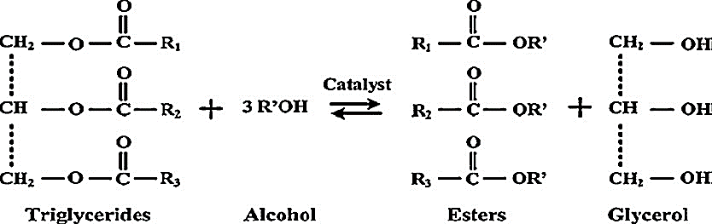

Figure 2. 4: Transesterification of triglycerides (overall reaction)

(Source Hanis *et al.*, 2016)

# 2.10. DESIGN OF EXPERIMENT

The DOE is a methodical way to learn how changing different variables in a process can affect the outcome. Using a simple experimental design can help you pinpoint the weak points in your setup that are preventing you from getting reliable results. If you want to create a design that gets better results, hire a designer.

Unsatisfactory P values that prevent us from drawing inferences about treatment differences are the most obvious sign of a "problem" or "failed" design. In comparison studies, the four pillars of experimental design—replication, randomization, blocking, and the size of experimental units—can be applied in novel, clever, and thoughtful ways to address both real and hypothetical problems.

## 2.10.1 Taguchi for Experimental Design

G. Taguchi devised a novel method called Taguchi Orthogonal Arrays to examine the effects of parameters on the mean and variance of a technique. This statistical method may greatly cut down on the need for experiments ( Taguchi and Konishi, 1987). Therefore, it may be possible to save time and money by conducting as few experiments as possible. The Taguchi approach also permits the isolation of the factors that affect product quality. As a conclusion, the Taguchi experimental design process is a very useful resource for developing high-quality systems. In reality, using orthogonal rows makes it easy to cut down on the number of experiments required when planning the experimental setup. The use of orthogonal arrays by sets in tabular form, however, was standardized and simplified by Taguchi. In this method, we only looked for a subset of the possible parameter permutations. This allowed for a large number of variables to be generated from a relatively small set of tests.

The minimum number of experiments, N, is determined by the equation

N = (L 1) P + 1,

where P is the number of parameters and L is the level of variation in each parameter.

Taguchi technique can lessen the cost of innovation by enhancing the efficiency with which information is gathered for planning frameworks that ignore utilization situations, yield of a process, manufacturing variation, and part deterioration. This allows for a drastic reduction in development time while simultaneously pinpointing the most important design factors that influence performance, cost, and operation. In addition, with careful parameter choice, you can boost the tolerance range and make use of low-cost production strategies and parts. Production and administrative expenses can be cut significantly with this method as well. Taguchi's method for determining parameters is utilized in the present research strategy.

# CHAPTER THREE

# MATERIALS AND METHODS

# 3.1 MATERIALS

Neem seed oil was purchased from Luco Chemical (NIG) Limited, Benin City, Edo State. The snailshell used as catalyst was gotten from Uselu market Edo State why orange peel was collected from orange vendor as waste. All analytical grades chemicals and reagents such as methanol (99.8 %), sulphuric acid (98 %), benzene (99%), absolute ethanol (99.8%) and potassium hydroxide (99 %) were purchased also from Luco Chemical (NIG) Limited.

Table 3. 1**:** Materials and Reagents used during the cause of this experiment are shown below

|  |  |
| --- | --- |
| Raw Materials | Uses |
| Absolute ethanol | Acid value test |
| Benzene | Acid value |
| Chloroform | In iodine value test and peroxide test |
| Distilled water | In snail shell and orange peel washing and washing of biodiesel |
| Glacial acetic acid | For peroxide test |
| Methanol | The second reaction component is low molecular weight alcohol |
| Neem seed oil | Feedstock for biodiesel synthesis |
| Sodium hydroxide | For snail shell treatment, acid value test titration and saponification value test. |
| Sodium thiosulphate (Na2S2O3) | For iodine value test and peroxide test titration. |
| Sulphuric acid | Was used for acidic catalyst in the first step esterification process |
|  |  |
| Phenolphthalein indicator | Used for endpoint indication in titration |
| Potassium Iodide | For iodine value test |
| Warm water | Used in washing the produced biodiesel |

Table 3. 2: Equipment, Apparatus and their uses

|  |  |
| --- | --- |
| Equipment and Apparatus | Uses |
| Beakers | They are used for pouring, mixing and keeping reagents for use |
| Burette | For titration of acid value test |
| Conical flask | It is used as the reactor for laboratory biodiesel synthesis and acid value test titration |
| viscometer | Used to measure the kinematic viscosity of oil |
| Density bottle | Used to evaluate the density of oil |
| Heating mantle | This was used to heat water for biodiesel washing and drying of biodiesel |
| Magnetic stirrer and stirring bar | This is the machine that supplies heat to the reaction. It has a rotating magnetic element that causes the stirring bar to create an agitated motion in the reactor. |
| Muffled furnace | Used to calcinate the eggshell catalyst at high temperature |
| Retort stand and separating funnel | These are used to hold up the reacted mixture so at to allow separation by gravity. |
| Round bottom flask | It is used as the reactor for the esterification process and to heat water for biodiesel washing |
| Steel containers | The catalyst to be calcined were placed in steel containers before being put into the muffled furnace |
| Centrifuge | To take off the biodiesel layer after separation |
| Volumetric cylinder | To measure given volumetric quantities of reagent |
| Weighing balance | Used to evaluate the mass of the substance |

# 3.2. METHODS

## 3.2.1. Oil Characterization

### 3.2.1.1. Acid Value Test

The purpose of this test was to evaluate the acid value of the oil before and after the transesterification procedure. Direct titration of the oil in an alcoholic medium (ethanol) with aqueous Potassium Hydroxide (KOH) solution yielded the acid value. 1.0g of oil sample was weighed into a conical flask, and 10ml of benzene, ethanol, and 2 drops of phenolphthalein indicator were added. The combination was then titrated with KOH, and the acid value was determined as follows:

**Acid value = ………………………………(*3.1)***

The free fatty acid (FFA) content is the weight percentage of fatty acid in the oil. The FFA content was calculated as thus:

**FFA (%) = …………………………………………(*3.2)***

### 3.2.1.2. Iodine Value

Weighing 1g of NSO into a conical flask, 10ml of chloroform (CCl4) was added, gently warmed, and allowed to cool for 10 minutes to ascertain the iodine value. 25ml Wij's reagent was added with vigorous but cautious mixing and placed in the dark for 30 minutes to prevent reactivity with light. Following the stated time, 20ml of 10% KI was titrated against sodium thiosulphate until a yellow color appeared. The yellow mixture was titrated against sodium thiosulphate (Na2SO3) using 1% starch solution as an indicator until the color changed from blue-black to colorless (end point). Under the same settings, a blank test was conducted.

**Iodine Value = ………………………………………….(*3.3)***

Where:

V1 = Volume of Na2SO3 solutionused for the blank test

V2 = Volume of Na2SO3 solutionused for the test oil

N = Normality of Na2SO3 (i.e. 0.1N)

### 3.2.1.3. Saponification Value

50ml 0.5M ethanolic KOH was added to 1g of material in a conical flask. The mixture was refluxed for an hour. After the fixed time, 3 drops of phenolphthalein were added and titrated with 0.5M HCl until color changed. A blank test was also run.

**Saponification Value (SV) = ………………………………..(*3.4)***

Where:

N = factor of 0.5M HCl

V1 = Titre volume of HCl solution used for blank

V2= Titre volume of HCl used for oil

### 3.2.1.4. Peroxide Value

In the conical flask, 1g of sample was weighed and 12ml of acetic acid-chloroform (3:2) was added. After swirling the mixture for one minute with 0.2ml of saturated potassium iodide and 12ml of distilled water, the iodine was released from the chloroform layer. As an indicator, 1 ml of starch solution was added to the resultant combination and titrated against 0.1N sodium thiosulphate until the blue-grey color disappeared from the aqueous layer. For blank, the same technique was used.

**Peroxide value (PV) = …………………………………………(*3.5)***

Where,

N1 = Volume of sodium thiosulphate used for blank

N2 = Volume of sodium thiosulphate used when 1.0g of oil was used

### 3.2.1.5. Viscosity

### Digital Viscosity was utilized to calculate the viscosity in millipascal seconds.

### 3.2.1.6. Density

Neem oil was added to a density bottle with a known volume, the density of the bottle was measured and recorded until it was empty, and then the weight of the neem oil was measured and recorded beside the density bottle. The change in weight was noted and recorded in order to ascertain the weight/mass of the oil by calculating the contrast between the two values. The density of the oil was then calculated by dividing the mass of the density bottle by the known volume of the density bottle. The unit of measurement was kg/m3.

**Density = ………………………………………………..(3.7)**

## 3.2.2. Catalyst Preparation

### The catalysts utilized in this study were made from orange peel and snail shell. These catalyst raw materials end up as trash in the environment, producing annoyance and pollution. The catalysts' preparation is discussed here.

### 3.2.2.1. Preparation of Orange Peels

### The orange peel was dried in the sun for several days to remove moisture before being crushed to enhance surface area. The crushed OP was partially carbonised at 2800 degrees Celsius and pre-treated with phosphoric acid for two days before being extracted, decanted, and washed with warm and cold distilled water to remove contaminants and free ions. It was dried in an oven at 1050 degrees Celsius. The dried pre-treated orange peel was then calcined in the muffle furnace for 5 hours at 5000 degrees Celsius. It was then removed from the desiccator and left to cool. It was further sulphonated using 90-97% sulphuric acid at 1500C-2000C for 2 hours while stirring. The sulphonated OP was then washed multiple times with warm distilled water until no sulphate ions could be identified in the wash water before being oven dried at 1100C.

### 3.2.2.2. Preparation of Snail Shell

The gathered snail shells were washed with warm water to remove debris and contaminants, then dried in the sun before being crushed and sieved. The crushed snail shell powder was then pre-treated for 24 hours with 0.1N potassium hydroxide solution (made by dissolving 5.61g of KOH pellets in 1000ml standard flask with distilled water), after which the liquid residues were filtered off. Before calcination, the wet catalyst was oven dried at 100 C for 30 minutes to eliminate moisture. The dried catalyst was thus calcined in a muffled furnace at 900 C for 4 hours, and the hot sample was left to cool in the desiccator before being transferred to an air - tight container..

### 3.2.2.3. Preparation of Bi-Functional Catalyst

## The snailshell was then treated with orange peel in a 2:3 ratio. 20g of snail shell was dissolved in a tiny amount of distilled water, and 30g of orange peel was added to the aqueous solution and agitated for several minutes until completely mixed. The resulting sludge was placed on a magnetic stirrer and constantly stirred until the distilled water evaporated and a solid mixture formed. The resulting solid was then oven dried at 1100 degrees Celsius and canned.

## 3.2.3. Experimental Design using Taguchi L16 Matrix

Taguchi experimental design is useful for system design. Using orthogonal rows while designing experiments can reduce the number of tests. Taguchi simplified orthogonal arrays by tabularizing sets. In the process, only a few parameter pairings were searched. It became possible to create many variables with few experiments.. The orthogonal array to be exploited is selected according to the number of parameters (P) and the variation level (L) of each parameter by

Using Eq. 𝑁 = (𝐿 − 1) ∗ 𝑃 + 1

where 𝑁 is the minimum number of experiments.

|  |  |  |  |  |  |  |  |  |  |  |  |
| --- | --- | --- | --- | --- | --- | --- | --- | --- | --- | --- | --- |
| **Run No.** | **M:O** | **Cat (wt.%)** | **Temp (oC)** | **Agitation Speed (rpm)** | **Time (min.)** | **Mass of Oil (g)** | **MeOH (g)** | **Total Weight** | **Cat. Load (g)** | **Biodiesel Yield (%)** | **A. V. (mg KOH/g)** |
| 1 | 15 | 1.5 | 60 | 642.78 | 150 | 60 | 36.14 | 60.91 | 0.91 |  |  |
| 2 | 9 | 1 | 55 | 928.46 | 150 | 60 | 21.68 | 60.61 | 0.61 |  |  |
| 3 | 12 | 2.5 | 55 | 642.78 | 120 | 60 | 28.91 | 61.54 | 1.54 |  |  |
| 4 | 15 | 2.5 | 50 | 928.46 | 90 | 60 | 36.14 | 61.54 | 1.54 |  |  |
| 5 | 15 | 2 | 55 | 1071.30 | 60 | 60 | 36.14 | 61.22 | 1.22 |  |  |
| 6 | 9 | 1.5 | 50 | 1071.30 | 120 | 60 | 21.68 | 60.91 | 0.91 |  |  |
| 7 | 6 | 1.5 | 55 | 785.62 | 90 | 60 | 14.46 | 60.91 | 0.91 |  |  |
| 8 | 9 | 2 | 65 | 642.78 | 90 | 60 | 21.68 | 61.22 | 1.22 |  |  |
| 9 | 12 | 2 | 50 | 785.62 | 150 | 60 | 28.91 | 61.22 | 1.22 |  |  |
| 10 | 15 | 1 | 65 | 785.62 | 120 | 60 | 36.14 | 60.61 | 0.61 |  |  |
| 11 | 6 | 2.5 | 65 | 1071.30 | 150 | 60 | 14.46 | 61.54 | 1.54 |  |  |
| 12 | 6 | 2 | 60 | 928.46 | 120 | 60 | 14.46 | 61.22 | 1.22 |  |  |
| 13 | 9 | 2.5 | 60 | 785.62 | 60 | 60 | 21.68 | 61.54 | 1.54 |  |  |
| 14 | 6 | 1 | 50 | 642.78 | 60 | 60 | 14.46 | 60.61 | 0.61 |  |  |
| 15 | 12 | 1 | 60 | 1071.30 | 90 | 60 | 28.91 | 60.61 | 0.61 |  |  |
| 16 | 12 | 1.5 | 65 | 928.46 | 60 | 60 | 28.91 | 60.91 | 0.91 |  |  |

# CHAPTER FOUR

# RESULT AND DISCUSSION

# 4.1 PHYSIOCHEMICAL PROPERTIES OF NEEM SEED OIL

In Table 4.1, the physiochemical characteristics of the raw neem seed oil that was obtained are outlined. This research calls for a significant amount of acid value. According to the data that was collected, the acid value of the neem seed oil is relatively high at 9.79 mg KOH per gram, and its percentage of free fatty acid is 4.895%, both of which are satisfactory for the purposes of this investigation. This result falls within acceptable parameters relative to the standard.

Table 4. 1**: Physiochemical Properties of NSO**

|  |  |
| --- | --- |
| **Properties** | **Values** |
| Acid value (mg KOH / g) | 9.79 |
| % FFA | 4.895 |
| Density (g / ml) | 0.915 |
| Saponification value (mf KOH / g) | 210 |
| Iodine Value I2 / 100g | 86.4 |
| Peroxide value (m EqO2 /kg) | 8.6 |
| Moisture Content (%) | 0.53 |
| Viscosity at 30.90C (MPa.s) | 85.4 |

Table 4. 2: Physiochemical Properties of Neem Seed Oil Biodiesel

|  |  |
| --- | --- |
| Moisture content (vol %) | 0.02 |
| Viscosity at 30oc | 5.8 |
| Density at 30oc | 862.4 |
| Acid value (mgKOH/g) | 0.365 |
| Cloud point (oc) | 1.3 |
| Pour point (oc) | -8.9 |
| Iodine value mgl2/100g | 78.0435 |
| Saponification value (mgKOH/g | 199.155 |
| Flash point (oc) | 143.5 |
| Calorific value MJ/kg | 39.6 |
| Centane number | 56.09 |
| Peroxide value (Meg/kg) | 2.5 |

The physicochemical features of neem seed oil biodiesel were investigated and compared to those of other researchers' NSO biodiesels. The density of the produced biodiesel was 862.4 kg/m3, and the acid value was 0.365. The biodiesel had a viscosity of 5.8 mm2. The viscosity of the biodiesel developed in this investigation, however, was within the ASTM D6751 range. The iodine content of biodiesel was determined to be 78.04mgl2/100g. The biodiesel flash point was 143.5oC, which is within the acceptable range. The cetane and calorific values were respectively 56.09 and 39.6 MJ kg. As shown in the table, the physicochemical parameters of the NSO biodiesel produced using the developed SSOPC are within acceptable limits and are comparable to those achieved by other researchers for neem seed oil biodiesel..

# 4.2 CHARACTERIZATION OF PREPARED CATALYST

## 4.2.1 Bio-based Bifunctional Catalyst Characterization

## 4.2.2 Surface Morphology of the SSOPC

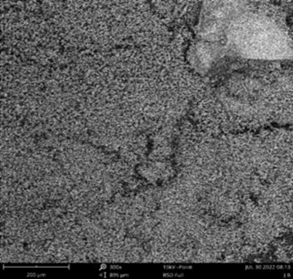

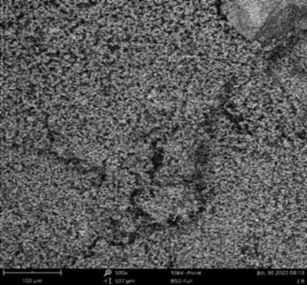

Figure 4. 1**:** Surface Morphology of the SSOPC

The surface morphology of SSOPC synthesized from Achatina fulica snail shells and unripe plantain orange peels was examined using scanning electron microscopy (SEM) pictures at various magnifications, as shown in Fig.4.1. The catalyst appears to generate a lump mass of particles with pores of varying physical properties.

The characterisation of a heterogeneous catalyst refers to the determination of physical and chemical properties that are responsible for the catalyst's performance in a reaction. X-ray fluorescence was used to investigate the catalyst (XRF).

## 4.2.3. Oxide composition of the SSOC

Table 4.3 shows the results of an analysis of the oxides present and their compositions in the SSOC. CaO, a basic oxide, was the most abundant oxide found, accounting for 44.865% of the catalyst's composition. Other basic oxides discovered in the catalyst included MgO (0.2933%) and K2O (0.3089%). The acid oxides SO3 and P2O5 were also detected in the catalyst, with concentrations of 0.9388 and 0.5761%, respectively. Amphoteric oxides, which are oxides with both acidic and basic characteristics, are present in the catalyst and had compositions of 0.0283 and 0.0275%, respectively.. The compositions of the other oxides are listed in the table

Table 4. 3: Percentage Oxides in the SSOPC

|  |  |
| --- | --- |
| Fe2O3 | 0.02674 |
| Cuo | 0.000021 |
| Nio | 0.000091 |
| Zno | 0.000186 |
| Al2o3 | 0.00184 |
| Mgo | 0.2933 |
| So3 | 0.9388 |
| P2O5 | 0.10682 |
| CaO | 44.227 |
| K2O | 0.3089 |
| MnO | 0.00139 |
| SrO | 0.04623 |
| WO3 | 0.0028 |

## 4.2.4. Crystal structure of the SSOPC

The findings of the XRD chromatogram point to the presence of caco3 in portlandite and calcite existing as two distinct phases. The peaks of the calcite were observed at.2 degrees at 23.12 degrees, 28.82 degrees, 36.06 degrees, 39.52 degrees, 43.24 degrees, 47.65 degrees, 48.67 degrees, 57.43 degrees, 60.69 degrees, and 65.81 degrees. In addition, the peak at the portlandite was seen to be 18.13 degrees, 29.52 degrees, 34.19 degrees, 43.27 degrees, 50.97 degrees, 64.69 degrees, and 71.96 degrees.

The process of calcination has been shown to accelerate the transformation of calcium carbonate into calcium oxide.

Figure 4. 2**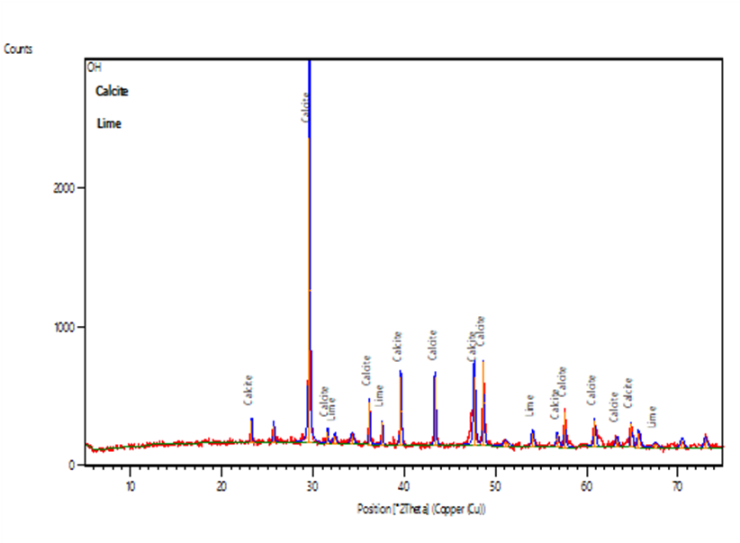:** Crystal structure of the SSOPC

## 4.2.5. Functional groups present in the SSOPC

The catalyst's FTIR spectra revealed IR bands that related to CaCO3. The OH stretching vibration of the hydroxyl is responsible for the broad transmission band at 4000 cm1. Sharp peaks at 3650 cm-1 are caused by OH stretching vibrations, and another peak at 3450 cm-1, 3150 cm-1, 2850 cm-1, and 1600 are typical characteristic peaks for CaCO3 C-O stretching and bending modes..

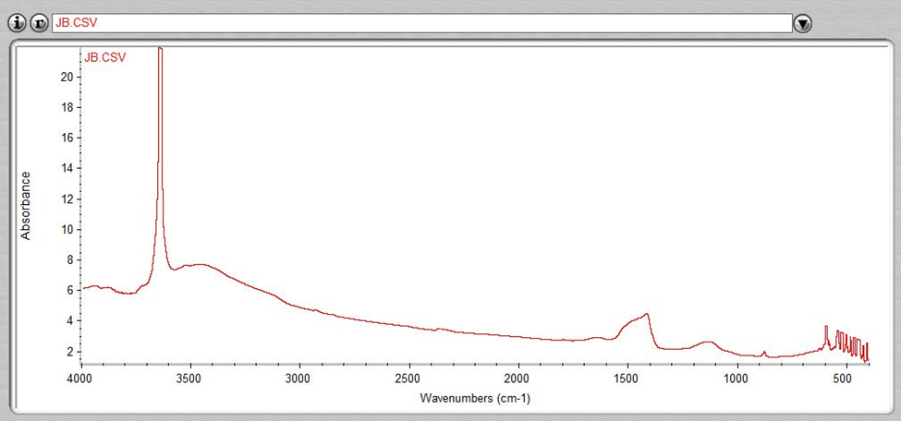  
Figure 4. 3**:** The FTIR spectrum of SSOPC

Table 4. 4: Taguchi Experimental Design Matrix and Values of Responses.

|  |  |  |  |  |  |  |  |
| --- | --- | --- | --- | --- | --- | --- | --- |
|  | Factor 1 | Factor 2 | Factor 3 | Factor 4 | Factor 5 | Response1 | Response 2 |
| Run | A:Methanol:Oil | B:Catalyst Loading | C:Temperature | D:Agitation Speed | E:Time | NOME Yield | Acid Value |
|  | mol/mol | wt.% | deg. C | Rpm | min | wt.% | mg KOH/oil |
| 1 | 15:01 | 3 | 65 | 642.78 | 150 | 78.48 | 0.422 |
| 2 | 15:01 | 5 | 55 | 928.46 | 90 | 76.58 | 0.353 |
| 3 | 9:01 | 2 | 60 | 928.46 | 150 | 74.55 | 0.61 |
| 4 | 12:01 | 4 | 55 | 785.62 | 150 | 74.33 | 0.428 |
| 5 | 6:01 | 2 | 55 | 642.78 | 60 | 76.43 | 0.387 |
| 6 | 12:01 | 3 | 70 | 928.46 | 60 | 76.73 | 0.58 |
| 7 | 9:01 | 5 | 65 | 785.62 | 60 | 78.58 | 0.582 |
| 8 | 9:01 | 4 | 70 | 642.78 | 90 | 70.38 | 0.584 |
| 9 | 6:01 | 4 | 65 | 928.46 | 120 | 75.71 | 0.501 |
| 10 | 12:01 | 2 | 65 | 1071.3 | 90 | 77.92 | 0.857 |
| 11 | 15:01 | 2 | 70 | 785.62 | 120 | 74.12 | 0.413 |
| 12 | 6:01 | 5 | 70 | 1071.3 | 150 | 71.42 | 0.754 |
| 13 | 12:01 | 5 | 60 | 642.78 | 120 | 78.03 | 0.635 |
| 14 | 9:01 | 3 | 55 | 1071.3 | 120 | 70.02 | 0.792 |
| 15 | 6:01 | 3 | 60 | 785.62 | 90 | 75.68 | 0.515 |
| 16 | 15:01 | 4 | 60 | 1071.3 | 60 | 83.48 | 0.734 |

# 4.3. ANALYSIS OF VARIANCE OF THE ESTERIFICATION AND TRANSESTERIFICATION PROCESS

## 4.3.1. Statistical ANOVA of Esterification and Transesterification Process

The Taguchi L16 experimental design was utilized to achieve variations in the sets of parameters needed for the SSOPC catalyzed one-way generation of biodiesel from NSO. Using the experimental parameters created by Taguchi as indicated in Table 4.4, the catalytic one-way esterification and transesterification processes were performed. The results are also displayed in the table. For the selected model, statistical analysis was done on the biodiesel yield and Acid Value. ANOVA was used to construct a powerful mathematical model. High sum of squares parameters were chosen for the model, while low sum of squares parameters were disregarded..

The FFA Value and Biodiesel Yield ANOVA findings.

Table 4.5 and Table 4.6 from Table 4.5 contain the ANOVA results for the biodiesel yield and acid value, respectively. The biodiesel yield model's F-value was 71.92 and its probability value (p-value) was 0.0001. The p-value for a model needs to be lower than 0.5 in order to be considered significant. To determine the relevance of each parameter, the p-value was utilized. The most significant factor affecting the biodiesel output was the agitation speed, which had an F-value of 22.66 and a sum of squares value of 46.94, followed by the methanol-to-oil molar ratio, which had an F-value of 121.17.

The ANOVA findings for the Acid Value presented in Table 4.6 had a model with an F-value of 77.96 and a p-value <0.0001. The only variable significantly affect the Acid Value is catalyst loading, being the most important with a sum of squares value of 31.01 and an F-value of 77.96.

Table 4. 5: ANOVA for the Biodiesel Yield Model

|  |  |  |  |  |  |  |
| --- | --- | --- | --- | --- | --- | --- |
| **Source** | **Sum of Squares** | **Df** | **Mean Square** | **F-value** | **P-value** |  |
| Model | 297.92 | 6 | 49.65 | 71.92 | < 0.0001 | Significant |
| A-Methanol:Oil | 250.97 | 3 | 83.66 | 121.17 | < 0.0001 |  |
| D-Agitation Speed | 46.94 | 3 | 15.65 | 22.66 | 0.0002 |  |
| Residual | 6.21 | 9 | 0.6904 |  |  |  |
| Cor Total | 304.13 | 15 |  |  |  |  |

Table 4. 6: ANOVA for the Acid Value Model.

|  |  |  |  |  |  |  |
| --- | --- | --- | --- | --- | --- | --- |
| **Source** | **Sum of Squares** | **Df** | **Mean Square** | **F-value** | **P-value** |  |
| Model | 31.01 | 3 | 10.34 | 77.96 | < 0.0001 | Significant |
| B-Catalyst Loading | 31.01 | 3 | 10.34 | 77.96 | < 0.0001 |  |
| Residual | 1.59 | 12 | 0.1326 |  |  |  |
| Cor Total | 32.6 | 15 |  |  |  |  |

## 4.3.2. Regression Model

Only responses with a 95% confidence level were taken into account when creating the mathematical model for the response; the model for the responses stated in terms of coded factors is shown in Eq (5). While Eq. (5b) displays the Acid Value mode, Eq. (5a) displays the model for the biodiesel yield.

Biodiesel yield (wt.%)

= 75.78 ‒ 0.9675[1] ̶ 2.40[2] + 0.9750[3] ̶ 1.44[1] + 2.16[2]

+ 1.89[3] +3.03[1] ‒ 0.6375[2] ̶ 1.31[3] …………………….. (5𝑎)

Acid Value

= 0.5717 ̶ 0.0324[1] + 0.0703[2] + 0.0533[3] ̶ 0.0817[1]

+ 0.0518[2] ‒ 0.8388[3] ‒ 0.647[1] ̶ 0.0872[2] ‒ 0.0607[3] ……………….5(b)

The methanol-to-oil molar ratio, catalyst loading, reaction, temperature, agitation speed, and time are represented by the letters A through E, respectively. Within a set of parameters, the model can be used to predict the responses because each parameter's level is given by [1] [2] [3]. The results of the plot are displayed in Fig. 4.4. The projected biodiesel output and Acid Value for biodiesel generation from NSO are plotted against the actual values. The fact that the data points in both plots are near to the diagonal line, demonstrating that the projected and actual reactions were quite similar, supports the model's suitability for reliably forecasting acid value and biodiesel yield..

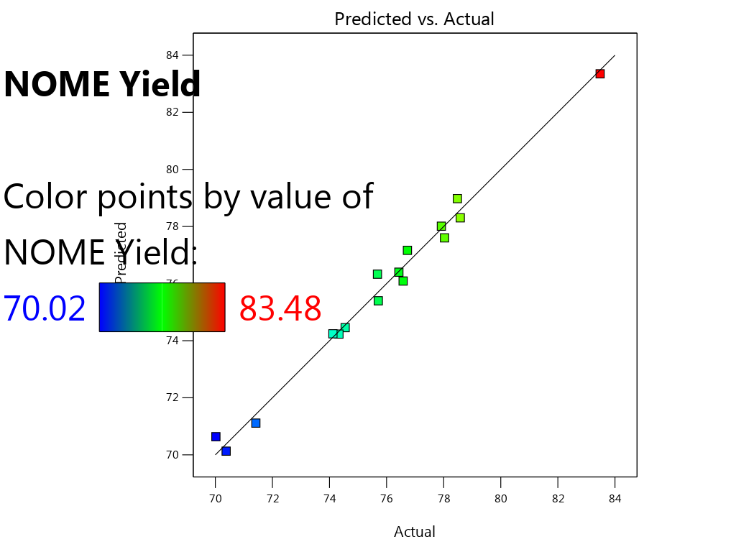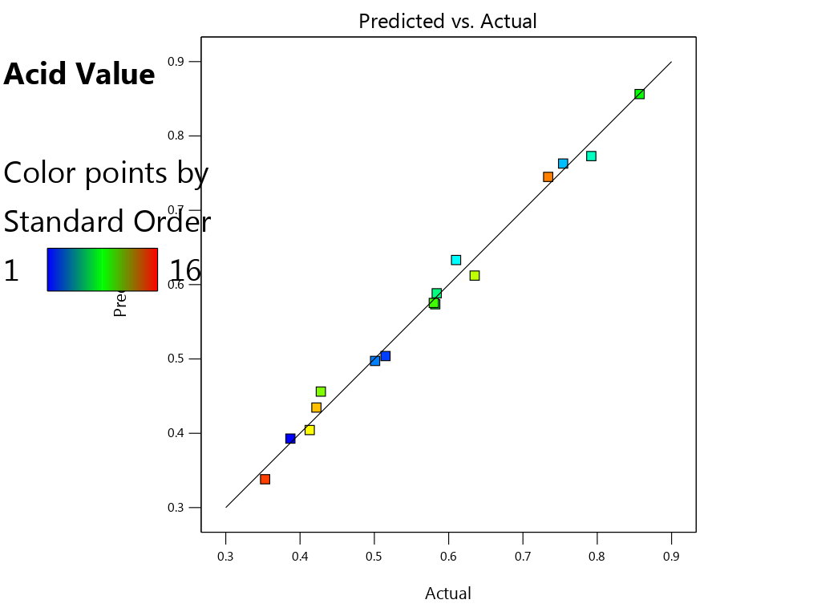

Figure 4. 4**:** Predicted and Actual Value of Biodiesel Yield and Acid Value

## 4.3.3. Fit Statistics

Fit statistics were run on the data to further support their model fitness. Table 4.6 displays the results of the fit statistics for both models. The Acid Value and Biodiesel Yield coefficients of determination (R2) were 0.9796 and 0.9512, respectively. An approximate value of unity is preferred. The predicted and adjusted R2 for both models were reasonably close to one another, with discrepancies of less than 0.2. The models' appropriate R2 precisions, which were 26.9927 and 19.9246, were both higher than 4. The numbers for both models show a sufficient signal that can be used to move about the design area..

Table 4. 7: Model fit Statistics for the One Pot Biodiesel Synthesis

For Biodiesel Yield

|  |  |  |  |
| --- | --- | --- | --- |
| Std. Dev. | 0.8309 | R² | 0.9796 |
| Mean | 82.16 | Adjusted R² | 0.9659 |
| C.V. % | 1.01 | Predicted R² | 0.9354 |
|  |  | Adeq Precision | 26.9927 |

For Acid Value

|  |  |  |  |
| --- | --- | --- | --- |
| Std. Dev. | 0.3641 | R² | 0.9512 |
| Mean | 93.37 | Adjusted R² | 0.939 |
| C.V. % | 0.39 | Predicted R² | 0.9132 |
|  |  | Adeq Precision | 19.9243 |

# 4.4. EFFECT OF PROCESS PARAMETERS ON BIODIESEL YIELD AND ACID VALUE

Investigations were also conducted on how the significant parameters affected the responses. As stated previously, the catalyst loading and reaction temperature were determined to be the variables of the oil's acid value, while the methanol-to-oil molar ratio, agitation speed, and reaction duration were discovered to have a substantial impact on the biodiesel production..

## 4.4.1. Effect of Methanol-To-Oil Molar Ratio

The molar ratio of methanol to oil is one of the key factors impacting the biodiesel output. Transesterification is a reversible process, thus it's crucial to employ extra methanol to maintain the forward reaction. The remaining parameters were held constant at a catalyst loading of 2 weight percent, reaction temperature at 55 oC, agitation speed at 642.78 rpm, and time at 60 min. in order to examine the impact of methanol-to-oil molar ratio on biodiesel yield. Fig. 4.4 displays the fluctuations in the biodiesel yield at various methanol-to-oil molar ratios. According to the plot, the biodiesel yield increased when the methanol-to-oil molar ratio decreased from 6:1 to 9:1. However, a higher methanol-to-oil ratio than 9:1 resulted in a higher biodiesel production. This might be explained by the rise in the methanol-to-oil ratio, which caused an increase. Also to be considered is the possibility that excessive methanol consumption could reduce conversion, which would inevitably cause equilibrium to move in the opposite direction. (Corro et al., 2016).

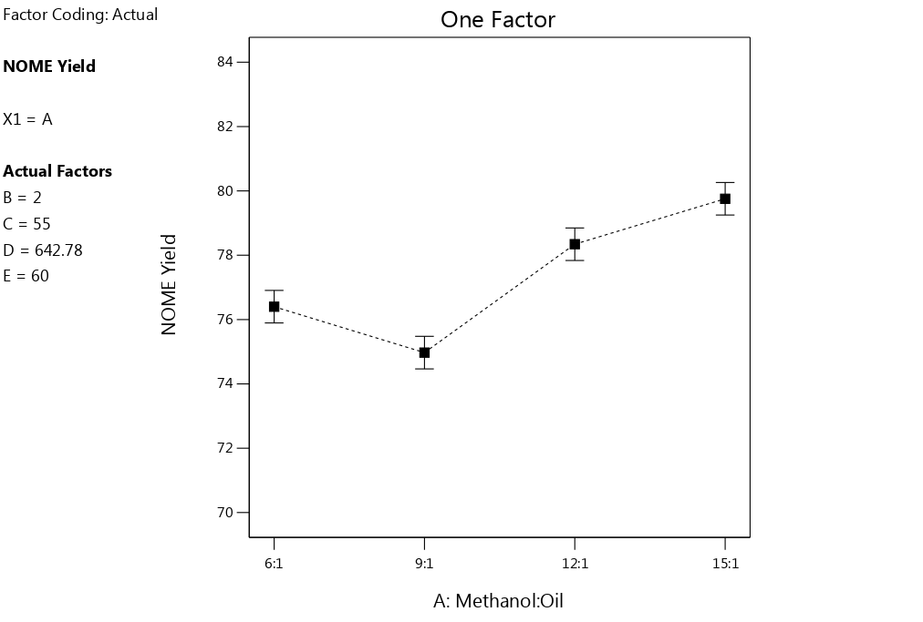

Figure 4. 5**:** Effect of methanol-To-Oil Molar Ratio on Biodiesel Yield.

## 4.4.2. Effect of Reaction Temperature on Biodiesel yield

The production of biodiesel is significantly impacted by the temperatures of the catalyzed reactions. High temperatures are typically necessary for the majority of heterogeneously catalyzed processes to go to completion (Dantas et al., 2017; Mardhiah, Ong, Masjuki, Lim, & Lee, 2017). According to the plot, the biodiesel yield increased as the temperature rose from 55 to 60. However, the production of biodiesel decreased as the temperature rose over 60. This might be explained by the possibility of product deterioration and reactant loss as a result of temperature increases. The effect of temperature on Biodiesel yield of the oil is shown in Fig.4.5.

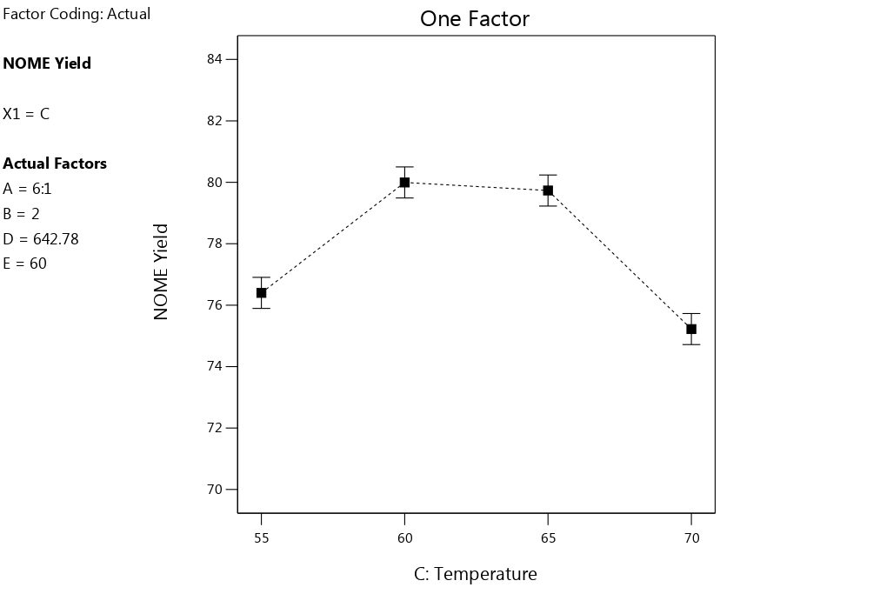

Figure 4. 6**:** Effect of Temperature on Biodiesel yield

## 4.4.3. Effect of Reaction Time on Biodiesel Yield

The reactants need enough time to interact in order to ensure maximal biodiesel generation. Figure 4.6 depicts how the reaction time affects the biodiesel yield. The conditions were maintained at a 6:1 methanol-to-oil ratio, a 2 weight percent catalyst loading, a temperature of 55 oC, and an agitation speed of 642.78 rpm. According to the plot, when the reaction time extended from 60 to 90 minutes, the biodiesel yield significantly reduced. However, the biodiesel yield declined when the reaction time was increased to 150 minutes, whereas it increased when the reaction time was increased to 120 minutes..

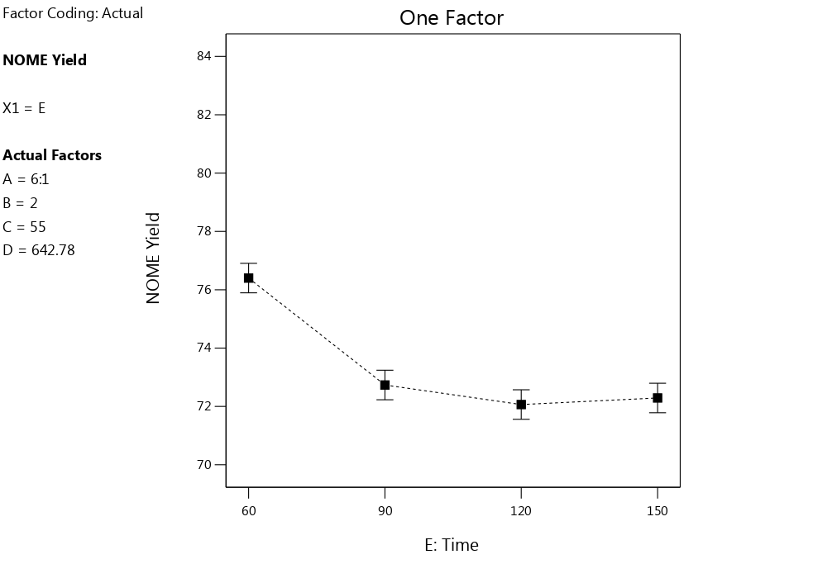

Figure 4. 7**:** Effect of Reaction Time

## 4.4.4. Effect of Methanol-To-Oil Molar Ratio on Acid Value

The molar ratio of methanol to oil is one of the key factors impacting the biodiesel output. The other parameters were held constant at a catalyst loading of 2 weight percent, reaction temperature at 55 oC, agitation speed at 642.78 rpm, and time at 60 min. to evaluate the effect of methanol-to-oil molar ratio on FFA conversion. Fig. 4.7 displays the difference in acid value at various methanol-to-oil molar ratios. According to the plot, the Acid Value increased when the methanol to oil molar ratio was raised from 6:1 to 9:1. However, the Acid Value decreased when the methanol-to-oil ratio exceeded 9:1.

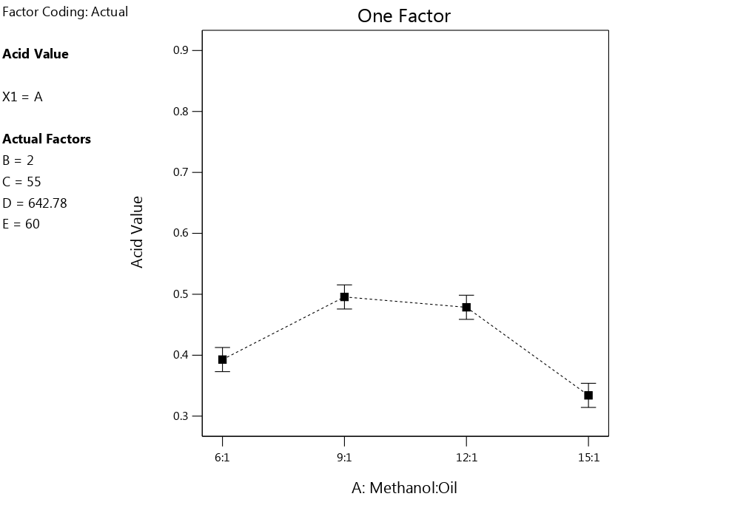

Figure 4. 8**:** Effect of methanol/ oil ratio on Acid Value.

## 4.4.5. Effect of Reaction Temperature on Acid Value

The molar ratio of methanol to oil is one of the key factors impacting the biodiesel output. The other parameters were held constant at a catalyst loading of 2 weight percent, reaction temperature at 55 oC, agitation speed at 642.78 rpm, and time at 60 min. to evaluate the effect of methanol-to-oil molar ratio on FFA conversion. Fig. 4.7 displays the difference in acid value at various methanol-to-oil molar ratios. According to the plot, the Acid Value increased when the methanol to oil molar ratio was raised from 6:1 to 9:1. However, the Acid Value decreased when the methanol-to-oil ratio exceeded 9:1. But there was significant change in Acid Value when the temperature was move from 65 to 70.oC.

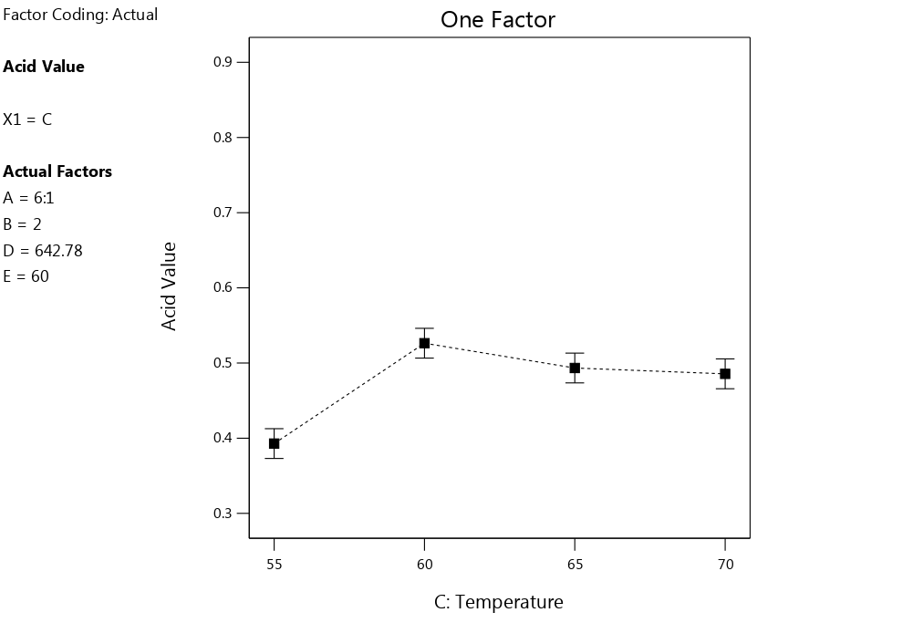

Figure 4. 9: Effect of Reaction Temperature on Acid Value.

## 4.4.6. Effect of Agitation Speed on Acid Value.

An important consideration is the agitation speed, which is related to the mixing intensity. By increasing the interactions between reactants, mixing intensity helps a chemical reaction. While keeping the other variables (a 6:1 methanol-to-oil molar ratio, a 2 w% catalyst loading, a reaction temperature of 55 oC, and a reaction time of 60 min), Figure 4.8 illustrates the effect of agitation speed on the biodiesel yield. According to the plot, the Acid Value did not significantly alter as the agitation speed increased from 642.78 to 785.62 rpm. At 1071.30 rpm, the greatest Acid Value was recorded. From the plot, increasing agitation speed lead to increase in Acid Value.

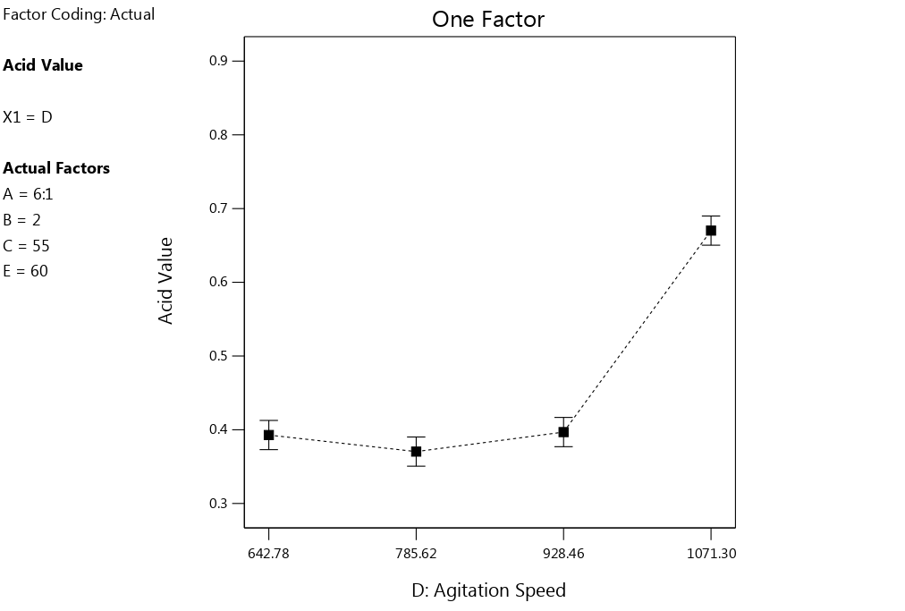 Figure 4. 10: Effect of Agitation Speed on Acid Value**.**

# 4.5. OPTIMISATION AND MODEL VALIDATION

It was important to optimize the one-way manufacture of biodiesel from NSO in order to comprehend the best values of parameters that can maximize the NSO biodiesel yield and FFA conversion. The settings were set within their limitations using numerical optimization. This was due to the fact that the methanol-to-oil molar ratio, catalyst loading, and duration all had a substantial effect on the biodiesel yield, whereas the methanol/oil ratio, agitation speed, and temperature all had a significant effect on the Acid Value. The optimum conditions obtained for the present study were as follows:

15:1 methanol-to-oil molar ratio, 2 weight percent catalyst loading, 55 °C reaction temperature, 642.78 rpm agitation speed, and 120 min reaction time resulted in 94.05 weight percent biodiesel production and an acid value of 0.3341. Confirmatory experiments were run to verify the model, and 93.63 weight percent of biodiesel output and an Acid Value of 0.3158 mgKOH/g were obtained.

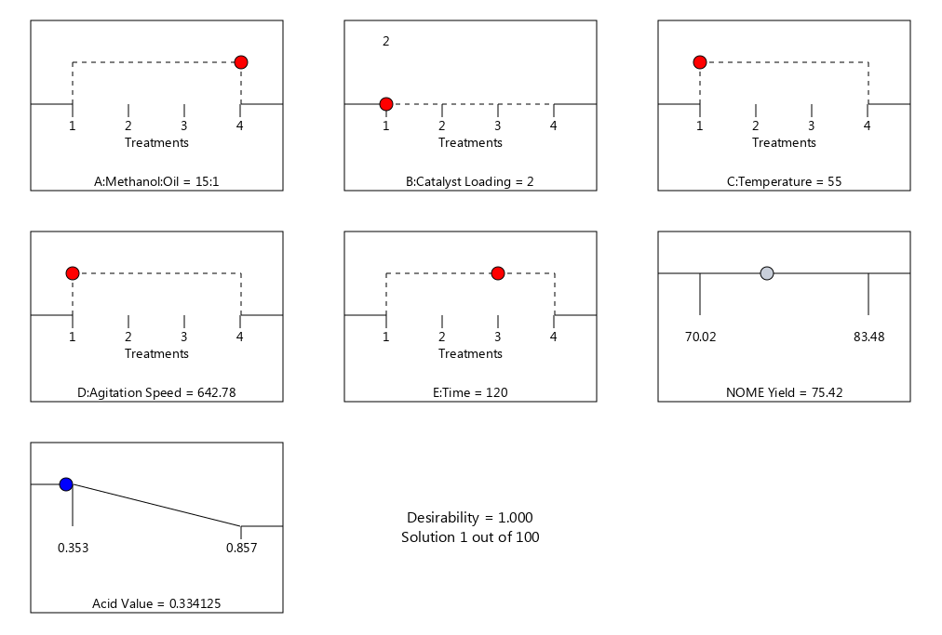

Figure 4. 11: Model Validation

# CHAPTER FIVE

# CONCLUSION AND RECOMMENDATIONS

# 5.1 CONCLUSION

The development of a bio-based bifunctional catalyst from the Shells of Snail and Orange peels was found to be very effective with basic and acidic oxides present in substantial amounts in the present study. The developed catalyst was found to have a BET surface area of a pore diameter of and a pore. The catalyst was used for one –way esterification and transesterification of neem seed oil and the process was optimized using the Taguchi L16 approach. Under optimised conditions of a methanol-to-oil molar ratio of 15:1, catalyst loading of 2 wt.%, reaction temperature of 60 oC, agitation speed of 642.78 rpm and a agitation time of 120 min, biodiesel yield of 85% and Acid Value 0.3341mgKOH/g were achieved respectively. Physio-chemical properties of the biodiesel obtained using the catalyst were within the appropriate range of ASTM D6751 and EN specifications for biodiesel.

# 5.2 RECOMMENDATIONS

The following recommendations are suggested:

1. The kinetics of biodiesel production using the developed catalyst should be carried out.
2. The production process should be carried out under reflux and comparative study undertaken.

# REFERENCES

Furuta, S., Matsulashi, H., and Arata, K (2004). In: Ejikeme, P.M , Anyaogu, I. D., EJikeme, C. L., Nwafor, N. P., Egbuogu, A.C., Ukogu, K., and Ibenesi, J.A (2010). Catalysis in Biodiesel roduction by Transesterification processes-An Insight*. E-Journal of Chemistry,* 7 (4):1120-1132.

Gaydou, A.M., Menet, L., Ravelojaona, G., and Geneste, P., (1982). Vegetable Energy Source, in Madagascar: ethyl alcohol and oil seeds (French) *oleagineux* 37(3): 135-141.

Gangadhara, R. and Prasad, N. B. L. (2016) ‘Studies on optimization of transesterification of certain oils to produce biodiesel’, pp. 59–69.

Gerpen, J. Van (2005) ‘Biodiesel processing and production’, 86, pp. 1097–1107. doi: 10.1016/j.fuproc.2004.11.005.

Hassan, M. H. and Kalam, A. (2013) ‘An overview of biofuel as a renewable energy source : development and challenges’, *Procedia Engineering*. Elsevier B.V., 56, pp. 39–53. doi: 10.1016/j.proeng.2013.03.087.

Heterogeneous, S. *et al.* (2012) ‘BIODIESEL FROM TRANS-ESTERIFICATION OF TRIGLYCERIDES WITH METHANOL : A REVIEW’, 2(1), pp. 72–78.

Ilgen, O., and Akin, A. N. (2009). Development of alumina supported alkaline catalyst used for biodiesel production. Turk. J. chem., 33:281-287.

A.C., Ukogu, K., and Ibenesi, J.A (2010). Catalysis in Biodiesel Production by Transesterification processes-An Insight*. E-Journal of* *Chemistry,* 7 (4):1120-1132.

Akhabue, C. E., & Ogogo, J. A. (2018). Modelling and optimisation of transesterification of palm kernel oil catalysed by calcium oxide derived from hen eggshell wastes. Ife Journal of Science, 20(1), 127. https://doi.org/10.4314/ijs.v20i1.13

Akhabue, C. E., Osa-Benedict, E. O., Oyedoh, E. A., & Otoikhian, S. K. (2020). Development of a bio-based bifunctional catalyst for simultaneous esterification and transesterification of neem seed oil: Modeling and optimisation studies. Renewable Energy, 152. https://doi.org/10.1016/j.renene.2020.01.103

Alaei, S., Haghighi, M., Toghiani, J., & Rahmani Vahid, B. (2018). Magnetic and reusable MgO/MgFe2O4 nanocatalyst for biodiesel production from sunflower oil: Influence of fuel ratio in combustion synthesis on catalytic properties and performance. Industrial Crops and Products, 117, 322–332. https://doi.org/10.1016/j.indcrop.2018.03.015

Aleman-Ramirez, J. L., Moreira, J., Torres-Arellano, S., Longoria, A., Okoye, P. U., & Sebastian, P. J. (2021). Preparation of a heterogeneous catalyst from moringa leaves as a sustainable precursor for biodiesel production. Fuel, 284. https://doi.org/10.1016/j.fuel.2020.118983

Belafi-bako, K.F., Kovacs, L.G., and Hancsok, J. (2002). Enzymatic Biodiesel production from sunflower by Candida antartica lipase in a solvent-free system. *Biocatalysts Biotrans.,* 20: 437-439.

Benzonana, G. and Densnelle, P., (1968). Action of some effectors on the hydrolysis of long chain triglycerides by pancreatic lipase.

Bhasabutra, R., and Sutiponpeibum, S. (1982). Jatropha curcas oil as a substitute for diesel engine oil. *Renewable Energy Review Journal*, 4: 56-70.

Bhatti, H.N., M.A. Hanif, M. Qasim and A. Rehman, (2008). Biodiesel production from waste tallow. *Fuel,*87:2961-2966.

Bridgwater, T., (2006). Biomass for Energy. *Journal of the Science of Food and Agriculture*, 6: 1755-1768.

Chakraborty, (1998). Enzyme hydrolysis of solid tannery waste, solid sate enzyme production. *Journal of the Society of Leather Technology and Chemists*, 2 (2):56-58.

Chandler, I.C.( 2001).Determining the regioselectivity of immobilized lipases in triacylglycerol acidolysis reactions. *Journal of Am. Oil Chem. Soc*., 78: 737-742.

Chen, G., M. Ying and W.Li (2006). Enzymatic Conversion of Waste Cooking Oil into Alternative fuel –Biodiesel. Applied Biochem. Biotechnol., 129:911-921.

Chen, J.W. and W.T. Wu, ( 2003). Regeneration of immobilized*Candida Antarctica* lipase for transesterification. *Journal of Biosci. Bioen*g., 95: 466-469.

Coggon, R.,P.T.Vasudevan and F.Sanchez,(2007).Enzymatic Transesterification of olive oil and its precursors.*Biocatal. Biotrans*. J*ournal*, 25: 135-143.

Crabba E, Nolasco-Hipolito C, Kobayashi G, Sonomoto K and Tshizaki A, (2001). Biodiesel Production from Crude Palm Oil and Evaluation of Butanol Extraction and Fuel Properties. *Process Biochemistry*, 37(1): 67-71

Cvengros, J. and F. Povazanec. (1996). Production and Treatment of rapeseed Oil Methyl Esters as Alternative Fuels for Diesel Engines. *Bioresource* *Technology* 55: 145 – 152.

Demirbas, A., ( 2008).Relationships derived from physical properties of vegetable oil and biodiesel fuels.*Fuel*,87:1743-1748.

Demirbas, A., (2003). Biodiesel fuels from vegetable oils via catalytic and non-catalytic supercritical alcohol transesterifications and other methods, a survey. *Energy* *Conver. Manage*., 44: 2093-21.

Diwarker, V. J. M. (1993). Energy from the humble Castor. The Indian express. Dizge, N and B. Keskinler (2008). Enzymatic Production of Biodiesel from Canola Oil using Immobilized Lipase. *Biomass Bioenergy*, 32:1274-1278.

Du, W., W. Li, T. Sun, X. Chen and D. Liu (2008). Perpectives for Biotechnological Production of Biodiesel and Impact. *Applied Microbial Biotechnol.*, 79:331- 337.

Edem. D.O. (2000).Palm oil; Biochemical, physiological, nutritional, heamatological, and toxicological aspects. *A review, Kluwer academic Publishers,* 57: 319-341.

Ejikeme P M, Egbuonu C A C and Anyaogu I D, (2008). Fatty Acid Methyl Esters of Melon Seed Oil, Characterization for Potential Fuel Applications, Book of Proceedings, Coalcity Chem, Enugu-Nigeria. Fairless, D (2007). Biofuel :The Little Shrubs that could may be Nature, 449: 652-655.

Emil, A., Yakubu, Z., Kamaruah, S. K., Ismail, M., and Salimon, J. (2009). Characteristic and composition of Jatropha curcas oil seed from Malaysia and its potential as biodiesel feedstock. *European journal of scientific Research*, 29 (3): 396-403.

Ergun, N. and P. Panning. (2002). Method for Producing Fatty Acid, Esterification of Lactic Acid. *Biotechnology Letters* 19(4): 315 –317.

Farooq, M. and Ramli, A. (2015) ‘Biodiesel production from low FFA waste cooking oil using heterogeneous catalyst derived from chicken bones’, *Renewable Energy*. Elsevier Ltd, 76, pp. 362–368. doi: 10.1016/j.renene.2014.11.042.

Fjerbaek, L., K.V. Christensen and B. Norddahl, (2009).A review of the current state of biodiesel production using enzymatic transesterification. *Biotechnol.Bioeng*., 102: 1298-1315.

Formo, M. W. (1954). In: Ejikeme, P.M , Anyaogu, I. D., EJikeme, C. L., Nwafor, N. P., Egbuogu,

Francis, A. (1988). Bussiness maths and statistic, 2nd Ed. DP Publication Ltd. Aldine place, London W128AN. Pp 64-99.

Freedman B, Butterfield R O and Pryde E H, (1986). In: Ejikeme, P.M , Anyaogu, I. D., EJikeme, C. L., Nwafor, N. P., Egbuogu, A.C., Ukogu, K., and Ibenesi, J.A (2010). Catalysis in Biodiesel Production by Transesterification processes- An Insight*. E-Journal of Chemistry,* 7 (4):1120-1132

Freedman, B., E.H. Pryde, and T.L. Mounts, (1984). Variables Affecting the Yields of Fatty Esters from Transesterified Vegetable Oils. *Journal of American Oil Chem. Society*, 61: 1638-1643.

Fukuda, H., A. Kondo and S. Tamalampudi, (2009).Bioenergy: Sustainable fuels from biomass by yeast and fungal whole-cell biocatalysts. *Biochem. Eng. Journal*., 44: 2-12.

Fukuda, H., S. Hama, S. Tamalampudi and H. Noda, (2008). Whole-cell biocatalysts for biodiesel fuel production. Trends *Biotechnol*., 26: 668-673.

Fukuda, H.,A. Kondo and H. Noda.( 2001). Biodiesel fuel production by transesterification of oils. *Journal of Biosci. Bioeng*., 92: 405-416.

Jairam, S., Kolar, P., Sharma-shivappa, R., Osborne, J. A., and Davis, J. P. (2012). KI impregnated oyster shell as solid catalyst for soybean oil transesterification. Bioresources Technology., 104: 329-335.

Jharna, G., and Madhu, A. (2016). Preparation and characterization of highly active solid base catalyst from snail shell for biodiesel production. Biofuels

Jyoti, M. *et al.* (2019) ‘Transesteri fi cation of waste cooking oil for biodiesel production catalyzed by Zn substituted waste egg shell derived CaO nanocatalyst’, *Fuel*. Elsevier, 242(May 2018), pp. 345–354. doi: 10.1016/j.fuel.2019.01.060.

Kadapure, S. A. *et al.* (2018) ‘Studies on process optimization of biodiesel production from waste cooking and palm oil’, *International Journal of Sustainable Engineering*. Taylor & Francis, 7038(January), pp. 1–6. doi: 10.1080/19397038.2017.1420107.

Knothe, G. and Gerpen, J. Van (2005) *The Biodiesel Handbook Editors*.

Kumar, A., Osembo, S. O., Namango, S. S., and Kiriamiti, K. H. (2012). Proceedings of the 2012 Mechanical Engineering Conference on Sustainable Research and Innovation, Volume 4, 3rd-4th May 2012.

Kumar, A., Valoyi, R., Aoyiochieng and Onayango, M. (2002). Acid-Base transesterification of oil with high free fatty acid content. Journal of Biosciences Bioengineering.2002; 67: 77-82.

Kumari, A., Mahapatra, P., Garlapati, V. K., and Banerjee, R. (2009). Enzymatic transesterification of Jatropha oil. Biotechnology for Biofuels, 2009, 2:1.

Lam, M. K., Lee, K. T. and Mohamed, A. R. (2010) ‘Homogeneous , heterogeneous and enzymatic catalysis for transesteri fi cation of high free fatty acid oil ( waste cooking oil ) to biodiesel : A review’, *Biotechnology Advances*. Elsevier Inc., 28(4), pp. 500–518. doi: 10.1016/j.biotechadv.2010.03.002.

Mardhiah, H. H. *et al.* (2017) ‘A review on latest developments and future prospects of heterogeneous catalyst in biodiesel production from non-edible oils’, *Renewable and Sustainable Energy Reviews*. Elsevier, 67, pp. 1225–1236. doi: 10.1016/j.rser.2016.09.036.

Manieniyan, V., Kumar, R.S., and Dr. Sivaprakasan, S. (2006). Experimental investigation on optimized biodiesel (based on various catalysts) used in a twin cylinder diesel engine. JAOCS, 2006; 830:836.

N., and Faungnawakij, K. (2012). Industrial eggshell wastes as the heterogeneous catalysts for microwave-assisted biodiesel production. Catalysis Today 190, 112-116.

Nor, W. *et al.* (2011) ‘Optimization of heterogeneous biodiesel production from waste cooking palm oil via response surface methodology’, *Biomass and Bioenergy*. Elsevier Ltd, 35(3), pp. 1329–1338. doi: 10.1016/j.biombioe.2010.12.049.

Nurul, H. M. G., Jolius, G., and Said, N. (2014). Transesterification of waste cooking oil using chemically treated catalyst. Journal of Applied Sciences, 14: 1425-1429.

Nurul, H. M. G., Jolius, G., and Said, N. (2014). Transesterification of waste cooking oil using chemically treated catalyst. Journal of Applied Sciences, 14: 1425-1429.

Ragit, S. S. *et al.* (2010) ‘Optimization of neem methyl ester from transesterification process and fuel characterization as a diesel substitute’, *Biomass and Bioenergy*. Elsevier Ltd, 35(3), pp. 1138–1144. doi: 10.1016/j.biombioe.2010.12.004.

Romano, S. D., and Sorichetti, P. A. (2011). Dielectric spectroscopy in biodiesel production and characterization. Green Energy and Technology, Springer-Verlag London Limited.

Sathya, T. and Manivannan, A. (2013) ‘Biodiesel production from neem oil using two step transesterification’, 3(3), pp. 488–492.

Shankar, V., and Jambulingam, R. (2017). Waste crab shell derived CaO impregnated Na-ZSM-5 as a solid base catalyst for the transesterification of neem oil into biodiesel, Sustainable Environment Research.

Silva, G.F., Camargo, F.L., and Ferreira, A.L. (2011). Application of response surface methodology for optimization of biodiesel production by transesterification of soybean oil with ethanol. Fuel Processing Technology 92, 407-413.

Stamenkovi, O. S., Veljkovi, V. B. and Bankovi, I. B. (2012) ‘Biodiesel production from non-edible plant oils’, 16, pp. 3621–3647. doi: 10.1016/j.rser.2012.03.002.

Vinayaka, A. S. *et al.* (2018) ‘Biodiesel production by transesterification of a mixture of pongamia and neem oils’. Taylor & Francis, 7269(May). doi: 10.1080/17597269.2018.1464874.

Yusuf, N. N. A. N., Kamarudin, S. K. and Yaakub, Z. (2011) ‘Overview on the current trends in biodiesel production’, *Energy Conversion and Management*. Elsevier Ltd, 52(7), pp. 2741–2751. doi: 10.1016/j.enconman.2010.12.004.

# APPENDIX

Average molecular Weight of NSO = 874.19g/mol

Molecular weight of methanol = 32.04g/mol

Density of methanol = 0.792g/ml

Mass of oil per run of all optimised process = 50g

Where = methanol equivalent ratio

= Oil equivalent ratio

|  |  |  |  |  |
| --- | --- | --- | --- | --- |
|  |  |  |  |  |
|  |  |  |  |  | |
|  |  |  |  |  |
|  |  |  |  |  |