Assignment 3

Team 2: Riti Dabas, Anoushka Mahar, Dylan Koury

11/17/2021

## Summary

A company named Appshop is trying to decide the most lucrative contract terms for a new project, which requires them to implement Oracle software in seven international locations for their client. Their options include taking a lower monthly revenue than they originally proposed in the contract, an even lower monthly revenue with a potential added bonus, and to make a bid with competing offers. To help inform this problem, we built a decision tree outlining the potential options, and used this model to help calculate the expected value of each option with present value formulas, and in one case a simulation. Given this approach, we recommend that Appshop take Option 2: the bonus.

## Analysis

As previously mentioned, we have three options. In order to determine which option is best, we must calculate the expected payout in terms of present net value.

Option 1 offers a monthly revenue of 155,000 dollars.

Option 2 offers a monthly revenue of 125,000 dollars, however depending on Appshop’s performance they may earn an added bonus of 1.5 million dollars.

Option 3 requires Appshop to bid for the contract against competitors. They plan to offer 150,000 dollars as a Request for Proposal. Should they get the bid, Appshop would also qualify for a potential additional revenue depending on the realized savings their project would offer the client.

### Option 1

In order to get the expected value of this option we must first find the monthly profit. With a cost of labor of 140 dollars and Appshop working 1000 hours a month, the monthly cost is 140000 dollars. This means that given a monthly revenue of 155000, Appshop’s profit would be 15000 dollars. We must then discount this to present value.

Op1EV <- Op1Prof*((1-(1+DiscRate)^-Mths)/DiscRate)

Using Appshop’s monthly discount rate of 0.5%, the expected value is 338443.

### Option 2

The second option has a lower monthly revenue of 125000 dollars, which is less than our monthly costs of 140000 meaning we have a net loss of -15000 dollars. Discounting this to the present value the net loss is -338443 dollars.

This option offers a bonus at the end of the 24 months if the work is completed with commendable performance. The bonus is worth 1.5 million dollars. Appshop believes they have a 70% chance of receiving this bonus. Discounting 2 years to the present day with an annual rate of 6.17%, this bonus is worth 2743551 dollars.

Op2EV <- Op2EVProf + PBonus*(EVBonus)

With a 70% chance of receiving the bonus, the total expected value is 1582043 dollars.

### Option 3

## Warning: package 'triangle' was built under R version 4.1.1

The final option requires Appshop to make a bid against competing offers. They plan to offer to complete the project for 150000 dollars a month, giving them a monthly profit of 10000 dollars. Discounted to the present, that is 225629 dollars. Appshop believes that given their bidding strategy they have a 45% chance of winning the bid.

However, there is a possibility to receive a greater expected value depending on the realized savings their project will offer the client. In the appendix is a table describing the share of savings the winning bidder can expect given the realized savings of the project.

Forecasting the potential savings of this project, Appshop predicts a low of 3.2 million dollars, a high of 12.8 million dollars, and a most likely value of 5.6 million dollars.

In order to estimate the expected value of the share of savings given this triangle distribution, we simulated 100000 trial outcomes.

set.seed(123)  
savings <- rtriangle(n=rep,a=SavingsLow,b=SavingsHigh,c=SavingsLikely)  
shares <- c()  
for (i in savings) {  
 if (i < Mil4) {  
 shares <- c(shares, 0)  
 } else if (i < Mil6) {  
 shares <- c(shares, (i-Mil4)*.2)  
 } else if (i < Mil8) {  
 shares <- c(shares, 400000 + (i-Mil6)*.4)  
 } else {shares <- c(shares, 1200000 + (i-Mil8)*.6)}  
}

We found that the average savings were about 7195457 dollars, giving an average share of savings of 1049077 dollars. Discounted to the present that is 1918798 dollars.

Op3EV <- PWin*(Op3EVRev + EVShares)

Given the probability of winning the bid, the expected value of this option is 964992 dollars.

## Illustration

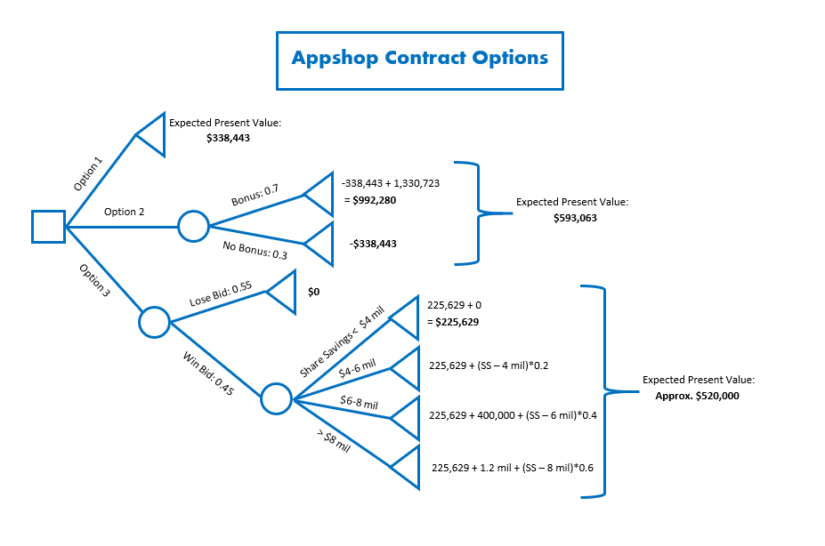

Decision Tree

## Conclusion

Our recommendation is for Appshop to choose the contract with the bonus, because it has the highest expected value. Despite this, there is still a 30% chance of walking away with a net loss of -338443 dollars. This recommendation assumes that Appshop is risk-neutral. If Appshop is more risk-averse, they may feel safer taking Option 1 which guarantees a positive net return. However, if Appshop were more risk-savvy they may be inclined to choose Option 3. With a 55% chance of walking away with nothing, they are more likely to win a coin toss; However, despite a 25% lower probability of a net gain than our current recommendation, option 3 offers the highest maximum revenue possible.

Another pitfall is that we are relying on the accuracy of numbers provided by Appshop to make our recommendations. Should the company’s actual chances of winning the bid be higher, or perhaps their chances of getting the bonus be lower, our recommendation may have been different. We have been provided no information with regard to how these numbers were calculated or any confidence interval with which to allow for sensitivity analysis.

We must also consider that there are other variables not covered or unknown to Appshop, such as a new potential competitor who can outbid Appshop. When considering a final decision, it is imperative to look at the pitfalls of this analysis as this recommendation would have Appshop take significant risks, including possibility of a severe loss. In addition to company resources spent on the OS-7 project, Clark’s compensation and workers’ hourly revenue depend on the financial performance of this project, and ultimately a more holistic approach involving risk consideration and sensitivity analysis is advised.

## Appendix

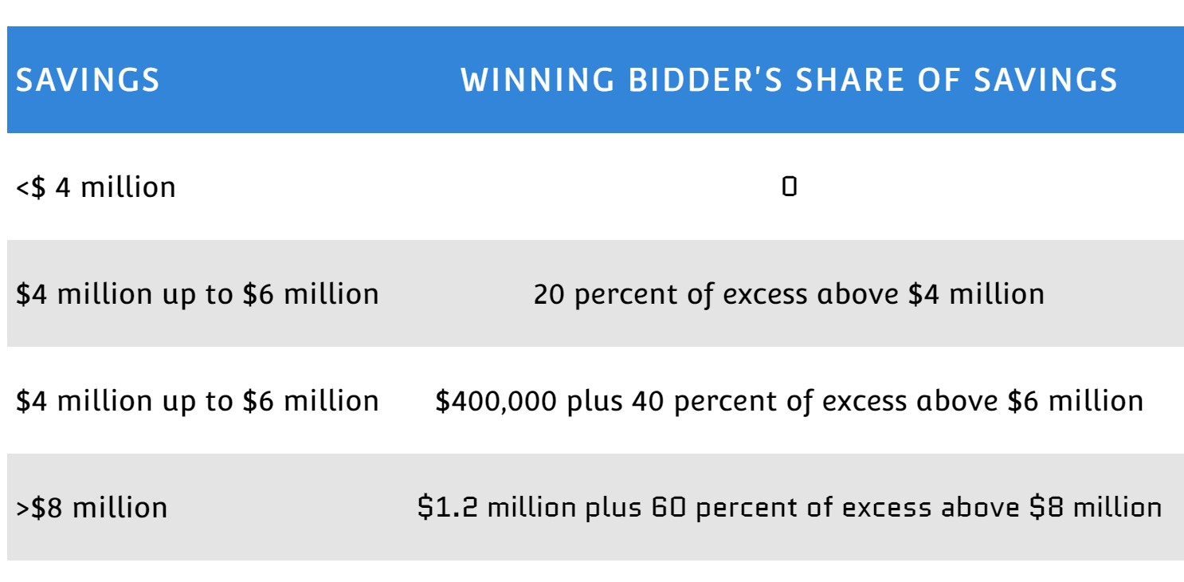

Share of Savings

