1. Query Tab
   1. Icons

* Data
* Combine
* Fusion
* Adapter
* Analytics
* Library
* Terminal
* Printer
* IO
* IF
* Connect
* Wait On
  + 1. To add Icons: For example, add data icon on canvas.

1. Click Data Icon,

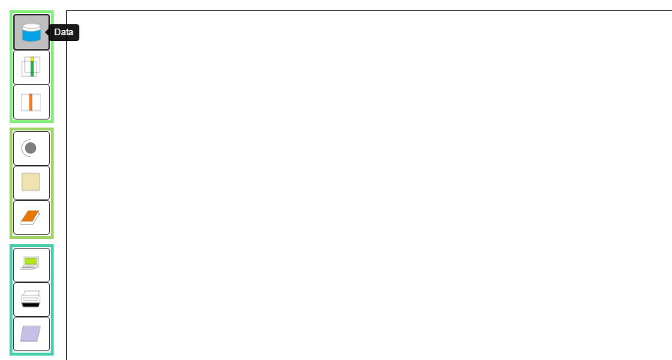

1. Click anywhere in the canvas, an icon will show up.

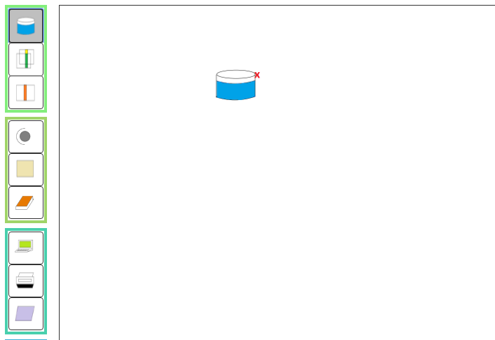

1. Continue click on the canvas to the more data icons,

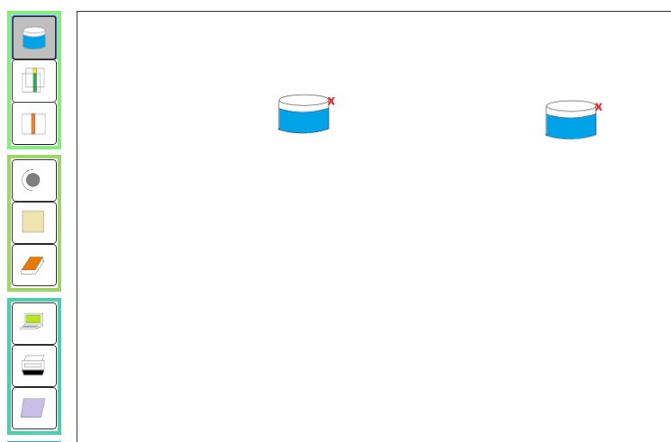

1. Click data icon again to stop adding.
   1. Control buttons

* Edge
* Select
* Delete
* UnDel
  + 1. Add Edges

1. Click edge button

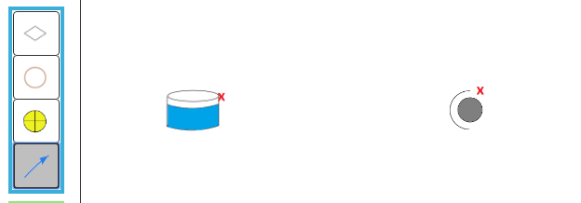

1. Left click on the data icon and hold, drag the edge to the adapter icon

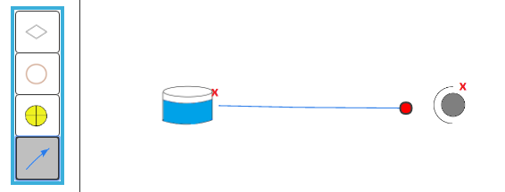

1. Release the button on adapter icon, then the new edge is present.

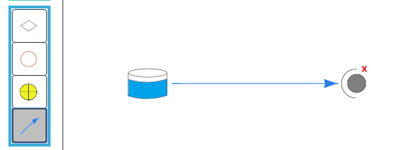

* + 1. Select button

Select button will allow you select icon and see the detailed information, the other way is directly click the icon. The only differences between select and directly click is the node information panel will pop up if it’s hidden by the user.

* + 1. Delete and Un-Delete button

You can delete an icon on canvas by click the delete button and click the icon. You also can delete an icon by select the icon first, then press the delete key on your keyboard to delete it. The un-delete button right now only will recover the last time you deleted icon.

* 1. Node Information panel

Node information panel is on the right side.

Machine generated alternative text:
Node Information 
y pe Data 
453BBd5E-ö44E-4E4E-ö9ff- 
La be 
Resources 
Update Node Information 
Web service 
Top-k Matching k: 3 
Name tilter: 
ttribute tilter: 
Results 
User 
resource name: 
resource type: 
separated by comma 
separated by comma 
resource organization: 

you can expand the view by drag the left line.

To hide this panel, just click the green button named Node Info.

To show this panel, click the green button named Node Info.

* 1. Output sub window

Output sub window is hidden initially. Click the green button named Output on the right to show it.

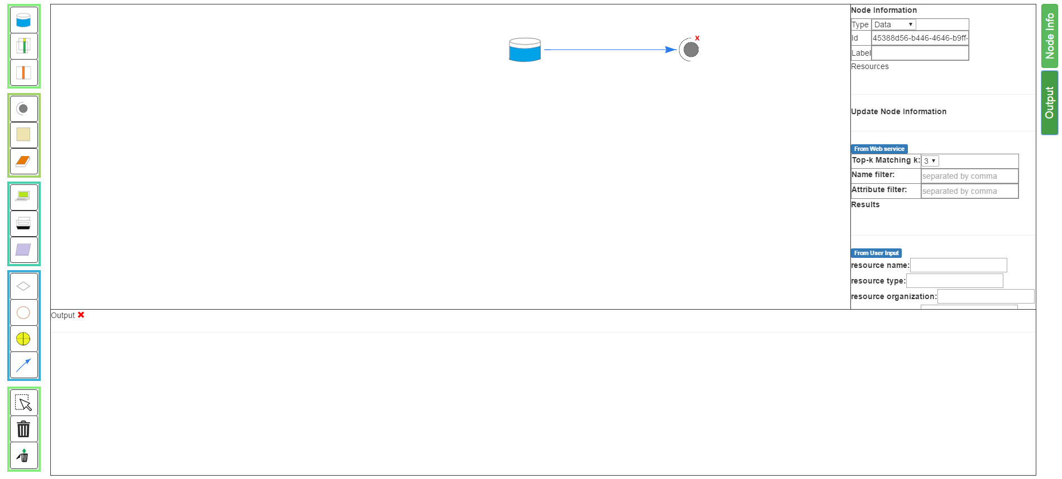

You can change the height by dragging the top line.

* 1. Run button, clear button, Load Example Three, Load Example Four, refresh button

Click Run button will run the workflow.

Click clear button will delete the workflow.

Load Example Three and Load Example Four are the demo examples

Refresh button update the running information label to show current status. The default running information status is updated 2 seconds. You can hard refresh it by click this refresh button.

* 1. Running Examples

For example, we want to run example four.

1. Click load Example Four, after the canvas loads this example, it looks like this:

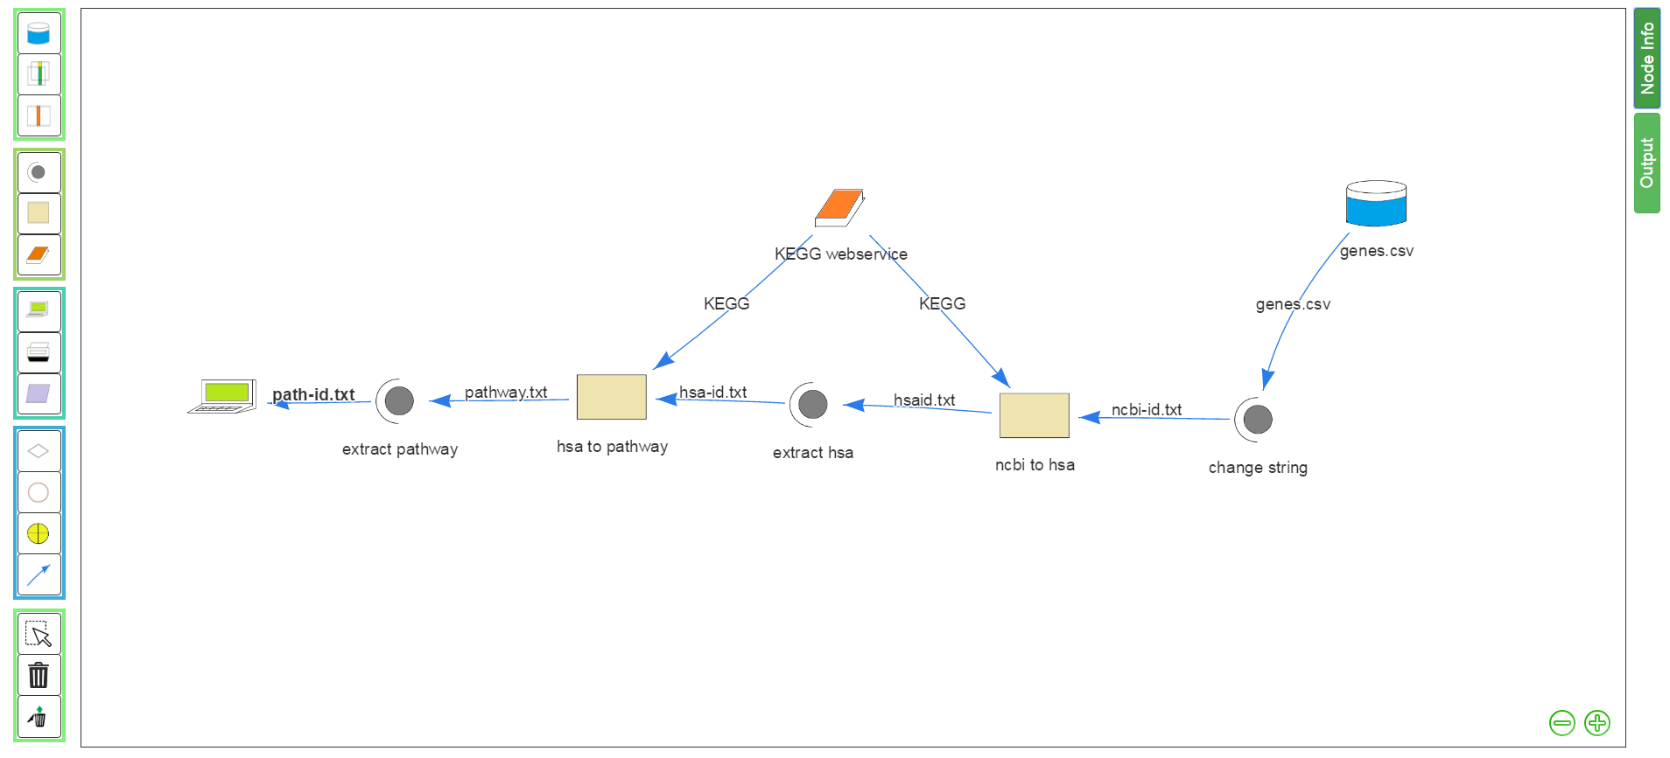

1. Click run button, the program will run, you can check the status by looking at the information showing on right of refresh button. 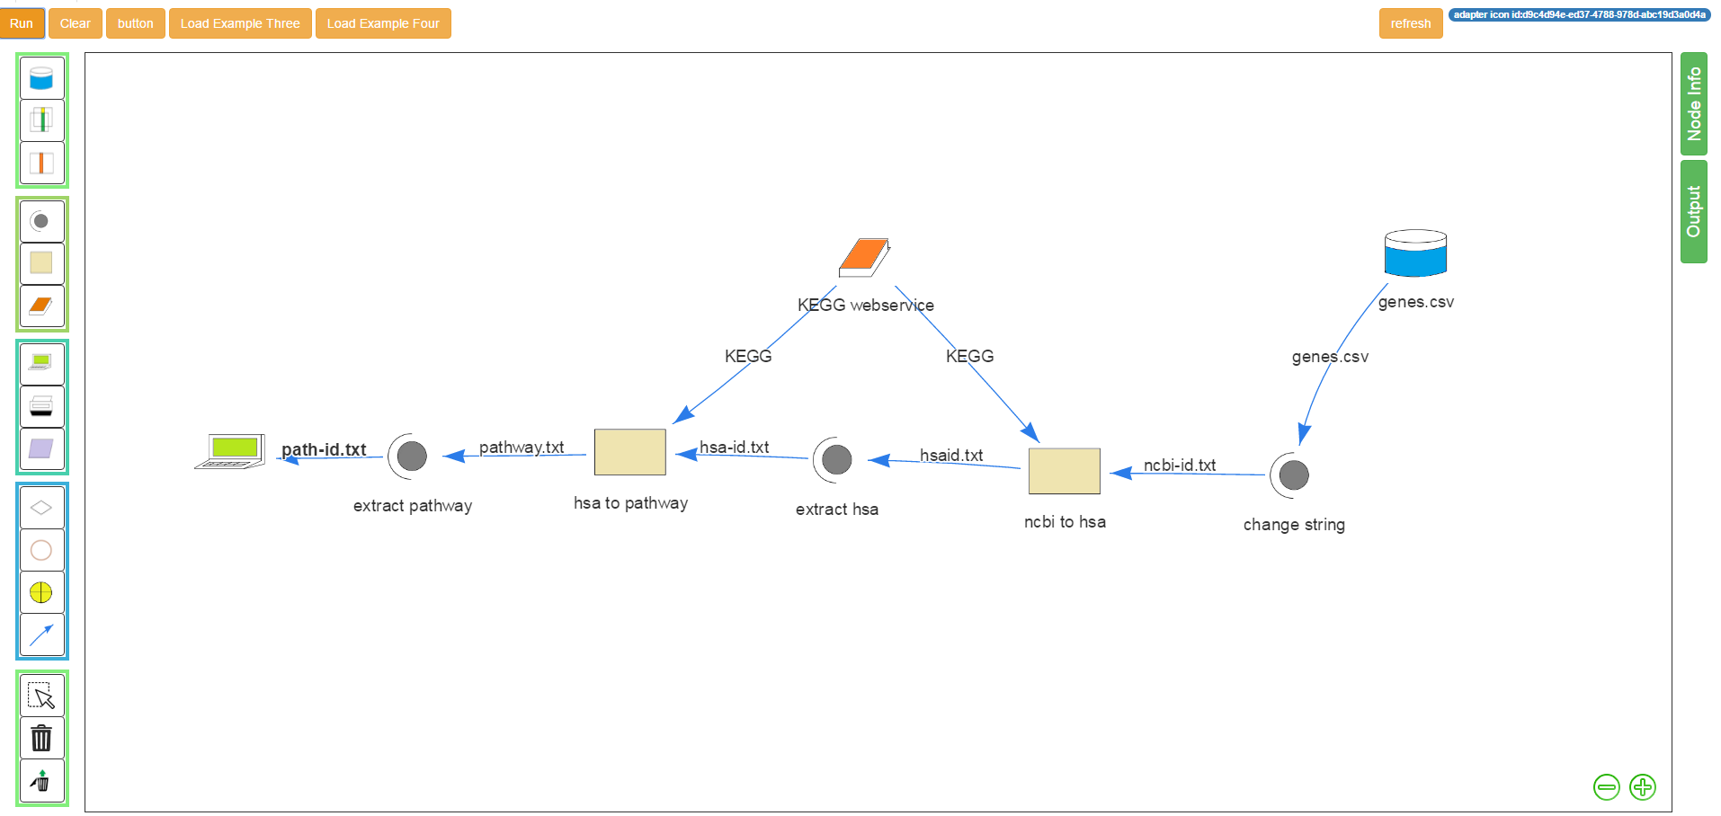

As you can see, the running information just tells you where the workflow is running. It’s an adapter icon and the icon’s id. After the whole workflow is done, the output window will pop up to show the results.

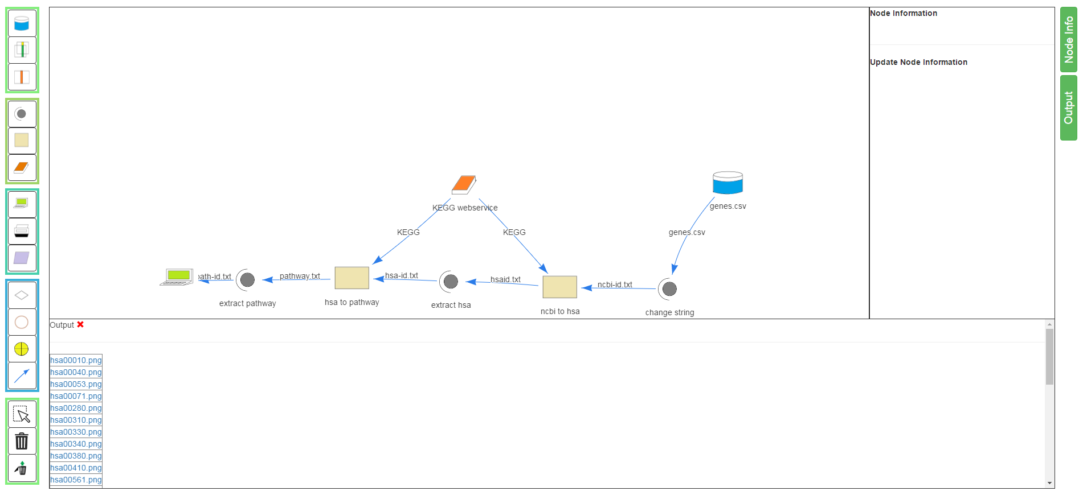

And you can click them to see the detail, or download them depend on the type.

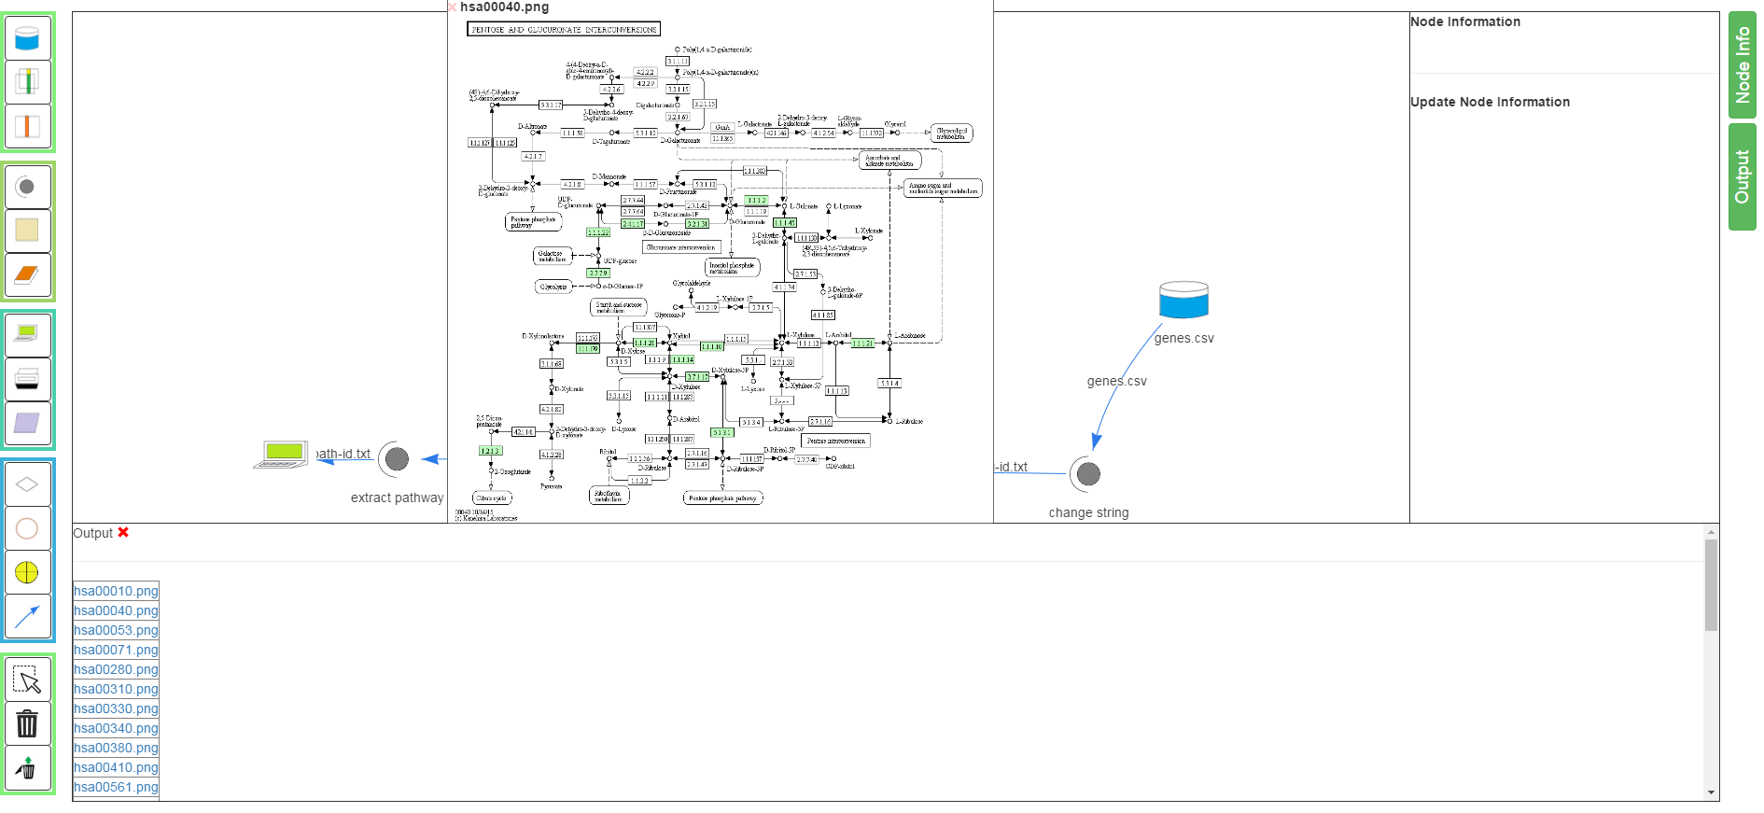

As you can see, the default image is not clear, you can drag it anywhere you like and resize the height and width by dragging the bottom and right lines to enlarge the image.

