Daniel Doubrovkine, Art on Paper G19, New York, 2024
@artdblockdotorg

While Josef Albers is mostly known for his “Interaction of Color”, it is “Despite Straight Lines” that impressed me the most. After reading it for the 33rd time I began experimenting with the ideas in the book using a computer. In 2021 I reimplemented four works from the book in JavaScript using p5.js without using any generative algorithms, drawing lines, rotating angles, and finally drawing more lines. In many ways I chose to ignore the complex geometry suggested by Albers to produce something much more primitive using 21st century technology. Finally, I decided to carefully remove some unnecessary steps, generating subsets that I found visually more satisfying.

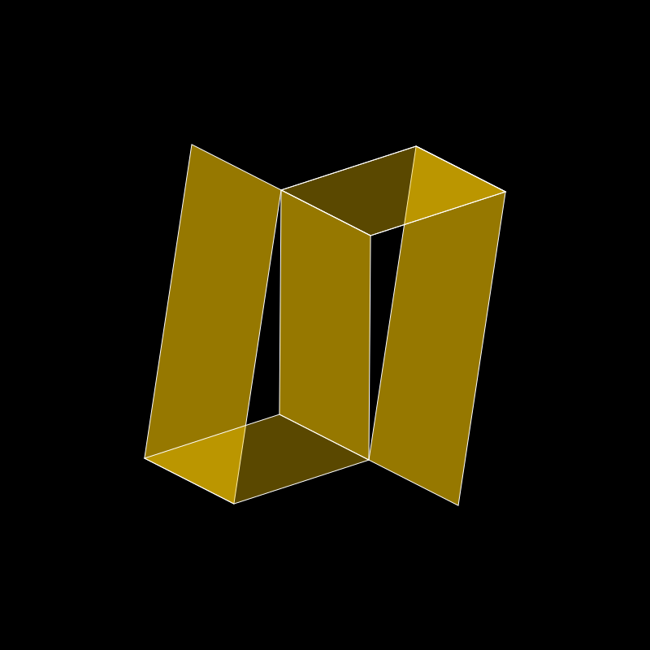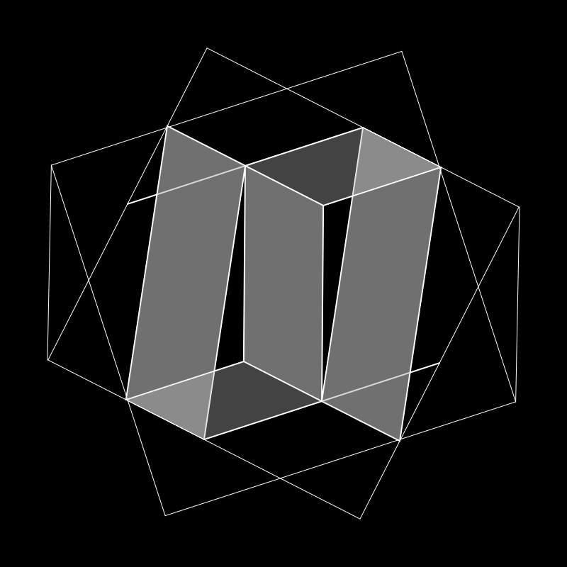

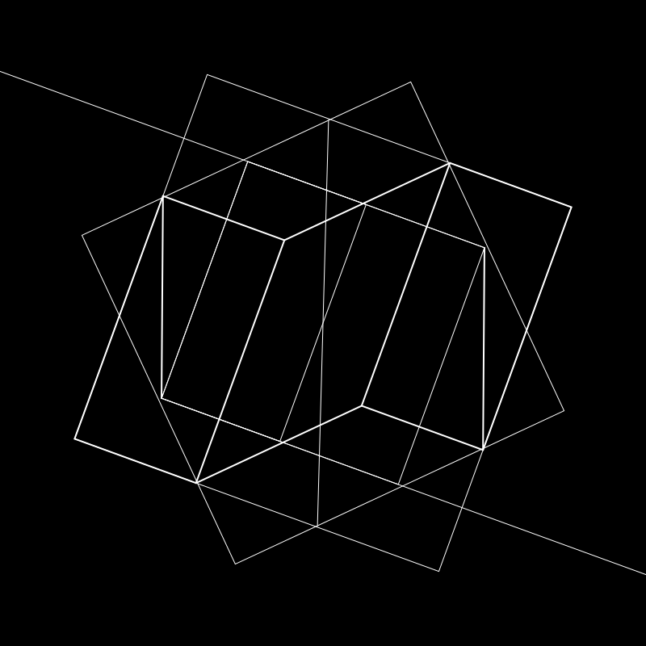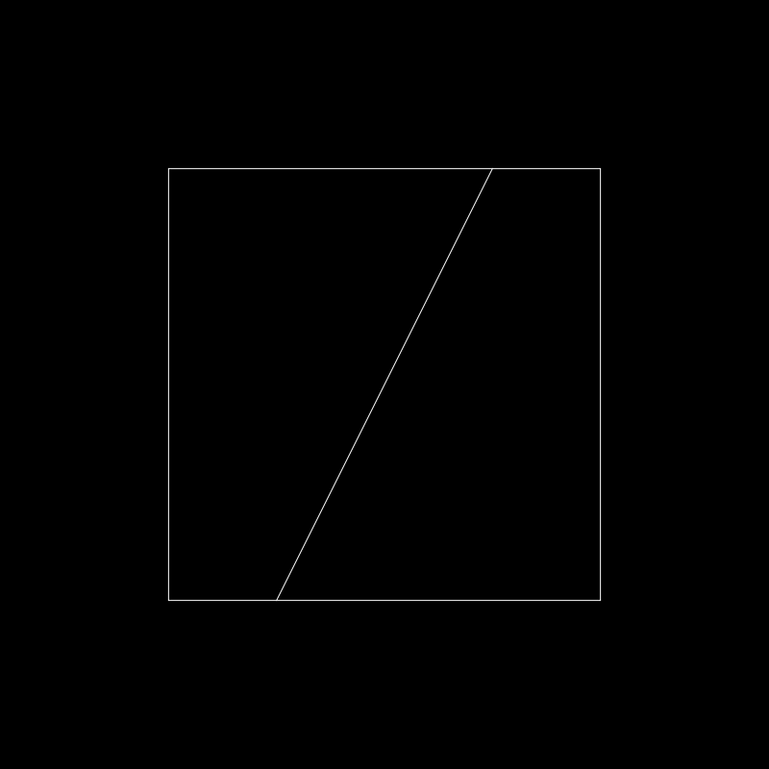
I wondered whether I was in any way copyminting Albers, a term used for duplicating NFTs to be sold as fakes, where the seller pretends to be the original artist. After all, I was using Albers’ algorithms and geometry! Would Albers object to the use of JavaScript as a medium in 1968? Or would he be minting NFTs on Tezos and listing them on Hic-et-Nunc and objkt.com?

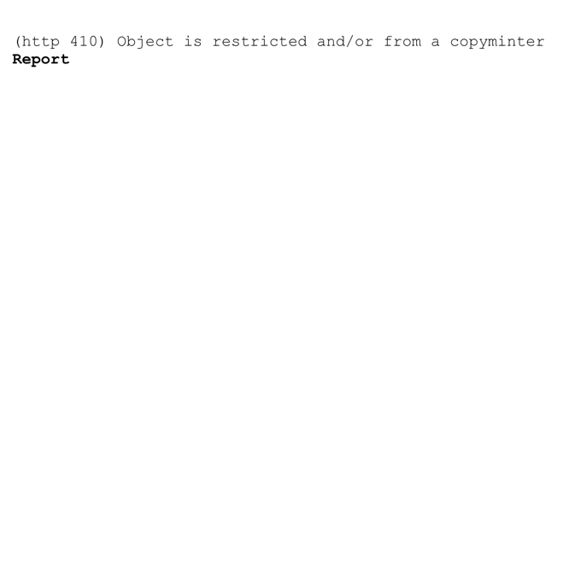

I don’t have answers to any of these questions, but to quote Man Ray, “My mail, which I have just collected from the post office, lies on the table in front of me. On top of the little pile of letters is a book of poems by my not-so-old friend, Georges Hugnet. Its title is - 1961. Upside down as seen from my seat it still reads 1961. As Hugnet points out, it will not be possible to read a date upside down until 6009. However, we are concerned with the present, a form of eternity - at the moment, time seems to be marking time.”

Limited editions of these works are also available as NFTs on objkt.com/@dblock.

