Content Management on the New DBMI Website

Site Access
To View the site as a user, go to: http://stage.dbmi.pitt.edu
To Access the site as an editor:
- Go to: http://stage.dbmi.pitt.edu/user
- Log in using your username and password (Username is the part of your email before the @ sign e.g if the email address is akg19@pitt.edu, the username is akg19)

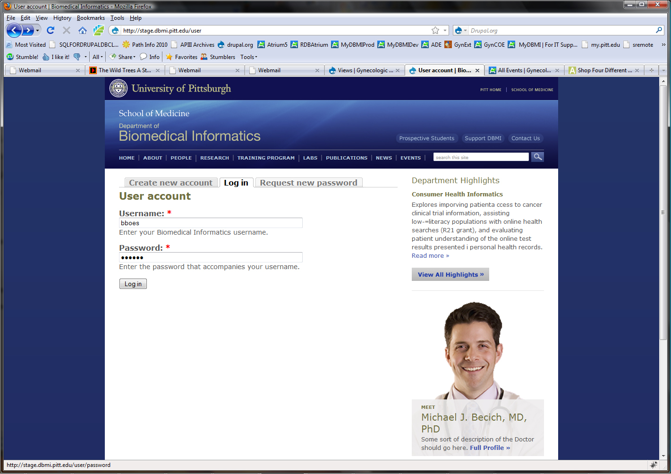

Site Navigation
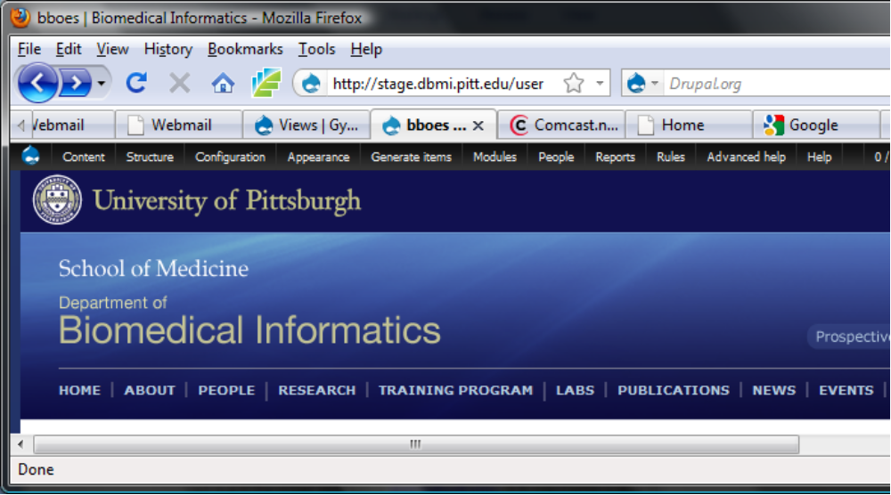The black menu at the top of the page is the administrative menu and people without access will not see it. Most adding and editing of content will be controlled in the “Content” section of the admin menu.
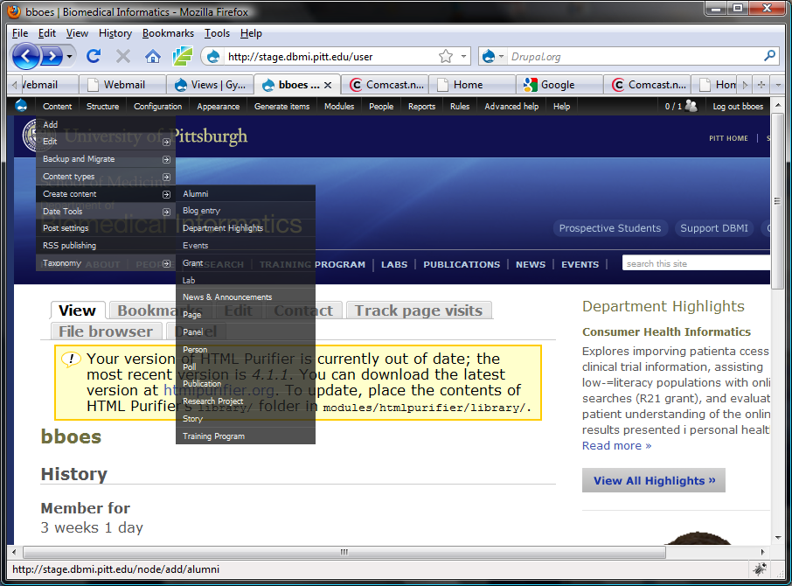
Admin Menu->Content->Create content->Page
Content Types

Alumni
Blog
Department Highlights
Events
Grant
Lab
News and Announcements
Page
Panel
Person
Poll
Publication
Research Project
Story
Training Program

Many of the content types correspond to the items in the main menu. Generic information pages (like Home and About) are usually Page content types.



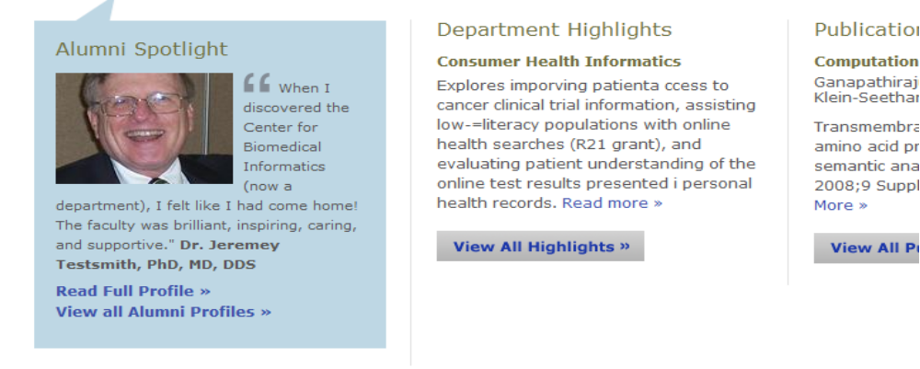
Adding Content

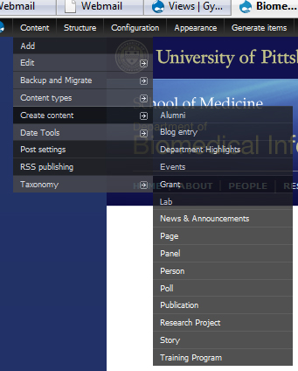

In the admin menu bar, go to:
Content->Create content and select the content type you want to create. Each type has its own form with fields related to the content type. All fields with red asterisks are required and Drupal will not allow you to create content unless required fields are filled out.

Example Form:
Select Person from the list of content types.
- Use the field instructions as a guide for how the information should be entered.
- If there is ever a question about what information is required, bring it to our attention and we will work to define the correct to fill out the field.
- In this content type, Title and Directory Name are both required fields (see red asterisks)
- Many fields that are textual will use an editor so that the information can be formatted.
- Try to avoid using formatting as we need to have a consistent look throughout the site.
- Do not change font types since the look of the text is also controlled by internal style sheets.
- Fill out as many fields as possible and press the save button at the bottom of the form.

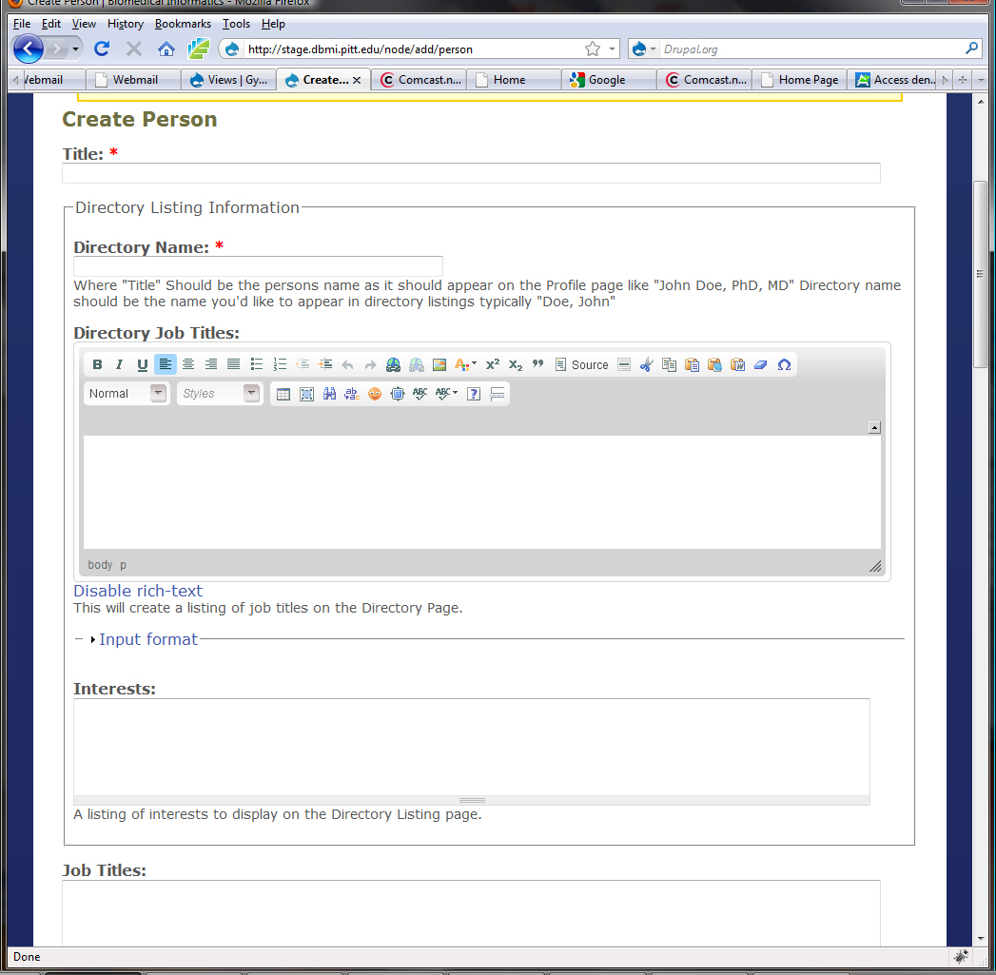

Editing Content

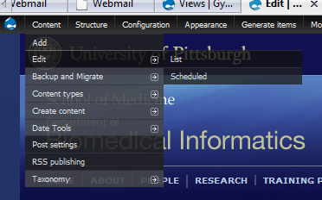

In the Admin menu, select:
Content->Edit->List

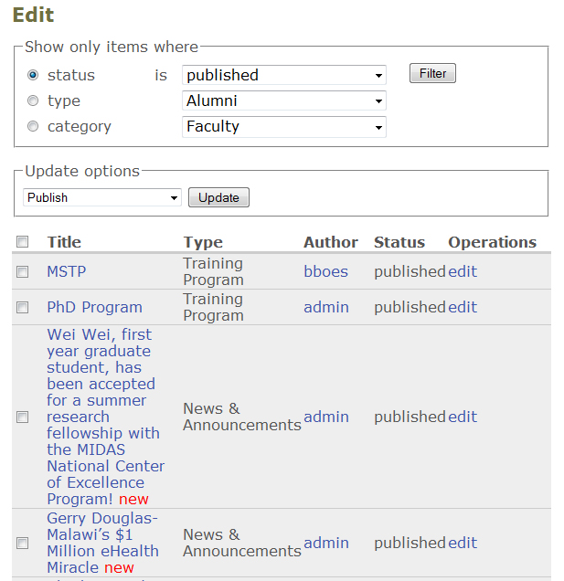

A list of all DBMI content will be displayed. After much of the content is entered, this list will become so long that it will be difficult to find content. The top box above the list is designed to filter by specific content types, status or category.

Suppose you want to see only the Person content on the site.

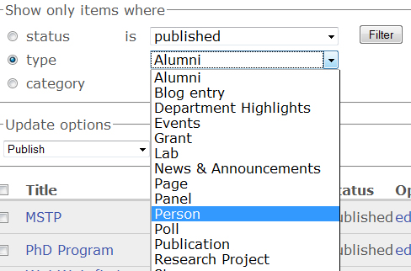

- Select the “type” radio button, select the Person content type and press the Filter button.

All of the “Person” content types will be listed with links for editing. If the title link is selected, it will display the information for that Person.

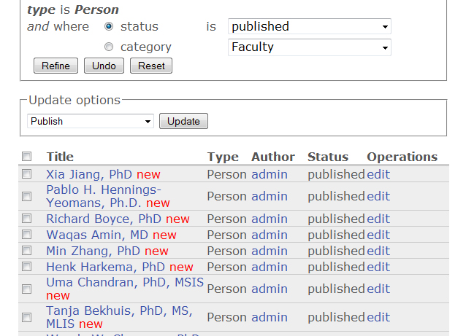

To edit any Person in the list, select the “edit” link on the right and an editable form will be displayed (this form is the same form that was used to create the content type). Make any changes and Save.

Division of DBMI Content

People
- Faculty
- Staff
- Training Program
- Post Docs
- Alumnus

Training Program
- Overview
- Programs
- Courses
- Degree and Non-degree Programs
- Faculty
- Apply
- Opportunities
- Funding

Other
- Home Page
- About
- Research
- News
- Events
- Careers
- Highlights
- Labs
- Services
- Publications

Editors

"Barbara J Karnbauer" <karnbauerbj@upmc.edu>
Training: "Toni Lou Porterfield" <tls18@pitt.edu>
Melissa Scwenk mds127@pitt.edu

karnbauerbj
tls18
mds127

