How-to Guide for Common DBMI Content Management Tasks

DBMI: This section of the help doc will be limited to changes on the production DBMI server.

**DBMI Website**

Server/DB: Linux,MySQL

URL: <http://www.dbmi.pitt.edu/>

Login URL: <http://www.dbmi.pitt.edu/user>

Your username/password

Your role: profile admin

Your focus area: Faculty Profile Page

Your content type: Person, Publication, Grant, Project

Contact: [Melissa Schwenk](mailto:mds127@pitt.edu?subject=Big%20Data%20Course)

If you are reading this, the profile admin role has been added to your user account so that you can create and edit content on the DBMI Website. Basic rules apply when you create any kind of content on the site, but this document contains specific information for several content types that you may use.

To login, go to the Admin login URL listed above: <http://www.dbmi.pitt.edu/user>

**Two Main Faculty Views**

View 1: In the main DBMI Menu, under People>>Primary Faculty, the Faculty List View is available.

http://www.dbmi.pitt.edu/people/faculty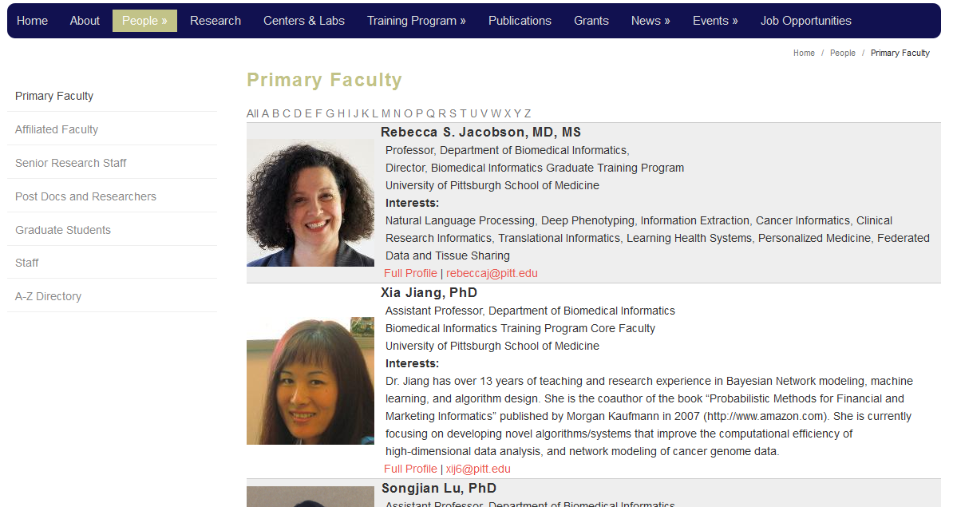

View 2: In the main DBMI Menu, select People, then click on link for specific faculty member:

http://www.dbmi.pitt.edu/person/michael-j-becich-md-phd

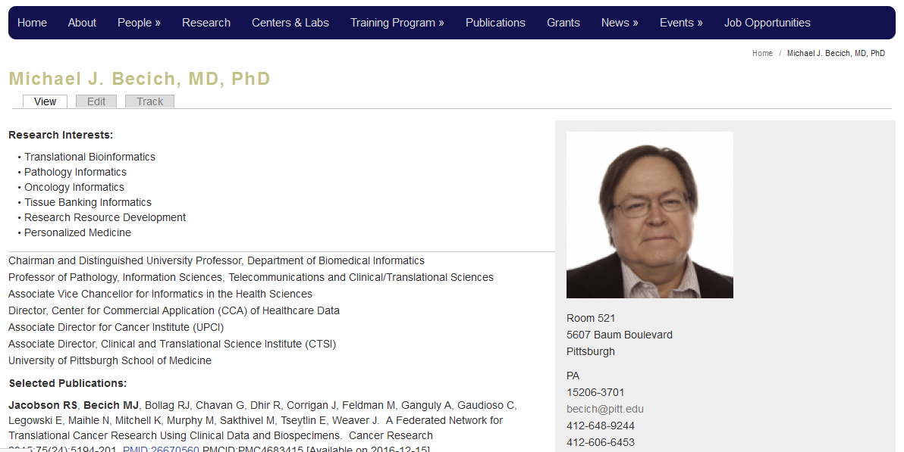

Once you are logged in and have the profile admin role, you should be able to see an extra administrator’s menu in a black bar at the top of the screen. This has additional tasks that are needed to work with content on the site.



**To find the content you need to edit:**

In the admin menu, select Content.

This will bring up a list of all content on the site and includes the Name, Content Type and Edit buttons for each page:

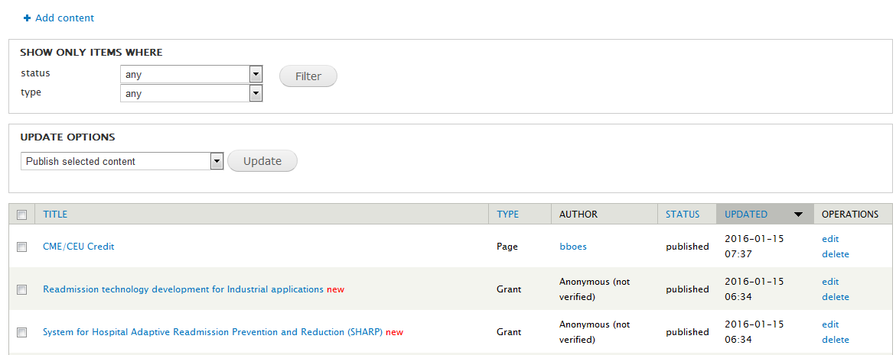

If you click on the Title link, you will go to a View of the page.

If you click on the Edit link, you will go an editable version of the page.

**Never delete content unless you are absolutely sure it isn’t needed –ask before deleting existing content (unless it’s something you have created and you want to start fresh).**

## **Note: For general editing instructions refer to the Website User Manual – Drupal 7.**

## Task 1: Editing a Faculty Profile:

1. Login to DBMI
2. Go to Content->Edit->List and filter on “type=Person”
3. Select the person to edit and hover over the “edit” link on the right (under Operations)
4. Check to see the node number that appears in the link.

For example, if you click on the “edit” link for: [Fuchiang (Rich) Tsui, PhD](http://www.dbmi.pitt.edu/person/fu-chiang-rich-tsui-phd)

You should go here:

<http://www.dbmi.pitt.edu/node/40/edit?destination=admin/content>

Note the node/40 part of the link. “node/40” is the identifier of the “Person” content-type for Rich Tsui. The same content can be reached using the aliased link:

<http://www.dbmi.pitt.edu/person/fu-chiang-rich-tsui-phd>

1. In the Edit Person Form, there are a set of horizontal tabs that contain all the information required for each person in the database. Several tabs are faculty specific.

The “Basic Info” tab should be left alone unless a new degree needs to be added.

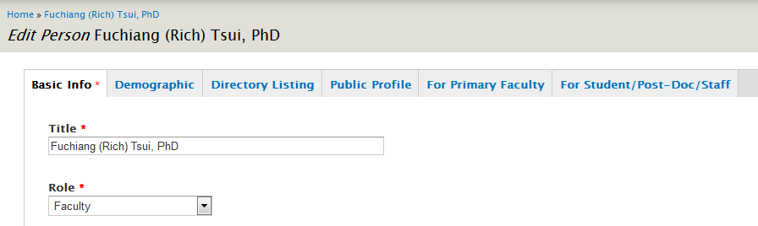

The “Demographic” tab may be updated when there is a change of address/email/phone number or other related information.

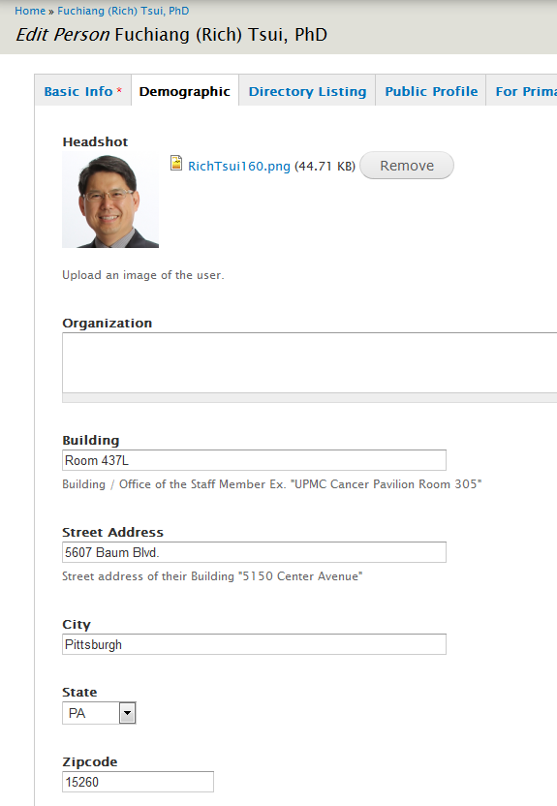

The “Directory Listing” tab should be left the same unless new research interests need to be added. Add “Directory Job Titles” here. 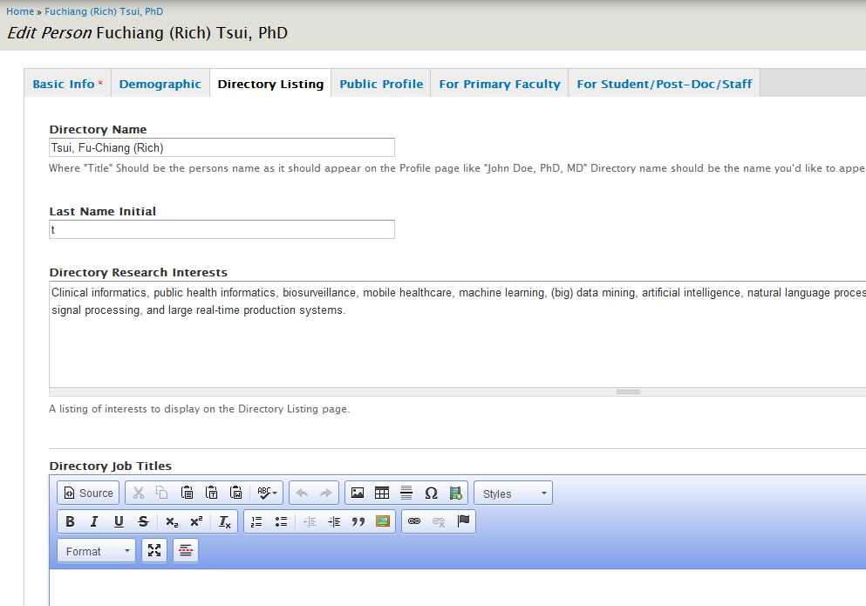

1. Modify this link for each student using their ID.  (Note that this will only work for students.  Other categories of people will have their own view names like: https://dbmi.secure.pitt.edu/faculty/<node id>)
2. If a person doesn’t have “Full Profile” in their Body fields, you will have to add it in order for other people to see the profile.

## Task 2: Editing/Adding a Seminar/Lecture:

The training program administrator (Toni Porterfield) will send weekly updates for the Training Program Seminar that is held on Fridays at 11AM. The schedule is created at the beginning of the semester and individual seminars are created and added even though they hold “To Be Determined” information that is filled in each week. This must be done on the MyDBMI intranet site as well (see notes below).

1. Login to DBMI
2. Go to Events (in the main horizontal menu) and select the appropriate seminar
3. Edit the seminar. Typically this just means adding the abstract and possibly the instructors and title/speakers
4. Save the changes to the Seminar node/
5. Go back into the schedule and makes sure that the new descriptions appear.

## Task 3: Editing a Big Data Course page:

All course pages will have “big-data-course” as a part of the URL. For example:

<http://www.dbmi.pitt.edu/big-data-course> = homepage

<http://www.dbmi.pitt.edu/big-data-course/registration> = application form

With the admin role, each page should have an Edit tab. Click on the tab and you will see all the form fields needed to populate your Page content. All Big Course Data pages are “Page” content except for the Application Form which is “Webform” content.

The main page content is located in an the Body text area with an icon bar on the top that looks similar to any editor and works like a typical editor. Below the editor you can choose the Text format. In most cases, Filtered HTML is sufficient but when there is more complicated content (for example, using tables) Full HTML is preferred.

If you know html, you can always toggle the Source button to see and edit the underlying HTML code. This is quite useful when you need to tweak the look of the page. Steps for using particular features of the editor can be found in the Drupal 7 Manual.

Remember to save your changes.

## Task 4: Adding a Big Data Course page:

In the admin menu, open the Content dropdown and select “Add Content”

Select Page.

Fill in all required fields and the main Body text area with your new content.

In the Options area at the bottom make sure that you change the URL Path Settings:

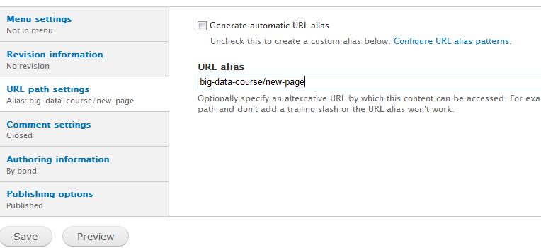

Uncheck the Generate automatic URL alias.

Create a new URL alias that starts with “big-data-course” and a slash(/) plus your new page name.

Make sure Comment settings is closed (it is by default) and that the document is marked “Published” (also the default)

Save and Review saved page.

## Task 3: Uploading Items:

Images, files, links and documents may be embedded within text in most DBMI content types. When you are embedding these items, make sure that your text editor is using the “Full HTML” format because this gives you access to extra functionality that includes browsing for files on your PC, easy link creation and image configuration.

## Steps to Add an Image:

1. In the “Full HTML” mode of the item that you are adding/editing, put your cursor where you want to add an image.
2. Select the Image icon from the editor tool bar:



1. In the Image Properties dialog box, select “Browse Server”.

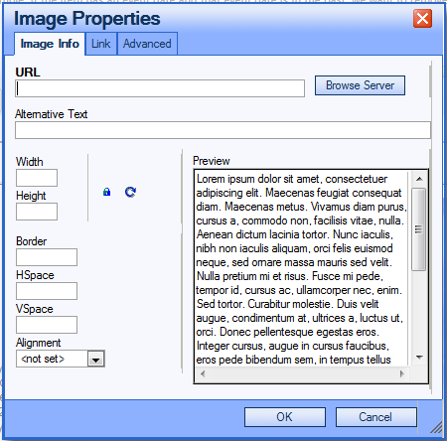

1. In the file browser dialog, if the image has already been uploaded to the MyDBMI server, select it from the list of files on the right in the browser. If you need to upload a new file, select the upload link in the editor.

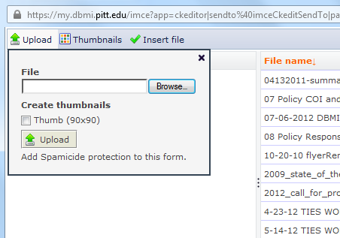

1. Find the file you want to upload on your own computer and select upload. The uploaded file should appear in the list of files on the right. Select the file and click on “Insert file” to upload it to the page you are editing.
2. You can adjust the size of the image in the Image Properties dialog by changing the Width and Height fields. If you change the width, it will automatically change the height so the image proportions remain intact.
3. Save the Image Properties by selecting OK and check to see if the image is where it should be.
4. Continue editing and save.

## Steps to Add a File (any file – pdf, powerpoint, word etc.):

1. In the “Full HTML” mode of the item that you are adding/editing, put your cursor where you want to add an image.
2. Select the Link icon from the editor tool bar:



1. In the Link dialog box, select “Browse Server”.

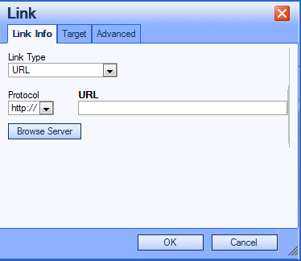

1. In the file browser dialog, if the file has already been uploaded to the MyDBMI server, select it from the list of files on the right in the browser. If you need to upload a new file, select the upload link in the editor.



1. Find the file you want to upload on your own computer and select upload. The uploaded file should appear in the list of files on the right. Select the file and click on “Insert file” to upload it to the page you are editing.
2. Save the Link by selecting OK and check to see if the file has been uploaded and linked.
3. Continue editing and save.

## Steps to Add a Link :

1. In the “Full HTML” mode of the item that you are adding/editing, highlight the text where your link will be added.
2. Select the Link icon from the editor tool bar:

