How-to Guide for Common DBMI Profile Editing Tasks

If you are reading this, the profile editor role has been added to your user account so that you can create and edit profile content on the DBMI Website. Basic rules apply when you create any kind of content on the site, but this document contains specific information for several content types that you may use.

**DBMI Website**

Server/DB: Linux,MySQL

URL: <http://www.dbmi.pitt.edu/>

Login URL: <http://www.dbmi.pitt.edu/user>

Your username/password

Your role: profile editor

Your focus area: Faculty Profile Page

Your content type: Person, Publication, Grant, Project, Lab, Research

Contact: [Melissa Schwenk](mailto:mds127@pitt.edu?subject=Editing%20Profiles)

## Log in to the Site:

Go to the login URL: <http://www.dbmi.pitt.edu/user>

Enter username/password and complete the CAPTCHA field.

Once you are logged in and have the profile admin role, you should be able to see an extra administrator’s menu in a black bar at the top of the screen. This has additional tasks that are needed to work with content on the site.



# Edit the Faculty Profile:

There are two methods that may be used to go to the page that needs to be edited. Method 1 is the easiest way to get to the content if you are already on the page of the person that you are modifying. Method 2 is a more generic method that will allow you to find any person from any page.

**Method 1**: **Finding the content to edit**: In the DBMI main menu, Click on People and select the Faculty that you would like to edit. You should see tabs at the top of the content. Click on the Edit tab.



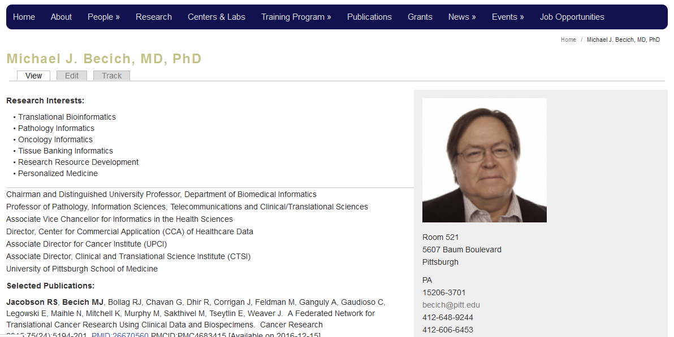

**Method 2**: **Finding the content to edit:** In the administrator’s menu, select Content.

This will bring up a list of all content on the site and includes the Name, Content Type and Edit buttons for each page. If you select type=Person in the “SHOW ONLY ITEMS WHERE” box, you will see all people in the database including all Faculty.



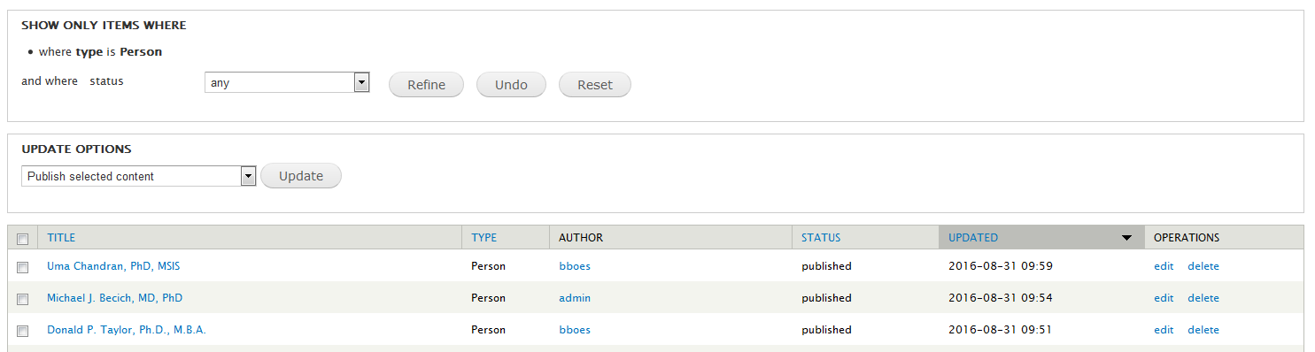

If you click on the Title link, you will go to a View of the page.

If you click on the Edit link, you will go an editable version of the page.

**Never delete content unless you are absolutely sure it isn’t needed –ask before deleting existing content (unless it’s something you have created and you want to start fresh).**

**Editing:** In the Edit Person Form, there are a set of horizontal tabs that contain all the information required for each person in the database. Several tabs are faculty specific.

1. The “Basic Info” tab should be left alone unless a new degree needs to be added.



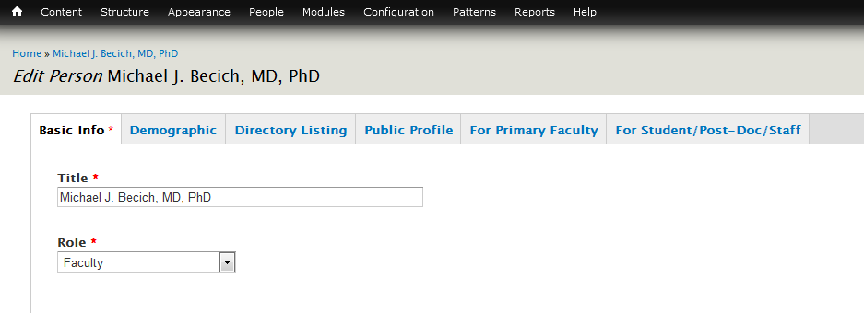

1. The “Demographic” tab may be updated when there is a change of address/email/phone

number or other related information. There is a field in this tab that allows you to upload a local CV. The Headshot photo size must be 160x160px. You may have to use a photo editor to resize and crop an image to this size. (I can help with this).



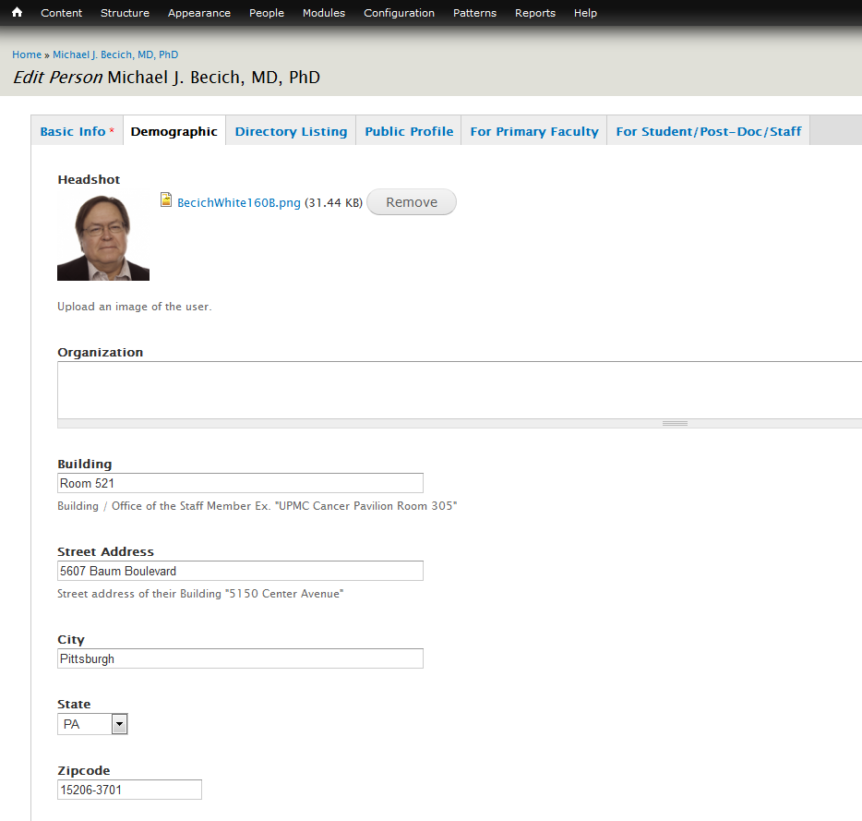

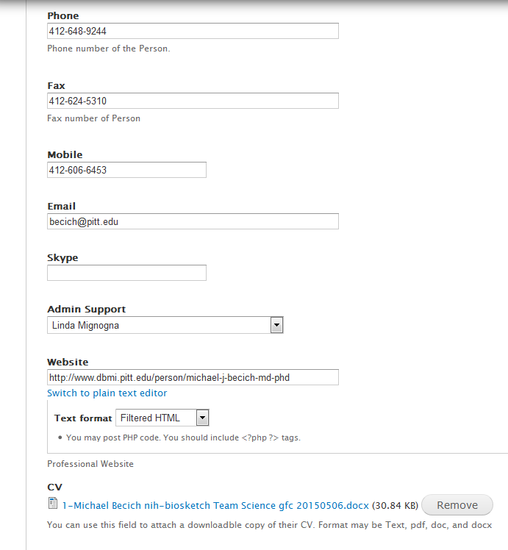

1. The first two fields in the “Directory Listing” tab should be left alone. The “Directory Research Interests” field appears in the A-Z list of short faculty profiles. The “Directory Job Titles” field appears in the long faculty profile page AND the short faculty profile. There is another “Research Interest” field that lists bulleted interests in the long faculty profile and we DO NOT use the “Appointment and Positions” field at this time.



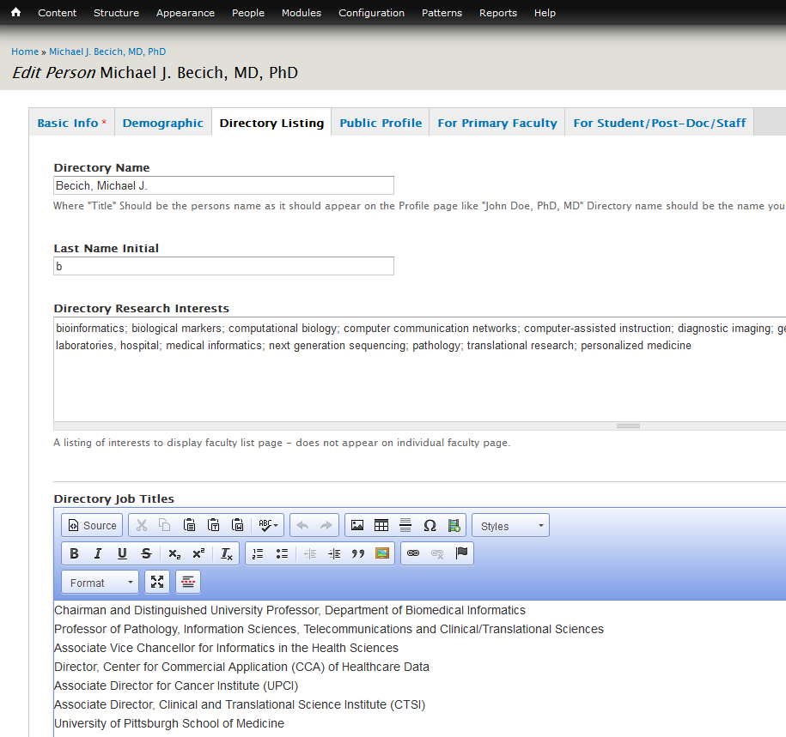

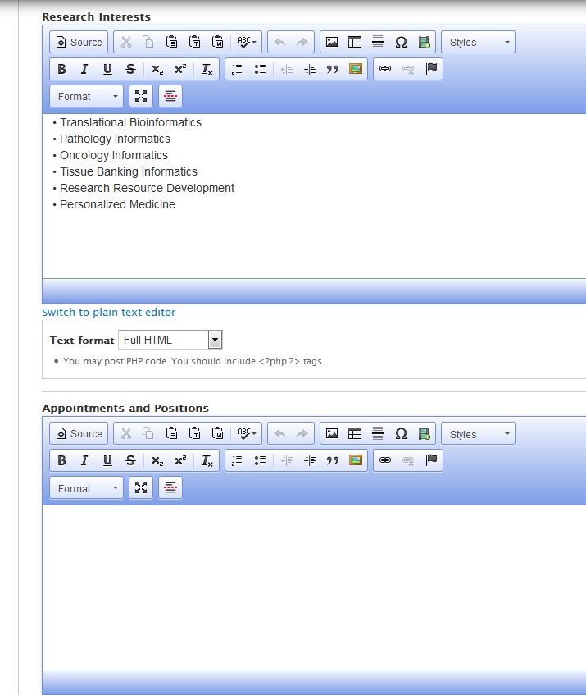

1. The “Public Profile” is used to add information that is not captured in other profile fields. **For people who used the DV import, this field is used to show the static DV import data so it looks like the original imported data. (see image below “*Edit Person* Michael J. Becich, MD, PhD”.) This does not include publications which must be entered as individual content (see section on Creating Publications).**



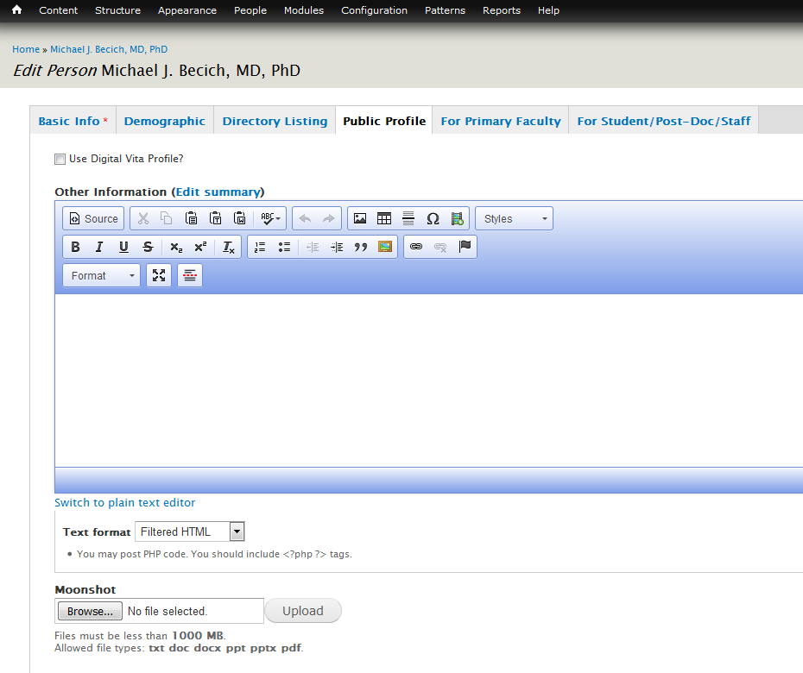

**New Grants, Titles, Accomplishments need to be manually added to this field for people who are still relying on the Digital Vita import style.**



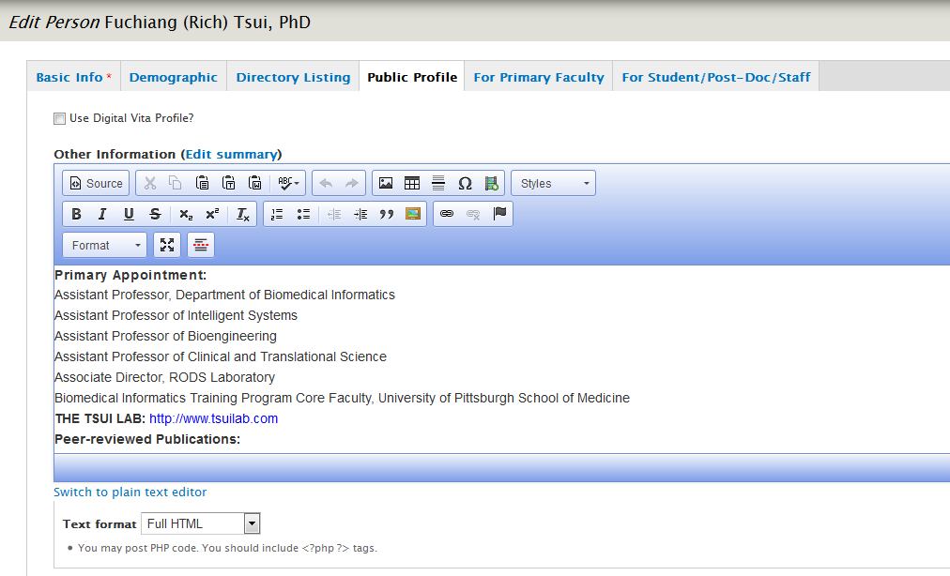

1. The “For Primary Faculty” tab contains the fields needed for the front page faculty photo and accompanying text. The photo must be 300x330px size



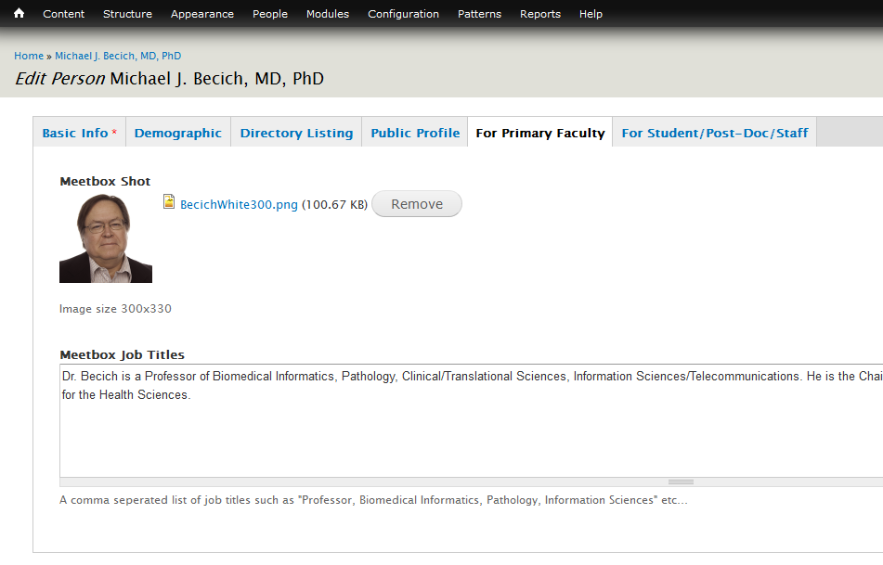

1. The “For Student/Post Doc/Staff” tab allows a staff/student to select the faculty that supervises them in three categories: Research Advisor, Academic Advisor or Lab Supervisor.

(Not to be used by faculty).



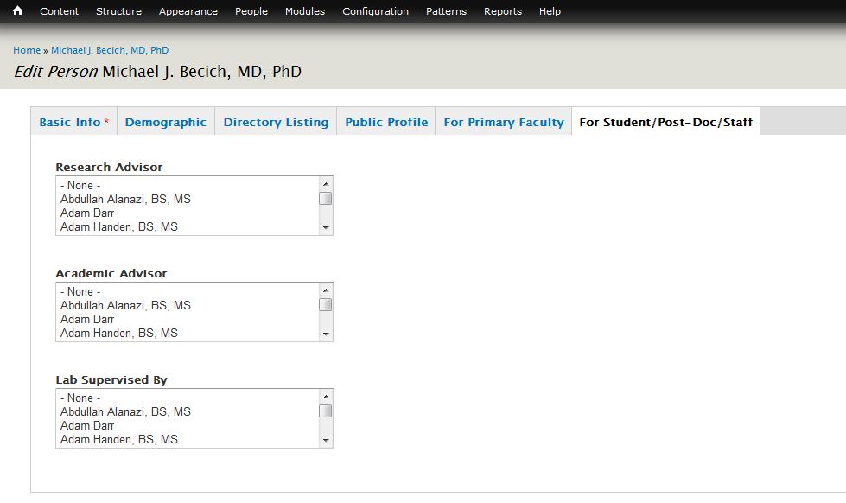

# 3. Two Main Faculty Views (Informational)

View 1: In the main DBMI Menu, under People>>Primary Faculty, the Faculty List View is available.

<http://www.dbmi.pitt.edu/people/faculty>

This view uses the “**Directory Research Interests**” and “**Directory Job Titles**” fields in the Directory Listing tag.

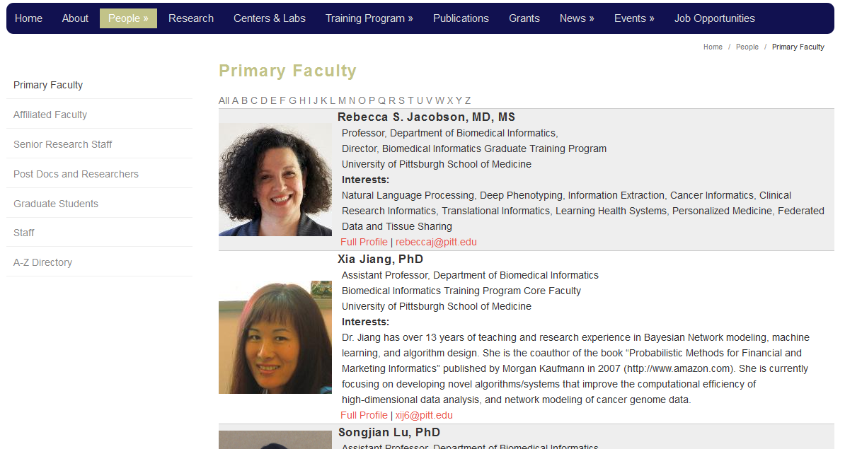

View 2: In the main DBMI Menu, select People, then click on link for specific faculty member:

<http://www.dbmi.pitt.edu/person/michael-j-becich-md-phd>

This view uses the “**Research Interests**” and “**Directory Job Titles**” fields in the Directory Listing tag.



Note: There are two URLS that may be used to access a person:

For example, if you click on the link for: [Fuchiang (Rich) Tsui, PhD](http://www.dbmi.pitt.edu/person/fu-chiang-rich-tsui-phd) by selecting the “Content” link in the administrator’s menu and filtering on Person, you should go here:

<http://dbmi.pitt.edu/node/40>

Note the node/40 part of the link. “node/40” is the identifier of the “Person” content-type for Rich Tsui. The same content can be reached using the aliased link:

<http://www.dbmi.pitt.edu/person/fu-chiang-rich-tsui-phd>

## Adding/Editing a Publication

A DBMI publication must be added into the website database as a unique “Publication” in order for it to show up in a person’s list of Publications. This is separate from the faculty profile and in order for it to appear in the faculty profile, it must be explicitly marked on the Publication page using the “Display on Profile?” checkbox. In the administrator’s menu go to:

Content->Add Content->Publication



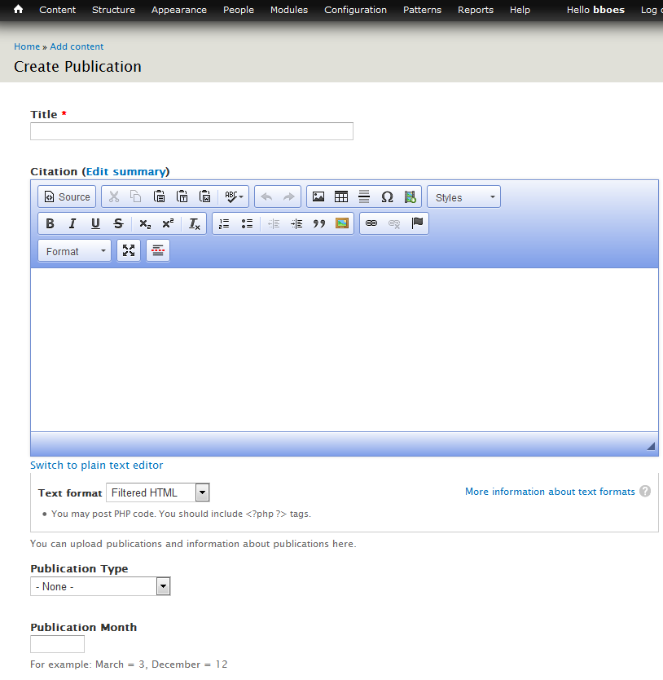

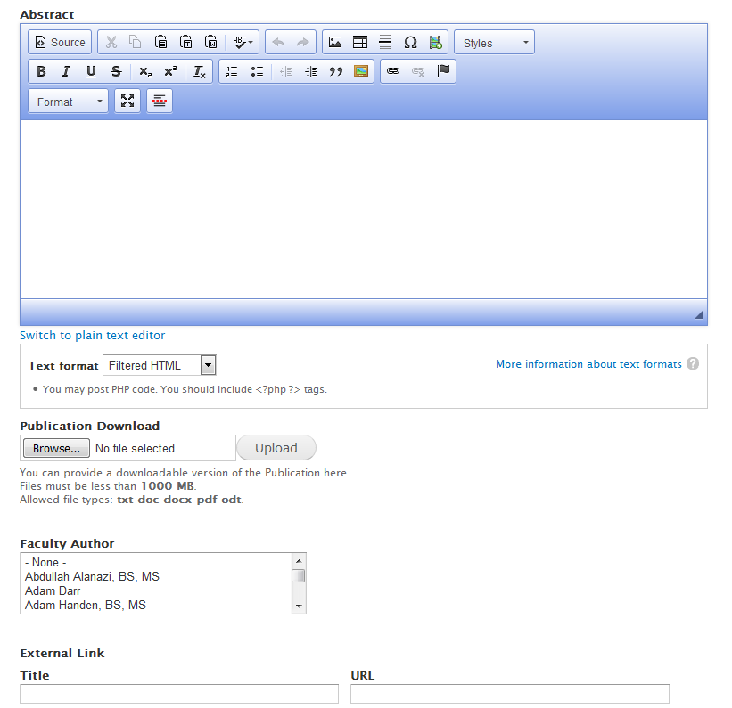

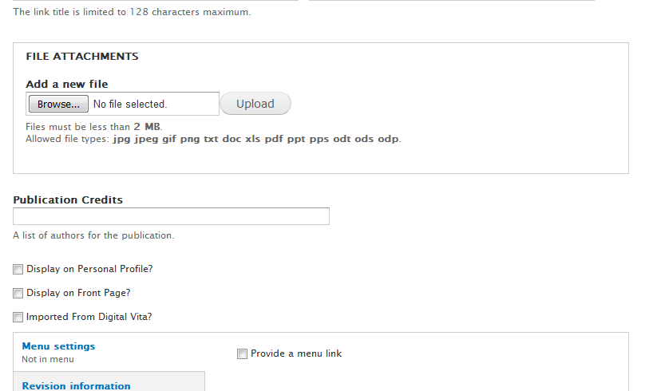

Fill in the fields for the publication. For most publications, search in a browser using the full title and first look for a hit with from <http://www.ncbi.nlm.nih.gov>. Use the information on that page to fill in the fields below. **Always Save before leaving the page**.

Title: Required: Full title of publication

Citation: Full citation including authors, pub name, publication, dates, PMID, other links

Publication Type: Journal, Conference Presentation, Book, etc.

Publication Month

Publication Year

Abstract: Full abstract text

Publication Download: If available

Faculty Author: Select multiple DBMI faculty authors

External Link: Title/URL if available

File Attachments: Use Publication Download Field

Publication Credits: comma separated list of all authors

Display on Profile?: Select yes to display on faculty page

**Note:** To edit an existing publication, go to Content in the administrator’s menu and filter on type=Publication. Select Edit under “Operations”.

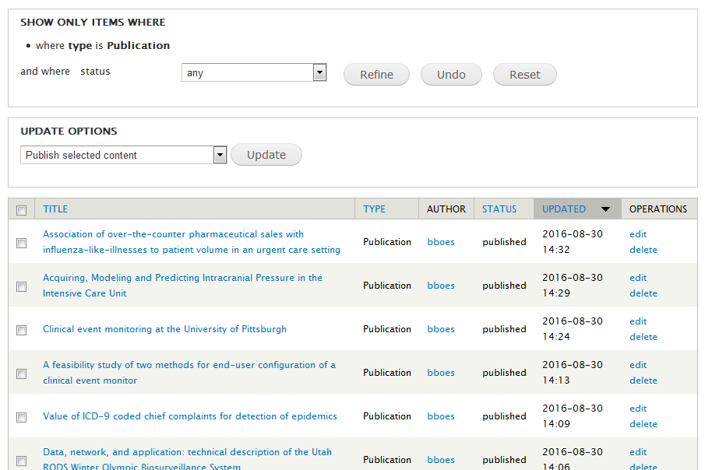

# Adding/Editing a Grant

DBMI grants are not posted in the main profile for faculty. There is a “Grant Funding” link on the right side of the profile that links to a list of grants that have been entered into the database individually. **For DV Profile Users, the grants appear within the profile page in a table and must be manually entered in the Person content type “Other Information” field (****see Edit the Faculty Profile section****).**

Content->Add Content->Grant (**Always Save before Leaving Page**)



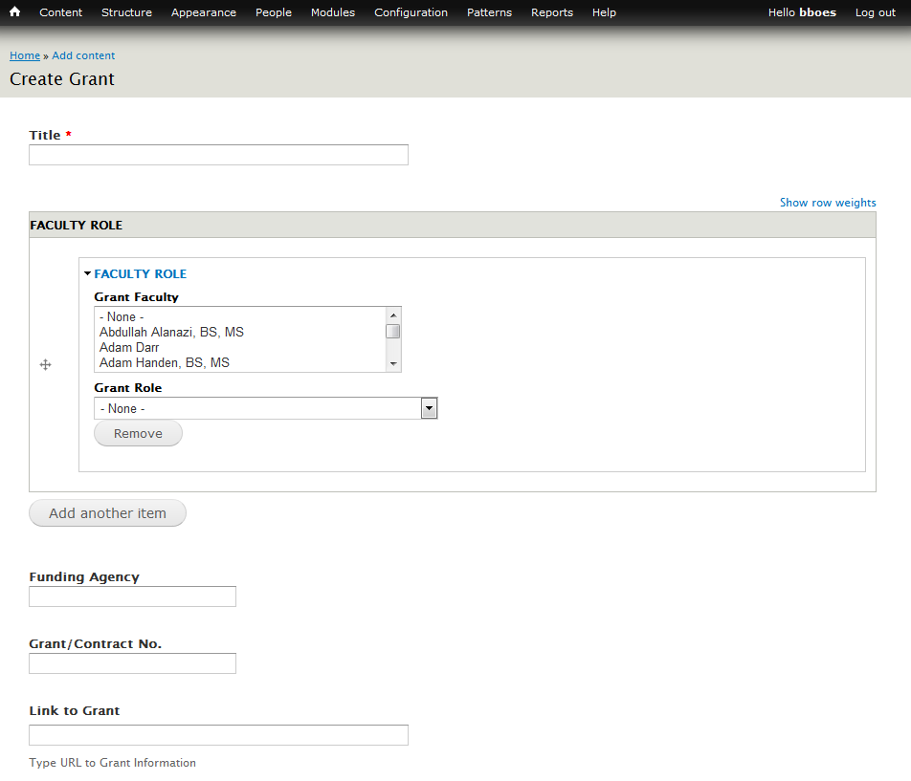

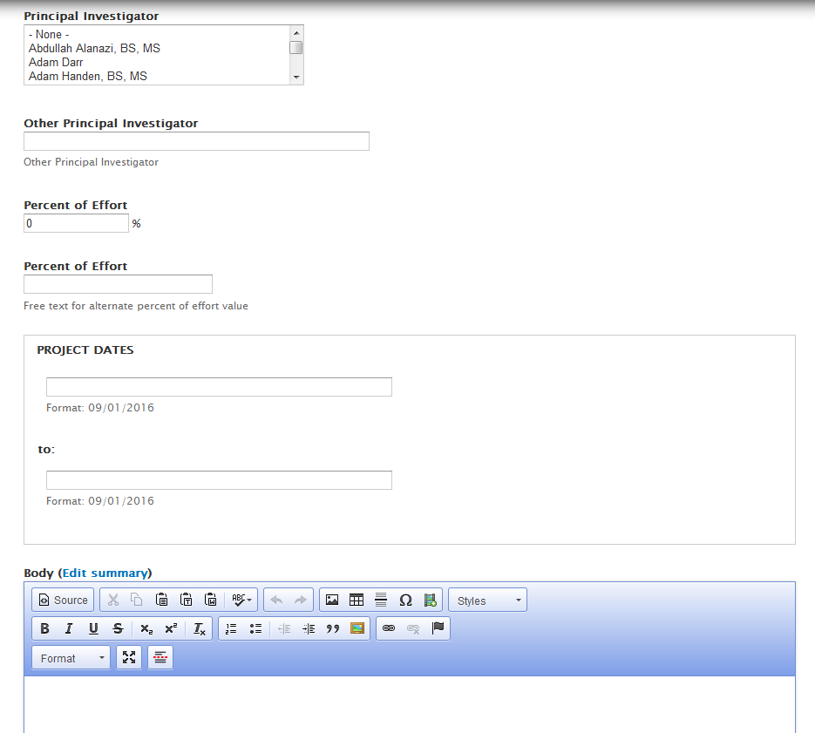

Grant Fields Include:

Title (Required)

Faculty Role (PI, Co-PI, etc. – can be multiple faculty roles)

Funding Agency

Grant/Contract No.

Link to Grant

Principal Investigator from DBMI(can be multiples)

Other Principal Investigator (outside DBMI)

Percent of Effort (usually not filled in since multiple faculty may be selected)

Project Dates: To – From

Body: Description of Grant

# Adding/Editing Other Content Types

There are other faculty-related content types that can also be added and edited in much the same way as grants and publications. These include:

Labs (found in DBMI Main Menu under Centers & Labs): Content->Add Content->Lab

Projects (found in Faculty Menu under Research Projects and Collaborations): Content->Add Content->Project

Research (found in DBMI Main Menu under Research): Content->Add Content->Research

## Appendix A: Uploading Items

Images, files, links and documents may be embedded within text in most DBMI content types. When you are embedding these items, make sure that your text editor is using the “Full HTML” format because this gives you access to extra functionality that includes browsing for files on your PC, easy link creation and image configuration.

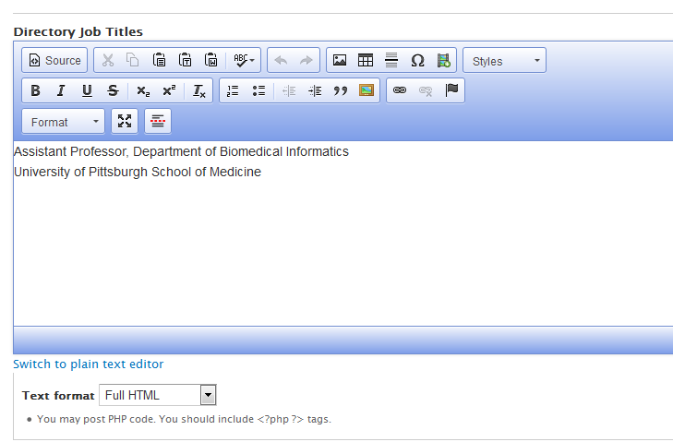

## Steps to Add an Image:

1. In the “Full HTML” mode of the item that you are adding/editing, put your cursor where you want to add an image.
2. Select the Image icon from the editor tool bar:



1. In the Image Properties dialog box, select “Browse Server”.

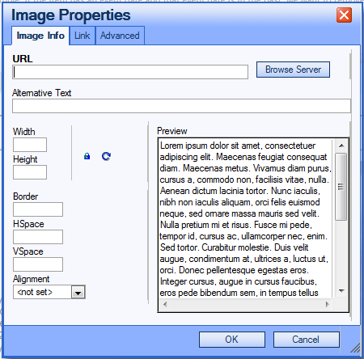

1. In the file browser dialog, if the image has already been uploaded to the MyDBMI server, select it from the list of files on the right in the browser. If you need to upload a new file, select the upload link in the editor.

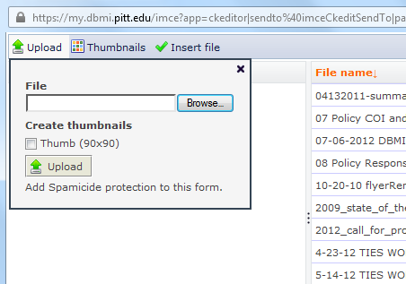

1. Find the file you want to upload on your own computer and select upload. The uploaded file should appear in the list of files on the right. Select the file and click on “Insert file” to upload it to the page you are editing.
2. You can adjust the size of the image in the Image Properties dialog by changing the Width and Height fields. If you change the width, it will automatically change the height so the image proportions remain intact.
3. Save the Image Properties by selecting OK and check to see if the image is where it should be.
4. Continue editing and save.

## Steps to Add a File (any file – pdf, PowerPoint, Word etc.):

1. In the “Full HTML” mode of the item that you are adding/editing, put your cursor where you want to add an image.
2. Select the Link icon from the editor tool bar:



1. In the Link dialog box, select “Browse Server”.

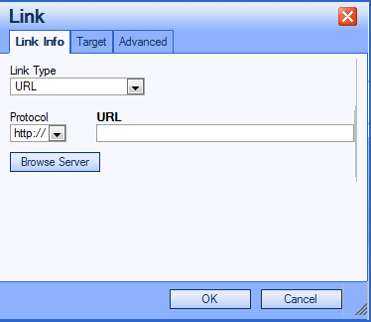

1. In the file browser dialog, if the file has already been uploaded to the MyDBMI server, select it from the list of files on the right in the browser. If you need to upload a new file, select the upload link in the editor.



1. Find the file you want to upload on your own computer and select upload. The uploaded file should appear in the list of files on the right. Select the file and click on “Insert file” to upload it to the page you are editing.
2. Save the Link by selecting OK and check to see if the file has been uploaded and linked.
3. Continue editing and save.

## Appendix B: Steps to Add a Link

1. In the “Full HTML” mode of the item that you are adding or editing, highlight the text where your link will be added.
2. Select the Link icon from the editor tool bar:

