
DomainBuilder User Manual
Table of Contents
Introduction 3
Logging In 3
Becoming an Authenticated User 4
Opening DomainBuilder 4
Create a New Knowledge Base 5
Browse an Existing Knowledge Base 5
Importing an Existing Knowledge Base 5
Exporting an Existing Knowledge Base 5
Deleting an Existing Knowledge Base 5
Using Menu Trees to Select Items 5
Locating Items in the Menu Tree 6
Selecting an Item from the Menu Tree 6
Case Tab 7
Case Maintenance 7
Creating a New Case 7
Opening a Case 8
Saving a Case 8
Importing a Case 9
Exporting a Case 9
Adding Clinical Report Information 9
Importing a Report 9
Cut/Copy/Paste in the Report 9
Spelling Suggestions 10
Using a Worksheet to Input Clinical Information 10
Parsing the Report 10
Adding Concepts to the Knowledge Base from the Report 10
Adding/Removing Knowledge Base Concepts to the Case 11
Getting Knowledge Base Concepts for a Case 12
Loading Digital Slides 12
Navigating Digital Slides 13
Move around Slide 13
Zoom In/Out 13
Refresh Digital Slide 13
Magnifier Window 13
Navigator window 13
Modifying Digital Slides 14
Expand Digital Slide Area 16
Annotating Digital Slides 16
Modifying Shapes 16
Cut/Copy/Paste Shapes 17
Taking Example Pictures from a Digital Slide 17
Tags 17
Create a Tag 17
Delete a Tag 18
Organizing Annotations with Tags 18
Case Authoring for SlideTutor ITS 18
Locations Annotations 18
Linking Annotations with Knowledge Base Concepts 20
Case Concept Properties 21
Viewing Case Concept Properties 21
Modifying Linked Annotations Using Case Concept Properties 21
Asserted Concepts 21
Validating Knowledge Base Concepts for a Case 21
Adding Additional Pathologies to the Case 22
Creating and Deleting Additional Pathologies 22
Marking Unrelated Diagnoses with Respective Pathologies 22
Viewing Different Pathologies 22
Case Status 23
Knowledge Tab 23
Hierarchy Builder Tab 23
Adding Concepts 24
Cut/Copy/Paste/Delete Concept Options 25
Adding Concept Information 25
Manually Adding Definitions and Synonyms 26
Importing Definitions and Synonyms from the Terminology 27
Diagnosis Builder Tab 27
Adding Diagnoses 28
Adding Findings to Diagnoses 28
Modifying Rules for Findings 29
Adding Multiple Patterns of a Diagnosis 29
Cut/Copy/Paste Findings 29
Align Findings 29
Import Findings from Spreadsheet 30
Find/Replace Findings Inside all Diagnostic Rules 30
Report Builder Tab 31
Creating a New Template 32
Deleting a Template 32
Reportable Items 32
Adding Reportable Items 33
Deleting Reportable Items 33
Reorder Reportable Items 33
Triggers 33
Adding a Trigger 33
Deleting a Trigger 34
Search 35
Preview Cases 35
Right Click Menu Options 35
Glossary 35
Bookmark/Unbookmark 35
Open Option 35
Summary 36

Introduction
DomainBuilder is a tool designed to create a Knowledge Base and annotate cases that are used by an intelligent tutoring system to provide instruction within a particular pathology domain. This process consists of creating/editing a Knowledge Base, inputting all of the case information, and annotating/drawing shapes on the digital images.

Logging In
When you first start DomainBuilder you have an option to log in. If you log in with valid credentials for a selected institution you will be able to save all of your authoring to the central curriculum server which will make your authoring available to others.

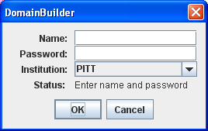

If the system cannot authenticate you then you will become a not authenticated user which means that all of your authoring will be done in your local cache and will not be visible to others. In that case you will receive the warning message below.

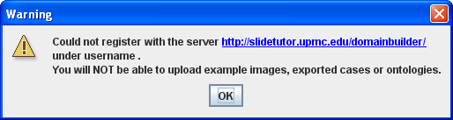

Becoming an Authenticated User
Contact the DomainBuilder administrator to gain log in credentials.

Opening DomainBuilder
Once DomainBuilder loads, a popup will appear with several options.
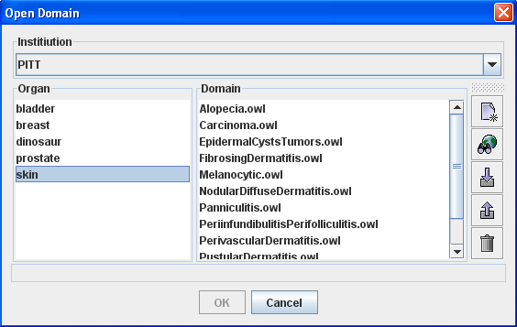

Create a New Knowledge Base
To create a new knowledge base, click on. Fill in the appropriate fields and click OK.

Browse an Existing Knowledge Base
To browse the contents of an already existing Knowledge Base, select the appropriate Knowledge Base and then click on . A popup will appear with all of the existing concepts within the Knowledge Base. To navigate through the concepts, simply click on a parent concept to open the children concepts in a new column to the right of the parent concept.

Importing an Existing Knowledge Base
To import an existing Knowledge Base in the .owl format, click on .

Exporting an Existing Knowledge Base
To export an existing Knowledge Base in the .owl format, highlight the appropriate Knowledge Base and click on.

Deleting an Existing Knowledge Base
To delete an existing Knowledge Base, highlight the appropriate Knowledge Base and click on .

Using Menu Trees to Select Items
Throughout DomainBuilder, menu trees are used at various times for selecting findings and diagnoses. Below is a screenshot of a sample menu tree.

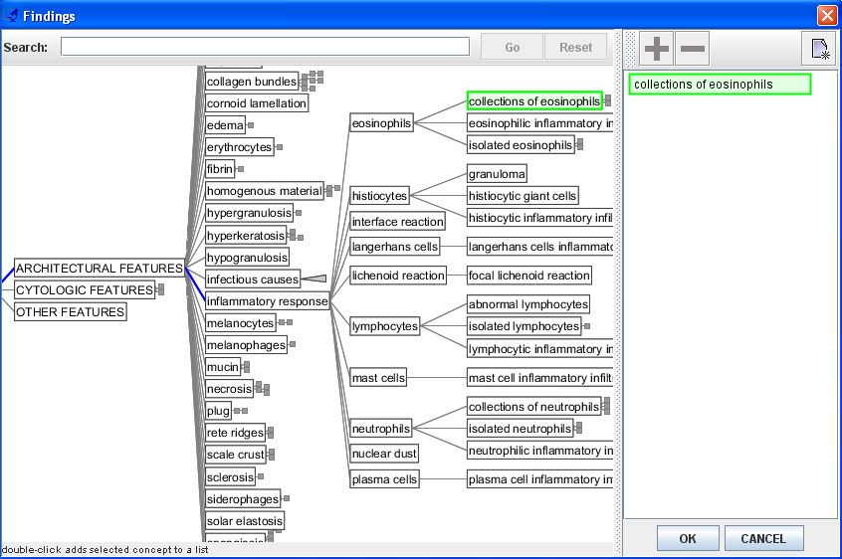
Screenshot of Menu Tree for Findings with an Item Selected

Locating Items in the Menu Tree
There are two ways you can locate items in the menu trees: opening and closing the tree, or typing in a string to search for in the tree. To expand the tree, click a “branch” of the tree and that branch will open to display its contents. Branches that can be opened are indicated by a triangle or rectangle on the right of the item. To open another branch, click on the expandable item. Alternatively, you can have the program search the tree for a particular string of letters by typing the string in the search box, and clicking “Go” or pressing the enter key on your keyboard. The tree will highlight in orange any items containing that string. To go back to the original view of the tree, click the “Reset” button.

Selecting an Item from the Menu Tree
To select items from the menu tree:
- Do one of the following:
  - Click on the item to highlight it and click the button.
  - Right click the item.
  - Double click the item.
- Repeat step 1 to add additional items to the selection list as desired.
- Click OK.

Even if the item appears to be highlighted from using the search tool, you still need to click the item to make sure it is selected.
To remove an item from the selection list:
- Click on the item to highlight it. Make sure you are in the selection list in the right portion of the menu tree screen.
- Click to remove the selection.

Case Tab

The Case Tab is where you enter all of the information at the level of individual cases. In this tab, you can load digital slides, add clinical report information, annotate the digital image, and link annotations with knowledge base concepts. This entire process is referred to as case authoring.

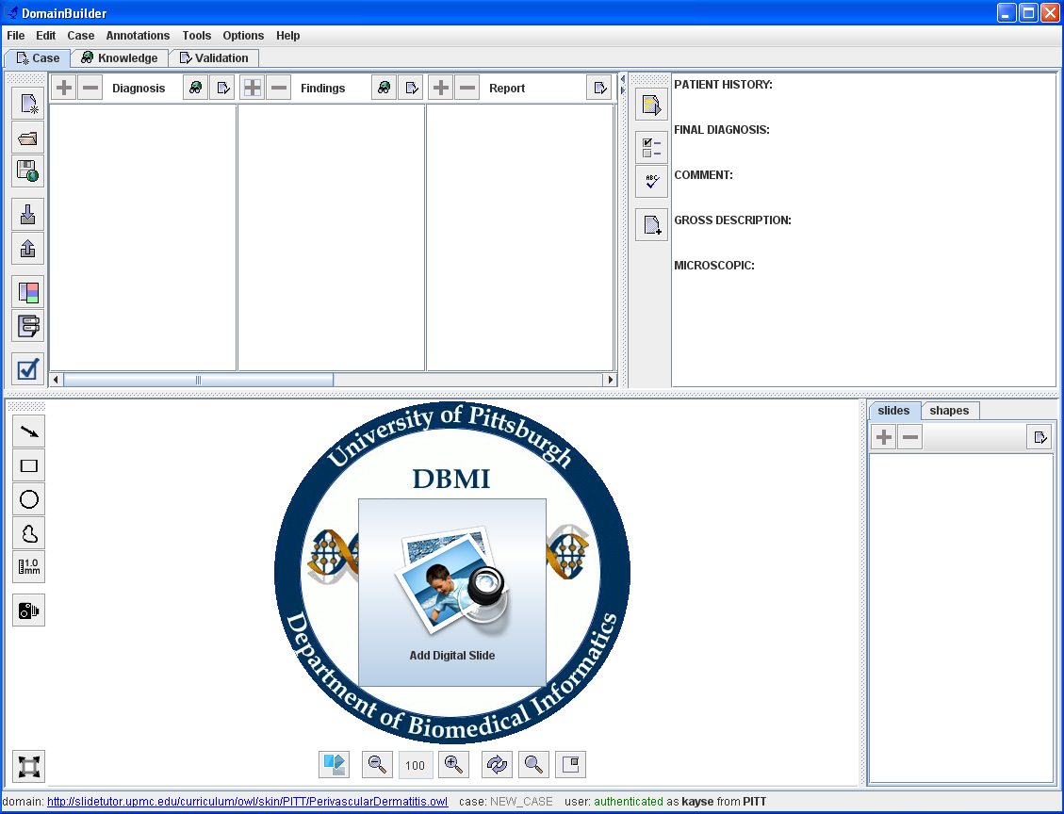
Knowledge Base Concepts Panel
Clinical Report Panel
Digital Slide Viewer Panel

Case Maintenance
When the Case Tab opens, it opens a new case. Previously saved cases can be opened, and cases can be imported and exported.

Creating a New Case
To create a new case:
1. Click the button OR select New from the File menu.

Opening a Case
To open a previously saved case:
1. Click the button OR select Open from the File menu.
2. Select the case you want to open by clicking it. You can filter cases by selecting a diagnosis. When a case is selected, its diagnosis is highlighted (if available) and a preview of the report is shown. You can also search for a case by the case name by typing in the "Search" field.
3. Click OK.

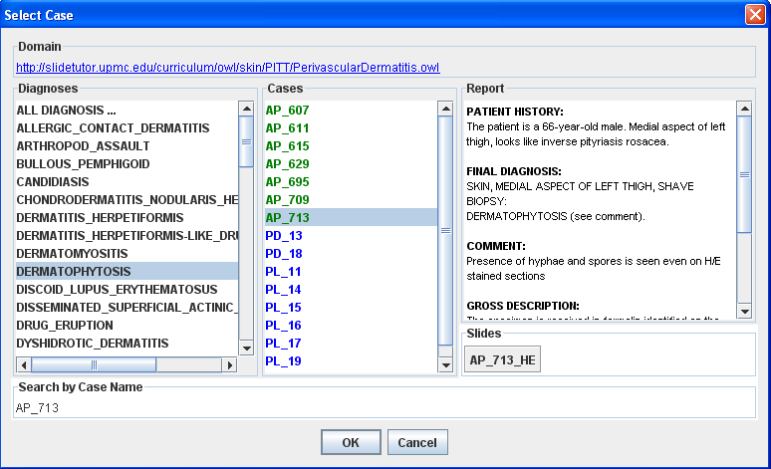

The cases are colored based on the Case Status (see Case Status section below). “Incomplete” cases are displayed in red. “Complete” cases are displayed in blue. “Tested” cases are displayed in green.

Saving a Case
If you are an authenticated user, saving a case will save the file in your local cache as well as upload it to the curriculum server. If you are not an authenticated user, the file will only be saved to the local cache.

To save a case:
1. Click the button ( for authenticated users )OR select Save from the File menu.
2. If the “Enter Case Name” popup appears, type in an appropriate name for the case and click OK.

Importing a Case
Cases can be imported from previously saved case files stored locally on your computer.
To import a case file:
1. Click the button OR select Import from the File menu.
2. Select the file you wish to import.
3. Click Open.

Exporting a Case
Cases can be exported and saved locally on your computer.

To export and upload a case:
1. Click the button OR select Export from the File menu.
2. If the “Enter Case Name” popup appears, type in an appropriate name for the case and click OK.
3. Navigate to the folder where you want the case file to be saved.
4. Type in a file name for the case file to be saved as in the File Name box if you want it saved as a different name.
5. Click Save.

Adding Clinical Report Information
The top right portion of the Case Tab is where clinical report information is added. Reports can be added by either typing into the report area or importing a previously saved text file.

Importing a Report
You can import an existing clinical report in a text format (.txt). Some clinical reports may not follow the same conventions used by DomainBuilder. That is why the Align Report to a Template dialogue pops up to help users import all relevant clinical information into the format that is understood by the system.

To import a report:
1. Click the button OR select Add Report from the Case menu.
2. Locate the file you want to import.
3. Click Open.
4. Use the Align Report to Template dialogue to select the sections that you want to add to the Target Report (in case they were not extracted automatically).

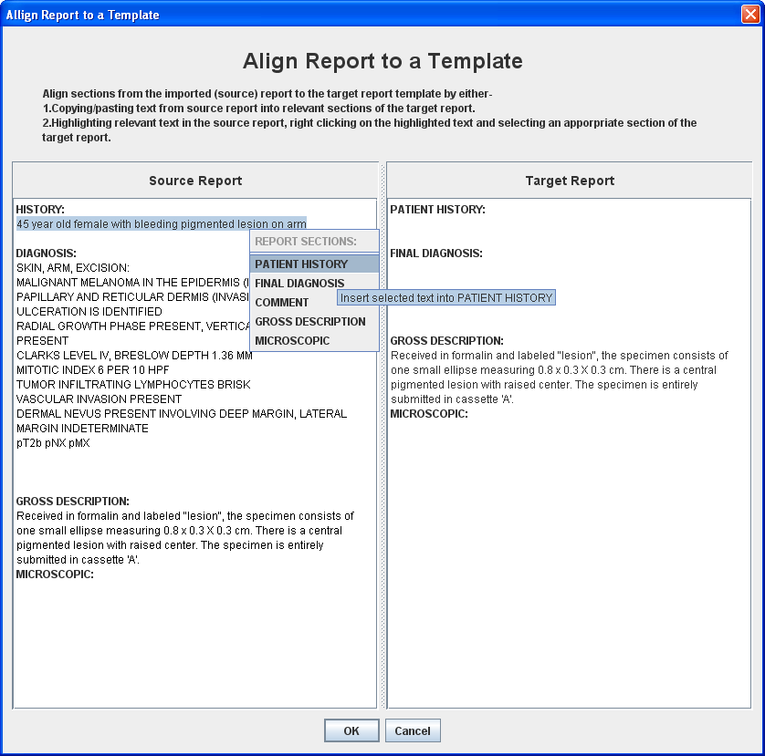

Cut/Copy/Paste in the Report
Like a word processor, you can cut, copy, and paste text.
To cut or copy text:
1. Highlight the text you wish to cut or copy using your mouse.
2. Right click your mouse and select cut or copy.
To paste text:
1. Move your cursor to the location you wish to paste text.
2. Right click your mouse and select paste.
You may also use the standard keyboard shortcuts to cut, copy, and paste text.

Spelling Suggestions
A spell checker is available to provide spelling suggestions.
To spell check the report:
1. Click the button.
2. For each misspelled word, select the correct spelling from the suggestions provided and click “Change”.

Using a Worksheet to Input Clinical Information
Some clinical information may be added to a report using the worksheet button. Using this button, information can be added by selecting the appropriate radio buttons rather than typing it in. To create a worksheet of concepts please see the creating a worksheet section.
To use a worksheet:
1. Click the button.
2. If there are multiple worksheets available, select the appropriate tab at the top of the popup window for the information you want to add.
3. Click the appropriate radio buttons to select values.
4. Repeat steps 2 and 3 as needed.
5. Click OK.
Your selections will be appended to the end of your report in the Final Diagnosis section.

Parsing the Report
Once a report is entered (either typed in or imported) it can be processed by clicking the button. At that point, any report text that is matched with concepts in the Knowledge Base will turn blue, and any Knowledge Base concepts found in the report will be listed appropriately under Diagnosis, Findings, Report, Clinical and/or Ancillary.

Adding Concepts to the Knowledge Base from the Report
If there are any concepts that did not parse in the report, you can add the concept from the report text directly to the knowledge base..
To add report text to the Knowledge Base:
1. Highlight the text in the report.
2. Right click the highlighted text.
3. Choose Suggest Term from the drop down menu.
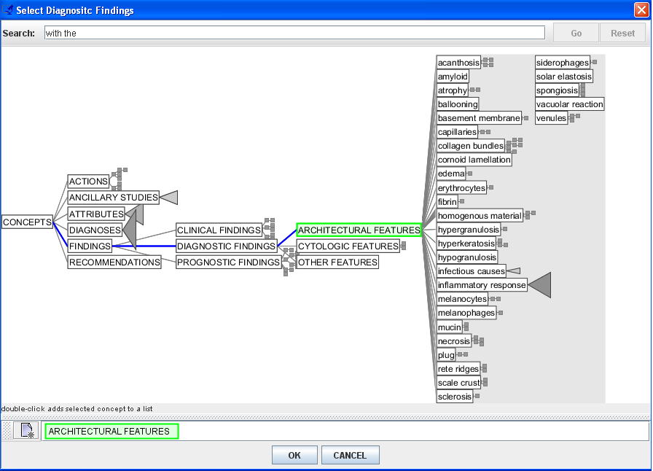
If the highlighted text is a synonym for an existing concept:
1. Highlight the text in the report.
2. Right click the highlighted text.
3. Choose Suggest Term from the drop down menu.
4. Select the existing concept from the tree. (The highlighted text from the report will become a synonym of the existing concept).
5. Click OK.
If you would like to create a new concept in the Knowledge Base from a term in the pathology report:
1. Highlight the concept in the report that you would like to add to the Knowledge Base.
2. Right click on the concept and click on Suggest Term.
3. Select the parent concept in which you would like the new term to be created under. If there is no parent concept that fits, you can create a new concept by clicking .
4. Click OK.

Adding/Removing Knowledge Base Concepts to the Case
In addition to pulling knowledge base concepts from a processed report, knowledge base concepts can also be added and removed manually using the and buttons for the appropriate concept type (Diagnosis, Findings, Report, Clinical or Ancillary).
To manually add knowledge base concepts:
1. Click the button for whichever concept type you wish to add (diagnosis, finding, or prognosis).
2. Select the desired item(s) from the menu tree that appears.
To remove knowledge base concepts:
1. Click the item you wish to delete to select it.
2. Click the appropriate button for whichever concept type you are removing.

Getting Knowledge Base Concepts for a Case
You can have DomainBuilder look for missing concepts within the Knowledge Base and have those concepts populated by clicking the button in the appropriate column (Diagnosis, Findings, Report, Clinical, and/or Ancillary).

AUTHORING NOTE:
For example, if you know that the diagnosis is Bullous Pemphigoid, you can utilize the “get findings” button in the Findings column to look up all of the appropriate findings for Bullous Pemphigoid in the Knowledge Base.

Conversely, if you have a set of findings {X, Y and Z}, you can infer the possible diagnoses for that set of findings by clicking the “get diagnoses” button in the Diagnosis column.

Loading Digital Slides
To load digital slides:
  - Click the button in the slides portion of the screen (lower right-hand side of the screen), select Add Slide from the Case menu, or click the 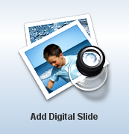 button in the center of the digital slide viewer panel.

  - Select a location from the drop down menu. The location is the registered institution that hosts the digital slide images.

  - Browse for an appropriate digital slide, keeping in mind that some slides can be organized within sub folders. You can search for slides in the currently opened folder by typing text into the search field.
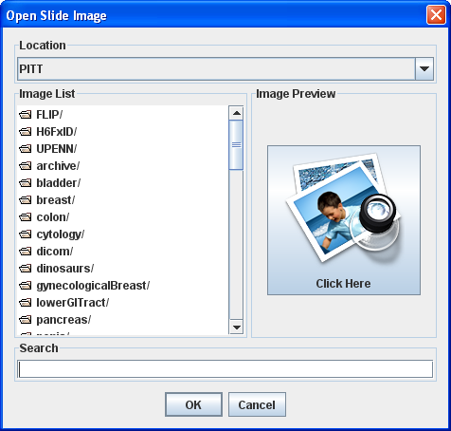

3. Click OK.
AUTHORING NOTE:
Multiple slides can be loaded at the same time by using shift-click (to select slides listed consecutively) or control-click (to select slides not listed consecutively).

You can author digital slides from different locations (institutions) by using the location drop down menu in the open slide dialog box.
All loaded slides will appear in the slide list on the right-hand side of the screen. Click on a thumbnail to change slides.

Navigating Digital Slides
DomainBuilder incorporates a virtual microscope that has similar functions as a regular microscope but operates using a mouse.

Move around Slide
To move around the slide, press and hold the left mouse button. Drag the mouse, then release the mouse button. Repeat until the desired area is in view.

Zoom In/Out
To zoom in:
Left click the button OR click the mouse over the image.
To zoom out:
Left click the button OR right click the mouse over the image.
You can also zoom in and out using the scroll wheel on your mouse when your mouse is over the image.
To return to the whole slide view, click the button.

Refresh Digital Slide
If the viewer is not refreshing, allow a few seconds for the new view to appear. If that does not help, click the button and try using the viewer again – sometimes resetting the viewer helps.

Magnifier Window
The Magnifier window provides a small window that shows a portion of the slide at a higher magnification. To open the Magnifier window, click the button. The mouse cursor changes to a box. Move your mouse cursor over the slide to view different areas of the slide in the Magnifier window or drag the magnifier window itself over the area of the slide that you want to magnify. To close the Magnifier window, click the button again.

Navigator window
The Navigator window provides a smaller view of the entire slide that you can use to see where you are on the slide and to control what is displayed in the main window. To open the Navigator window, click the button. The area of the slide you are viewing has a box around it. You can move to a different area of the slide using the Navigator window by clicking on a different area, or by dragging the box around by pressing and holding the mouse button and dragging the mouse. To close the Navigator window, click the button again.

Modifying Digital Slides
The digital slides can be modified in the context of the case. They can be rotated, flipped, or/and cropped. Users can also adjust the brightness and contrast. All of the changes are not persisted on the original digital slide but are stored within the case and only work within the context of the case.

To transform the orientation of a slide:
    - Click the  button.
    - Make sure that the Transform tab is selected and select the rotation that you desire.
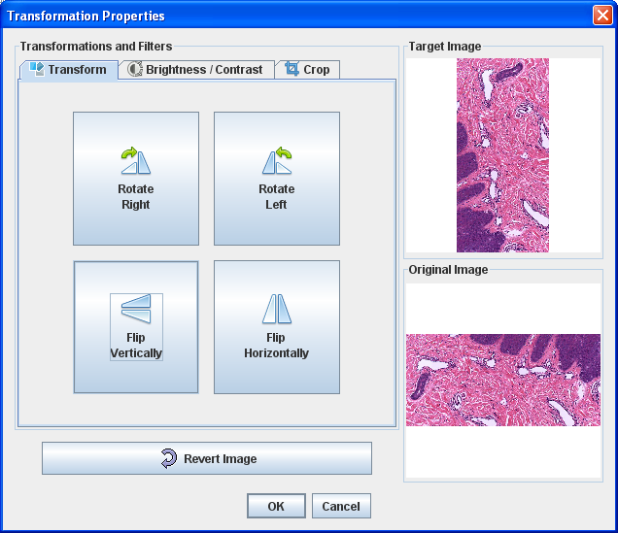

To change the brightness or contrast of a slide:
      - Click the button.
      - Make sure that the Brightness/Contrast tab is selected and move the sliders to set the desired brightness and/or contrast.
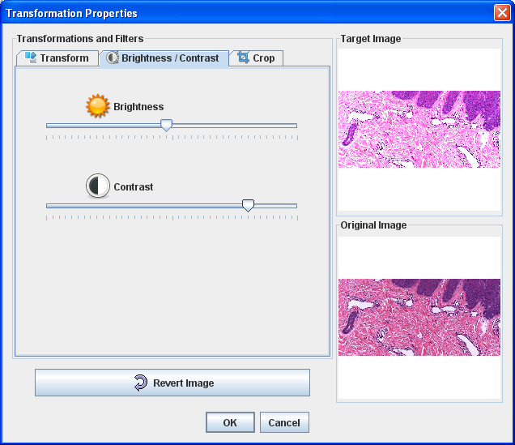

To crop a slide:
      - Click the button.
      - Make sure that the Crop tab is selected.
      - Click the Crop Image button and set box to desired points to crop the image.

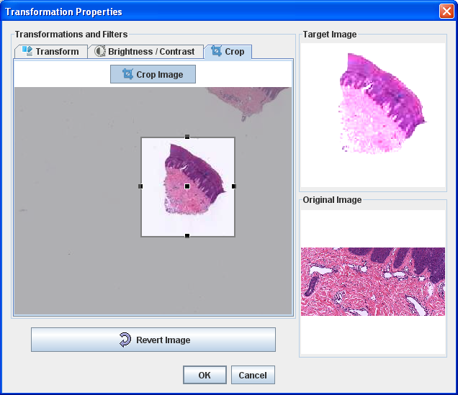

If at any time you want to go back to the original image click the  button at the bottom of the window. When this button is selected it will undo of all the transformation that were made to the slide.

Expand Digital Slide Area
The viewer area can be expanded by clicking the button or pressing Alt + W on your keyboard. The viewer area will open in a popup window. To close the expanded viewer area, click the button again or press Alt + W on your keyboard.

Annotating Digital Slides
Various shapes are available for annotating slides. To draw an annotation on a slide:
1. Select the appropriate drawing button by either clicking the button or using the appropriate keyboard shortcut.
2. Hold down the left mouse button over the slide and move the mouse to draw the shape.
3. Release the mouse button.
Below is a table listing each type of shape available, a picture of the button used for drawing it, and the keyboard shortcut for selecting the button.

Shape | Button | Shortcut
Arrow |  | Alt + A
Rectangle |  | Alt + R
Oval/circle |  | Alt + O
Polygon |  | Alt + P
Measuring tool |  | Alt + M

Annotations can also be added by choosing the appropriate option from the Annotations menu.
Once a shape is drawn, it will be listed on the Shapes Tab on the right-hand side of the screen. To delete a shape, right click the shape in the list of shapes and select the Delete option.

Modifying Shapes
Shapes that are drawn can be modified using the black boxes that appear on the edges and midpoint of each shape. Boxes on the edges can be used to resize or rotate shapes, and the midpoint can be used to move the shape to a different area of the slide. Simply hold down the left mouse over the appropriate box, and drag the mouse to resize, rotate, or move the shape as desired.

Cut/Copy/Paste Shapes
You have the ability to cut, copy, and paste shapes. Cutting and pasting shapes under a new tag will simply move the shape to that new tag. Copying shapes will duplicate the shape which can then be pasted under a different tag.

To copy a shape:
        - Right click the shape and select Duplicate Shape or select the shape and select Copy from the Edit menu.

To paste a shape:
        - Select the tag that you want to paste to and select Paste from the Edit menu.

To cut a shape:
        - Select the shape that you want to cut and select Cut from the Edit menu.

Taking Example Pictures from a Digital Slide
You have the ability to capture a region of a digital slide to be saved as an example picture of any Knowledge Base concept.
To take a screenshot:
1. Click the button.
2. Select the portion of the screen you want to take a screenshot of by holding down the left mouse button and dragging the mouse. A shaded box will indicate what region is selected.
3. Navigate to the folder where you want the screenshot to be saved.
4. Type in a file name for the screenshot to be saved as in the File Name box.
5. Click Save.

Tags
Tags can be created to group annotations together to keep them organized and to simply linking annotations with concepts. For example, if you have drawn a lot of shapes marking the area of a lymphocytic infiltrate, you might want to create a tag called “lymphocytes” and put all of the lymphocyte shapes under this tag.

Create a Tag
To create a single tag:
- Click the button in the shapes tab, choose Add Tag from the Case menu OR right click a particular shape and choose the Add Tag option (NOTE: using the right click method will automatically move that shape under the tag being created.)
- Type in the name of the tag.
- Click OK.
To create multiple tags at once:
- Click the button in the shapes tab.
- Type in each name of a tag separated by a comma.
- Click OK.

Delete a Tag
To delete a tag:
- Select the tag you would like to delete
- Click on the button or Right click on the tag and select Delete.

Any shapes associated with that tag WILL NOT be deleted. They will be moved underneath the default tag, “Untagged”.

Organizing Annotations with Tags
To associate untagged annotations to a single tag:
- Select the shapes you would like to associate with a tag
- Drag and drop (hold down the left mouse button and drag) shapes to the appropriate tag.
If a shape(s) are already associated with a tag, they can also be copied to another tag. To associate shapes to an additional tag:
- Select the shapes you would like to associate with an additional tag
- Click the button
- From the pop up window, select the additional tag you would like the shape(s) to be associated
- Click OK.

Case Authoring for SlideTutor ITS

The case authoring process for SlideTutor ITS is unique from the standard authoring of digital slides. In order to ensure the case content will work properly in the ITS, it is imperative that you first understand the ITS requirements.

Locations Annotations
The first annotation requirement is the list of Locations annotations. These annotations must have an area(s) of the digital slide associated with them. Typically freehand polygons, rectangles and circles are used as Locations. The Locations annotations are used to monitor where a student can identify a particular Knowledge Base concept and also provide assistance to the student on where he/she should look for a particular concept. To learn how to add shape(s)/tag(s) as a Location Annotation see the “Linking Annotations with Knowledge Base Concepts” section below.

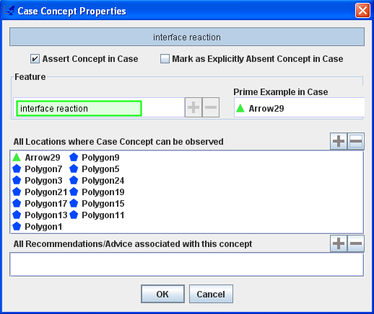

AUTHORING NOTE:
Using the concept authored above, the ITS provides a hint using one of the polygons listed to provide a hint to the student where to look for “lymphocytes”. Therefore, Locations should be use to point the student in the general area of where to look for a concept.
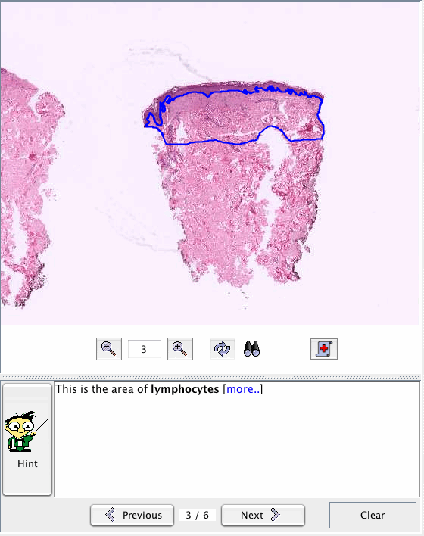

Prime Example Annotations
The second annotation requirement is the Prime Example annotation. The prime example annotation can be any type of shape. However, arrows are the most common form of Prime Example annotation. The Prime Example annotations are used to point to an exact location of a concept. To learn how to add shape(s)/tag(s) as a Prime Example annotation see the “Linking Annotations with Knowledge Base Concepts” section below.

AUTHORING NOTE:
Using the concept authored above, the ITS provides a hint using the Prime Example annotation to show the student what a “lymphocyte” looks like.

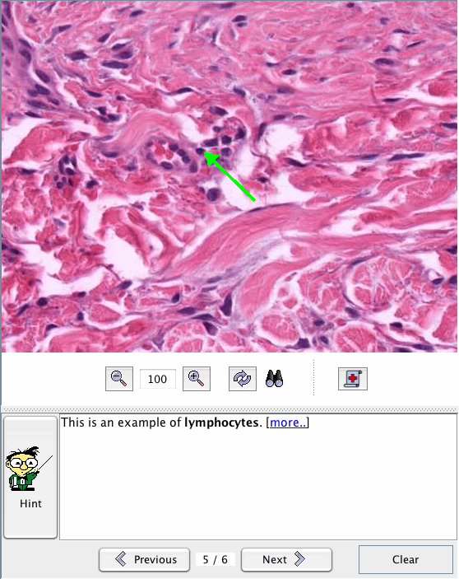

Linking Annotations with Knowledge Base Concepts
Once annotations have been added to a case, they should be linked with knowledge base concepts to establish what each shape’s purpose is. Each shape can be used for multiple concepts; however, each shape must be linked with at least one concept. Linking can be done in numerous ways:
• Drag the shape or tag in the Shapes list up to the appropriate concept.
• Drag the concept to the appropriate shape or tag in the Shapes list.
• Right click the shape or tag and choose Link. Choose the appropriate concept from the popup that appears.
• Right click the concept and choose Link. Choose the appropriate shape or tag from the popup that appears.

Concepts that have only Location annotations OR Prime Example annotation linked with it, it will turn yellow. Once a concept has both a Prime Example annotation and Locations annotations linked to it, it will turn green.

Case Concept Properties
Properties of concepts within a particular case include the annotations linked with that concept, whether that concept is asserted (has all appropriate annotations linked with it), and whether the concept is present or explicitly absent in the case.

Viewing Case Concept Properties
To view properties for a particular concept, double click that concept. A popup window will appear showing the properties for that concept.
To view the properties of all concepts of a particular type (diagnoses, findings, or prognosis), click the button. Each concept will be listed as a tab at the top of the popup window.

Modifying Linked Annotations Using Case Concept Properties
Additional annotations can be linked to a concept using the Case Concept Properties popup window by dragging shapes or tags from the Shapes list to the appropriate box in the popup, or by using the appropriate button and selecting the shape or tag from the popup window that appears.
Annotations can also be unlinked by clicking the annotation in the Case Concept Properties popup window and clicking the appropriate button.

Asserted Concepts
Asserted concepts are concepts that are true for that individual case. For example, if the set of findings {X or Y} is associated with the diagnosis of Bullous Pemphigoid and only Y is present in the case, then you would want to assert concept Y to inform the ITS that Y is indeed part of the case. Asserted concepts have a green border around them. Concepts that are parsed through the report or manually added to the case will automatically be asserted. To manually assert a concept you can right click the concept and choose Assert Concept from the menu.

Recommendations/Advice
In some tutoring systems it may be desirable to associate recommendations or advice with a diagnosis or a finding in the tutoring case. For example, if recommendation concept “use steroid cream” is associated with diagnosis “acute burn” then the tutoring system may do additional tutoring incorporating that recommendation if that diagnosis is observed.

Validating Knowledge Base Concepts for a Case
After completing the case authoring, click on the button to check that the case information is consistent with the Knowledge Base content for a disease. If the information authored is NOT consistent with what is in the Knowledge Base, DomainBuilder will add any missing concepts to your case OR it will give you a warning message telling you what is inconsistent.

Adding Additional Pathologies to the Case
Some cases may have multiple unrelated diagnoses on one or several slides within the same case. These instances should be marked so that the system can distinguish between the unrelated diagnoses.

Creating and Deleting Additional Pathologies
Before you can add additional pathologies to unrelated diagnoses you must first create it.
To create additional pathologies:
    - Click on the button or select Other Pathology from the case menu.
    - Click on Add Other Pathology
    - Type a description of the pathology being added in the popup window.
    - Click OK.
Once you have added your additional pathologies they will be available for selection the Other Pathology menu. You can remove unwanted pathologies by clicking
Remove Pathology and selecting the pathology that you want to remove from the drop down menu and clicking OK.

Marking Unrelated Diagnoses with Respective Pathologies
Once new pathologies have been added you can mark the unrelated diagnoses with their respective pathologies to tell the system that the case diagnoses are in fact unrelated to each other and do not constitute a differential diagnoses.

To mark unrelated diagnoses with their respective pathologies:
      - Right click on a diagnosis.
      - Select Pathologies sub menu
      - Click to check off pathologies that apply to the diagnosis

AUTHORING NOTE:
When a pathology is added to a diagnosis all findings that are associated with that diagnosis will automatically be marked with the same pathology. You can manually set pathologies for individual findings by right clicking them and selecting or deselecting the appropriate pathologies.

Viewing Different Pathologies
In order to view different findings and diagnoses that are associated with different pathologies:
    - Click on the button or select Other Pathology from the case menu.
    - Select a pathology description that you would like to view

Once a pathology is selected all findings and diagnoses that are not associated with the selected pathology will be grayed out. To return to original display select the All Pathologies option from the same menu.

Case Status
The case status is set for case management purposes so that the author will know which cases are ready to be deployed, which cases still need to be tested, and which cases still have authoring issues associated with them.

To mark the status of a case:
- Select Case Status in the Case menu or Click the button.
- Select the appropriate status from the list (Incomplete, Complete, Tested).

Knowledge Tab
The Knowledge Tab is where all of the creating and editing of knowledge base information is handled, and contains three sub-tabs:
- Hierarchy Builder: This tab allows concept creation and the organization of concepts into a tree-like structure.
- Diagnosis Builder: This tab allows you to link diseases with its associated findings and visualized the similarities and differences between them.
- Report Builder: This tab allows you to create report templates to help guide a student in writing a complete prognostic report.

Hierarchy Builder Tab
The first sub-tab is the Hierarchy Builder tab, where you create a hierarchy containing all concepts that go into the knowledge base. In this tab, you can add concepts to the knowledge base, edit/arrange concepts in the knowledge base, and add/edit definitions, synonyms, and example pictures of concepts.
When creating a new knowledge base, certain concepts will already exist. The various concept types (ACTIONS, ANCILLARY STUDIES, DIAGNOSES, FINDINGS, LOCATION, MODIFIERS, and VALUES) will all be present. Additionally, specific concepts will be listed under ACTIONS and VALUES.

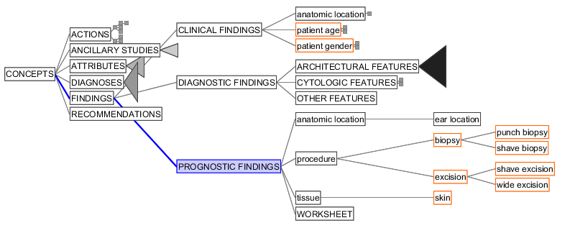
Pre-existing concepts in Knowledge Base

Adding Concepts
To add concepts to the hierarchy:
1. Click the appropriate parent concept/concept type in the hierarchy to select it. (NOTE: concepts will always be added beneath the selected concept.)
2. Choose the Add Concept option by either right clicking the selected concept OR choosing Add Concept from the Builder menu.
3. In the popup window, you can add the concept(s) you would like to create. If you would like to create a hierarchy of concepts, simply type the parent concept first and then in the next line insert a tab before the child concept. For example, if you wanted to create the following hierarchy under "MALIGNANT MELANOCYTIC LESION"...
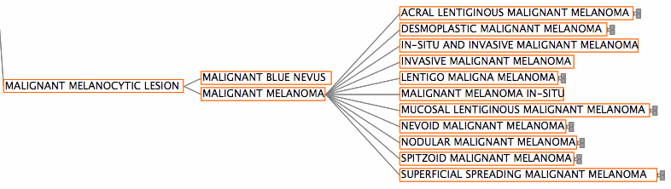
You would insert the following into the popup window...
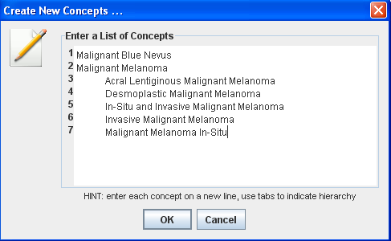
4. Click OK.

Cut/Copy/Paste/Delete Concept Options
In addition to adding new concepts, changes can be made to the knowledge base hierarchy using the cut, copy, paste, and delete options. Below is a table listing each option, a picture of the button used for that option, and the keyboard shortcut. The keyboard shortcuts for cut, copy, and paste are the standard keyboard shortcuts for these options.

Option | Button | Shortcut
Cut |  | Ctrl + X
Copy |  | Ctrl + C
Paste |  | Ctrl + V
Delete |  | Delete

These options are also available when you right click a concept.
Information that is cut or copied is displayed in the clipboard popup box displayed in the lower left-hand area of the screen to allow easy viewing of this material.
When the delete option is selected, a confirmation box appears asking if you want to delete the selected item.

Adding Concept Information
When a concept is selected in the hierarchy, information for that concept can be added in the panel on the right-hand side of the screen. A definition can be added, as well as synonyms and example pictures.

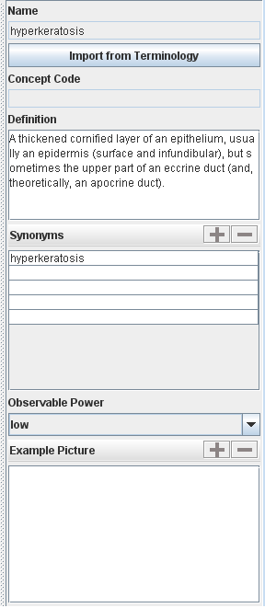

Manually Adding Definitions and Synonyms
It is important for definitions and synonyms of concepts to be included in the knowledge base.
To add a definition:
1. Select the appropriate concept in the hierarchy by left clicking it.
2. Click the definition textbox to place your text cursor.
3. Type in the definition.
To add synonyms:
1. Select the appropriate concept in the hierarchy by left clicking it.
2. If there aren’t any empty rows in the synonyms table, click the button to add a row.
3. Click the first empty synonym textbox to place your text cursor.
4. Type in the synonym.
You can move your cursor to other synonym textboxes by using your mouse like in step #2 above, using the Tab or Enter keys on your keyboard, or using the up and down arrows on your keyboard.

Importing Definitions and Synonyms from the Terminology
Definitions and synonyms can also be imported from the terminology by clicking the button. When this button is clicked, a popup window appears listing possible matches found in the terminology. When a match is selected, the terminology information will be displayed for that item. To import information from the terminology into the knowledge base, select the appropriate term and click OK.

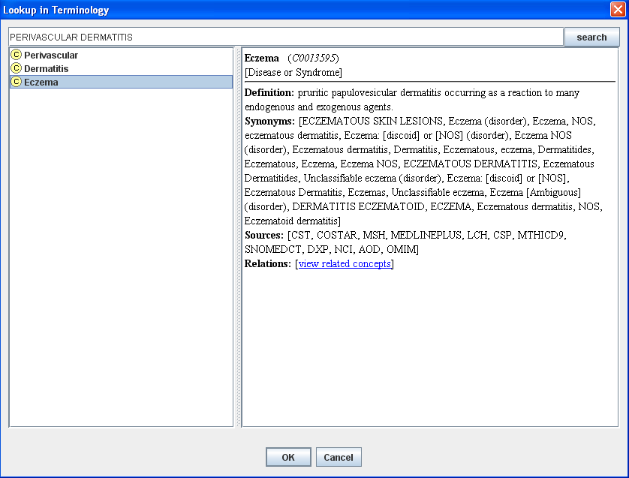

Creating a Worksheet
Some clinical information may be added to a report using the worksheet button. Using this button, information can be added by selecting the appropriate radio buttons rather than typing it in.

To create a worksheet:
      - Click on PROGNOSTIC FINDINGS in the Knowledge tree.
      - Right Click on WORKSHEET
      - Click Add Concept
      - Type in the concept hierarchy for the worksheet that you would like to create. Below is a screen shot of an example hierarchy of pathologic staging of melanoma.
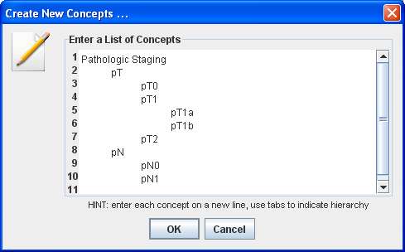

Once all the information is entered along with definitions the end result will look something like this.

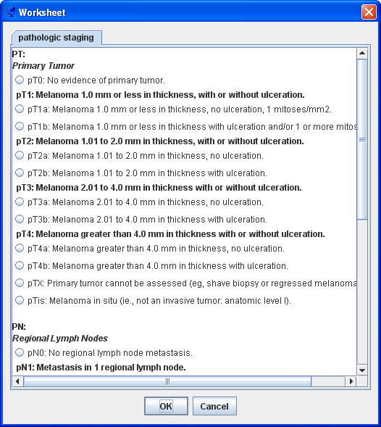

Diagnosis Builder Tab
The next sub-tab is the Diagnosis Builder tab, which allows you to say what findings each disease has, and to compare findings in different diseases and see similarities and differences between them. Diseases can have multiple distinct feature sets.
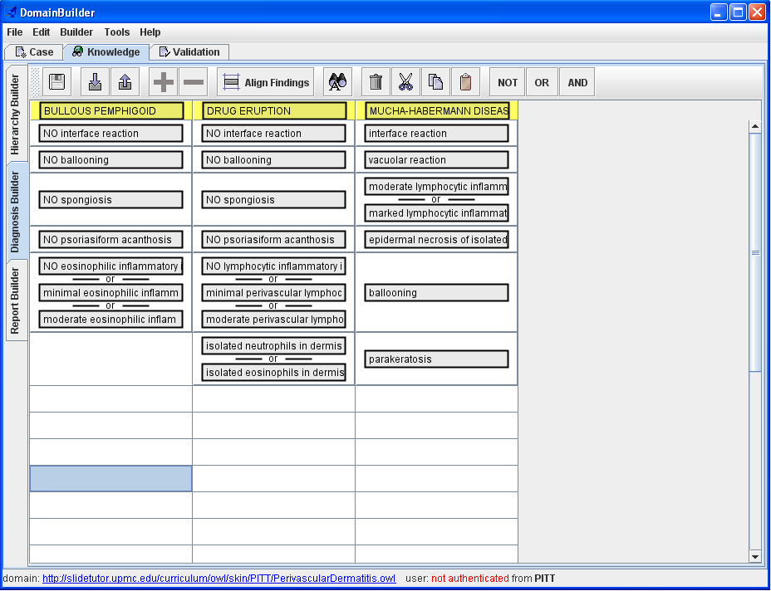

Adding Diagnoses
The Diagnosis Builder tab is empty when it is first opened. The first step is to add the diagnoses you want to “build”.
To add diagnoses:
1. Click the button.
2. Select the desired item(s) from the menu tree that appears.
AUTHORING NOTE:
If you would like to see all of your diagnoses that were previously worked on, you must individually add each and every diagnosis that you would like to see.

Adding Findings to Diagnoses
Once diagnoses have been added, you can add findings to diagnoses, saying what findings a particular diagnosis must have (or must not have).
To add findings:
1. Start typing already existing findings and selecting the appropriate finding from the combo box.
OR
1. Right click and choose Add Finding.
2. Select the appropriate finding(s) from the tree.
3. Click OK.

Modifying Rules for Findings
When findings are initially added to a diagnosis, they indicate that this one finding is present for that diagnosis. The default is for cells to be ANDed, meaning all of the findings listed must be present. However, findings can be modified to mean other things – you can indicate that a finding is not present for a diagnosis, and you can indicate that you have to have either one finding OR another finding in that diagnosis. These options are performed using the NO, OR, and AND options.
To add rules for findings:
1. Highlight the appropriate finding cell(s) by clicking and dragging your mouse.
2. Click the appropriate rule button OR right click and choose the appropriate option.

Adding Multiple Patterns of a Diagnosis
Sometimes a diagnosis can present itself with multiple visualized patterns. In order to create multiple patterns for a given diagnosis, make sure the diagnosis is added to the panel and then select the diagnosis name (highlighted in yellow) and click the OR button. Another column will be added to the panel with the same diagnosis, which indicates that this disease has two different patterns of findings associated with it.

Cut/Copy/Paste Findings
Findings can also be linked to a diagnosis using the cut, copy, paste, and delete options. Below is a table listing each option, a picture of the button used for that option, and the keyboard shortcut. The keyboard shortcuts for cut, copy, and paste are the standard keyboard shortcuts for these options.

Option | Button | Shortcut
Cut |  | Ctrl + X
Copy |  | Ctrl + C
Paste |  | Ctrl + V
Delete |  | Delete

Align Findings
Findings can be aligned to make comparing findings across diseases easier. To align findings, click the 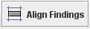 button. Findings will then be aligned as much as possible.

Import Findings from Spreadsheet
Findings can be automatically created and linked to a diagnosis by importing a Comma Separated Value(.csv) file into DomainBuilder. Comma Separated Value files can be created through applications, such as Microsoft Excel. To create a .csv file...
1. Create a spreadsheet with the first row of each column being the diagnosis and each subsequent row the appropriate findings associated with the diagnosis.

COMPOUND MELANOCYTIC NEVUS | INTRADERMAL MELANOCYTIC NEVUS | JUNCTIONAL MELANOCYTIC NEVUS
lentiginous proliferation of melanocytes OR junctional nest of melanocytes | melanocytes in dermis OR nest of melanocytes in dermis | lentiginous proliferation of melanocytes OR junctional nest of melanocytes
melanocytes in dermis OR nest of melanocytes in dermis | NO lentiginous proliferation of melanocytes | NO melanocytes in dermis
NO cytologic atypia | NO junctional nest of melanocytes | NO nest of melanocytes in dermis
NO pagetoid spread | NO cytologic atypia
maturation | maturation

AUTHORING NOTE:
In order to create an OR-ed rule simply place "OR" (in caps) between the two features. In order to create an absent finding simply place "NO" (in all caps) before the concept.
2. In the menu, click on File and then Save As. Enter in the name of the file and make sure to choose CSV or Comma Separated Value as the file type.
3. Open DomainBuilder and create/open the appropriate Knowledge Base.
4. Click on the Knowledge Tab and then the Diagnosis Builder Tab.
5. Click on and browse for the .csv file. Click OK.
NOTE: Please be patient! It can take several minutes to create and import all of the concepts in the spreadsheet.
6. Once the tool is finished importing the concepts, you can click on the Hierarchy Builder tab to find all of the newly created concepts.
The concepts are not automatically created in a hierarchy from this import process. All of the diagnoses are simply added to the DIAGNOSIS class and all findings are added to the DIAGNOSITC FINDINGS class. In the Hierarchy Tab, it is up to the user to create the proper hierarchy from the added concepts or use the button to organize the hierarchy automatically.

Find/Replace Findings Inside all Diagnostic Rules
Sometimes it may be desirable to replace all occurrences of one finding from all diagnostic rules with another or remove it all together. Often times this happens when two findings are merged into a single finding due to a typo or new information from a source.

To find/replace findings inside all diagnostic rule:
      - Click on the 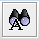 button or Find/Replace Finding from the Builder menu.
      - Click the button next to Search for Finding field to add a finding to search for.
      - Click the button next to Replace with Finding field to add a finding to replace it with.
      - Click Find to open all diagnostic rules that contain the finding you are searching for OR click replace to perform a replacement operation in all rules that the finding is located in.

Below is a screen shot for the Find/Replace function:
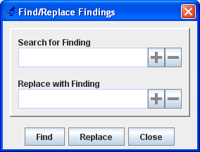

Report Builder Tab
The last sub-tab in the Knowledge Tab is the Report Builder tab, which contains templates for writing prognostic reports. In this tab, you can create and edit templates, and assign individual prognostic findings to a template.
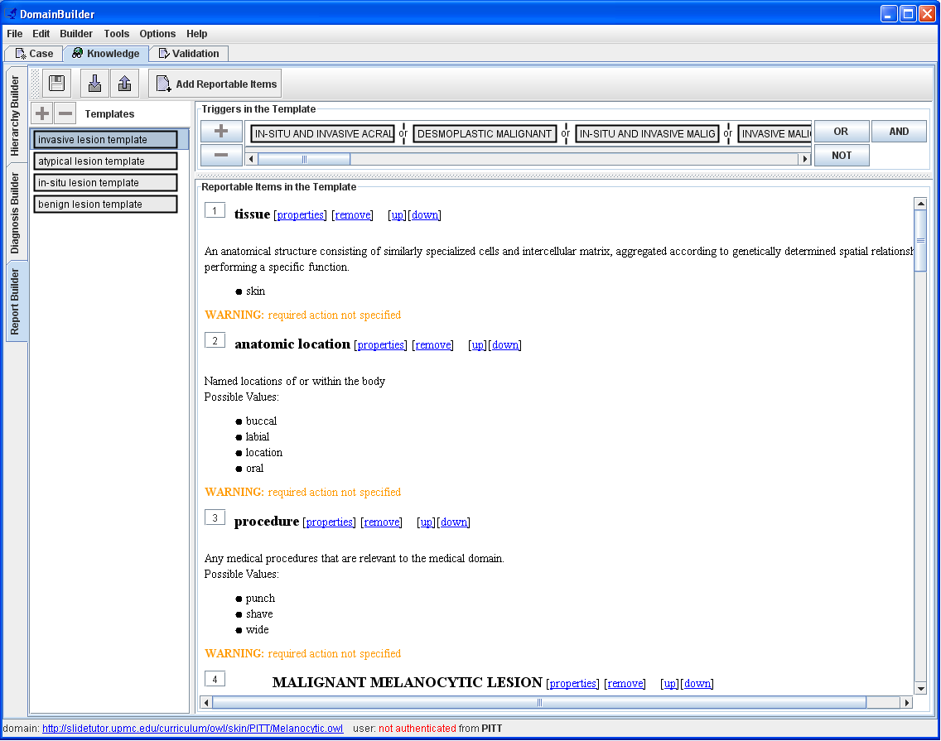

Creating a New Template
To create a new report template:
1. Click the button in the Templates area of the screen OR right click in the Templates list area and select the Add Template option.
2. Type in a name for the template.
3. Click OK.

Deleting a Template
Report templates can be deleted from the Knowledge Base.
To delete a template:
1. Click the template to select it.
2. Click the button in the Templates area of the screen OR right click and select the Remove Template option.

Reportable Items
Reportable Items are a list of concepts that you would like the ITS to monitor the student’s ability to assess and include in a prognostic report.

Adding Reportable Items
To add a Reportable Item click on the Add Reportable Items button either in the middle of the template or on the menu bar at top. Select the appropriate concept(s) in the order you would like the items to appear in the student’s report. Click OK.

Deleting Reportable Items
To remove a Reportable Item click on the remove link to the right of the concept you would like to be deleted.

Reorder Reportable Items
After Reportable Items are added to a template, they can be reordered.

To increase the priority of a Reportable Item, click the “up” link at the right of the concept to move the concept up one position. Continue clicking the “up” link until the concept is in the desired position.

To decrease the priority of a Reportable Item, click the “down” link at the right of the concept to move the concept down one position. Continue clicking the “down” link until the concept is in the desired position.

You can also reorder reportable items by changing the order number to the left of the item.

Triggers
Each template needs to be assigned triggers to indicate when the template should be used.

Adding a Trigger
To add a trigger:
  - Click on the button under Triggers in the Template heading.
  - Select the appropriate conditions that will activate this report template
  - Select OK

The default is for triggers to be ANDed, meaning all triggers must be present for the template to be triggered. You can also use the OR or NO to create more complex triggers scenarios within the template.

AUTHORING NOTE:
Triggers are the conditions upon which a template is activated. For instance, if there is one format for reporting about a needle core biopsy of adenocarcinoma and another format for reporting about a resection of adenocarcinoma, you would create one template that has the triggers “Adenocarcinoma” and “Needle core biopsy” and another template with the triggers “Adenocarcinoma” and “Resection”.

Deleting a Trigger
To delete a trigger:
    - Select the trigger that is to be deleted
    - Click the button.

Validation Tab
The Validation Tab allows you to verify information in the knowledge base and individual cases. By mousing over a particular item, all items of other types containing that item will by highlighted. For example, if you mouse over a finding, all diagnoses and cases containing that finding will be highlighted. If you mouse over a particular diagnosis, all findings that disease contains (according to the knowledge base) and all cases with that diagnosis will be highlighted. If you mouse over a particular case, all findings and diagnoses that case contains according to the authoring will be highlighted. In this way, information in the knowledge base and individual case authoring can be checked and validated before being used in the tutoring system.

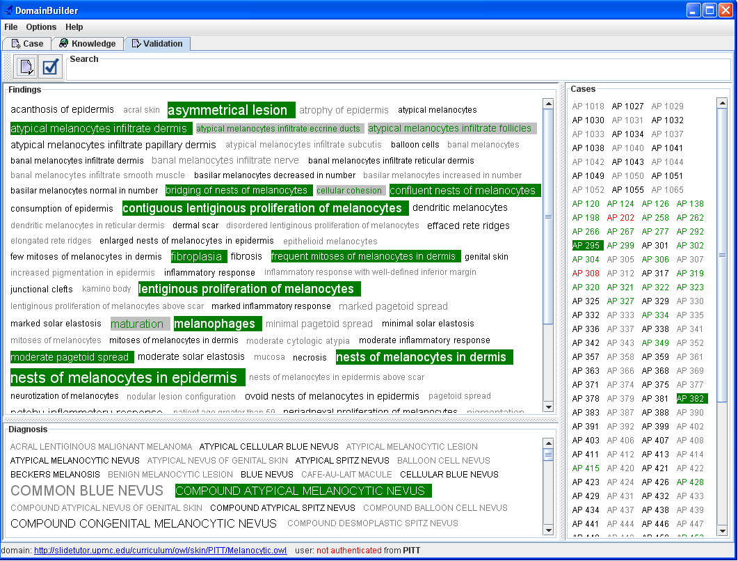

Search
A search tool is available at the top of the screen to make finding particular items easier. Simply type in the word or string you wish to search for. Any items containing the search string will be highlighted yellow.

Preview Cases
Cases can be previewed in the Validation Tab. When you double-click a case, a popup window will appear containing a preview of the digital slides and the pathology report assigned to that case during case authoring. You can open the case using the Go To option described below.

AUTHORING NOTE:
Cases are colored based on the Case Status assigned from the Case Tab. Cases in red are Incomplete cases. Cases in blue are Completed cases. Cases in green are Tested cases.

Right Click Menu Options
Several options are available when you right click a finding, diagnosis, or case in the Validation Tab.

Glossary
The glossary option will display the definition of the selected finding or diagnosis. For cases, the glossary will display the difficulty of the case, and whether the case is ready to use. To view glossary information for an item, right click the item and select the Glossary option.

Bookmark/Unbookmark
Bookmarks can be set to help with verification. When a bookmark is set, any items linked with that item will be highlighted green. For example, if a bookmark is set for a particular finding, all diagnoses and cases containing that finding will be marked. If a diagnosis is bookmarked, all findings that diagnosis contains and cases with that diagnosis will be marked.
To set a bookmark, right click the item and select the Bookmark option. A bookmark that has been set can be removed by right clicking the item and selecting the Unbookmark option.

Open Option
The Open option allows you to jump to a particular concept in the knowledge base or open a case from the Validation Tab. To go directly to a concept or case from the Validation Tab, simply right click the appropriate item and select the Open option.

Summary
A case summary is available that provides basic statistics of cases that are in DomainBuilder. To access this case summary click on the button in the upper left hand corner of the Validation Tab.

